HOSPITALITY AND TOURISM MANAGEMENT
BMIH5006
Student Id:2245647
Student Name:EDDYSON FERNANDES
:
Executive Summary
The purpose of this report is to look in detail at the way land transport helps to create a link and connection to tourists in the hospitality industry. It investigates the contamination of the environment produced by land transport, something due to carbon emissions, air pollution, congestion of traffic, noise pollution and the loss of biodiversity. The results show that land transport has a major role in climate change and urban problems in tourism-dependent regions.
The report identifies some possible solutions for sustainable land transport such as electric and hybrid vehicles adoption, public transport partnerships, smart transport systems, infrastructure development, etc. and government policy intervention. These measures are shown to be feasible to reduce environmental damage and maintain efficient access while maintaining a low gate required for efficient access.
Additionally, the report evaluates the feasibility of sustainable transport projects, considering their cost and guest acceptability. The case for eco-friendly transport solutions in hospitality enhances the benefits of this environmentally, such as less carbon emissions, better air quality and less congestion. Finally, suggestions to boost sustainable parcel forwarding adoption are provided.

Table of Contents
1. Introduction 2
2. Main Findings 2
2.1 Overview of Land Transport in the Hospitality Industry 2
2.2 Environmental Impact of Land Transport 2
2.3 Possible Solutions for Sustainable Land Transport in Hospitality 2
2.4 Feasibility and Realism of Sustainable Land Transport Solutions 2
2.5 Environmental Benefits of Sustainable Land Transport 2
3. Conclusion and Recommendations 2
References 2

1. Introduction
Hospitality transport describes the carriage of tourists, guests, hospitality products, and hospitality services across destinations(Inkson and Minnaert, 2018). Transport is a vital part of the hospitality sector, as good transport connections ensure access to restaurants, hotels, attractions, and other related hospitality services. There are modes of hospitality transport, such as air transport, land transport, and sea transport, that collectively contribute towards guest experience as well as efficient operation.
A key part of hospitality operations, especially in urban and rural areas and in hotel transfers and food supply logistics, land transport is the focus of the report. Private vehicles, buses, rail, and ride-hailing services all cause carbon emissions, traffic congestion, and ecological degradation, and thus, constitute land transport (Cooper, 2021). The area of focus is on the environmental footprint of many of the hospitality businesses that rely on efficient road and rail networks to transport visitors and their goods.
One of the important areas of interest is the dependence on fossil-fuel-based automobiles, which account for air and climate pollution. The report will discuss the environmental implications of transport on land for hospitality and weigh the innovative methods used in the industry to avert harm. Through the consideration of sustainable substitutes, the industry can transition toward cleaner, eco-friendly modes of transport without sacrificing operational effectiveness.

2. Main Findings

2.1 Overview of Land Transport in the Hospitality Industry
Hospitality land transport describes a system that includes road and rail transport such as taxis, buses, trains, and private cars (Haski-Leventhal, 2018). However, it is vital for connecting the tourists to the destinations, making them more accessible, and creating great information on a database for an involved and enriched guest experience. These modes are commonly used by hotels, tour operators, and travel agencies to offer a seamless travel experience to guests.

2.2 Environmental Impact of Land Transport
The hospitality industry greatly depends on land transportation for the moving of guests as well as goods. Although carbon emissions and air pollution are now consumed, the environmental footprint includes carbon emissions, air pollution, traffic congestion, noise, light pollution, and land degradation.
2.2.1 Carbon Emissions and Air Pollution
Tourism contributes around 8% of global carbon emissions. Tourism's carbon impact is influenced by a variety of activities, including aircraft trips and boat journeys, souvenirs and housing (Sustainable Travel International, 2024). The tourism industry depends significantly on land transport modes like private cars, buses, and taxis, which are mainly fossil fuel-based. The use of these modes results in enormous emissions of greenhouse gases (GHG), leading to climate change. Tourism-related transport emissions equated to about 5% of total man-made CO₂ emissions in 2016, with estimates suggesting a growth to 5.3% by 2030 (UN Tourism, 2025).
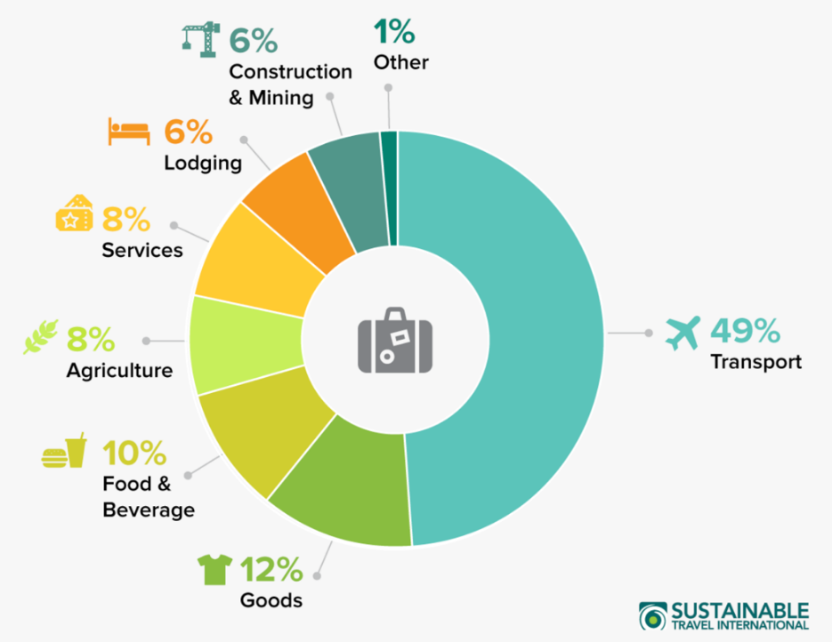
Figure: Carbon Footprint of Globe Tourism
(Source: Sustainable Travel International, 2024)
Much of these emissions come from road transport. For example, cars and buses produce large quantities of CO₂ per passenger-kilometre, with cars producing an average of about 192 grams and buses about 105 grams. Urban areas have hotel shuttle services and taxi operations that add to high levels of nitrogen oxides and particulate matter (PM), resulting in poor air quality and related health conditions.
2.2.2 Traffic Congestion and Urban Impact
In tourism-intensive regions, there is an increase in road congestion brought about by the influx of visitors using land transport. The strain of this surge puts existing infrastructure under a severe strain, meaning that locals and tourists are forced to travel longer. Congestion challenges are major, usually impacting major tourist destinations like London, Paris, and Barcelona, especially in peak tourist seasons (Management Association, 2018). Moreover, the additional traffic negatively affects the quality of life of residents and takes away from the visitor experience.
2.2.3 Noise and Light Pollution
The operation of land transport vehicles is a source of noise pollution, disturbing local communities as well as wildlife habitats. Prolonged noise from hotel shuttles, tour buses, and taxis can cause stress and health problems among residents. Wildlife, especially nocturnal animals, might develop disturbed behaviours due to ongoing noise, impairing their survival and reproduction.
Light pollution is also an issue, particularly where transport terminals run throughout the day and night. Artificial light from vehicles and infrastructure can disturb the natural habits of wildlife and human circadian rhythms, with health implications.
2.2.4 Land Degradation and Biodiversity Loss
Land degradation often takes place during the expansion and maintenance of road networks to satisfy tourist transport needs. New roads constructed can deforest and destroy habitats, thus threatening biodiversity (Sloan, Legrand and Chen, 2017). Road development in national parks and protected areas fragments habitats, which can lead to difficulty for species to thrive. For instance, increased road expansion in areas of certain national parks does motivate the decline of native species due to habitat disruption.

2.3 Possible Solutions for Sustainable Land Transport in Hospitality
The hospitality industry is a field where land transport is of prime importance in the movement of guests and staff, as taxis, buses, trains, and private cars are some of the frequently used modes of transport. Yet, these modes of transport have their disadvantages, such as giving rise to carbon emissions, air pollution, and noise disturbance. However, the industry is incorporating several sustainable solutions to address these issues.
2.3.1 Adoption of Electric and Hybrid Vehicles
By moving to electric and hybrid vehicles, carbon emissions linked with the transport of fuel that is burned come down to a great extent. Directly, electric vehicles (EVs) eliminate air pollutants because they have zero tailpipe emissions (Wickham, Donnelly and French, 2021). One example: Marriott International teamed up with EV Connect to deploy EV charging stations at Marriott properties across the U.S. and Canada to enable guests to drive electric vehicles on its properties and lessen its guests’ carbon footprint when riding around on trips.
2.3.2 Implementation of Public Transport Partnerships
Local public transport systems are encouraged to collaborate with guests to encourage them to opt for sustainable travel options. Transit passes could be a cost for hotels to offer for free or at a discount. Tourists in Amsterdam get free or discounted access to many of the tourist attractions and get unlimited access to any buses, trams, and metros for a limited period with the 'I Amsterdam City Card' (Amsterdam.net, 2025).
These partnerships can reduce the number of trips made by private vehicles, which would lessen traffic congestion and emissions of those trips. In addition, guests get convenience with their prices, and the local community enjoys cleaner air, cleaner streets, and less traffic.
2.3.3 Smart Transport Systems and Carpooling
Smart transport solutions such as ridesharing and carpooling can not only help integrate but also use smart transport solutions to try to overcome situations such as reduced vehicle usage and the number of trips needed. Electric shuttle services like those that Circuit offers allow platforms to customie shuttles for hotel guests and satisfy a specific need within a specific area.
App-based carpooling systems can enable multiple guests or staff members to share rides, thus effectively reducing the number of cars on the road (Jauhari, 2021).
2.3.4 Infrastructure Development for Sustainable Travel
Investment in the infrastructure of an alternative mode of transport is necessary. Cycling lanes and pedestrian-friendly pathways developed, which encourages guests to choose to travel via bike or foot instead of vehicular. Bicycles and electric scooters are sometimes part of the amenities offered by some hotels (Sustainable Tourism, 2019). Alternatively, some Amsterdam hotels make bicycles available for guests to help them ride around the city sustainably.
2.3.5 Government and Policy Interventions
Sustainable transport is promoted by government policies in the hospitality sector. Low-emission zones, taking the incentive of tax for green activities and investing in public transportation infrastructure are good ways out (Edgell, 2020). For example, an ideal example of this would be cities like Amsterdam where there is a referral to comprehensive public transport passes like the 'Amsterdam & Region Travel Ticket,' which provides unlimited travel across various forms of public transport, encouraging both locals and travellers to use the other or private cars.

2.4 Feasibility and Realism of Sustainable Land Transport Solutions
To implement such sustainable land transport solutions, it is required to evaluate the cost-effectiveness, scalability, guest perception and challenges.
Cost-Effectiveness: The transition to electric and hybrid vehicles involves a large initial investment, including the purchase of vehicles and more expensive infrastructure. However, operational savings are notable. Electric vehicles (EVs) are a more efficient way of transportation due to the savings of around $4,000 per vehicle a year on fuel costs and maintenance (Costa & Costa, 2022). Additionally, government incentives and grants also cover initial expenses, resulting in financial viability.
Scalability: Large hotel chains have more capital resources and can easily absorb the costs of sustainable transport initiatives. Marriott International has implemented electric shuttle fleets across dozens of properties. However, smaller independent hotels may be operating with a low budget but can take advantage of local governments or ride-sharing companies, which can be scaled. Interacting industries including shared infrastructure such as charging, can reduce costs for smaller establishments.
Guest Perception: Guests are more focused on sustainability than ever. According to a survey from Booking.com, 76% of those surveyed said they plan to travel more sustainably in the next year (World Economic Forum, 2023). Providing sustainable transportation choices can lead to increased guest satisfaction and loyalty since environmentally responsible guests will favour properties that reflect their values. Nevertheless, it must be transparent, since guests have become very good at spotting greenwashing, and misleading claims could do good hotels no good.
Challenges: It is a large hurdle in infrastructure readiness. Upgrading electricals with the installation of EV charging stations can be expensive and time-consuming. It will depend on the location and where the permitting process can extend project timelines. There may be challenges to the regulatory policies especially in regions with strict environmental standards. It also requires additional resources to adopt the technology such as training staff and integrating the system.

2.5 Environmental Benefits of Sustainable Land Transport
There are many environmental benefits to adopting sustainable land transport solutions in the hospitality sector.
Gives a reduction in carbon emissions and improved air quality: The high-end electric and hybrid vehicles reduce greenhouse gas emissions by high margins (Batabyal, 2018). The impact of electric vehicles is not only that they produce zero tailpipe emissions, improving clean air locally, but that in doing so they also displace the combustion of diesel or gasoline in vehicles with internal combustion engines. In 2019, CO2 emissions from personal vehicles averaged 0.47 pounds per passenger mile.
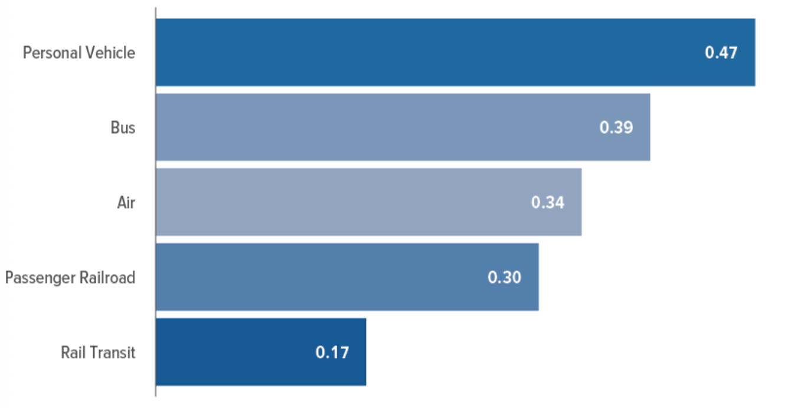
Figure: Average carbon dioxide Emission, by mode of Transportation
(Source: Congressional Budget Office, 2022)
Trying to Reduce Congestion and Increase More Visitor-Friendly Experiences: Ride-sharing programs and improving public transportation can help reduce the number of individual vehicles on the roads. It reduces the amount of traffic; therefore, travel time will be shorter, and it will be a more pleasant experience for the guest. In addition, efficient transport systems raise the attraction of tourist sites.
Protection of Natural and Cultural Heritage Sites: Sustainable transport does not degrade environmental conditions caused by traditional vehicles with air and noise pollution. Through such reduction, natural habitats and cultural heritage sites are preserved better to the integrity they may have for future generations (New governance and management in touristic destinations, 2022). For example, electric vehicles produce a quieter engine, thus providing fewer noise levels in hazardous areas.
Enhanced Sustainability Image for Hotel Companies: Embracing eco-friendly transport solutions helps hotel businesses increase sustainability reputation. Incorporating this commitment may also attract environmentally friendly travellers who, in turn, would increase bookings. A positive sustainability reputation will allow a brand to compete in a competitive market, create customer loyalty, and potentially command premium pricing. Also, certifications and awards are accessible, which can enhance a hotel’s market position as well.

3. Conclusion and Recommendations
Hospitality relies on land transport to ensure connectivity and accessibility to tourists. However, it comes with lots of environmental hazards, such as carbon emission, congestion, pollution, and biodiversity loss. So, hospitality companies should focus on sustainable alternatives like hybrid and electric vehicle adoption, public transport partnerships and ride-sharing. Closer work towards the improvements to infrastructure like cycling lanes and pedestrian-friendly zones will boost eco-friendly travelling. In addition, government policies like low emission zones and the incentivising of change within the industry. The challenges that present themselves include high initial investments and regulatory barriers, however, benefits, from a long-term perspective, will surpass costs and will improve the guest experience while reducing environmental degradation. It is now undisputed that for successful sustainable development, hospitality businesses and other relevant industries must embrace sustainability as a strategic priority, to sustain themselves in market competition, and to follow global environmental goals (Korstanje, George and Nedelea, 2020). This will help the implementation of these measures contribute to a greener hospitality sector that will be viable in the long run whilst preserving the natural and cultural heritage of the affected premises.

References
Amsterdam.net (2025) I Amsterdam City Card: guide, review and comparison[Online] Available at: https://www.amsterdam.net/en/amsterdam-card/#:~:text=The%20I%20Amsterdam%20City%20Card%20includes%20free%20entry%20to%20almost,Amsterdam's%20major%20museums%20and%20attractions [Accessed on: 25 February, 2024].
Batabyal. (2018). Managing Sustainable Tourism Resources. IGI Global.
Congressional Budget Office (2022) Emissions of Carbon Dioxide in the Transportation Sector[Online] Available at: https://www.cbo.gov/publication/58861 [Accessed on: 25 February, 2024].
Cooper, C. (2021) Essentials of tourism. Third edition. London: SAGE.
Costa, & Costa, C. (2022). Sustainability and competitiveness in the hospitality industry (Costa & C. Costa, Eds.). Business Science Reference.
Edgell. (2020). Managing sustainable tourism: a legacy for the future (Third edition). Routledge.
Haski-Leventhal, D. (2018) Strategic corporate social responsibility: tools & theories for responsible management. London: SAGE.
Inkson, C. and Minnaert, L. (2018) Tourism management: an introduction. 2nd ed. London: SAGE.
Jauhari, V (2021) ‘Managing Sustainability in the Hospitality and Tourism Industry: Paradigms and Directions for the Future’ 9thedn.Oakville: Apple Academic Press. Inc.
Korstanje, George, B., & Nedelea, A. (2020). Strategies for promoting sustainable hospitality and tourism services. IGI Global.
Sloan, P., Legrand, W. and Chen, J.S. (2017) Sustainability in the hospitality industry: principles of sustainable operations. 3rdedn. London: Butterworth-Heinemann.
Sustainable tourism: breakthroughs in research and practice. (2019). IGI Global.
Sustainable Travel International (2024) Carbon Footprint of Tourism [Online] Available at: https://sustainabletravel.org/issues/carbon-footprint-tourism/ [Accessed on: 25 February, 2024].
UN Tourism (2025) Transport-related CO2 emissions from the tourism[Online] Available at: https://www.unwto.org/sustainable-development/tourism-emissions-climate-change [Accessed on: 25 February, 2024].
Wickham, Donnelly, T., & French, L. (2021). Strategic Sustainability Management in the Event Sector. Event Management, 25(3), 279–296.
World Economic Forum (2023) Survey of travellers finds 76% want more sustainable options[Online] Available at: https://www.weforum.org/stories/2023/04/survey-of-travelers-finds-76-want-more-sustainable-options/[Accessed on: 25 February, 2024].

