Student Name: Saira Arif
Student ID: 220569
Lecturer Name: Zahida Khan
Module Code: LCHS4002_BIRM
Digital Skills and Research Methods

Contents
Introduction 3
Results 6
Conclusions: 9
References: 10
Appendix: 10

Introduction

In this report, our colleagues and I collaborated in groups. We are level 4 Health and Social Care students at University of Wales Trinity Saint David. We have been working together in our Digital Skills session gathering information on how digital skills can help students and how crucial is to consider digital skills even though you might already hold the skills, as when students attend university it will help them to utilise the digital skills and to discover and assess the information and use the internet more effectively. We'll talk about the data we obtained from the group's questionnaire that was generated using MS Form. We have designed a questionnaire that we will distribute to students in order to determine how important digital literacy is to them and what skills they value most. In order to see the results, we will typically excel the replies and insert them into our results table. Also, we created a group presentation that details how using digital skills may improve day-to-day work life and presented it to the tutor. This report lists all of the essential digital skills and emphasises their significance. Before handing out the form, the team requested students for permission which was the first Question on the Ms Forms. Colleagues were requested to scan the QR code to access the form and complete it because when they have done so, the form would collect their responses, and I would then collect responses and create a chart for it. I may then use this to learn more about the significance of digital skills.

  - Research Design
Which Digital Tool is most used by students at the University of Wales Trinity Saint David?

  - Research Question
At the University of Wales Trinity St David we have looked at how students can use digital skills and what sources they can use to develop. Digital tools are crucial because they improve consistency, security, efficiency, and effectiveness in education and the world of work. The primary digital tools utilised at UWSTD include MS WORD, Email, OneDrive, PowerPoint, Excel, IT skills, and mobile devices in general. The ability to create, collaborate, and communicate allows us to accomplish our jobs more successfully, which makes Microsoft 365 one of the most useful tools for UWTSD to use in the classroom. Teams is another skill that is commonly used in education since it can save and share files, arrange meetings from the calendar, and generate ms word, PowerPoint, and emails, as well as communicate with students and tutors.

  - Method
The methods we used was as a team we designed a questionnaire on Ms Forms based on our question (Which students most often utilise digital technology at the uwtsd?) as a team, We created a form with 7 questions and had the class to scan the QR code to gather responses, which we then translated into charts in Excel to provide us the information we needed, we then made the information into charts using excel so the results were clearly shown. In our ms forms, we asked questions based on digital skills 1. How confident are you in using digital skills? 2. Which format would you prefer using in PowerPoint? 3. My work is improved by technology? 4. Do you think that using one drive is the most important? 5. Do you use WhatsApp more than digital tools? We also got consent from students on the form. The questionnaire provided feedback on what skills are most commonly used and demonstrated that students will become more confident in using technology with their peers within the university and will be able to use technology effectively as well as use and discover more using various types of technology. In week 4, we were shown how to collect data and obtain information in order to construct a questionnaire, which helped us with ms form skills as well as information and note-taking. This was also a skill for digital skill as it helped me learn how to use several Microsoft 365 sources.
We also created a presentation about digital skills, explaining why they are vital and how they may help in everyday work life. We picked many sources students may use in our presentation and presented them to the instructor. We obtained information from Google and the uwtsd library.( Dahlström, H. (2018) We made a question and put all of the information gathered on it to determine how students regard digital skills and what their points to these talents are. Digital skills cover a variety of sources such as MS Word, PowerPoint, Excel, teams, and even using your phone is a skill.
As stated in the (Reedy, K. and Parker, J. (2018) Digital) Digital literacy is a strong subject that promotes social progress and equality. Including research and experience from several fields, and current view on digital literacy and learning. Whatever the position or environment, Digital Literacy Unpacked aims to inspire, foster cooperation, and provide a snapshot of cutting-edge approaches to digital literacy. Digital skills is a broad field that encompasses a wide range of abilities and is widely applied in a variety of sectors.

  - Ethical Considerations
Ethical concerns are a collection of principles that guide the designs and practices of your study. These principles include informed consent, voluntary engagement, and privacy. To maintain this, we chose to seek consent as part of our questionnaire for all students to agree to do the form we have told them about them accepting will mean we are not violating data protection and completing with their consent. Confidentiality is the idea and practice of keeping sensitive information private unless the data owner expressly consents to its disclosure to another party. Each work or study university has its own confidentiality policy in place to avoid misunderstandings or worries.

Results
Question 2/5
How Confident are UWTSD students in using their digital skills? 0-5
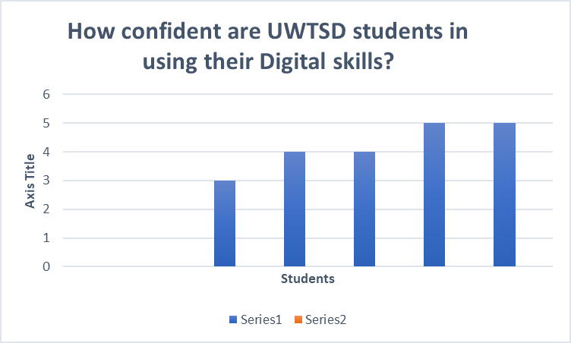
The graph above indicates how many students felt competent in applying digital abilities on a scale of 0 to 5, based on the findings of a questionnaire.
Question 3/5
Which form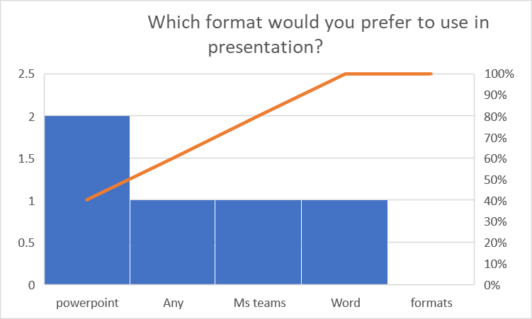at would you prefer to use in presentations?

The results above indicate how many students choose to use different abilities in their presenting work such as Ms teams, PowerPoint, MS word, and any other sources; this is information from students who filled out the questionnaire, and it demonstrates how significant particular skills are.

Question 4/5
My work is improved by Technology.
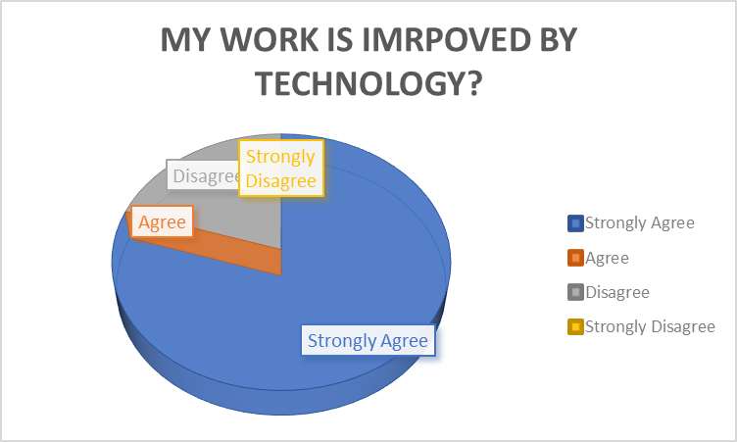
Technology is defined as techniques, processes, and equipment that are the outcome of knowledge being applied in a practical setting. The graph above illustrates how many students agreed and disagreed that technology should be enhanced in their day-to-day job life.
Question 5/5
Do you think that using one drive is the most important in digital skills?
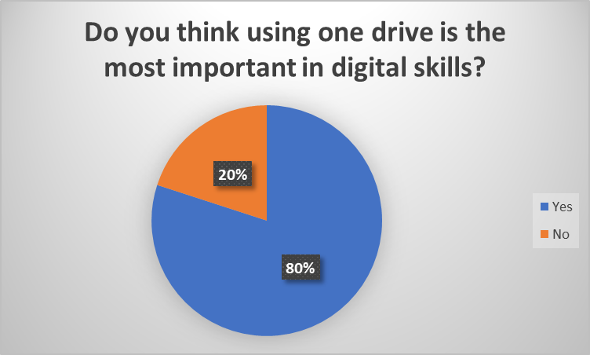
Diverse abilities include digital skills. Using One Drive is a skill because it enables file sync and uploads, download, and sharing, which enables communication between all users. The student’s responses to the questionnaire have demonstrated the importance of digital skills, though some would prefer one drive while others wouldn't because they might use other resources.

Conclusions:
We have gathered data for this research based on digital literacy and the value of literature. Digital citizenship and literacy are becoming increasingly important in today's student lives, making them some of the most important skills to have. The three main categories of digital literacy skills—consumption, creation, and communication—have been covered in our questionnaire. Students gave permission to complete these forms by scanning a QR code, and I gathered responses to see if they represented the opinions of the students. I have observed that students will grow more comfortable using technology and interacting with their peers at the university.

References:
Dahlström, H. (2018) Digital writing tools from the student perspective - education and Information Technologies, SpringerLink. Springer US. Available at: https://link.springer.com/article/10.1007/s10639-018-9844-x (Accessed: February 17, 2023).
Reedy, K. and Parker, J. (2018) Digital literacy unpacked. Edited by K. Reedy and J. Parker. London: Facet Publishing.

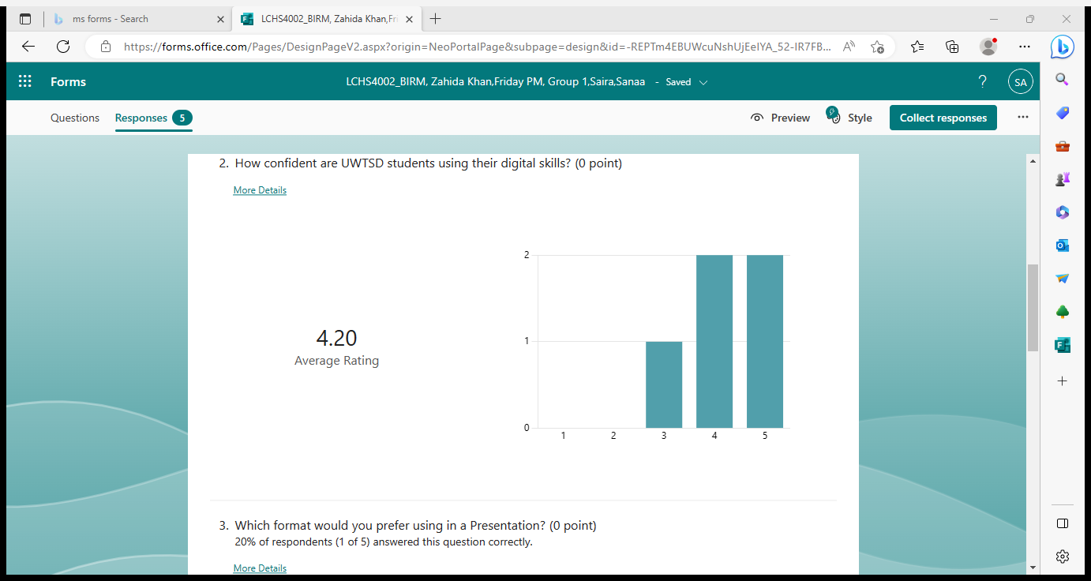
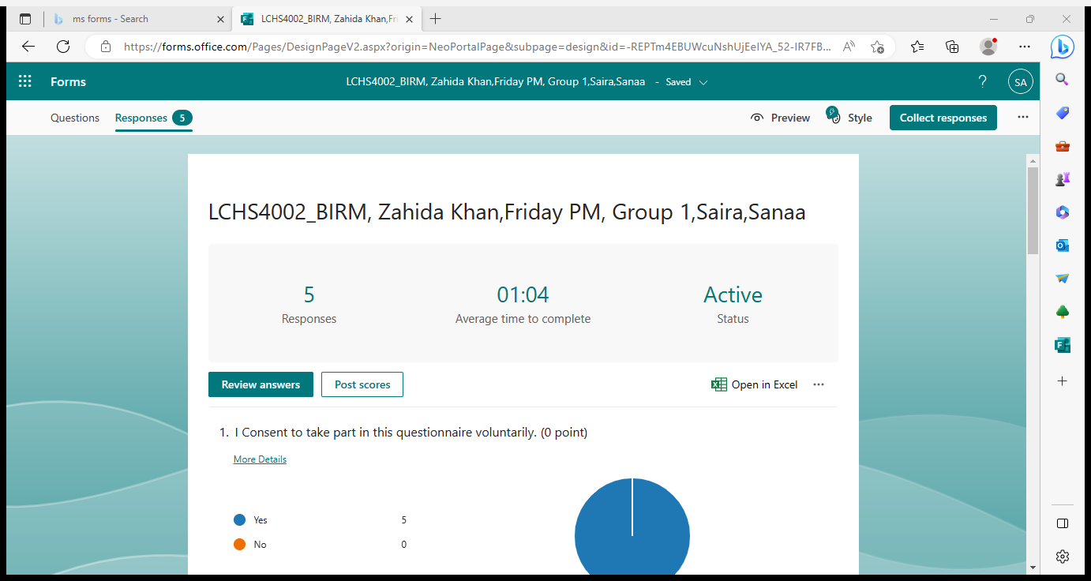
Appendix:


