Contemporary Themes in the Hotel and Hospitality Sector

Chosen Theme:
Contactless Payment

Student Name: Marius Alexandru Neagu
Student ID: 2026287

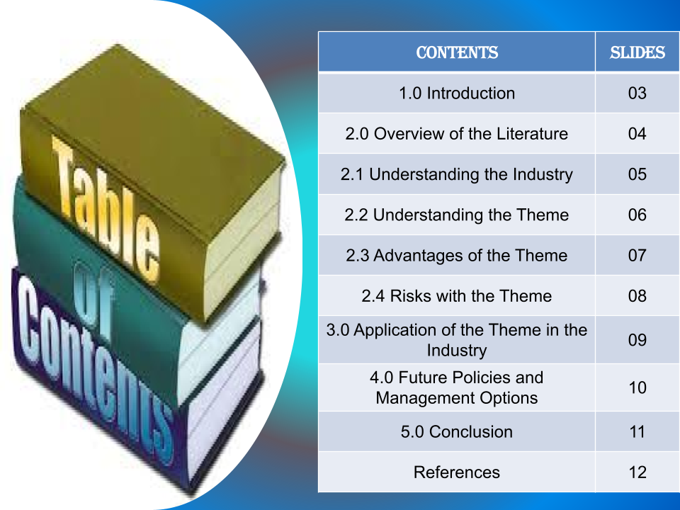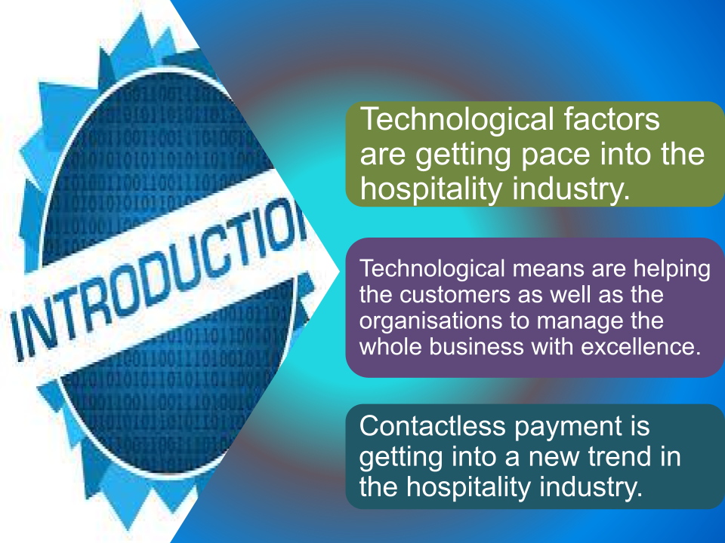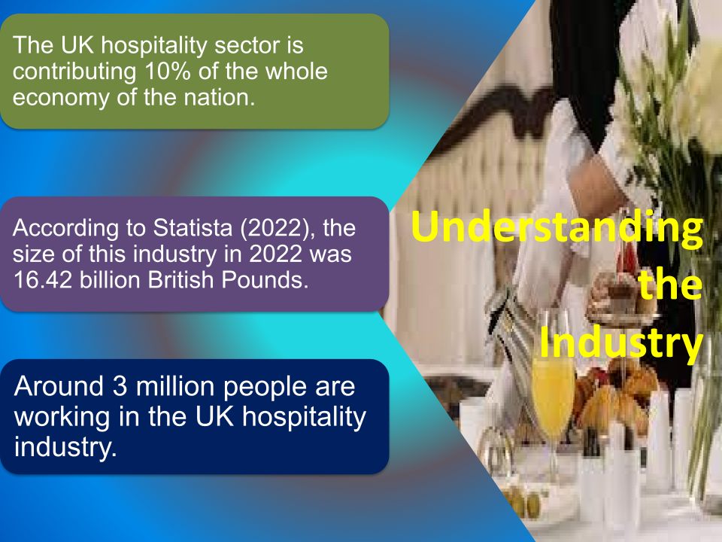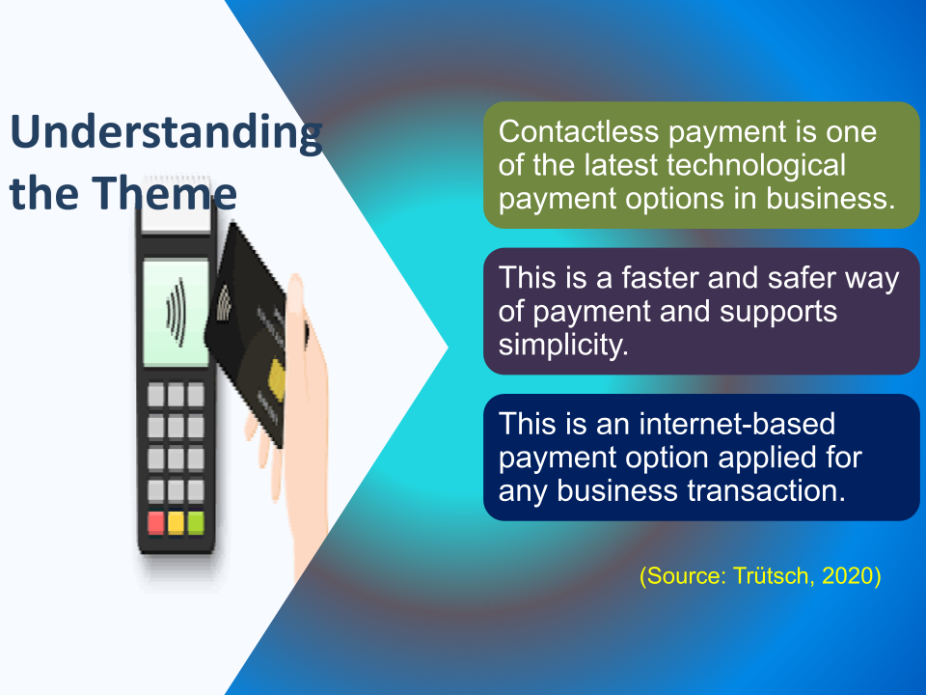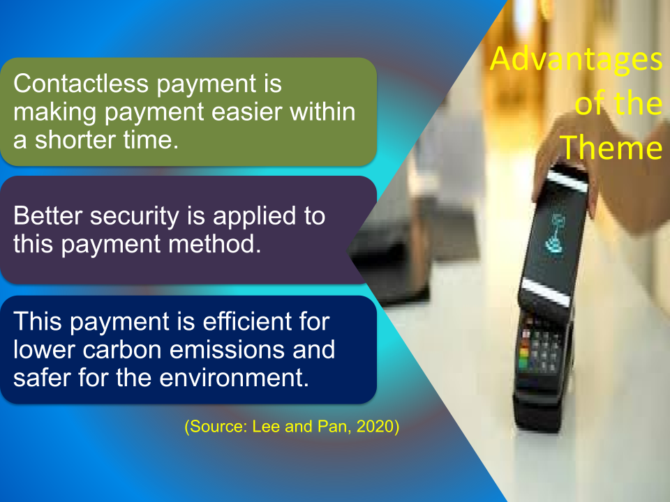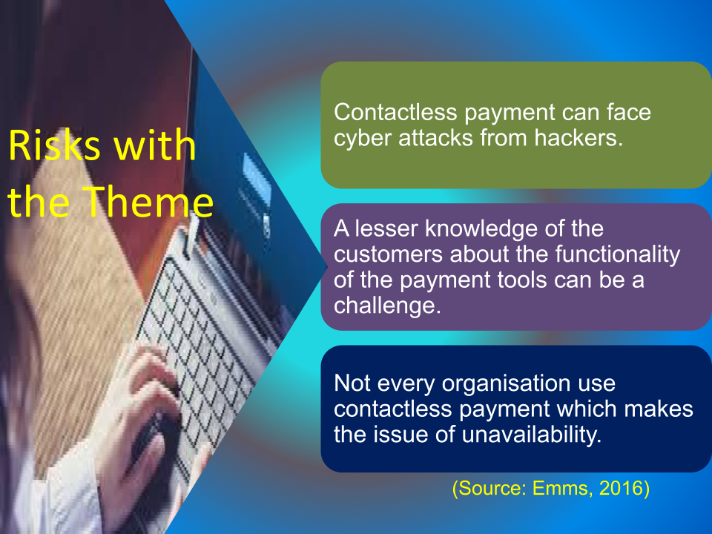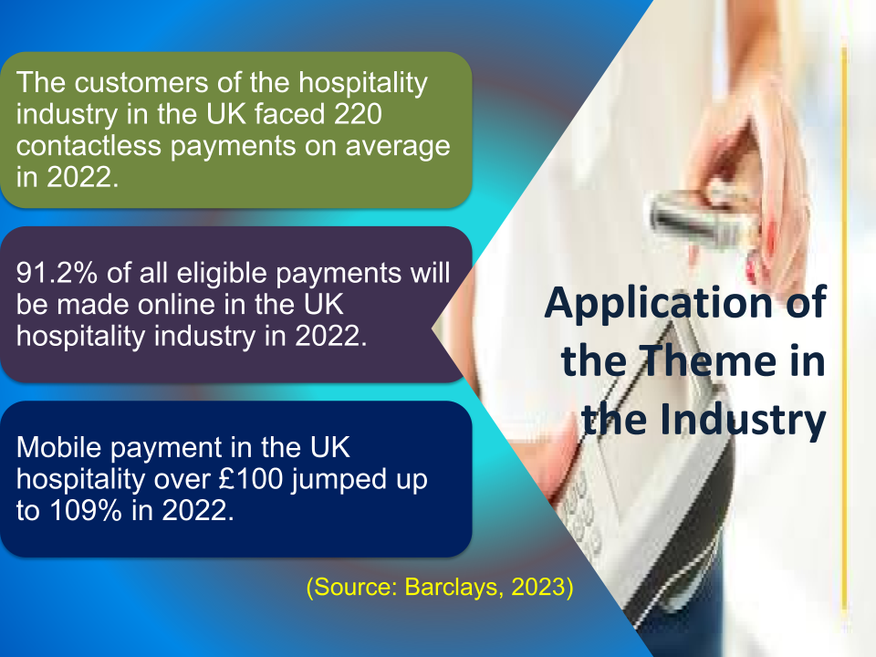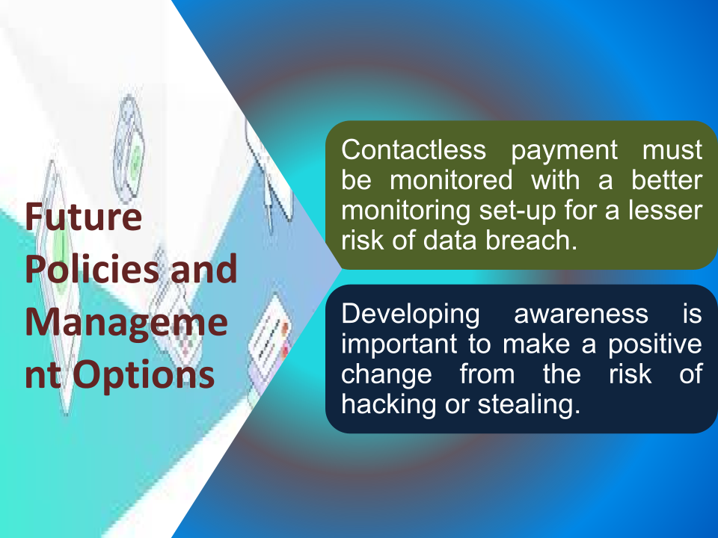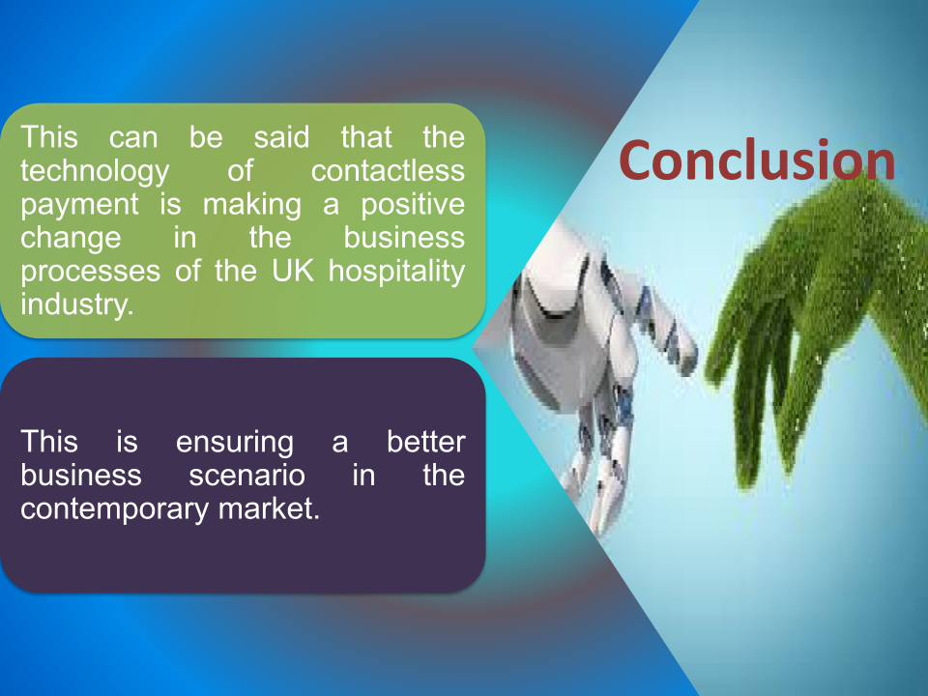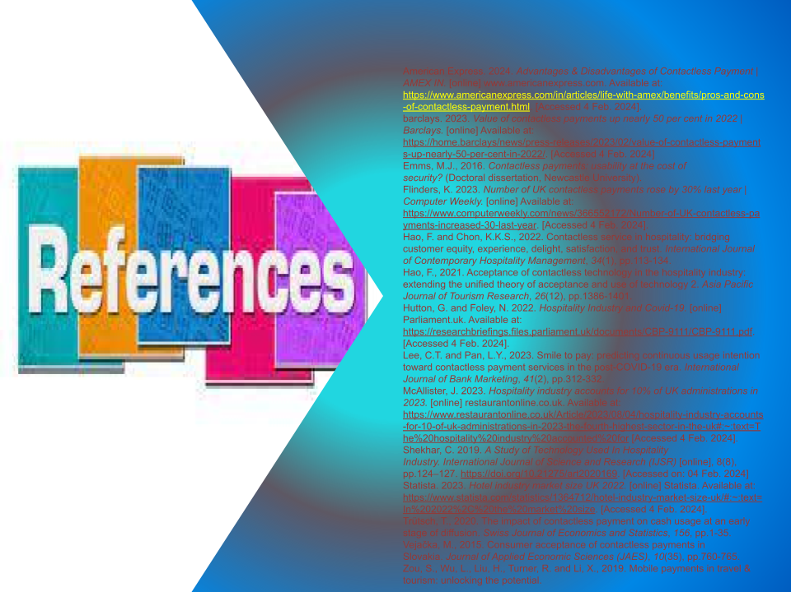
Refrences

American Express. 2024. Advantages & Disadvantages of Contactless Payment | AMEX IN. [online] www.americanexpress.com. Available at: https://www.americanexpress.com/in/articles/life-with-amex/benefits/pros-and-cons-of-contactless-payment.html. [Accessed 4 Feb. 2024].
barclays. 2023. Value of contactless payments up nearly 50 per cent in 2022 | Barclays. [online] Available at: https://home.barclays/news/press-releases/2023/02/value-of-contactless-payments-up-nearly-50-per-cent-in-2022/. [Accessed 4 Feb. 2024]
Emms, M.J., 2016. Contactless payments: usability at the cost of security? (Doctoral dissertation, Newcastle University).
Flinders, K. 2023. Number of UK contactless payments rose by 30% last year | Computer Weekly. [online] Available at: https://www.computerweekly.com/news/366552172/Number-of-UK-contactless-payments-increased-30-last-year. [Accessed 4 Feb. 2024].
Hao, F. and Chon, K.K.S., 2022. Contactless service in hospitality: bridging customer equity, experience, delight, satisfaction, and trust. International Journal of Contemporary Hospitality Management, 34(1), pp.113-134.
Hao, F., 2021. Acceptance of contactless technology in the hospitality industry: extending the unified theory of acceptance and use of technology 2. Asia Pacific Journal of Tourism Research, 26(12), pp.1386-1401.
Hutton, G. and Foley, N. 2022. Hospitality Industry and Covid-19. [online] Parliament.uk. Available at: https://researchbriefings.files.parliament.uk/documents/CBP-9111/CBP-9111.pdf. [Accessed 4 Feb. 2024].
Lee, C.T. and Pan, L.Y., 2023. Smile to pay: predicting continuous usage intention toward contactless payment services in the post-COVID-19 era. International Journal of Bank Marketing, 41(2), pp.312-332.
McAllister, J. 2023. Hospitality industry accounts for 10% of UK administrations in 2023. [online] restaurantonline.co.uk. Available at: https://www.restaurantonline.co.uk/Article/2023/08/04/hospitality-industry-accounts-for-10-of-uk-administrations-in-2023-the-fourth-highest-sector-in-the-uk#:~:text=The%20hospitality%20industry%20accounted%20for [Accessed 4 Feb. 2024].
Shekhar, C. 2019. A Study of Technology Used In Hospitality Industry. International Journal of Science and Research (IJSR) [online], 8(8), pp.124–127. https://doi.org/10.21275/art2020169. [Accessed on: 04 Feb. 2024]
Statista. 2023. Hotel industry market size UK 2022. [online] Statista. Available at: https://www.statista.com/statistics/1364712/hotel-industry-market-size-uk/#:~:text=In%202022%2C%20the%20market%20size. [Accessed 4 Feb. 2024].
Trütsch, T., 2020. The impact of contactless payment on cash usage at an early stage of diffusion. Swiss Journal of Economics and Statistics, 156, pp.1-35.
Vejačka, M., 2015. Consumer acceptance of contactless payments in Slovakia. Journal of Applied Economic Sciences (JAES), 10(35), pp.760-765.
Zou, S., Wu, L., Liu, H., Turner, R. and Li, X., 2019. Mobile payments in travel & tourism: unlocking the potential.

