
GAC TRANSPORT


December 1, 2019
UWTSD
COSTEL GRIGOREAN 1812755

SMART FOR GAC TRANSPORT

My proposal is for a new company to be introduced on the market in the next 5 years, that will deal with nationwide freight transport. The name of this company will be GAC TRANSPORT.
GAC TRANSPORT is a company born from the needs of the existing biggest companies in the country that are looking at ways to deliver their goods on time, in good conditions and most important their goods be delivered safely.
This need also applies to new companies that are now growing into big companies and as their online commerce presence is helping them become part of the biggest companies in the country. A great example of such a company would be Amazon, that needs a lot of trucks to deliver their goods nationwide to its customers.
If everything will be running fine the company will reach a turnover of 15 million pounds over 5 years.
The market
The market is represented by transport companies operating both in the UK and internationally. Transport businesses generally depend on the volume of national and international trades; moderate growth is expected, of about 1.5% - 3% annually of national transport needs. (docs.publishing.service.gov.uk, 2019) 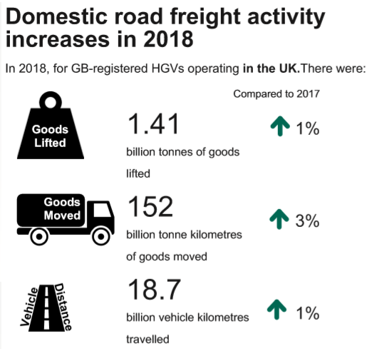 (docs.publishing.service.gov.uk, 2019)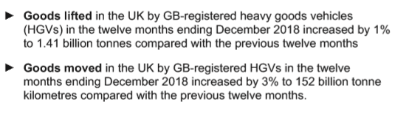 (docs.publishing.service.gov.uk, 2019)
To reduce the risk of not being able to fulfil its transport contracts, in case the trucks break down, GAC TRANSPORT will rent for the first year, 3 towing units.
With these 3 towing units GAC TRANSPORT will be able to carry and fulfil all its contracts. The contract for the rental of the towing units will include full maintenance of the trucks, and in case the trucks break down any towing unit will be replaced within 12 hours maximum. The contract price will be $400 a week.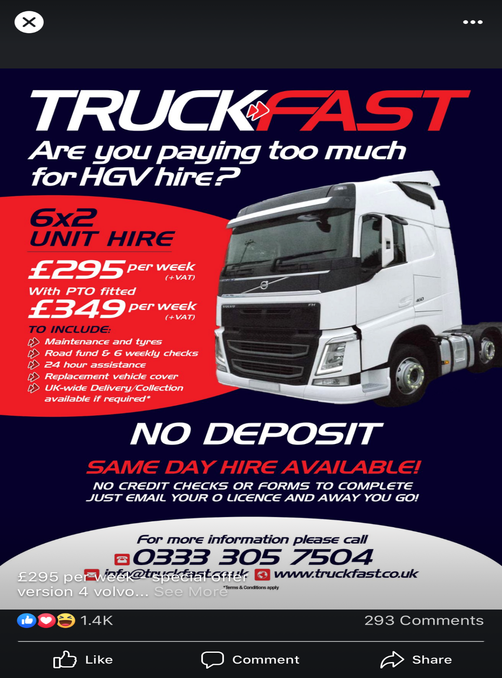 (truckfast.co.uk, 2019)

Objectives

- Short-term (1 year)

  - Obtaining the Operator’s License
OPERATOR’S LICENCE REQUIREMENTS
To qualify for an Operator’s License, GAC TRANSPORT must satisfy a traffic commissioner:
REQUIREMENTS:
- Good reputation and fit to hold a license.
- Appropriate financial: have enough money to run this business.
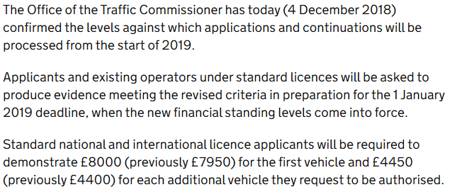 (www.gov.uk, 2019)
- Have suitable facilities or arrangements for maintaining your vehicles.
- Is capable of ensuring that both you and your staff obey all the rules.
- Must have a competent transport manager.
- Pay fees
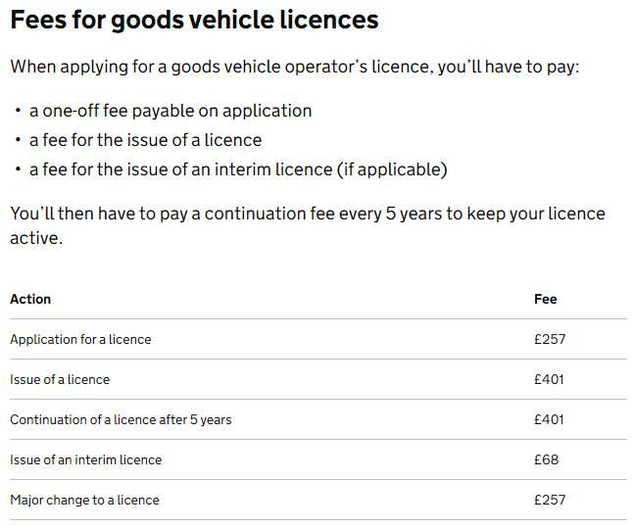 (www.gov.uk, 2018)
- The license holder must have “access” to a vehicle. This means that the holder owns at least one vehicle or has in place a formal contract with a hire company, other operator or other organization to hire one when needed.

HOW CAN APPLY FOR AN OPERATOR’S LICENSE
To apply for a new license, GAC TRANSPORT needs to complete Form GV79. This form is available from the VOSA Contact Centre, Tel 0300 123 9000.
The completed form, with the relevant application fee, must be sent to the Traffic Area where you have your operation centre.
GAC TRANSPORT also needs to advertise the application in a local newspaper before to 21 days after making the application. Tear out the whole page of the newspaper showing your advertisement and send it straight away to the Traffic Commissioner.
GAC TRANSPORT should apply for Operator’s License at least 9 weeks before the date when the license is needed. This allows time for the Traffic Commissioner to make any enquiries thought to be needed. (mvcommercial.com, 2019)
1.2 Open an account with www.uberfreight.com
By opening an account with www.uberfreight.com, GAC TRANSPORT will be able to start the transport activity immediately. (finding jobs online)
‘’Whether you’re a local business or expanding across the globe, our upfront, instant quotes, real-time tracking, and 24/7 access to trusted carriers will keep you moving at full speed’’. (uber freight, 2019)
  - Collaboration contract with an accountant
To start its activity, the company will begin a collaboration contract with an accountant, because the volume of work will not be so high and being a company at the beginning of the road the expense would be lower.

1.4 Collaboration contract with a transport manager
GAC TRANSPORT can employ an external Transport Manager to work as a consultant on a contract or part-time.
The transport manager contractor must:
- Have effective and continuous management responsibility for the transport activities of the operator.
- Be of good reputation and be resident in a European Union country.
- Act solely in the interests of the operator and independently of transport customers.’’ (mvcommercial.com, 2019)

1.5 A rental agreement for parking spaces

- Medium-term (2-3 years)

- Compilation of 3 towing units from the profit
- Rental of parking space for towing units and office
- The owner to obtain the license of transport manager
- Accountant(s) – one or more from partners will be making a course. Based on the know-how they have used to guide important financial decisions, integrity and intelligence, accountants are essential to business growth.
- Planer – one or more of the partners will be making a course. Transport planner manages road transport networks at the local, regional and national level.
- Hiring 3 to10 drivers

- Long-term goals (over 3 years)

- Increasing the company's profit between 10% and 25% every year
- Reinvesting the profit for the purchase of a fleet of 50 towing units and 50 trailers in the next five years
- Obtaining direct collaboration with least one of this (Amazon; XPO; DHL; Tesco; Lidl; Welsh Water etc)
- Renting or buying a space needed to carry out the activity for longer-term

STRENGTH (Advantages) and WEAKNESSES (Disadvantages) of sole traders Businesses Structures
In the beginning, GAC TRANSPORT will have just one employee who is also the owner of the company. The Company will grow by hiring drivers from recruitment agencies, and for the other positions, it will have collaboration contracts.
In the first year of activity, GAC TRANSPORT works as sole traders, to reduce the costs, increase profits and reduce risks.

Sole traders (without employees)
STRENGTH
- Quick reaction to changing circumstances as one person makes all decisions;
- One person takes all profit;
- Only needs to find sufficient work to cover one wage;
- Does not need to register with Companies House under the Companies Act and is therefore exempt of any of those requirements such as needing to file annual accounts;
- Can sell up or close down at any time without any legal implications

WEAKNESSES
- One person has to do everything and may not have strong all-round knowledge;
- There is nobody else to cover in the event of illness;
- May find it harder to raise capital;
- Solely responsible for all debts

Sole traders (with employees)

STRENGTH
- Quick reaction to changing circumstances as one person makes all decisions;
- One person takes all profit;
- Employees may provide a wider base of ideas or support;
- Does not need to register with Companies House under the Companies Act and is therefore exempt of any of those requirements such as needing to file annual accounts;
- Can sell up or close down at any time without any legal implications

WEAKNESSES
- Little if any cover during illness;
- Harder to raise capital;
- Needs to find sufficient work to cover all employee overhead expenses (including any income-generating ones) (www.business.tas.gov.au, 2019)

Partnership
More heads are better than one
After the first year of activity, GAC TRANSPORT will become a partnership because the owner predicts the volume of work will increase.
Starting with the second year, the owner will continue to rent 3 towing units, and from the profit, he will buy two towing units 6x2 Volvo.

- Commonly
A partnership is formed where two or more people want to come together to form a business. They may have a common business idea that they want to put to the test, or they may realize that their skills and talents will make a good business team.
As a partnership, business owners are required to share profits, liabilities and decision-making. This is one of the advantages of a partnership, especially where partners have different skills and can work well together.

Advantages (STRENGTHS) of Partnership

- Capital – Due to the nature of the business, the partners will fund the business with a capital start-up. This means that the more partners there are, the more money they can put into the business, which will allow for greater flexibility and potential growth. It also means more potential profit, which will be shared proportionally between the partners.
- Flexibility – Partnerships are generally easier to form, manage and operate. They are less regulated than companies, in terms of the laws governing the formation, and because the partners have the only say in the way the business is run (without the intervention of the shareholders), they are much more flexible in terms of management, as long as all the partners can agree.
- Shared Responsibility – Partners can share responsibility for running a business. This will enable them to make the most of their abilities. So, if one partner is good with the numbers, that partner could deal with bookkeeping and accounts, while the other partner might have a sales flare and thus be the main salesperson for the business.
- Decision-making – Partners share the decision-making process and can help each other when necessary. More partners are more brains to solve the problems. (www.thecompanywarehouse.co.uk, 2019)

Disadvantages (WEAKNESSES) of Partnership

- Disagreements – One of the disadvantages of partnership is the danger of disagreements between the partners. Disagreements can lead to disputes which might not only harm the business, but also the relationship of those involved.
- Agreement – Because the relationship is managed together, it is important for all parties, to agree with the things that are being done, which means that in some cases there is less flexibility to manage the company.
- Liability – Partnerships are subject to unlimited liability, ensuring that each partner shares the company's liabilities and financial risks.
- Taxation – The taxation law is one of the main disadvantages of partnerships and means that partners have to pay tax in the same way as the single trader each year by filing a self-assessment tax return. They are also required to register as self-employed with HM Revenue & Customs.
- Profit-Sharing – Profits are shared equally by partners. This may lead to incoherence if one or more partners do not make a fair amount of effort for the business, but still reap the benefits. (www.thecompanywarehouse.co.uk, 2019)

SWOT ANALISIS
Strengths:
- The owner has 15 years’ experience in the transport
- Rental of towing units with all costs included
- Advantages over competitors in terms of the prices offered;
- Efficient marketing activity
- A well-trained team
- High level of education and training of persons with leadership duties;
- Availability of association in the business.
- Establish the tasks and responsibilities clearly of each position,
- Maintenance costs of the transport units will be zero

Weaknesses:
- The extreme fluctuation of the load, due to the seasonality of merchandise (in the summer months, and the Christmas period there is a larger volume);
- Poor knowledge of the legislation in the field, lack of an accounting expert;
- Lack of specialized personnel in certain sectors in the accounting and marketing department.
- Profit made are smaller compared to work
Opportunities:
- Transportation of any type of products (food, general goods, dangerous goods, packages, tarmac, fuel, etc)
- The possibility of extending the truck fleet applying for a grant to the Welsh Government
- The business will be able to grow due to online business.
Threats:
- Following the EU referendum on 23 June 2016, IBISWorld analyzed the potential effects of the United Kingdom's exit from the European Union without an agreement. Although the relationship between the UK and the European Union is unclear after this date, the EU referendum could affect transport industries. (https://www.ibisworld.com, 2018)
- Brexit is probably the most important issue for UK fleet managers and a no-deal outcome would have a major impact on the transportation and logistics sectors. (Lilwall, 2019)
- competition with other companies

CONCLUSIONS

A conclusion of a business plan defines the needs of the company and the ability of the management to reach its objectives, showing the innovative way in which the company solves the problems and how cash flow can prosper. (smallbusiness.chron.com, 2019)
a) Business is achievable from the point of view:
- commercial, as new customers will appear;
- financially, because the company has substantial guarantees for any credit;(very good business plan)
- technically, because the quality and image of the towing units are very high performance;
- human, because on the labour market there is the personnel with the qualification required by the expansion of the business (schools of management, trade, accounting, marketing).
b) Businesses are profitable because in five years the credit can be paid, obtaining a certain profit, after which the profit will grow rapidly and substantially.
c) The activity is credible for:
- makes a good profit;
- the partners involved have a high level of education;
- the possibility to pay the loan in 5 years from the realized profit.
The final conclusion of the business plan is the following: the business is feasible, profitable and credible, recommending the start of the steps for its development.

References

docs.publishing.service.gov.uk, 2019. docs.publishing.service.gov.uk. [Online]
Available at: https://docs.publishing.service.gov.uk/manual/assets.html
[Accessed 25 11 2019].
https://www.ibisworld.com, 2018. www.ibisworld.com/united-kingdom. [Online]
Available at: https://www.ibisworld.com/united-kingdom/market-research-reports/freight-road-transport-industry/
[Accessed 28 11 2019].
Lilwall, R., 2019. www.fleetnews.co.uk. [Online]
Available at: https://www.fleetnews.co.uk/blog/impacts-on-the-transport-sector-in-2019
[Accessed 1 12 2019].
mvcommercial.com, 2019. www.mvcommercial.com. [Online]
Available at: https://www.mvcommercial.com/pages/how-to-get-an-operators-licence
[Accessed 25 11 2019].
truckfast.co.uk, 2019. www.truckfast.co.uk. [Online]
Available at: http://www.truckfast.co.uk/
[Accessed 26 11 2019].
uberfreight, 2019. https://www.uberfreight.com. [Online]
Available at: https://www.uberfreight.com/shippers
[Accessed 25 11 2019].
www.business.tas.gov.au, 2019. www.business.tas.gov.au. [Online]
Available at: https://www.business.tas.gov.au/starting-a-business/choosing-a-business-structure-intro/sole-proprietorship-advantages-and-disadvantages
[Accessed 26 11 2019].
www.gov.uk, 2018. www.gov.uk. [Online]
Available at: https://www.gov.uk/being-a-goods-vehicle-operator/fees-for-goods-vehicle-licences
[Accessed 1 12 2019].
www.gov.uk, 2019. www.gov.uk. [Online]
Available at: https://www.gov.uk/government/news/2019-financial-levels-confirmed-for-commercial-vehicle-operators
[Accessed 1 12 2019].
www.thecompanywarehouse.co.uk, 2019. www.thecompanywarehouse.co.uk. [Online]
Available at: https://www.thecompanywarehouse.co.uk/blog/advantages-and-disadvantages-of-partnership
[Accessed 26 11 2019].

