
APPENDIX GA36a

LEVEL 4 ASSESSMENT SPECIFICATION

Student name: |  | Student ID number:
Programme: | All BEng Foundation Engineering Streams
Module: | Introduction to Automotive Engineering / Manufacturing & Materials
Module code: | M4X01507 / M4X01511 | Contribution to Overall Module Assessment (%): | 50%
Lecturer: | Dr K Tudor | Internal Verifier: | Tim Tudor
Assignment Title: | SolidWorks Assignment | Word count (or equivalent):
Submission deadline: | Part A – 18/10/2018  Part B – 2/11/2018  Part C – 7/12/2018 | Return date of provisional marks & written feedback: | 20 working days after submission
Submission method: | All written assessments, where practical and possible, must be submitted via Turnitin unless otherwise instructed by the Lecturer. (Please DO NOT put this assessment specification into Turnitin or it will match many similarities with other students’ submissions.)  Alternative submission method (if applicable):  Late submission of the assessment will result in a late penalty mark. Penalties for late submission: Up to one week late, maximum mark of 40%. Over one week late, 0%. Only the Extenuating Circumstances Panel may approve a change to submission dates.
Academic honesty / referencing: | Academic honesty is required. In the main body of your submission you must give credit to authors on whose research and ideas your work is based. Append to your submission a reference list that indicates the books, articles, etc. that you have used, cited or quoted in order to complete this assessment.

Module Learning Outcomes
(from module syllabus)
M4X01507
- Show an appreciation for the varied disciplines required in the field of Automotive Engineering and associated pathways and to prove an understanding of the current state of the Automotive Industry and the requirements for more sustainable developments and advances in the field.
M4X01511
- Demonstrate skills in CAD.

TASK DESCRIPTION
This coursework comprises of three distinct parts which will be handed out at different points in the term;

PART A – 15%
To show your understanding of a technical drawing you will complete a short online quiz that will ask questions regarding different aspects of a technical drawings.

PART B – 25%
You will be provided with a technical drawing of a Tappet from a Ford Engine. You are to create a new version of this part in SolidWorks, using your student number to define some dimensions.

PART C – 60%
Using the additional technical drawings provided of the Valve, Collet and Spring Pan, you will create these three parts in SolidWorks again using your student to define some dimensions.

You will be provided with the SolidWorks part file for the spring. This is then to be assembled with tappet (from Part B) and the three new parts created in this section (valve, collet and spring pan).

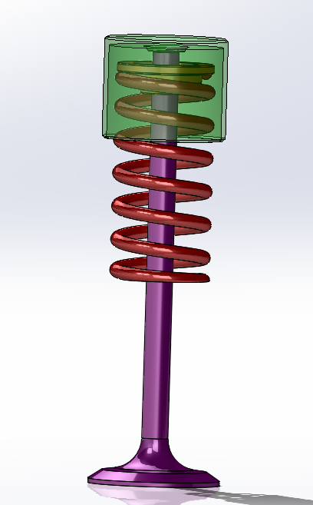

Figure 1 – Assembly of the Tappet, Valve, Collet and Spring Pan

Part A – Quiz (worth 15%)
On the Moodle page for ‘Introduction for Automotive Engineering’ or ‘Manufacturing and Materials’ you will find a quiz called Part A - Technical Drawing Quiz. For this part of the quiz you just need to complete the quiz.

Using what you have learnt in lectures about technical drawings and their importance in Engineering Design, you should be able to answer all the questions that will appear.

There are a mixture of question types including multiple choice questions and questions that will require you to give a written response.

The quiz is timed and you will only have 45 minutes in which to complete the quiz, once you have started it.

If you want to revise technical drawings and what is conveyed in them, please see the links and supporting documents available on the Introduction to Automotive Engineering / Manufacturing and Material Moodle pages.

The quiz will be available from 9am on 12th October 2018 until 5pm on 19th October 2018.

Marking Scheme; Part A is out of 15 marks and contains 12 questions.

Part B – Tappet (worth 25%)
You are to create a new version of the Tappet, shown in Figures 2 and 3, as well as an A3 version of which is attached to this brief. You will also find a .pdf version of the technical drawing on Moodle. You will see in the technical drawing that some of the dimensions are missing and have been replaced by letters. You will need to use our student number to work out what these dimensions should be.

For example, if your student number was 123456, this would be represented by ABCDEF and if the drawing asks for a dimension of 1 + 0.CD, this case it would be 1.34mm (1 + 0.34).

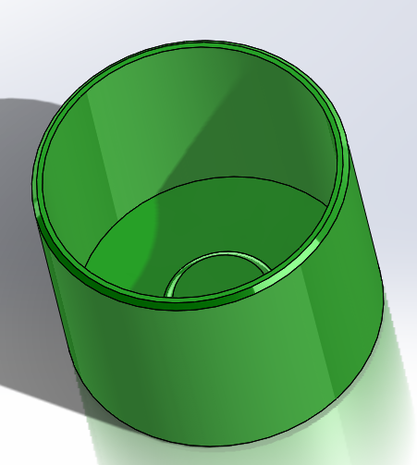
Figure 2 - Tappet

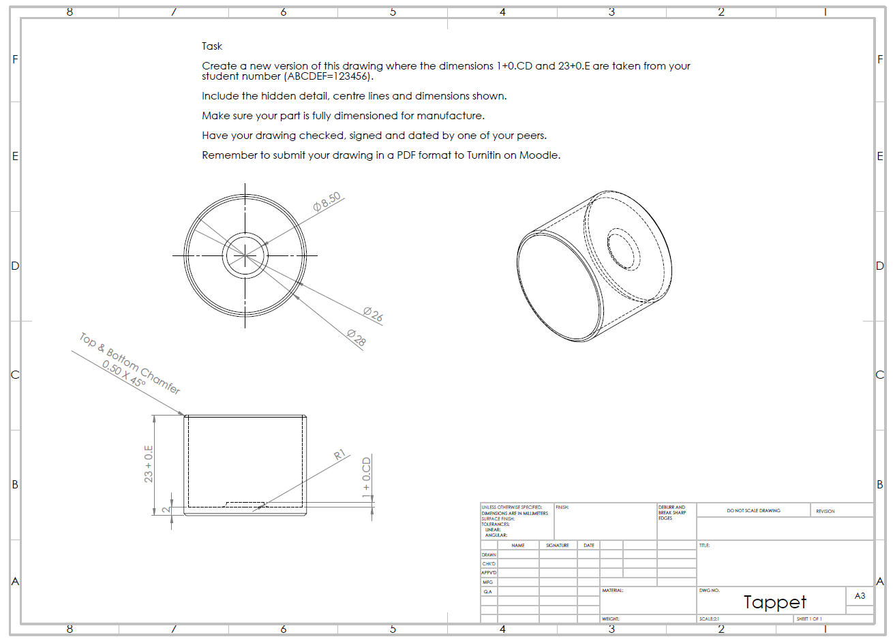
Figure 3 – Tappet technical drawing

You will need to create your part in SolidWorks as a 3D model and then create a technical drawing which must include all necessary dimension and centre lines that would be required for manufacture.

To create this part you will be required to use some of the following processes;
- Sketch
- Boss Extrude
- Cut Extrude
- Chamfer
- Fillet
- Smart Dimension

You will find at the end of this assignment brief is a check list for the technical drawing. This will show you how the marks are going to be awarded for this assignment. Remember that you need to get one of your peers (i.e. a course mate) to check your drawing and have them sign off your technical drawing before submitting as well.

Drawing to be submitted

You are expected to have completed your pdf version of your technical drawing by 5pm on Friday 2rd November and this is to be submitted via Turnitin on Moodle.

Part C – Valve, Collet, Spring Pan and Assembly (Worth 60%)
Using SolidWorks you will produce the components shown in Figures 4 to 6 from the technical drawings provided.

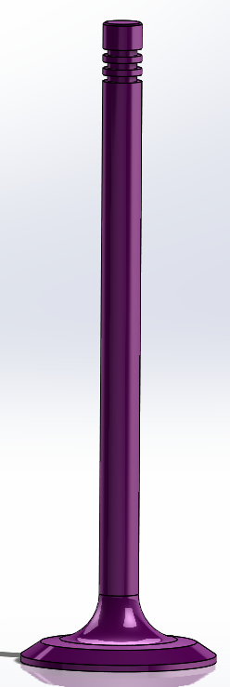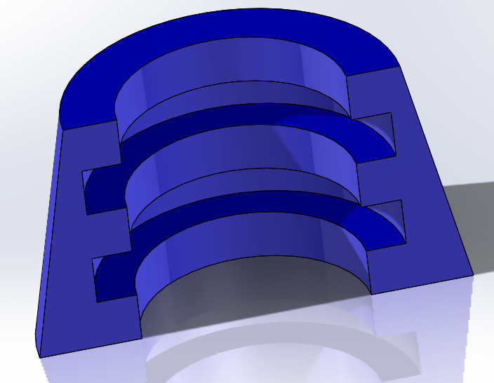
Figure 4 – Valve Figure 5 – Collet

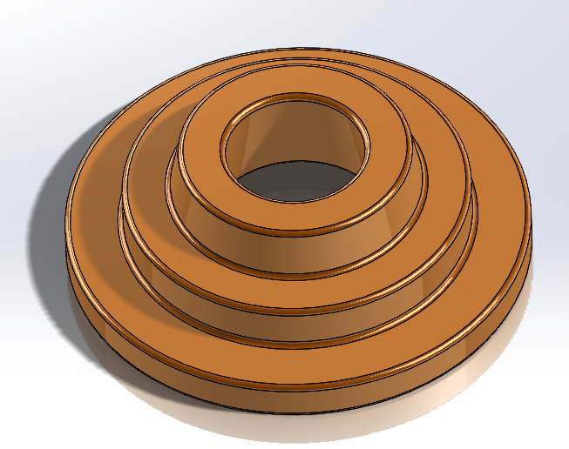
Figure 6 – Spring Pan

On Thursday 22nd November 2018 you will be provided with the technical drawings with all the required dimensions and information that is required to produce these components. You will notice on the technical drawings that there are some dimensions that again are related to your student number in the same was as in Part B of this assignment.

Having created your 3D components you will then need to create the technical drawings for each of the components. The technical drawings must have all the necessary dimensions, centre lines and hidden lines included that would be required for manufacture. Each drawing should also be checked and signed off by one of your peers on the course.

After creating these three components, you will then be expected to assemble them along with the spring. You will be provided with a SolidWorks file of the completed spring to be used in your assembly. After assembling your components, you are then to produce a technical drawing of the full assembly.

You will find at the end of this assignment brief is a check list for the technical drawings. This will show you how the marks are going to be awarded for this assignment.

For these components you will need to use the following processes;
- Sketch
- Boss Extrude
- Cut Extrude
- Revolve
- Chamfer
- Fillet

Drawings to be submitted
You are expected to have completed all four technical drawings in pdf format by 5pm on Friday 7th December. The pdf files need to be submitted via Turnitin. The Turnitin on Moodle has been split into four sections to allow you to upload all four technical drawings

The drawings to be submitted are;
- Front and Top views of the Valve correctly dimensioned with hidden detail. There should also be centre marks and lines included. You may want to include an Isometric view as well. Scale should be 1:1
- Front and Top views of the Collet correctly dimensioned with hidden detail. There should be also be centre marks and lines included. You may want to include an Isometric view as well. Scale should be 10:1
- Front and Top views of the Spring Pan correctly dimension with hidden detail. There should be also be centre marks and lines included. You may want to include an Isometric view as well. Scale should be 5:1
- For the Assembly drawing you will need to include a front view in 1:1 scale, showing the tappet, valve, collet x 2, spring pan and spring. A detail section A showing the valve, collet x2 and spring pan, which will be 2:1 scale. In both of these views hidden detail should be shown. Finally you will need to include an isometric view in 2:1 scale in shaded with edges display format.

M4X01507/M4X01511 Part B Check Sheet
Student Name | Student Number
Submit an electronic .pdf format to Moodle.
Each check point is worth one mark unless stated otherwise.
 | Hints | Mark
Pdf file format has been used for submission
The page has a complete border on all four sides of the page. Your name, student number, title of the drawing and scale 2:1 should all be correct and written within the boxes. (worth 2 marks) | Use the A3 (ISO) sheet format. Follow ‘Lesson 3- Drawings’ on SolidWorks to see how to edit the sheet.
Drawing is positioned well on the page with all the drawing and lines (including dimensions) within and not touching the border. The two views are in line with each other.
The drawing is actually drawn at a scale of 2:1. When measured with a ruler, the thickness of the tappet walls is 2mm.
All hidden lines are a regular dash dash dash pattern and a thin line. Hidden lines remain at the same dash pattern for the complete length.
Centre marks have a dash-dot-dash pattern
All centre lines are a regular dash-dot-dash pattern that is regular for the complete length of the line. Centre lines must end in open space and NOT end touching another line. (worth 2 marks) | Use the Centre Line or Centre Mark buttons on SolidWorks rather than drawing the lines in.
Dimension lines are thin, have an arrow that is visible and visible numbers above, or to the left of the line. There is a visible gap between the number and the line they are above. Numbers are not in contact with any line. (worth 2 marks) | Use Smart dimension tool.
Circular components are dimensioned with a diameter symbol ø
The fillet and chamfer are both correctly dimensioned (worth 2 marks) | Use Smart dimension tool drop down options.
The minimum number of dimensions have been used to fully dimension the part so that there would be no ambiguity for a person manufacturing the component, and no dimensions are repeated on different views. (worth 2 marks)
There are no extra lines anywhere on the page or any missing lines or gaps or spelling mistakes.
Correct Value for 1 + 0.CD
Correct Value for 23 + 0.E
All other diameters are correct (worth 2 marks)
All other thicknesses are correct (worth 2 marks)
Technical Drawing signed off and dated by peer (worth 2 marks)
TOTAL (out of 25)

M4X01507/M4X01511 Part C Check Sheet
Student Name | Student Number
Submit an electronic .pdf format to Moodle.
Each check point is worth one mark unless stated otherwise.
 |  | Hints | Mark
Pdf file format has been used for submission
The page has a complete border on all four sides of the page. Your name, student number, title of the drawing and correct scales used and written within the boxes. (worth 4 marks) |  | Use the A3 (ISO) sheet format. Follow ‘Lesson 3- Drawings’ on SolidWorks to see how to edit the sheet.
All hidden lines are a regular dash dash dash pattern and a thin line. Hidden lines remain at the same dash pattern for the complete length.
Centre marks have a dash-dot-dash pattern
All centre lines are a regular dash-dot-dash pattern that is regular for the complete length of the line. Centre lines must end in open space and NOT end touching another line. (worth 2 marks) |  | Use the Centre Line or Centre Mark buttons on SolidWorks rather than drawing the lines in.
Dimension lines are thin, have an arrow that is visible and visible numbers above, or to the left of the line. There is a visible gap between the number and the line they are above. Numbers are not in contact with any line. (worth 2 marks) |  | Use Smart dimension tool.
Where a dimension is taken from a centre line, the centre should stop, a small gap and then a dimension line start. |  | Again Smart Dimension tool will make sure this happens.
Circular components are dimensioned with a diameter symbol ø
The minimum number of dimensions have been used to fully dimension the part so that there would be no ambiguity for a person manufacturing the component, and no dimensions are repeated on different views. (worth 2 marks)
There are no extra lines anywhere on the page or any missing lines or gaps or spelling mistakes.
Sub Total (out of 16)
Valve
Correct views included with dimensions, hidden and centre lines using correct scale (worth 2 mark)
Correct value for 85 + C.D
Correct value for ø30 + 0.EF
Correct overall valve height and diameter and height (worth 5 mark)
Correct diameters (worth 3 marks)
Correct fillets (worth 2 marks)
Correct Chamfer
Valve Sub Total (out of 15 marks)
Spring Pan
Correct views included with dimensions, hidden and centre lines using correct scale (worth 2 mark)
Correct value for R1 + 0.BC
Correct value for ø15 + 0.D
Correct value for ø13 + 0.F
Correct diameters (worth 5 marks)
Correct thicknesses (worth 4 marks)
Correct internal angle
Correct fillets (worth 2 marks)
Spring Pan Sub Total (17 marks)
Collet
Correct views included with dimensions, hidden and centre lines using correct scale (worth 2 marks)
Correct internal dimensions (worth 2 marks)
Correct radii’s (worth 4 marks)
Correct angle of outside slope
Collet Sub Total (9 marks)
Assembly
Assembly drawing from front and detail view with hidden detail but no dimensions. Isometric view included as well. (worth 3 marks)
Inclusion of tappet, valve, collet x 2 and spring pan (worth 4 marks)
Inclusion of spring
Hidden Detail shows correct alignment of parts. (worth 5 marks)
Assembly Sub Total (13 marks)
TOTAL (out of 70)

