Module Title:
Management & Organisational Behaviour
Module Code: BMIH5004
Assessment 2: Written report
Chosen topic:
Wyndham Hotel & Resorts

Student name: Katerina Hristova
Student ID: 2232205
Lecturers name: Daniel Payne, Scott James, Jessica Newpor, Lola Villard-Coles, Giulia Chifari

Executive Summary
Management & Organisational Behaviour is essential for every business. Wyndham Hotel & Resorts needs to recruit proper and skilled employees into the team which will allow them to maintain the customers properly with proper leadership, skills, and experience. Employees must put up their best efforts and become completely motivated in order to accomplish the organisational goal. They must also be able to take on challenges and possess the necessary abilities to do their assignment on schedule. In order to get the most out of their staff, Wyndham Hotel & Resorts also places a strong emphasis on collaboration and teamwork. The purpose of the organisation is the aim and objective that the business strives to achieve.
Table of Contents
Executive Summary 2
Introduction 4
Organisation structure, culture, and Goals 5
Organisation structure 5
Organisation culture 6
Organisation goals 7
Recent change initiatives, their impacts on the Organisation, and how well these were managed. 8
Recent change initiatives 8
Impacts of the Changes in the Organisation 9
How Organisations manage those change 10
Organisational strategic direction and the current performance of the Organisations 11
The strategic direction of the Organisations 11
The current performance level of the Organisations 12
Conclusion 14
Recommendations 14
References 15

Introduction
This report will discuss the structure of Wyndham Hotel & Resorts organisation, the culture, and the company goal. Wyndham Hotels & Resorts, Inc., is an American hospitality company based in Parsippany, New Jersey, USA. It describes itself as the largest hotel franchisor in the world, with 9,100 locations. This will also include the initiatives and their impact on the company along with the management of these initiatives. The strategies, behaviour management, modified environment events, and analysis of various aspects have a direct effect on the company's performance. This report will discuss the company's behaviour along with the various initiatives and strategies that they have used in recent times to improve their performance. The evaluation of their performance after applying these strategies will be discussed in this report.
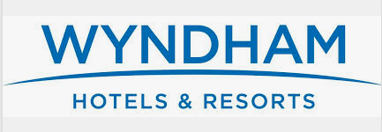
Figure: Wyndham Hotel & Resorts (Arnold, 2020)

Organisation structure, culture, and Goals

Organisation structure
The structure of the company determines the overall performance and the management of the company. Wyndham Hotel & Resorts also follows an organisational structure that will help them to maintain the company structure perfectly. The Wyndham Hotel & Resorts follows the web and power model of Pfeffer and Saleinck, this helps the company to maintain a proper relationship among the company customers and the employees. This model will help the company to maintain a proper customer-friendly environment along with good problem-solving ability and provide the best experience to their audience. This also helps the company to maintain good relations among the company employees and the higher authority. (Valeri et al, 2021)
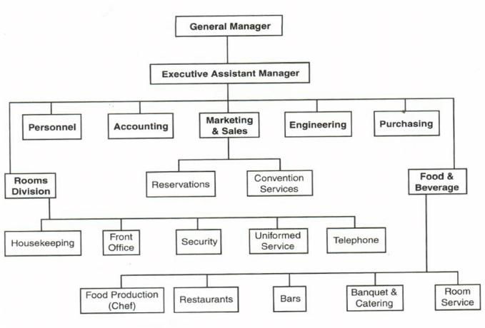
Figure: Organisation structure (Tang et al, 2020)
For the best possible outcome and success from Wyndham Hotel & Resorts, the employees must practice all the skills properly and collaborate to solve any problems properly and in a very efficient way. Given that Wyndham Hotel & Resorts operates in the travel and hospitality industry, they must continue to establish new initiatives and enhance their problem-solving and strategy-building skills in order to increase client satisfaction and profitability.

Organisation culture
Wyndham Hotel & Resorts tries to maintain the best possible customer service for their customers. This mainly follows the methodology by Edgar S, Schein, and his Organisational culture model. Wyndham Hotel & Resorts will be able to offer the greatest service and be the top travel agency in the UK with a few significant management and maintenance improvements. Additionally, this will facilitate their global commercial operations. The Wyndham Hotel & Resorts properly follows the model which helps them proper attention of the customers for their outstanding service. (Mariani et al, 2022)
Along with that, the organisation also tries to maintain the best services by applying their initiatives properly. The organisation has lately implemented a number of new initiatives, such as fostering a culture of mutual aid, giving all employees equitable access to facilities, offering appropriate training for skill development, keeping an eye on everyday work, and more. Wyndham Hotel & Resorts also emphasizes the teamwork and cooperation approach to bring out the best possible outcome from their employees.

Organisation goals
The organisation's goal is the objective and the aim of the company that the company tries to attain or reach. To achieve the organisational goal, it is important for the employees to provide their best efforts and to get fully motivated. Also, they need to take challenges and need to have proper skills for completing their work on time. The company goal helps the employees to stay motivated and focused on their target and work hard
To reach the organisation's goal, the company management and the employees need to work together to maintain their work. This also needs a proper leadership skill which will allow the employees to have proper guidelines about the organisation's goal.
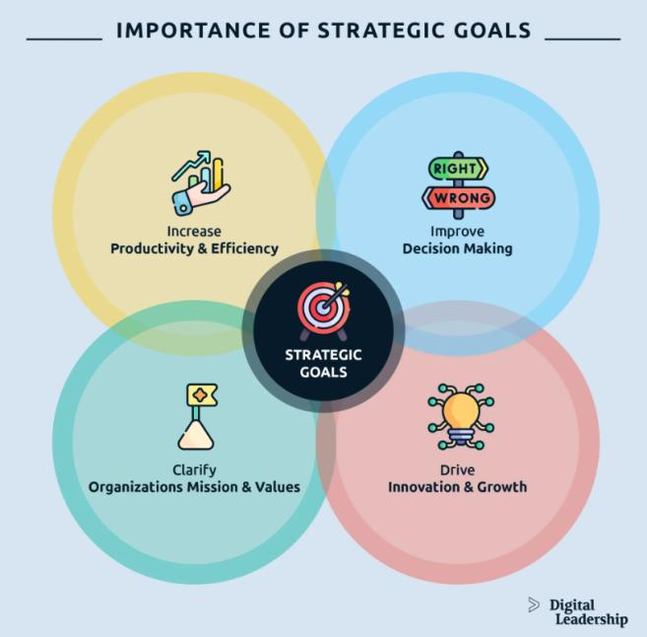
Figure: Different types of goals (Nuryyev et al, 2020)

Recent change initiatives, their impacts on the Organisation, and how well these were managed.

Recent change initiatives
As Wyndham Hotel & Resorts works in the tourism and hospitality sector, they need to maintain and take some new initiatives and improve their abilities like problem-solving and building strategies which will help them to satisfy their customers and improve their profit. Some important changes in the management and maintenance will help Wyndham Hotel & Resorts to provide the best service and be the best tourism company in the UK. This will also help them to operate their business worldwide.
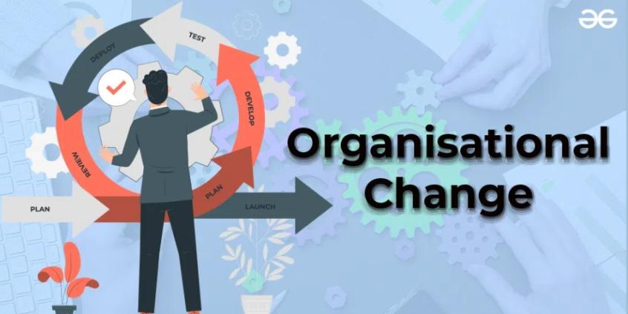
Figure: The recent changes (Andrades et al, 2019)
The company has recently taken some new initiatives like the culture of mutual aid, providing equal facilities to all the employees, providing proper training for the development of skills, monitoring the daily work, and more. These initiatives will help and allow the company to make trained and skilled employees for their company. (del Vecchio et al, 2022)
Application of the new leadership theory will allow the company to keep up a new pace in the tourism market. The administration and general performance of the organisation are determined by its structure. This will allow the employees to maintain a proper working environment and stay motivated in their work. This will help the company to make more profit by doing more business (Arnold, 2020)

Impacts of the Changes in the Organisation
Encourage innovation:
The change in the company and the company management strategy will allow the company to make innovations in its system. Change in the organisation will allow Wyndham Hotel & Resorts to improve its decision-making process along with the communication process. Additionally, Wyndham Hotel & Resorts adheres to an organisational structure that will enable them to flawlessly maintain the business structure. Also, this will allow them to come up with new strategies and marketing plans that will allow them to make new plans to attract their customers. This will help Wyndham Hotel & Resorts to make a leading role in the tourism and hospitality industry. (Jiang et al, 2019)
Improve employee skills:
The organisational change in the company will allow the company to improve the company skills with the help of proper training and motivation. With the change, the company will need to make several changes in its management. For this, they will need to train their employees about new skills and new ideas. With the aid of this model, the business will be able to keep up a suitable, customer-friendly atmosphere, solve problems effectively, and give their audience the greatest experience possible. This will allow the companies to become more skilled and active in their work and motivated to make things better (Armstrong, 2012)
Create business opportunities:
Wyndham Hotel & Resorts will try to improve its company structure and company profit by creating more opportunities. Organisational change will help them to create business opportunities. Additionally, it helps the business keep positive relationships between its employees and higher-ups. Wyndham Hotel & Resorts strives to provide its patrons with the greatest possible customer service. For example, a change in the marketing strategy will allow them to attract more customers and increase sales. This will allow them to make a profit and will create business opportunities for the company. (Mariani et al, 2022)

How Organisations manage those change
ADKAR is the model which focuses on the achievement of goals for the company. This helps to achieve five goals; awareness, desire, knowledge, ability, and reinforcement. With the help of these goals, Wyndham Hotel & Resorts will get the maximum results. This primarily adheres to Edgar S. Schein's methodology and his organisational culture model. This theory will allow the company to maintain a proper organisational structure and climate and will provide them with a proper pathway to reach their goal. (Mareque et al, 2019)
The SMART will help the company reach a goal. Wyndham Hotel & Resorts has some mission and vision on which they will set their goal and work hard to achieve this goal properly. This will help them to bring out the desired outcome for the company. The methodology that Wyndham Hotel & Resorts adheres to helps them give their guests the attention they need for exceptional service (Adair, 2009)
If Wyndham Hotel & Resorts can apply these strategies to their business properly, this will allow them to operate their business properly and will enable them to make specialized operations. Additionally, by appropriately implementing its efforts, the business strives to maintain the highest quality of services (Boddy, 2017)
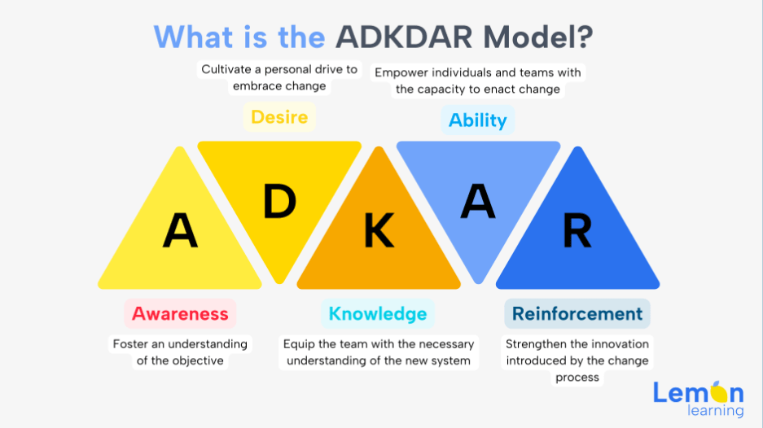
Figure: ADKAR (Mariani et al, 2022)

Organisational strategic direction and the current performance of the Organisations

The strategic direction of the Organisations
The strategic direction is the plan that one organisation needs to apply and implement properly to reach its goal and fulfil its vision. This is also known as the international management hospitality business. In order to get the most out of their staff, Wyndham Hotel & Resorts also places a strong emphasis on collaboration and teamwork. The purpose of the organisation is the aim and objective that the business strives to achieve. Wyndham Hotel & Resorts maintains a proper organisational strategy and provides proper services by maintaining the internal process and with the help of the various skills that the employees of the company learned properly. (Nuryyev et al, 2020)
This includes the study of maintaining and managing organisational behaviour to build a proper relationship between the customers and the company, along with the maintenance of the company structure, company employee behaviours, marketing and management practices, and more. One of the crucial moments in business management is the modern management practice which allows the company to maintain its company with the modern techniques of management (Mullins, 2019)
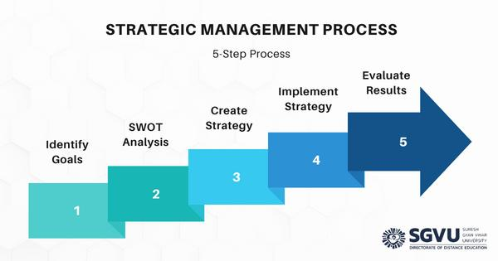
Figure: The strategic direction (Valeri et al, 2021)

The current performance level of the Organisations
Organisational Level
The level of the organisation indicates the level of the organisational structure that is determined by the upper management for the purpose. For Wyndham Hotel & Resorts, situational leadership will be very beneficial as they maintain a high-volume and high-pressure workplace, where the employees need to work very hard to maintain their customers properly to meet their demands on proper time (Mullins, 2013)
Wyndham Hotel & Resorts needs to recruit proper and skilled employees into the team which will allow them to maintain the customers properly with proper leadership, skills, and experience. Wyndham Hotel & Resorts will employ highly skilled and trained employees to maintain the organisational level by making proper moves and with innovative contributions. The level of effort, employee performance, and the outcome will also be measured to identify the change in the level. (Nuryyev et al, 2020)
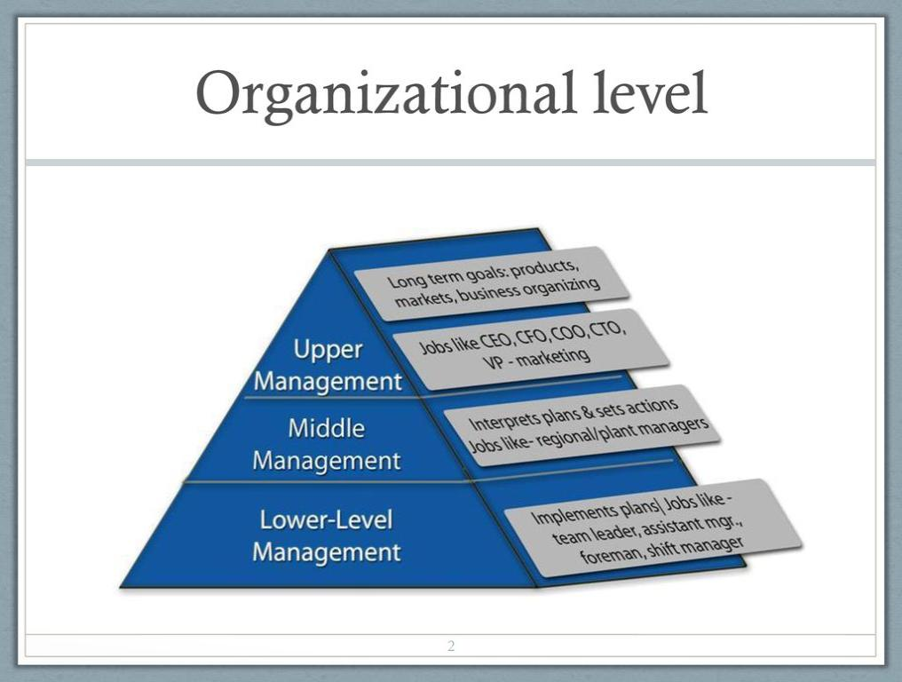
Figure: Organisational Level (Tang et al, 2020)
Operation level:
The operational level is the second level of command and control in the organisation. This encourages the employees of the company to promote or do more challenging work. The operation level will help the company to maintain the environment among the employees and they will eventually help the company to maintain their services properly. This will motivate the company employees and help to improve the services. (Valeri et al, 2021)
Individual level
This includes the person in the organisation and his responsibility. Wyndham Hotel & Resorts provides enough resources and training to their employees along with proper materials to improve their skills. This will allow the employee to improve his various skills along with gaining experience. This will also help him to understand human behavior, organisational culture, teamwork works, and more. With this, one individual employee can improve his performance for the company and help the company to make a proper profit. (Tuan et al, 2019)
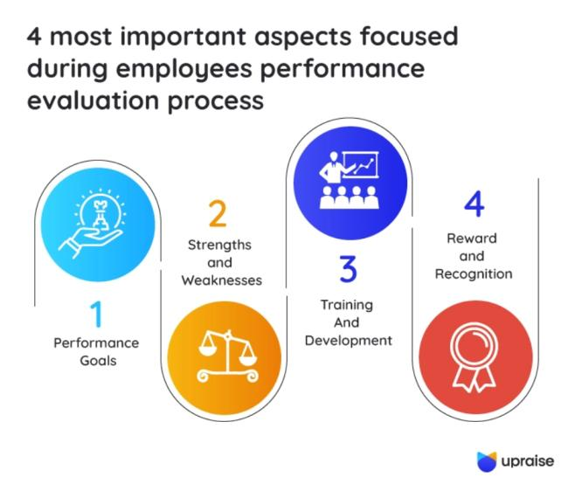
Figure: Performance evaluation (Tang et al, 2020)

Conclusion
To maintain the company properly, Wyndham Hotel & Resorts should maintain the organisational structure, culture and properly. Along with that, the company should change its initiatives with new ones to make a positive impact on the business environment. Employees and firm management must collaborate to sustain their work in order to achieve the organisation's purpose. Also, they should analyse the current performance of the organisation and make a strategic plan that will allow them to overcome all the problems and increase the company's profit.

Recommendations
Thus, Employees must put up their best efforts and become completely motivated in order to accomplish the organisational goal. They must also be able to take on challenges and possess the necessary abilities to do their assignment on schedule. There is a very much comparative and collaborative atmosphere in the Wyndham Hotel & Resorts among the employees. Additionally, this calls for effective leadership that will enable the staff to have clear guidelines regarding the organisation's objective.

References
Adair, J. (2009) The Inspirational Leader (2nd Ed), London: Kogan Page
Andrades, L. and Dimanche, F., (2019). Destination competitiveness in Russia: Tourism professionals’ skills and competences. International Journal of Contemporary Hospitality Management.
Armstong, M. (2021) Armstrong's handbook of performance management (7th Ed), London: Kogan Page
Armstrong, M. (2012) Armstrong’s Handbook of Management and Leadership (3rd Ed), London: Kogan Page.
Arnold, J. (2020) Work Psychology (7 th edition) Harlow: Pearson Education Limited.
Bloisi, W. et al (2007) Management and Organisational Behaviour, (2nd edition) Maidenhead: McGraw-Hill.
Boddy, D. (2017) Management: An Introduction (7 th Ed), Harlow, Pearson
Buchanan, D. And Huczynski, A. (2007) Organisational Behaviour: An Introductory Text (6th edition), Harlow: Prentice Hall.
del Vecchio, P., Malandugno, C., Passiante, G. and Sakka, G., (2022). Circular economy business model for smart tourism: the case of Ecobnb. EuroMed Journal of Business, 17(1), pp.88-104.
Jiang, Y., Ritchie, B.W. and Verreynne, M.L., (2019). Building tourism organisational resilience to crises and disasters: A dynamic capabilities view. International Journal of Tourism Research, 21(6), pp.882-900.
Mareque, M., De Prada, E. and Pino-Juste, M., (2019). Creativity among business and tourism management university students: determining sociodemographic factors. Creativity Studies, 12(2), pp.258-279.ASF
Mariani, M. and Baggio, R., (2022). Big data and analytics in hospitality and tourism: a systematic literature review. International Journal of Contemporary Hospitality Management, 34(1), pp.231-278.
Mullins, L & Dosser, P. (2013) Hospitality Management and Organisational Behaviour (5th Ed) Harlow, Pearson.
Mullins, L (2019) Organisational Behaviour in the Workplace (12th edition) Harlow:Pearson
Mullins, L. (2023) Management and Organisational Behaviour (13th edition) Harlow: Pearson
Nuryyev, G., Wang, Y.P., Achyldurdyyeva, J., Jaw, B.S., Yeh, Y.S., Lin, H.T. and Wu, L.F., (2020). Blockchain technology adoption behavior and sustainability of the business in tourism and hospitality SMEs: An empirical study. Sustainability, 12(3), p.1256.
Tang, K.N., (2020). The importance of soft skills acquisition by teachers in higher education institutions. Kasetsart Journal of Social Sciences, 41(1), pp.22-27.
Tuan, L.T., Rajendran, D., Rowley, C. and Khai, D.C., (2019). Customer value co-creation in the business-to-business tourism context: The roles of corporate social responsibility and customer empowering behaviors. Journal of Hospitality and Tourism Management, 39, pp.137-149.
Valeri, M. and Baggio, R., (2021). Social network analysis: Organisational implications in tourism management. International Journal of Organisational Analysis, 29(2), pp.342-353.

