REFLECTIVE PRACTICE

Case study: Investigation in Amazon Inc

Student Name: Liliana Sandra Vasile
Student No.: 1813443
Module Name: Community Engagement
Module No.: LCBB4002
Lecturer Name: Gregory Cowan

TABLE OF CONTENTS

Introduction……………………………………………………………..…....3
The meaning and the benefits of reflective practice ……………….....3-4
The conflict and the role-play negotiation……………………………....5-8
Key issues………………………………………………………………….7-9
Area of success………………………………………………………..…....7
Area of development……………………………………………………...8-9
Conclusion ………………………………………………………………...…9
Appendix…………………………………………………………………10-15
References………………………………………………………………….16

INTRODUCTION
The aim of this report is to find out the nature and the purpose of reflective practice, with reference at Amazon Inc Investigation.

The meaning and the benefits of reflective practice
Being reflective will guarantee you have an extensive range of skills as you find better approaches to learn or to teach. This will build up your confidence at your working environment as you find the most ideals approaches to deliver your knowledge of a subject.
By reflecting, you will create capacities to take care of issues. Through questioning and changing the manner you deliver your lessons, you will discover new solutions and become increasingly adaptable with your teaching. It enables you to take time to assess and appreciate your own teaching or learning.
Reflective practice likewise create confident people. As a result of reflecting, people are challenged as you use new methods at your workplace.
Being reflective causes you challenge your own training as you will legitimize choices and support decisions you have made.
It urges you to build up a comprehension of alternate points of view and perspectives. These perspectives may be those of workers, concentrating on their qualities, inclinations and advancements, or those of different associates, sharing best practice and diverse methodologies.(https://www.cambridge-community.org.uk/professional-development/gswrp/index.html)

The conflict and the role-play negotiation
Amazon's values according to Amazon's job site:
- Customer Obsession. Leaders start with the customer and work backwards...
- Invent and Simplify. ...
- Learn and Be Curious. ...
- Hire and Develop the Best. ...
- Insist on the Highest Standards. ...
- Think Big.
- Earn Trust
- Dive Deep
- Deliver Results
As you can above, Amazon doesn’t says anything about their employees when they speak about their values.
In one of their hire announcement they say
“Work inside an Amazon warehouse, selecting, packing and shipping customer orders. If you like a fast-paced, physical position that gets you up and moving, then come help bring orders to life. Work a set, full-time schedule. Shift options include overnight and days, and usually at least one weekend day. “
“Delivery Stations – Amazon’s delivery stations are the final stop before an order heads out for delivery to the customer’s door. In this active job you sort packages into routes to ensure we meet the customer promised delivery time. Part-time, and either overnight or early morning. Shifts are 4 to 6 hours long, 15-25 hours each week.”
( https://www.amazon.jobs/en/jobs/SF190023282/warehouse-team-member-part-time-full-time-hours).
But in real life working at Amazon can be a nightmare.
Over the years, many undercover journalists spent in one of the Amazon a few weeks to see how people are are treated. “To meet demand staff are falling asleep on their feet, exhausted from toiling for up to 55 hours a week, with shifts beginning at 7.30am and ending at 6pm in a warehouse with no natural light it is claimed.” (https://www.unilad.co.uk/news/amazon-workers-complain-about-shocking-conditions-in-warehouse/)
“Right now, at that fulfillment center, if an employee is a picker, they want that person to pick up 400 items per hour, picking each item every seven seconds (https://www.theguardian.com/technology/2019/jan/01/amazon-fulfillment-center-warehouse-employees-union-new-york-minnesota)
The list of complains can continue indefinitely.
An element that gives color and charm to the atmosphere at work is the conflict, omnipresent and impossible to remove. In fact, it is not desirable for the conflict to be totally annihilated because, although at first glance it has only negative effects, it constitutes a driver of change and progress. (among the beneficial effects of the conflict, the "diminishing of the tensions accumulated, helping to stabilize and integrate the members" the possibility of the groups to express their opinions and wishes, the impulses thus emerged can be consumed more efficiently due to the effect of their transformation in changes maintaining the level of stimulation necessary for creativity, intergroup conflicts being a source of motivation in search of change, suggesting a group identity.

In my role-play I negotiate a big change made by them, the working hours.
When you go to the interview they promise you a good life-work balance they offer you a schedule. But after they hire you, the changes do not stop to appear.
Before the change, we started working at 08:30 pm, but they come with the brilliant idea to start at midnight. A big problem for all my colleagues, for many reasons.
The key to successfully negotiating a change in work hours, I discovered, was to provide my boss with a list of reasons why the new schedule is not right for the employees and for the company.
First of all, from the beginning, they only should try a trial period to see if the employees are feeling good with this change. But they do not care this change It is not in the best interest of the staff.
With the new schedule our work-life balance is very poor. Having to work a schedule with these awkward hours, make the life difficult, because we also have daily obligations.
As you know, the majority of the employees are parents, and they can’t drop the kids at school or pick them up,or they are responsible for the care of an elderly relative.
Majority are commuting, and at that hours they catch the roughest traffic or they are late at work because at night are a lot of cancelled trains.
The manager understood our reasons and promise he will make his best to change again the schedule.
Key issues
Area of succes
One of good aspects that was discussed in the negotiation was the work-life balance, and the other one was that I discuss on behalf of my colleagues.
Work life balance
“It would be a shame if work-life balance faded away into the dustbin of business jargon. Underneath its banal-sounding aspirations are some-seated, radical challenges to organizations and to individuals. If work-life balance means anything of value at all, it is a clarion call for a better quality of life, for better parenting and, above all, for greater personal autonomy. It seems to me that work-life balance is either a crusade for human freedom or it is nothing”(Reeves,R. 2007).

Area of development
The organization should adopt equitable human resource management policies and procedures, respect the role of trade union officials and staff representatives and the concept of organizational culture.
The idea of hierarchical culture alludes to everything that by and large mirrors the reasoning, mentalities, values, convictions, standards and traditions that exist in an association. The social part can separate some noticeable components, for example, normal practices and language, behaviors and symbols.
Organizational culture is shaped by repeated cooperations between the individuals from the association, uniting the beliefs and values of people who make it however they are ground-breaking displaying factors that modify it, for example, administration style and, certainly, decision-making, dimension of formalism, hierarchical structure, policies, and all frameworks that offer esteem and backing to a specific sort of work and conduct.
Organizational culture is important because it helps organizational management, strategic planning, changing mentality, and active employee engagement. In fact, the organization hires people who fit their culture.
How can organizational culture be changed?
The success in such a change relies upon the comprehension of the past culture, the help of the workers with positive thoughts, the help given to the workers in completing their activities for expanding the productivity. Effectively influence any of the employees of the organization This gives it the power to significantly influence the organizational culture of the company. Leadership and culture are interdependent each need the other. The creator of a company develops a work culture that reflects his image, it is about what needs to happen in the firm to survive and enjoy success. Leaders are real moms for those in the firm and for those who come in contact with it in one form or another. The important source of the leader's ability to persuade his power is his own cultural base, the system of beliefs, values, attitudes and compartments in which he strongly believes and marks decisively the actions.

CONCLUSION
Reflective practice is very helpful tool, especially decision-making, that is way it should be used by the managers, but also by the simple employees. By teaming up with the rest of the team and managers, relationships are transformed into better ones and shows mutual respect. Colleagues feel part of the learning cycle and are more self-aware. Colleagues can ‘team up’, drawing on expertise and support. This will develop the whole company’s best practice. All of these things together result in a productive working environment. I think a major change can start from the lowest hierarchical scale, in our case by the warehouse assistants.

Appendix
Feedback

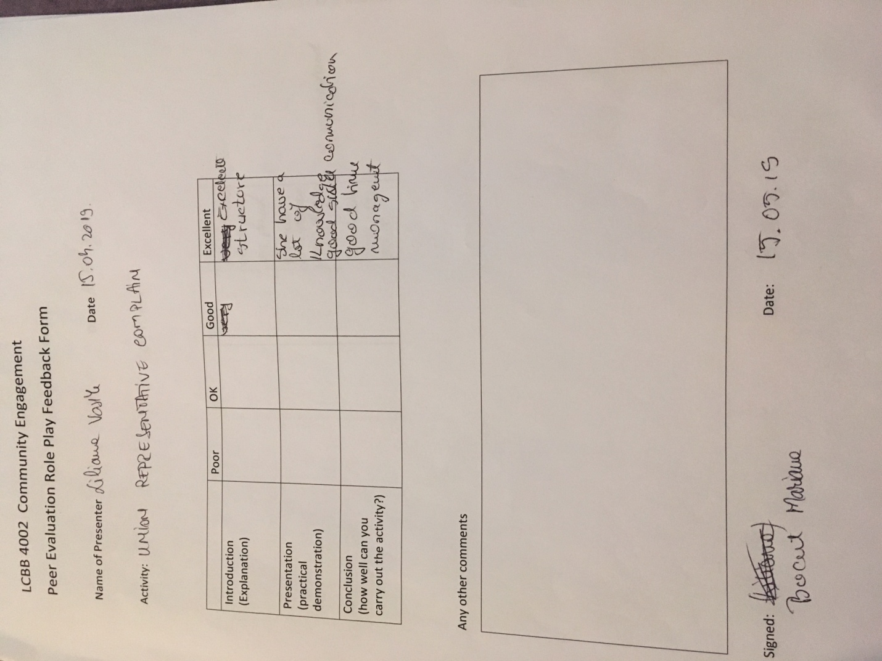

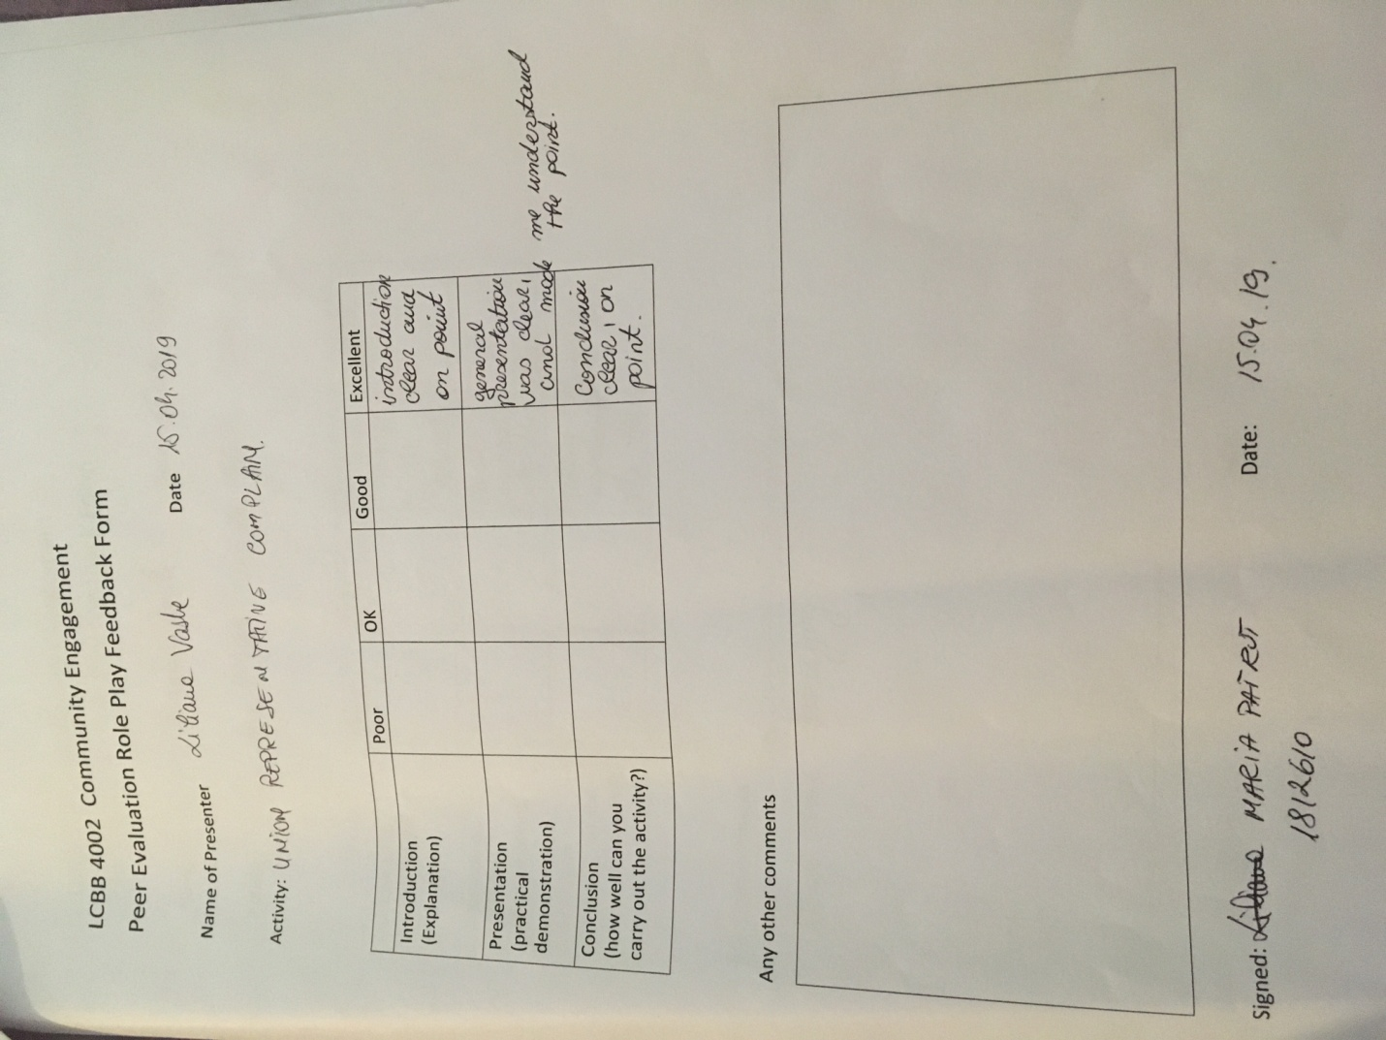

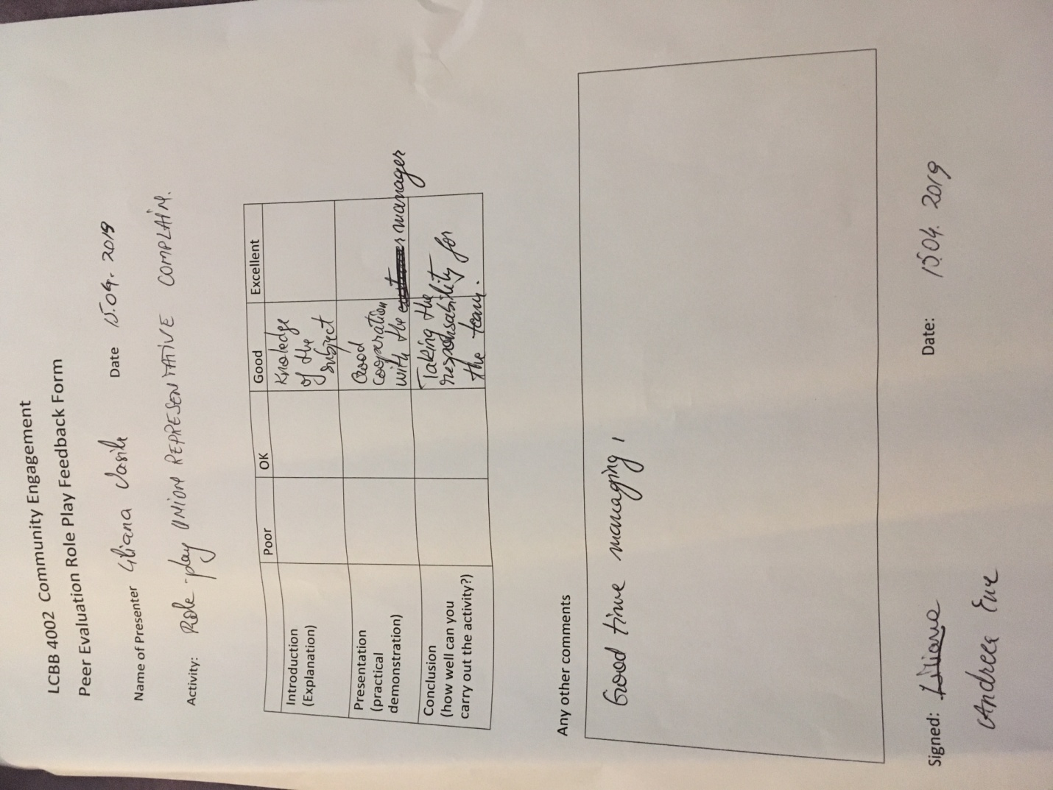

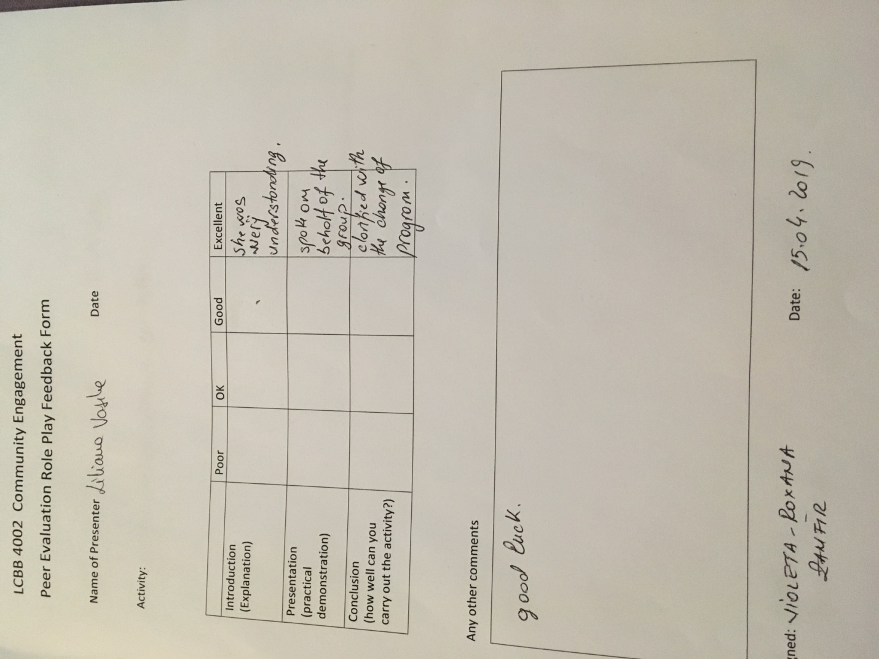

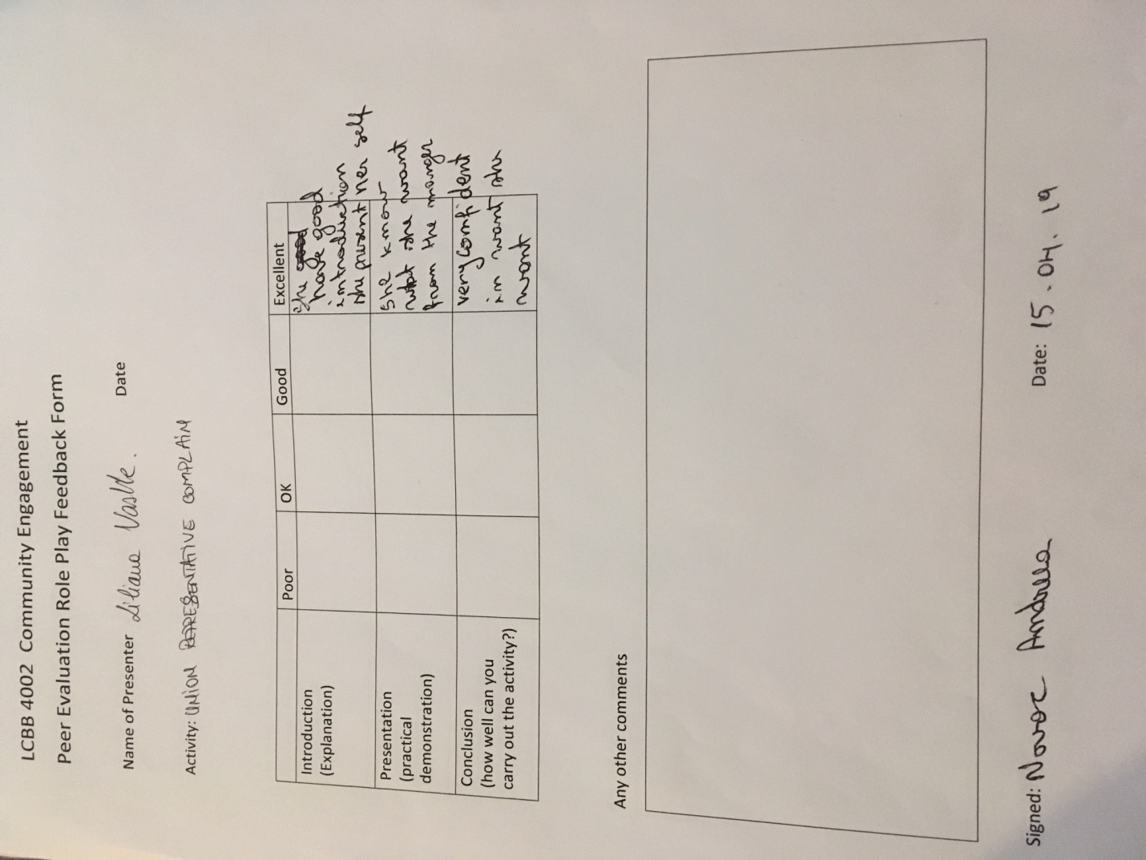

REFERENCES

Amazon Careers,“Warehouse team member” . [Online] [Accessed on 22 April 2019] Available from:https://www.amazon.jobs/en/jobs/SF190023282/warehouse-team-member-part-time-full-time-hours

Cambridge International Education Learning and Teaching team “Getting started with reflective practice” . [Online] [Accessed on 23 April 2019] Available from:https://www.cambridge-community.org.uk/professional-development/gswrp/index.html

Reeves,R.”Still Juggling After All These Years”, Management Today, June 2007, pp36-43.

The guardian, “We are not robots': Amazon warehouse employees push to unionize”. [Online] [Accessed on 22 April 2019] Available from:https://www.theguardian.com/technology/2019/jan/01/amazon-fulfillment-center-warehouse-employees-union-new-york-minnesota

Uniland,”Amazon Workers Complain About Shocking Conditions In Warehouse” [Online] [Accessed on 20 April 2019] Available from:https://www.unilad.co.uk/news/amazon-workers-complain-about-shocking-conditions-in-warehouse/

