Exercises for Files

- Exercise 1 – Read integers from a file

Create a file with 5 integers in it (Readings.txt). Then write a program with an array of 5 elements. Read the contents of the file into the array using a loop, then use a second loop to print the array on the screen. Your file might look like the following:

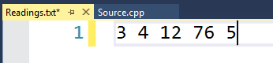

Your output should look something like this:

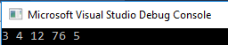

- Exercise 2 – Read strings and integers from a file

Create a file with a list of marks – names and scores. Your file might look something like this:

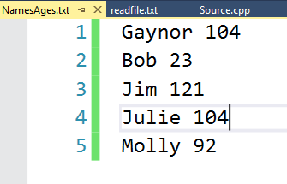

- Using a C program, read the first name into a string (name) and the score an integer (score), then print them on the screen.

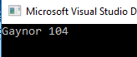

- Turn char name and int score into arrays and read the full high score table from the file, then print it on the screen.

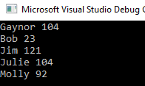

- Extension – VERY HARD (for the brave among you ): Sort the list held into order with highest score at the top. If you intend to swap element, note that in C you cannot directly transfer one string to another because they are arrays in their own right. However, you can use strcpy() from the string.h library. Ask me for details of the use of the strcpy() function.

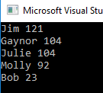

- Exercise 3 – Recording the best score in an external file.

Write a game to guess a random number (we have done something like this previously) Here’s some starter code for a “guess the number” game:

#include<stdio.h>
#include<time.h>
#include<stdlib.h>

void main()
{
srand(time(NULL));
int high = 10, low = 1, myrandom,guess=0;
int turns = 0;
myrandom = rand() % (high - low + 1) + low;
printf("I am thinking of a number...");
printf("\nTry to guess what it is, it's between 1 and 10...\n");

while (guess != myrandom)
{
printf("\nEnter your guess: ");
scanf("%d", &guess);
turns = turns + 1;
}

printf("Well done, you guessed! You took %d turns", turns);
}

For this program, create a current high score file called HighScore.txt (set the initial High Score to 20)

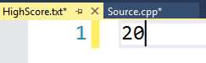

Add code to:

- Read the high score from the file and tell the user what it is at the start of the game:

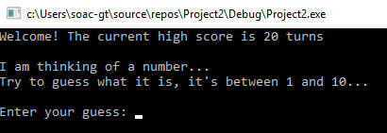

- At the end of the game, decide if the value of turns is a new high score, and if it is, inform the user, and write the new high score to the file (you will overwrite the old high score)

Some sample output:



