Student Name: Mikey Scourfield
Student ID: 2410362
Programme: BSc/HND/HNC Built Environment Portfolio
Module: Fundamentals of Construction Technology
Module Code: ACBA4022
Lecturer: Allan Nantel

Table of Contents
1. Introduction 3
2. Historical Overview of Swansea Mumbles Road Site 3
2.1 Ownership of the site 3
3. Site Investigation 4
3.1 Geotechnical Overview 4
3.2 Recommendations for Further Investigation 4
3.3 Environmental and Social Considerations 5
3.4 Foundation Recommendations 7
3.4.1 Assessment of Foundation Options 7
3.4.2 Technical Recommendations 9
3.4.3 Groundwater Management 9
3.4.4 Summary 9
3.5 Visual Summary 9
4. Reference List 12

Introduction
This section provides a detailed historical overview of the Swansea Mumbles Road site, including its ownership and past uses.
Comprehending the site's historical context is essential for recognising potential obstacles, including contamination, existing subterranean structures, or other site-specific limitations. A comprehensive site study is necessary for guaranteeing the stability, safety, and sustainability of the new build. Ultimately, choosing the suitable foundation system for the project necessitates meticulous evaluation of the building's specifications and the site's geotechnical characteristics.
This report intends to deliver a thorough historical analysis of the site, propose site assessment methodologies, and offer a well-informed proposal for an appropriate foundation type. By addressing these topics, the study aims to assist the project team in making informed, evidence-based decisions for the effective execution of the Swansea Mumbles Road development.

Historical Overview of Swansea Mumbles Road Site

Ownership of the site
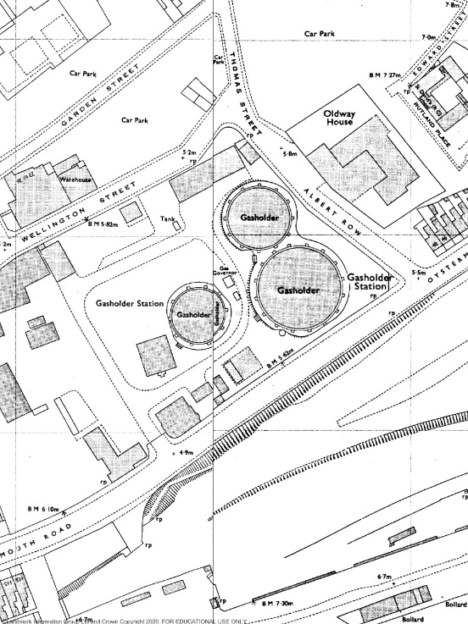
The proposed site on Mumbles Road, Swansea, holds a rich and layered industrial history. In 1804, the Swansea and Mumbles Railway was established, initially for transporting quarried materials, and later became the world’s first passenger railway in 1807 (Swansea Museum, n.d.; Coflein, n.d.). The railway served passengers and goods for over a century before its closure in 1960.
Historical maps from the 1870s indicate that part of the site was also occupied by a gasworks, labelled as a Gasometer, operated by the Swansea Gas Light Company. This facility stored and distributed town gas to the surrounding area, operating alongside the railway for several decades (Coflein, n.d.; Archives Hub, n.d.).
After the railway closed in 1960, the gasworks continued to function as a key energy facility until the late 20th century, when advancements in energy technology and the transition to natural gas rendered the facility obsolete. The site was subsequently sold and redeveloped in the 1990s, with a Tesco superstore opening in 2000 to mark its transformation from industrial to retail use (Archives Hub, n.d.; Coflein, n.d.).

Site Investigation

Geotechnical Overview
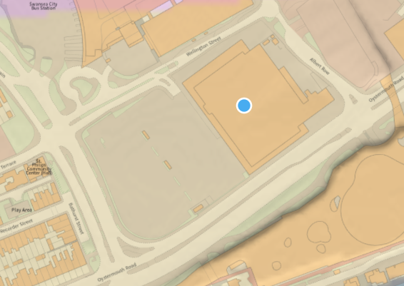
Comprehending the underlying conditions at the Swansea Mumbles Road location is essential for evaluating the viability of the proposed development. This document summarises the geological setting and results from drilling research.
Geological Context:
- The site is underlain by the South Wales Middle Coal Measures Formation, a sequence of mudstone, sandstone, and coal seams. Superficial deposits comprise Blown Sand, which may exhibit variable strength and stability (British Geological Survey, n.d.).
- Implications:
  - The diversity of surface deposits and the existence of compressible layers require meticulous geotechnical evaluation to ascertain risks associated with excavation and load-bearing capacity (British Geological Survey, n.d.).
Borehole Data Summary:
- Boreholes 370487, 370488, and 370489 reveal:
  - 0–3m (Made Ground): Composed of rubble, silty clay, and gravelly sand. Weak and inconsistent, posing settlement risks.
  - 3–5m (Alluvium): Layers of peat and sandy silt, which are highly compressible and unsuitable for foundations.
  - >6m (Dense Gravel or Bedrock): Provides stable conditions for anchoring deep foundations.
(British Geological Survey, n.d.)
Groundwater:
- Due to the collated borehole data it was observed that at depths of 1.5 – 2m there were groundwater strikes, this indicates the need for dewatering systems during construction (British Geological Survey, n.d.).

Recommendations for Further Investigation
Given the historical industrial use of the site and the current findings, the following investigations are recommended:
- Geotechnical Tests:
  - Trial Pits: Excavate shallow pits to visually confirm the variability in the made ground and its depth.
  - Cone Penetration Testing (CPT): Determine soil strength and stiffness, providing continuous profiles for validation.
  - Plate Load Testing: Assess the bearing capacity of silty clay and gravel layers to evaluate their performance under load (British Standards Institution, 2020).
Contamination Tests:
- Soil Sampling:
  - It is advised that the developer target made ground and peat layers for hydrocarbons, heavy metals (e.g., arsenic, lead), and cyanides from historical gasworks and railway activities (British Standards Institution, 2013).
- Groundwater Sampling:
  - Test for leachates, including hydrocarbons and dissolved metals, to evaluate contamination risks (British Standards Institution, 2013).
- Gas Monitoring:
  - Install gas monitoring wells to detect methane and carbon dioxide emissions, particularly near organic layers (British Standards Institution, 2013).

Environmental and Social Considerations
The urban nature of the site and its proximity to residential and commercial areas require thoughtful planning to minimize environmental and social impacts.
- Environmental Impacts:
  - The NRW Phase 1 Vegetation Habitat Map indicates urbanized land use with no direct ecological sensitivity. However, indirect impacts such as runoff to nearby watercourses must be managed (Natural Resources Wales, n.d.).
  - Recommendations:
    - Implement sustainable drainage systems (SuDS) to control water runoff (Construction Industry Research and Information Association, 2015).
    - Prevent contamination of adjacent areas by managing on-site spills and leachates (Construction Industry Research and Information Association, 2015).
- Flood Risk and Planning Maps:
  - The following maps illustrate the flood risks associated with the site and its surroundings (Natural Resources Wales, n.d.).
Figure 1: Flood Risk Map for Planning: The Mumbles
(Source: Natural Resources Wales, n.d.)
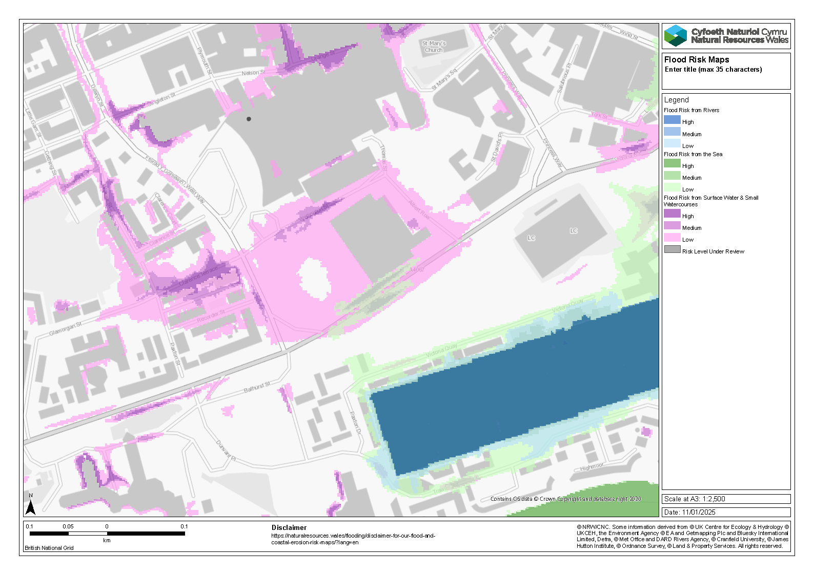Figure 2: Flood Map for Planning: The Mumbles (Surface Water)
(Source: Natural Resources Wales, n.d.)
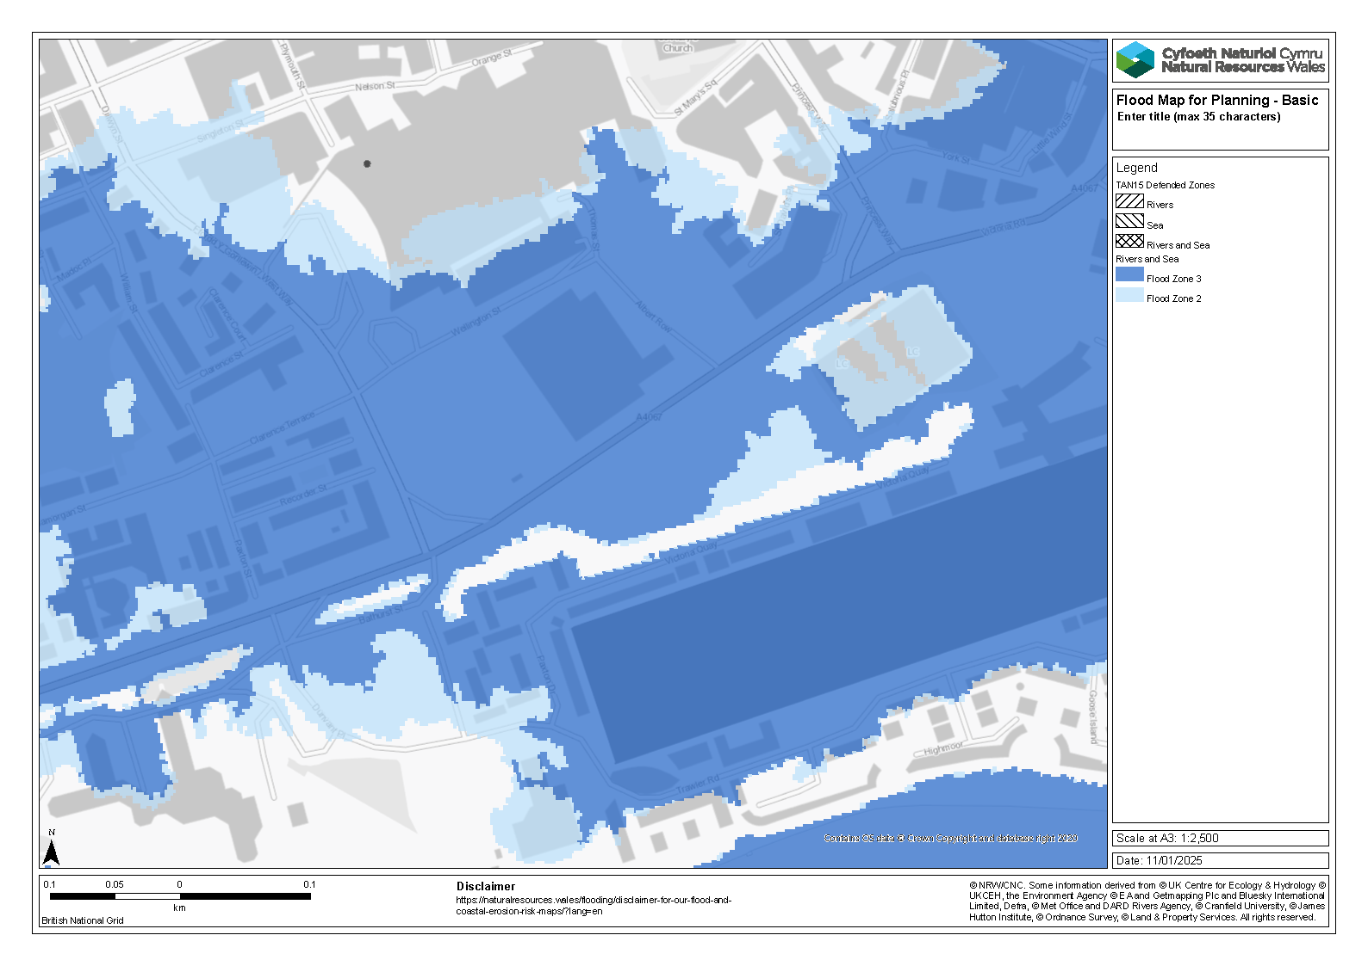
- Social Impacts:
  - Proximity to residential and commercial properties means construction noise, dust, and disruption may affect the local community.
  - Recommendations:
    - Follow Considerate Constructors Scheme guidelines to mitigate noise and dust (Considerate Constructors Scheme, n.d.).
    - Engage local stakeholders early to address concerns and share project timelines (Considerate Constructors Scheme, n.d.).

Foundation Recommendations
The geotechnical and borehole data collected from the Swansea Mumbles Road site provide critical insights for foundation design. The upper layers of the site, composed of made ground and alluvial deposits, exhibit significant variability and compressibility, making shallow foundations unsuitable. At greater depths, dense gravel and bedrock layers offer the stability required for anchoring deep pile foundations.

3.4.1 Assessment of Foundation Options
The Swansea Mumbles Road site presents challenging geotechnical conditions, particularly in the upper strata. Based on borehole data and insights from similar projects, the following foundation options were assessed:
Shallow Foundations
Shallow foundations, such as strip or raft foundations, are typically cost-effective and straightforward to design. However, they are unsuitable for the Swansea Mumbles Road site due to the weak bearing capacity of the upper layers.
- Site-Specific Constraints:
  - Borehole logs (370487, 370488, and 370489) reveal that the upper 3m consists of made ground, including rubble, silty clay, and sandy silt, which are prone to settlement.
  - Beneath this, the 3–5m layer comprises peat and silty clay (alluvial deposits), which are highly compressible and unsuitable for supporting structural loads (British Geological Survey, 2025a–c).
- Supporting Evidence from Case Studies:
  - A study on foundation challenges in diatomaceous soil (ScienceDirect, 2013) highlighted the risks of settlement and structural instability when using shallow foundations on compressible layers.
  - The failures observed in soft marine clay foundations (DFI Journal, 2009) underscore the need to avoid shallow foundations in sites with weak upper strata.
- Conclusion: Shallow foundations would result in uneven settlement and instability, making them unsuitable for this site.
Deep Pile Foundations
Deep pile foundations offer a viable solution for transferring structural loads through weak strata to stable bearing layers.
- Geotechnical Justification:
  - Dense gravel and bedrock layers (>6m), identified in borehole logs, provide the necessary stability for supporting significant structural loads.
  - Deep pile foundations can bypass compressible layers, ensuring minimal settlement and long-term performance.
- Case Study Support:
  - Optimized bored piles used in London’s Hyde Park (Case Studies in Structural Engineering, 2014) successfully overcame similar challenges with weak upper layers, demonstrating cost-efficiency and reliability.
  - The setup effects observed in driven pile foundations in diatomaceous soil (ScienceDirect, 2013) highlight the potential for increased bearing capacity over time.
  - Lateral resistance improvements for piles in complex strata (ISFOG, 2015) further validate the importance of proper pile design for urban developments.
- Comparison of Options:
  - Bored Piles:
    - Advantages: Minimal noise and vibration, ideal for urban settings.
    - Recommended due to compatibility with the site's constraints and reduced disruption to nearby properties.
  - Driven Piles:
    - Advantages: Faster installation and high initial capacity.
    - Limitations: Noise and vibration make them less suitable for urban areas like Swansea Mumbles Road.
- Conclusion: Based on borehole data and precedents, bored piles are the most appropriate foundation option for this site.
The following table provides a comparison of foundation types, evaluating their advantages, disadvantages, and suitability based on the site's geotechnical profile and urban context.
Foundation Type | Advantages | Disadvantages | Suitability for Site
Shallow Foundations | Cost-effective and easy to construct. | Prone to uneven settlement due to weak upper layers; low bearing capacity. | Unsuitable: Weak and compressible layers make shallow foundations unreliable.
Driven Piles | Quick installation; high load capacity. | High noise and vibration levels; disruption to nearby properties. | Limited: Suitable for less sensitive areas but not ideal for urban settings.
Bored Piles | Minimal noise and vibration; adaptable to urban constraints; bypasses weak strata. | Higher initial cost compared to shallow foundations. | Recommended: Provides stability by anchoring into dense gravel/bedrock layers (>6m).

3.4.2 Technical Recommendations
- Recommended Method:
The Swansea Mumbles Road site presents significant geotechnical challenges due to the variability and compressibility of the upper strata. Based on borehole data, case studies, and recognized industry standards, the following recommendations are provided to ensure a stable and efficient foundation design.
Selection of Deep Pile Foundations
Deep pile foundations are the preferred choice for this site, as they can bypass the compressible upper layers and anchor securely into the dense gravel or bedrock layers identified at depths exceeding 6m. Borehole logs (370487, 370488, and 370489) confirm that the upper 5m comprises made ground, peat, and silty clay, all of which are unsuitable for bearing structural loads (British Geological Survey, 2025a–c).
- Preferred Pile Type:
  - Bored Piles are recommended due to their adaptability to urban constraints, such as minimal noise and vibration during installation. This makes them ideal for densely developed environments like Swansea.
  - Case Study Support: The use of bored piles at Hyde Park in London demonstrated their efficacy in urban sites with similar geotechnical challenges (Case Studies in Structural Engineering, 2014).
Pile Installation Methods
The installation of deep piles must be carefully planned and executed to mitigate risks and ensure structural stability.
- Recommended Method:
Continuous Flight Auger (CFA) piles are advised for this site. They offer:
  - Quiet and vibration-free installation, minimizing disturbance to nearby properties.
  - Real-time monitoring capabilities, enabling adjustments during installation to maintain stability.
- Additional Measures:
  - Utilize casing or bentonite to stabilize boreholes in loose or saturated soils.
  - Ensure proper alignment and depth of piles through continuous monitoring.
Structural and Geotechnical Considerations
Given the site’s characteristics, additional design considerations are essential to address lateral resistance and settlement risks.
- Lateral Resistance:
  - Design the piles to withstand lateral forces, especially in areas with uneven load distribution.
  - Case Study Support: Research from ISFOG (2015) highlights the importance of rotational restraints or pile caps for improving lateral resistance in complex geotechnical environments.
- Settlement Control:
  - Piles must bypass compressible layers to minimize settlement risks and ensure long-term stability.
  - Insights from diatomaceous soil projects further validate the importance of robust pile design in mitigating settlement risks (ScienceDirect, 2013).
Post-Installation Monitoring
To ensure foundation performance, rigorous monitoring and testing are required both during and after installation.
- Dynamic Load Testing:
  - Conduct load tests on selected piles to confirm their load-bearing capacity and validate design assumptions.
- Instrumentation:
  - Install sensors to monitor lateral displacement and settlement throughout construction, ensuring compliance with design parameters and early detection of potential issues.
Standards Compliance
The design and implementation of the foundations must adhere to the following industry standards:
- BS 8004:2015: Guidelines for the design of pile foundations.
- BS 5930:2015: Site investigation protocols for reliable geotechnical data.
- BS 8485:2015: Recommendations for mitigating ground gases, such as methane or carbon dioxide, if identified during site investigations.
By combining deep pile foundations, advanced installation techniques, and robust monitoring protocols, the recommendations outlined above ensure that the proposed development at Swansea Mumbles Road will be both stable and sustainable. These strategies, supported by real-world case studies and industry standards, address the site’s unique challenges effectively.

3.4.3 Groundwater Management
- Groundwater strikes observed at depths of 1.5–2m necessitate temporary dewatering during construction.
- Suggested methods include:
  - Sump Pumps: Cost-effective and easy to deploy for localized dewatering.
  - Wellpoint Systems: Suitable for managing shallow groundwater over larger areas.
- Effective dewatering ensures stability during pile installation and prevents water ingress, aligning with BS 5930:2015 guidelines.

3.4.4 Summary
- Deep Pile Foundations: Anchor piles in dense gravel or bedrock (>6m) to ensure structural stability.
- Groundwater Management: Implement tailored dewatering systems to manage groundwater strikes and maintain site safety.
- These recommendations align with site-specific conditions, project sustainability goals, and best practices observed in similar case studies.

Visual Summary
Table 1: Borehole Summary and Key Findings
Borehole ID | Depth Range (m) | Strata Description | Implications
370487 | 0-3.0 | Made Ground (rubble, silty clay, organic debris) | Highly variable, weak; removal or replacement recommended to avoid settlement.
 | 3.0-5.0 | Peat and sandy silt (Alluvium) | Compressible and prone to subsidence; unsuitable for foundations.
 | >6.0 | Dense gravel/sandstone | Stable and capable of supporting deep pile foundations.
370488 | 0-3.0 | Made Ground (rubble, silty clay, brick fragments) | Similar composition to Borehole 370487; requires removal or replacement.
 | 3.0-5.0 | Peat and fibrous organic material (Alluvium) | Compressible and unsuitable for structural loads.
 | >6.0 | Dense gravel/sandstone | Provides stable conditions for anchoring deep piles.
370489 | 0-3.0 | Made Ground (cobbles, silty clay, gravelly sand) | Variable composition; poses settlement risks; removal advised.
 | 3.0-5.0 | Peaty clay and silty alluvium | Compressible; unsuitable for shallow foundations.
 | >6.0 | Dense gravel | Stable for foundation piling; low risk of settlement.
Figure 1: Borehole Locations and Groundwater Strikes (To be added based on site layout.)
(Source: British Geological Survey (n.d.)
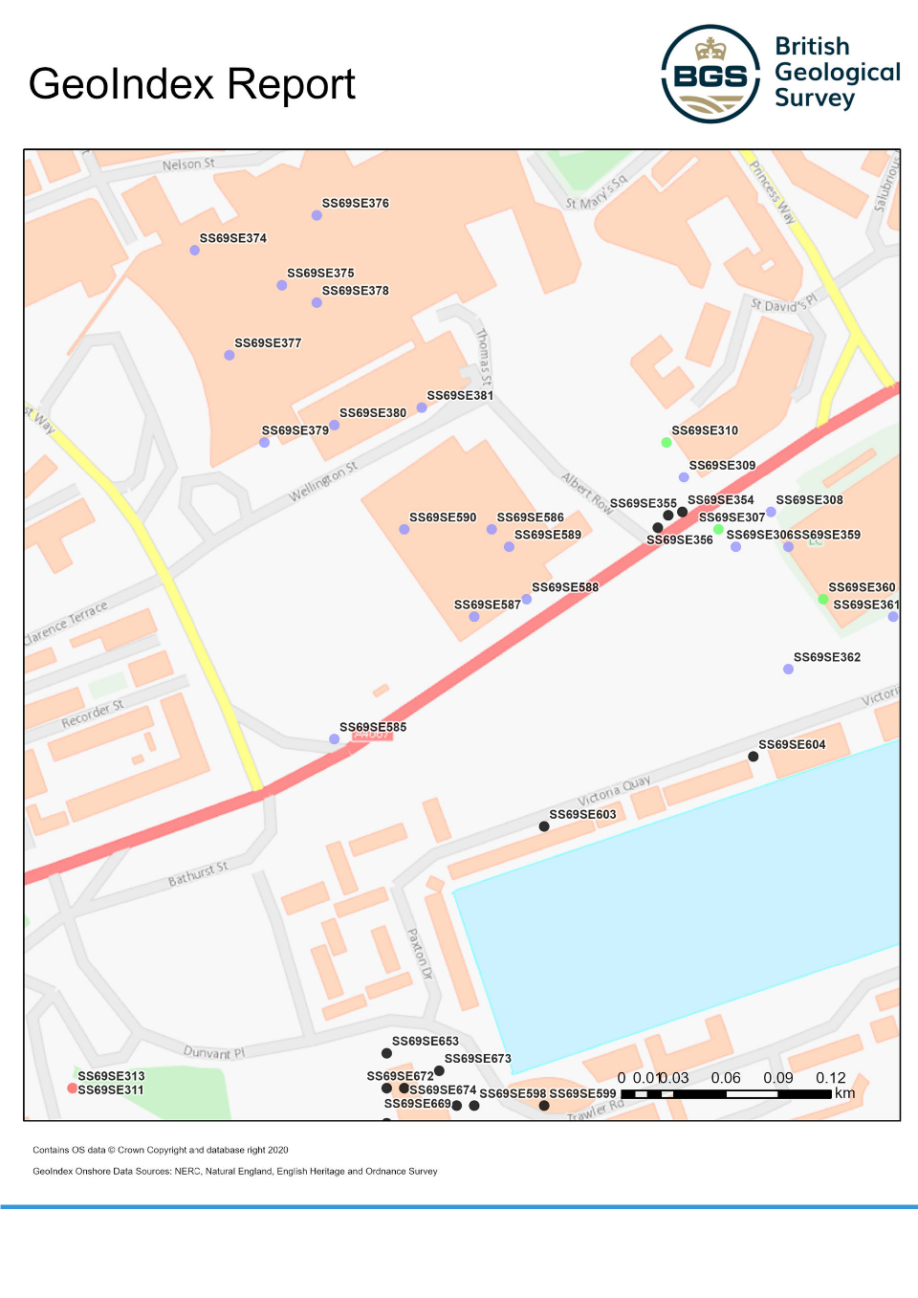

Conclusion and Recommendations

Conclusion
The Swansea Mumbles Road site presents a unique blend of challenges due to its historical industrial use, urban setting, and complex geotechnical profile. This report has outlined key findings from the site investigation, including the unsuitability of shallow foundations and the critical need for deep pile foundations to ensure stability. By anchoring piles into dense gravel or bedrock layers at depths exceeding 6m, the proposed design mitigates settlement risks and ensures long-term structural integrity. Furthermore, groundwater management strategies and adherence to industry standards provide a robust framework for addressing environmental and construction challenges.
The combination of borehole data, case study insights, and compliance with British Standards ensures that the recommendations align with both project-specific requirements and broader industry best practices. Ultimately, the proposed measures create a safe, sustainable, and efficient foundation system for the Swansea Mumbles Road development.

Recommendations
Based on the findings and analysis in this report, the following recommendations are provided for the successful implementation of the project:
- Foundation Design:
  - Adopt deep bored piles, designed to anchor securely into stable strata beyond 6m, to bypass compressible upper layers.
  - Ensure design compliance with BS 8004:2015, addressing site-specific load and lateral force requirements.
- Groundwater Management:
  - Implement dewatering systems during excavation, using sump pumps or wellpoint systems to manage groundwater strikes at depths of 1.5–2m.
  - Monitor groundwater levels continuously to avoid destabilizing adjacent areas.
- Environmental and Social Mitigation:
  - Minimize construction impacts on the surrounding community by following Considerate Constructors Scheme guidelines.
  - Install sustainable drainage systems (SuDS) to manage surface water runoff and prevent contamination of nearby watercourses.
- Post-Construction Monitoring:
  - Conduct dynamic load testing and instrumentation monitoring to validate foundation performance during and after construction.
  - Regularly inspect and maintain drainage and groundwater control systems.
- Further Studies:
  - Undertake additional contamination testing to assess risks associated with historical industrial activity and mitigate potential environmental hazards.
  - Conduct utility surveys to identify and address any existing underground services.

Reference List
            - Swansea Museum (n.d.) Mumbles Train. Available at: https://www.swanseamuseum.co.uk/swansea-a-brief-history/mumbles-train (Accessed: 10 January 2025).
            - Coflein (n.d.) Swansea Gas Works, Oystermouth Road, Swansea. Available at: https://coflein.gov.uk/en/site/85432/ (Accessed: 10 January 2025).
            - Archives Hub (n.d.) Photographs of preliminary building work on the former gas works site, Oystermouth Road, Swansea, in preparation for the construction of a Tesco supermarket. Available at: https://archiveshub.jisc.ac.uk/data/gb216-d/dpp/d/dpp/49/1 (Accessed: 10 January 2025).
            - British Geological Survey, n.d. BGS Geology Viewer. Available at: https://www.bgs.ac.uk/map-viewers/bgs-geology-viewer/ [Accessed 10 January 2025].
            - British Geological Survey, n.d. GeoIndex Onshore: Borehole Records. Available at: https://mapapps2.bgs.ac.uk/geoindex/home.html [Accessed 10 January 2025].
            - British Standards Institution, 2020. BS 5930:2015+A1:2020 Code of Practice for Ground Investigations. London: BSI Standards Limited.
            - British Standards Institution, 2013. BS 10175:2011+A2:2017 Investigation of Potentially Contaminated Sites. London: BSI Standards Limited.
            - Natural Resources Wales, n.d. Phase 1 Vegetation Habitat Map. Available at: https://naturalresources.wales [Accessed 10 January 2025].
            - Construction Industry Research and Information Association, 2015. The SuDS Manual (C753). London: CIRIA. Available at: https://www.ciria.org [Accessed 10 January 2025].
            - Natural Resources Wales, n.d. Flood Risk Map for Planning. Available at: https://flood-risk-maps.naturalresources.wales/?locale=en [Accessed 10 January 2025].
            - Natural Resources Wales, n.d. Flood Map for Planning. Available at: https://flood-map-for-planning.naturalresources.wales/ [Accessed 10 January 2025].
            - Considerate Constructors Scheme, n.d. Code of Considerate Practice. Available at: https://www.ccscheme.org.uk [Accessed 10 January 2025].
            - British Geological Survey, 2025a. Borehole Log 370487 (SS69SE586). Unpublished borehole record. British Geological Survey Records. [Accessed 10 January 2025].
            - British Geological Survey, 2025b. Borehole Log 370488 (SS69SE587). Unpublished borehole record. British Geological Survey Records. [Accessed 10 January 2025].
            - British Geological Survey, 2025c. Borehole Log 370489 (SS69SE588). Unpublished borehole record. British Geological Survey Records. [Accessed 10 January 2025].
            - Case Studies in Structural Engineering (2014) ‘Optimum design methodologies for pile foundations in London’. Case Studies in Structural Engineering, 1(1). Available at: https://www.sciencedirect.com/science/article/pii/S2214399814000113?ref=pdf_download&fr=RR-2&rr=900621a398a093e7 [Accessed: [10 January 2025].
            - ScienceDirect (2013) ‘Case study of a driven pile foundation in diatomaceous soil. II: Pile installation, dynamic analysis, and pore pressure generation’. ScienceDirect, 4(3). Available at: https://www.sciencedirect.com/science/article/pii/S1674775521000032 [Accessed: [10 January 2025].
            - ISFOG (2015) ‘Improving the lateral resistance of offshore pile foundations for deepwater application’. Proceedings of ISFOG. Available at: https://www.researchgate.net/profile/Harry-Arshi/publication/281294010_Improving_the_lateral_resistance_of_offshore_pile_foundations_for_deepwater_application/links/55e0953408aede0b572eaa03/Improving-the-lateral-resistance-of-offshore-pile-foundations-for-deepwater-application.pdf [Accessed: [10 January 2025].
            - DFI Journal (2009) ‘A case study of passive piles failure in open excavation’. DFI Journal, 3(2). Available at: https://www.researchgate.net/publication/272252035_A_Case_Study_of_Passive_Piles_Failure_in_Open_Excavation [Accessed: [10 January 2025].
            - British Standards Institution (BSI) (2015a) BS 5930: Code of Practice for Site Investigations. London: BSI.
            - British Standards Institution (BSI) (2015b) BS 8004: Code of Practice for Foundations. London: BSI.

