Internet Technologies and Security – Proposed Network Solution for CoffeeCapulus

Oliver Bird
Second Year Applied Software Engineer
1910716@student.uwtsd.ac.uk

ABSRACT
Cyber security has become and imperative part of modern business and communications. It is easier than ever before to implement and execute sophisticated malicious attacks against both companies and individuals, often for a large reward. It is therefore of upmost importance, that businesses and users are both protected and prepared for such an event. This paper will propose a complete network solution for the Jamaican coffee retailer, ‘CoffeeCapulus’, which will ultimately allow for both staff and customers to connect to the corporate network using their own devices.

INTRODUCTION
Cyber crime is still on the rise, and large corporations are a key and valuable target for them. As shown in the recent 2020 Cyber Crime survey in the United Kingdom, 75% of ‘large’ business have reported cyber security breeches and attacks against them [1].
This has highlighted the potential need for care and evaluation of the current systems at CoffeeCapulus.
In light of this, CoffeeCapulus have requested a new and dynamic solution which would encompass all internal communications and systems for employees, as well as integrate with external customers. The solution is also required to allow for all users both internal and external to access the network using their own home devices. This is a concept known as ‘Bring Your Own Device’ and will be denoted as BYOD.
One of the largest concerns is the security and protection of both internal staff and consumer data, therefore there must be intense and scrutinous auditing of the solution to ensure this data is given the highest classification and protection.
The retailer is also concerned with the protection of its intellectual property and internal systems, so the solution must be robust enough to allow for all of the above. It is also noted that there should be minimal impact on the current systems, as the company have a large online presence and is unlikely to allow for downtime in main customer facing systems.

Table of Contents:
- BYOD Evaluation
  - Pros
  - Cons
- Network design and evaluation
  - Hosting
  - Design
  - Device Security
    - Device Virtualisation
    - Acceptable Use Policy
      - Security Policy
    - Disclaimer
    - Remote Management
    - Endpoint Detection and Response
      - EDR
      - SIEM
      - SOAR
    - Full Disk Encryption
    - System Hardening
    - Human Response – Direct Attacks
  - Network Security
    - Corporate VPN
    - Proxies
    - Firewalls
    - Physical Infrastructure Protection
  - Information Security
    - Encryption
    - Database locations
    - Data Classifications
    - Data Use
    - Data Retention
    - Remote Storage
    - Redundancy
- Conclusion

- BYOD Evaluation
  - Pros
The premise of BYOD for staff and consumers is purely based on convenience. By allowing the user to connect any of their home devices to the network, it allows for ease of use in an environment they know and are comfortable with. It allows the user to have a small number of devices within their home / place of work as opposed to the additions brought by having a designated work device.

For the end consumer or customer, it is the preferable and obvious solution, as it is not feasible to supply each customer with their own corporate device, therefore to access even a part of the network, some level of open access is required.

It is also a preferable solution financially in the first instance, as it means the company do not have to provide their staff with hardware. This reduces the initial cost of device purchase, potential maintenance costs, insurance costs in the case of lost, damage or theft.
Chountalas et al found that to less educated employees and users, BYOD is an important and innovative function of business. It is believed that by simply employing this option, staff will work more efficiently and become more flexible in their work [2]

It has also been found that employee satisfaction is greatly improved by the availabilities that BYOD brings. [3] poses that by allowing employees to select their own devices, their productivity increased. [3] also states that the transition to a BYOB is an inevitability of modern business, and that the associated benefits from employee satisfaction and productivity massively outweigh potential security violations due to the level of control which can be applied to a device.

  - Cons
Due to the open access nature of BYOD, there comes alongside a significant amount of security risk.
By allowing users to directly connect their home use devices to the network, the scope for malicious attack grows massively. Many users do not understand the importance of up to date anti-virus software, as is shown in a recent report from Microsoft’s intelligence report [4]. The report claims that around one quarter of all PCs around the globe are not protected by up to date anti-virus software. Whilst this report is a little dated, it appears that in many cases the opinion of the public is one of ignorance around the matter of cyber security. In an anonymous survey from the statistics-based site Statista, even in the most prominent case, 30% of users were not concerned around bank account hacking. For other types of cyber-crime these figures only become worse [5].
There is also a significant issue with employee and user compliance with BYOD restrictions. [6] has observed that due to a device being owned by a user, as opposed to the corporation, there can be a level of ‘freedom threat’ felt by the user which ultimately causes resentment of the BYOD system and opens avenues for mal--compliance to the regulations imposed by the corporation.

These issues are exacerbated in the case of mobile access. Operating systems for mobile have been developed primarily for user friendliness, where in many cases security vulnerabilities have been ‘ignored’. Findings from Positive Technologies detail the highest risk vulnerabilities were found in around 40% of devices, covering android and iOS [7]. Whilst better suited to BYOD, vulnerabilities are far more difficult to patch when compared to a desktop OS

BYOD devices are far easier targets, as they are not always protected by a corporate firewall or filter. Email accounts are easy targets for phishing due to a lack of filter on many domains. Clients such as Gmail can be used to give some level of protection, but many providers do not offer adequate filtration.
Home networks are also far easier targets, and in the likely event of a targeted attack against a home, the majority of users will not have a reasonable level of network protection

Detailed below are the nature of some potential attacks and breaches which can occur due to mismanagement of a BYOD device:

- Network Infection
Malicious software can be transmitted onto the corporate network with the goal of a deeper breach. It is unlikely that a single device could hold enough information to commit severe damage to the corporation, if at least some guidelines have been followed regarding data protection. The device is simply an attack vector to the network. This could include ransomware or other malicious software, even if the host device is not the direct target.

- A listener
The infected device may remain dormant to any malicious activity and may act simply as a listener to transmit corporate data, keys etc out of the network.

- Direct attack
The infected device may become the target of the attack itself, for example under ransomware or data harvest.

- Phishing
The device may have already been breached via a phishing attack, but could be used further to inflict a spray phishing attack across the larger network

- Network Design and Evaluation

  - Hosting

The current design of the network is almost completely cloud based; therefore, it makes sense to continue this utilisation. Whilst there are many cloud-based providers each must be evaluated for their ease of use and suitability for the CoffeeCapulus requirements.

The choices include:
- Microsoft Azure
- Amazon Web Services (AWS)
- Google Cloud
- IBM Cloud
- Rackspace
All of the above choices apart from Rackspace offer quality in house content delivery network (CDN) solutions, or the ability to offload this to a third party CDN. For the case of CoffeCapulus, the recommendation is to use AWS. The management console is simple to use, their services have excellent integration with further CDN networks globally such as Cloudflare or Limelight and comes with a plethora of other features for data protection, retention, auditing and analytics.

  - Design

The network will be split into multiple sections to allow for different levels of access.
These will be described as tier zones. The tiers correspond to security levels within the network.
There is a customer facing frontend for purchases, social media and non-essential traffic. This is denoted as tier 0. Behind this will be two secure portals for both staff and customers, allowing staff into the ‘intranet’ and customers into the financial and purchase history, allowing access to support from the company. These will be marked as tier 3 and tier 2 respectively.

- Tier 0 – Frontend, Company Websites, Social Media
- Tier 1 – Customer Portal / Staff Portal
- Tier 2 – Staff Intranet
- Tier 3 – Restricted Databases
- Tier 4 – In strictest Confidence Database, IAM Security roles, IT Security

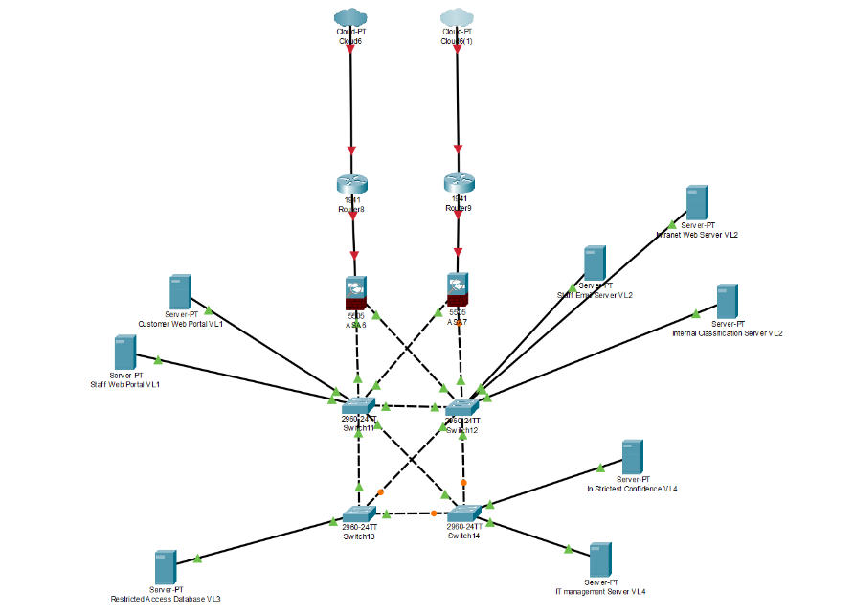

Figure 1 - Physical Network Diagram

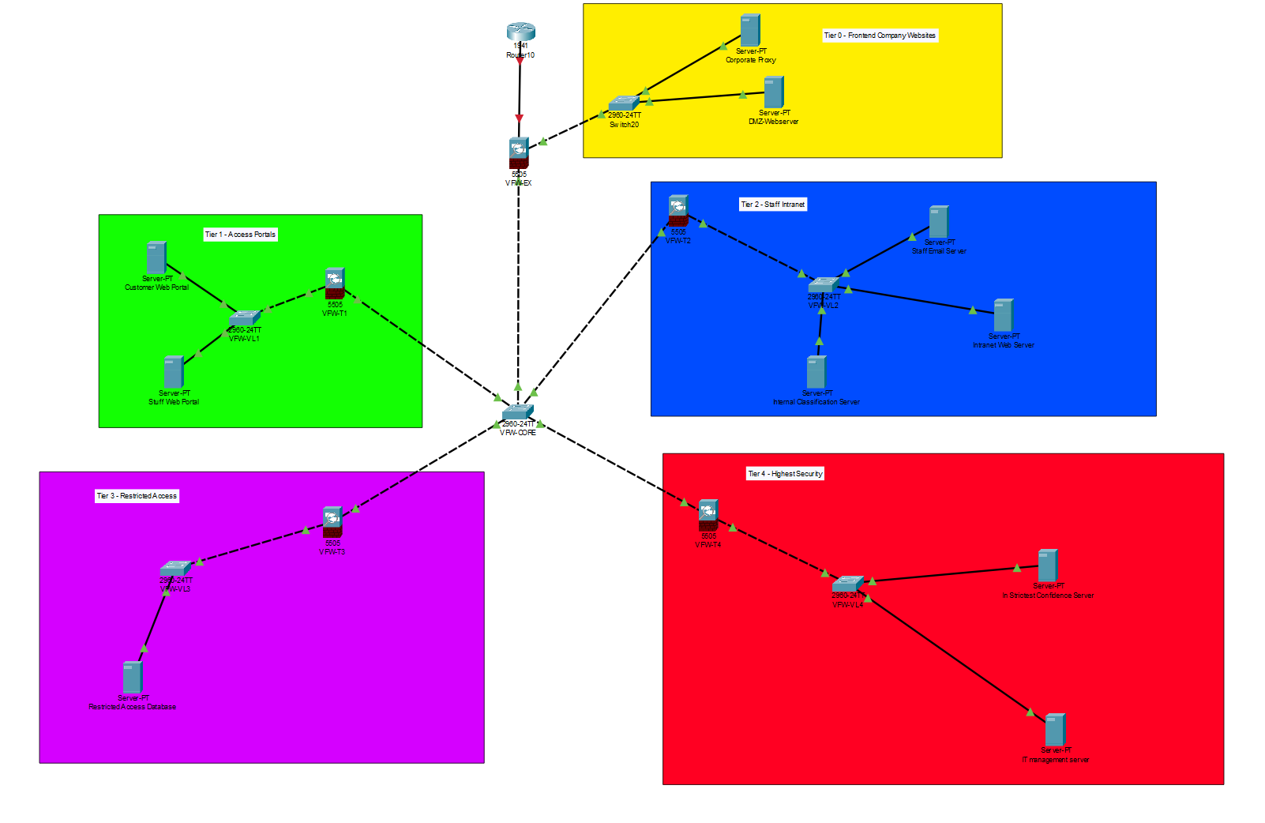
Figure 2 - Logical Network Diagram

The core network contains a simple failover. There are two routers, switches and firewalls to allow for hardware failure. The main firewall, denoted as ASA 6 splits the network into 4 separate VLANs each with their own firewall, representing the different tiers of the network. This firewall restricts access to each tier of the network, allowing through authorised connections. A non-authorised user will be redirected via ASA 6 to the DMZ [F] webserver. From here, this webserver can authorise a user to tier 1 in the case of them being a customer and having an account with CoffeeCapulus. In the case of an authorised user, such as a connection via the corporate VPN, the user will be redirected to the same tier 1 portal to login to the intranet. All further activities on the network will be carried out from here. Information / system control can be requested via the tier 1 servers, hence limiting user direct access to the deeper tiers.

BYOD is a contained system here as all devices connecting into the network will be done via the VPN.

  - Device Security

    - Device Virtualisation / Partitioning

In the most extreme cases, devices both mobile and pc based can be modified to contain a completely separate operating system upon boot. In the case of a laptop, the boot disk can be partitioned to contain an additional operating system which could contain all of the corporate systems, whilst leaving the original partition intact with the users original files. Depending on the availability of space on the drive, this may or may not be possible.

Furthermore, depending on availability, an operating system can be virtualised as a VM within the host OS, designed specifically to manage corporate operations. This would contain all company data within an isolated VM, which could be removed at any time. Not all devices support this feature, and would take significant time and resource to implement

The same can be done with Android devices, in which the flash memory can be partitioned to have a dual boot option. An example of this can be found in secure phone applications [8].

For CoffeeCapulus, this can be implemented only as an additional protective measure for employees who are willing to engage with it. It is not suitable for both employee and customer.

    - Acceptable use policy

In the case of which a device cannot be partitioned, and must be used alongside a client / employees regular usage, it is imperative that a clear set of rules must be followed when either connected to the corporate network or when using the device for work.

These can and should include a comprehensive outline of what is allowed when working. Common examples include which websites (and the nature of them) are permitted, what content can be viewed at work (such as playing games, checking emails, visiting social media etc), any actions taken whilst on the network must be of either directly or indirectly benefit the company, what is strictly prohibited on a device for example:

- Transmission of illicit or illegal material
- Transmit or hold information about another company
- Engage in harassment of any kind
- Engage in any other business activities which may be a conflict of interest
- Installation of software from outside of the permitted list provided by the company (could be from a certain store, or have a list of acceptable applications)

It is imperative that employees and customers understand the potential threats present with BYOD, and by engaging with it as a business option, that their device effectively becomes an extension of corporate property, and that it should be treated in almost the same manner as a device distributed by the company. Due to this, there are many considerations that the end user must make when deciding actions on their device with regards to security. To ensure the integrity of the device, the tools used can be extremely invasive to personal privacy, in the setting where a device has not been partitioned or virtualised.

Alongside the definitive acceptable use policy for actions on the devices themselves, there needs to be actions and plans in place for what devices are acceptable, and what to do in the event of hardware issues. For example, standard practice of revoking administrator rights during work hours (without good reason) should be employed.
Certain operating systems and device types should also be restricted. The use of an OS such as Kali Linux should be completed against policy, along with the use of ‘cracked’ phones either Android or iOS.
Details down to the specific version of the operating systems on both PC and mobile based should be restricted. The Author recommends all devices be run on the most up to date software available at the time of writing, including larger patches for windows and iOS.
To ensure the acceptable use policy is followed from the outset, the IT team at CoffeeCapulus should ensure devices pass the minimum spec requirements manually, before allowing access to the network.
      - Security Policy

As with the acceptable use policy above, there must be a specific security policy which outlines actions either automatically or can be controlled manually. This includes:
- All devices must be password protected
- The password must follow a reasonable standard. For example, be a minimum of 8 characters containing both letters and numbers and at least one special character.
- Passwords must be changed approximately every 3 months to prevent a breach
- Passwords must be unique from any other third-party website
- Passwords once inside the operating system can be stored with a keychain such as KeyPass.
- The Device must lock itself automatically after a short period of time due to inactivity
- The use of multi-factor authentication should be used where available
- Machines will auto lock after 3 failed password attempts. The password can be changed remotely via the IT team.
- Downloads are prevented from automatically running, and administrator permission is required to install any software not on the accepted list.
- System access is heavily prohibited whilst on the corporate network, and even when disconnected installations and security violations are logged.
- The employee device / partition may be remotely wiped if the device is lost or stolen, the employee leaves the organisation or the endpoint detection and response (EDR) software detects a breach
- All external storage devices must be encrypted when first accessed by the device, this should include remote storage devices along with USB and external hard disks.

Both policies must be signed by the user in order to connect to the network.

    - Disclaimer

There are two disclaimers which must be available to the user, malicious or not. Firstly, upon accessing any system including the BYOD device, there must be a presentation screen detailing that the user of this machine has signed the appropriate policies, and if those policies are breeched, they will be subject to criminal action.

It must also have been stated to the user the details of how both the company and the employee are expected to behave. For example:

- The company reserves the right to disconnect a device without warning.
- The employee is responsible for the device and its maintenance, including costs of repair should they cause damage.
- The company reserves the right to terminate the employees’ contract should the policy be breeched sufficiently.

    - Remote Management Software

The central IT team must have remote access to all devices which can be connected to the networks internal structure. This can either be to control any software driven by the corporation i.e to grant access to remotely purge the device completely, or of corporate data. Tools such as Beyond Trust are designed for enterprise use cases and are capable of using Microsoft Active Directory to authenticate users [9]. Many other solutions do exist for this such as AnyDesk or TeamViewer, the pros and cons of which are beyond the scope of this report. It should also be noted, that a remote access session cannot be initiated without the consent of the user. This mean ins every case, the organisation must receive explicit permission to access the device.

    - Endpoint Detection and Response (EDR)

This section will be split into three to cover all aspects of detection, analysis and response.

The entire system is designed to give maximum protection, with minimal human interaction.
      - EDR
Each end device must be protected with some form of EDR solution.
The purpose of an EDR tool is to protect and scan a device for potential and current threats. The software can manage activities on the device to restrict access to administrative features, block installations or malicious processes, manage browser activities and extensions and many other security features.

It is imperative that in this case, the EDR solution attempts to block any kind of data exfiltration from the device, and should alert the SIEM to any kind of such activity.

There is a huge array of options available to cover this in the form of both free and paid for. This report will not cover the benefits of each individual solution, however will pose that A SOLUTION must be enforced. This should be installed by the IT department PRIOR to a device being permitted access to the internal network.

The Author recommends either BitDefender, as the product is dependable and an easy install on both mobile and pc operating systems, or CrowdStrike which again is a simple install and integrates well with the proposed SIEM solution. CrowdStrike also has the benefit of being designed specifically for large organisations

      - SIEM – Security Information and Event Management
SIEM allows for an EDR solution to integrate with a wider network of devices. It is extremely difficult to manage the information an EDR tool spits out manually. This is exacerbated by increasing numbers of devices within a network. A SIEM tool will intake all of the data coming from the EDR and other security solutions (system firewalls, returned proxy information etc), digest and filter the data for what is ‘useful’ and report its findings onto a SOAR solution. In doing this, it allows for the IT / Security teams to be notified of only security threats or breaches, as opposed to all events from a given device.
A popular mid-tier product for this is QRadar provided by IBM.

      - SOAR – Security Orchestration, Automation and Response
SOAR is the top-level security solution in which security analysts / IT staff will interact with. It aims to provide an automated response to some security threats in the case of which they can be automated (i.e, a phishing email is reported, the SOAR solution analyses the email, finds that it is malicious, blocks the sender and informs the user that the email the reported was malicious). In the event that an automated security response cannot be offered, it will alert an analyst to the issue.

    - Full Disk Encryption

Bitlocker is a Windows produced tool for prevention of unauthorised physical access to a system. Bitlocker encrypts all drives on the system and locks them with a passcode in order to decrypt them. This is a deterrent in the case a device is stolen, however it only affects windows devices. There are many other alternatives tools to do this.

Mobile devices using android can also be encrypted via their storage settings.

Most modern iOS devices encrypt their storage automatically but can also be force encrypted via the device settings.

    - System Hardening
Systems should have been reasonably hardened manually prior to being allowed to connect to the network. This is the case for both internal systems (databases, servers etc) and end user systems. Hardening the system means to attempt to remediate security vulnerabilities, in most cases prior to the system being brought online. The remaining vulnerabilities come mostly from a networking perspective, as the devices will have all been secured with an EDR solution.

For all endpoints, there needs to be a level of network access control. This is for most systems in the form of an internal firewall. The Principle of Least Privilege [10] should be adopted in all cases for systems connecting to the network. Port evaluation should be carried out prior to connection with the above principle applied. All unused ports should be CLOSED. In the cases for which administrative and access ports (such as 22 for SSH) are open, authentication must be controlled from within the device. Attacks such as brute force [A] can be easily executed without a policy against re-attempts. As with devices, login attempts should be declined after 2 failed password attempts.

Pen testing [B] [11] should be performed on all internal systems. For maximum effectiveness they should be treated as black box tests. In the case of time becoming a concerning factor, the tests can be done as white box, with minimal depth testing, however this can be less realistic and effective

    - Human Response – Direct Attacks

Solutions must be implemented in the case of a direct attack against a user. The most likely event of this is via a phishing email [C]. A secure system should be implemented to both filter out spam emails to company inboxes, along with a strategy for dealing with them should a user receive one. There are many examples of policies regarding this, however a standard can be summarised here [12]. The organisation should also have a protocol to add the sender to a ‘blacklist’[D] to ensure further emails cannot be received from them.
  - Network Security

    - Corporate VPN

A Corporate VPN [E] should be used in all cases when accessing the networks internal structure. By design, the customers should not need access to the internal structure of the network for employees, so will not need access to the VPN. The VPN configuration can be installed onto all new users’ devices prior to access being granted. The VPN entry point will be situated within the tier 2 section of the network, allowing access to basic staff resources.

    - Proxies

Proxies are a secure gateway out of the network, they will act as a middleman in any connections made to the internet. In the case of CoffeeCapulus, the corporate Proxy is a secure connection back out of the network to the internet. It allows for content filtering and delivery back to users within the network. Whilst using the VPN, all users will be forced through the proxy to control the traffic back into the network. The proxy is able to filter out any unwanted content, malicious or inappropriate for the workplace before it enters the network.

    - Firewalls

Firewalls are strictly implemented with allow or deny connectivity rules. These will be placed between tiers of a network to prohibit unwanted traffic to the more secure areas. These will deny any traffic not necessary for the requested endpoint and provide a further level of protection within the network.

    - Physical Infrastructure Protection

One of the many advantages to Cloud based computing is the physical security controls. Given the choice of provider for CoffeeCapulus being AWS, the need for physical infrastructure protection provided by CoffeeCapulus is non-existent. Amazon have an extremely strict access policy regarding their data centres [13] and follow the suggested security policy of Least Privilege. Having everything stored within the AWS network completes removes the need and cost of infrastructure protection, other than the end device protection provided by Bitlocker / drive encryption.

  - Information Security

This section will cover how corporate data and information should be used.
All data collected and used by CoffeeCapulus MUST obey the respective data protection laws which govern the specific data in question. Under GDPR, customer personal data is owned specifically by the person, and have full control of their data. Access channels must be available from the outset by CoffeeCapulus to allow for this. The same process must be observed for all similar data protection acts in the respective locations the company operates.

- Encryption

From the outset, all stored data with CoffeeCapulus systems must be encrypted at rest. This includes all internal database systems, email clients, storage devices etc. The security policy must be observed in all cases.

Encryption in transit within the network is also required,. This can be done via SSL, which can be configured across all of the AWS offered database tools. Depending on the data classification, data can be subject to different levels of encryption. These will be discussed below. Once leaving the network and passing the data across the internet to the end user, all traffic is encrypted by the VPN, so there is no need for further action.

ii. Database Location
Databases should be located depending on the data they hold. Databases holding potentially protected data should be the most restricted within the network. These should be stored within the AWS secure zones.
iii. Data Classification
All data stored and used within the company should be defined under a classification. This allows for the data to be handled appropriately, depending on its nature. Below are some guideline classifications, however CoffeeCapulus can either adopt these examples, or use standards set by themselves or any governing body. Classifications must cover any data protection laws in their respective countries / regions.
- Public
This information is freely available to the public. This includes what is listed on any corporate websites, social media pages, interviews etc. No levels of encryption required as data is already easily available. This data is available in tier 0 and tier 1.

- Internal
This information should be kept internal, such as details regarding activities of the company, for example Meeting times and subjects. Basic levels of encryption are acceptable here, such as Bitlocker for devices and the corporate VPN. This data is controlled within tier 2 and open in tier 3 of the network.

- In confidence
Data detailing company activities which could potentially damaging to the brand. For CoffeeCapulus this could be new blends or a new line of business which has not been released for public knowledge. Encryption at rest and in transit is required for this level of information. This level of data should be stored within tier 3 of the network

- In Strictest Confidence
This is the most protected classification of data. This covers all personal information harvested or stored by the organisation, staff or customer. It should also cover any potentially critically damaging data regarding the organisation. Highest levels of encryption should be used here at rest such as AES 256. The beauty of AES as a standard can be shown here: [14]. Any In strictest confidence data must be removed from a system once it has been used. Its usage is subject to the data use policy below.

iv. Data Use
Data must be used only for its required purpose. Under Jamaica’s new Data Protection act [15], data must only be used / collected for specific lawful purposes with the explicit consent of the concerned individual, and must not be used in any way other than what it was intended for. This classification defines explicitly how data must be used within Jamaica, however it does not extend to other regions of the World, however similar it may be. Within Europe, GDPR covers data regarding European citizens / organisations.
v. Data Retention – Information Retention Policy (IRP)
How long data is kept both on internal databases and on corporate devices must be managed. Under the above acts, data must be removed from external storage locations once it has been used in its intended purpose. This is however subject to the nature of the data and its classification.
- Public
Data can be stored for as long as required, there is no restrictions.

- Internal
Data should be kept for as long as is necessary, however redundant data should be purged.

- In Confidence
Unused data should be purged immediately.

- In strictest confidence
Unused data should be purged immediately. Failure to do so will be in breach of data protection regulations and will result in fines to the corporation.

vi. Remote Storage
Microsoft OneDrive should be used as the primary location for data storage for corporate data. OneDrive will integrate with Microsoft Active Directory for user management, which can then link into IAM from AWS which controls access to various systems within the network. No non corporate accounts can access the one drive file system, which is remote in any case.
vii. Redundancy
In the case of an employee leaving the organisation, it is very difficult to completely ensure that their device is clean of data. In the case of which it is too ambiguous to leave the device open, the device can be wiped. This is one of the huge disadvantages of BYOD. Before this can happen, all corporate applications, VPN profiles, contacts, email accounts, work related data should be removed from the device. Their access to OneDrive will be revoked as their account was purely work associated. If the device has been able to be partitioned, or has been able to be virtualised, these can simply be wiped leaving the personal data on the device untouched.

CONCLUSION
To conclude, the above proposed network, device security and information security policies will allow for CoffeeCapulus to implement a seamless cloud-based network which allows for both staff and customers to access their relevant data, along with the addition of BYOD for both. The pros and cons of BYOD as a secure system have been evaluated in full, trading off user friendliness and cost at the price of security.

Appendix:
[A] – Brute force attack:
A type of attack in which the attacker forces many attempts to programmatically ‘guess’ login credentials, cypher or decryption keys in order to gain control of a system.
[B] – Pentesting / Penetration Testing
A active replica of a full cyber-attack. A team of testers are employed to attempt to break into the network / end device as if they had malicious intent. The test is documented in full and solutions are proposed at the end of the test.
[C] – Phishing
Phishing is the attempt to lure a target into a trusting the attacker usually via an email. The sender attempts to coerce the victim into parting with personal details, login credentials or to install software on behalf of the attacker.
[D] – Blacklist
A list defining users or any identifiable media which is prohibited from accessing a resource.
[E] – VPN / Virtual Private Network
An application that provides end to end encryption between two devices. It allows for in transit security and authentication and can be used as an entryway into a network.
[F] – DMZ / De-Militarized Zone
A part of a corporate network designed to face unauthorized sources and VLANs such as the internet.

References

[1] | Department for Digital, Culture, Media & Sport, “Cyber Security Breaches Survey 2020,” 26 March 2020. [Online]. Available: https://www.gov.uk/government/publications/cyber-security-breaches-survey-2020/cyber-security-breaches-survey-2020#:~:text=Almost%20half%20of%20businesses%20(46,in%20the%20last%2012%20months.&text=The%20charity%20findings%20show%20a,26%20per%20cent%20in%2. [Accessed 02 November 2020].
[2] | A. K. Panos Chountalas, “Bring your own device philosophy from the user's perspective: An empirical investigation,” in Proceedings of the 2nd HOBA International Conference - Vol.1, Patras, 2015.
[3] | A. D. H. N. E. S. S. T. G. &. D. S. Pillay, “Does BYOD increase risks or drive benefits?,” University of Melbourne , Melbourne , 2013.
[4] | Microsoft, “Latest Security Intelligence Report Shows 24 Percent of PCs are Unprotected,” 17 Apr 2013. [Online]. Available: https://blogs.microsoft.com/blog/2013/04/17/latest-security-intelligence-report-shows-24-percent-of-pcs-are-unprotected/. [Accessed 29 Nov 2020].
[5] | Statista, “Awareness of online security risks according to internet users worldwide as of August 2016,” Statista, August 2016. [Online]. Available: https://www.statista.com/statistics/463767/awareness-of-online-security-risks/. [Accessed 18 November 2020].
[6] | F. F. P. Anat Hovav, “This is my device! Why should I follow your rules? Employees' compliance with BYOD,” Mobile Security, Privacy and Forensics, vol. 32, pp. 35-49, 2016.
[7] | Positive Technologies, “Vulnerabilites and threats in mobile applications,” Positive Technologies, London, 2019.
[8] | S. L. Matthias Lange, “L4Android: A Generic Operating System Framework for Secure Smartphones,” October 2011. [Online]. Available: https://www.researchgate.net/publication/228486710_L4Android_A_Generic_Operating_System_Framework_for_Secure_Smartphones. [Accessed 28 November 2020].
[9] | BeyondTrust, “Remote Support for Android Devices,” [Online]. Available: https://www.beyondtrust.com/remote-support/platforms/android. [Accessed 29 Nov 2020].
[10] | M. G. S. Barnum, “Least Privilege,” CYBERSECURITY & INFRASTRUCTURE SECURITY AGENCY, Washington D.C, 2013.
[11] | B. T. B. C. M. J. Aileen G Bacudio. Xiaohong Yuan, “An Overview of Penetration Testing,” International Journal of Network Security & Its Applications, vol. 3, no. 6, pp. 19-38, 2011.
[12] | Universtiy of Buffalo, “What to Do If You Recieve a Phishing Attempt,” 9 Sept 2016. [Online]. Available: http://www.buffalo.edu/content/www/ubit/service-guides/safe-computing/managing/recognizing-a-phishing-attempt/what-to-do-if-you-received-a-phishing-attempt.html. [Accessed 30 Nov 2020].
[13] | Amazon, “Our Controls,” Amazon, 2020. [Online]. Available: https://aws.amazon.com/compliance/data-center/controls/. [Accessed 15 Nov 2020].
[14] | 3Blue1Brown, “How Secure is 256 bit security?,” 8 Jul 2017. [Online]. Available: https://www.youtube.com/watch?v=S9JGmA5_unY. [Accessed 01 Dec 2020].
[15] | Government of Jamaica, “THE DATA PROTECTINO ACT, 2020,” May 2020. [Online]. Available: https://japarliament.gov.jm/attachments/article/339/The%20Data%20Protection%20Act,%202020.pdf. [Accessed 01 Dec 2020].

marking criteria and Student FEEDBACK

This section details the assessment criteria. The extent to which these are demonstrated by you determines your mark. The marks available for each criterion are shown. Lecturers will use the space provided to comment on the achievement of the task(s), including those areas in which you have performed well and areas that would benefit from development/improvement.

Common Assessment Criteria Applied (Assignment 1) | Marks available | Marks  awarded
1. Engagement with Literature Skills
Extent of research and/or own reading, selection of credible sources, application of appropriate referencing conventions.
You have discussed key concepts using appropriate reference convention used. However, try to use more updated peer reviewed articles/journals for your research lit areas. (Grade mark: 80.00%) | 15 | 12
2. Knowledge and Understanding Skills
Extent of knowledge and understanding of concepts and underlying principles associated with the discipline.
You have demonstrated relevant understanding of your research work; see comment above. You did not use the IEEE report format. (Grade mark: 80.00%) | 15 | 12
3. Cognitive and Intellectual Skills
Analysis, evaluation and synthesis; logic, argument and judgement; analytical reflection; organisation of ideas and evidence
Your report discussed and analysed appropriately the relevant areas that is required for this assignment as well as you inter-related most aspect with the case study. Your research on Boyd could be inter-related with the case study. See comment in your report on introduction and conclusion could be improved; conclusion summarised all the key aspect from the report. Your policy could be part of your appendix. (Grade mark: 85.00%) | 40 | 34
4. Practical Application Skills
Deployment of methods, materials, tools and techniques; application of concepts; formulation of innovative and creative solutions to solve problems.
Your practical design was labelled appropriately, explained in your report and the relevant security measures applied and explain. Tested and all areas mentioned in your report are functional and working. You have considered redundancy and your design is above expectation for this level. (Grade mark: 100.00%) | 20 | 20
5. Transferable Skills for Life and Professional Practice
Attributes in professional practice: individual and collaborative working; deployment of appropriate media; presentation and organisation.
Your work flow but could do with format/justify. Your appendix should go after your referencing list. (Grade mark: 85.00%) | 10 | 8.5

Assignment Mark (Assessment marks are subject to ratification at the Exam Board. These comments and marks are to give feedback on module work and are for guidance only until they are confirmed. ) | Late Submission Penalties (tick if appropriate) |  | 87%
 | Up to four weeks late |  | 87%
 | First Attempt? |  | 87%

