
Recommendation of a Machine Learning Model
L7 – Application of Machine Learning

Student: Vera Karakoleva
ID:2232348
UWTSD Birmingham
MSc Data and Artificial Intelligence

Lecturer:
Dr Aliyu Sambo
25/06/2026

Contents
List of Figures 3
List of Tables 3
Abstract 4
Introduction 4
Literature Review 5
Overview of Predictive Maintenance Approaches 5
Analysis of Real Studies 6
Study 1: Comparison of machine learning methods in predictive maintenance of machines 7
Michał Cioch , Monika Kulisz , Arkadiusz Gola 7
Study 2: An intelligent predictive maintenance system based on random forest for addressing industrial conveyor belt challenges 9
Study 3: Explainable Predictive Maintenance of Rotating Machines Using Explainable AI (2024) 10
Comparative Analysis of the Three Studies 12
Implications for Industrial Applications 13
Comparative Analysis of Research Methodologies 13
Proposed workflow methodology 15
Data Preparation 17
Recommended Algorithm 17
Model Evaluation 18
Justification of the Recommendation 19
Conclusion 19
References 20

List of Figures
Figure 1. Comparison of Reactive, Preventive and Predictive Maintenance Strategies (author's adaptation based on [1]). 7
Figure 2.ROC curves for the machine learning models evaluated by Cioch et al. [4]. 9
Figure 3. Confusion matrices for the models evaluated by Cioch et al. [4]. 9
Figure 4. Comparison of the research methodologies adopted in the three predictive maintenance studies (author's synthesis based on [4], [5] and [6]). 15
Figure 5. Methodological approaches and research objectives of the three predictive maintenance studies (author's synthesis based on [4], [5] and [6]). 16
Figure 6.Proposed predictive maintenance workflow for the manufacturing company (author's design). 17
Figure 7.Selection of the Recommended Predictive Maintenance Algorithm (author's synthesis). 19

List of Tables
Table 1. Summary of Cioch et al. [4] Predictive Maintenance Study 8
Table 2.Summary of Wu et al. [5] Random Forest Predictive Maintenance Framework for Industrial Conveyor Belts 10
Table 3. Summary of Study 3: Explainable Predictive Maintenance of Rotating Machines Using Explainable AI (2024) 12
Table 4. Recommended Evaluation Metrics 19

Abstract
Selecting an appropriate machine learning algorithm for predictive maintenance remains a significant challenge for manufacturing organisations operating under limited computational resources. While complex artificial intelligence models often achieve high predictive performance, their computational requirements may limit practical deployment in many industrial environments. This report investigates whether traditional machine learning algorithms can provide an effective alternative for resource-constrained industrial environments.
A critical review of recent predictive maintenance literature and three representative industrial studies was undertaken to evaluate traditional machine learning approaches from the perspectives of predictive performance, computational efficiency, interpretability and industrial applicability. The findings demonstrate that algorithm selection should be guided by operational requirements rather than predictive accuracy alone. Based on the evidence reviewed, a Decision Tree model is recommended as the most appropriate solution for the client because it provides a practical balance between prediction accuracy, computational cost and model transparency. Building upon these findings, the report proposes a predictive maintenance workflow that integrates data preparation, model development and performance evaluation into a structured framework suitable for real-world manufacturing applications. The proposed methodology also provides a scalable foundation for future integration of ensemble learning, Explainable Artificial Intelligence and Remaining Useful Life prediction.

Introduction

Selecting an appropriate machine learning algorithm is a key challenge when implementing predictive maintenance in modern manufacturing. Although industrial equipment continuously generates sensor data such as temperature, vibration and pressure, accurate prediction alone is not sufficient. Manufacturing companies also require models that operate efficiently with limited computational resources while remaining easy for maintenance engineers to understand and apply. Consequently, selecting an algorithm involves balancing predictive performance, computational efficiency and model interpretability [1], [3].
This consultancy report evaluates the application of traditional machine learning for predictive maintenance in a manufacturing environment operating under limited computational resources. A critical review of recent literature and industrial case studies is conducted to compare different machine learning approaches and assess their practical suitability. Based on the findings, the report proposes a predictive maintenance workflow and recommends an appropriate algorithm that balances prediction accuracy, computational efficiency and interpretability while meeting the operational requirements of the client.

Literature Review

Overview of Predictive Maintenance Approaches

Predictive maintenance (PdM) has become a key component of Industry 4.0, enabling organisations to use operational data to monitor equipment condition and predict failures before they occur [1]. As illustrated in Figure 1, predictive maintenance represents an evolution from reactive and preventive maintenance approaches, aiming to perform maintenance based on the actual condition of equipment rather than fixed schedules [2]. Preventive maintenance reduces this risk by performing maintenance at scheduled intervals; however, it may lead to unnecessary maintenance activities when equipment is still operating effectively. Predictive maintenance overcomes these limitations by using sensor data and machine learning techniques to identify potential failures before they occur, allowing maintenance activities to be performed only when required, enabling more efficient and cost-effective maintenance decisions. By using real-time sensor data such as temperature, vibration, and pressure, PdM enables organisations to perform maintenance only when it is needed, reducing downtime, maintenance costs, and production disruptions [1].
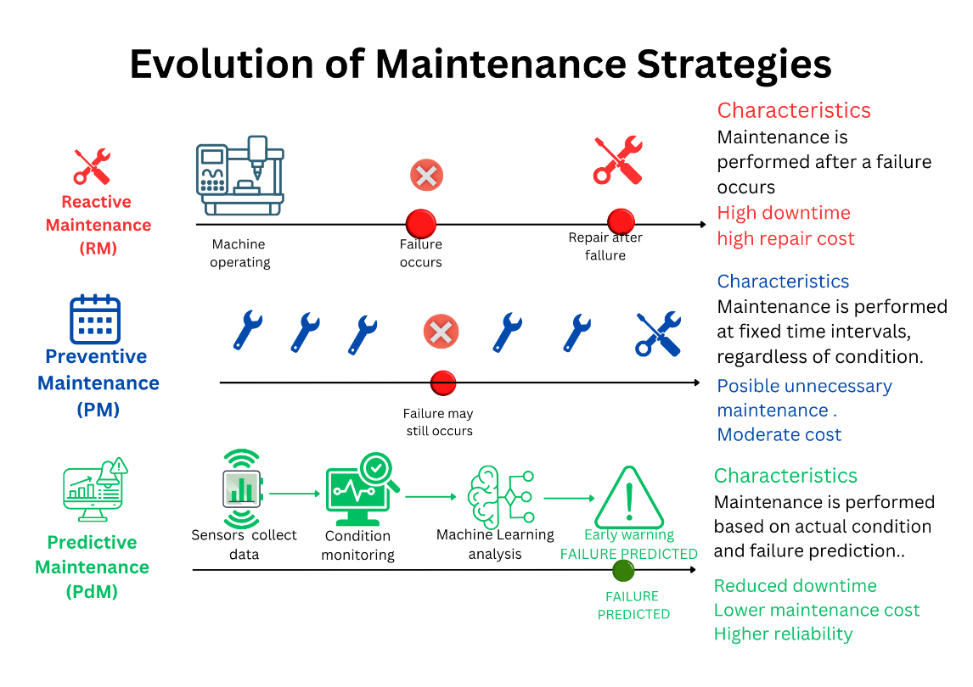
Figure 1. Comparison of Reactive, Preventive and Predictive Maintenance Strategies (author's adaptation based on [1]).

According to Çınar et al. [1], the increasing availability of industrial sensor data has accelerated the adoption of machine learning techniques in predictive maintenance systems. Data collected from sensors, including temperature, vibration, pressure and electrical measurements, can be analysed to identify patterns associated with equipment degradation and potential failures. Traditional machine learning algorithms such as Decision Trees, Random Forests, Support Vector Machines (SVM) and k-Nearest Neighbours (KNN) are commonly used because they provide reliable predictive performance while remaining relatively easy to implement and interpret [1], [2], [3]. These techniques enable organisations to identify early signs of equipment degradation and support proactive maintenance decision-making. Compared with deep learning approaches, traditional machine learning methods generally require less computational power, smaller datasets and shorter training times, making them particularly suitable for organisations operating under limited computational resources [1], [3]. Therefore, selecting an appropriate machine learning algorithm is essential to achieve a balance between prediction accuracy, model interpretability, and computational efficiency.

Analysis of Real Studies
The previous section established that traditional machine learning methods are suitable for predictive maintenance when organisations need accurate but computationally efficient models. This creates the need to examine empirical studies that compare algorithms not only by accuracy, but also by their suitability for real-time and resource-constrained industrial use.

Study 1: Comparison of machine learning methods in predictive maintenance of machines

Michał Cioch , Monika Kulisz , Arkadiusz Gola

To examine how traditional ML models perform in practice[4] provides a useful comparative study because they evaluate both predictive performance and computational efficiency.

Table 1.Summary of Cioch et al. [4] Predictive Maintenance Study
Aspect | Description
Study Objective | Compare traditional machine learning algorithms for predictive maintenance under limited computational resources
Dataset | 100,000 machine records (90,000 training, 10,000 testing)
Input Variables | Temperature, Vibration, Machine Condition
Algorithms Evaluated | Decision Tree, Neural Network, SVM, KNN, Naïve Bayes, Logistic Regression
Experimental Method | 5-fold cross-validation using the same dataset and evaluation framework for all models
Evaluation Metrics | Accuracy, F1-score, AUC, Confusion Matrix, Training Time, Prediction Speed, Model Size
Best Performing Model | Decision Tree
Key Results | Accuracy: 98.24%; F1-score: 98.24%; AUC: 0.9553
Computational Performance | Fastest training time, highest prediction speed, smallest model size (4.7 KB)
Main Limitations | Limited number of sensor variables; no specific industrial case study; no comparison with deep learning models
Industrial Relevance | Suitable for real-time predictive maintenance in resource-constrained manufacturing environments

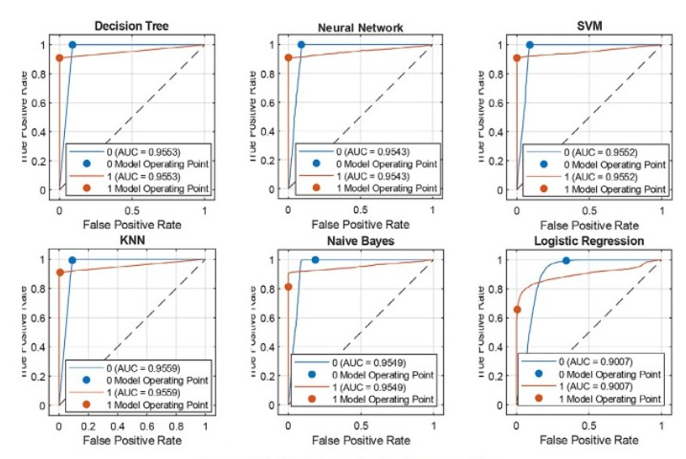
Figure 2.ROC curves for the machine learning models evaluated by Cioch et al. [4].
Figure 2 shows that most models achieved strong classification performance, with AUC values above 0.95. This means that Decision Tree, Neural Network, SVM, KNN, and Naïve Bayes were all able to distinguish effectively between machines requiring maintenance and machines operating normally. Logistic Regression achieved the lowest AUC value, suggesting a weaker ability to capture the relationship between sensor variables and maintenance needs.
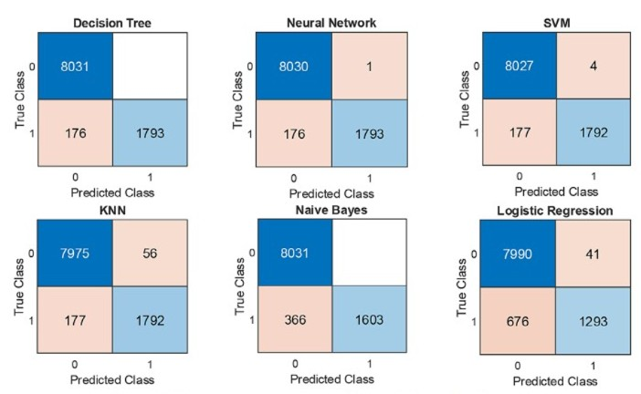
Figure 3.Confusion matrices for the models evaluated by Cioch et al. [4].
Figure 3 provides a more practical view of model performance by showing the types of errors each algorithm makes. For predictive maintenance, False Negatives are particularly important because they represent real maintenance needs that the model fails to detect. The Decision Tree produced no false positives and only 176 false negatives, while Logistic Regression produced 676 false negatives. This indicates that the Decision Tree was more reliable for identifying maintenance needs while avoiding unnecessary maintenance alerts.
The study demonstrates that model selection should not be based solely on accuracy. Although Neural Networks achieved similar predictive performance, the Decision Tree required significantly fewer computational resources. This finding is particularly important for manufacturing companies operating with limited processing power or real-time constraints. Furthermore, the study highlights the importance of considering practical factors such as training time, prediction speed, and model size when selecting a predictive maintenance solution. However, using only three sensor variables may not fully capture the complexity of real industrial environments, where machinery is often monitored with a much larger set of operational parameters.

Study 2: An intelligent predictive maintenance system based on random forest for addressing industrial conveyor belt challenges
Wu et al. (2024)
To further explore the practical use of machine learning in predictive maintenance, [5] developed an intelligent maintenance system for industrial conveyor belts. Unlike Cioch et al. [4], who focused on comparing algorithms using a standard dataset, Wu et al. evaluated machine learning models in a real industrial environment, with the aim of improving fault detection and maintenance decision-making.

Table 2.Summary of Wu et al. [5] Random Forest Predictive Maintenance Framework for Industrial Conveyor Belts
Aspect | Description
Study Objective | Develop an intelligent predictive maintenance system for industrial conveyor belts using machine learning techniques to reduce unexpected failures and improve maintenance planning.
Dataset | Industrial conveyor belt operational and condition monitoring data collected from equipment sensors.
Input Variables | Equipment condition indicators, operational parameters, monitoring and fault-related sensor measurements.
Algorithms Evaluated | Random Forest, Decision Tree, Logistic Regression, Neural Network, Gradient Boosting.
Experimental Method | Comparative evaluation of multiple machine learning models using the same dataset and performance assessment framework.
Evaluation Metrics | Accuracy, Precision, Recall, F1-score and overall predictive performance.
Best Performing Model | Random Forest.Random Forest.
Key Results | Random Forest achieved the most reliable overall performance and demonstrated strong capability in identifying conveyor belt faults.
Computational Performance | Moderate computational requirements while maintaining high predictive performance and robustness.
Main Limitations | Focused on conveyor belt systems only; results may not be directly generalisable to all industrial equipment types.
Industrial Relevance | Demonstrates successful real-world implementation of predictive maintenance in an industrial environment using sensor-based monitoring.

Table 2 summarises the main characteristics and findings of the study. Similar to [4], multiple machine learning algorithms were evaluated using the same experimental framework. However, the dataset used by Wu et al. consisted of operational and condition-monitoring data collected from industrial conveyor belt systems, making the study more representative of real-world maintenance challenges.
The results showed that Random Forest achieved the best overall performance among the evaluated models, demonstrating strong capability in identifying equipment faults from complex sensor data.
Compared with Study 1, Study 2 [5] reached a different conclusion regarding the most suitable algorithm. While Cioch et al. [4] recommended Decision Tree due to its high accuracy and low computational cost, Wu et al. found that Random Forest delivered better predictive performance in a real industrial environment. This suggests that algorithm selection depends on the application context, with Decision Trees being more suitable for resource-constrained environments and Random Forest offering greater robustness for complex industrial data.
A limitation of the study is its focus on conveyor belt systems, which may limit the applicability of the findings to other industrial equipment. Nevertheless, the research demonstrates the practical effectiveness of Random Forest in real-world predictive maintenance applications.

Study 3: Explainable Predictive Maintenance of Rotating Machines Using Explainable AI (2024)
Fernando Velasco-Loera
Fernando Velasco-Loera et al. (2024)
This study investigates the application of Explainable Artificial Intelligence (XAI) in predictive maintenance for industrial rotating machinery. While many predictive maintenance systems focus primarily on achieving high prediction accuracy, the authors argue that maintenance engineers also need to understand why a model predicts an upcoming failure. The research, therefore, combines machine learning techniques with explainability methods to improve both predictive performance and transparency in industrial decision-making.
Table 3.Summary of Study 3: Explainable Predictive Maintenance of Rotating Machines Using Explainable AI (2024)
Aspect | Description
Study Objective | Develop an explainable predictive maintenance framework capable of detecting machine faults while providing understandable explanations for maintenance engineers.
 | Sensor data collected from rotating industrial machinery, including condition monitoring measurements.
  Dataset
Input Variables | Vibration signals, temperature measurements, operational parameters and equipment condition indicators.
Algorithms Evaluated | Multiple machine learning models combined with Explainable AI techniques.
Experimental Method | Machine learning models were trained using sensor data and then analysed using explainability methods to identify the factors contributing to fault predictions.
Evaluation Metrics | Accuracy, predictive performance, interpretability and feature importance analysis.
Primary Approach | Explainable machine learning using XAI techniques (e.g., SHAP and LIME) applied to predictive maintenance models.
Key Results | The proposed approach successfully identified machine faults while highlighting the sensor variables that contributed most to each prediction.
Computational Performance | Moderate computational requirements suitable for industrial monitoring environments.
Main Limitations | Focused on rotating machinery and explainability; results may not directly transfer to other industrial systems.
Industrial Relevance | Demonstrates how explainable predictive maintenance can increase trust and support maintenance decision-making in real industrial environments.

Study 3 provides a different perspective from the previous two studies by focusing on model interpretability rather than only predictive accuracy. While Study 1 concluded that Decision Tree was the most suitable algorithm because of its high accuracy, compact model size and extremely low computational requirements, Study 3 argues that prediction performance alone may not be sufficient in industrial environments. Maintenance engineers often require explanations that justify maintenance decisions before taking corrective action.
Similarly, Study 2 identified Random Forest as the most reliable model due to its strong fault detection capability and robust predictive performance. Study 3 does not challenge the effectiveness of Random Forest but extends the discussion by highlighting the importance of understanding how predictions are generated. This is particularly relevant in safety-critical industrial environments where maintenance decisions may have significant operational and financial consequences.
Compared with Study 1, the findings suggest that Decision Trees offer a natural advantage in terms of explainability because their decision-making process can be visualised and interpreted directly. Compared with Study 2, the research supports the continued use of Random Forest while emphasising the need for additional explainability techniques to make ensemble models more transparent.
Overall, Study 3 contributes an important complementary perspective to predictive maintenance research. Rather than focusing solely on accuracy or computational efficiency, it demonstrates that trust, transparency and interpretability are becoming increasingly important factors when selecting machine learning solutions for industrial maintenance applications.

Comparative Analysis of the Three Studies
The three studies show that the most suitable machine learning algorithm for predictive maintenance depends on the industrial context and available resources. Study 1 identified Decision Tree as an effective solution for resource-constrained environments due to its high accuracy, fast prediction speed and low computational cost. Study 2 demonstrated that Random Forest achieved better performance when analysing more complex industrial sensor data, making it a robust option for real-world applications. Study 3 introduced a different perspective by highlighting the importance of model interpretability. The findings suggest that maintenance engineers benefit not only from accurate predictions but also from understanding the factors influencing those predictions.
Overall, the studies indicate that algorithm selection should balance predictive performance, computational efficiency and interpretability. Decision Trees offer simplicity and efficiency, Random Forest provides greater robustness, while explainable machine learning approaches improve transparency and support maintenance decision-making.

Implications for Industrial Applications

The reviewed studies suggest that no single algorithm is universally superior for all predictive maintenance applications. Although Random Forest demonstrated the strongest performance in a real industrial environment, its higher computational requirements may not be suitable for all organisations. In contrast, Decision Tree achieved comparable predictive performance while requiring significantly fewer computational resources, making it attractive for companies operating under hardware or budget constraints.
For the manufacturing company considered in this report, where limited computational resources are an important requirement, the findings of Study 1 [4] are particularly relevant. The study showed that a Decision Tree can provide high predictive accuracy while maintaining fast prediction speed and a very small model size. However, the results of Study 2 [5] also indicate that more complex models, such as Random Forest, may offer additional robustness when larger and more diverse sensor datasets become available.
Therefore, a Decision Tree model appears to provide the most appropriate balance between predictive performance, interpretability and computational efficiency for the client's current requirements. As the predictive maintenance system matures and more operational data becomes available, more advanced approaches such as Random Forest or explainable ensemble models could be considered. These findings are consistent with recent surveys that recommend selecting machine learning algorithms according to data characteristics, computational resources and industrial requirements [2], [3].

Comparative Analysis of Research Methodologies
Although the three studies investigate predictive maintenance using traditional machine learning, they adopt different research methodologies to address different industrial challenges. Figures 4 and 5 summarise the key methodological differences and explain why each research approach was selected.
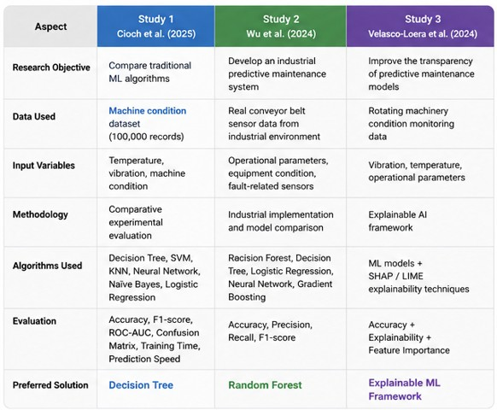
Figure 4. Comparison of the research methodologies adopted in the three predictive maintenance studies (author's synthesis based on [4], [5] and [6]).
Figure 4 compares the main characteristics of the three studies, including their research objectives, datasets, algorithms, evaluation methods and preferred solutions. Study 1 employs a comparative experimental methodology to identify the most computationally efficient algorithm under identical evaluation conditions. Study 2 focuses on implementing a predictive maintenance system in a real industrial environment, while Study 3 extends the analysis by incorporating explainable artificial intelligence techniques to enhance the transparency of maintenance predictions.
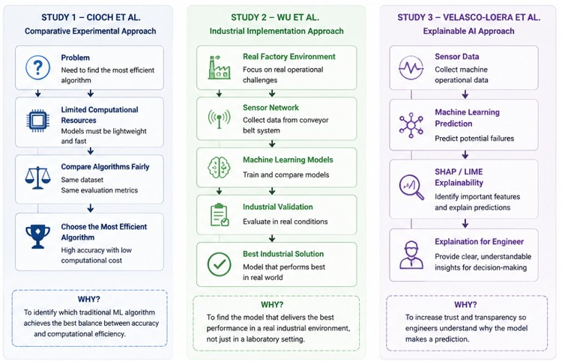
Figure 5. Methodological approaches and research objectives of the three predictive maintenance studies (author's synthesis based on [4], [5] and [6]).
Figure 5 illustrates the methodological workflow adopted in each study. Although all three studies use sensor data and machine learning models, they differ in their primary objectives. Study 1 aims to compare algorithms fairly using the same dataset and evaluation metrics. Study 2 validates machine learning performance in an operational manufacturing environment, providing stronger industrial evidence. Study 3 emphasises model interpretability, enabling maintenance engineers to understand the reasons behind failure predictions rather than relying solely on prediction accuracy.
Overall, the comparison demonstrates that predictive maintenance should not focus exclusively on selecting the most accurate algorithm. Instead, an effective industrial solution should balance predictive performance, computational efficiency, practical applicability and model interpretability. These findings provide the foundation for the proposed workflow and algorithm recommendation presented in the next section.

Proposed workflow methodology

Based on the literature review and comparative analysis, this section proposes a predictive maintenance workflow tailored to the client's requirements. The proposed workflow follows the general stages of predictive maintenance systems described in recent review studies, including data collection, data preparation, model development, evaluation and maintenance decision-making [7]. It integrates the key findings of the reviewed studies into a practical framework while addressing the company's limited computational resources. Figure 6 presents the proposed workflow, which aims to achieve an effective balance between prediction accuracy, model interpretability and computational efficiency.

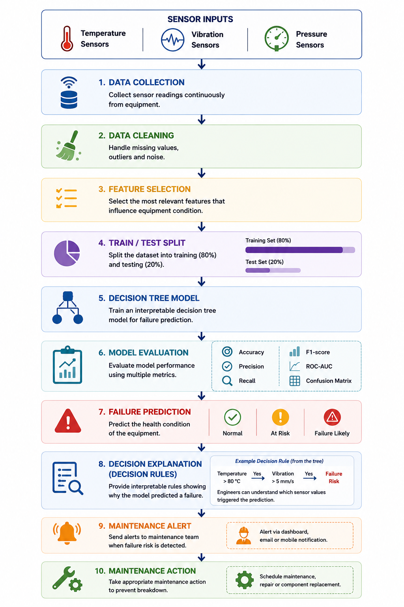
Figure 6.Proposed predictive maintenance workflow for the manufacturing company (author's design).
Figure 6 presents the proposed predictive maintenance workflow for the manufacturing company. The workflow follows the general stages of predictive maintenance systems described in recent review studies, including data collection, data preparation, model development, evaluation and maintenance decision-making [7]. It also integrates the key findings of the reviewed studies [4]-[6] into a practical framework tailored to the client's operational requirements. By using a Decision Tree model, the workflow provides clear decision rules that allow maintenance engineers to understand why a potential equipment failure has been predicted. This supports faster and more confident maintenance decisions without requiring additional explainability techniques.

Data Preparation

Before developing the predictive maintenance model, the collected sensor data must be prepared to ensure reliable predictions. The manufacturing company collects measurements from temperature, vibration, and pressure sensors, which provide information about the operating condition of the equipment. During data preparation, missing values, duplicate records, and noisy sensor readings should be identified and removed to improve data quality. If the sensor measurements have different scales, the data should be normalised to ensure consistent model training. Finally, the prepared dataset is divided into training and testing sets before being used to develop the Decision Tree model [2], [4].

Recommended Algorithm

Based on the literature review and comparative analysis, a Decision Tree is recommended as the most appropriate algorithm for the manufacturing company. This recommendation is supported by the findings presented in the reviewed studies [4]-[6].Although Random Forest demonstrated greater robustness in more complex industrial environments, the reviewed studies showed that Decision Trees provide an excellent balance between predictive performance, computational efficiency and interpretability. The algorithm achieves high prediction accuracy while requiring minimal computational resources, making it suitable for organisations operating with limited hardware capacity. In addition, the tree structure allows maintenance engineers to understand the decision rules behind each prediction, increasing confidence in the model and supporting faster maintenance decisions. For these reasons, the Decision Tree is considered the most appropriate solution for the client's current operational requirements. Presented in Figure 7.
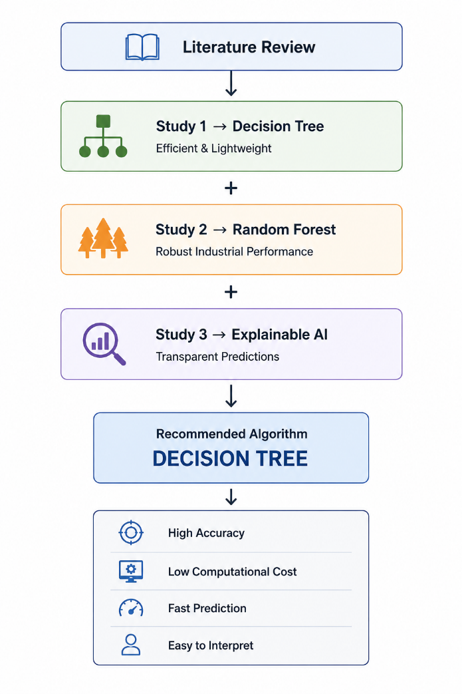
Figure 7.Selection of the Recommended Predictive Maintenance Algorithm (author's synthesis).

Model Evaluation
The proposed Decision Tree model should be evaluated using a combination of performance metrics to ensure accurate and reliable failure prediction. As shown in Table 4.
Table 4.Recommended Evaluation Metrics
Metric | Purpose
Accuracy | Overall prediction performance
Precision | Reduce unnecessary maintenance
Recall | Detect actual failures
F1-score
  Balance Precision and Recall
ROC-AUC | Classification capability
Confusion Matrix | Analyse prediction errors
Prediction Speed | Real-time suitability

The selected metrics are widely recommended for assessing predictive maintenance models and provide a comprehensive evaluation of predictive performance, reliability and practical applicability in industrial environments [2], [3], [8]. Accuracy provides an overall measure of prediction performance, while Precision and Recall evaluate the model's ability to identify equipment failures and minimise unnecessary maintenance actions. The F1-score balances Precision and Recall, making it particularly useful when both missed failures and false alarms are important. In addition, ROC-AUC and the Confusion Matrix provide further insight into the model's classification capability and prediction errors. Prediction speed should also be considered to ensure that the model is suitable for real-time industrial applications.
Among these metrics, Recall is considered particularly important because failing to detect a real equipment fault (False Negative) may lead to unexpected downtime and increased maintenance costs.

Justification of the Recommendation
The proposed methodology is designed to meet the client's current operational needs while allowing future system development. Rather than selecting the most complex machine learning model, the recommendation focuses on delivering a practical solution that can be implemented using the company's existing sensor infrastructure and available computational resources. This approach provides a reliable foundation for predictive maintenance while allowing more advanced models, such as Random Forest, to be considered as the volume and complexity of operational data increase.
Future System Development
As the company collects additional sensor measurements, larger volumes of historical failure data and gains access to greater computational resources, the predictive maintenance system can be further enhanced. More advanced ensemble models, such as Random Forest, and Explainable AI techniques may be integrated to improve predictive robustness and model transparency [5], [6]. Recent review studies also highlight the growing importance of scalable predictive maintenance systems and Remaining Useful Life (RUL) prediction as industrial datasets become larger and more complex, enabling more accurate maintenance planning and decision-making [8], [9].

Conclusion
For the manufacturing company considered in this report, implementing a predictive maintenance system does not require the most complex machine learning solution. The evidence reviewed suggests that a practical, interpretable and computationally efficient model can provide reliable failure prediction while remaining suitable for the company's existing hardware and operational requirements.
The proposed Decision Tree workflow offers a realistic starting point for introducing predictive maintenance with minimal computational cost and straightforward implementation. At the same time, the proposed methodology provides a flexible foundation that can be expanded as the organisation's data capabilities mature. Future developments may include additional sensor measurements, Remaining Useful Life prediction and more advanced explainable machine learning techniques to further improve maintenance planning and operational efficiency [8]-[10].

References

[1]Z. M. Çınar, A. A. Nuhu, Q. Zeeshan, O. Korhan, M. Asmael, and B. Safaei, “Machine Learning in Predictive Maintenance towards Sustainable Smart Manufacturing in Industry 4.0,” Sustainability, vol. 12, no. 19, p. 8211, Oct. 2020, doi: https://doi.org/10.3390/su12198211.
[2] T. Zhu, Y. Ran, X. Zhou, and Y. Wen, “A Survey of Predictive Maintenance: Systems, Purposes and Approaches,” arXiv preprint arXiv:1912.07383, Dec. 2019. [Online]. Available: https://arxiv.org/abs/1912.07383. [Accessed: 23-Jun-2026]
[3] I. Hector and R. Panjanathan, “Predictive maintenance in Industry 4.0: a survey of planning models and machine learning techniques,” PeerJ Computer Science, vol. 10, p. e2016, May 2024, doi: https://doi.org/10.7717/peerj-cs.2016.
[4] M. Cioch, M. Kulisz, and A. Gola, “Comparison of machine learning methods in predictive maintenance of machines,” Advances in Science and Technology Research Journal, vol. 19, no. 11, pp. 33–44, Nov. 2025, doi: https://doi.org/10.12913/22998624/208284.
[5] M. Wu et al., “An intelligent predictive maintenance system based on random forest for addressing industrial conveyor belt challenges,” Frontiers in Mechanical Engineering, vol. 10, Dec. 2024, doi: https://doi.org/10.3389/fmech.2024.1383202.
[6] F. Velasco-Loera, Mildreth Alcaraz-Mejia, and J. L. Chavez-Hurtado, “An Interpretable Hybrid Fault Prediction Framework Using XGBoost and a Probabilistic Graphical Model for Predictive Maintenance: A Case Study in Textile Manufacturing,” Applied Sciences, vol. 15, no. 18, pp. 10164–10164, Sep. 2025, doi: https://doi.org/10.3390/app151810164.
[7] J. Garcia, L. Rios-Colque, A. Peña, and L. Rojas, “Condition Monitoring and Predictive Maintenance in Industrial Equipment: An NLP-Assisted Review of Signal Processing, Hybrid Models, and Implementation Challenges,” Applied Sciences, vol. 15, no. 10, pp. 5465–5465, May 2025, doi: https://doi.org/10.3390/app15105465.
[8] Somayeh Bakhtiari Ramezani et al., “Scalability, Explainability and Performance of Data-Driven Algorithms in Predicting the Remaining Useful Life: A Comprehensive Review,” IEEE Access, vol. 11, pp. 41741–41769, Jan. 2023, doi: https://doi.org/10.1109/access.2023.3267960.
‌[9] JDMD Editorial Office, Nagi Gebraeel, Y. Lei, N. Li, X. Si, and Enrico Zio, “Prognostics and Remaining Useful Life Prediction of Machinery: Advances, Opportunities and Challenges,” Feb. 2023, doi: https://doi.org/10.37965/jdmd.2023.148.
[10] Bernar Taşcı, A. Omar, and Serkan Ayvaz, “Remaining useful lifetime prediction for predictive maintenance in manufacturing,” Computers & Industrial Engineering, vol. 184, pp. 109566–109566, Oct. 2023, doi: https://doi.org/10.1016/j.cie.2023.109566.
‌

