

Programme: Computer Networks and Cyber Security
Module: Data Security, Governance and Compliance
Module code: ACCA7028
Lecturer: Assoc. Prof. Carlene Campbell

Student ID：2106260
Student Name：Hairong Lyu

Research on the Information Technology Security Risk Framework Model

Abstract
The arrival of the big data Internet era has brought great risks and tests to information technology. This paper first analyzes the current threat sources of information technology, and puts forward the information technology security framework model for the specific information security problems faced by the Blue Coffee Company, so as to further optimize the company's information technology means, so that the information technology can better create benefits for the company.

Key words: information technology; security risk; information security

Introduction
In recent years, with the deepening of the computer Internet and the deepening application of big data, artificial intelligence, the Internet of Things and other technologies, information security problems have become increasingly serious, which to a large extent brings risks, such as file secrets, intellectual property rights and user privacy leakage, to the government and enterprises.Big data information technology security has become a stumbling block in its development process. An effective information technology security framework model can help organizations get rid of security problems, and efficiently and safely use big data and network technology.

- Information technology security risk threat
The current security risks in the field of information technology include two major aspects: security risks caused by the internal environment of the organization with information technology, and security risk factors that the external environment is not within the control of its own organization.

Among them, the information security problems in the internal environment of the organization mainly focus on three aspects, including: infrastructure construction, data management, and technical loopholes. Information security problems in the organizational external environment are mainly focused on external invasion. Each of the above aspects can be subdivided into several sub-aspects that together constitute the framework of the information technology security risks in this paper, as shown in Figure 1.
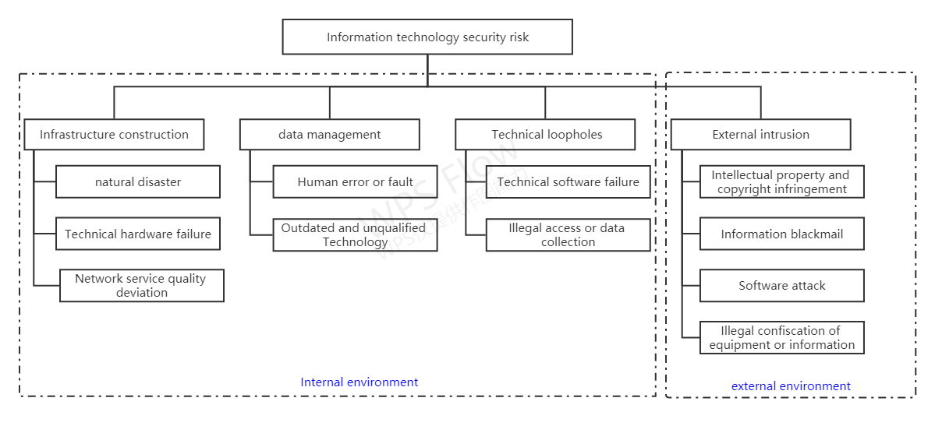
Fig1. Information Technology Security Risk Framework
  - Internal environment
The information technology security threat caused by the internal environment is caused by the organization's own construction of the information technology environment, the poor internal data and information management, and the technical vulnerability risk, etc., which can be effectively prevented and controlled by strengthening the self-construction management system. Among them, the information technology security problems of the organization's internal environment can be divided into three categories: infrastructure construction, data and information management, and technical loopholes.

    - Infrastructure construction.
Infrastructure construction convenience mainly refers to the information technology security risk caused by the damage and aging of organizational infrastructure such as technical hardware or network services. These include defense against natural disasters, technical hardware failures or errors, and Internet Service Providers (ISP), power, and WAN service issues.

- Natural disasters. Natural disasters here mainly refer to earthquakes, typhoons, fires, and floods. Because the collected data is usually stored in the organization's server, once the aforementioned natural disaster occurs, it is likely to cause damage to the server, which results in the loss of data. Or, due to the uncontrollable factors such as the power failure, it will lead to the sudden interruption of the line during the data transmission process, which will also cause the loss of the data and affect the safety of the data.
- Network hardware. Firstly, due to the explosive growth of data volume, the existing hardware devices and storage environment can no longer meet the storage needs of massive data. Secondly, aging hardware or slow Internet speed can also affect the transmission speed of data transmission. Therefore, in the process of data transmission, once the transmission rate is reduced due to the function lag or aging of the hardware device, the network delay may lead to the collapse of the system, and then result in the loss and leakage of the data, and threaten the security of the data.
- Internet service providers. One important task of internet service providers is to establish a data service system, collect, process and store information, regularly maintain and update it, and provide information content services to users through the network. Based on the background of big data technology, each information and data depends on Internet services.

    - Data and information management
Information security problems in data and information management mainly refer to the risks of data leakage and system damage caused by poor management in the process of managing information resources and data.For example: human error or failure, technology is outdated or unqualified, damage to the system or information.

- Operate miss. No matter how experienced data managers are, they may operate improperly. In the process of operation, there may be a mischange of the parameters affecting the normal operation of the system, or misdelete the important documents of the system, or do not operate according to the prescribed requirements, resulting in the system outage. Especially in the face of massive data and very complex operating systems, the probability of operational errors will be greatly increased. The above operation errors will threaten the integrity and security of the data.
- The technology is outdated or unqualified. Organizational information security technology is outdated, and it also provides an organic opportunity for hackers, which not only has the risk of information and data being stolen, but also may lead to the destruction of the entire system or information and data. The whole process of technology use, it is a process of constant game between technicians and hackers, and information security technology will continue to progress with the process of the cycle.

    - Technical vulnerabilities
The data and information security problem at the level of technical vulnerabilities mainly refers to the non-linear growth of users and data, and the existing information security technology has been difficult to ensure the absolute security of massive data, resulting in the increased security risk of data.Mainly technical software failure or error failure, unauthorized access, and data acquisition.

- Technical software failure or error fault. Now the software emerge a variety, but people demand for information processing speed is much faster than software update and new software development, information is a variety of, software development group can not be for every user to develop specialized software, software in the process of use may also be wrong, this reason, also because of the defects of the software itself. For example, when using the software may accidentally delete some software internal files, and paralyze the software; sometimes the software will produce a bug in use, making the soft operation stop, unable to complete the specified task. The software runs stably to process the information better and more accurately, which is what we need.
- Unauthorized access and data acquisition. Unauthorized access or data acquisition here mainly covers access or collects information from a technical defect in organizational technology. Update security patches or upgrading the technology stack can further reduce the risk of information technology attacks.

  - External environment
The information technology security threat caused by the external environment is caused by the illegal infringement of the organization's information technology and data assets by individuals or organizations outside the organization, and the threat comes from outside the organization. Information technology security in an organizational external environment is an external intrusion.

    - External invasion
External hacker intrusion attacks will further aggravate the information security risks in the big data environment. First of all, due to the huge number of big data information resources and the huge value contained, its own existence is a huge temptation for criminals and other network hackers. Second, in the Internet environment, data in big data mode is more likely to detect and to be attacked. Typical acts include intellectual property rights, copyright infringement; information extortion, software attack, illegal confiscation of equipment or information.
- The Information Technology Security Framework
CoffeeBlue is a company which is selling Blue Mountain Peak coffee from Jamaica and is the most popular coffee supplier. The company's network is wireless, and the cloud services to complete its online trades and social media businesses. As employee data and customer data grow larger, the company faces huge information security pressure, mainly including the huge number of employees and customers accessing the company's network and resources, and the lack of billions of dollars in intellectual property protection, and the established dollar policies to meet the company's security needs. In this regard, a set of information technology security framework model ( see Figure 2) is designed to solve the information technology security problems faced by the company.
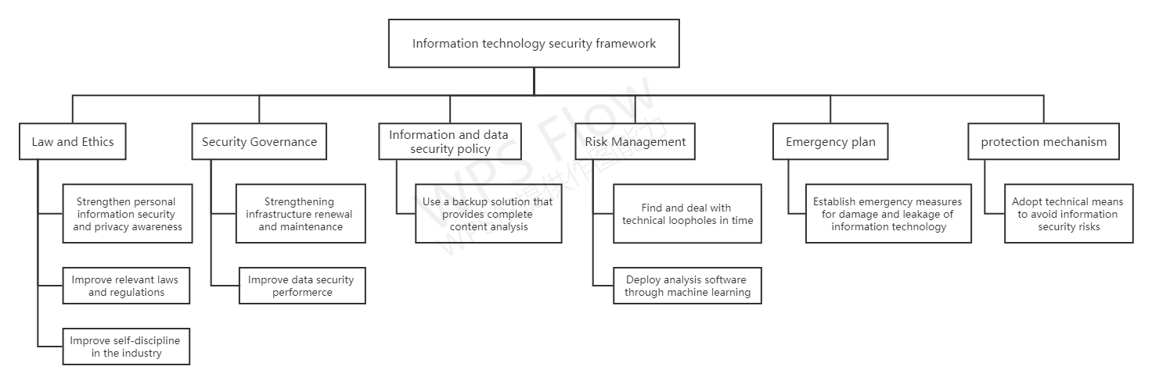
Fig 2. Information Technology Security Framework model
  - Law and the code of ethics
In terms of the legitimacy of information technology, it mainly covers three aspects, namely improving relevant laws and regulations, improving self-discipline in the industry, and strengthening the awareness of personal information security and privacy.

    - Improve relevant laws and regulations
Setting up strict management measures and laws and regulations to forcibly protect users' privacy data is also an essential way. Most of the existing laws and regulations have problems such as too principle, insufficient specificity, and poor operability to give strong protection to the data. Therefore, it is necessary to improve the existing laws and regulations, and improve their specificity and operability. Specific improvements can be made from the following aspects.

- Additional protection is given to specific types of privacy data. For instance, in Europe, sensitive people's data can only be processed in very special situations (sensitive data including race data, political life data, etc.);
- Control the collection of data specific. For example, the European Union has introduced special laws to limit the collection of coke and location data;
- Limit the use of the data unless authorized;
- Appropriate checks and balances are adopted for automatic decision-making technology, so as to limit their infringement of user privacy data.

    - Improve the self-discipline in the industry
As the holder of information technology and data resources, the organization has the responsibility and obligation to consciously protect the security of data and technology, and improve its own self-discipline. Specific performance is the following two aspects.

- Establish strict information security protection measures. At the organizational level, access rights should be set to limit the number of members who can access the data. This helps to prevent technology and data leakage. On the other hand, it also helps to hold the technology accountable and find the source of the leak. From the perspective of the partners and members of the organization, they should strictly abide by the information security policies formulated by the organization, standardize the data operation behavior, avoid the data leakage caused by improper operation, and ensure that the data should not be sold for their own interests to ensure the safety of the data.
- Specify the technical data processing. When processing the data, the organization should take full account the privacy security of users, and try to reduce the risk of identifying the user identity. There are two ways to address this problem: 1 to delete sensitive data about users, such as their gender, age, and preferences; 2 to conduct massive aggregation of data. Converting typical data into atypical data to reduce the risk of users being identified.

    - Strengthen the awareness of personal information security and privacy
In the era of big data, the widespread use of social networks has led to the lack of awareness of information security. The leakage of user privacy is not only related to hacker attacks and merchants reselling user information, but also directly related to the personal unprotection and inaction of their own privacy. It can be seen that the protection of big data and information security cannot be separated from the cultivation of personal information security awareness. Therefore, it is necessary to strengthen the public publicity and education, make it realize the importance of protecting privacy information and become the consciousness of the whole society, make individuals realize the importance of privacy security in daily life, not random private information to others to browse unsafe websites is not registered on the Internet containing private information letters should be destroyed after discarded to some institutions draw small gifts but need to use real-name registration activities should be strictly screened after participation. In addition, once they find that their private information is leaked, they should report to the police immediately. According to the relevant provisions of network information protection, the relevant competent authorities should investigate and deal with them after receiving the report, and the infringed can also file a lawsuit according to law.

  - Safety governance
For information security governance, it is recommended to strengthen infrastructure update and maintenance and improve data security performance.
    - Strengthen infrastructure renewal and maintenance
Infrastructure plays a vital role in the information security of big data. Once the infrastructure is faulty or damaged, it can easily cause the loss or leakage of information. Therefore, the organization should strengthen the construction of infrastructure, mainly refers to the hardware and network level, timely update and maintenance of hardware equipment. Organize the regular inspection, update and maintenance of the hardware equipment and the network lines, so as to prevent the data loss and leakage caused by the aging and other problems of the equipment.

    - Improve data security performance
Big data information security problems at the level of data privacy mainly refers to the possible risk of user privacy leakage in the analysis and processing of big data. It specifically includes two aspects: the data combination and the analysis technology of big data.

- Data combination. Combination of data will seriously violate the security and privacy of personal information. Combine data from multiple data pools. This is due to the difficult ability to infer the identity of a user from single lines of data, but when a combined analysis of multiple data, the probability of inferred user identity features will be greatly increased.

In March 2012, Google revised its privacy policy to allow the integration of relevant data from all of its services to build a more refined personal record for its users to improve the accuracy of its advertising campaigns.But Google's move drew a quick response from privacy regulators, with CNL noting that it would try to "regulate" Google's actions if it did not properly address its privacy issue.

- Analytic technique. When people use big data analysis technology to analyze and mine massive data, this behavior itself poses a threat to users 'information security and infringes on users' privacy. For example, network analysis can expose users' social and working relationships; semantic analysis can infer user attitudes, opinions, or ideas; cluster analysis clusters users according to some similarity to discover the group of users, etc. This behavior has actually violated the privacy of users and threatened their privacy security.

  - Information and data security policies
    - Use a backup solution that provides complete content analysis
Today's backup solutions often have some level of content analysis capabilities and claim the ability to identify if any data has been corrupted. However, these applications have limitations, where the main function is that they can only scan for metadata and basic information about a file or database (for example, the creation date or location). Other applications generally use metadata analysis, and if the possible corrupted data is found, they will analyze the contents of the file.While this is better, there are still flaws and may miss more advanced attacks. Perhaps more importantly, this may provide a false sense of security. A better solution is to perform a comprehensive content-based analysis scan from the start that not only verifies the integrity of the data, but also enables the organization to discover and eliminate complex hidden attacks.

  - Risk control
Two important risk control means for handling technical vulnerabilities through machine learning deployment and analysis software and technical discovery to prevent risk loss accidents from the root.

    - Deploying the analysis software through machine learning
Cybercriminals can use machine learning to leverage their strengths, and organizations should do so. Most cybercriminals are constantly changing ways to infect and attack organizational operations in new ways, and discover new vulnerabilities. And well-funded and organized cyberattackers who redesign their tactics using advanced technology are no longer a loosely connected group of opportunists. Analysis software containing AI and machine learning capabilities can detect patterns and predict changes that humans cannot predict.

    - Timely find and deal with technical vulnerabilities
Big data information security at the level of technical vulnerabilities mainly refers to the non-linear growth of data, the existing information security technology has been difficult to ensure the absolute security of massive data, resulting in the increased security risk of data. It specifically includes safety protection and real-time monitoring.

The explosion of data for the existing security technology, which leads to the update of security technology has failed to keep up with the pace of data nonlinear growth, increase security protection measures from the source, take the initiative to repair big data security vulnerabilities, do not give network hackers and criminals to take the opportunity.

A study by Mc Afee, a well-known cybersecurity technology firm, shows that only 35 percent of companies with big data have the ability to monitor security vulnerabilities in their data in minutes, while 22 percent need a day to monitor that another 5% need a week to monitor them. On average, it takes 10 hours for each enterprise to monitor the security risks of the data. In addition to increasing security protection measures, improving the existing real-time monitoring technology, and conducting a full range of real-time monitoring of the data, which also greatly reduces the information security risk leading to the data.

  - Emergency plan
    - Establish emergency measures for information technology damage and leakage
Establish an emergency plan for information technology damage and leakage, and formulate emergency measures. The organization shall develop a series of emergency response measures, so that the safety and effective operation of the infrastructure can effectively ensure the safety of the technology.

  - Protection mechanism
    - Use technical means to avoid information security risks
This is a crucial means of information technology security protection in the era of big data, which mainly includes security protection and real-time monitoring. The main function of security protection technology is to protect data security and prevent data from network attacks such as firewall technology; real-time monitoring technology is to detect the system vulnerabilities and hacker data as quickly as possible.Current real-time monitoring technology is difficult to quickly identify security risks, therefore, the existing real-time monitoring technology should be improved to ensure the information security of the data. In addition, the user feature information in the hidden data, such as the data release anonymous protection technology and the digital watermark technology 24, should be comprehensively used to protect the user privacy.

- conclusion
To sum up, in the face of information technology security risks in the big data environment, caffeine should respond from the following aspects: legal and ethics, security governance, information data security policies, risk control, emergency plan and protection mechanism.

Reference:
- Huang Guobin, Zheng Lin. Research on Big Data Information Security Risk Framework and Response Strategy [J]. Library Science Studies, 2015(13):24-29. DOI:10.15941/j.cnki.issn1001-0424.2015.13.005.
- Zhang Xiaowei. Research on Big Data Information Security Risk Framework and Response Strategy [J]. Computer Knowledge and Technology, 2021, 17(27):42-43+61. DOI:10.14004/j.cnki.ckt. 2021.2694.
- Jiang Baoyu. Big Data Information Security Risk Framework and Response Strategy Analysis [J]. China New Communications, 2020,22 (01): 103.
- Chen Zhen. Research on Big Data Information Security Risk Framework Construction [J]. Information and Computer (Theory Edition), 2018 (19): 192-193.

