BSc Cloud Computing
Data Analysis and Visualisation

Data Description

BBC UK has provided covid-10 infection rate between white people and BAME, all the infected patients have ages in between 20 to 100 years. The dataset has been taken from UCI
The dataset contains following attributes [1]:

Attribute | Type | Description
Name
Patient No | Nominal | Patient Id, number
White Patient | Nominal | Age of White people
BAME | Nominal | Age of black people

- ​​Data Storage and Wrangling

Initial loading and inspection of datasets exposed some challenges in it for our study.

We wrangled the data to make it fit for our analysis. Google Colab is used for these tasks, google colab is an outstanding cloud based IDE python notebook.
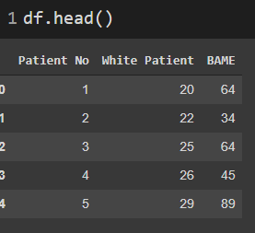
The link is mentioned in the assignment for downloading a dataset. After downloading the dataset, I uploaded it on google drive and mounted that drive to google Colab respectively [2].

Columns have no null values
df.dropna()
Each Patient No should be linked to a single White Patient. So we tried using White Patient and BAME linkage to fill missing values. As we could not find the linkage, we dropped the null values. Deleting missing Patient No removed all missing Description rows too [2].

Then we checked the values of the unique df.nunique() pandas function in python.
Each Patient No should uniquely represent an item Description. But the original dataset has multiple Descriptions for the same Patient No. This is because there are data entry errors in the description as shown below

- Descriptive Analysis
We have dropped the Patient No column from the dataframe as we converted it from dataset file xlsx.

3.1 Summary of Descriptive Analysis

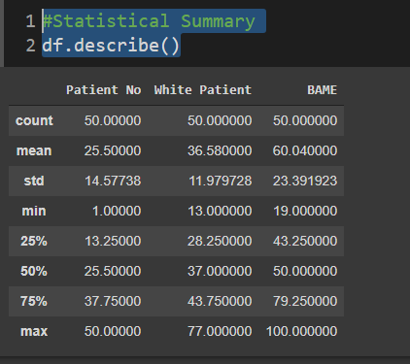

Observations:

- There are some minimum values for White Patient and BAME. We drop these observations [3].
- The maximum value for White Patient and BAME is very high, so we should do outlier analysis to remove the outliers.

3.2 Outlier Analysis
We used statistical graphs (BOXPLOT) to identify outliers from White Patient and BAME and dropped the observations which are more than 3 standard deviations away. This is how the summary statistics looks after removing outliers.
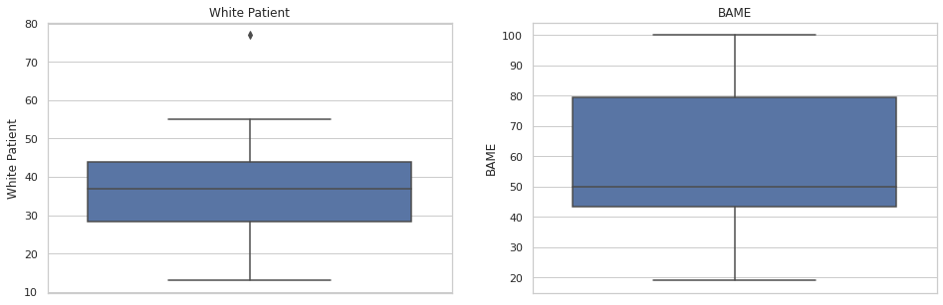

Interquartile range used for? The iqr is utilized to allot how spread the
data focuses in a set are from the mean of the data set. The higher the iqr, the more fanned out the data focuses; conversely, the more modest the iqr, the more bundled up the information focuses are around the mean [4].
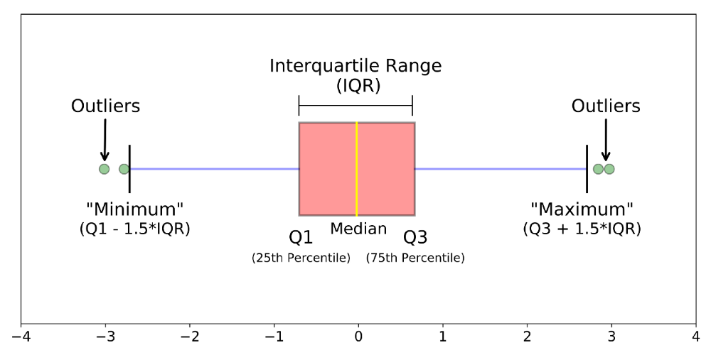
Outlier has been removed using interquartile technique, Above image for understanding of structure of boxplot.
#finding a IQR
Q1 = df.price.quantile(0.25)
Q3 = df.price.quantile(0.75)
IQR = Q3-Q1
lower_b =Q1-1.5*IQR
upper_b =Q3+1.5*IQR

For searching and checking the outliers values, pandas allows us to use query like this
dfx= df[(df['White Patient']>lower_b) & (df[' White Patient ']<upper_b)] [4]

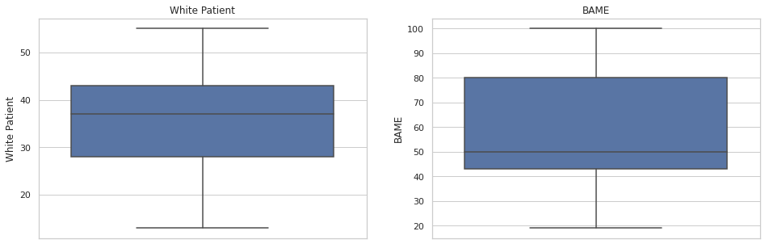

3.3 Data Exploration
Covid infection age of White and Bame people
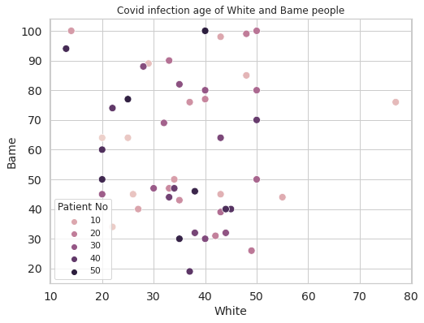

Scatter plot represents the distribution of two variables White Patient and BAME
There is no relationship between these two variables; the points are not aligned and not nearer [5].

White people infected by Covid-19

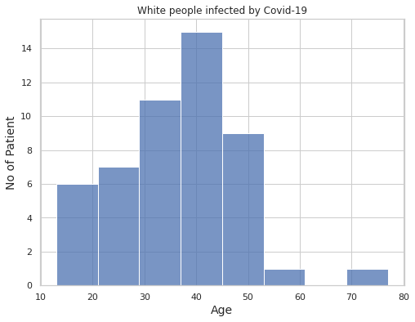

Left side represents no of patients (frequency) in particular ages. Data is aligned and centered but the right of data represents one sign alone bar of 70-80 that might be an outlier. We need to work on the outliers analysis phase. Otherwise data distribution looks good and balanced.

BAME people infected by Covid-19

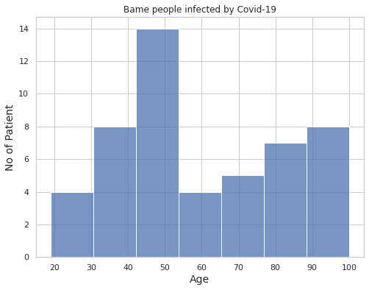
Left side represents no of patients (frequency) in particular ages. Data is aligned and is not centered but the centered of data represents some few more values alone in the bar of 40-50 that might be an outlier. We need to work on the outliers analysis phase. Otherwise data distribution looks good and balanced [5].
7
Number of BAME people infected by Covid-19

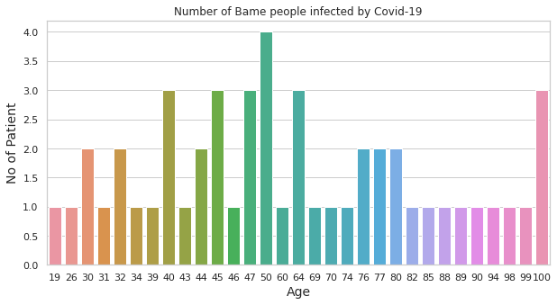
Here we have used a count plot for individual counting and numbers occurrence. This plot explains bame people become infected age. 50 is the most common age in white people. 40, 44, 47, 64, 100 are second most occurrence values [6].

Number of White people infected by Covid-19

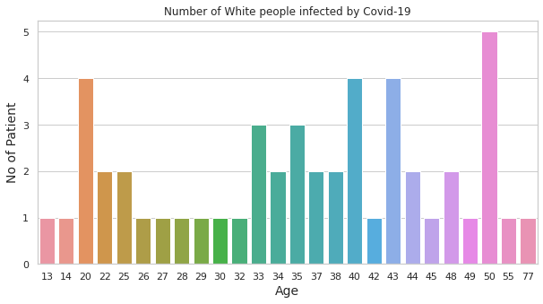
Here we have used a count plot for individual counting and numbers occurrence. This plot explains White people's infected age. 50 is the most common age in white people. 20, 40, 43, are the second most occurrence values.

Comparison between white and bame. Ages of White and Bame peoples

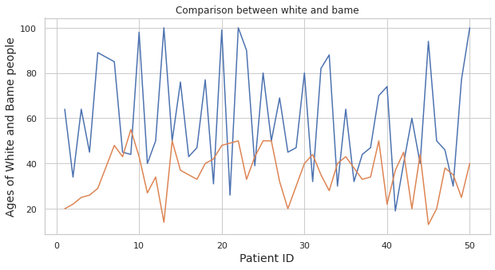
The lineplot represents comparisons of white and bame people infected ages.

Correlation between features – Heatmaps
Correlation between White and BAME people

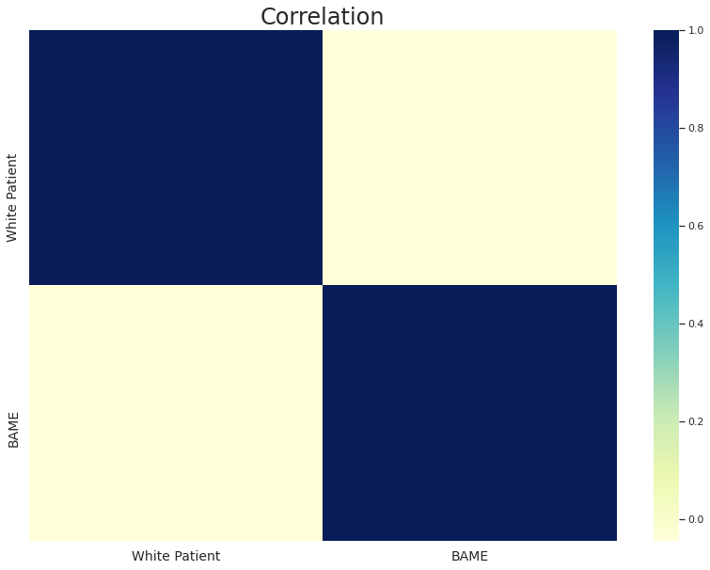
6

There is no such relationship between these two variables as seen above.

What do you mean by t-Test?
The T-TEST looks at two methods and advises in case there is a huge distinction between them, if the outcomes are repeatable for a whole populace and tells the likelihood of those outcomes occurring by some coincidence [6].
For example:- H0: The Covid-19 effect on White and Bame people are not equal i.e., μ1 ≠ μ2
H1:- The Covid-19 effect on White and Bame people are equal i.e., μ1 = μ2

What is the hypothesis? How to develop null and alternative hypotheses?

Hypothesis (theory) is a presumption about a populace boundary. This suspicion can or cannot be valid. For example, H0: The Covid-19 effect on White and Bame people are not equal i.e., μ1 ≠ μ2
H1:- The Covid-19 effect on White and Bame people are equal i.e., μ1 = μ2. So we are going to take the understanding and interpretation of p_value level of significance so we can decide that the hypothesis is true or false, so we will find infection of people rate. A specialist may direct a factual investigation to test the legitimacy of this hypothesis.

The null hypothesis is a run of the mill factual hypothesis which recommends that no measurable relationship and importance exists in a bunch of given single noticed variables, between two arrangements of noticed information and estimated wonders.

Alternative hypothesis is the opposite and different side of null, if null hypothesis says its bad mango then definitely this will say its not a bad mango. It's new that a person can have this.

Testable hypotheses for given data.
Hypotheses
H0: The Covid-19 effect on White and Bame people are not equal i.e., μ1 ≠ μ2
H1:The Covid-19 effect on White and Bame people are equal i.e., μ1 = μ2
H0: The Covid-19 white people has weaker immune system than Bame people i.e., μ1 < μ2
H1:The Covid-19 white people has not weaker immune system than Bame people i.e., μ1 > μ2
H0: White people has more death rate than Bame people i.e., μ1 > μ2
H1:Bame people has more death rate than white people i.e., μ1 > μ2
To check the truthfulness of the data and testing hypotheses on the following p values= 0.10, 0.02, 0.01.
Python coding in google colab has been used.
Libraries.
1. Numpy: Numerical computing and arrays facilitate advanced mathematics, providing data types conversion to matrix arrays.
2. Pandas: Data cleaning and wrangling, reshaping, selecting data, importing data from various file sql, json, excel, csv and many more. This library is used for preprocessing the data and transforming it into a data frame 2d array.
3. Seaborn: Provide attractive graphs and representation of data.
4. Matplotlib: Open source of MATLAB, data visualization and graphical plotting library and also supports every graphical library.
5. Scipy: Scientific and mathematical problems are used to solve by Scipy, this is made on the numpy library and allows the user to handle and visualize data [7].

The code of T test hypothesis is in the google colab ipynb file, it's attached with a report.
Here is explaining main decision making code
if p_value<=0.01 or p_value<=0.02 or p_value<=0.10
We have rejected the null hypotheses.
else
We accepted alternative hypotheses.
Because in calculation using Scipy library the python code provides p_value = 0.0000 on the given data.
Results conclusion of hypotheses after programming calculations.
1. Hypothesis
H0: The Covid-19 effect on White and Bame people are equal i.e., μ1 = μ2.
H1: The Covid-19 effect on White and Bame people are not equal i.e., μ1 ≠ μ2.
In this scenario H1 (alternative hypothesis) has been accepted. μ1 ≠ μ2, and reject the null hypothesis, yes this is true according to data effects on Covid-19 on white and Bame people are not same because average age of both are different [8].
2. Hypothesis
H0: The Covid-19 white people have no weaker immune system than Bame people i.e., μ1 > μ2.
H1: The Covid-19 white people have weaker immune systems than Bame people i.e., μ1 < μ2.
In the hypothesis H1 (alternative hypothesis) has been accepted. μ1 < μ2, and reject the null hypothesis, yes this is true according to data that white people have weaker immune systems than bame because the average age of white people is less than bame people average.
3. Hypothesis
H0: White people have an equal death rate than Bame people i.e., μ1 = μ2.
H1: Bame people have not equal death rate than white people i.e., μ1 ≠ μ2.
The hypothesis H1 (alternative hypothesis) has been accepted. μ1 < μ2, yes this is true according to data that there is no brief and proven data found in the data table that white and bame people have equal death rate. Therefore we reject the null hypothesis on the behalf of p_value [9].

Statistical techniques for the Data analysis

- Descriptives

Descriptive Statistics
 | N | Minimum | Maximum | Mean | Std. Deviation
WhitePatient | 49 | 13 | 55 | 35.76 | 10.572
BAME | 49 | 19 | 100 | 59.71 | 23.519
Valid N (listwise) | 49

Applications: Descriptive summary, applications summarizes such as sales,
customers attrition, Tabulation of Fb likes, Tweets followers.
Finds summary of numerical data and mean, standard deviation, minimum and maximum values of the numerical data. So calculation can be used for every sales to accounts, finance and statistical representation like cricket stats, football stats and many more.
Interpretation: White Patient and BAME Patient have a number of records 49 in N column. The minimum column can be seen. White Patient minimum value is 13, and BAME Patient minimum value is 19. In the Maximum column as a person can see in the above table, White Patient maximum value is 55, and BAME Patient maximum value is 100 [10].
In the mean column it can be seen that the White Patient mean value is 35.76, and BAME Patient mean value is 59.71. In Std. Deviation column, it can be seen that White Patient Std. Deviation value is 10.572, and BAME Patient Std. Deviation value is 23.519.
Correlations
Correlations
 |  | WhitePatient | BAME
WhitePatient | Pearson Correlation | 1 | -.107
WhitePatient | Sig. (2-tailed) |  | .465
WhitePatient | N | 49 | 49
BAME | Pearson Correlation | -.107 | 1
BAME | Sig. (2-tailed) | .465
BAME | N | 49 | 49

Applications: The application of correlation an individual can find everywhere like business, government, education, medical, agriculture, IT sector and many more, correlation is used for finding the relationships, negative or positive and no relation between two and more quantities, data and records.
Interpretation: Pearson correlation of BAME and White Patient is -0.107, negligible correlation.
Yes it is true that these two variables are not correlated to each other, and they are independent as well. These two columns have their own values and no dependencies.

Chi-Square Tests

PatientNo * WhitePatient

Chi-Square Tests
 | Value | df | Asymp. Sig. (2-sided)
Pearson Chi-Square | 1176.000ª | 1152 | .305
Likelihood Ratio | 299.441 | 1152 | 1.000
Linear-by-Linear Association | .076 | 1 | .782
N of Valid Cases | 49
.

PatientNo * BAME
Chi-Square Tests
 | Value | df | Asymp. Sig. (2-sided)
Pearson Chi-Square | 1470.000ª | 1440 | .285
Likelihood Ratio | 323.487 | 1440 | 1.000
Linear-by-Linear Association | .259 | 1 | .611
N of Valid Cases | 49
Applications: Chi squared test might be used in goodness of fit, independence of attributes, homogeneity, population variance.
Interpretation: The chi-square test table displayed in the value column of the Chi-Square Tests table, approximately in row of Pearson Chi-Square [10]. For instance, the chi-square value is 1470. The p-value 0.285 seems in exactly the same row in column of Asymptotic Significance (2-sided).

P-value is less 0.285 and 0.305 in the chi-square test table of white and bame patients.
According to the given significance levels 0.1, 0.01, 0.02, we concluded that our data accept the data as 0.285 and 0.305 is more than significance level values [11].

References
[1] https://www.kaggle.com/mashlyn/online-retail-ii-uci

[2] https://archive.ics.uci.edu/ml/datasets/Online+Retail+II

[3] https://towardsdatascience.com/a-quick-guide-on-descriptive-statistics-using-pandas-and-seaborn-2aadc7395f32

[4] https://towardsdatascience.com/data-wrangling-with-pandas-5b0be151df4e

[5] https://www.kaggle.com/nathdip/analysis-of-diagnosis-data

[6] https://medium.datadriveninvestor.com/data-analysis-with-python-part-1-a794e08e96bf

[7] https://www.packtpub.com/product/data-acquisition-and-manipulation-with-python-video/9781788291415

[8] https://medium.com/@d.moni91/rossmann-store-sales-sales-forecasting-using-time-series-regression-in-python-1e7ad6fb0aec

[9] https://towardsdatascience.com/simple-linear-regression-model-using-python-machine-learning-eab7924d18b4

[10] https://www.geeksforgeeks.org/python-mean-squared-error/

[11] https://machinelearningmastery.com/how-to-use-correlation-to-understand-the-relationship-between-variables/

