EFFECTIVE TEAM WORKING AND COMMUNICATION

Name:ADAMACHE ANAIDA
Student number: 2026381
Module code and title:BMSW4002
COMPONENT 1 Effective Teamworking for team success
Lecture’s name:Sujeewa Herath

Executive summary
The report is going on cohesive and effective team working. The process of developing the effective team and assembling the team will be briefly discussed in this report. The Tuckman Team model will be mentioned and how the model helps to create an effective team that will mentioned in this report. The impact of team members to create a good effective team to perform the particular project that will be discussed. Some barriers are coming to creating the effective and the process of overcoming the situation that will be mentioned in this report. The type of roles of the team and some different abilities are needed to generate the cohesive effective team, that roles and abilities will be briefly discussed in this report.

Table of Contents
1. Introduction 5
2. Process of developing an effective team 5
2.1 Define the purpose: 6
2.2 Assemble the team: 6
2.3 Providing a good perception: 6
2.4 Confidence in work: 6
3) The impact effective team working can have for team success 6
3.1 The Tuckman Team Model 7
3.2 Forming: 8
3.3 Storming: 8
3.4 Norming: 8
3.5 Performing: 8
3.6 Adjourning: 8
4) Barriers to effective teamwork 9
4.1 Individuals shirking duties: 10
4.2 Lake of trust: 10
4.3 Conflicts hamper progress: 10
4.4) Lack of team and task skills: 10
4.5 Stuck information: 10
4.6 Skewed influences over decisions: 10
4.7 Too much groupthink: 10
5) The types of roles that are needed to create a cohesive and effective team 11
5.1 Team abilities: 12
5.2 Team roles: 12
5.3 Team diversity: 12
5.4) Work design process: 12
6) Conclusion 13
7) Reference List: 14
Appendices 16
Appendix 1: Process of develop an effective team 16
Appendix 2: The Tuckman Team Model 17
Appendix 3: Team roles 18

Introduction
Effective team working is the process in which the students achieve their targets with the help of the available team in university. It helps to solve the problem of all students, decision making, and get interpersonal and communication skills. The report is going to develop the effective team, a different theory of team building, and barriers to effective teamwork.

Process of developing an effective team
The students can develop an effective team to give high performances in their team and require many intelligent and talented people. The team members should be more effective in their work in the same vision of work and need to share the goals of the projects, committed to each other in team members to succeed in teamwork.

Figure 1: Process of develop an effective team
(Source: Influenced by Bui et al. 2019)

2.1) Define the purpose:

At first, the team members need to define the purpose of the project and during the project, the team members work together. After completing the project the outcome has divided the team members together to achieve. According to Bui et al. (2019), the main purpose of every team member, changing and improving on the work and defining a particular and clear vision is needed to develop an effective team. Any teammates of the group if faced any problem that time all members of the team need to face that challenge and solve it.

2.2) Assemble the team:

Good performance teams always embrace their work passionately and they believe that their performance is meaningful and can get their best effort in teamwork. As stated by Cass (2020), the team members always respect each other and must trust, support each other in the team. The team members have good communication skills and best performing abilities that are brought to develop the team and good ideas in the team. The team achieve the good balance of team members and enable to perform the work in harmoniously and could challenge each other of the team when they are needed.

2.3) Providing a good perception:

A good team can see the future of their project. The teammates always approach the team with a good and perfect strategy, that time they can see a good perception of the future of the team. The rules are available and resources will help them to achieve their success. According to De Florio and Pannunzio (2019), all teammates of the team follow rules and communicate with each other. They provide a good vision and that is helpful for being productive and concentrating on their work.

2.4) Confidence in work:

The teammates have positive confidence in their own work and solving different problems. As stated by Cooper-Duffy and Eaker (2017), this can be improved by working and communicating with the team members and keeping an eye on them all time. This is the right way to approach their problem. The team members always have confidence in their particular work, this is more beneficial to do the work and give the project to the university.
[Refer to Appendix 1]

3) The impact effective team working can have for team success
Team building depends on some theories and models. The models help to effective team working and get success in the project. The team can follow the theory and models to improve the team and develop a high-performance team.

3.1) The Tuckman Team Model
The theory stages of team development were created by Bruce Tuckman in 1965 (Pressbooks, 2021). The theory has four stages to develop the team. The stages are norming, forming, storming, and performing. There is another stage that was included in theory later, that is adjourning.

3.2) Forming:

Forming stages has some critical components to communicate with each other in the team. According to Eisenberg et al. (2019), the time when the team members want to know each other and they are trying to build a good relationship is known as forming stages in the theory. The team members create a good idea to create trust in each other and know the weaknesses and strengths of the team members. This stage is the orientation stage and helps to build the boundaries in professional level and exceptions in interpersonal level.

3.3) Storming:

The storming level is a team conflict and is characterized by exceptions of preliminary. The time when the boundaries and exceptions of the team are challenged in their teamwork and the group members can learn about them individually. As stated by Cooper-Duffy and Eaker (2017), this stages constraints of the brainstorming stage in the team design process. Each team member can contribute their own idea in the project to potentially improve and focus only on the project.

3.4) Norming:

The norming stage provides the conflicts of flexible work and during the project time they work independently, particularly this stage. After work, the team members check the project.

3.5) Performing:

The performing stage makes the teamwork effort to improve the performance of their work and objectives. According to Guest et al. (2020), the relationships between teammates create a pattern to improve coordination and help to solve the problem of work. The team members trust in each other and gave the corporation to achieve success.

3.6) Adjourning:

After completing the project the team members feel fulfilled in the job and the team gets adjourned. The team referred to an adjourned process in their project.
[Refer to Appendix 2]
The model helps to succeed in teamwork and suggests the team mature in the first two stages storming and forming theory. The students can build a good team and relationship with team members. The team members spend the time with the team members and build a good relationship and effort on a good project. The team gets success in the third stage of the theory. It is so difficult and they need more experience to build the team and get success on the project. The team successfully navigated using the storming stage and entered the next stage of the models. The members are working together to get the best result in their work. According to Niebuhr and Michalsky (2019), the impact of effective teamwork are productivity boost, improves the morale of the project, promotes the team members innovation, support the teamwork and network, also established the good relationship with the team members, improving communication skills, enables flexibility, increases knowledge and skills, develops the quality of work and project, get facilities on career progress, improve the services, and expands the project in professional network.

4) Barriers to effective teamwork Effective teamwork is performed individually in a team and creates different projects. During the project time, there are some barriers in the team, some barriers of teamwork are mentioned below.

Figure 2: Barriers to effective teamwork
(Source: Influenced by Petrova et al. 2020)

4.1) Individuals shirking duties:

The team members can share the project details and add the extra effort in the project which is not performed by him and not contributing any effort to the project. As stated by Petrova et al. (2020), this type of situation makes negative thinking on team members and makes them a failure in the project. The teams make norms of account to search the individual contribution in team works.

4.2) Lake of trust:

The effective team requires the confidence and trust of each team member. Every member shares the goals individually. According to Pandey and Karve (2017), when the members are missing their belief in each member that time the team is not perfect and members cannot get comfortable doing their work on a particular project. Lack of trust can miscommunication and create misunderstanding in team members.

4.3) Conflicts hamper progress:

The team members are not working together on the project and cannot get more benefits in the team. As stated by SHEHZAD (2018), that time creates a negative approach on the team members and its effect on their performance. For this reason, the work is submitted too late and delays getting work done.

4.4) Lack of team and task skills:

The team members need good skills and knowledge on their work. According to Tang and Bradshaw (2020), when the team members did not have the needed skills and the ability to create a project that time the team faced problems with their work. Task skills are a barrier to effective teamwork. The team has not had good knowledge to perform the project and activities. That is created to delay the project and increase the risk.

4.5) Stuck information:

In many times the team cannot understand their project and execute the outline work and priorities. Due to lack of specification tools on the projects, roles and tasks of the members create that problem.

4.6) Skewed influences over decisions:

The lack of team members have faced the problem to perform the project. As stated by SHEHZAD (2018), a small number of members can not dominate easily. The team missed the strong personalities, good ability and individual thinking that created a problem in their project idea and they reduced their work on the project.

4.7) Too much groupthink:

The team has many numbers of members and the members share their thinking differently. It impacts the team project, the team cannot make the project perfectly. According to Wotherspoon et al. (2020), the team faced complexity on their project and team members cannot handle the team and as well as their project properly. They faced the problem to solve their work on the project.

5) The types of roles that are needed to create a cohesive and effective team
An effective team has to work on particular projects and jobs. To create an effective team there are some different roles and abilities. These roles and abilities are briefly discussed below.

Figure 3: The types of roles that are needed to create a cohesive and effective team
(Source: Influenced by Wotherspoon et al. 2020)

5.1) Team abilities:

Create an effective and cohesive team and need good abilities in the team. An assessment team and team members have the abilities to accomplish the team. A good type of team abilities are needed there and all of the team member’s effort can make a good team and perfect abilities of the team. As stated by Petrova et al. (2020), different skills and technical skills are needed to perform in a good team. These types of skills help to become a good team and help to create an effective team.

5.2) Team roles:

The team members are needed to select the good roles on the team. The team roles can improve using some abilities. These are the plant, specialist in skills, finisher on the work, resources investigator of work, implementer in a practical way, a good shaper in dynamically, monitor evaluator in strategically, and a good team worker to build the perfect team. In this section I mentioned about Belbin team roles, Belbin describes a team role as "a tendency to behave, contribute and interrelate with others in a particular way." There are 3 action oriented roles – Shaper(problem solving ,ambition) Implementer(task completion)and Completer Finisher(meeting deadlines); 3 people oriented roles - Co-Ordinator, Team worker(team worker excels in helping colleagues to overcome differences and avoid conflict while striving towards a common goal) and Resource Investigator and 3 cerebral roles - Plant, Monitor Evaluator and Specialist.
[Refer to Appendix 3]

5.3) Team diversity:

Team diversity helps to create a successful team. The team members need diversity skills. According to Wotherspoon et al. (2020), the team needs some features to diversity, these are gender, functional background, age, education, and must experience in work. The team needs a different culture in a particular single team to achieve success and learn the process of work for a long time.

5.4) Work design process:

The effective team needs to design a good model to motivate the institution on their team and build a strong effective team. As stated by Cooper-Duffy and Eaker (2017), to design the project the team members need various skills, detect the work significance, and identity of the task. The effective team should follow the process to work perfectly on their project. The process is team efficiency, minimizing the social loafing, detecting the common purpose, managing the level of the conflict. This process helps to create a cohesive effective team.

6) Conclusion
The report is based on cohesive and effective team working. The process of developing an effective team and assembling the team is briefly discussed in this report. The Tuckman Team model is mentioned and how the model helps to create an effective team that is mentioned in this report. The impact of team members to create a good effective team to perform the particular project that is discussed. Some barriers are coming to creating the effective and the process of overcoming the situation that is mentioned in this report. The type of roles of the team and some different abilities are needed to generate a cohesive effective team, that roles and abilities are briefly discussed in this report.

7) Reference List:

Bui, H., Chau, V.S., Degl'Innocenti, M., Leone, L. and Vicentini, F., (2019). The resilient organisation: A meta‐analysis of the effect of communication on team diversity and team performance. Applied Psychology, 68(4), pp.621-657.
Cass, B., (2020). Developing Connectivity, Leadership, and Effective Team Working Using the Working Styles Model. In Three Pillars of Organization and Leadership in Disruptive Times (pp. 147-159). Springer, Cham.
Cooper-Duffy, K. and Eaker, K., (2017). Effective team practices: Interprofessional contributions to communication issues with a parent's perspective. American Journal of Speech-Language Pathology, 26(2), pp.181-192.
De Florio, G. and Pannunzio, E., (2020). Effective Communication and Team Working in the Conservation of Private Buildings: The Rediscovery of Original Surfaces in the Palazzo Berlendis, Venice. Studies in Conservation, 65(sup1), pp.P63-P66.
Eisenberg, J., Post, C. and DiTomaso, N., (2019). Team dispersion and performance: The role of team communication and transformational leadership. Small Group Research, 50(3), pp.348-380.
Guest, T., Ghatnekar, P. and Peres, N., (2020). O2 Team skills development using a gamified virtual reality ‘VR Team Talk’workshop.
Niebuhr, O. and Michalsky, J., (2019), September. PASCAL and DPA: A Pilot Study on Using Prosodic Competence Scores to Predict Communicative Skills for Team Working and Public Speaking. In INTERSPEECH (pp. 306-310).
Pandey, A. and Karve, S., (2017). Understanding the Relationship of Team Roles and Communication in Team Tasks. International Journal of Business Insights & Transformation, 11(1).
Petrova, L.G., Platoshina, V.V. and Volkov, O.V.,(2020). TRAINING FOREIGN RESIDENT-STUDENTS TO EFFECTIVE TEAM COMMUNICATION IN THE RUSSIAN LANGUAGE. Проблемы современного педагогического образования, (67-3), pp.157-159.
Pressbooks (2021) TEAMWORK AND COMMUNICATION. Available at: https://pressbooks.bccampus.ca/technicalwriting/chapter/understandingteamdynamics/ [Accessed on 29th September, 2021]
SHEHZAD, N., 2018. Effective Team Communication Stimulates Teacher Effectiveness: A Study of a Private College in Attock City, Pakistan (Doctoral dissertation, The British University in Dubai (BUiD)).
Tang, C.M. and Bradshaw, A., 2020. Instant messaging or face-to-face? How choice of communication medium affects team collaboration environments. E-learning and digital media, 17(2), pp.111-130.
Wotherspoon, R.J., Mannion, C.J. and Harlow, R.E.A., 2020. Maintaining medical team communication using video conferencing during the COVID-19 lockdown. British Journal of Oral and Maxillofacial Surgery, 58(10), pp.e326-e327.

Appendices

Appendix 1: Process of develop an effective team

(Source: https://www.michaelpage.ae/sites/michaelpage.ae/files/styles/advice_latest_article/public/legacy/Webp.net-resizeimage%20%2818%29.jpg?itok=c5z_KdoI)

Appendix 2: The Tuckman Team Model
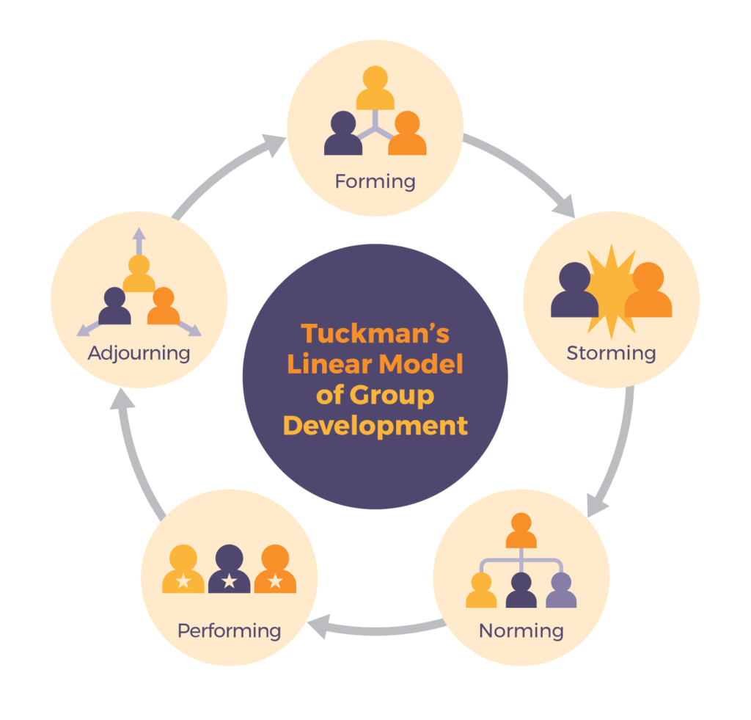
(Source: https://pressbooks.bccampus.ca/technicalwriting/wp-content/uploads/sites/296/2018/05/Tuckman_CC-1024x981.png)

Appendix 3: Team roles
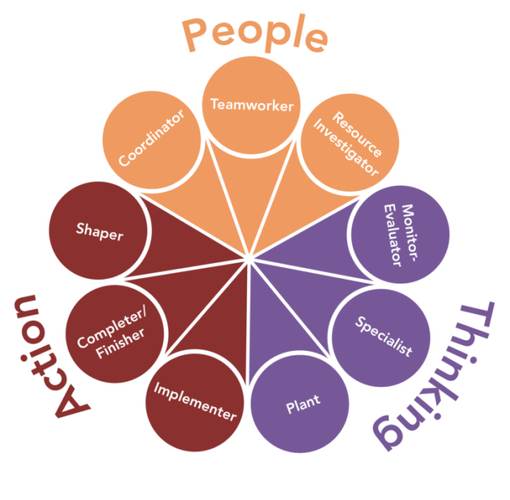
(Source: https://s3-us-west-2.amazonaws.com/courses-images/wp-content/uploads/sites/4052/2019/03/18212944/TeamRoles_update-768x755.png)

