Student Number: STUDENT NAME: EDINAH NYIRANKUSI
STUDENT ID: 2333162
MUDULE: CHANGE MAKER: BUILDING YOUR PERSONAL BRAND FOR SUSTAINABLE EMPLOYMENT.
MODULE CODE: BMHP5015
LECTURER: OLUFEMI OLURANTI.
COMPONENT 2: REPORT

1. Introduction
This report explores the role of a Mental Health Nurse within the UK healthcare system and evaluates the employability skills needed to pursue this career. Mental health nurses play a critical role in supporting individuals experiencing mental health conditions, delivering person-centred care, and promoting recovery and wellbeing. The role involves assessment, care planning, therapeutic communication, and multidisciplinary collaboration.
I am motivated to pursue this career due to my passion for improving mental health outcomes and supporting vulnerable individuals. This report will analyse the required skills, evaluate my current capabilities, and present an action plan to achieve this career goal.

2. Job Advertisement
A job vacancy for a Mental Health Nurse was found via the NHS Jobs website (NHS Jobs, 2024).
Key responsibilities include:
- Assessing patients’ mental health needs
- Developing and implementing care plans
- Working within multidisciplinary teams
- Ensuring patient safety and safeguarding
Person specification highlights:
- Effective communication skills
- Empathy and compassion
- Clinical knowledge
- Ability to work under pressure.
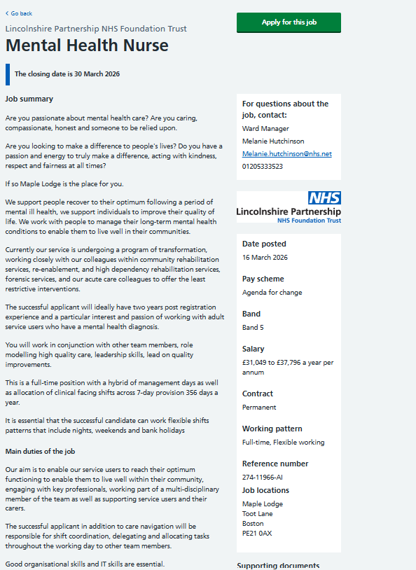

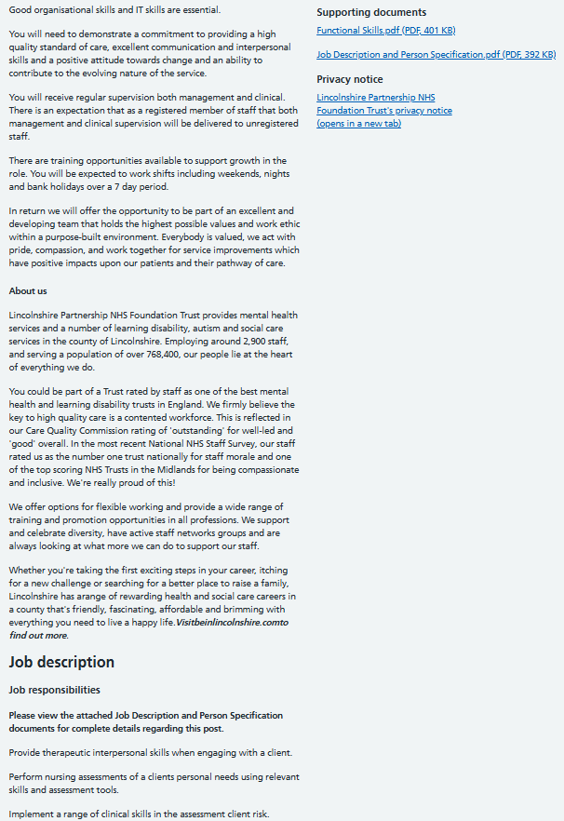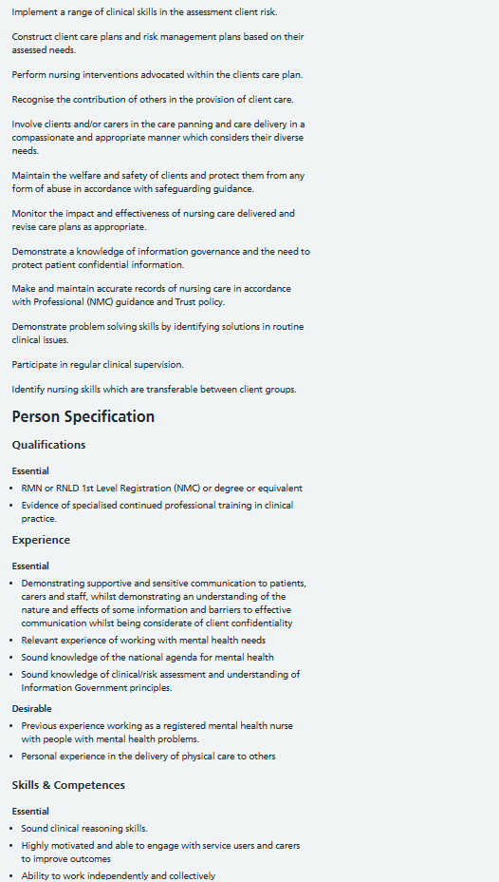
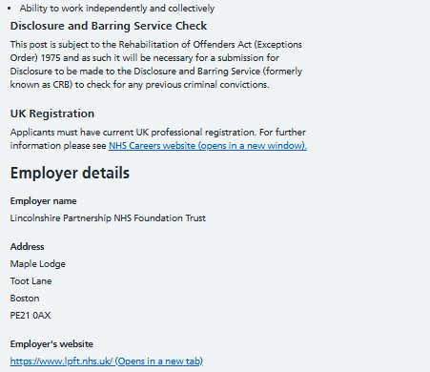

3. Job Role Employability Skills
Mental health nursing requires a combination of clinical, interpersonal, and professional skills.
Communication Skills – Effective communication is essential for building therapeutic relationships with patients. Mental health nurses must actively listen, show empathy, and communicate clearly with patients and colleagues. Poor communication can negatively affect patient outcomes (National Health Service, 2024).
Empathy and Compassion – Empathy enables nurses to understand patients’ emotional experiences, which is crucial in mental health care. Compassionate care improves trust and patient engagement (Nursing and Midwifery Council, 2018).
Teamwork – Mental health nurses work within multidisciplinary teams, including psychiatrists, social workers, and psychologists. Collaboration ensures holistic care and better patient outcomes.
Problem-Solving and Decision-Making – Mental health settings can be unpredictable. Nurses must assess risks, respond to crises, and make quick decisions to ensure patient safety.
Resilience and Emotional Stability – Working with individuals experiencing distress can be emotionally demanding. Resilience helps nurses manage stress and keep professional performance.
Clinical and Technical Skills – Knowledge of mental health conditions, medications, and therapeutic interventions is essential for safe and effective care (NICE, 2020). Each employability skill plays a vital role in enabling a Mental Health Nurse to deliver safe, effective, and person-centred care. Communication skills are essential for building therapeutic relationships, allowing nurses to understand patients’ thoughts, feelings, and behaviours, which supports exact assessment and care planning. Empathy and compassion help nurses connect with patients on an emotional level, fostering trust and encouraging engagement in treatment. Teamwork is crucial as mental health nurses collaborate with multidisciplinary teams to ensure holistic care. Problem-solving and decision-making skills enable nurses to respond appropriately to complex and unpredictable situations, such as mental health crises, ensuring patient safety. Additionally, resilience and emotional stability are important for managing the emotional demands of the role and preventing burnout. Finally, clinical knowledge and skills ensure that care provided is evidence-based and aligned with professional standards. Together, these skills contribute to improved patient outcomes and overall quality of care.
4. Evaluation of My Own Skills
Self-Assessment
I have developed strong foundational skills through my academic studies in health and social care, particularly in understanding person-centred care, safeguarding, and effective communication techniques. My current experience in healthcare has further strengthened my ability to interact professionally with patients, maintain confidentiality, and work within ethical guidelines. Additionally, taking part in peer group work has enhanced my teamwork, leadership, and problem-solving abilities, allowing me to collaborate effectively in diverse settings. My volunteering experience has also improved my empathy, cultural awareness, and adaptability when supporting individuals with unique needs. Overall, these experiences have provided me with a solid base to build upon for a future role as a Mental Health Nurse.
Strengths
One of my key strengths is effective communication. I can listen actively, interpret both verbal and non-verbal cues, and respond appropriately, which is essential for building trust and rapport with patients. I also prove an elevated level of empathy, enabling me to understand individuals’ experiences and provide compassionate support. In addition, I have strong teamwork skills developed through group projects and collaborative environments. I can work respectfully with others, share ideas, and contribute to collective goals, which aligns well with the multidisciplinary teamwork needed in mental health nursing practice.
Unique Selling Point (USP)
My unique selling point lies in my strong combination of empathy, cultural awareness, and commitment to person-centred care. These qualities enable me to understand and respect diverse backgrounds, beliefs, and experiences, which is essential in mental health settings. I can build trust with individuals from different communities, ensuring inclusive, respectful, and tailored support that promotes positive health outcomes.

Areas for Improvement
However, I recognise several areas for improvement that are essential for becoming a competent Mental Health Nurse. I need to gain more clinical experience within mental health settings to build confidence in practice. Additionally, I aim to develop stronger crisis management skills and enhance my understanding of specific evidence-based mental health interventions.
Who Can Help?
To improve these areas, I can seek support from academic tutors, clinical mentors, healthcare professionals, and placement supervisors. Academic tutors can offer theoretical guidance and help strengthen my understanding of mental health concepts. Clinical mentors and placement supervisors can offer practical insights, hands-on training, and constructive feedback in real healthcare settings. Additionally, experienced healthcare professionals can share knowledge, advice, and best practices, helping me develop confidence, competence, and professional standards needed for a Mental Health Nurse role.
5. Action Plan and Timeline
To successfully achieve my goal of becoming a Mental Health Nurse, I have developed a structured action plan with clear timelines and measurable outcomes. This plan is divided into short-term, medium-term, and long-term stages to ensure gradual development of the required knowledge, skills, and professional competencies.
Time limit | Goals | Actions | Resources Needed | Expected Outcomes
Short-Term (0–1 year) | Build foundational knowledge and awareness | Complete relevant coursework; undertake volunteering in mental health settings; attend workshops (e.g., Mental Health First Aid) | University modules; local charities; training providers | Improved understanding of mental health; enhanced communication and empathy skills
Medium-Term (1–3 years) | Develop clinical competence | Enrol in an NMC-approved Mental Health Nursing degree; complete clinical placements; develop assessment and care planning skills | University programme; NHS placements; mentors | Practical experience; improved clinical and decision-making skills
Long-Term (3–5 years) | Achieve professional qualification and employment | Obtain NMC registration; apply for Mental Health Nurse roles; engage in continuous professional development (CPD) | NMC registration; NHS Jobs; CPD courses | Qualified Mental Health Nurse; career progression opportunities

In the short-term, my focus is on strengthening my theoretical knowledge and gaining initial exposure to mental health care environments. Volunteering will allow me to interact with individuals experiencing mental health challenges, while workshops will enhance my awareness and confidence.
In the medium-term, enrolling in an NMC-approved degree is essential to gain the qualifications needed for practice. Clinical placements will provide hands-on experience, enabling me to apply theoretical knowledge in real-world settings and develop critical skills such as risk assessment and care planning.
In the long-term, achieving NMC registration is a key milestone that allows me to practice as a qualified Mental Health Nurse. Applying for roles within the NHS will enable me to begin my professional career, while continuous professional development will ensure I keep and enhance my skills in line with evolving healthcare standards. Overall, this action plan ensures a clear and realistic pathway to achieving my career goal while aligning with professional standards set by the Nursing and Midwifery Council (2018).
6. Building My Personal Brand
Building a strong personal brand is essential for standing out in the competitive health and social care sector, particularly as an aspiring Mental Health Nurse. My personal brand will reflect my values of empathy, professionalism, and commitment to person-centred care, aligning closely with the expectations of the healthcare profession.
To develop this, I will create and keep a professional profile on LinkedIn, ensuring it clearly highlights my skills, qualifications, experiences, and career aspirations. I will also consider developing a simple personal website or digital portfolio to highlight my achievements, certificates, and reflective practice. Attending professional networking events and engaging with online healthcare communities will further strengthen my visibility and connections within the sector. In terms of content, I will actively share and engage with relevant materials such as blog posts, articles, and case studies related to mental health awareness and practice. This will prove my knowledge, ongoing learning, and genuine commitment to the field. Additionally, I will document my learning journey through reflective writing, which will show my ability to critically evaluate experiences and improve professionally.
Overall, this approach will help set up a credible and authentic professional identity, making me more attractive to potential employers.
7. Promoting My Professional Identity
Promoting my professional identity is essential for effectively communicating my skills, values, and readiness for a career in mental health nursing. To achieve this, I will adopt a strategic and professional approach across multiple platforms.
Firstly, I will develop a well-structured CV that clearly highlights my relevant skills, qualifications, and experiences, particularly those related to health and social care. I will ensure that my CV is tailored to each job application, aligning with the job description and person specification. In addition, my cover letter will be personalised to show my passion for mental health nursing, my understanding of the role, and how I can contribute positively to patient care.
Secondly, I will keep an active and professional presence on LinkedIn. This will include regularly updating my profile with achievements, skills, certifications, and any relevant experiences. I will also engage with professional content to prove my interest and commitment to the field. Furthermore, I will develop a professional portfolio that includes certificates, reflective practice, and evidence of learning. This portfolio will provide tangible proof of my development and competencies.
Overall, these strategies will enhance my visibility, credibility, and employability as a future healthcare professional.

8. Building a Network for Successful Employment
Networking is a vital part of career development within the health and social care sector, particularly for aspiring Mental Health Nurses. Building strong professional relationships can provide access to opportunities, support, and valuable insights into the profession.
To develop my network, I will actively attend healthcare events, workshops, and seminars where I can engage with professionals and learn about current practices in mental health care. These events provide opportunities to exchange knowledge and build meaningful connections. Additionally, I will use LinkedIn to connect with healthcare professionals, join relevant groups, and take part in discussions related to mental health nursing.
I also plan to seek mentorship from experienced nurses who can provide guidance, share their experiences, and support my professional development. Mentors can offer practical advice on career progression, skill development, and navigating challenges within the field.
Furthermore, joining professional organisations such as the Royal College of Nursing will provide access to networking events, training opportunities, and career resources. Overall, effective networking will enhance my professional growth, increase my awareness of opportunities, and support my transition into a successful mental health nursing career.

9. Conclusion
This report has analysed the role of a Mental Health Nurse and the employability skills needed to succeed in this profession. Key skills such as communication, empathy, teamwork, and resilience are essential for delivering high-quality care. Through self-evaluation, I have found my strengths and areas for improvement. My action plan provides a clear pathway for developing the necessary skills and achieving my career goal.
Additionally, building a personal brand, promoting my professional identity, and developing a strong network will enhance my employability. Overall, I am highly motivated to pursue a career in mental health nursing and committed to continuous learning and professional development to make a positive impact in healthcare.

References
Department of Health and Social Care (2021) Mental health workforce strategy. London: DHSC.
Health Education England (2022) Becoming a mental health nurse. London: HEE.
National Health Service (2024) Mental health nurse job description. Available at: https://www.jobs.nhs.uk
National Institute for Health and Care Excellence (2020) Mental health guidelines. London: NICE.
NHS England (2019) The NHS Long Term Plan. London: NHS.
Nursing and Midwifery Council (2018) The Code: Professional standards of practice and behaviour for nurses. London: NMC.
Public Health England (2020) Improving mental health outcomes. London: PHE.
Royal College of Nursing (2021) Careers in mental health nursing. London: RCN.
Skills for Care (2022) Workforce development in health and social care. Leeds: Skills for Care.
World Health Organization (2023) Mental health and wellbeing. Geneva: WHO.

