Email 1: Employment Regulation (AC1.1) (419)
Ensuring legal compliance and staying updated with relevant employment law is fundamental to effective people practice. The legal framework governing employment is extensive, with significant regulatory developments in recent years (Taylor and Wilkinson 2022). Key legislation includes the Health and Safety at Work Act 1974, the Employment Rights Act 1996 (ERA1996), the Working Time Regulations 1998 (WTR 1998), and the Equality Act 2010 (EA 2010). These aim to safeguard employees, promote equality, and maintain a secure working environment by balancing employer requirements with employee protection (CIPD 2025a).
A thorough understanding of employment status is crucial for all organisations, as it directly impacts rights and tax obligations. Employment rights encompass entitlements such as paid holidays, protection against unfair dismissal, and statutory sick pay (ACAS 2024a). Given that 15% of the UK workforce has engaged in gig economy work, issues such as ‘bogus self-employment’ requires clear distinctions in worker classification (Baska 2019; Barnard and Georgiou 2024). Cases like Uber BV v Aslam (2021) reinforced worker status recognition with its associated rights going beyond contractual terms, ensuring minimum wage entitlements under the National Minimum Wage Act 1998 (NMW) (CIPD 2024a, People Management 2025).
While employment regulations may introduce additional bureaucratic and financial burdens, they are essential in preventing exploitation, ensuring fair treatment, and supporting economic stability (Belton 2025). Employment disputes can be lengthy and costly, particularly in discrimination cases, where employment tribunals (ET) impose no compensation cap. Wrongful dismissal claims may be pursued in civil courts for up to six years. Advisory bodies such as ACAS and EHRC provide essential guidance and play a pivotal role in workplace dispute resolution. Non-compliance with ACAS codes can lead to a 25% increase in compensation awards. Also, with potential for multiple overlapping claims, illustrating the complexity and financial implications of legal disputes (CIPD 2024b). In 2023/24, the average compensation for age discrimination cases was £100,000, while the highest award for sex discrimination reached £995,000 (Powell 2021).
Employer vicarious liability extends beyond the workplace, as illustrated in Chief Constable of Lincolnshire Police v Stubbs (1999]. Employees working overseas for UK-based companies may also be eligible for claims ET fees removal in 2017 led to increased claims, expanding the risk of legal challenges to management decisions. Effective people practice requires strong employment law knowledge and access to specialised legal advice to mitigate costs. Continuous regulatory compliance is vital in creating a positive workplace culture, ensuring employee well-being, preventing reputational damage, and minimising financial and operational risks (Lewis, Sargeant and Schwab 2011, Daniels 2022, Taylor and Wilkinson 2022).

Email 2: European Court of Justice (ECJ) role (AC1.2) 331 words
Prior to the UK withdrawal from the European Union (EU), the European Court of Justice (ECJ) and EU law held supremacy over domestic legislation. The European Union (Withdrawal) Act 2018 was enacted to retain all EU-based legislation within UK law, ensuring continuity and legal certainty post-Brexit. Within the Brexit agreement in 2020, the UK committed to maintaining employment standards as of 2020, with Section 6.2 stating that employment protections would not be ‘weakened or reduced’ (CIPD 2024c).
The Retained EU Law (Revocation and Reform) Act 2023 further addressed the status of EU-based laws within the UK legal framework. From 1 January 2024, this act retained certain EU laws reclassified as ‘assimilated law’. (GOV.UK 2023a).
While the ECJ no longer holds a constitutional role in the UK, and UK courts are not obligated to follow new ECJ rulings, judgments made by the ECJ prior to 2020 remain part of UK law. Although EU employment law has been replicated into UK law, ECJ rulings can now be challenged. For example, The UKs opt-out from the EU Working Time Directive's 48-hour workweek limit, which many UK companies utilise (PAI 2025), could fully be fully revoked if the UK government chooses to do so. Therefore, whilst the UK has retained much of this EU employment legislation, it now possesses the ability to amend or repeal laws as necessary, reflecting a move towards a more self-governing legal framework. Key retained provisions include irregular hour workers and TUPE consultation, with possible areas for future change being holiday pay accrual during sickness absence (Belton 2025).
The UK court hierarchy for employment cases begins with the ET, followed by the EAT, the Court of Appeal, and the UK Supreme Court. Some cases may also be heard in the County or High Courts (Daniels 2022).
Figure 1: The Structure of UK Courts (Judiciary 2021)
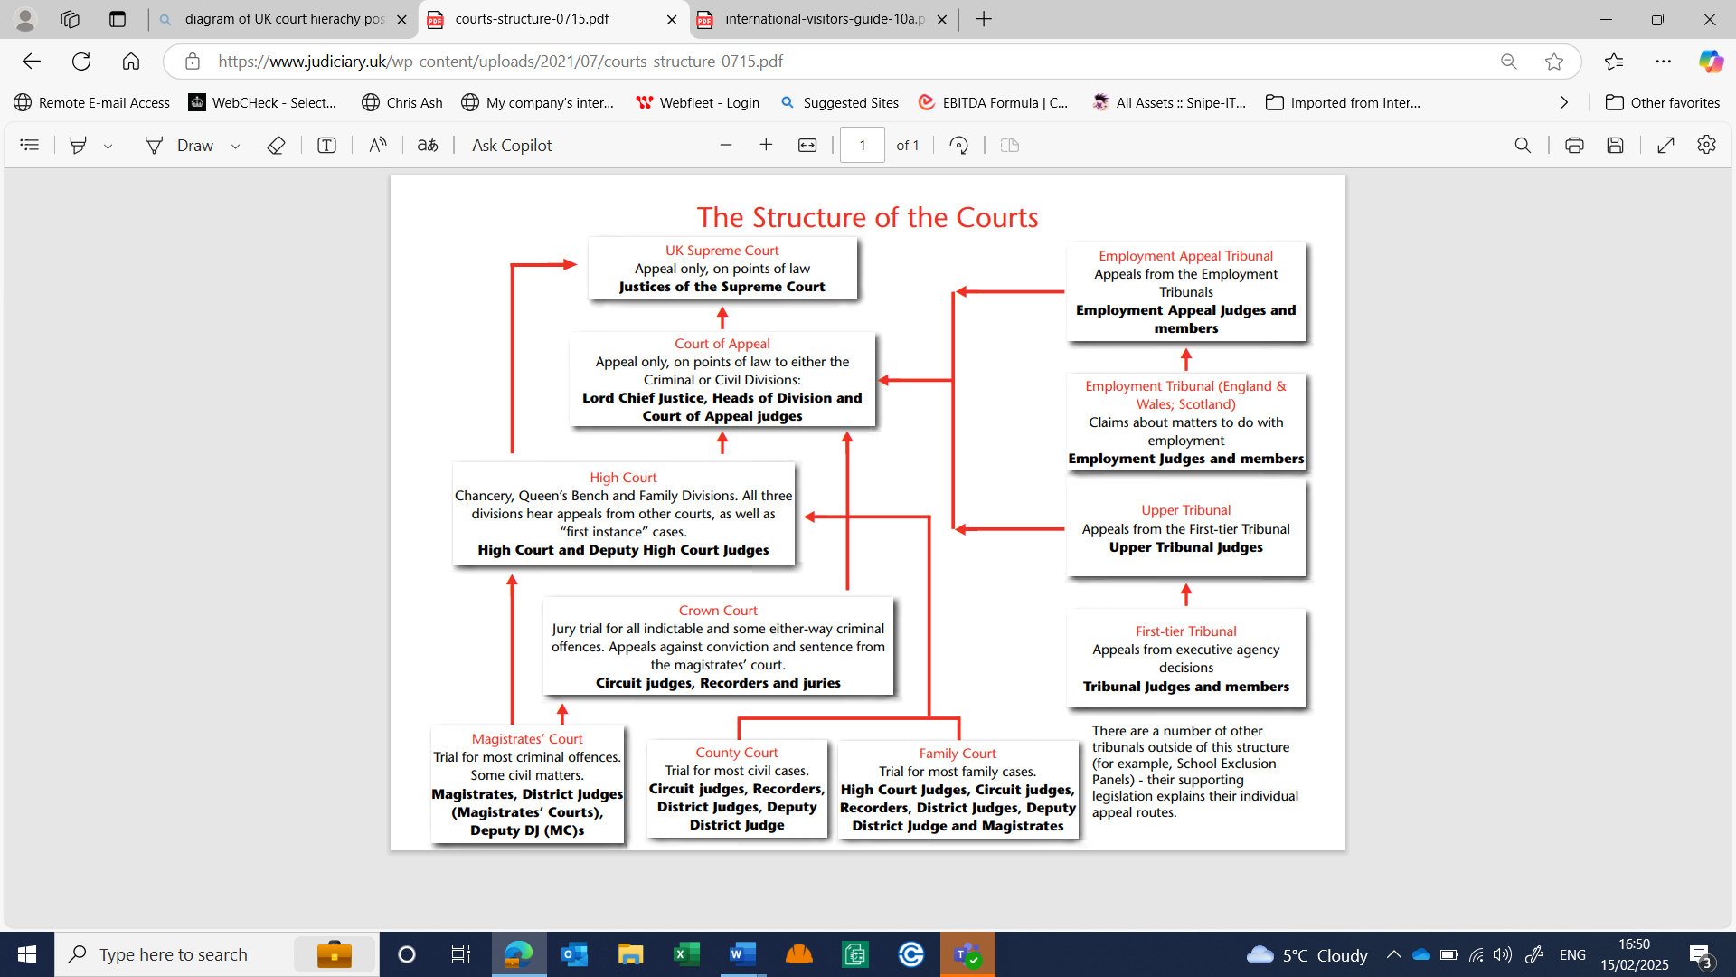
Nevertheless, given the numerous EU laws now embedded in UK legislation, it remains essential to maintain a comprehensive understanding of these laws and their application, as they continue to impact practical, day-to-day UK employment activities.
EMAIL 3: Occupational Requirements (AC2.1) 388 words
Legislation on discrimination has expanded significantly in recent years, covering direct, associative, perceptive, and indirect discrimination, as well as harassment and victimisation. These protections apply to nine characteristics of age, disability, gender reassignment, marriage or civil partnership, pregnancy and maternity, race, religion, sex, and sexual orientation (Lewis, Sargeant and Schwab 2011). The simplified approach in direct discrimination in determining if unfavourable treatment has occurred as follows:
Figure 2: Breakdown of the approach in direct discrimination (Cabrelli 2017,pp.75)
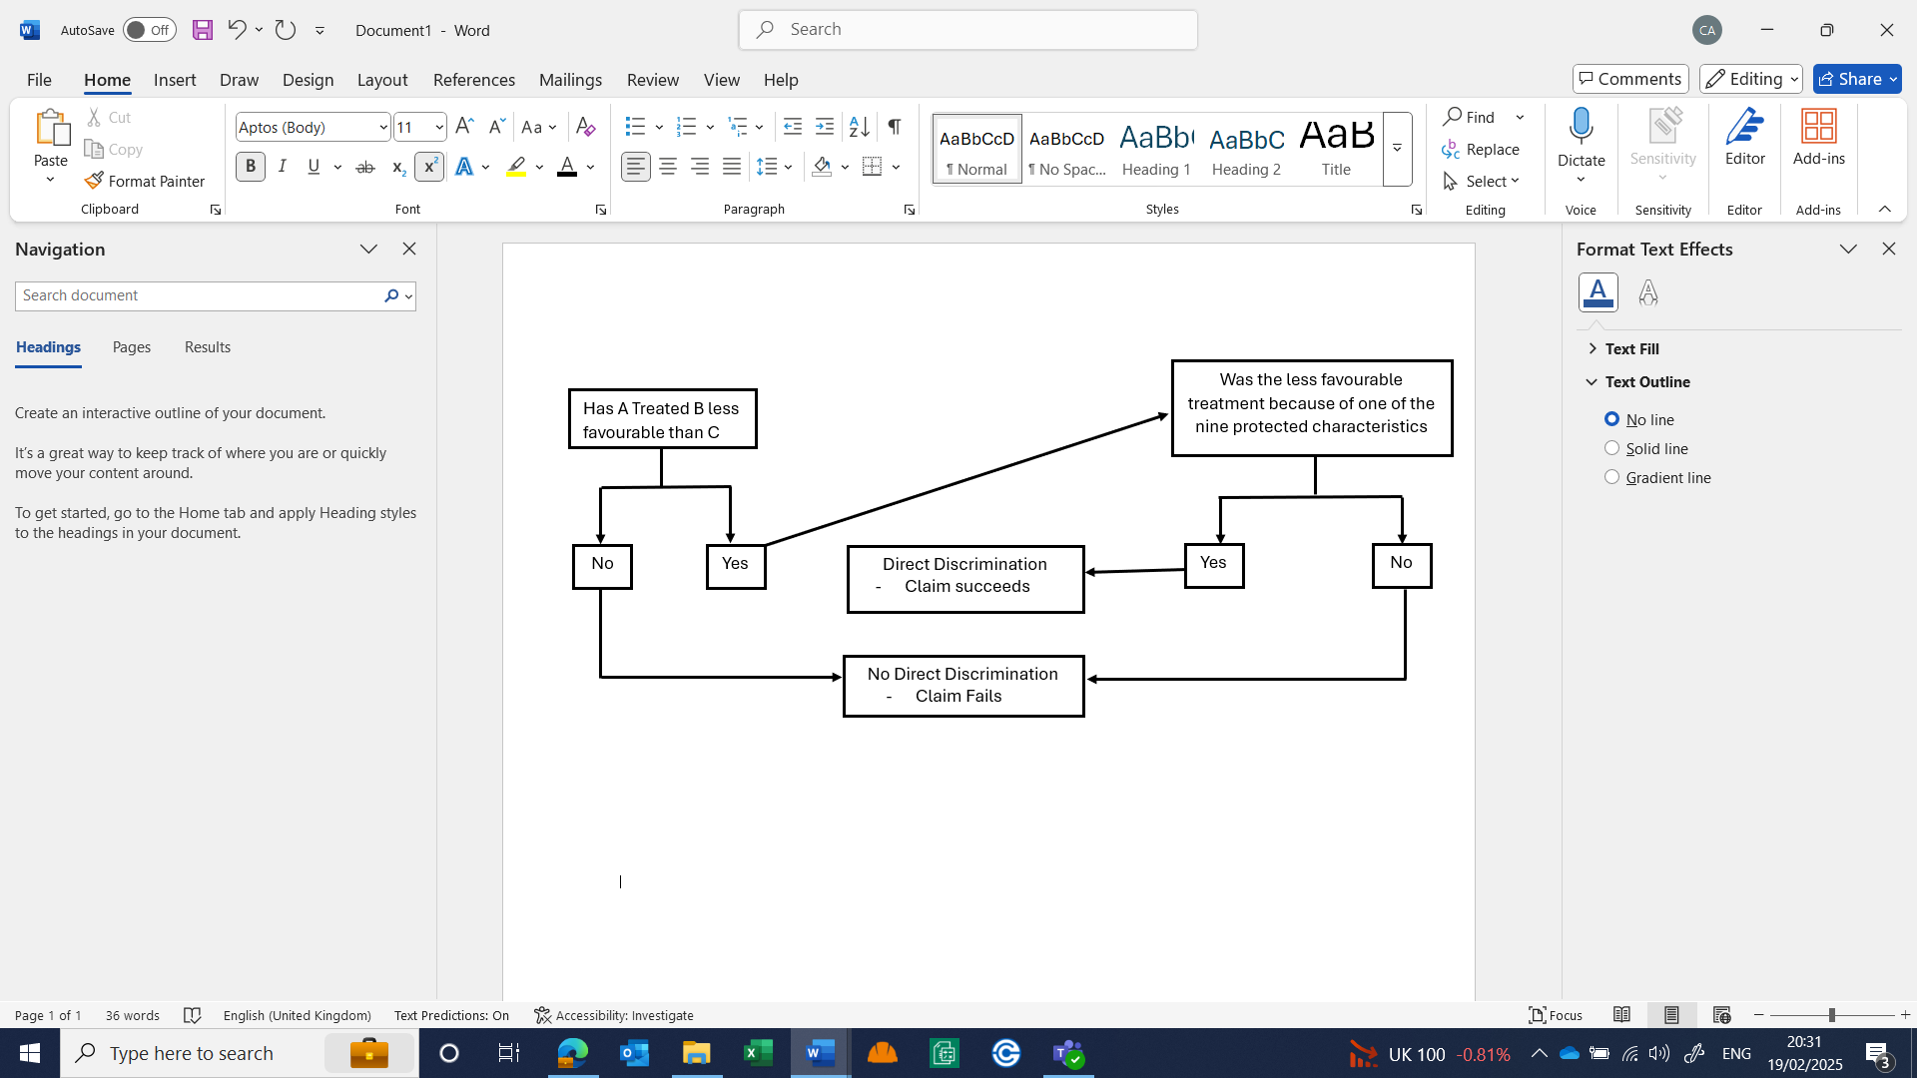
The burden of proof in discrimination cases shifts to the employer once a claimant establishes facts suggesting potential discrimination, as demonstrated in Barton v Investev Henderson Crosthwaite Securities Ltd (2003). Compensation awards are uncapped and vary based on severity (Daniels 2022). Damages for injury to feelings, as guided by Vento v Chief Constable of West Yorkshire Police [2003], the updated ‘Vento bands’ for claims from 6 April 2024 are (Judiciary 2024):
- Lower band (£1,200–£11,700): Less serious cases
- Middle band (£11,700–£35,200): Moderate cases
- Upper band (£35,200–£58,700): Most serious cases
- Exceptional cases: Awards exceeding £58,700.
Section 158 of the EA 2010 permits positive action to encourage and train individuals from underrepresented groups. Where two candidates are equally qualified, an employer may favour one to address representation imbalances in the organisation (CIPD 2024d).
Under Section 9 of the EA 2010, occupational requirements (ORs) allow employers to lawfully recruit based on protected characteristics if it is essential for the role. ORs must be objectively justified as proportionate and legitimate (Cushway 2017). These include:
- Authenticity in performance roles, such as casting a Black actor as Martin Luther King Jr.
- Privacy and decency concerns, e.g. Outreach workers.
- Religious requirements for selecting faith leaders, as upheld in R (Amicus–MSF Section) v Secretary of State for Trade and Industry (2004) (Lewis 2015).
ORs misuse will lead to legal consequences. In Etam v Rowan (1989), a male applicant was unlawfully denied employment in a women’s clothing store, as intimate interactions were a minimal aspect of the role (Daniels 2022). The EHRC’s 2024 guidance reinforces that improper application of ORs constitutes unlawful discrimination, subject to prosecution. ORs must be genuine and directly linked to job requirements (EHRC 2024a). Employers must exercise caution when specifying gender-based roles in the directorate. Courts and tribunals require a demonstrable legitimate aim behind any discriminatory practice. Failure to fully justify an OR appropriately will result in legal enforcement and compensation claims (IDS 2010).
EMAIL 4: Sex discrimination and Equal Pay (AC2.2) 509 words
Male HCA promotion to Grade B within a predominantly female workforce requires a cautious approach to ensure EA 2010 compliance. Failure to comply may expose the directorate to equal pay claims, direct and indirect sex discrimination claims, and potential reputational damage (Lewis 2015).
Equal pay claims can be initiated at any time during employment or within six months of leaving. Alternatively, claims may be pursued in the High Court or County Court within a six-year period. Successful claims may result in compensation covering pay differentials, legal costs, and injury to feelings damages. Men and women doing equal work must receive equal pay. There cannot be any pay secrecy clauses (Daniels 2022).
Equal pay law is complex and requires reform (IDS 2010). Nevertheless, Section 65 establishes three separate key legal principles under which a claim may succeed:
- Like Work: Roles must be broadly similar, focusing on actual tasks, not job descriptions or titles. In Capper Pass v Lawton (1977), differences in tasks were deemed inconsequential (Daniels 2022).
- Work of Equivalent Value: Assessed through job evaluation schemes including ranking, paired comparisons or points rating, In Springboard Sunderland Trust v Robinson (1992), comparable scores demonstrated equal value yet pay remained unequal (Cabrelli 2017).
- Equal Value: Different roles requiring comparable skill, effort and responsibility still require equal pay. In Asda Stores Ltd v Brierley (2021) female retail workers successfully compared their pay to male warehouse staff (Daniels 2022).
In equal pay claims, the comparator must be a real male employee of the same or associated employer, unlike sex discrimination claims, which allow hypothetical comparators (Lewis 2015).
Under Section 69 an employer may defend a pay difference due to a genuine, proportionate, and necessary material factor unrelated to sex. In Enderby v Frenchay Health Authority (1993), an employer justified pay disparities based on market forces, paying a female speech-therapist less than male pharmacists. The ECJ ruled where statistical evidence indicates a gender pay-gap for equal value work, it is indirect sex discrimination. The burden of proof then shifts to the employer to prove it is objectively justified and unrelated to sex (Belton 2025; Lewis, Sargeant and Schwab 2011).
Figure 3: Equal Pay claim flow (Cabrelli 2017,pp.114)
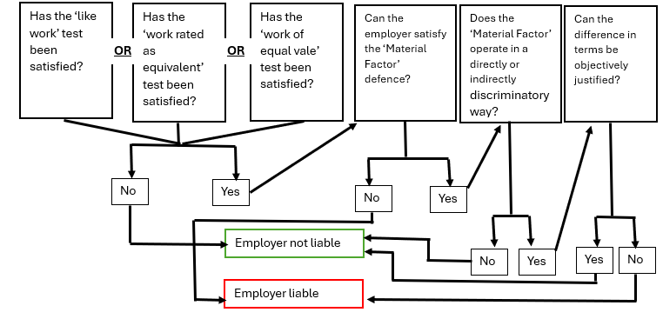
Under Section 70, equal treatment must apply across all contractual terms. In Hayward v Cammell Laird (1988), it ruled employers cannot offset less favourable terms with other more favourable terms to justify lower pay (Cabrelli 2017).
Employers must also address historical disparities, as illustrated in Brennan v Sunderland City Council (2012). Direct sex discrimination can occur when part-time female lecturers are overlooked and dismissed, in favour of male full-time contracts as illustrated by the Court of Appeal in Allonby v Accrington and Rossendale College [2001]. Additionally, indirect discrimination arises if a policy change disproportionately benefits male employees as in London Underground Ltd v Edwards [1998] (Lewis 2015).
To mitigate legal risks, whilst possibly judgemental and time-consuming employers should conduct a transparent, merit-based person and job evaluation through a robust recruitment process to ensure promotions are objectively justified and bias-free. If claims are successful, the directorate can be ordered to undertake full equal pay audits (Kidner 2019).

EMAIL 5: Constructive Dismissal (AC3.1) 436 words
A constructive dismissal claim arises when an employee resigns due to a fundamental breach of contract by the employer, making continued employment untenable. Therefore, an employee may treat themselves as dismissed under ERA 1996 section 95. To successfully establish a claim the employer must have committed a serious breach of contract, the employee must resign in direct response to that breach, and the resignation occurred without undue delay. A lengthened delay may be interpreted as acceptance of the new terms (Lewis, Sargeant and Schwab 2011).
Employees must have a minimum of two years’ continuous service to qualify. The claim must be submitted to ET within three months minus one day from the effective date of termination, as detailed in section 11. In exceptional circumstances, such as the claimant experiencing mental health issues or anxiety, the ET may grant an extension (ACAS 2024b, Belton 2025).
Contractual working hours variation generally requires mutual agreement. Unilateral changes may constitute a breach of contract as illustrated in United Bank Ltd v Akhar (1989). Where a contract includes a variation clause (e.g. mobility), such clauses may be unreasonable to be enforceable. Furthermore, as in Malik v Bank of Credit and Commerce International (1997), breaches of the implied duty of trust and confidence can also amount to constructive dismissal (Lewis 2015; Cushway 2017; Daniels 2022).
While contractual variations are permissible following proper consultation, employers must ensure that they engage in meaningful discussions and provide legitimate business reasons for such changes. Effective handling of employee grievances is crucial in mitigating disputes. Managers should ensure appropriate behaviours when dealing with workplace conflicts. Additional management training is available (CIPD 2023a).
Successful constructive dismissal claims may include reinstatement where feasible or compensation for unfair dismissal. Compensation is subject to a statutory cap of £115,115 or one year’s salary, whichever is lower Additionally, any award may be adjusted up by 25% depending on whether the employer or employee has failed to adhere to the ACAS Code of Practice on disciplinary and grievance procedures. The Polkey deduction principle also allows for a reduction in compensation if it is determined that the employee would have been dismissed even if fair procedures had been followed (Lewis 2015, NACAB 2025a).
The validity of a constructive dismissal claim depends on the specific circumstances and procedural actions taken prior to resignation. The ET will evaluate evidence to establish a link between the employer’s conduct and the employee’s resignation. Key factors include the consultation, timeline of contractual changes, any grievances raised, and the employer’s response. The tribunal will also assess the resignation letter's content and consider whether the employee worked under protest (Landy 2017).

EMAIL 6: Redundancy (AC3.2) 404 Words
Senior management may wish to accelerate redundancies, but employment law requires strict procedural compliance to protect employee rights and minimise legal risks and operational disruptions (Daniels 2022).
Redundancy, as defined under ERA 1996 section 139, occurs when dismissal results from a workplace or business closure, or a reduced need for specific work. Employers must consider alternative employment, minimise compulsory redundancies, ensuring thorough consultation, fair selection pools and objective criteria. Under the EA 2010, selecting protected employees, such as pregnant individuals or those on maternity leave, constitutes automatic unfair dismissal (Waite et al 2021, CIPD 2024e)
Employers should implement objective selection criteria where possible. If subjective criteria are used, it must be supported by evidence to mitigate legal risks, as seen in Eversheds Legal Services Ltd v De Belin (2011), where a female employee on maternity leave received notional maximum performance points (Law Gazette 2011).
The Trade Union and Labour Relations (Consolidation) Act (TULRCA) 1992 governs collective redundancies. With fifty redundancies proposed, consultation with recognised NHS trade unions must occur for 30 days. Additionally, employers must notify the Redundancy Payments Service (RPS) via an HR1 form, failure will mean unlimited fines. Lord Bridge stated in the millstone Polkey case that an employer is unlikely to act reasonably unless affected employees are adequately warned and consulted (CIPD 2024f, Barnett 2025a). Non-compliance with consultation requirements can lead to protective awards of up to 90 days’ full pay per affected employee, as in GMB v Susie Radin Ltd (2004) (Eversheds 2004).
Figure 4: The Redundancy Process (Cushway 2017,pp.252)
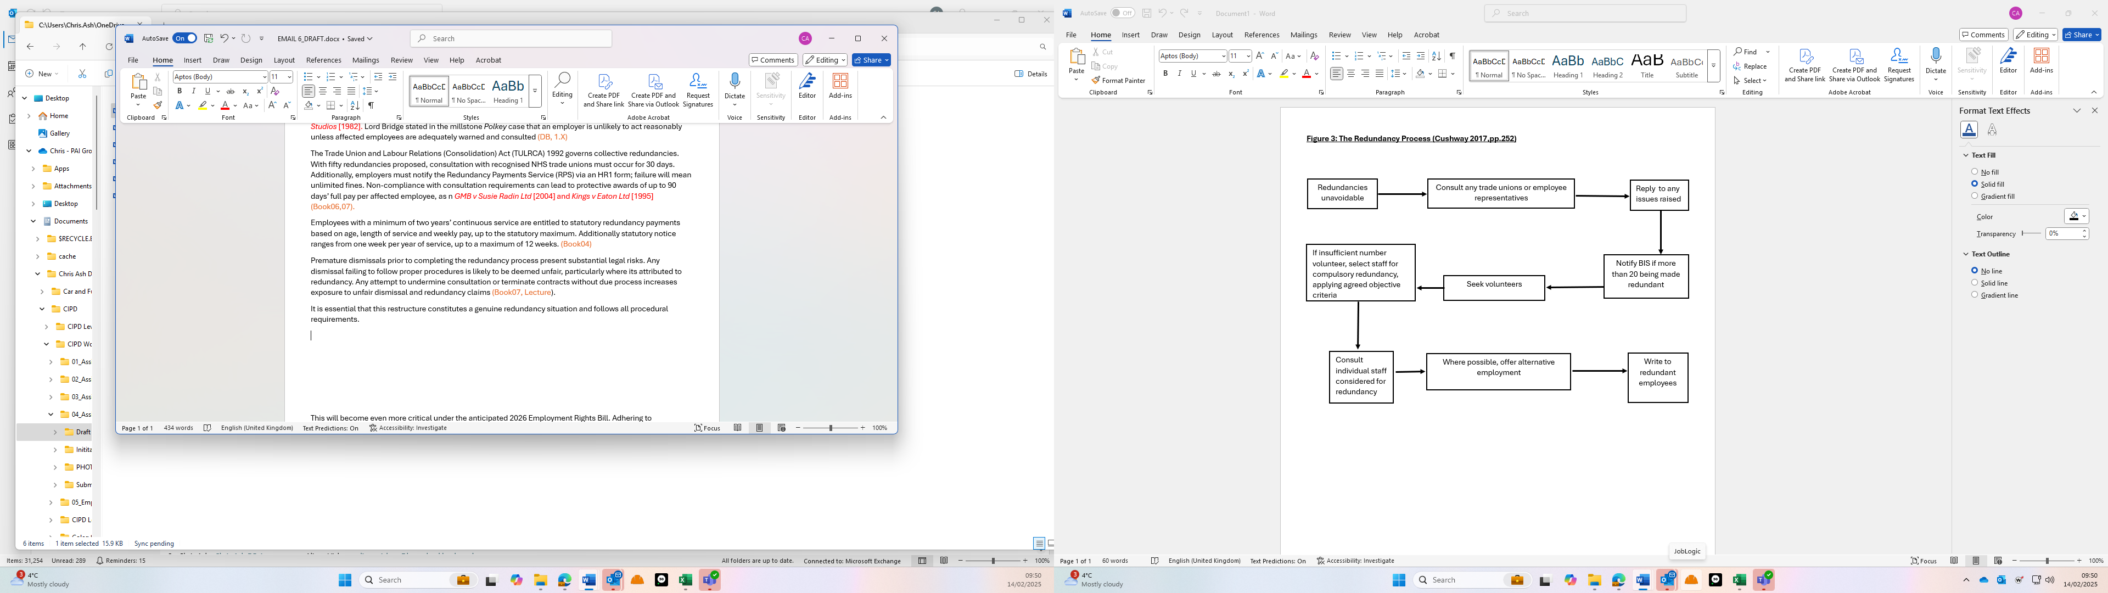
Employees with a minimum of two years’ continuous service are entitled to statutory redundancy payments based on age, length of service and weekly pay, up to the statutory maximum. Additionally statutory notice ranges from one week per year of service, up to a maximum of 12 weeks. (Lewis, Sargeant and Schwab 2011)
Premature dismissals prior to completing the redundancy process present substantial legal risks. Any dismissal failing to follow proper procedures is likely to be deemed unfair, particularly where it’s attributed to redundancy. Any attempt to undermine consultation or terminate contracts without due process increases exposure to unfair dismissal and redundancy claims (Lewis 2015, Belton 2025).
It is essential that any restructure constitutes a genuine redundancy situation and follows all procedural requirements. This will become even more critical under the anticipated 2026 Employment Rights Bill. Adhering to established legal procedures not only ensures compliance but also upholds employee trust and morale (Lewis 2015, Taylor 2022, CIPD 2025b).
EMAIL 7: Transfer of Undertakings regulations 2006 (TUPE) (AC3.3)……457 Words
TUPE will apply to a future pharmacy merger, safeguarding employees’ rights when businesses transfer or service provision changes. Due diligence is essential to assess potential risks, employment costs, and liabilities while preserving existing terms and conditions (ACAS 2024c, CIPD 2024g).
Regulations apply to both the outgoing employer (the 'transferor') and the incoming employer (the 'transferee'). Employees uncertain about TUPE’s implications may raise a grievance, consult a trade union representative, or seek guidance from ACAS and legal professionals (GOV.UK 2025a).
Employees must be informed, consulted, and retain their continuity of service along with all contractual terms, including role, salary, sick leave, and holiday entitlement. Consultation is required for all affected employees, as established in I Lab Facilities Ltd v Metcalfe (2013). This process must include confirmation of the transfer, its reasons, and any anticipated measures affecting employees. Failure to inform and consult can result in claims of up to 13 weeks' full pay, with no minimum service requirement. Todd v Strain (2011) reaffirmed both transferor and transferee must engage in meaningful consultation (Lewis 2015, Daniels 2022).
Contractual changes post-transfer must not disadvantage employees unless justified by an Economic, Technical, or Organisational (ETO) reason. Regent Security Services Ltd v Power (2007) confirmed employers must also honour post-transfer agreements. TUPE protections remain indefinitely applicable, as demonstrated in Taylor v Connex South Eastern Ltd (2000). Dismissals resulting solely from the transfer are automatically unfair under Regulation 7, unless for ETO reason. Lister v Forth Dry Dock and Engineering Ltd (1989) confirmed employees dismissed prior to transfer remain protected, with their rights transferring to the new employer. Trade union recognition transfers only if employee maintain a distinct identity post-transfer (Personneltoday 2008, Lewis 2015, Working Families 2025a).
While contractual private pensions transfer, workplace pensions are generally exempt but must be replaced with an alternative scheme. Effective planning and communication are critical for any transfer, ensuring both legal compliance and a positive work environment. A structured transfer plan, shared with employees, removes concerns and clarifies the process (ACAS 2024c)
The transferor must provide Employee Liability Information at least 28 days before the transfer, detailing names, ages, employment terms, disciplinary records, and claims. Failure to provide accurate or timely information may result in penalties of up to £500 per employee. To mitigate risks, we should obtain transferor indemnities to protect against transferred undisclosed liabilities, including pending discrimination claims, as highlighted in DJM International v Nicholas (1996). Employees cannot be made redundant solely due to the transfer, as this constitutes unfair dismissal. If twenty or more employees are at risk, a collective consultation is required under TULRCA (Lewis 2015, CIPD 2024g, ICO 2025).
In conclusion, employees benefit from wide-ranging protections, including the automatic transfer of existing terms, dismissal safeguards, consultation requirements and our ongoing obligations post-transfer.

EMAIL 8: Casual / irregular hours workers holiday pay entitlement (AC4.1)…..374 Words
Nurse bank staff engaged on a casual but regular basis, as workers are entitled to the national minimum wage, rest breaks, rest periods, and statutory holiday entitlement, including holiday pay, as stipulated by the WTR 1998. They are eligible for 5.6 weeks of paid leave annually on a pro-rata basis, determined by hours worked, with no minimum service requirement. Holiday pay must be calculated based on the worker’s average weekly earnings over the previous 52 weeks, replacing the former 12-week reference period. This includes all non-guaranteed overtime as illustrated by Bear Scotland Ltd v Fulton (2014) and any additional work-based payment or commission in Lock v British Gas Trading Ltd (2014 (Daniels 2022, Belton 2025).
Employers may alternatively calculate holiday pay at a rate of 12.07% of actual hours worked. However, Harpur Trust v Brazel (2022) deemed this method unlawful, as it increased wages without guaranteeing paid leave. To resolve this legal confusion, the Employment Rights (Amendment, Revocation and Transitional Provision) Regulations 2023 reinstated the 12.07% accrual method, effective from 1st April 2024. Holiday pay must be calculated per pay period and itemised separately on the worker’s payslip (Cresswell 2023, Stepney and Lumsden 2024).
If a bank nurse works 60 hours in a pay period, their additional holiday pay would be calculated as 60 hours x 12.07% = 7.242 hours x hourly rate. If they then work 78 hours in the subsequent pay period, the calculation would be 78 hours x 12.07% = 9.415 hours x hourly rate.
Bank staff retain the right to take holiday leave. However, they will not receive payment at the time of taking leave under this 12.07% system. Additionally, holiday pay must not be lost due to sickness or statutory leave, including maternity or parental leave (ACAS 2024d).
Employers can only select one of these dual approaches when calculating holiday pay for bank staff. Failure to provide accurate holiday pay can result in claims for unlawful wage deductions, financial penalties, tribunal awards, and reputational damage. While backdated claims are limited to two years, King v Sash Windows Workshop Ltd (2017) demonstrated the potential for extended liabilities, with an employer required to backpay thirteen years of holiday entitlement due to the misclassification of workers as self-employed (Faragher 2017, ACAS 2024e).

EMAIL 9: Maternity leave compared to Shared Parental Leave (AC4.2)………431 words
The decision between maternity leave and shared parental leave (SPL) is personal, influenced by financial and individual circumstances. Whilst both aim to support employees during early parenthood, they differ in duration, financial impact, flexibility, and legal safeguards (Kidner 2019, Daniels 2022).
Maternity leave, governed by the ERA 1996 and the Maternity and Parental Leave Regulations 1999, entitles pregnant employees to up to 52 weeks of leave. This period comprises 26 weeks of ordinary maternity leave (OML) and 26 weeks of additional maternity leave (AML). Statutory Maternity Pay (SMP) is provided for 39 weeks. The first six weeks at 90% of average weekly earnings, followed by 33 weeks at currently £184.03 per week or 90% of earnings, whichever is lower. Maternity leave is non-transferable. It also offers up to ten ‘keeping in touch’ days. Employment contracts remain in effect throughout maternity leave, excluding remuneration, and employees retain the right to return to their previous role with identical terms, including salary uplifts granted during their absence (MA 2025a, ACAS 2024f).
Legal protections for maternity leave are extensive. Under the ERA 1996, dismissal due to pregnancy or maternity leave is automatically unfair. Additionally, enhanced redundancy protections require employers to prioritise suitable alternative employment for employees on maternity leave. These protections extend for 18 months post-birth (CIPD 2024e, MA 2025b).
By contrast, SPL, introduced under the Children and Families Act 2014 and the Shared Parental Leave Regulations 2014, allows eligible parents to share up to 50 weeks of leave and 37 weeks of statutory shared parental pay (ShPP). The first two weeks post-birth (four weeks for factory workers) remain reserved for the mother. Beyond the initial six weeks, ShPP is paid at the same lower rate as SMP, which can make SPL financially less advantageous. Hextall v Chief Constable of Leicestershire Police (2019) upheld this payment differential. If a mother shares any portion of AML, her right to return to the same job is subject to different protections, while she remains entitled to a suitable role, the terms must not be less favourable (Faragher 2018, Daniels 2022, CIPD 2024e, EHRC 2024b).
Eligibility for SPL requires both parents to have been employed by the same employer for at least 26 weeks by the 15th week before the expected due date and to earn a minimum of £123 per week. SPL offers greater flexibility, allowing parents to take leave concurrently or alternately, with up to twenty ‘shared parental leave in touch’ days. However, SPL uptake remains low, potentially due to limited financial incentives and prevailing UK attitudes toward childcare (Alidina 2019, MA 2024, Jackson and Clemo 2025).

EMAIL 10: Flexible Working Rights (AC4.3)…………….424 words
From April 2024, employees have enhanced rights under the Flexible Working (Amendment) Regulations 2023, including the right to apply for flexible working from day one of employment. Employees can now submit two requests per year, covering flexibility in working hours, times, or location, while employers must respond within two months, reduced from the previous three-month timeframe (Jackson 2024).

Under the ERA 1996, employers may refuse requests based on excessive costs, operational challenges, recruitment difficulties, or adverse effects on quality, performance, customer demand, or workload distribution. It is advisable for employers to cite multiple grounds when refusing a request (Belton 2025). Employers must reasonably consider requests and engage in employee consultation. Whilst there is no longer a statutory right to appeal, an appeals process is recommended. (Leech 2024, GOV.UK 2025b).

Failure to follow correct procedures may lead to ET claims, with potential compensation of up to eight weeks' pay or an order to reconsider the request. Additionally, it is automatically unfair to subject an employee to detriment or dismissal for requesting flexible working (Lewis 2015, Daniels 2022).

Employers also face risks of indirect discrimination claims. In Thompson v Scancrown Ltd (2019) refusals to accommodate flexible working were deemed indirect sex discrimination, as the employer failed to balance business needs with those of the employee and resulted in over £184,000 compensation (Penman 2021).

The demand for flexible working is increasing, with 31% of job advertisements now including flexible options. Also, it can serve as a valuable retention tool in a competitive labour market. Research indicates that flexible working fosters a more inclusive, diverse, and productive workplace, improving job satisfaction and employee commitment. Furthermore, 66% of employees consider leaving their jobs if required to work on-site five days per week. Nevertheless, concerns persist regarding younger employees' ability to work remotely and reservations from business leaders, such as Lord Stuart Rose, who argue remote working lacks efficiency (Avgoustaki and Bessa 2019, Daniels 2022, CIPD 2024h, Clemo 2025, Timewise 2025, Jacobs 2025).

Not all requests are feasible, so don’t be afraid once a process has been completed, to refuse an application. However, employers should ensure clear communication and sound justification, backed by robust policies and procedures. When agreeing to any flexible working request, review issues including work-life balance blurring, ‘out of sight, out of mind’ concerns, with potential for discrimination or constructive dismissal claims (Crossland 2018, Greenhalgh 2019).
It is essential for employers to genuinely consider flexible working requests, as failure to follow due process will result in legal challenges (Bloom, Han and Liang 2023, Smith and Mitchell 2022).

