Anna Podmore

Student number: 1902149
Module: Academic study skills
Module code: ECGE4002P

Assignment Title: Component 1: A portfolio of tasks reflecting the Skills, Knowledge and Dispositions needed for Higher Education Study.

Contents
Portfolio Task 1- Developing your skills: vision of success as a student- teacher. 2
Create a digital mind map of all the resources available to me as a university student. 2
Portfolio Task 1-Developing your skills: vision of success as a student-teacher. 3
Complete a Current Skills Audit. 3
Portfolio Task 1- Developing your skills: vision of success as a student- teacher. 4
What success would look like for me. 4
Portfolio Task 2- Developing Critical Thinking. 5
Developing Effective Analysis and Argument By Stella Cotrell Summary. 5
Portfolio Task 3- Developing Critical Writing. 7
What I think about Education in Wales. 7
References 9

Portfolio Task 1- Developing your skills: vision of success as a student- teacher.

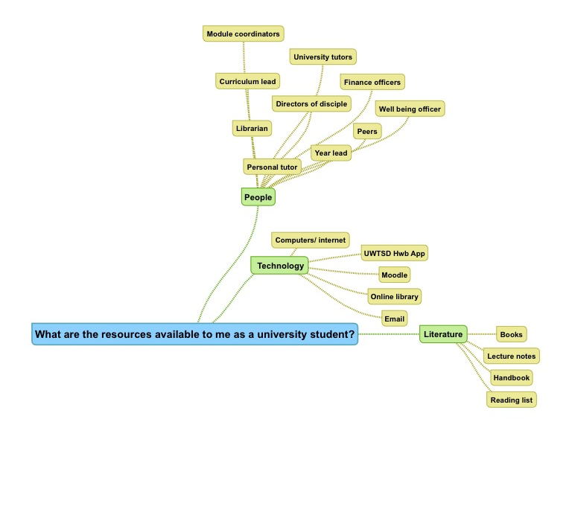
Create a digital mind map of all the resources available to me as a university student.

Portfolio Task 1-Developing your skills: vision of success as a student-teacher.

Complete a Current Skills Audit.
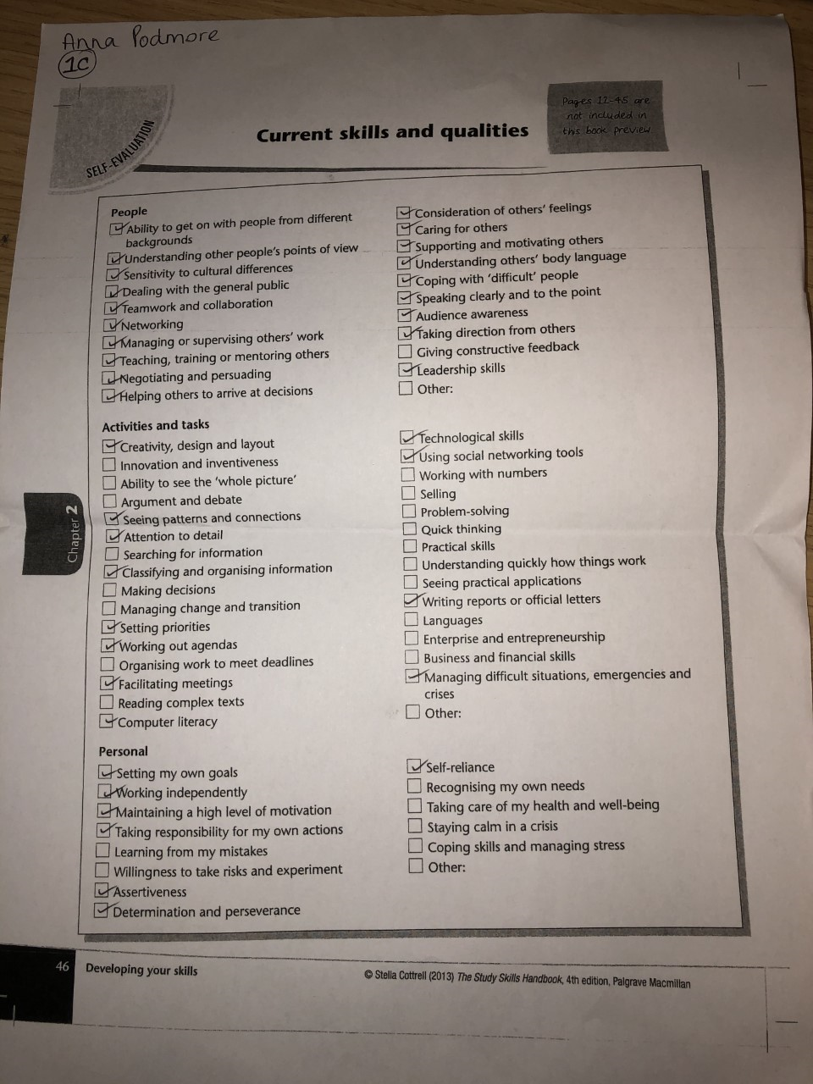

Portfolio Task 1- Developing your skills: vision of success as a student- teacher.

What success would look like for me.

Success for me would be becoming a student who achieves and excels in all aspects of learning; and becomes an outstanding teacher. I have a very focused and driven aim of qualifying to teach, but also to embrace all that is necessary to arrive there. I have worked in schools and education settings for the past six years, but I finally now feel ready and equipped to master an expertise in teaching.
After reflecting on my skills audit, there are areas of my current skills and qualities that I need to invest time, thought and energy into developing. For example, I know that I can sometimes find it challenging to take risks and experiment- I find it easier and more comfortable to stick to what I know. I understand that this will not be effective whilst studying to become a successful teacher as I will need to show willingness to try new ideas when it comes to encouraging pupils to become ‘ambitious and capable learners’ (Donaldson, 2015) in my classroom. To succeed in this area, I will need to utilise the resources around me, for example, by taking the time to research and undertake extra reading to find innovative and original ideas rather than simply drawing upon what I already know.

Portfolio Task 2- Developing Critical Thinking.

Developing Effective Analysis and Argument By Stella Cotrell Summary.

Stella Cotrell unpacks and explains the idea of Critical Thinking in her text ‘Critical Thinking skills: Developing Effective Analysis and Argument’ (Cotrell, 2005). Cotrell begins the chapter by introducing learning outcomes of the text. These are to:
- Understand what critical thinking is
- Recognise some of the benefits associated with critical thinking.
- Recognise the personal qualities associated with critical thinking
- Recognise barriers to the development of good critical thinking skills
- Assess your current understanding of critical thinking and identify your priorities for improvement (Cotrell, 2005)
Cotrell firstly explains critical thinking by discussing the two dispositions of scepticism and reasoning. She encourages people that in order to think critically, we should ‘use the tools of scepticism and doubt to analyse’. (Cotrell, 2005, p. 2) This does not mean that we should never believe things we hear or see but instead constructively analyse and assess whether something is legitimate. Cotrell tells us that we will be able to think critically by knowing and using our own reason to ‘analyse evidence and draw conclusions from it’ (Cotrell, 2005, p. 3).
There are many benefits of critical thinking in both professional and everyday life. Cotrell informs us that critical thinking is not a quick process because of its precision, but nevertheless will help to discover what is accurate, specific and relevant.
Cotrell suggests that people may already posses underlying thinking skills such as categorising, differentiation and comparison, but that these skills are not enough alone and need to be supported by knowledge and research of a subject. Cotrell also explains that critical thinking can ‘engage emotions and even passionate responses’ (Cotrell, 2005, p. 5) and that it is important to manage emotions when people may disagree with your ideas by staying calm and logical to put across your view convincingly.
The text states that it is essential to establish the influences that affect our judgement by being self-aware. Cotrell explains that becoming self-aware can be challenging, especially when belief systems are questioned but that it is imperative to be self-aware in order to think critically.
Cotrell describes critical thinking in academic contexts and how it is important to develop understanding as a student via critical debates, presentations or writing. Upon reflection, I personally find it easy to be occasionally narrow-minded and not explore or dig deep with gaining further knowledge and simply rely upon what I already know.
Cotrell unpacks some barriers to critical thinking. She explains how there is a negative connotation to criticism and that can sometimes stop people making critical comments. Our thinking habits are another potential barrier as our thoughts can run automatically without reason. Cotrell suggests how some may be reluctant to think critically because it feels disrespectful to critique someone who has greater knowledge than yourself, but Cotrell reminds us that we can still find an argument to be good, despite not always agreeing with it.
To conclude, Cotrell encourages the reader to reflect upon their own critical thinking skills, knowledge and attitudes. She clarifies how to prioritise for action on areas that are needed to improve upon to develop critical thinking abilities. Having self-evaluated, I can see that I most definitely need to develop my critical thinking skills and the most urgent and essential action I need to complete, is to apply critical thinking when taking notes.

Portfolio Task 3- Developing Critical Writing.

What I think about Education in Wales.

Education in Wales, I believe, is about to embark on one of the most significant and trajectory- changing moments it has ever seen. From reading and researching about the upcoming Curriculum Reform, I think that it is going to shape and define young peoples’ education across Wales in an impacting and powerful way.
The report titled Successful Futures (Donaldson, 2015) tells us that it seems the reasons for the changes being made within Wales’ education system is due to ‘concerns about perceived shortcomings in the present curriculum and assessment arrangements.’ Kirsty Williams, the Cabinet Secretary for Education, supports the idea that changes need to be made to ‘raise standards and reduce the attainment gap’ (Williams, 2017).
Having read sections of Professor Graham Donaldson’s report, it seems that the changes that are about to be undertaken within education in Wales are going to build an exciting new phase in the history of Welsh Education. Donaldson’s hopes for the new curriculum are to develop ‘ambitious capable learners’, ‘ethical informed citizens’, ‘enterprising, creative contributors’ and ‘healthy, confident individuals’ (Donaldson, 2015). I think that these statements are inspiring and encapsulate what it means to prepare young people for their future adult lives. As a student teacher, I also think that having these four purposes of the curriculum to refer to when preparing and delivering lessons and teaching material is a helpful reminder and guide.
Donaldson has also divided the contents of the new curriculum into six areas of learning and experience (AoLEs): Expressive Arts, Health and Well-being, Humanities, Languages, Literacy and Communication, Mathematics and Numeracy, Science and Technology (Donaldson, 2015). A guide to Curriculum for Wales 2022 (Government, 2019) states that the purpose of these AoLEs is ‘designed to operate together as part of a holistic curriculum.’ I can understand and appreciate that ensuring the AoLEs are not to become ‘watertight compartments’ (Government, 2019) is essential to creating a curriculum that helps pupils to understand the connections between areas and relevance of learning.
Nigel Newton, a research associate at Wales Institute of Social & Economic Research, Data & Methods, Cardiff University, is working on a Welsh-government funded project which researches and discovers the possible effects of curriculum reform in Wales, specifically with young people who come from underprivileged backgrounds. He shares his thoughts in the online article ‘Hopes and fears: The development of a new curriculum in Wales’ (Newton, 2018). After discussing the new curriculum reform with teachers from pioneer schools, Newton (2018) discovered that some of those teachers believe they are ‘providing a more engaging and relevant education to pupils’. I would agree that it seems the ideas suggested by Donaldson for the new curriculum are indeed both engaging and relevant for learners, as the framework has a significant focus on making the education of leaners applicable and transferable into the real world.
In summary, Education in Wales is modifying its curriculum with the interest of learners becoming equipped for adulthood and the ever-changing world. I think that Wales is entering into dramatic advancement for its education system and it is exciting to watch it unfold, develop and succeed.

References
Cotrell, S., 2005. In: Critical Thinking Skills: Developing Effective Analysis and Argument. s.l.:Palgrave Macmillian , pp. 1-16.
Donaldson, P. G., 2015. Successful Futures. [Online]
Available at: https://moodle.uwtsd.ac.uk/pluginfile.php/315883/mod_resource/content/1/Successful-futures.pdf
[Accessed 29 October 2019].
Government, W., 2019. A guide to Curriculum for Wales 2022. [Online]
Available at: https://hwb.gov.wales/draft-curriculum-for-wales-2022/a-guide-to-curriculum-for-wales-2022
[Accessed 4 November 2019].
Newton, D. N., 2018. Hopes and fears: The development of a new curriculum in Wales.
Williams, K., 2017. Education in Wales: Our national mission, s.l.: Welsh Government.

