Programme: BA Business Management
Module: Introducing the Modern Workplace

Individual reflective report

Student ID:2124369

Contents
Introduction 3
Gibb’s Reflective Model 3
Kolb’s Reflective Model 4
Conclusion 6
Referencing list 6

Introduction

Every individual has to identify their areas of strength and weakness in order to have dreams and aims as well as to be more successful and satisfied with the results. It is very beneficial for me to analyze and observe my personality and to carry out various forms of self-evaluations in order to identify what must be altered and corrected so that I can accomplish more in my work, continuing to obtain information, analytical, as well as in my profession. In order to assess my skills, ways of thinking, study methods, challenges, and room for progress, self-reflection is an essential tool (Rimmer,2018).

Gibb’s Reflective Model

Working as part of the team and delivering presentation as part of the group efforts was very productive and development activity to complete. My team skills and experience needs to be improved so I can deliver more results for my future employment. Most of the companies targets are linked and involving team work and the actual objectives can be achieved only within the team work. The whole situation impacted me strange way, because it took time until we dedicate specific tasks for each team members so at the end the whole work can be done properly, as per the expectations and with good quality. For some of the team members took more time than expected and they need it more explanations and support, but this learned me that the team help and support to each other is very important and critical for the team performance and achieving the targets (Duran,2020).
In my future works I am feeling more confident what and how to do and how to organize the team if I am the leader in order to be achieved the final target and also to make every team member more confident and secured that he can do the tasks and there are always other team members support for him.
Figure 1
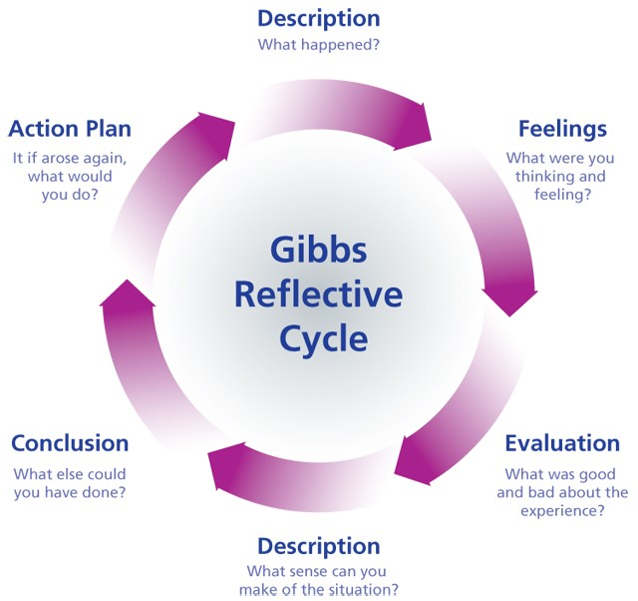

Kolb’s Reflective Model

When I use and implement the Kolb’s reflective model into our team work and my reflection I can see how the different team members used their personal experience and knowledge different way when comes to completing the task. The observation, evaluation and reflection over the team work experience for completing the task one is very useful and effective activity, because it gives me also specific point for improvement, actions and development based over the past experience (Lomas,2015).
As per the figure 2 the concrete experience is the completing the task one, next step is the reflective observation where is completed analysis and observations and then to be find ways for future improvements and in the active experimentation stage there is need of implementing the changes as per the experience, mistakes and outcomes learned from the self-reflection (Locke,2015).
Completing only self-reflection is not enough for delivering better results and progress into the person future tasks or team works. The most important part is the extracting important and developing conclusions and decisions so they can contribute for much better and improved results into the next available tasks with delivering maximum productivity and results when comparing with the first task.
Using Gibbs and Kolb’s methods helping for better understanding of the importance of the each stages of the reflection and then setting proper development plan with specific deadline and target objectives for improvement. This is great way to understand what and how you can improve for your successful future and at the same time to also learn from the mistakes of others to gain more knowledge from their experience and this will lead to your higher improvement and results.
After the first few courses, I begin to observe and understand more about motivating employees, various theories, and what elements have an affect on that degree of motivation. After understanding the theories and using the examples, I came to my own judgments about the choices I should make in the future and the steps I should take to advance in my ability to inspire others to their highest levels and keep them giving the best outcomes possible for the business.

Figure 2

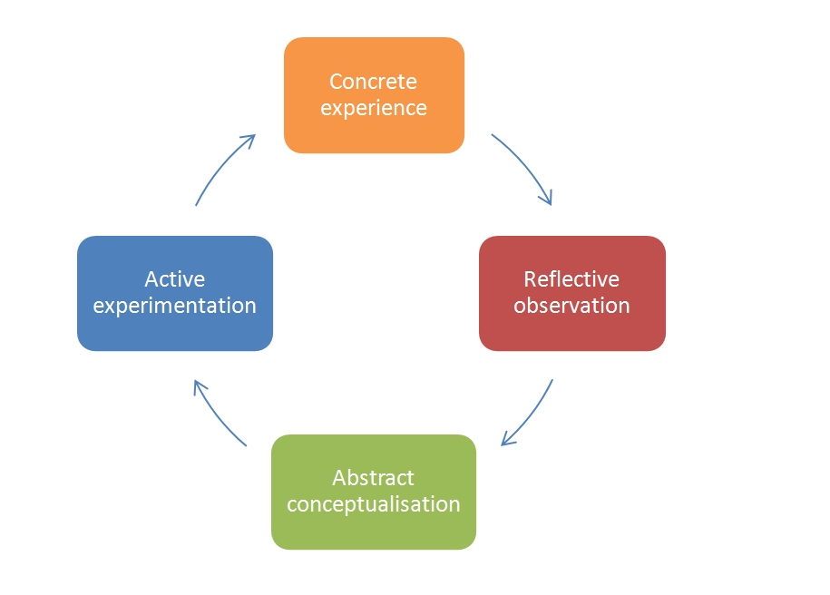

Conclusion

Personal reflection is crucial to me, and I gained knowledge and abilities that will help me improve. When I register for a job opportunity, I will use the knowledge and abilities that have been offered for my advantage, and I am confident that I will have competitiveness over other applicants who may not have understood the academics and high labor as well. Since I'm now aware of what I must learn in order to be among the top candidates for the positions I want, I can progress correctly with sufficient focus and future outcomes.

Referencing list

Kennett, P. and Lomas, T., 2015. Making meaning through mentoring: Mentors finding fulfilment at work through self-determination and self-reflection. International Journal of Evidence Based Coaching and Mentoring, 13(2), pp.29-44.
Özer, B., Can, T. and Duran, V., 2020. Development of an Individual Professional Development Plan Proposal That Is Based on Continuing Professional Development Needs of Teachers. European Educational Researcher, 3(3), pp.139-172.
Porter, J., 2017. Why you should make time for self-reflection (even if you hate doing it). Harvard Business Review, 21.
Rimmer, A., 2018. How do I prepare a personal development plan?. Bmj, 363.
Schunk, D.H. and DiBenedetto, M.K., 2020. Motivation and social cognitive theory. Contemporary Educational Psychology, 60, p.101832.
Serrat, O., 2021. Personal leadership development plans: Essentials and practicum. In Leading Solutions (pp. 19-26). Springer, Singapore.
Travers, C.J., Morisano, D. and Locke, E.A., 2015. Self‐reflection, growth goals, and academic outcomes: A qualitative study. British journal of educational psychology, 85(2), pp.224-241.
Wilby, J., 2020. Motivation, self-regulation, and writing achievement on a university foundation programme: A programme evaluation study. Language Teaching Research, p.1362168820917323.

