

University name University of Wales Trinity Saint David
Student name: Cocea Florentin
Student ID:2134142
ID module: LCBB5005
Module name, assesstment number: Project Management - Assessment 1
Lector name: Xavier Matieni

Table of Contents
Introduction 3
Project scope 3
Budget assumption 4
Assumptions 4
Constraints 5
Stakeholders’ involvement 7
Project organisation structure 8
Project control mechanisms 10
Reporting framework 10
Project planning with milestones 11
Conclusion 11
References 14
Appendices 17
Appendix 1: Team meeting at King’s Cross 17

Introduction
The upcoming project of Google deemed with the aim of establishing a new headquarters (HQ) at King’s Cross, London can be a significant endeavour requiring a comprehensive review of various core elements. The key focus of this assessment is to focus on the budget, quality, stakeholders, timeline, and risk factors. The project has a huge scope to draw the attention of the people of the UK and also foster employability. Sustainability and environmental-friendly approaches are mention-worthy with green building certification, and acquiring LEED, and BREEAM criteria of the project. The project's core objectives are to provide a sustainable, flexible workplace across King’s Cross with sophisticated employability.
Apart from these, the project has an objective of platform G development that augurs well with sustainability concepts. Apart from these, maintaining a good relationship with the stakeholders, investors, and business partners is effective in achieving the key goal of the project. Along with these, project control mechanisms, and budget assumptions are important factors. Technological improvements, and management of various operational, and strategic risk management are highly effective in being removed from the organisational goals, and objectives. Henceforth, the project has significant milestones while setting up the HQ at the heart of the UK.

Project scope
The key objective of the project is to enhance employability by taking the cream of the crops from the UK as the new HQ would make the work exciting. The dynamic self-image of the company would be heightened with the establishment of this long-coveted HQ. The sustainable and flexible workplace will be curate for and by the local community. While the parameters are concerned, the support of Google for the local community is of immense significance. The vibrancy and entrepreneurship will also be considered with a sustainable, carbon-free future. The real-estate values and production of space ultimately lead to a beacon of 21st-century urbanism (Robin, 2022). The floor plans depict a “wellness centre” comprising gyms, sports activities, and MUGA.
The technology giant moved to the UK following a £1bn property deal although other associated costs are not disclosed by Google. The objective of this property deal is also to offer a green space with a densely planted outdoor roof garden providing a habitat for various protected species of birds, and bats as it collaborated with the borough of Camden and London Wildlife Trust. It is expected that the project can achieve passive and active environmental design considerations with LEED GOLD, and BREEAM Excellent ratings (Standard.co.uk, 2022.). Hence, a spontaneous nature of the work, and collaboration of people is expected to deliver richness.

Budget assumption
A colourful office space has been bought by Google in London for £1 billion and there was an unnecessary delay on the heavily-delayed UK HQs for completion. This £1bn project is also known as the “Zone a Building'' that provides 80,820 square m of space for the tech giant. In this regard, a construction value of more than £600m is estimated whereas £400m for the sale (Constructionnews.co.uk, 2017). Moreover, £200m of the budget is estimated for the fit-out of the project as the new building can bring all the employees under a roof. Furthermore, Google collaborated with AHMM to redesign the plans with £300m to be built by Bam Construct.

Assumptions
This can be a top-notch business opportunity for Google as it set up its HQ in London which is the first wholly-owned building outside the US. The 11-story building comprises more than 65,000 million sq ft. and was designed by BIG or Bjarke Ingels Group to house 7000 Google employees. Besides, the landmark “Platform G” developmentof Google will arrive in London by 2024 where a BIM model is used (Brill and Conte, 2020). This project is designed by Heatherwick Studio with a low-rise scheme. The currently built 60,000-metre square wedge-shaped landscraper stretches 330 metres along the length of the pedestrianised boulevard that connects Granary Square with a swimming pool, and a running track (The Guardian, 2022).
While BIM is considered, CLT or cross-laminated timber was used and Atelier Ten was the base-build engineer of the project. Along with these, the orientation of the facade is grandiose as the project deftly dealt with the facade-generated cooling, and heating load whereas the internal office spaces offered computational fluid dynamics or CFDs. VAVs or variable air volume boxes are bound to monitor the airflow volumes. Besides BIM, a chiller approach was carried out where high-efficiency Turbocor water-cooler chillers provided cooling. However, the deadlines of the project and budget allocation are still wishy-washy for the purpose-built building at the moment.

Constraints
Setting up an important project like this is swamped with certain risks which are summarised below.
Risk register
Risk ID | Description | Chances | Impacts | Sharpness | Owner | Actions needed to minimise
1 | Operational risks due to communication barriers and cross-culture. | Medium | Medium | Low | Team leaders and management | Getting rid of cross-cultural conflicts to improve communication strategies. SCRM or supply chain risk management augurs well to evaluate the operational risks ( Pournader et al. 2020)
2 | Financial risks because of incorrect panning | Medium | Medium | High | Finance department | Adepts in finance need to be employed
3 | Strategic risks due to scarcity of knowledge in execution | Low | High | Medium | Project coordinating body | Fruitful training and decision-making processes can solve this issue
4 | Technical risks may be there while implementing networking structures such as LAN, MAN, or WAN. | Low | Medium | Low | IT department | Increasing the speed, and installation of updated systems, and adhering to cyber security laws can solve this issue (Lee, 2020)
5 | Environmental risks can appear due to adverse weather, and natural calamities | Low | Medium | Medium | Team management | Proper weather forecast and taking necessary measures can be useful
6 | Administration risks because of inappropriate, unethical, or improper actions | High | High | Medium | Board of control | Identification, evaluation, and above all prioritisation of risks are effective to be dealing with (Darko et al. 2020)

Table 1: Risk register
The above table highlights the presence of various risks or constraints that may crop up while Google is all set to establish its new HQ at King’s Cross. Of these risks, technological, and financial risks are the major constraints which need to be deftly handled. Therefore, essential project management skills are needed to refrain from such issues.

Stakeholders’ involvement
Stakeholder analysis and their involvement of them are crucial factors for the development of any project. Besides, the changing demand of the customers can be mitigated through the stakeholders and the project can be managed. Above all, meeting stakeholders’ expectations can aid in minimising the negative influences that are the barriers to the project with a good hand. Along with these, good management can help to communicate properly with the stakeholders for an improved outcome of the project (Adelfio et al. 2021). Aside from these, the necessary resources can be collected while there is a good rapport with the stakeholders. The common goals can be set to meet the market demand followed by achieving them.
HIGH
POWER
POWER
LOW

Figure 1: Stakeholder mapping
(Source: Kain et al. 2022)
The above figure gives a view of the stakeholders involved in the project. In this context, it can be said that the internal stakeholder are employees, users, investors, and technological suppliers. On the other hand, the UK government, regulating bodies, UK media vendors, and project sponsors are the external stakeholders. Bjarke Ingels Group and Heatherwick Studio constitute the external stakeholders as they were involved in the design of the project (Dağ Gürcan and Gürcan, 2020). The maximum attention is to be given to the UK government, technical suppliers, and project sponsors as sans collaboration, the profitability would not be achieved. Lastly, the data management process can also be heightened while a good rapport is maintained with the stakeholders and also to make this project an eco-friendly one.

Project organisation structure

Thomas Kurian
CEO, Google Cloud
Ruth Porat
CFO
CEO
Sundar Pichai
Fiona Cicconi
Chief People Officer
Jerry Discler
President, Cloud Applications
Phillip Schindler
SVP, Chief Business Officer
Rick Osterloh
SVP, Devices & Services
Kent Walker
President, Global Affairs
Prabjakar raghavan
SVP, Search, Assistant & Ads
Jeff Dean
SVP, Google Research & Health
Jeff Markowitz
VP, Talent Advisor to the CEO

Figure 1: Organisational structure of Google
The above organisational chart describes the current status of Google in terms of the hierarchy. Sundar Pichai, taking the pole position is the CEO of the organisation. He is the highest-ranking executive to set the overall strategic direction of the organisation. The position of CEO of Google Cloud is focused on cloud computing services. Kent Walker oversees the legal matters, and global affairs of Google. The CFO is accountable for the financial health of the organisation whereas the human resources are taken care of by the chief people officer (AlHamad et al. 2021). The position of SVP, chief business officer includes identification of novel business opportunities, overseeing business initiatives, and developing partnerships. Furthermore, the online advertising platforms of Google are taken care of by SVP, search, ads and assistant. SVP, devices, and services leads the product innovation aspects of Google followed by management of the overall ecosystem. Jeff Dean oversees the research initiatives of Gogle in several domains along with emerging technologies. Finally, talent-related matters are dealt with by the talent advisors to guide talent acquisition aligned with company goals.

Project control mechanisms
Bjarke Ingels Group and Heatherwick Studio deftly handled the project design from the beginning and Atelier Ten was the build engineer. WysePower collaborated with the project from its beginning regarding site services installation, and proposed pipe, and cable routes. The £1 billion investment is a long-term commitment from the tech giant. The strategic asset and facilities management consultancy team provided the operational cost that enabled Google to plan during the operational phase and design decisions. The area of King’s Cross is an amalgamation of unique building types, and railway stations are the most connected points in London. The project as an infrastructural excellence was controlled by quality flexibility and interchangeable elements.

Reporting framework
The master plan of the project emerged from the integrity patterns of King’s Cross and across the development, the engineers, and BIG communicated in a well-structured way to foster a fruitful outcome. The sourcing of the materials was carried out through the Healthy Materials program of Google. Moreover, there was fruitful communication between the landowners namely “London & Continental Railways Limited and Excel” or DHL for approval (AbdelShakour Ali et al. 2020).

Project planning with milestones
The entire project is deemed with the aim of reaching a global crowd with the perfect mix of shininess, and grittiness simultaneously for a creative future. The 11-story building would provide more than 76,000 sqm. of space for offices along with 11,054 sqm. of basement area to provide a sophisticated working environment (Koivuniemi, 2024). Moreover, a unique feature of this project is the inclusion of cutting-edge technologies, and healthy indoor finishes by promoting the well-being, and health of the occupants while using LEED, BREEAM criteria. Furthermore, the innovative workplace-desk concept is carried out by warehouse-style floor plates that hang from the above
Green building certification is another milestone of this project with the sustainability design team and the commitment of multidisciplinary consultancy firm Mott MacDonald to achieve ‘Platinum’, and ‘Outstanding’ ratings. Besides, a large vegetated roof with 3800 sqm space including a lawn and windflower plantation provides exclusive outdoor amenities, and biodiversity as well (Leiringer, 2020). Energy efficiency and passive design techniques with concrete ceilings helped maintain the internal temperature effectively. Additionally, the mechanical ventilation system is fitted with heat recovery that reduces the chances of additional heating with centralised ventilation plans. Lastly, the open-plan office areas offer energy-efficient under floor and air displacement ventilation.

Conclusion
From the above study, it can be concluded that the sophisticated concept of Google to set up the HQ at King’s Cross gained significant attention from the people. Furthermore, the involvement of BIG and Heatherwick Studio has also been effective in order to manage the entire project by far. In addition to these, there may be certain kinds of constraints while setting up the projects in the form of operational, strategic, financial, and technical risks which are supposed to be mitigated. The chiller approach, BREEAM rating, and grandiose facade of the project are valuable in terms of £1 billion investment in the entire project.
Recommendations
Recommendation 1: Teamwork
Proper teamwork is the order of the day while the HQ setting up is on the way. In this context, as imprinted by Yapiet al. (2020), Teamwork is a vital ingredient in project management to cater to the needs of communication, leadership, and maintenance of job roles. Moreover, project-based learning, project delivery, and above all construction can be achieved successfully. For this reason, Google can set their teamwork where the roles, and responsibilities are categorically divided for flawless execution of the project in a timely manner. Lastly, TOE or “Technology, Organisation, And External Environment” can also be controlled with proper team management.
Recommendations 2: Building a diverse team with cross-culture mitigation
Delving into the culture of the organization is a vital need which is required to be followed. For this reason, Google needs to adopt a cross-cultural approach to get the insights of the location. Additionally, it is also recommended that the discrimination that might take place at the workplace must be removed while working with a diverse team Adler and Aycan (2018). Along with these, tactical avoidance, and creative compromise are invariably linked to the core business aspects to lead a successful team. Lastly, the problem-solving skills of the team can get a real boost when there are diverse thinking and team members.
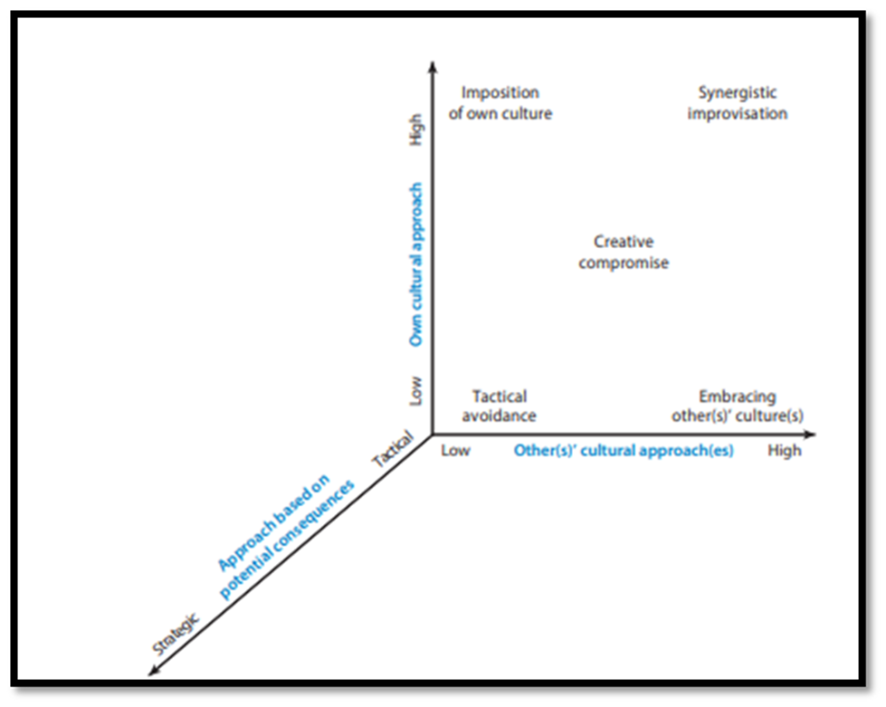
Figure 2: Cross-cultural interactions
(Source: Adler and Aycan, 2018)
Recommendations 3: Technological innovation
It goes without saying that technological integration is the most important aspect of this technologically advanced world. With higher efficiency and security measures, Google can have a better customer experience. It is also recommended that innovation and quality improvement are the critical factors which are aligned with technical innovation. This can help in cost reduction in an effective manner while earning profit for the organisation. Apart from this, El Khatib et al. (2022) claimed that the aspects of “e-governance” can also be achieved with technical innovation with cutting-edge technology. In essence, technological innovation can give Google a competitive advantage in terms of knowledge sharing, robust security, and efficiency.

References
AbdelShakour Ali, H., Hassan Elborombaly, H.E. and Maarouf Ahmed, D., 2020. ECONOMIC DEVELOPMENT OF HISTORIC DISTRICTS THROUGH ADAPTIVE REUSE:[THE CASE STUDY OF KING'S CROSS REGENERATION PROJECT IN LONDON, UK]. International Journal of Multidisciplinary Studies on Management, Business, and Economy, 3(1), pp.10-13.
Adelfio, M., Hamiduddin, I. and Miedema, E., 2021. London’s King’s Cross redevelopment: a compact, resource efficient and ‘liveable’global city model for an era of climate emergency?. Urban Research & Practice, 14(2), pp.180-200.
Adler, N.J. and Aycan, Z., 2018. Cross-cultural interaction: What we know and what we need to know. Annual Review of Organizational Psychology and Organizational Behavior, 5, pp.307-333.
AlHamad, M., Akour, I., Alshurideh, M., Al-Hamad, A., Kurdi, B.A.R.N. and Alzoubi, H., 2021. Predicting the intention to use google glass: A comparative approach using machine learning models and PLS-SEM. International Journal of Data and Network Science, 5(3), pp.311-320.
Brill, F. and Conte, V., 2020. Understanding project mobility: The movement of King’s Cross to Brussels and Johannesburg. Environment and Planning C: Politics and Space, 38(1), pp.79-96.
Constructionnews.co.uk, 2017. Google wins backing for £600m King’s Cross HQ. Available at: https://www.constructionnews.co.uk/project-reports/google-wins-backing-for-600m-kings-cross-hq-11-08-2017/ (Accessed on 1 April, 2024)
Dağ Gürcan, A. and Gürcan, H.E., 2020. Darwinian Approach and Mutations: Bjarke Ingels (BIG) and Analysis of His Stepped Pixels Buildings.
Darko, A., Chan, A.P., Yang, Y. and Tetteh, M.O., 2020. Building information modeling (BIM)-based modular integrated construction risk management–Critical survey and future needs. Computers in Industry, 123, p.103327.
El Khatib, M., Al Mulla, A. and Al Ketbi, W., 2022. The role of blockchain in e-governance and decision-making in project and program management. Advances in Internet of Things, 12(3), pp.88-109.
Kain, J.H., Adelfio, M., Stenberg, J. and Thuvander, L., 2022. Towards a systemic understanding of compact city qualities. Journal of Urban design, 27(1), pp.130-147.
Koivuniemi, M., 2024. Sustainable headquarters’ buildings: A multiple case study on multinational corporations in sustainable cities.
Lee, I., 2020. Internet of Things (IoT) cybersecurity: Literature review and IoT cyber risk management. Future internet, 12(9), p.157.
Leiringer, R., 2020. Sustainable construction through industry self-regulation: the development and role of building environmental assessment methods in achieving green building. Sustainability, 12(21), p.8853.
Pournader, M., Kach, A. and Talluri, S., 2020. A review of the existing and emerging topics in the supply chain risk management literature. Decision sciences, 51(4), pp.867-919.
Robin, E., 2022. Performing real estate value (s): Real estate developers, systems of expertise and the production of space. Geoforum, 134, pp.205-215.
Standard.co.uk, 2022. New pictures of £1bn Google HQ bringing retail parade, community space and rooftop running trail to King’s Cross. Available at: https://www.standard.co.uk/homesandproperty/property-news/google-hq-new-office-kings-cross-london-plans-b994436.html (Accessed on 1 April, 2024)
The Guardian, 2022. Behold London’s ‘landscraper’! Google’s new UK HQ – as long as the Shard is tall. Available at: https://www.theguardian.com/business/2022/jul/01/behold-londons-landscraper-googles-new-uk-hq-as-long-as-the-shard-is-tall (Accessed on 1 April, 2024)
Yap, J.B.H., Leong, W.J. and Skitmore, M., 2020. Capitalising teamwork for enhancing project delivery and management in construction: Empirical study in Malaysia. Engineering, Construction and Architectural Management, 27(7), pp.1479-1503.

Appendices

Appendix 1: Team meeting at King’s Cross
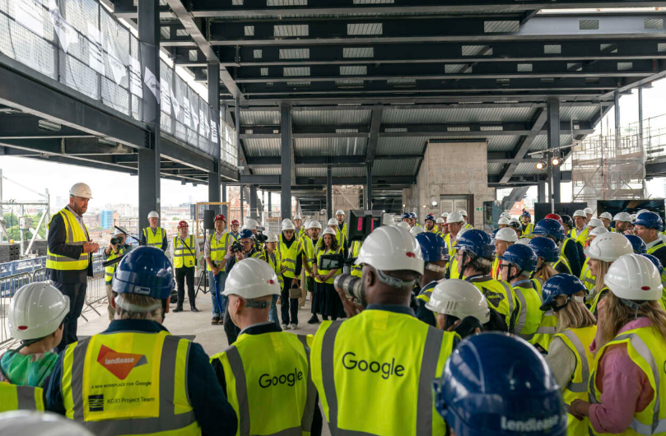
(https://www.gillespies.co.uk/news/google-headquarters-in-kings-cross-tops-outs)

