Analysis of Data

Chapter 4.0 – Introduction
The aim of this chapter is to complete the fourth section of this dissertation, conduct the primary research. With the completed research, the researcher then analysed the results and information gained to establish if this research has successfully answered the themes set out in the previous chapters and if any further gaps in the research has been identified for further investigation in the future.
4.1- Demographic
The researcher has conducted a survey consisting of 19 questions that was put to 43 police officers, with service ranging from 1 year to over 17 years as a police officer, this will gather a broad range of information from these officers, which will have an age range of 18 to over 50 years old. The researcher believed that this information was relevant to establish the experience of the officers taking part in this study. The survey was completed anonymously to ensure there would be no data protection breaches whilst also giving the participants the freedom to answer honestly and openly.
4.2 – Survey
The survey has been completed to answer the themes established in the proposal, which were:
- How do police officers remain calm whilst attending stressful incidents?
- What are the main contributors of work-related stress and poor mental health?
- What do police officers do to de stress and wind down?
- Has the participant considered leaving the police in the last three years?
A web-based survey was chosen as this provides a safe and secure method of obtaining and storing the results, which is quick and easy to share meaning it causes minimum inconvenience to the participant, which in turn encourages responses.
Most questions had pre-decided multiple choice based, with a minority of “free text” options for participants to express their own thoughts, feelings and experiences.
The chosen website, Survey Planet, automatically collates the results as they are collected and converts these into pie charts giving the result both in a percentage and a number.

4.3- Results
Within this Chapter the results of each theme will be analysed with all relevant statistics detailed in the corresponding theme.

4.4– Theme One
How do police officers remain calm whilst attending stressful incidents?
Questions 8 and 11 were the most relevant to this answer this theme.
Question 11 allowed for multiple answers to be given, since the nature of policing the incidents that officers attend will vary as does the level of stress. But the results appear to be quite a strong indication that officers rely on their own experiences and that of the colleagues to remain calm. 34 of the 43 respondents answered with “Teamwork with colleague”, this demonstrates how key a good working relationship and trust in each other is. With 26 of the participant’s stating “experience” is how they effectively manage their stress levels in a difficult incident, the researcher understands that to mean as officers gain more experience they de sensitise to the incidents and it therefore effects them less.
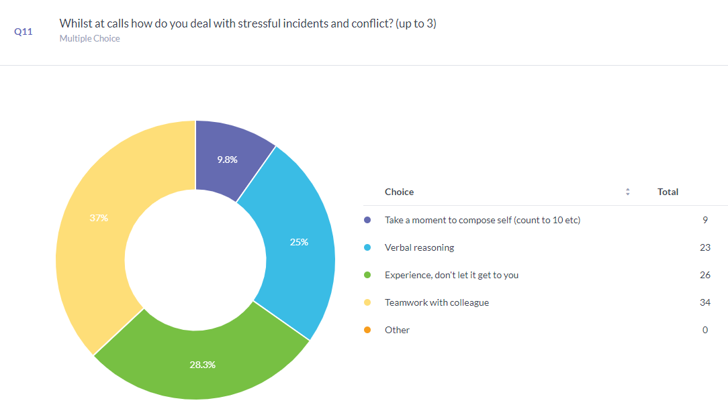

Question 8 was simply a yes or no answer. Almost 84% of respondents stated that they believed they were not adequately trained for the incidents that they attend. This in part can be associated with the rise in mental health calls that officers now attend. According to Dennis Campbell (2020), The number of such 999 calls in England has increased by 41% in the last five years, with some police forces seeing more than a twofold increase since 2015.

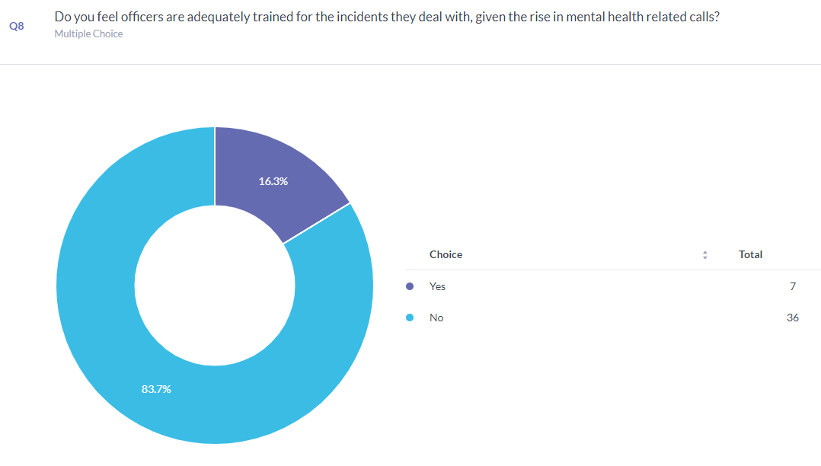

4.5 Theme 2
What are the main contributors of work-related stress and poor mental health?
Question 7 aimed to establish what officers deemed as the biggest contributors to work related stress, with the two highest responses being “Workload” and “Not enough officers to deal with demand”. Figures published in December 2022 show that there were approximately 172,000 officers in England and Wales in 2010, but despite the governments pledge of 20,000 extra officers, in 2022 there 164,000 police officers (Clark, 2022). So this study supports that. The researcher found it intresting that 19 of the 43 particpants (44%) stated that completing a degree at the same time as being police officer contributed to their elevated stress levels. Given the range of service of the particpants, it would be interesting to establish the level of service of the officers who selected that option? Was it all off them?. It is also worth noting that question 15, Do you feel that you need a degree to be a good police officer?, all 43 participants said they do not feel a degree is necessary to be a good police officer.

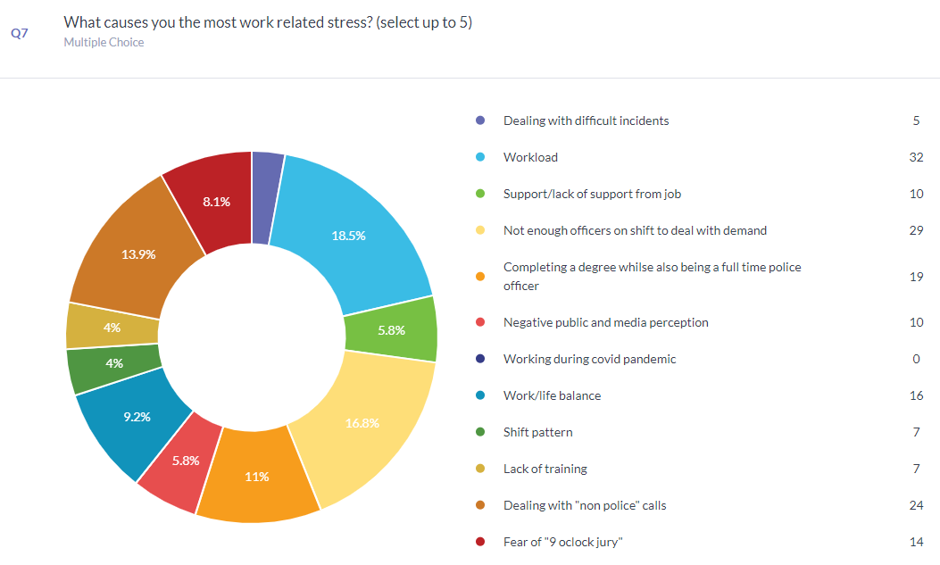
Questions 18 & 19 aimed to gauge if the officer felt appreciated for the hard work that they do and the stress they suffer to ensure that the public get the best possible service. 53% of police officers stayed that they felt appreciated by their supervisors, but rather worryingly over 81% felt that they were no appreciated by the general public, the people in which they serve.
As a sub point to this, the researcher deemed it appropriate to establish what would help to improve officers mental wellbeing with 32 participants stating a payrise would help. There has been a blanket pay freeze for two years an in real terms, since 2010 there has been a 20% pay cut (Parkes, 2022).
4.6 – Theme 3
What do police officers do to de stress and wind down?
Question 12 aimed to establish how police officers destress in their own time. This is vital as officers can be exposed to incredibly horrible situations that will take their toll mentally, so to avoid burnout, police officers must stay on top of their own mental health and recognise if and when others are struggling. 31 officers stated that spending time with their family helped them de stress, with 23 believing that exercise was key to staying mentally fit. It is proven that physical exercise improves mental well being (Mental Health Foundation, 2022).
Most surprisingly, only 8 responded with alcohol helping them to destress. Given the negative perception in the press of the police having a drinking culture and the stereo type of a police officer, the researcher found this to be a positive surprise.

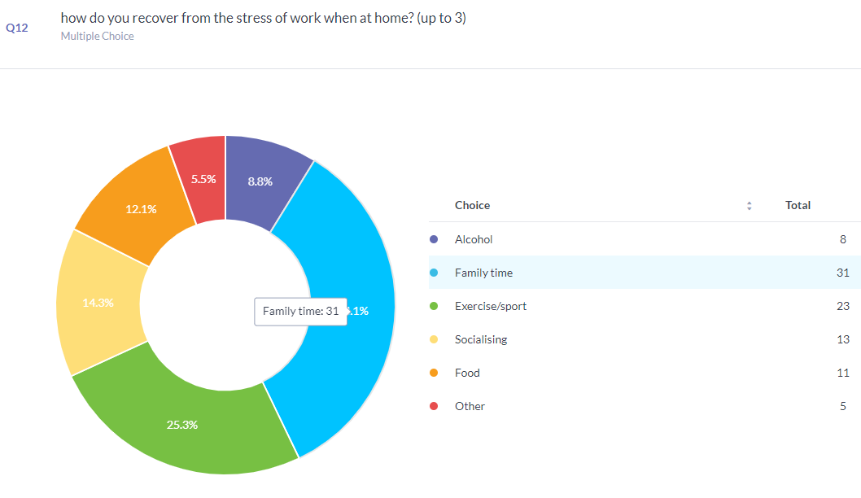

4.7 Theme 4
Has the participant considered leaving the police in the last three years?
Questions 4, 5 and 13 were most relevant in this theme.
This was a straightforward yes or no question, which the researcher has found reassuring as despite the negativity of the stress, high workload, and low pay 86% of the responding officers stated that they enjoy the job.
58% of those surveyed have not considered leaving the police. With 58% also indicating that they would recommend joining the police to friends or family.
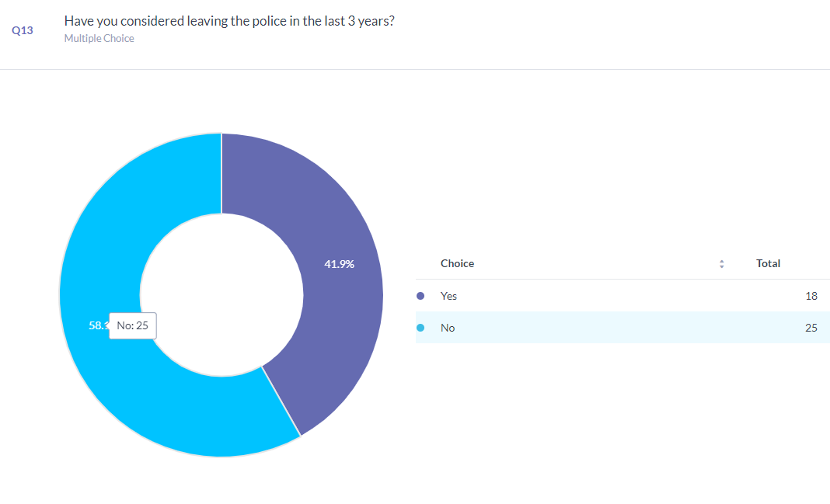
4.8 Conclusion
To conclude this chapter, it has detailed and explored the findings of a survey designed by the researcher and shared with fellow police officers. These have been detailed in graph format and further explained. These results are particularly important as they are formed by the opinions and experiences of current serving officers.

Word count:1175

Bibliography
Campbell, Dennis. (2020) “Police 999 Callouts to People Suffering Mental Health Crises Soar.” The Guardian, 18 Oct. 2020, www.theguardian.com/society/2020/oct/18/police-999-callouts-to-people-suffering-mental-health-crises-soars. Accessed 30 Jan. 2023

Clarke. “UK Police Officer Figures 2022.” Statista, 2022, www.statista.com/statistics/303963/uk-police-officer-numbers/#statisticContainer. Accessed 30th Jan 2023

Mental health foundation. “How to Look after Your Mental Health Using Exercise.” Www.mentalhealth.org.uk, 2022, www.mentalhealth.org.uk/explore-mental-health/publications/how-look-after-your-mental-health-using-exercise. Accessed 30 Jan. 2023.

Parkes, Thomas. “Police Pay Remains “Woeful” despite Pay Increase Announcement, Senior Officer Says.” Www.expressandstar.com, 2022, www.expressandstar.com/news/crime/2022/07/21/police-pay-remains-woeful-despite-pay-increase-announcement-senior-officer-says/. Accessed 30 Jan. 2023.

