Project 3 - Commercial Building Block Construction
Project Programme and Gantt Chart
Tim Stewart
17-Jan-19

Table of Contents
1. Introduction 2
1.1. Basic Scope of Work 3
1.2. Aim of Report 4
2. Background (Literature Review) 5
3. Case Study Characteristics 7
4. Programme restrictions 9
4.1. Adjacent building related programme restrictions 9
4.2. Ground related programme restrictions 11
4.3. Weather related programme restrictions 12
4.4. Technical related programme restrictions 12
4.5. Economic related programme restrictions 12
4.6. Management related programme restrictions 12
4.7. Legal related programme restrictions 13
4.8. Time related programme restrictions 13
4.9. Environment related programme restrictions 13
4.10. Social related programme restrictions 13
4.11. Height related programme restrictions 14
5. Solutions 16
5.1. Site establishment 16
5.2. Sub-structure 16
5.3. Super-structure 17
5.4. Roof 17
5.5. External finishing’s 17
5.6. Internal finishing’s 17
6. Discussion / Analysis 18
6.1. Site establishment 18
6.2. Sub-structure 18
6.3. Super-structure 19
6.4. Roof 19
6.5. External finishing’s 19
6.6. Internal finishing’s 19
7. Conclusion 20
8. References 21
9. Appendices 23
A. Resources – cost and labour 23
B. Gantt chart 26

Figures
Figure 1: Basic plan view of proposed commercial building block (Google, 2018). 3
Figure 2: Annotated AutoCAD plan (Drawing - project 3 assignment, 2018. Annotated - Stewart, 2018). 3
Figure 3: Project Programming presentation - final slide detailing time-scale (Stewart, 2018). 7
Figure 4: Grade 2 listed building - close to the proposed construction site (Swansea Council, 2018). 9
Figure 5: Conservation area - opposite the proposed construction site (Swansea Council, 2019). 10
Figure 6: Possible unexploded ordnance (UXO) - Swansea - Luftwaffe targets. World War 2 (Zetica, 2019). 11
Figure 7: Swansea 'Tall Building Strategy' zones (Swansea Council, 2016). 14
Figure 8: Swansea airport safe-guarding zone – Swansea Local Development Plan (Roberts & Holmes, 2018). 14
Figure 9: Formula for calculating the height of office building (CTBUH, 2019). 15
Figure 10: 90m Swansea airport safety zone height – not to scale (Stewart, 2019). 15
Figure 11: Similar underground basement 400m from proposed construction site (Stewart, 2018). 16
Figure 12: Resources- costs & labour - site establishment (Stewart, 2018). 23
Figure 13: Resources – costs & labour - sub-structure 1 (Stewart, 2018). 23
Figure 14: Resources - costs & labour - sub-structure 2 (Stewart, 2018). 23
Figure 15: Resources - costs & labour - sub-structure 3 (Stewart, 2018). 24
Figure 16: Resources - costs & labour - super-structure 1 (Stewart, 2018). 24
Figure 17: Resources - costs & labour - super-structure 2 (Stewart, 2018). 24
Figure 18: Resources - costs & labour - roof (Stewart, 2018). 24
Figure 19: Resources - costs & labour - external finishes (Stewart, 2018). 25
Figure 20: Resources - costs & labour - Internal finishes (Stewart, 2018). 25
Figure 21: Gantt chart - commercial building blocks (Stewart [95%], Hunt [5%], 2018). 26

Formula
Formula 1: Calculation of the height of the proposed building (Stewart, 2019). 15

Introduction

Basic Scope of Work

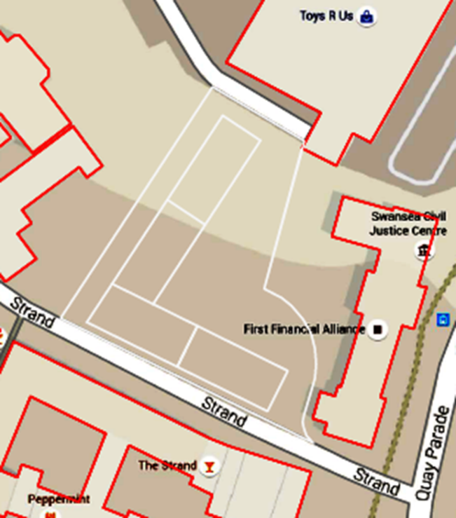
The basic Scope of Work is to construct a Commercial Building consisting of four blocks. (Figure 1). The construction project is to take place within a confined space, surrounded by other low and high storey buildings. This places some constraints on the project programming, as site set-up, proximity of other building foundations and underground services needed to be considered.

Figure 1: Basic plan view of proposed commercial building block (Google, 2018).

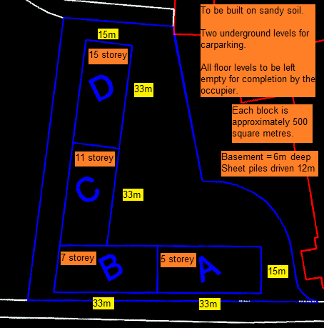
All four blocks will have two underground floor levels for car parking. Each block will be allocated a letter and will consist of a different number of floors above ground level. Block D will consist of fifteen floors, block C will consist of 11 floors, block B will consist of 7 floors and block A will consist of 5 floors. Each floor will have an area of approximately 500m², therefore each block will measure approximately 15m by 33m (Figure 2).
All floor levels are to be left empty on completion of construction, so the occupier can internally design and furnish the layout to their specific business model.
Figure 2: Annotated AutoCAD plan (Drawing - project 3 assignment, 2018. Annotated - Stewart, 2018).

Aim of Report
The aim of this report is to submit an effective construction programme to the Client, for the creation of a Commercial Building Block within the constraints of a plot, sited within the City of Swansea.

The objectives required to achieve the aim consist of the following;
- To gather a literature review with regards to the implementation of programming techniques within a project environment.
- To define the construction method.
- To list the ‘on-site’ task requirements to ensure successful completion of the construction project.
- To present cost, labour and plant information in the form of an Excel Spreadsheet table.
- To present an Asta programme Gantt chart, including the Critical Path and Total Float information.

Background (Literature Review)

There are two alternative ways of viewing the word ‘Programme’.

Firstly, A Programme can mean a structure within an organisation that manages the execution of a set of projects (Axelos Ltd, 2013. p217). Reiss concurs with this when mentioning that a Programme Board oversee many Projects within an organisation (Reiss, 1996. p50). He goes on to state within another of his publications that ‟The Multi-Project or Programme Management Environment is very common” (Reiss, 1995. p19). All this indicates that a Programme is the running of many Projects collectively.

However, secondly, it has also been stated that Programmes are a representation of the planning results, displayed visually on site, to aid the site management team with the understanding of the sequence of construction tasks (Illingworth, 2000. p6). This implies that Programmes are developed for single project use? In an additional publication by the CIOB, the organisation mentions that Programming is directly related to the planning of individual projects (CIOB, 2014. 100).

Further investigation has discovered statements that cover both scenarios. The CIOB mention that the word Programming can also mean ‟the statement of a plan, or some part, or detail, in positive terms by words or diagrams”, which implies that a Programme can be used within single projects or used to manage multiple projects (CIOB, 1991. p1). Furthermore, the CIOB states that ‟Programming is the process of producing a time related schedule of the planning decision” (CIOB, 1991. p1). Again, this can cover both scenarios. Illingworth agrees with this statement (Illingworth, 2000. p5).

So it can be seen that the word Programme can have two definitions. However, for this summary report, Programming will be construed to be associated with a single Project and that Programming will be the technique of allocating and linking specific tasks within a single Project.

Thorough and effective Programming, or lack of it, can mean the success or failure of a Project. A systematic approach undertaken by experienced Construction Planners needs to be adopted at the onset (CIOB, 1991. p1). Gantt Charts are a way of visualising the progress of a project. It displays individual tasks and indicates how they are linked together. A Gantt Chart should show the critical path for the project, consisting of critical events and critical activities (Chanas and Zieliński, 2001. p195). A Critical Path will have ‘Zero float’, which means there is no scope for a task to exceed its allocated time slot along the Critical Path. It is vital that the task activity is completed on time or the whole project will incur extra cost and/or extra time to complete.

Therefore it is of paramount importance that each Programmed Project Stage Boundary is managed and controlled correctly to ensure the Critical Path is maintained. An example of a Stage Boundary within a Project would be the activity change from finishing the Sub-Structure (foundations and basement) to starting construction of the Super-Structure above ground level (steel framework).

Managing a Programme Stage Boundary is usually undertaken by the Project Manager and the Project Board. It incorporates reviewing the existing Programme Stage, approving the following Programme Stage, reviewing and updating the Project Plan, approving the continued business justification and confirming that the risk factor is still within parameters (Axelos Ltd, 2013. p193). Programme Stage Boundary Management (also known as Boundary Control) controls the smooth flowing of work between Programmed tasks. Boundary Control techniques monitor the output of an existing Programme task and provides a feedback loop to deliver information to the Project Manager regarding the present state of that task (Walker, 2004. p157). For example, task cost expenditure or task time slippage.

Case Study Characteristics

Time and Cost are the main characteristics that define any Project, followed very closely by Quality. For this particular project it has been understood that time was the main driving force for the programming task. Programme guidance instructions indicated that costs were required at this initial Project Programming stage but did not need to be accurate. Quality was not mentioned by the Client, so has not been included in this report, although, it goes without saying, that workmanship and materials need to be of a high quality for Client satisfaction.

During the feasibility desktop study stage for this Project, a short presentation was conducted, detailing the initial Project construction strategy. Throughout the build up to this presentation it was first envisaged that the whole project would take one year to complete. More accurate costs and timescales were gathered closer to the presentation date (SPONS, 2015) and this showed that the one year time scale was a very ambitious statement. It was then estimated that the project would more likely take three years to complete. This was stated in the presentation (figure 3).
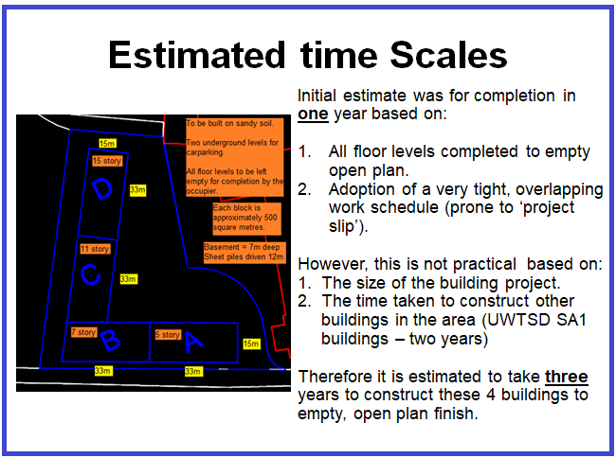
Figure 3: Project Programming presentation - final slide detailing time-scale (Stewart, 2018).

Following completion of the presentation, further analysis was undertaken amongst the Project Team, and it was decided that the whole project could be completed in twenty three months.

Other, important characteristics that may affect the Programming of this Project are:
- The construction project will involve many construction disciplines working on site at the same time, adding to Project Complexity. This will require the Project Manager, Construction Manager and Site Manager to display extremely flexible characteristics. Lack of flexibility may affect the Programme.
- The possible lack of skilled labour would be a characteristic that would affect the Programme.
- The retention of skilled labour would also be classed as an important characteristic which would enable the programme to flow smoothly and unimpeded.

Programme restrictions

Adjacent building related programme restrictions

Delivery vehicles and tower cranes need to be aware of a grade 2 listed building (Swansea Council, 2019b) within close proximity to the site (figure 4).
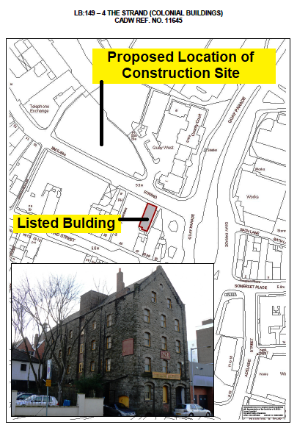
Figure 4: Grade 2 listed building - close to the proposed construction site (Swansea Council, 2018).

Consideration also needs to be taken regarding the whole area adjacent to the construction site on the opposite side of The Strand Road (figure 5). This has been designated a conservation area (Swansea Council, 2019a). Particular care needs to be taken with access and egress of site material deliveries, site waste removal and crane slewing activities.

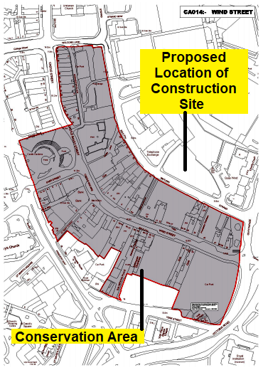
Figure 5: Conservation area - opposite the proposed construction site (Swansea Council, 2019).

Ground related programme restrictions

A thorough ‘desk top’ and ‘on-site’ ground investigation will need to be undertaken to confirm there are no utility services running through the site down to a depth of twelve metres (estimated depth of sheet piles). This will include water pipes, gas pipes, electrical cables and telecommunication cables (BT tower is right next to the site). Documents and plans will have to be obtained from various utility companies confirming that no ‘services’ will be encountered whilst piling and excavating on the site.

There is a high risk of unexploded ordnance (UXO) buried on the site which were dropped by the German Luftwaffe during the Second World War (figure 6) (Zetica, 2019). A thorough ground investigate will need to be conducted to confirm the site is clear of any UXO.

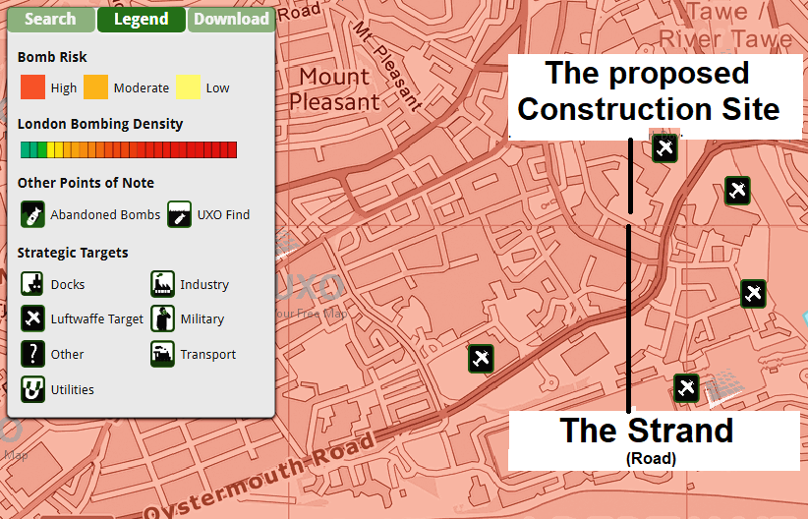
Figure 6: Possible unexploded ordnance (UXO) - Swansea - Luftwaffe targets. World War 2 (Zetica, 2019).

Weather related programme restrictions

Weather can also play havoc with the project programme. A possible contingency period may need to be added during the winter months to allow for any exceptional disruptive weather patterns that may occur. For example, prolonged heavy snows fall.

Technical related programme restrictions

Each task can restrict the progression of other tasks in the programme. It is important to ensure the smooth transition of one designated task starting after the completion of a previous task, or a particular task starting at the correct time during the progress of an existing task.

Further technical restrictions that could affect the programme could relate to the site access where local traffic could delay deliveries. Also, the lack of a decent size storage area may restrict the programme.

Economic related programme restrictions

The lack of a locally available workforce, plant and local suppliers of material are economic restrictions that may affect the programming.

Poor cash flow throughout the project will also affect the programming. For example, if a sub-contractor cannot be paid via ‘stage payments’ then they may become bankrupted and cease trading. This then would cause project delays whilst locating new sub-contractors.

Other economic restrictions that may affect the programme could be the lack of sub-contractor competition, which would drive up the cost. Also, national or local taxation levies.

Management related programme restrictions

Workforce Unions may impose restrictions for the benefit of their members’. Also the majority of the workforce may want to work ‘overtime’, and may purposely slow down the project to achieve this. These would both need management attention and intervention to arrange agreements with the workforce and Unions.

Legal related programme restrictions

Complying with various Acts and Regulations (e.g. The Health and Safety at Work etc. Act 1974 and The Construction Design and Management Regulations 2015), relating to a construction project can restrict a programme as the procedure can be extremely time intensive. However, non-compliance could delay or restrict a programme even longer in the form of prohibition notices issued for not following Laws and regulations related to employment, health and safety, welfare, the environment, building and planning etc.

Time related programme restrictions

Certain project targets need to be achieved. If these targets are not hit then this could resort in project slippage. Financial penalties may also apply if targets are not reaches on time, which could affect the programme restrictions in other ways.

Environment related programme restrictions

The management and disposal of contaminants, waste and foul water, fumes, dust, noise, energy usage, flora and fauna could all restrict the programme and hinder project completion.

Social related programme restrictions

The public objecting to the building being constructed can affect the programme and severely restrict its completion date through protests. Therefore, the public need to be informed from the start. The Client needs to show how the public will benefit from the construction of the build.
Privately funded buildings attract less scrutiny. However, publicly funded buildings quickly attract public attention.

Height related programme restrictions

The proposed construction development is within one of the ‘Welcome’ zones for tall buildings (figure 7) (Swansea Council, 2016). However, the Airport Safeguarding Zone has height restriction of 90m for this location (Roberts and Holmes, 2018. p23), which may restrict the height of the ‘Luffing Jib Tower Cranes’ planned for this project.

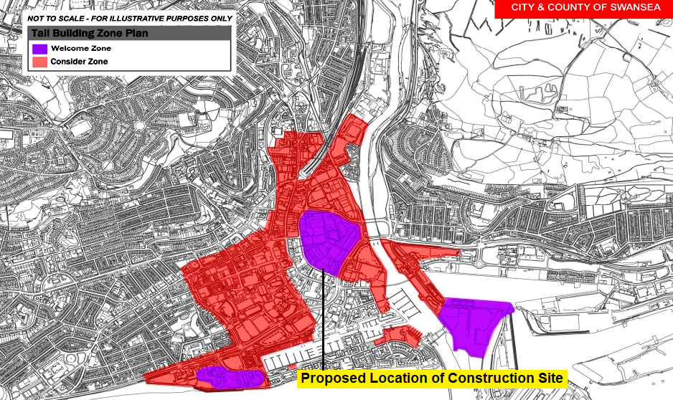
Figure 7: Swansea 'Tall Building Strategy' zones (Swansea Council, 2016).

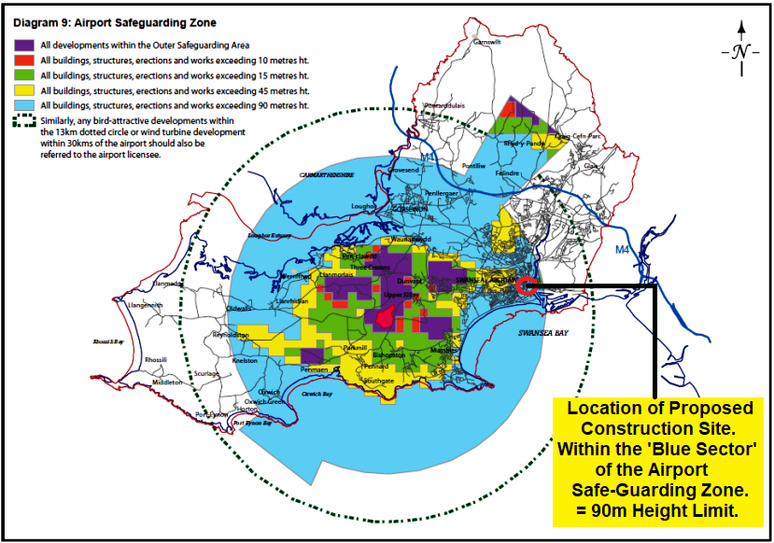
Figure 8: Swansea airport safe-guarding zone – Swansea Local Development Plan (Roberts & Holmes, 2018).

The British Telecom Building next to the proposed site is 13 storeys high and 63 metres tall (Skyscraper News, 2019). The maximum storey height of the proposed construction is 15 storeys which would equate to approximately 73 metres. The formula provide by ‘The Council of Tall Buildings and Urban Habitat’ concurs with this figure (CTBUH, 2016), which calculates out to 73.1 metres.
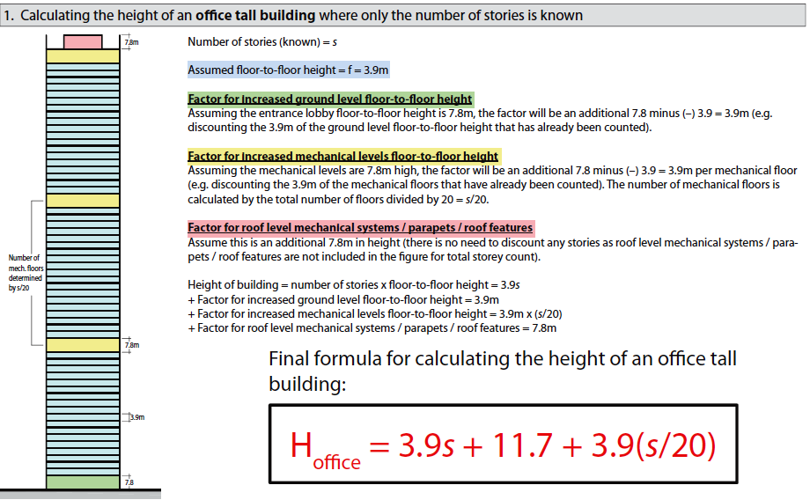
Figure 9: Formula for calculating the height of office building (CTBUH, 2019).
$$\left(3.9 x 15\right)+11.7+3.9\left(\frac{15}{20}\right)= 73.1m$$
Formula 1: Calculation of the height of the proposed building (Stewart, 2019).
To allow one of the cranes Jibs access above the 15 storey building the crane must utilise the maximum height allowance of 90m. Therefore the boom tip must be restricted to a height of no more than 17m above the 15 storey building.
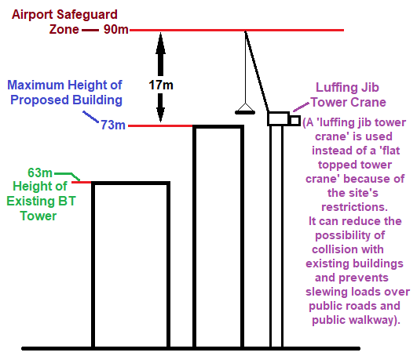
Figure 10: 90m Swansea airport safety zone height – not to scale (Stewart, 2019).

Solutions

Site establishment

This will consist of erecting boundary hoardings, site clearance (approximately one hectare), site set-up (offices, tower cranes etc.) digging trail pits and trial pit analysis.

Sub-structure

At this stage of the Programme Planning Process it has been decided that steel sheet piling, drive to 12m, will be used for the basement retaining walls. These sheet piles will be progressively anchored using tie rods as the excavation of the interior soil advances downwards. This philosophy follows other building basements within close proximity of this construction project (see figure 11). Total excavation depth will be to either six or seven metres (depth has not been fully decided upon yet).
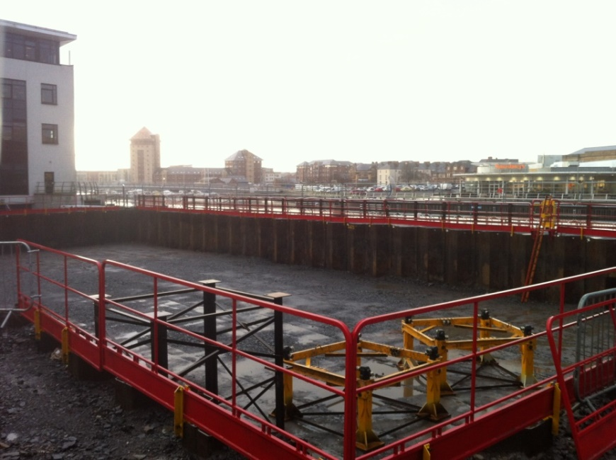
Figure 11: Similar underground basement 400m from proposed construction site (Stewart, 2018).

Two reinforced concrete slabs and reinforced concrete columns will then be developed up to ground level. These will form the two underground car park basement levels, which will further support the steel sheet piled walls from within.

Super-structure

Above ground level the structure will consist of steel frames with composite beams and concrete slabs.

Roof

The roof will be a flat 150mm reinforced concrete slabs on permanent steel shuttering, with an inconspicuous, very fine gradient to allow water run-off. The whole roof will be insulated and waterproofed.

External finishing

Insulated sheet cladding will be installed on the building’s exterior. Double glazed UPVC windows will be fitted throughout. Guttering and downpipes will be fitted to remove rainwater.

Internal finishing

Blockwork and brickwork will be established to provide internal facing walls and some partition walls. Most internal partition walls will however be insulated stud walls. Block and brick walls will be plastered and stud walls will be plaster boarded. All internal walls will then be painted.

Discussion / Analysis

Site establishment

If during the digging of trial pits, or through use of the underground utility location devices, it is found that utility services run through the site, a cost analysis will have to be conducted as to the re-routing of these services around the perimeter of the site. An alternative would be to change the design of the building and alter the whole programme or decide to cancel the project. To avoid this happening at the site set-up stage it might be prudent to conduct the ground investigation and trial pits long before the commencement of the site set-up.

If the tallest crane jib is going to exceed the 90m height restriction imposed by the ‘Airport Safe-guarding Zone’, then there may well be a requirement to apply for a dispensation to allow the crane to jib up higher that the 90m during set times.

Sub-structure

If sheet piling for the underground retaining walls is decided against at a later date, then an alternative method may be to develop the basement walls using drilled concrete reinforced ‘Secant’ piles, or ‘Contiguous’ piles. Another alternative may be the construction of a diaphragm wall for the basement walls, although this would be an expensive option.

A major problem with the majority of basement walls is water penetration through the wall or around joints in the wall. Therefore a damp proof membrane and a substantial drainage system need to be incorporated into the structure, along with an efficient pumping arrangement to remove water from the water collection sumps. The advantages of including pumps to remove water rather than an elaborate gravity drainage system would be less complicated designing involvement. However, the disadvantages would be constant pump maintenance and additional workload for employees.

Super-structure

An alternative method of constructing the super-structure would be to utilise reinforced concrete for the columns. It is the columns which are exposed to compression forces and concrete is better at absorbing compression forces than steel. However, steel columns were decided upon because it is a quicker construction method that involves simply bolting the columns and beams together rather than waiting weeks for any concrete columns to dry. There is also the possibility of finding the concrete has not moulded correctly when the formwork is removed. This would cause delays in remedial work or possibly demolish and start again.

Roof

An alternative pitch roof could be considered. However, there is a possibility you would need to employ addition tradesmen for a pitched roof, when you have already got the existing trade’s onsite to install the concrete flat roof.

External finishing’s

Particular attending will be paid to the cladding’s fire rating following the Grenfell Tower disaster. In theory, the literature will describe the fire rating. However, it might be prudent to practically test random selected samples before installation.

To improve energy consumption, an alternative to double glazed window might be to use triple glazes window. Over time, the reduction in energy costs could be laid off against the higher material costs.

Internal finishing’s

It could be considered that blockwork and brickwork are time consuming to install. An alternative method might be to install larger insulated cement boards. These could speed up the project. Plasterboard could be fixed directly to the insulated cement boards. It would be anticipated that this latter process is less labour intensive and therefore reducing the project cost.

Conclusion

This report has covered a comprehensive investigation that allows the Client to move forward with plans for the construction of their Commercial Building Block. It has conducted an evidence based literature review and has defined a construction method appropriate for this project. Alternative construction methods have also been suggested if the Client decides to alter the plan slightly. Labour and plant resources have been presented, along with costs (appendix A), and a Gantt chart has been produced as a visual aid for the Client to monitor the project development. Therefore, the aim and objectives have been achieved.

The implication in developing this construction programme report demonstrates that it has focused the mind in analysing different aspects and stages of a project. It has therefore been a significantly positive learning process. This report can also be transferred and applied as a guide to other similar project.

At this stage it is now recommended that the Client proceed with due diligence, and undertake a more comprehensive deck top and practical site ground investigation for buried utilities, services and unexploded ordnance (UXO). The findings of this evolution will determine the next course of action.

References

Axelos Ltd (2013) Managing Successful Projects with PRINCE2. 5th edn. The Stationery Office.

Chanas, S. and Zieliński, P. (2001) ‘Critical path analysis in the network with fuzzy activity times’, Fuzzy Sets and Systems, 122(2), pp. 195–204. doi: 10.1016/S0165-0114(00)00076-2.

CIOB (1991) ‘Planning and Programming in Construction. A Guide to Good Practice. Chartered Institute of Building.’

CIOB (2014) Code of Practice for Project Management for Construction and Development. Chartered Institute of Building.

CTBUH (2016) ‘CTBUH Tall Building Height Calculator’, Tall Building, 9, pp. 8–10. Available at:
http://www.ctbuh.org/HighRiseInfo/TallestDatabase/Criteria/HeightCalculator/tabid/1007/language/en-GB/Default.aspx.

Illingworth, J. (2000) Construction Methods and Planning. 2 Edition.

Reiss, G. (1995) Project Management Demystified - Today’s Tools and Techniques.

Reiss, G. (1996) ‘Programme Management Demystified - Managing Multiple Projects Successfully’.

Roberts, P. and Holmes, P. (2018) ‘Swansea Local Development Plan’, pp. 1–106.

Skyscraper News (2019) BT Tower, Swansea - Building.

SPONS (2015) SPONS Civil Engineering and Highway Works Price Book 2015. 29th edn. CRC Press.

Swansea Council (2016) ‘SWANSEA TALL BUILDINGS STRATEGY’.

Swansea Council (2019a) Swansea - Conservation areas index. Available at: https://www.swansea.gov.uk/conservationareasindex (Accessed: 18 December 2018).

Swansea Council (2019b) Swansea - Listed buildings index. Available at: https://www.swansea.gov.uk/listedbuildingsindex (Accessed: 17 December 2018).

Walker, A. (2004) Project Management in Construction. 4th edn. Hong Kong.

Zetica (2019) UXO - Luftwaffe Targets in Swansea. Available at: https://zeticauxo.com/downloads-and-resources/risk-maps/.

Appendices

Resources – cost and labour
Enlarge the document to read the script.
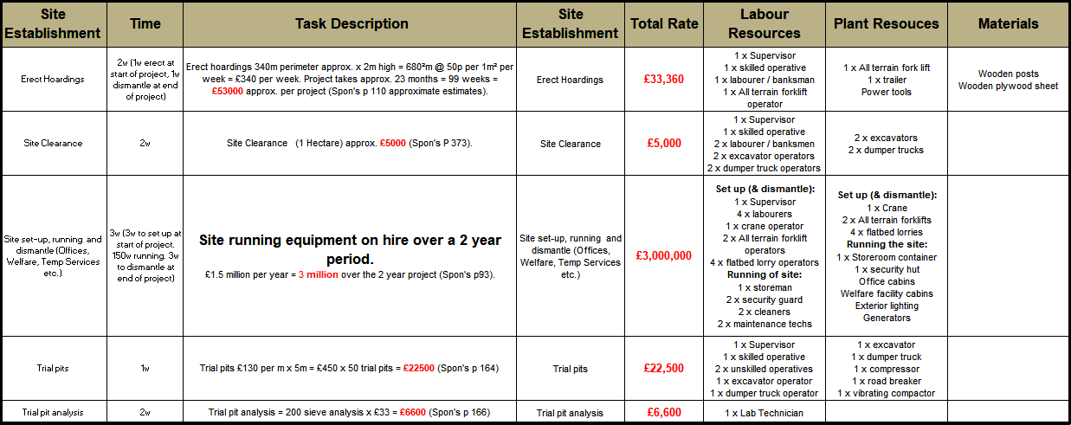
Figure 12: Resources- costs & labour - site establishment (Stewart, 2018).

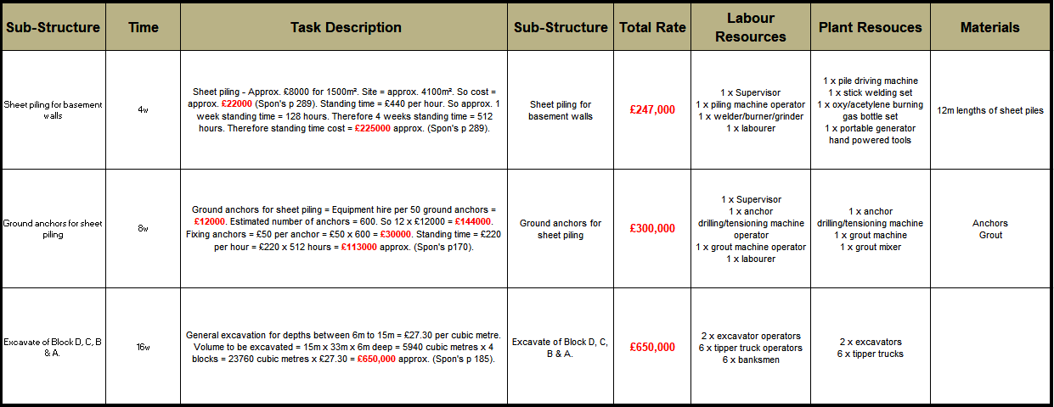
Figure 13: Resources – costs & labour - sub-structure 1 (Stewart, 2018).

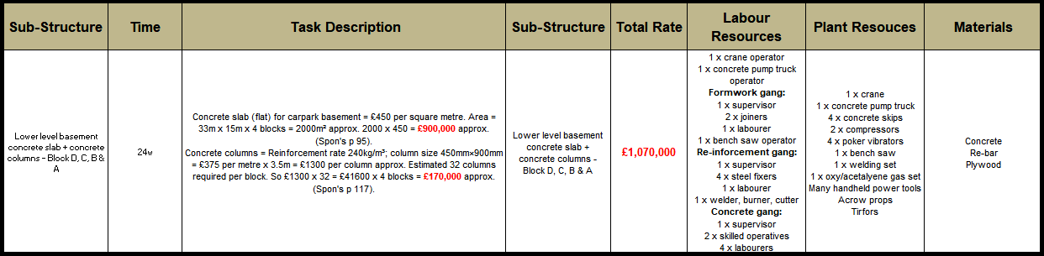
Figure 14: Resources - costs & labour - sub-structure 2 (Stewart, 2018).

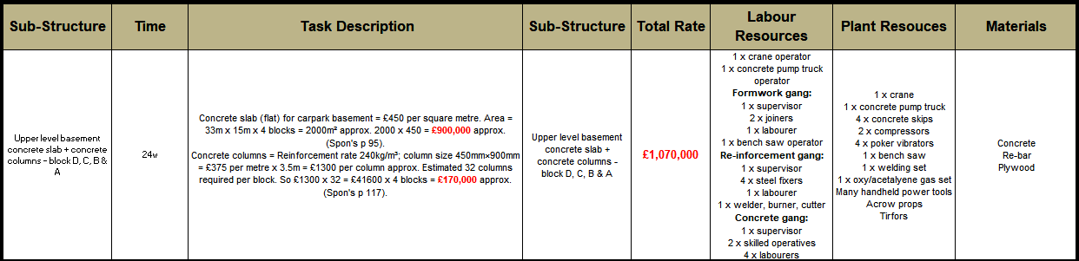
Figure 15: Resources - costs & labour - sub-structure 3 (Stewart, 2018).

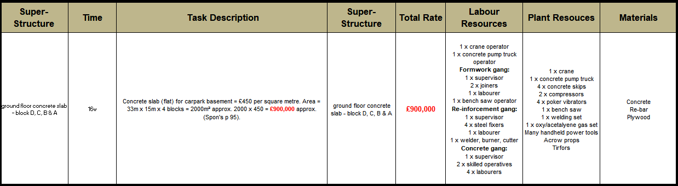
Figure 16: Resources - costs & labour - super-structure 1 (Stewart, 2018).

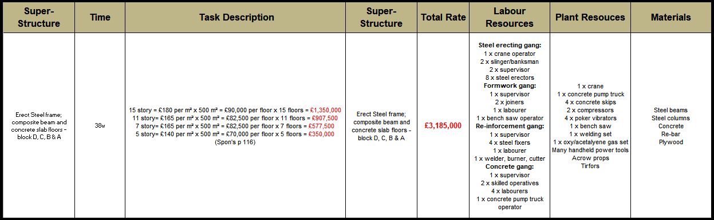
Figure 17: Resources - costs & labour - super-structure 2 (Stewart, 2018).

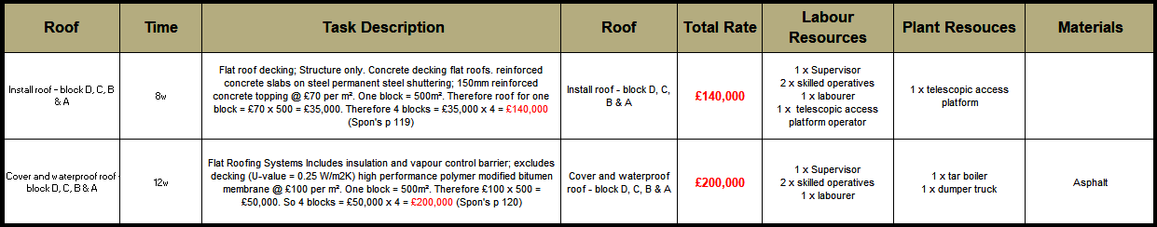
Figure 18: Resources - costs & labour - roof (Stewart, 2018).

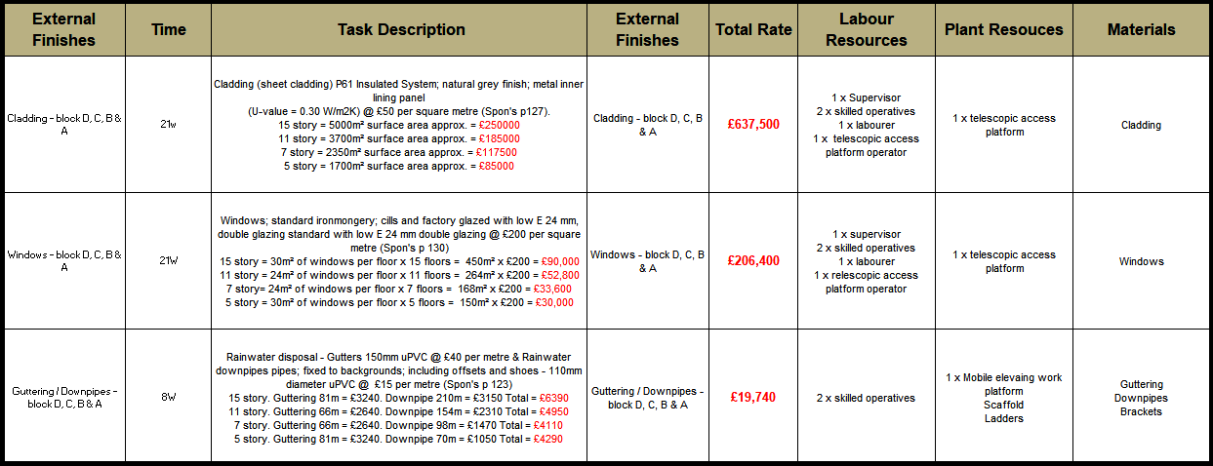
Figure 19: Resources - costs & labour - external finishes (Stewart, 2018).

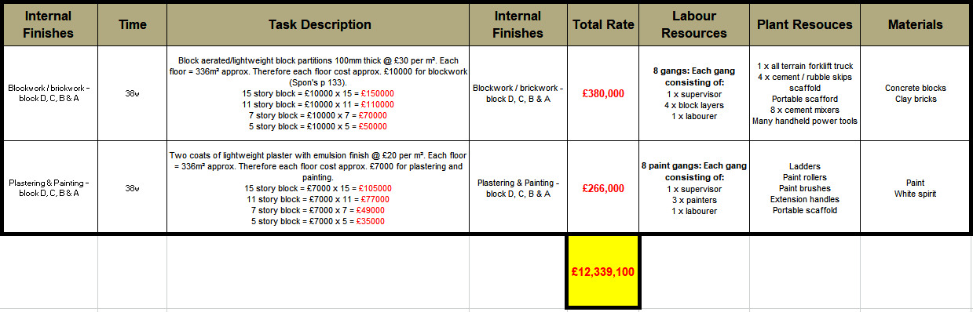
Figure 20: Resources - costs & labour - Internal finishes (Stewart, 2018).

Gantt chart
Note: Due to the Gantt chart’s physical reduction in size for inclusion in this report, it has become unreadable. However, it is still possible to make out the ‘critical path’, the task ‘total floats’ and the ‘link lines’. An email attachment of this Gantt chart has been forwarded to the Client, detailing tasks in full size for convenient viewing and analysis.
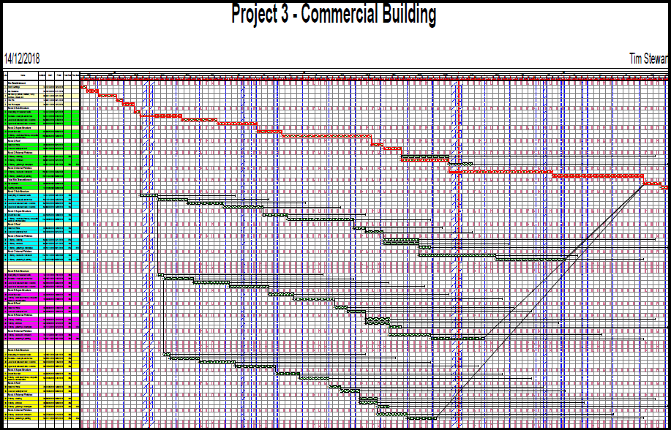
Figure 21: Gantt chart - commercial building blocks (Stewart [95%], Hunt [5%], 2018).

