Shelina Begum 1708781
Begum_salina@hotmail.com
Institution:
University of wales trinity saint David
Birmingham learning center
Lecturer name: Ernest ovia

Project Planning and Management in workplace Module code: BMSW5104

CONTENTS PAGE

Introduction……………………………………………………………….………..………...3
Project sponsor and steering group Dennis vintner:………………….……………3
Project overview ……………………………………….……………….........……………3
Risk management :………………………………………………………..……………….4
Risk analyse …………………………………………………………………………………5
Project management tools and techniques……….………………………………………………………………………….5 to 8
Communicated to the stakeholders:..……………………...…………………………...8
My personal reflection………………………………………………………………………9
Conclusion……………………………………………………………………………………9
References…………………………………………………….…………………………….10
Introduction to the vintner’s company case study:
The vintners run an antique store that has been in company for three generations. The store, maintained by a family bought more than 30 years ago, is located in Shirley, Stratford Road, Birmingham. The main stakeholders in the business are Denis vintner, Doreen vintner, Suha Madani and Omar King.
Project sponsor and steering group Dennis vintner:
- Dennis is the project sponsor.
He engaged throughout the project discovering and purchasing antiques, risk managing and helping the business goals and visions.
- Doreen vintner:
Doreen in charge of the funding side of the project. She plans how the money is spent. She also supervise day to day expense of moving the business.

- Suha Madani :
Suha operate in the sales area selling and supporting consumer service. She also discovers guides for extraordinary antics.

- Omar king:
Omar is the specialist in restoring and renovating antics. He find them retail area prepared and his experience of the warehouse and finding issues is renowned.

The family also owns another building, sparkhill in Birmingham. This building is mainly used for storage.

Project overview:
This project is an attempt carry out for vintners’ antiques to achieves a performing industry like the salvage hunters which in this example is to duplicate the business style managed by salvage Hunters.
Empty warehouse will be transform to a fully functioning office space with office equipment and create a separate storage/showroom space.
scope has been defined, timeline and cost to accomplish this plan for vintners’ antiques.
Tools that have been used for this project are as follows; planner, process diagram, user stories and Gantt chart, Delphi technique to facilitate this plan.
Risk management :
There is lot type of risk such as time. This is a risk factor that this organization are not performing projects similar to current projects. Because there is no previous experience, project team can ignore the activities that need to be performed, or project team can underestimate the time and resources required to execute those activities. No previous experience does not guarantee that project will have these problems, but it increases their likelihood.
All projects run through the following four phases of the life cycle, each of which may bring new risk factors to project:

- Starting the project
- Organizing and preparing
- Carrying out the work
- Closing the project
This is an example of the risk factors that may occur in these phases.
- Impact assessment is incomplete, resulting in loss:
- Understand the overall impact on project objectives, such as scope, time, cost, and quality
- Identify secondary or new risks arising from identified risks
- Lack of transparency and communication gaps within and outside the team
- Therefore, it is important for any project organization to establish an effective risk management framework. Creating practice as a project team culture ensures that:
- Identify and manage conscious and focused risks
- Project progress as desired, with the lowest number of deviations or surprises, and in line with the project and organization's goals
- Communicate project issues to stakeholders in the organization and project as early as possible
- Effective team building tools to ensure the acceptance and acceptance of equipment.
The risk of this project is mainly time.
Risk category : The risk category provides a list of areas that are prone to risk events. The organization recommended the use of advanced standard categories, which should be expanded according to the type of project.
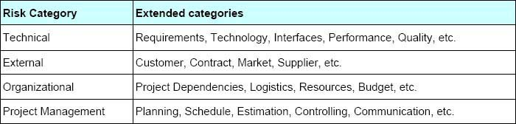

Risk Analysis:
Once the risk is identified, it will be analysed to determine its qualitative and quantitative impact on the project in order to take appropriate measures to mitigate the risk. The following guidelines are used to analyse risk.

. Probability of Risk Occurrence
- high
- Medium
- Medium
- Low probability
Risk Impact
- High
- Medium
- Low
(Lavanya, 2008)
Project management tools and techniques being used in the case study:
1. Gantt chart:
The Gantt chart is another visual project management technique, but it is even more applied to project managers. Making Gant charts is a technique, but it can be used in conjunction with gant charting tools to make it easier to execute.
Gantt chart Create a visual timeline, including start and end dates, throughout the life of the project. Add start and end dates to create a separate timeline for each task. Project team can see how long it takes to complete each task in the entire project. This can help them program better.
Using the Gantt chart online on ProjectManager.com allows to adjust schedule as needed, even by clicking and dragging links related tasks. Task dependencies are used when a task cannot be started until other tasks are completed. They can be linked to ProjectManager.com, so there is no downtime or blocking of team members.
Gant charts can help plan and schedule tasks in one or more projects. it can also plan and plan completion of projects, sprints and milestones, schedule teamwork, and compare planned deadlines to actual work on the project. (Landau, 2019)

2. The Delphi Technique:
As a project manager, it is important to consider that future events will affect their project. These events can be positive or negative, so knowing them can allow them to prepare and plan to deal with them. But how secure is the future? Delphi technology can help.
Delphi technology is a method for estimating the probability and outcome of future events. A group of expert’s exchanges views, each independently providing estimates and assumptions to facilitators of review ingress and summary reports.
Panellists reviewed and reviewed the summary report and provided the facilitator with an updated forecast, which re-examined the material and issued a second report. This process continued until all participants reached a consensus.
Each round of experts has a complete record of the predictions made by other experts, but they do not know who made the predictions. Anonymous allows experts to encourage openness by reviewing previous predictions from expressions, encouraging openness and preventing mistakes from being acknowledged.
This article describes how to run a Delphi session. By completing this guide, team will be able to run a session that allows them to predict future events and their possible impact on their project.
The technology is an iterative process that is first intended to obtain broad input from the expert group. The results of the first round of questions, in summary, provide the basis for the second round of questions. The results of the second round will be in the third and final round. (Haughey, 2018)

3. project management iron triangle:
Project managers often have to strike a balance between different factors to ensure high-quality project delivery. The concept of perfectly capturing this reality is the iron triangle of project management constraints. In this article, team will review the concept of the Iron Triangle that contributes to the success of the project.
The Iron Triangle model was launched by Dr. Martin Barnes in 1969. Limitations are measured iron because one project manager cannot adjust one control without involving the other. The previous model is developed from the cascading method of product growth.
The main restrictions of the iron triangle model include the following:
- Scope
- cost
- Time
- Quality
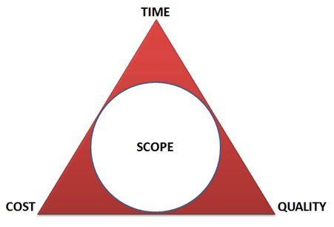 (Guardian, 2020)

These limitations affect the quality of project delivery. If they change any iron triangle constraints, other constraints are affected. The goal of the Iron Triangle is to provide the project manager with the necessary information to make trade-offs to help deliver quality products.
For example, if they change the scope of a project, the time and budget will be affected. The expansion will also lead to an increase in budget and time. Similarly, if the budget increases or decreases, the scope and time to complete the project will be affected. The same is true of time limits.

The main purpose of the triangle is to ensure quality improvement. The project manager should understand the relationship between the different constraints. The iron triangle model helps project managers understand how different constraints affect the quality of project results.
Understanding limitations can help them make more effective project decisions. It will enable project managers to allocate resources more efficiently to achieve the best project results to meet customer requirements.
Team, C. (2017).

User story :
User story normally are a lightweight way to quickly capture product requirements for "who," "what", and "why". Simply put, a user story is a requirement that expresses the user's needs. The user story is short, and each item typically contains fewer than 10 or 15 words. Using Microsoft planner, these can be saved and grouped so that it identifies the scope of the project, if we know what requirements needed that project will be able to deliver these needs and solve the obstacles.
How the project plans will be communicated to the stakeholders:
One part of the project management and project control cycle is that the plan is informed by communicating with stakeholders. This can be done using a method called "Standing". This is a method in which people with project-specific tasks are delegated to meet at the beginning of the day. This can be done face-to-face or via Skype video calls. Everyone has a certain amount of time, he gives feedback on his task, and he estimates how much work has been done. The project manager updates the gantt chart with this information, and then evaluates how the project is proceeding. This information is then shared with the project sponsor and skype email or call address group. Based on this information, the project sponsor decides on strategic decisions and whether to continue with the project plan or develop an alternative plan.
My personal reflection:
At the beginning of the project, I have being worried because project management and all aspects related to the project were new-found to me. Once I read out the Vintners project case study, I thought it was simple and didn't take into account the risks that might be involved. I don't understand the impact of risk management and risk assessment.
Throughout the project, I understood more about project management techniques, such as the value of people's role in the project. I did not know anything about Gantt chart and Delphi technique .this project case study helped me to learn lot of new things. I also learned more about how to define project requirements using user history techniques. One thing I may possibly have done well to improve the project was to plan more. This is critical to presenting the project. Plan every phase of the project from start to complete and analyse each phase of the project run. That is what I understood throughout the project.
In the future, I will utilize extra methods to manage project management. I have better idea now.
Conclusion:
A project management is an organization created by a project structure as a separate unit or department within a permanent functional structure, attracting experts and workers from various functions to complete technical and expensive projects under the general leadership, control and coordination of the project manager.
George R. Terry defines a project organisation as follows:
“A project organisation is a preferred means whenever a well-defined project must be dealt with or the task is bigger than anything, the organisation is accustomed to.” (Talathi, 2020)
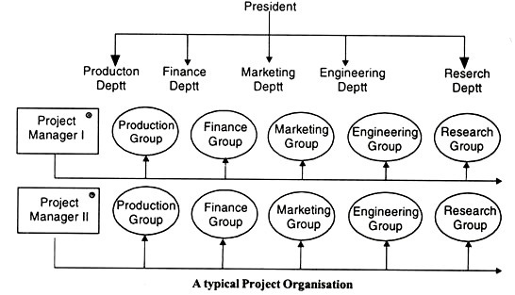

Reference:
Cantrill JA, SibbaldB, Buetow S. The Delphi and Nominal Group Techniques in Health Services Research. International Journal of Pharmacy Practice 1996;4:67-74

Guardian. (2020, 03 20). Retrieved from project managment iron triangle: https://www.hpa.com.eg/wp-content/uploads/2015/05/The-Iron-Triangle-of-Project-Management.png
Haughey, D. (2018, 02 01). Project Smart ~ Exploring trends and developments in project management today. Retrieved from https://www.projectsmart.co.uk/delphi-technique-a-step-by-step-guide.php
Landau, P. (2019, september 03). Project manager. Retrieved from https://www.projectmanager.com/blog/project-management-techniques-for-every-pm
Lavanya, N. |. (2008, March 03). Risk analysis and management. Retrieved from https://www.pmi.org/learning/library/risk-analysis-project-management-7070
Team, C. (2017). Retrieved from COPPER: https://www.copperproject.com/2017/12/iron-triangle-constraints-project-management/

Talathi, R. (2020, 20 03). YOUR ARTICLE LIBRARY the next generation libarary. Retrieved from https://moodle.uwtsd.ac.uk/pluginfile.php/339809/mod_resource/content/2/Level%205%20Assessment%20%281%29.pdf(access date:20/03/2020)

