REFLECTIVE PRACTICE

STUDENT NAME: HORHOCEA CRISTIANA-MARA
STUDENT NO.: 1604608
MODULE TITLE: COMMUNITY ENGAGEMENT
ASSESSMENT TITLE: REFLECTIVE PRACTICE
MODULE LECTURER: MARY MARCH

- Introduction
The purpose of this assessment is to show my first circumstance to have a deeper reflective practice on one of my experiences and also to provide the reader with more information about the Reflective practice and the relationship between theory and practice.
- Definition of Reflective practice
The Reflective practice is the ability to analyse our experiences, based on the awareness of our both positive and negative actions, on accepting the consequences and deciding what we will do differently in the future. Reflecting on our own actions is the perfect method to increase our self-confidence, which is the key component of our emotional intelligence and it also helps us to become more proactive and competent professionals. The reflective practice stimulates and develops our creative thinking skills, and encourages active engagement in work processes. It requires us to reflect on the development of effective self-management, communication, team working, leadership, interpersonal skills.
“Reflective practice is an active, dynamic action-based and ethical set of skills, placed in real time dealing with real, complex and difficult situations.” (Moon, 1999)
“Reflective practice (RP) is critical and deliberate inquiry into professional practice in order to gain a deeper understanding of oneself, other, and the meaning that is shared among individuals. This can happen during practice and after the fact, and can either be done alone or with others.” (Forrester, 2010; Peters, 1991; Schön, 1983)
- Reflection on my personal experience
With the help of the Learning Styles by Honey & Mumford, I managed to find out more about my learning style. I am a pragmatist, which means that I am keen to apply whatever I learn and I will always work out how I can apply it in real situation and plan how to put it into practice. I value the information that I am given only if I can see how it relates to practical tasks that I need to do.
Basically, I learn better from practice than from theory. It is easier for me to learn while doing something, especially when I like what I am doing, than reading or researching about that specific thing. I like applying my knowledge in real life experiences.
My biggest passion is make-up and everything that has to do with the eyes, since I was 13 years old. I have never learnt something about make-up from books, articles or other ways of reading or learning. The only way I always find out new things about my passion is watching video, listening to experienced make-up artists talking about the strategy, products, methods, different kinds of make-up and so on, and then putting everything in practice. I usually practice the make-up on my friends, from what I hear or see from the experienced people. While looking into the mirror and trying to reflect on the latest experience, I realized that my communication skills should be improved, because I still have stage fright, which means that I still have thrills while speaking in front of a group of people.
Also, thanks to our lecturer, Mary March, I was able to provide my listeners with a demonstration of how to apply the contact lenses. I also provided them with enough information about hygiene and how to keep the contact lenses away from bacteria and microbes, in order to keep the eyes health and away from any disease.
For my reflective practice, I chose the strategy of critical thinking, which, in my opinion, is essential for a good reflective practice. Critical thinking is questioning, describing, analysing, reasoning, reflecting, criticising, evaluating. It is asking a lot of questions, such as “How?”, “Who?”, “Why?”, “Where?”, “What?”, “What if?”, “What next?”, challenging myself to think more and deeper about how I could have done it better, what I did wrong or right:
What is the problem?
What are the consequences?
What should I have done?
What was going through my mind?
Why I did this, instead of that?
- The relationship between relevant theory and the experience

In my point of view, theory is a hypothesis, a process which, when it is repeatedly tested and proves, it transforms into theory. Practice is the application of the theory.
According to Kolb’s Theory, “You do something, reflect on your experience, try to conceptualise it and then test these concepts through more experience.” Theorising means changing our ideas in order to amend the experience.
Fig.1 Learning as a continuous process (adapted from Kolb)
Experience

Reflect
Act

Theorise

Repeating this process as we have new experiences, we can continue to develop our understanding. Experience without theory will teach us nothing.

- Peer Evaluation Role Play Feedback

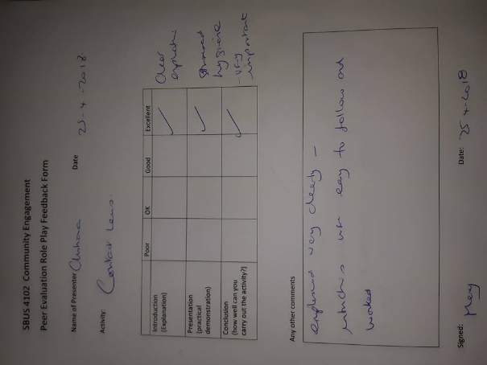Our lecturer, Mary March, marked my Introduction (Explanation), Presentation (practical demonstration) and Conclusion of the role play with “Excellent”.
The other five people in the lecture hall, my colleagues, marked my role play activity like this:

 | Poor | Ok | Good | Excellent
Introduction (Explanation) |  |  |  | 5/5
Presentation (practical demonstration) |  |  |  | 5/5
Conclusion (how well can you carry out the activity?) |  |  |  | 5/5

Any other comments:
1. Good explanation. The practice was good, it’s good to know the risks of wearing infected contact lenses;
2. Very well demonstrated;
3. Good explanation of safety rules and how to use the contact lenses, everything was good;
4. Very good explanation, it created my interest to try contact lenses, it is a very interesting thing;
5. Very good.

- Conclusion
I find the reflective practice a very good strategy for everybody who wants to develop themselves, improve their skills, way of thinking and the way of analysing their experiences. I decided to use Reflective practice for every experience, demonstration, role play or presentation in my future, so I can become a better speaker and person and have a better way of seeing my actions.
I decided to create my own Personal Development Plan, in order to improve my skills and abilities regarding to make-up and beauty. Now I know what to do different next time, what mistakes to avoid, in order to have a better presentation and to provide the listeners with a better demonstration and more knowledge.

- References
Moon, K. (1999), Reflection in Learning and Professional Development: Theory and Practice, Kogan Page, London

Reflective Practice (2011-2018). Available at: https://www.skillsyouneed.com/ps/reflective-practice.html

What is reflective practice? (2003-2018). Available at: https://brightknowledge.org/medicine-healthcare/what-is-reflective-practice

What is reflective practice? (2018). Available at: https://spielverlagerung.com/2018/03/07/what-is-reflective-practice/

