Goodrum, Joseph (J)
ACBA 5019 2025-2026

Table of Contents
Introduction. 2
Location and desktop survey 2
Foundations & substructures 3
Superstructure 6
Building envelope 11
Conclusion 13
Appendix. 14
References 20

Introduction.

This report will provide a series of material choices for the proposed multi storey commercial hotel development in the SA2 area adjacent to Sketty park boating lake. The report will provide choices for the substructure and superstructure of the building and prioritising, fire safety, aesthetics, environmental impact, and sustainability for these choices. Justifications for these choices over other materials will be provided within the report.

Location and desktop survey

Historical records indicate that the area was originally woodland, according to maps dated 1870 see Appendix 1, and later turned into a recreational area, according to maps dated 1940, see Appendix 2, with no further development of the site after this date, as the site remains a playing field (Goodrum, 2025a) (Goodrum, 2025b).

According to geological data the proposed site is composed of landscaped ground with the substrate comprising of beach sand and gravel deposits, see appendix 3. This data is confirmed by bore hole data taken near to the site that indicates the area mainly comprises of sand and clay deposits, see appendix 4 and figure 1. Below (Goodrum, 2025c) (British Geological Survey, 2025a) (British Geological Survey, 2025b).

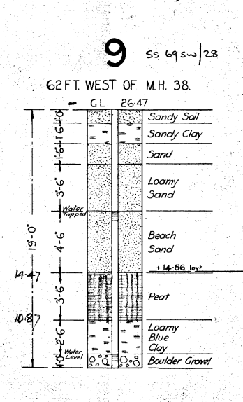
Figure 1.

The proposed area is located within the Swansea locality, historical climatic data shows that this area has a higher-than-average wind speed for the UK and double the rainfall compared to England in general. Refer to Appendix 5. & 6. For reference (Met office, 2025a) (Met office, 2025b).

The geophysical data obtained will directly impact the material choice suitability, as an example, certain foundation types, such as shallow foundations, may not be suitable for soil unstable soil types, like the sand deposits at this location, this may in turn cause differential settlement when the loads from the building are placed upon them. The Climatic data for the proposed site will also affect material choice suitability requiring a more durable selection to cope with the wind loading and the amount of rainfall that the building will receive (Bryan, 2010a, p.369).

Foundations & substructures

Since the proposed site is quite large and not restricted, we recommend that the building does not incorporate any basement substructures, such as underground parking. By building the parking facilities at ground level, basement construction is unnecessary, as shown in Figure 2 (Bhbasements.co.uk, 2025).

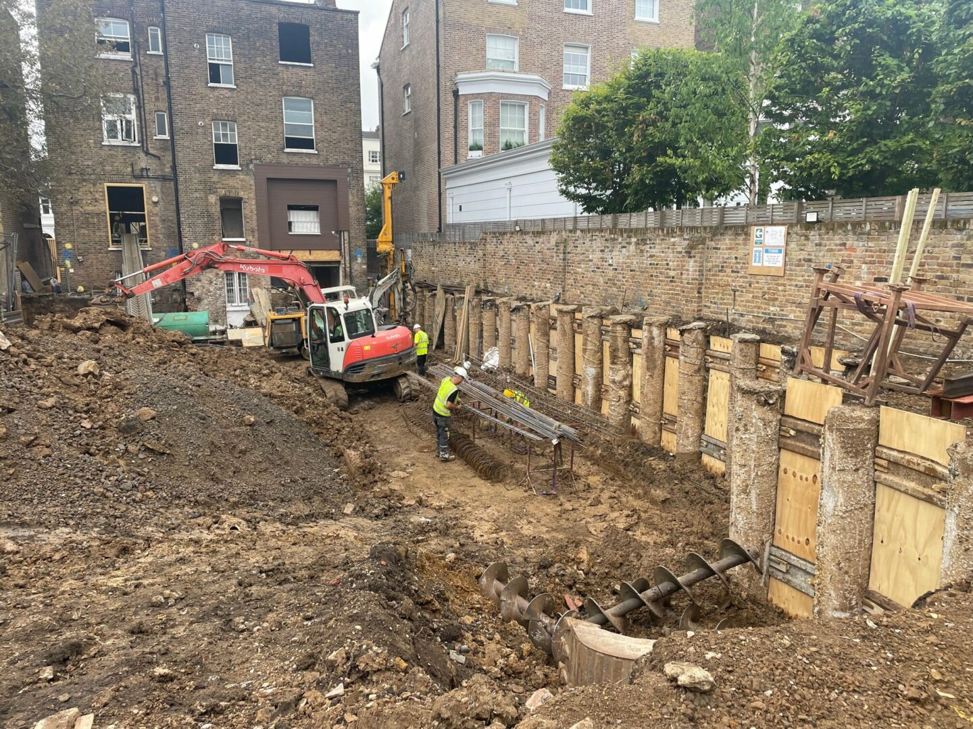
Figure 2.

By eliminating this feature, the amount of waste material due to excavations the construction of retaining walls can be eliminated along with the overall duration of the project reducing the project labour hours required to complete the building.
Reducing these factors will help lower the overall embodied carbon of construction and reduce waste, resulting in less environmental impact and making the building more sustainable (LETI, 2025) (GBC, 2025).
Due to the geophysical data available showing that the soils are made up of sand, clay and gravel and the depths of this deposits along with the heavy loads, kN, of a multistorey that will require significant support to prevent movement, for the proposed site, we recommend the use of a deep piling foundation method to support the superstructure of the building (Chudley and Greeno, 2015a, p.111).

Deep piling is a method of producing a foundation for a building, where columns made of concrete, steel, or wood are inserted deep into the ground to transfer the building's loads to more stable substrata. Deep piling methods will provide sufficient load bearing properties for the multistorey building and giving sufficient resistance to movement in the soil type for this area (Bryan, 2010b, p.369).

There are a range of piling methods available for use that mainly consist of either prefabricated, precast, sections that can be driven into place called displacement piles or cast in situ, bored pile called replacement piles, where a hole is drilled and the pile is formed on sit by pouring of concrete or other material into the hole forming the pile. Figures 3 & 4. Below show the two methods mentioned (Chudley and Greeno, 2015b, p.113) (Bryan, 2010c, p.110) (Chudley and Greeno, 2015c, p.112).

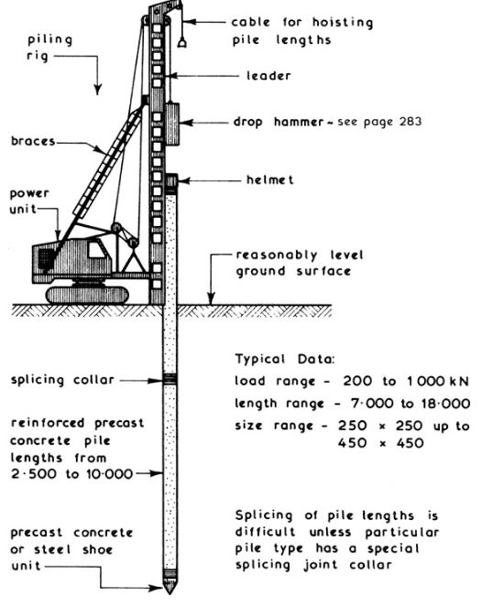
Figure 3. Driven pile (Chudley and Greeno, 2015b).

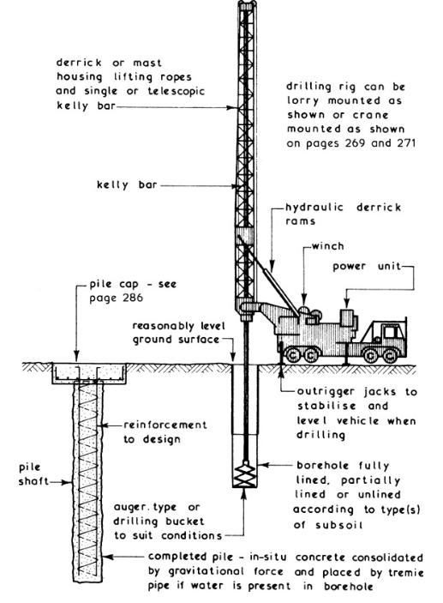
Figure 4. bored pile (Chudley and Greeno, 2015c).

By using a precast method, the amount of offsite construction is increased and there is minimal waste produced when compared to cast in situ.
There are several manufacturers that are producing more low carbon or recycled material piles than traditionally used, again reducing the environmental impact of the construction and the embodied carbon within the building (innovate UK, 2024) (Cerys, 2018).
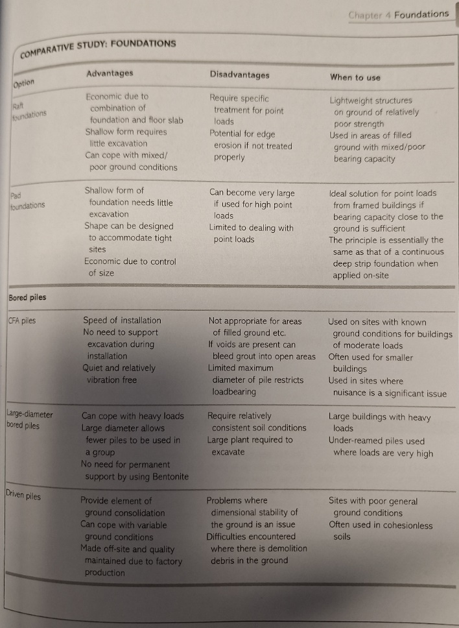
Figure 5. Foundation comparison (Riley and Cotgrave, 2014a.).

Figure 5. above compares foundation types showing applications and advantages and disadvantages. After comparing this table, we propose the use of a displacement recycled pipe pile for the building, rather than using a replacement pile (Riley and Cotgrave, 2014a, p.121).
When reviewing the desktop survey of the site the ground is artificially levelled and when referring to the table if figure 5. This rules out the use of CFA piles on the basis that there may be voids in the ground, these displacement piles were used in sheerness docks in similar strata (Aarsleff, 2025).
One of the disadvantages of using the driven piles is that they will produce significant noise when compared to a bored pile method however the proposed site is not in a residential area, and the risk of nuisance is negligible. The use of recycled piles will also improve the sustainability of the project by reducing the embodied carbon and by using a material that is easily recyclable when looking at the whole lifecycle of the building.
The exact specification of the pile will need to be determined after a structural design calculation, and ground investigation on site to determine the loads of the building and confirm the soil makeup.

Superstructure

This structure needs to be strong enough to withstand these dead loads, as previously mentioned, and durable enough to withstand the climate conditions and the intended usage of the building (live loads).

There are two types of construction available for the proposed building, framed superstructure and traditional load bearing structure. Figure 6. Below shows the difference between these types of structure (Hasan, 2025.)
.

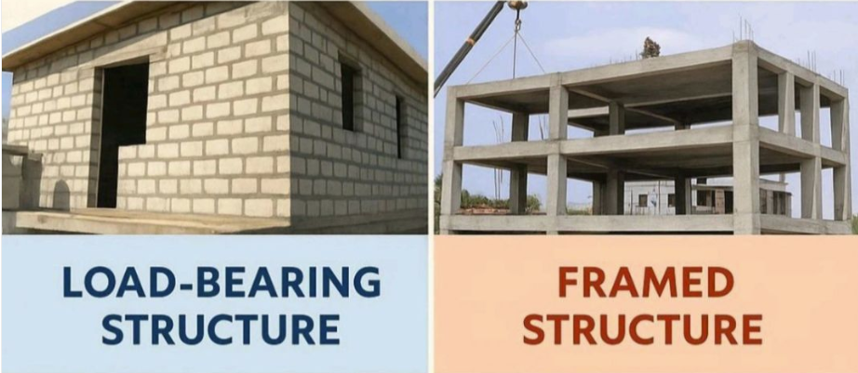
Figure 6.

The traditional load bearing structure will require the elements of the building, such as walls, to transfer the loads to the foundations, this limits the range of materials that can be used in the construction process relying on brick, stone, or block walls and requires more on site construction than a framed superstructure raising the embodied carbon of the building.
The Monadnock Building, shown in Figure 7 below, in Chicago, demonstrates that high-rise buildings can be constructed with a traditional load-bearing structure. However, to be strong enough to withstand the loads, the walls of this building are 6 feet thick at the base. This type of construction leads to restrictions on the buildings internal spaces with difficulty in creating large open plan spaces. This type of construction would increase the cost to complete in terms of extra materials required and the amount of time to complete the construction by not being modular in design (Anon, 2025).

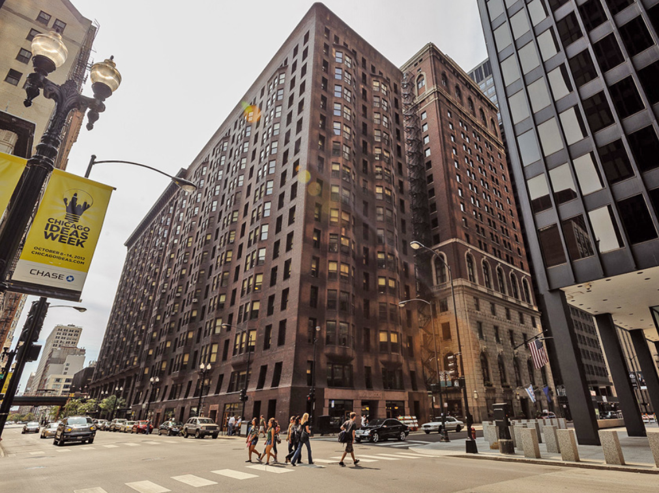
Figure 7.

A Framed building will transfer the loads through the frame rather than the walls in traditional load bearing buildings. The use of a frame superstructure minimises the amount of space taken up by the superstructure in turn maximising the available internal space available, unlike the load bearing structure the thickness of the frame does not need to increase towards the base of the building to support the loads, as highlighted in the Monadnock building. This Frame can also be adapted to create large open plan spaces that can be adapted for different building purposes. The exterior of a framed building acts as the wind tightness layer only (Riley and Cotgrave, 2014b, p.172).

For the proposed building we recommend the use of a skeleton framed superstructure because of the previously highlighted points. There are a range of materials available for the building framework. Frames are typically made from concrete, steel, and wood and can be a mixture of the above materials.

Steel and concrete are typically used for framed buildings but by combining the together to form reinforced concrete that uses the strengths of both materials, the compressive strength of concrete and the tensile strength of steel, you create a material that is incredible strong reducing the amount of material required to support loads. By using reinforced concrete and employing pre or post tensioning of the steel the material strength can be greatly increased. Both reinforced and tensioned concrete have excellent fire resistance providing a fire-resistant barrier with low thermal conductivity that will protect the steel within the concrete. Steel on its own will increase in plasticity as it is heated, reducing its mechanical properties. It may require the application of fire-retardant materials to provide protection in the event of a fire, in order to conform to Approved Document B, depending on building size, application, and fire suppression measures used (Riley and Cotgrave, 2014c, p.22) (Gov.UK, 2025).
Reinforced or tensioned concrete materials can either be formed on site, cast in situ, much like the replacement pilings, using formwork to create the shapes required or by using precast sections connected on site. By using precast, much like the displacement piling, there are several benefits.
The offsite construction process improves quality, reduces the amount of time on site to construct and the number of materials required to complete the building, almost eliminating the need for formwork construction except potentially the plinth and column connections. Again, this is the more sustainable building choice when compared to cast in situ framework because of the reduced material, and labour and site.

For the proposed building we recommend the skeleton framework be constructed from cross laminated timber, CLT, with reinforced precast concrete. Figure 8. Below shows the interior of a CLT framed building, the material consists of opposing layers of wood bound together to form panels, columns and beams this material can be classed as a modern method of construction (DPR Construction, 2023.) (Harte, 2017a).

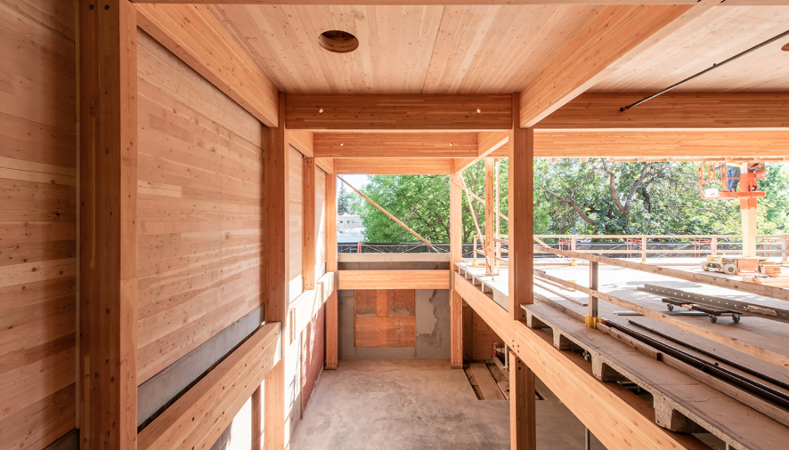
Figure 8.

CLT can be used to create multistorey buildings it has been used in multiple medium and high-rise buildings, such as the Limnologen apartment complex, Växjö,
Sweden. & Brock commons student residence, Vancouver, Canada (Hasan, 2017a) (Arkitektbolaget, 2024a).

The Limnologen apartment complex, Växjö Sweden. As shown in figure 9. incorporates the use of concrete ground floor to provide stability and the frame including lift shafts are constructed in mass timber wood, the building also incorporates a wooden façade and elements constructed from a range of non-virgin materials (Arkitektbolaget, 2024b).

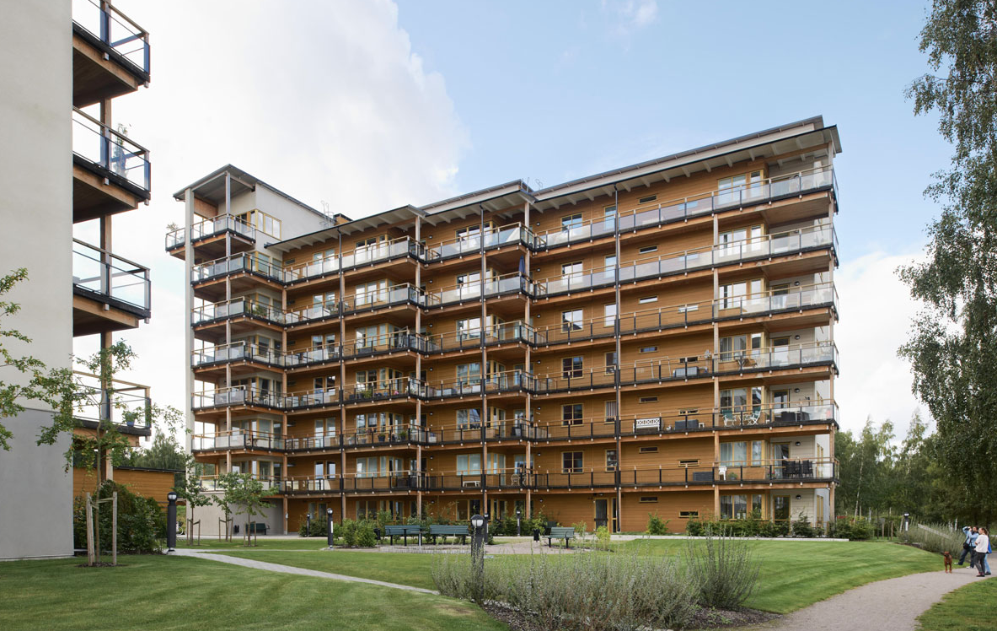
Figure 9.

Brock commons student residence, Vancouver, Canada. As shown in figure 10. Like The Limnologen apartment complex utilises wood frame and concrete elements to comply with fire safety regulations, this case study demonstrates that using this type of modular system can also be quicker when compared to erecting the same building in concrete (Hasan, 2017b).

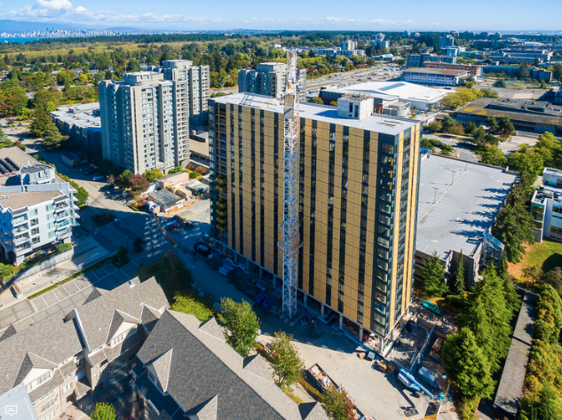
Figure 10.

CLT like precast and steel is manufactured offsite and is modular reducing the time to construct and just like concrete is resistant to fire due to the greater mass of the wood and the ability to form a fire-resistant char skin on exposure to fire, although the sections required to withstand the load and fire may be thicker than those of concrete and steel. It also has several advantages over these materials; it is more sustainable being a renewable material and has greater sequestered carbon due to the material being composed of wood. It can also be more visually appealing than concrete and steel and promote greater connection to the surrounding environment.
For the proposed building by combining CLT with elements comprised of tensioned concrete such as the stairwells the frame of the building can be sufficiently strong, fireproof, sustainable and visually appealing (Riley and Cotgrave, 2014d, p.202) (Harte, 2017b).

Building envelope

The building envelope on a framed building is essentially the building outer wind tightness layer that protects the interior of the building and acts as the exterior visual appearance of the building. There are a range of different envelopes for a framed building infill panel, non-load bearing cladding, rainscreen, and curtain walls.
Each of these envelopes offers advantages and disadvantages, some of these are listed in the table below, figure 11. These systems can come in a range of natural and synthetic materials including brick, timber, aluminium and glass (Riley and Cotgrave, 2014e, p.280).

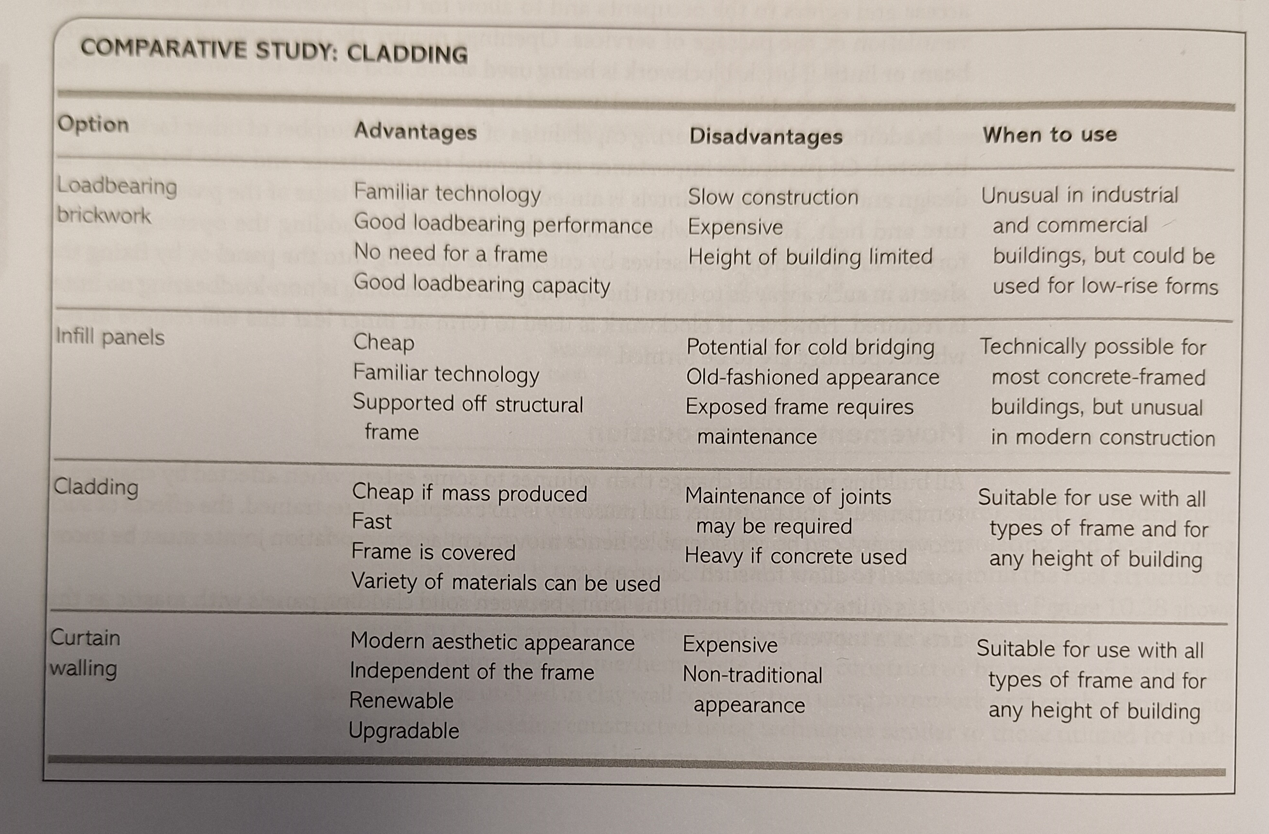
Figure 11. Cladding comparison (Riley and Cotgrave, 2014e.).

Figure 12. Below shows a typical cross section of a rainscreen, system that is attached to the building this system can incorporate insulation and a weatherproof wind tightness layer, this type of building envelope system can also incorporate systems to allow for differential settlement, a range of material options are available for use (Designing buildings, 2016.).

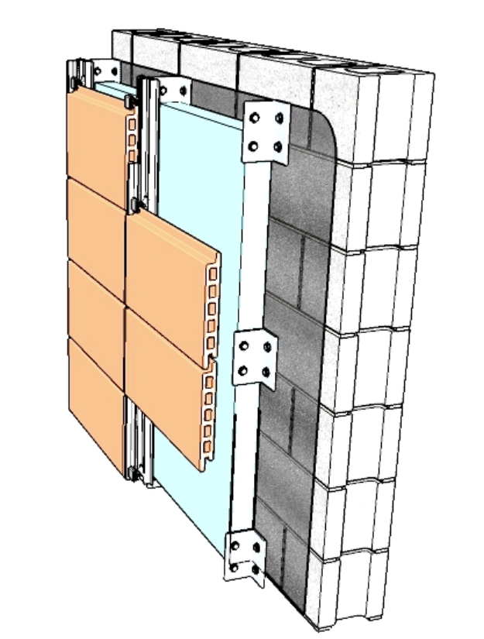
Figure 12.

For the proposed building we recommend the use of both a non-load bearing cladding system and a glazed curtain walling system. By combining these systems in one building, the advantages of both can be achieved. Brock Commons Student Residence in Vancouver, Canada, used non-load-bearing panels to seal the building envelope, which allowed for quick completion of the project. The panels were modular and came pre-assembled with glazing. Figure 13 below shows these being installed. The choice of finishes, including timber, are available and can match the proposed frame design to emphasis the timber frame construction and improve the aesthetics of the building (Hasan, 2017c).

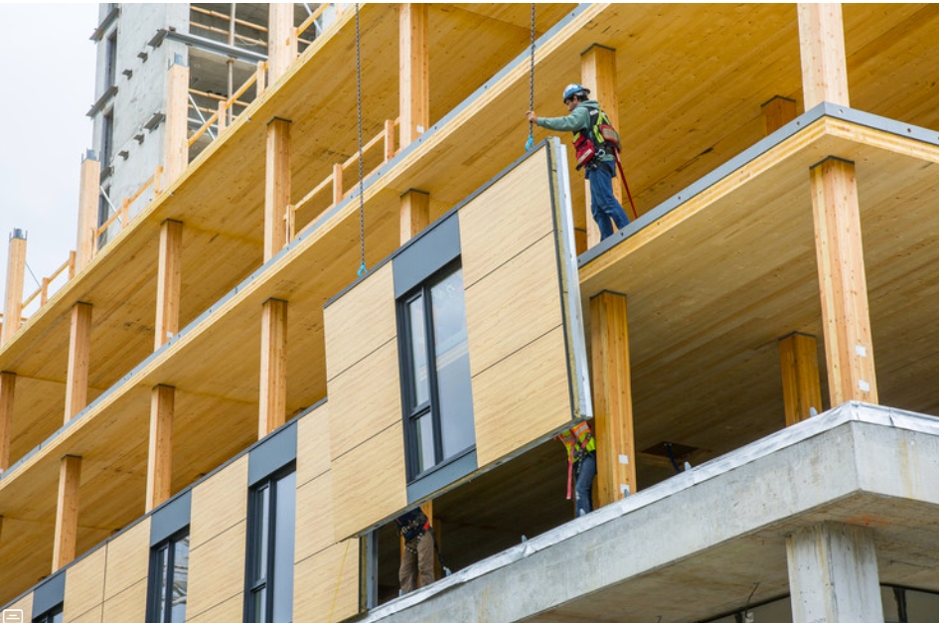
Figure 13.
By combining this with a glazed curtain walling systems the building can be designed in such a way the this can be incorporated into a passive heating and ventilation strategy making use of solar gains by maximising the use of glazing on aspect that benefits from the sun and using the cladding to insulate on aspects with the least amount of solar gains, the glazed systems can enhance the light withing the building and promote a connection between the interior of the building and the exterior environment (Designing buildings, 2022.).

Conclusion

The most used material in construction globally is concrete, this material is also significantly negatively impacts the environment from the amount of energy required to produce and the emissions arising from use. It is also forecast that some of the raw materials used in concrete are finite, and global reserves are in short supply.
Exploring alternative renewable construction materials to concrete can help to reduce the negative effects of concrete on our planet.
With careful selection of materials and building design, buildings can be sustainable. They can meet the expectations of all stakeholders by being constructed quickly, efficiently, and to higher standards; be environmentally responsible by lowering carbon emissions by using renewable materials and offsite modular construction; and minimize the impact on the local environment.
By incorporating modern methods of construction, we can construct buildings that are resilient to the present-day requirements and adaptable to future changing needs and environmental conditions.

Appendix.

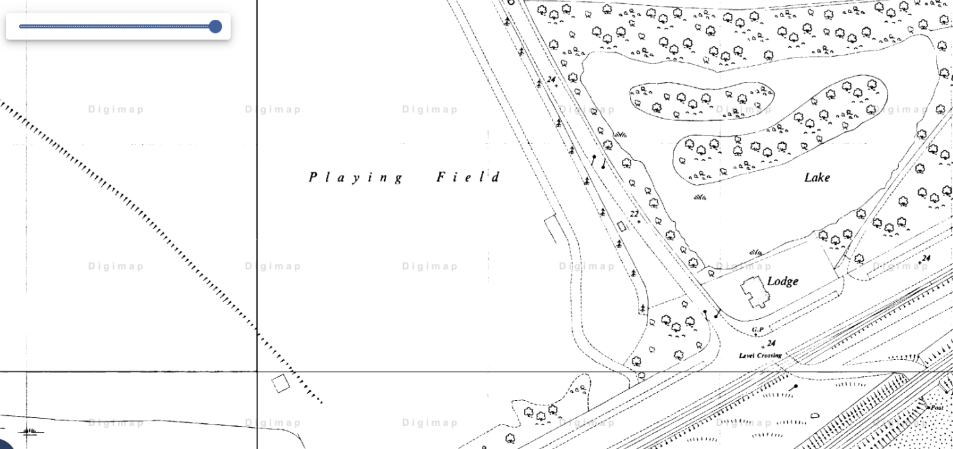
Appendix 1.

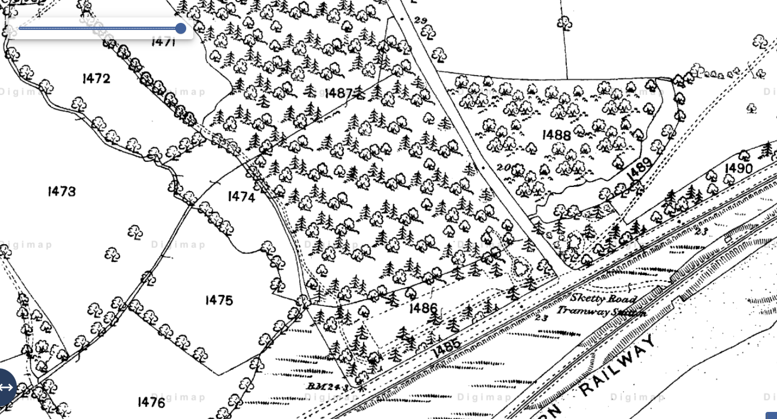
Appendix 2.

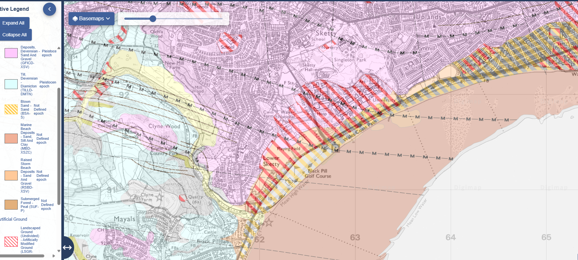
Appendix 3.

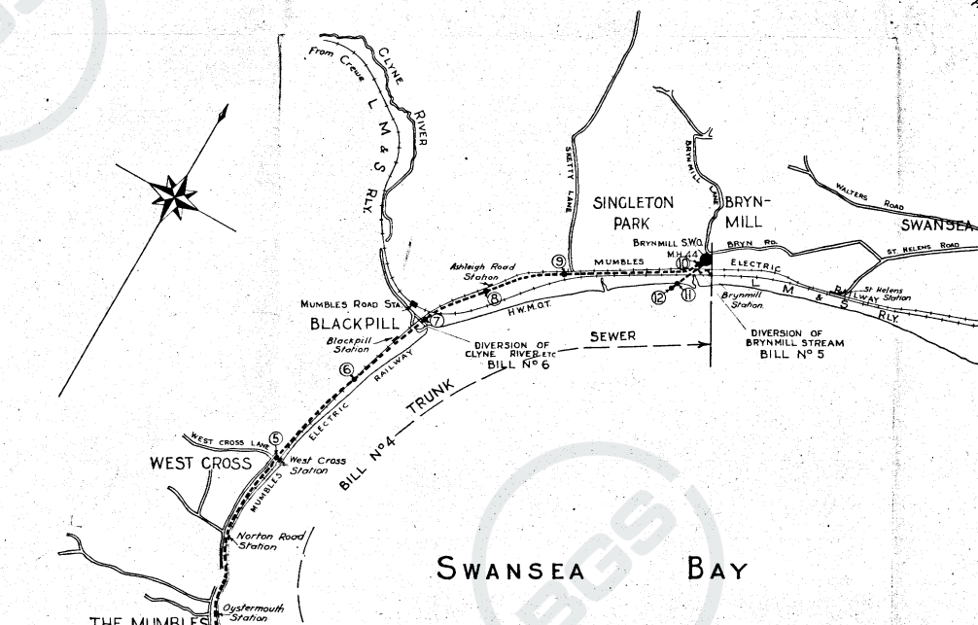
Appendix 4.

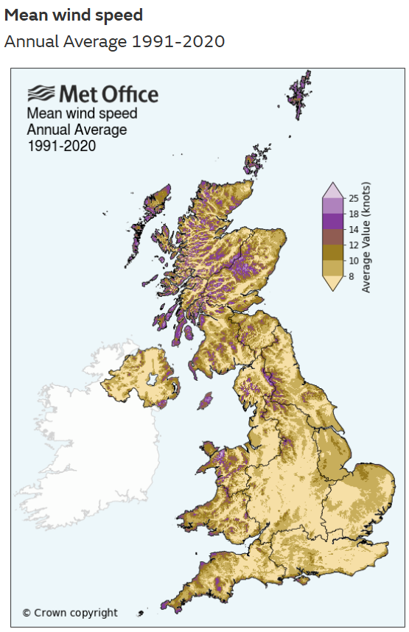
Appendix 5.

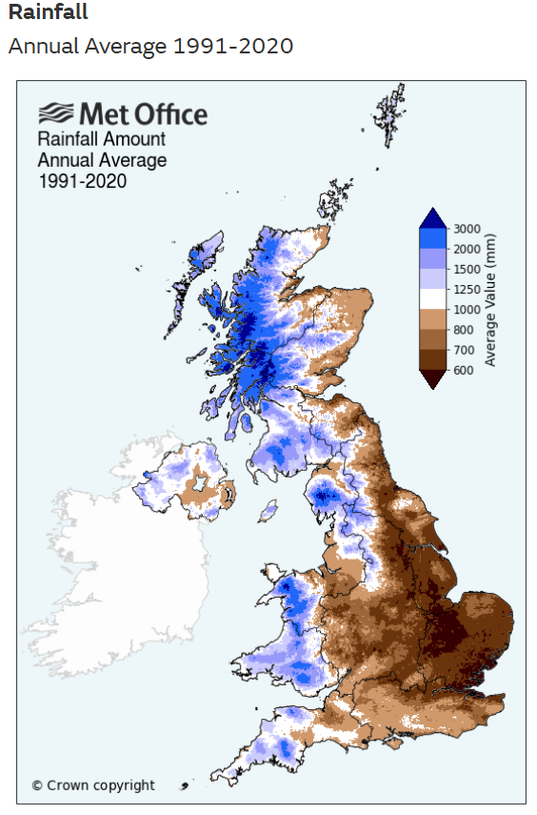
Appendix 6.

References

Aarsleff. (2025). “Sheerness Docks - Aarsleff Ground Engineering.” Aarsleff Ground Engineering, 17 Dec. 2025, https://aarsleff.co.uk/project/sheerness-docks/ . Accessed 5 Dec. 2025.
Anon, (2025). “About | Monadnock Building | Historic Office Building in Downtown Chicago.” Monadnock, 2025, https://monadnockbuilding.com/the-building . Accessed 7 Dec. 2025.
Arkitektbolaget. (2024a). Limnologen - Arkitektbolaget. [online] Available at: https://arkitektbolaget.se/projekt/limnologen/ . [Accessed 12 Dec. 2025].
Arkitektbolaget. (2024b). Limnologen - Arkitektbolaget. [online] Available at: https://arkitektbolaget.se/projekt/limnologen/ . [Accessed 12 Dec. 2025].
Bhbasements.co.uk. (2025). Basement construction. [online] Available at: https://www.bhbasements.co.uk/content/uploads/2023/11/bh-basements-hamilton-terrace-5-1440x1080.jpg . [Accessed 3 Dec. 2025].
British Geological Survey, (2025a), “Borehole cross section (screenshot)”, Available at https://api.bgs.ac.uk/sobi-scans/v1/borehole/scans/items/370520 . Accessed 02 December 2025.
British Geological Survey, (2025b), “Borehole cross section (screenshot)”, Available at https://api.bgs.ac.uk/sobi-scans/v1/borehole/scans/items/370520 . Accessed 02 December 2025.
Bryan, T. (2010a). Construction technology: analysis and choice. 2nd ed. Oxford; Malden: Wiley-Blackwell, Cop, p.369.
Bryan, T. (2010b). Construction technology: analysis and choice. 2nd ed. Oxford; Malden: Wiley-Blackwell, Cop, p.369.
Bryan, T. (2010c). Construction technology: analysis and choice. 2nd ed. Oxford; Malden: Wiley-Blackwell, Cop, p.369.
Cerys. (2018). “Driven Steel Tube Piles.” Aarsleff Ground Engineering, 7 Jan. 2018, https://aarsleff.co.uk/solutions/driven-steel-tube-piles/ . Accessed 4 Dec. 2025.
Chudley, R. and Greeno, R. (2015a). Building construction handbook. Taylor & Francis Group, p.111.
Chudley, R. and Greeno, R. (2015b). Building construction handbook. Taylor & Francis Group, p.113.
Chudley, R. and Greeno, R. (2015c). Building construction handbook. Taylor & Francis Group, p.113.
Designing buildings (2016). Rainscreen. [online] Available at: https://www.designingbuildings.co.uk/wiki/Rainscreen [Accessed 12 Dec. 2025].
Designing buildings (2022). Solar gain in buildings. [online] Available at: https://www.designingbuildings.co.uk/Solar_gain_in_buildings [Accessed 2025].
DPR Construction. (2023). The Big Picture: Building with Mass Timber. [online] Available at: https://www.dpr.com/media/blog/the-big-picture-building-with-mass-timber [Accessed 10 Dec. 2025].
GBC (2025). WHY IS IT IMPORTANT? [online] GBC. UK green building council. Available at: https://ukgbc.org/wp-content/uploads/2024/07/Sustainable-Construction.pdf [Accessed 3 Dec. 2025].
Goodrum, Joseph, “Swansea SA2”, PNG map, 1:1000, OS MasterMap, 1940, Ordnance Survey, using Digimap Ordnance Survey Collection, https://digimap.edina.ac.uk/ . Created 02 December 2025a.
Goodrum, Joseph, “Swansea SA2”, PNG map, 1:1250, OS MasterMap, 1870, Ordnance Survey, using Digimap Ordnance Survey Collection, https://digimap.edina.ac.uk/ . Created 02 December 2025b.
Goodrum, Joseph, “Swansea SA2”, PNG map, 1:25000, British National Grid, 2013, British National Grid, using Digimap Geology Collection, https://digimap.edina.ac.uk/ . Created 02 December 2025c.
Gov.UK, (2010). Approved Document B, https://www.gov.wales/sites/default/files/publications/2021-12/building-regulations-guidance-part-b-fire-safety-volume-2-buildings-other-than-dwellinghouses.pdf . Accessed 7 Dec. 2025.
Harte, A.M. (2017a). Mass timber – the emergence of a modern construction material. Journal of Structural Integrity and Maintenance, 2(3), pp.121–132. doi: 10.1080/24705314.2017.1354156, https://doi.org/10.1080/24705314.2017.1354156
Harte, A.M. (2017b). Mass timber – the emergence of a modern construction material. Journal of Structural Integrity and Maintenance, 2(3), pp.121–132. doi: 10.1080/24705314.2017.1354156, https://doi.org/10.1080/24705314.2017.1354156
Hasan, Kashif, (2025). Building Superstructure, www.linkedin.com/posts/md-kashif-hasan-569242212_load-bearing-structure-vs-framed-activity-7377662799076003840-ApzU Accessed 6 Dec. 2025.
Hasan, Z.G. (2017a). Inside Vancouver’s Brock Commons, the World’s Tallest Mass Timber Building. [online] ArchDaily. Available at: https://www.archdaily.com/879625/inside-vancouvers-brock-commons-the-worlds-tallest-timber-structured-building [Accessed 12 Dec. 2025].
Hasan, Z.G. (2017b). Inside Vancouver’s Brock Commons, the World’s Tallest Mass Timber Building. [online] ArchDaily. Available at: https://www.archdaily.com/879625/inside-vancouvers-brock-commons-the-worlds-tallest-timber-structured-building [Accessed 12 Dec. 2025].
Hasan, Z.G. (2017c). Inside Vancouver’s Brock Commons, the World’s Tallest Mass Timber Building. [online] ArchDaily. Available at: https://www.archdaily.com/879625/inside-vancouvers-brock-commons-the-worlds-tallest-timber-structured-building [Accessed 13 Dec. 2025].
innovate Uk, (2024). “Innovative Hollow Pile Technology to Reduce Carbon Emissions - Knowledge Transfer Partnerships.” Knowledge Transfer Partnerships, Nov. 2024, https://iuk-ktp.org.uk/case-study/ktp-develops-innovative-hollow-pile-technology-reducing-carbon-emissions/ . Accessed 4 Dec. 2025.
LETI (2025). Build less. [online] LETI. Available at: https://www.leti.uk/_files/ugd/252d09_aa3cb94a124e40fba747d6520afc4bce.pdf [Accessed 3 Dec. 2025].
Met Office, (2025a), “Mean wind speed (screenshot)”, Available at https://www.metoffice.gov.uk/research/climate/maps-and-data/location-specific-long-term-averages/gcjjm7j5g ,Accessed 02 December 2025
Met Office, (2025b), “Mean rainfall (screenshot)”, Available at https://www.metoffice.gov.uk/research/climate/maps-and-data/location-specific-long-term-averages/gcjjm7j5g . Accessed 02 December 2025
Riley, Mike, and Alison Cotgrave (2014a). Construction Technology. 2, Industrial and Commercial Building. 3rd ed., Basingstoke, Hampshire, Palgrave Macmillan, p. 121.
Riley, Mike, and Alison Cotgrave (2014b). Construction Technology. 2, Industrial and Commercial Building. 3rd ed., Basingstoke, Hampshire, Palgrave Macmillan, p. 172.
Riley, Mike, and Alison Cotgrave (2014c). Construction Technology. 2, Industrial and Commercial Building. 3rd ed., Basingstoke, Hampshire, Palgrave Macmillan, p. 22.
Riley, Mike, and Alison Cotgrave (2014d). Construction Technology. 2, Industrial and Commercial Building. 3rd ed., Basingstoke, Hampshire, Palgrave Macmillan, p. 202.
Riley, Mike, and Alison Cotgrave (2014e). Construction Technology. 2, Industrial and Commercial Building. 3rd ed., Basingstoke, Hampshire, Palgrave Macmillan, p. 280.

