
University of Wales Trinity Saint David
Wales Institute of Science and Art

Suspension Kinematics and Performance Analysis
Motorsport Technology (ACHA4012)


Nathaniel Fullylove
2101005
December 2021

Table of Contents

Table of Contents 1
1.0 – Introduction 2
2.0 – Laboratory Sessions 3
2.1 Equipment
2.2 Methodology
2.3 Results
3.0 – WinGeo Kinematic Simulation 7
3.1 Methodology
3.2 Kinematics Results and Discussion
3.3 RC Migration
4.0 – Suspension Calculations 9
4.1 Calculations
4.2 Discussion
5.0 – Validation 10
6.0 – Conclusion 11
7.0 Referencing List 12

1.0 – Introduction

The race car being investigated is a Van Dieman Single Seater, specifically the front suspension system of said car. This report will go into depth about the Formula Ford race cars front suspension and compare the laboratory gathered data, to simulated data produced using WinGeo Software. Then the report will compare the two sets of data and will include discussions on the data collected and compared. This will also look at spring deflection when under force, and tyre deflection under a force. It will also show different calculations and explain their relevance to the data.
The suspension on a Formula Ford Single Seater race car is a Double-A Wishbone suspension system.

2.0 – Laboratory Sessions

  - 2.1 Equiptment
The equipment used to measure the data from the front suspension in the lab was, two DTIs, used to measure the change in toe angle. Also used was a vernier calliper to measure the gap on the turnbuckle. A camber gauge was used to monitor the change in camber. Then a Height Gauge is used to measure the change in wheel position.
To measure the unsprung mass, a corner weight scale is used.
To measure the tyre stiffness, a tyre stiffness rig is used along with a DTI and a corner weight scale too.
For the spring stiffness, the spring compression tester is used as well as a DTI again.
Using a vernier calliper may not be the most accurate way to measure something as it allows for human error to affect the results, in terms of misreading the callipers. Therefore, a digital calliper may be more suitable to use for this investigation.
Another thing to mention is that DTIs are very sensitive, so this allows errors to appear in readings.
  - 2.2 Methodology
To take the required readings for the front suspension of the Formula Ford car everything must be set up correctly, the height of the wheel needs to be at a ride height of -20mm to start. Then using the height gauge, set it to the height of the plate on and zero it. The two DTIs need to be in contact with about 50% of the bar on either side of the DTI to allow movement to measure. The DTIs then need to set to zero. Due to the plate being on the wheel hub, the camber gauge will have to be on the wrong side of the wheel hub, so when taking the readings remember that it is negative for the number shown. Take down the reading on the camber gauge in the first row of your data table. Measure the gap on the turnbuckle as well and take note of this number in the table. It is best to have more than one person to take readings. Firstly, one person watching the DTIs so they don’t get knocked, as this would mean having to restart everything. Then one person to monitor the camber and wheel position, another to turn the turnbuckle and measure the gap to find the damper length, and then possibly one more to write the results down. Take readings every two full turns of the turnbuckle. Repeat this until the data table is complete. The Table should look like the one in Figure 1.
To measure the unsprung mass on the car, put a corner weight scale under the front tyre and take down the reading. Then, complete the same for unsprung mass off the car with the wishbones and all connections off and take the reading from the scale.
The spring stiffness test is done on the spring compression rig by increasing the load by one full rotation of the DTI and take measurements at every rotation as in Figure 2.
For tyre stiffness, put it on the tyre stiffness rig and increase the load on the tyre by one full rotation on the DTI and take measurements at each load as shown in Figure 3.
  - 2.3 Results
The following are the results of the tests completed in the workshop.
Figure 1 – Table of Data for Formula Ford suspension test, Including toespan.
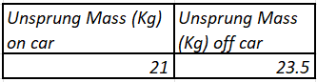
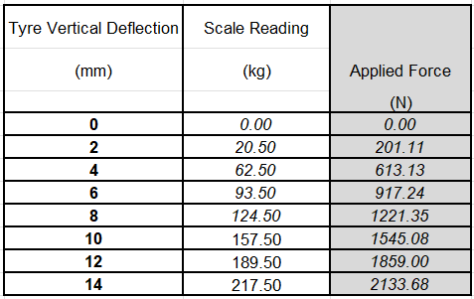
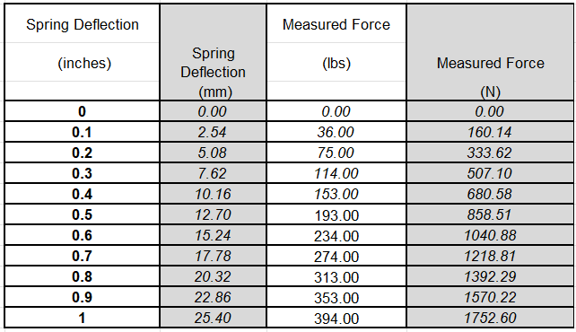
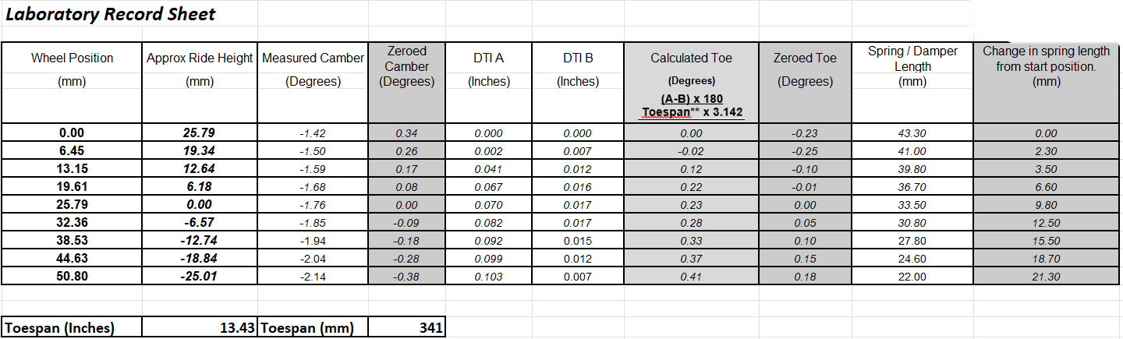
Figure 4 – Unsprung Mass Data
Figure 3 – Tyre Stiffness Table of Data
Figure 2 – Spring Stiffness Table of Data
Figure 5 depicts the graph of measured Camber versus Ride Height. Camber is the angle of the tyre relative to a vertical line from the centre of the tyre perpendicular to the floor. Ride height is the height of the chassis. The graph shows that camber and ride height have a directly proportional relationship as when one increases so does the other.
However, it is only small changes to the camber, as the overall change is only 0.5 degrees. This tells us that when the chassis is at maximum height, the camber will also be at the maximum height caused by the ride height increasing.
Figure 5 – Graph showing Camber Change with Ride Height.

Figure 6 - Toe Angle is the change in the angle relative to the centre line of the tyre. The measured Toe Angle decreases when the Ride Height decreases. From this, we can determine that when accelerating the toe goes out. This is detrimental, as toe in is desirable for straight line speed.
“On the front of the car, toe in increases straight line stability.” (Suspension Secrets, 2017).
Figure 6 – Graph showing Toe Change with Ride Height.

In Figure 7, it is shown that as the spring gets compressed the wheel position also increases. Spring Compression is how much the length of the spring changes. Wheel Position is the change in height of the wheel. This is expected, as when the wheel moves up, the spring will get compressed. From finding the gradient of the measured Spring Compression against Wheel Position you get the
Motion Ratio. So, the measured Motion Ratio is 0.4305.
Figure 7 – Graph depicting Spring Compression Versus Wheel Deflection.
The Motion Ratio tells us how the other side of the car would respond to a change in spring length.
“Motion Ratio is the difference in motion between two interconnected components due to some type of mechanical advantage.” (Rowley, 2004, p.10/10)

Figure 8 shows us how much a spring from the Formula Ford deflects when under load. Applied Force is the force put onto the spring, and Spring Deflection is the change in the length of the spring. As shown, it is a directly proportional relationship. So as the load increases, the spring compression increases. Finding the gradient of this gives us the Spring Rate of 69,302 N/m.
Figure 8 – A graph of Spring Deflection against Force

In Figure 9, the graph shows the relationship of Tyre Deflection, how much the tyre changes height, and Applied Force.
Figure 9 – Graph showing Tyre Deflection against Force
With greater loads the tyre deflects more, resulting in a greater contact patch, which should mean greater traction.

The gradient of the graph shows the tyre stiffness of 156,700 N/m.

3.0 – WinGeo Kinematic Simulation

  - 3.1 Methodology
In WinGeo software, create a table that has Ride, Roll, Steer, Camber_R, Camber_L, Steer_R, Steer_L, NetSteer, Motion_R, Motion_L, Spring_R, Spring_L as values. Set the ride to -25 and press Compute. Then, for every increase of 5, press Compute again until you reach 25 on Ride. This will fill in the table. Then export the data to Excel.
Next, set Ride to 0 and clear the table. Then increase the Roll by 0.1 increments up to 2.0. Press Compute at each increase. Then export the data to Excel.
After this, reset Roll to 0, press Mark RC, and then decrease ride to -20 and press Compute. Next, increase the Ride to -10 and Roll to 0.75, then press Compute. Now increase Ride to 0, with Roll at 1.5 and press Compute. Following this, change Ride to 10 and Roll to 0.75, then press Compute. Finally, set Ride to 20 and Roll to 0, then press Compute, and take a screenshot of the Roll Centre Migration.

  - 3.2 Kinematics Results and Discussion
In Figure 5, the WinGeo Camber and Ride Height data shows a positive directly proportional relationship. The WinGeo Camber and Ride Height data is very close to that of the measured data which tells us they are accurate.
In Figure 6, the WinGeo data shows a negative correlation with a directly proportional relationship between Toe Angle and Ride Height. Comparing Toe Angle WinGeo to measured data, there is a slight deviation. This could be due to human error when completing the test.
In Figure 7, the WinGeo data shows that the Spring Compression and Wheel Position have a directly proportional relationship. The simulated data is a bit higher than the measured data for Spring Compression. This could be due to wear on the spring, meaning it does not compress as much when simulated.

The graph in Figure 10 shows the change in Camber when Roll changes. It shows that when Roll is increased the Camber on the right tyre becomes positive and on the left negative. This means Camber_R and Roll have a directly proportional relationship and Camber_L has an indirectly proportionate relationship with Roll.
Figure 10 – Graph showing Camber Against Roll
  - 3.3 RC Migration
Roll Centre (RC) is an “Invisible moving point about which a vehicle is considered to rotate in a corner” (Staniforth, 1994, p.231). RC Migration is the path the RC takes as the chassis rolls through a corner.
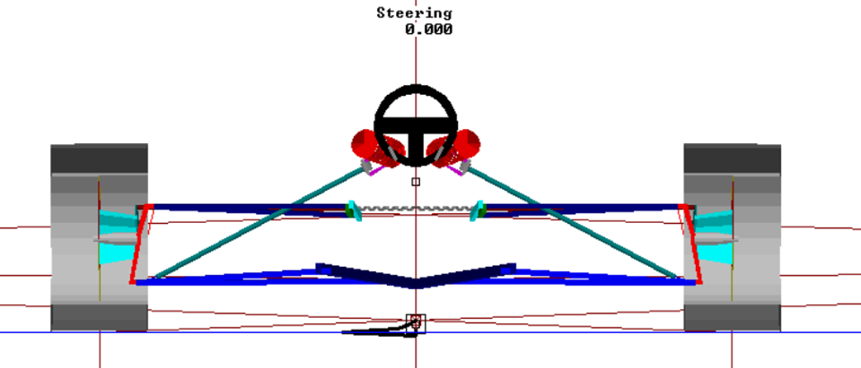
Figure 11 – WinGeo Diagram Depicting the RC migration of a formula ford.

4.0 – Suspension Calculations

  - 4.1 CAlculations
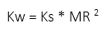
The formula for Wheel Rate is:

Ks=Spring rate
MR=Motion Ratio
Measured Data Wheel rate:
Kw=69302*(0.4305^2) = 12843.76N/m

The formula for Sprung Mass Natural Frequency is:
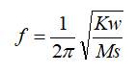

Given that Ms=115Kg
Measured Data
f=(1/2π)√(12843.76/115) = 1.68196615Hz

The formula for Unsprung Mass Natural Frequency:
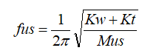

Kt=Tyre Stiffness
Measured Data
fus=(1/2π)√((12843.76+156700)/21) = 14.30050538Hz

  - 4.2 Discussion
The Sprung Mass Natural Frequency is worked out to be somewhere between 1-1.5Hz Comfortable ride (Sedan) and 2-25Hz Harsh ride (Sport/Performance) showing the calculated value is not that far off the correct value of a Formula Ford car.

5.0 – Validation

Figure 5 shows a comparison between measured data and simulated WinGeo data, comparing Camber and Ride Height. They are both very similar to each other, which shows that the data is accurate.
Figure 6 depicts the comparison of measured and simulated data for Toe Angle against Ride Height. The simulated data is a linear graph whereas the measured data is a non-linear graph. The non-linear results infer that it is not accurate. The measured data may be inaccurate due to human error during the measuring, as the DTIs are very sensitive, and a slight knock could skew the data. Also, they can be hard to accurately read, or there could be an error in the adjustment of the spring length.

6.0 – Conclusion

Overall, changing the ride height of a Formula Ford car has an impact on many different areas of a suspension system as shown by the measured and simulated data. When measuring, if more accurate equipment to take readings from the suspension system components were used, then a more correlated dataset to the simulated data could be achieved. However, the measured data and simulated data already correlate well with each other as shown in the various comparative graphs, suggesting that the measured data may be accurate enough.

7.0 Referencing List

Rowley, W., 2004. An introduction to race car engineering. 3 edn. Canada?: Rowley Race Dynamics.

Staniforth, A., 1994. Competition Car Suspension. 3 edn. Newbury Park, CA: Haynes.

Suspension Secrets (2017) What is Toe?.
Available at: https://suspensionsecrets.co.uk/toe/
(Accessed: 12 December 2021)

