

Data Warehouse & Data mining

Name: Sana Khan
ID Number: 2239157
Assignment Title: Data Mining
Module Code: ACCA6026
Lecturer: Dr Mobolanle Bello
Submission Date: 14th November 2025

Abstract
This study applies data mining techniques to the Student Performance dataset from Portuguese secondary schools to explore factors influencing academic success. Using predictive modelling and clustering, it identifies significant variables such as previous grades, study time, and attendance. Tableau visualisations reveal clear performance patterns, supporting targeted interventions, personalised learning approaches, and data-driven strategies to improve student achievement.

Table of Contents
Introduction 2
Purpose and Practice of Data Mining and Its Use in Business 4
Dataset Description, Algorithms, and Justification 6
MATHS EXPLORATION 7
PORTUGESE EXPLORATION 10
DATA PRE-PROCESSING AND POST-PROCESSING 13
Analysis, Methods, and Results 15
Key Insights from Maths Prediction Analysis 16
Key Insights from Portuguese Prediction Analysis 19
Key Insights from Maths Clustering Analysis 23
Key Insights from Portuguese Clustering Analysis 27
Business Recommendations 30
Reflection 31
Conclusion 32
References 33

Data Mining

Figure 1: Data Mining

Introduction
In today’s data-driven world, data mining plays a vital role in education by uncovering meaningful patterns that can help improve student performance [1]. This project applies data mining techniques to the Student Performance dataset from two Portuguese secondary schools, which includes detailed demographic, social, and academic information such as age, family background, study time, and previous grades. By analysing these factors, data mining helps reveal hidden relationships that influence academic success [2]. The main objectives are to develop predictive models that estimate students’ final grades and to use clustering techniques to group students with similar learning behaviours and performance patterns. Tableau is used for data preparation, visualisation, and analysis, enabling clear interpretation of patterns and trends. Through these data mining methods, educators and policymakers can make evidence-based decisions, implement targeted interventions, and enhance teaching strategies to support improved student outcomes.

Purpose and Practice of Data Mining and Its Use in Business
Data mining is the process of uncovering meaningful patterns, trends, and relationships within large datasets using analytical and statistical techniques [1]. Its goal is to transform raw data into actionable insights that support informed decision-making. Techniques such as classification, clustering, regression, and association analysis enable organizations to identify hidden insights not easily revealed through traditional analysis. Data mining typically follows the CRISP-DM framework, which includes data collection, cleaning, transformation, modelling, evaluation, and interpretation [3].
In business contexts, data mining enhances operational efficiency, strengthens customer relationships, and supports strategic growth [2]. Companies use it to predict customer behaviour, segment markets, detect fraud, and optimise supply chains, allowing data-driven decisions and accurate forecasting based on historical data [4].
In this project, Tableau serves as the primary tool for data mining and analysis. Tableau’s advanced visualisation and analytical capabilities allow users to explore, clean, and transform large datasets interactively [5]. Its predictive and clustering functions help identify student performance patterns, group similar learners, and reveal relationships between study habits, family background, and academic results. By interpreting these insights, educational institutions can support at-risk students, refine teaching strategies, and improve outcomes, demonstrating data mining’s role in evidence-based management [6], [7].

Table 1: Examples of Data Mining Techniques and Their Functions
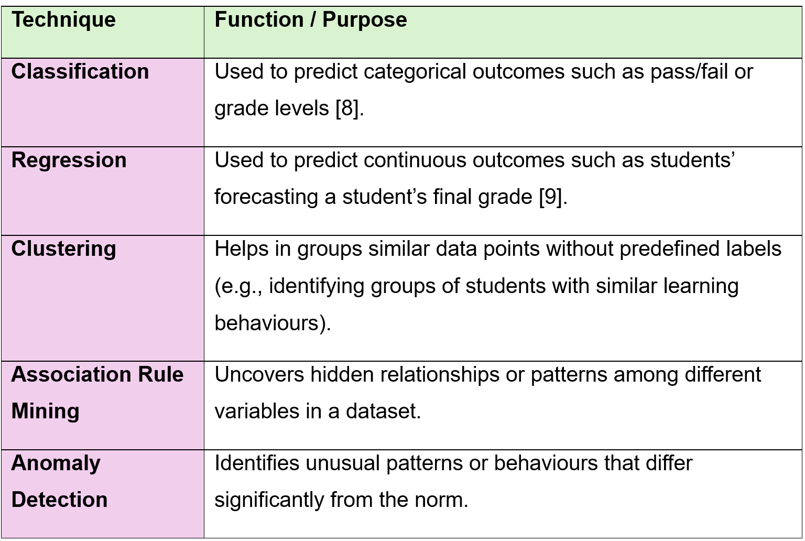
Figure 2: Data Mining Techniques and Functions Table.

Dataset Description, Algorithms, and Justification
The Student Performance dataset from the UCI Machine Learning Repository includes data from two Portuguese secondary schools, focusing on factors influencing academic achievement in Mathematics and Portuguese [10], [11]. It comprises student-mat.csv (395 records) and student-por.csv (649 records), each with 33 attributes detailing demographics, family background, academic history, and social behaviour. Key variables include age, gender, parents’ education, study time, past failures, free time, and alcohol consumption, while academic success is measured through grades G1, G2, and G3. Most variables are categorical, with some numerical ones like age and grades. The dataset is clean, requiring minor preprocessing such as standardising categories and removing duplicates. Tableau was used for predictive analysis through calculated fields, filters, and visual analytics to explore variable relationships [12], [13], [14]. Its K-Means clustering grouped students by shared traits [14], [15], offering educators interpretable, visual insights for understanding and improving academic performance [16].

MATHS EXPLORATION

G1 vs Absences
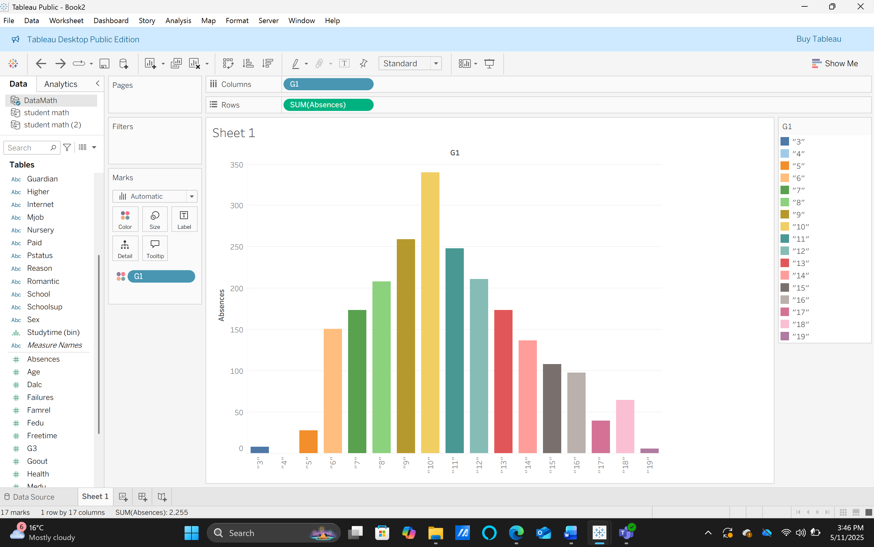
Figure 3: Maths exploration chart one.

The visualization suggests increased absences correspond to lower G1 scores: more absent students show reduced first-period performance, indicating absenteeism negatively impacts early grades and merits targeted attendance support interventions programs.

G2 vs Studytime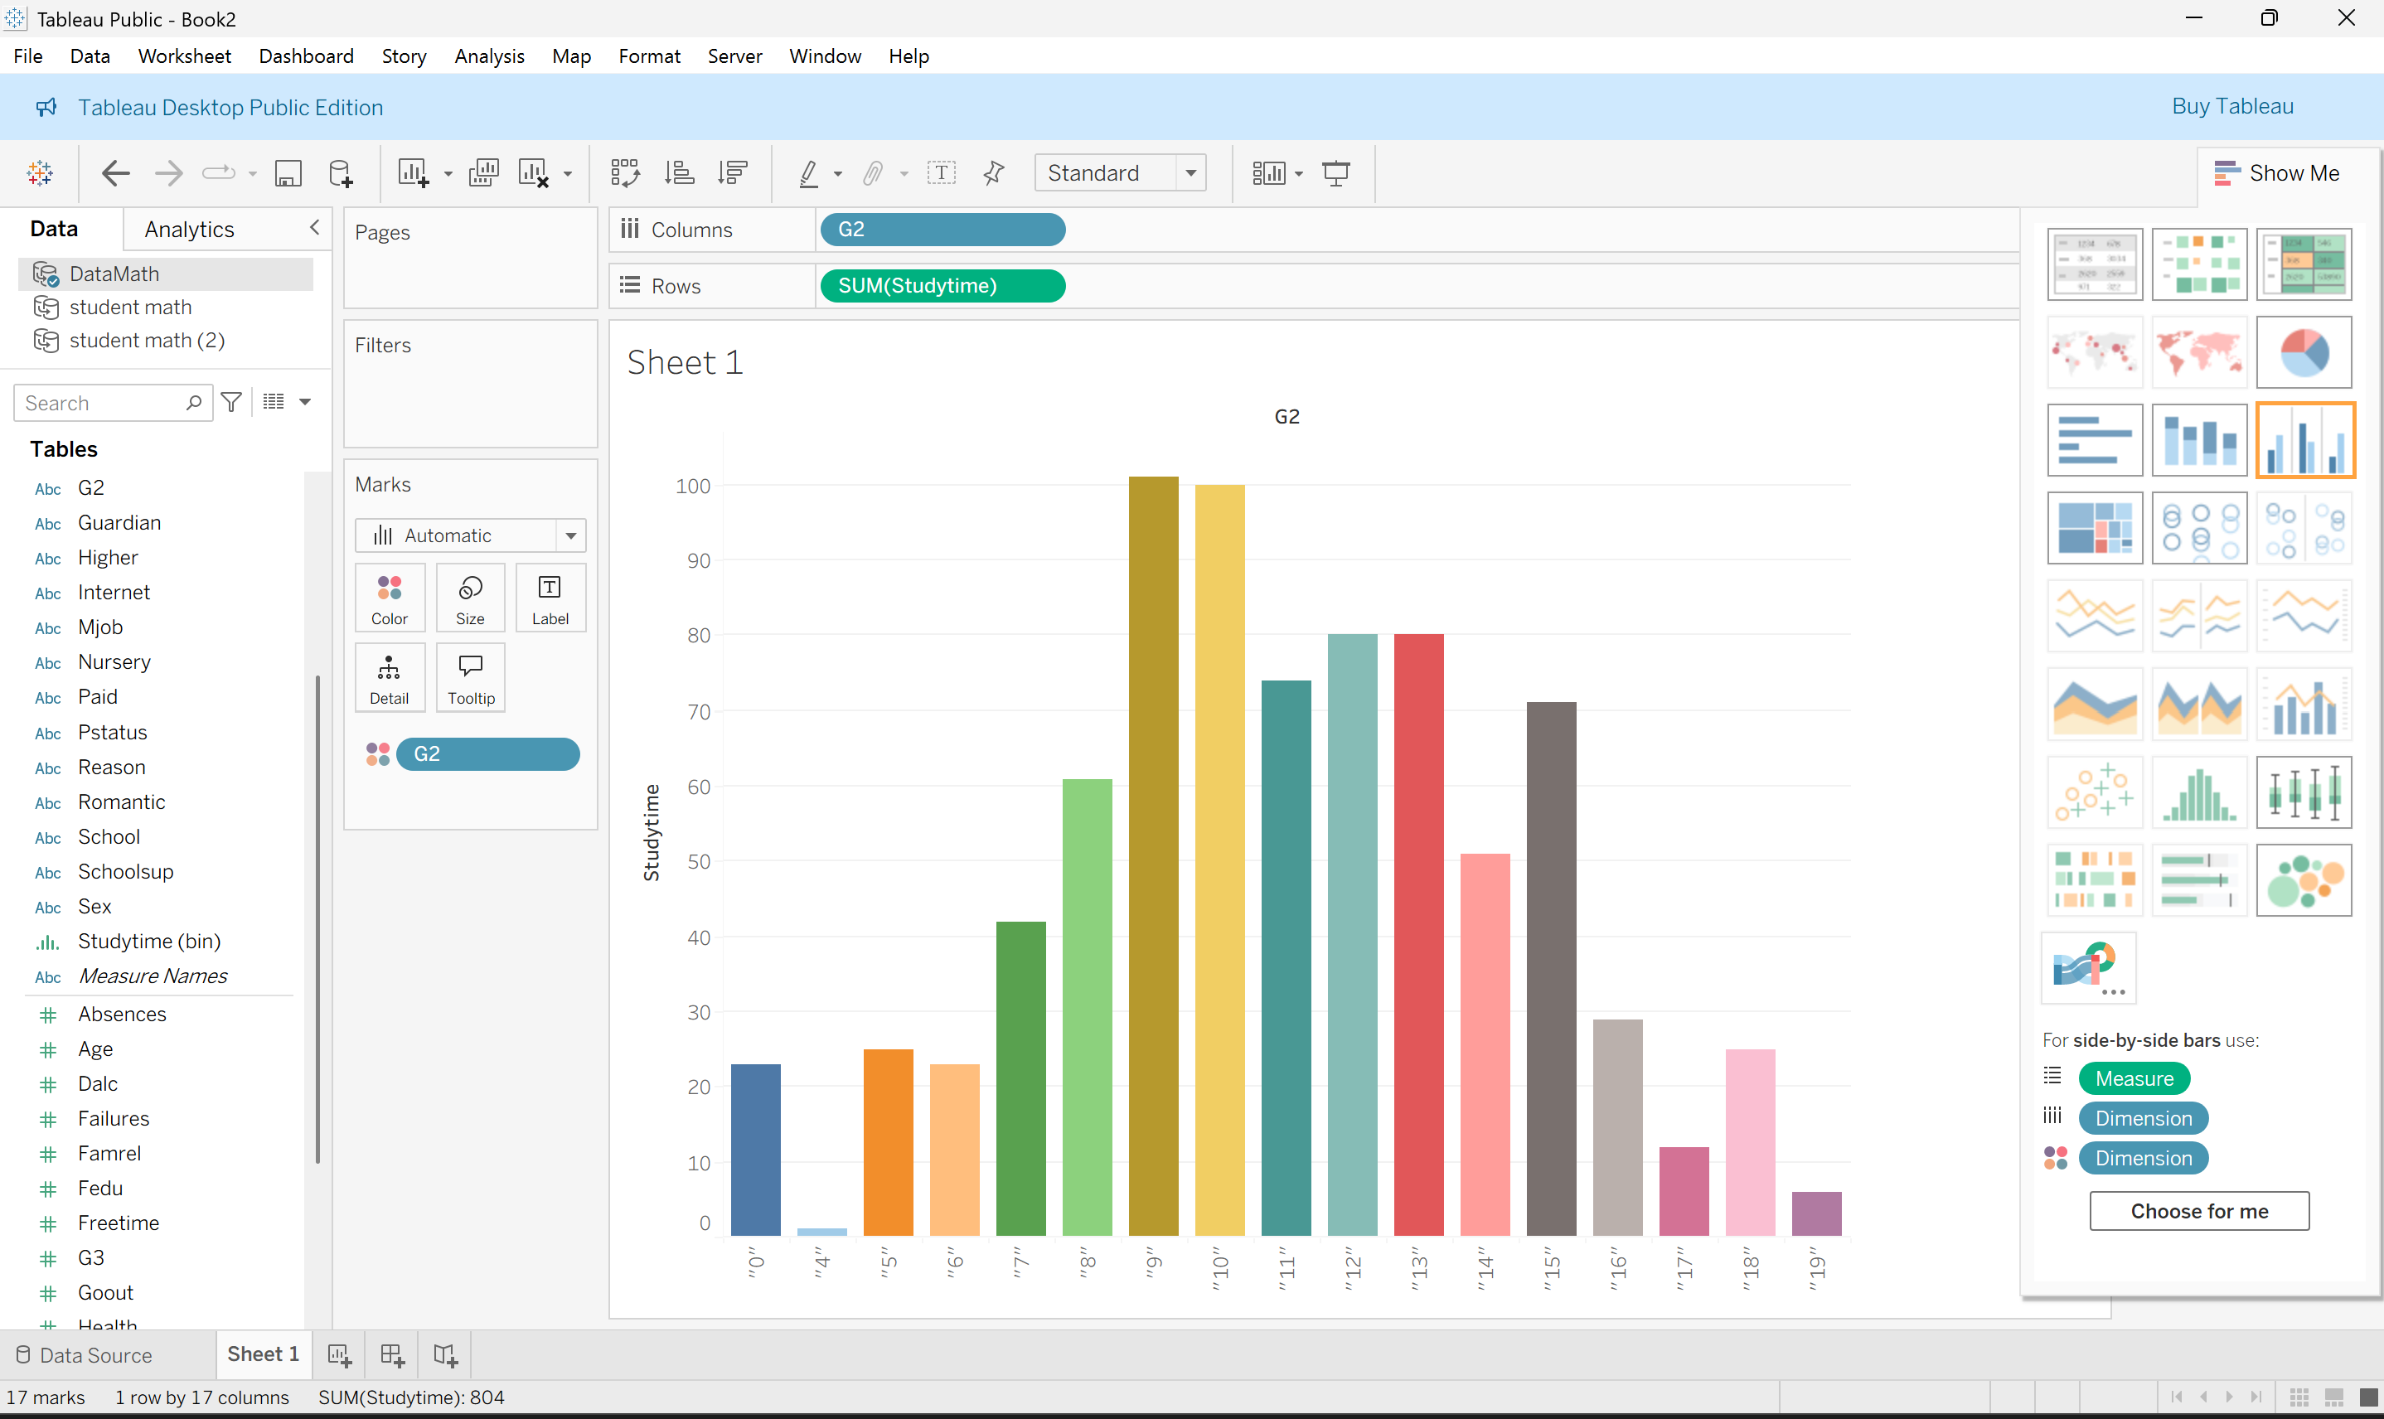
Figure 4: Maths exploration chart two.

In the chart shows student counts per G2 grade (sum of Studentnum). If increased studytime raises grades, you would expect taller bars at higher G2 values and fewer students in low-G2 bins compared to low-studytime groups.

Guardian vs G3
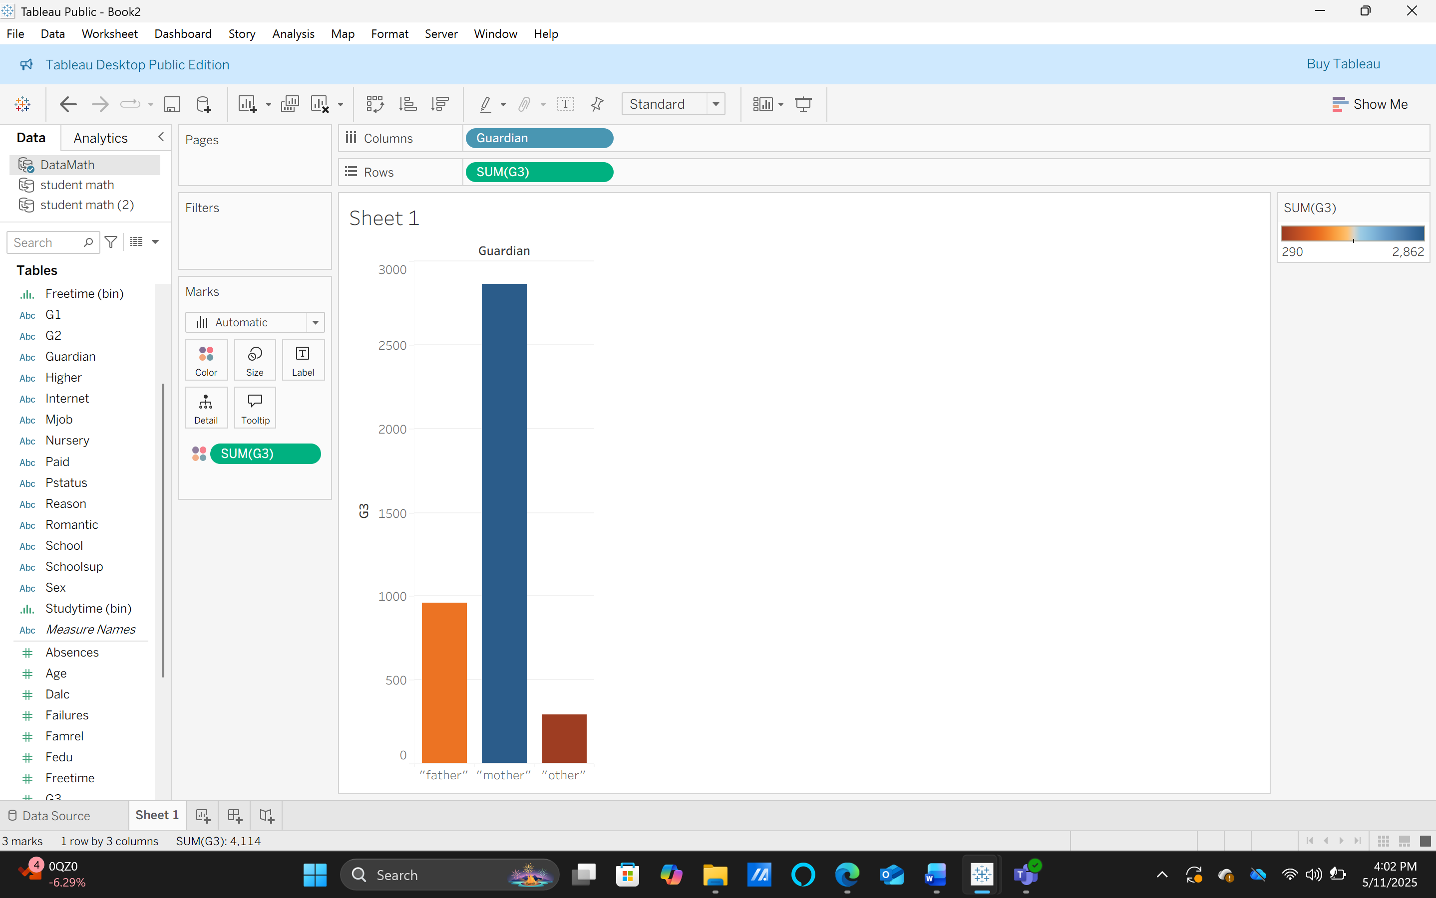
Figure 5: Maths exploration chart three.

Chart shows SUM (S3) by guardian: mother highest, father next, other lowest, suggesting students with maternal guardianship have higher final-grade G3 totals. Correlation not causation: control for parental education, studytime, and support and validate in Weka using regression, crosstabs, and clustering methods.
Overall, the exploration provided a clear understanding of the dataset’s structure, quality, and key patterns, forming a solid foundation for predictive modelling and clustering analyses to identify factors influencing student performance.

PORTUGESE EXPLORATION
G3 vs Fedu (Father Education)
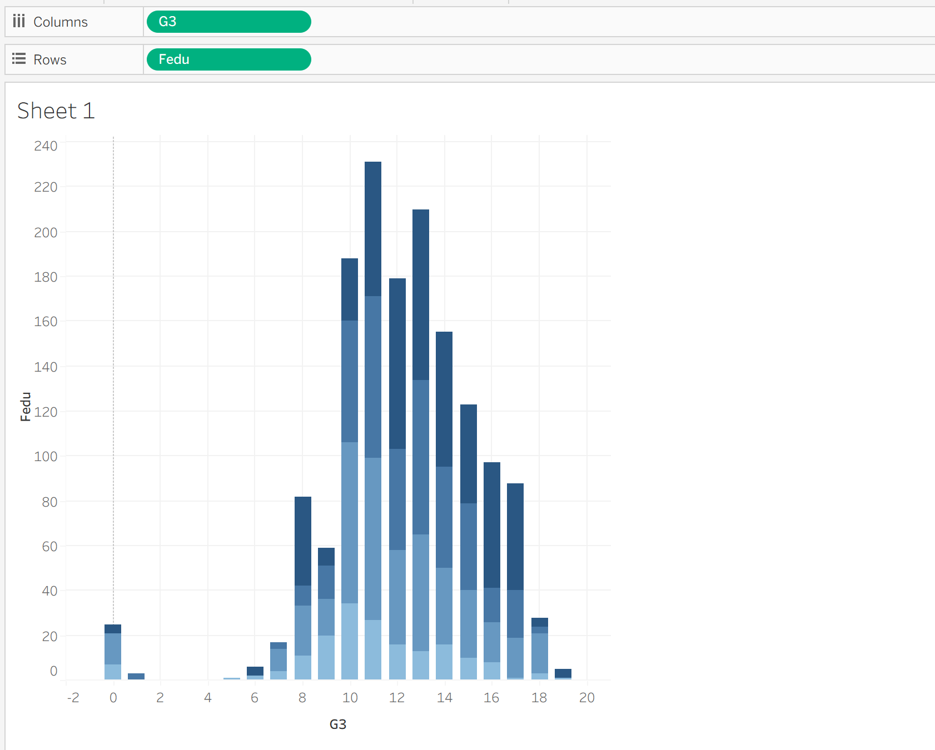
Figure 6: Portuguese exploration chart one.

The bar chart shows that most students score final grades (G3) between 12 and 14, regardless of their father's education level (Fedu). This suggests limited direct influence of paternal education on student performance, with other factors playing stronger roles.

Medu (Mother Education) vs Studytime
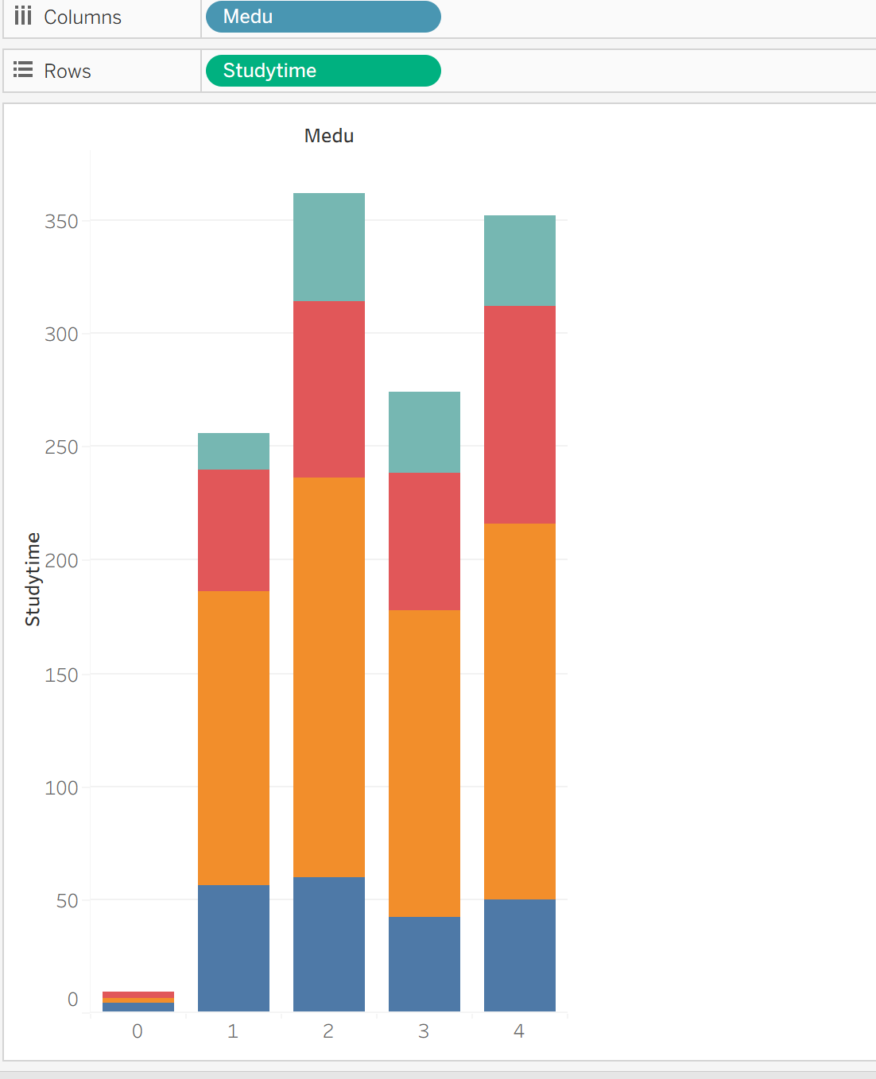
Figure 7: Portuguese exploration two.

The stacked bar chart shows a positive relationship between “Mother education” level (Medu) and student study time. As Medu increases from 0 to 4, total study time also rises, suggesting that students with more educated parents tend to dedicate more time to studying, influenced by supportive academic environments.

Health vs Studytime
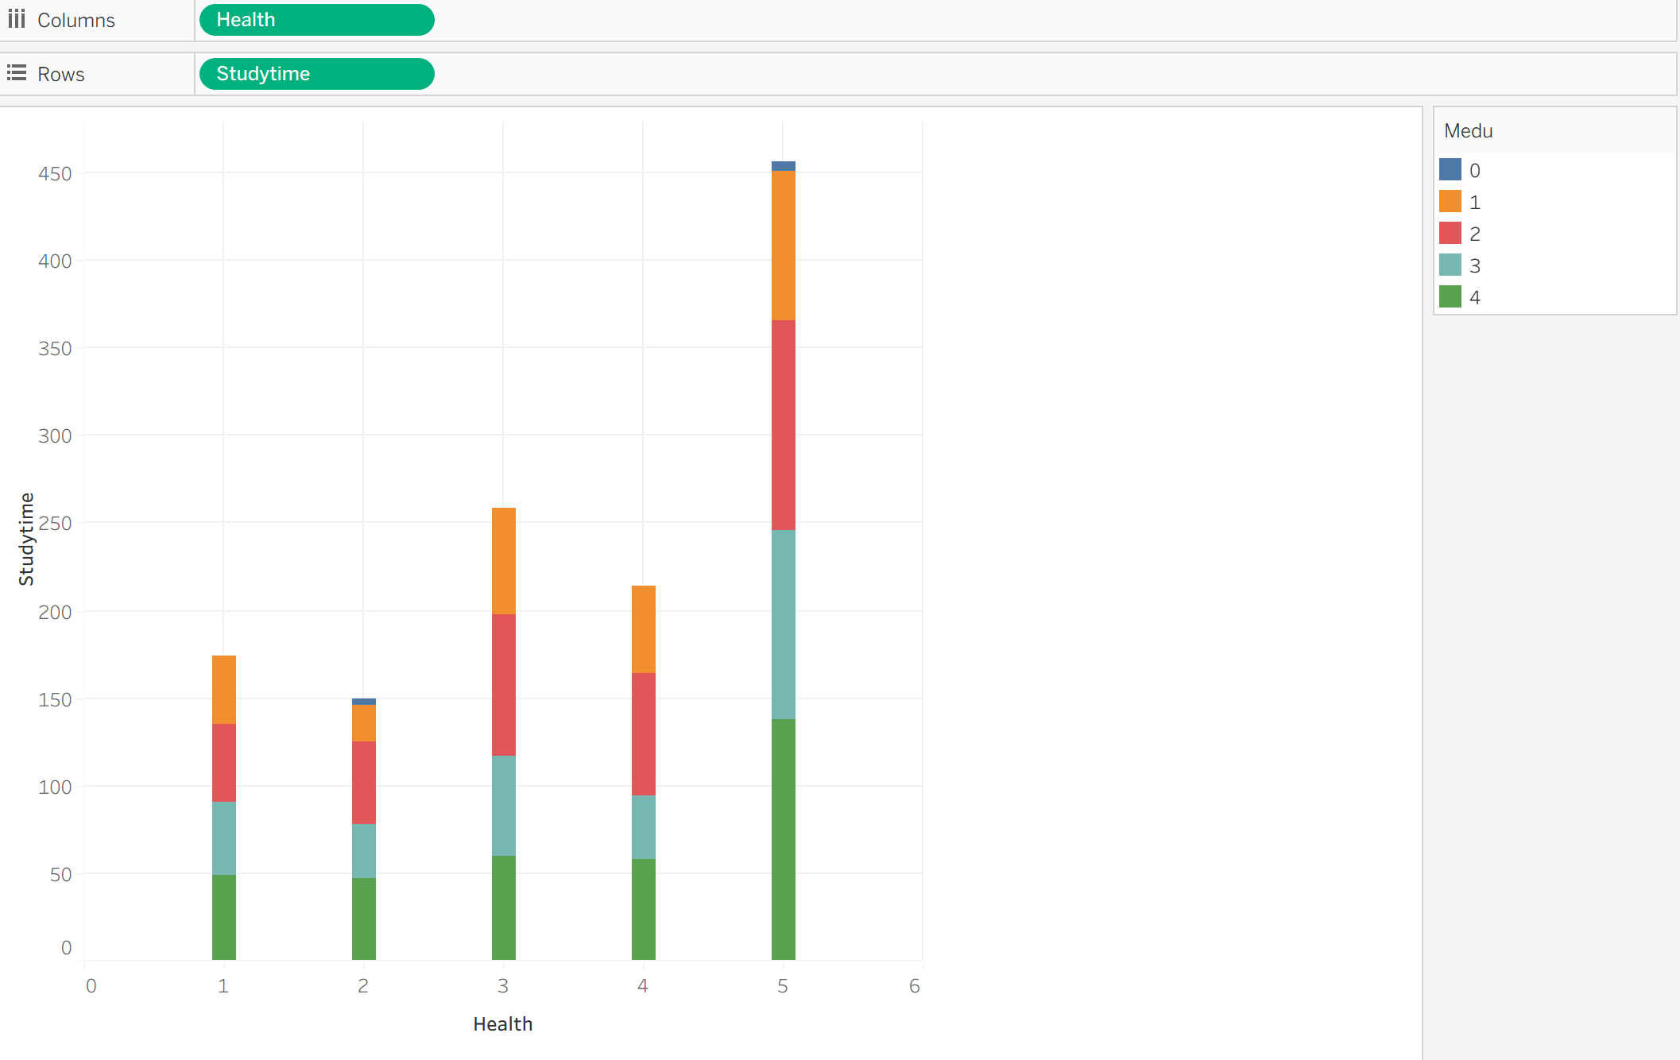
Figure 8: Portuguese exploration chart three.

The stacked bar chart shows that students with better health levels tend to study. As health improves, study time increases, especially for students whose mothers have higher education, suggesting combined influence of well-being and parental support on academic habits.

DATA PRE-PROCESSING AND POST-PROCESSING
Data pre-processing is a vital step in preparing raw data for analysis, ensuring it is clean, consistent, and suitable for exploration and modelling [17]. In this study, both pre-processing and post-processing conducted to guarantee data accuracy and reliability before analysis in Tableau. Tableau chosen as the main tool due to its ability to combine data transformation, analytics, and visualisation in an intuitive and interactive interface [6].

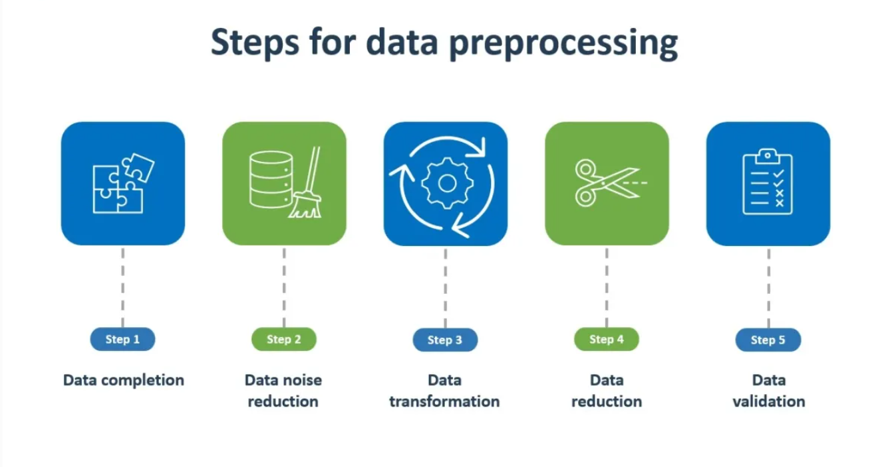
Figure 9: Shows the step of data preprocessing.

The pre-processing phase began with integrating the student-mat.csv and student-por.csv datasets from Portuguese secondary schools. Using Microsoft Excel, both files were merged by matching shared attributes such as school, age, address, and parental occupation, ensuring no duplication and providing a comprehensive academic profile for each student. The combined dataset was then imported into Tableau for further analysis and refinement.
Initial inspection confirmed there were no missing values, ensuring completeness and reliability [17]. Data type validation assigned categorical variables (e.g., gender, school, parental occupation) as strings and numerical variables (e.g., age, absences, grades G1–G3) as numeric, enabling accurate aggregation, filtering, and visualisation. Outlier detection using Tableau’s boxplots and scatterplots examined absences and final grades (G3). Meaningful outliers, such as irregular attendance or low grades, were retained to reflect real student variability [18]. Data normalisation scaled numerical variables between 0 and 1, ensuring balanced contributions to clustering and trend analysis [19].
Further refinements included creating calculated fields (e.g., average grade by study-time category) [20], applying filters to explore specific student groups, and categorising final grades (G3) into Low (0–9), Medium (10–14), and High (15–20) ranges for better interpretability.

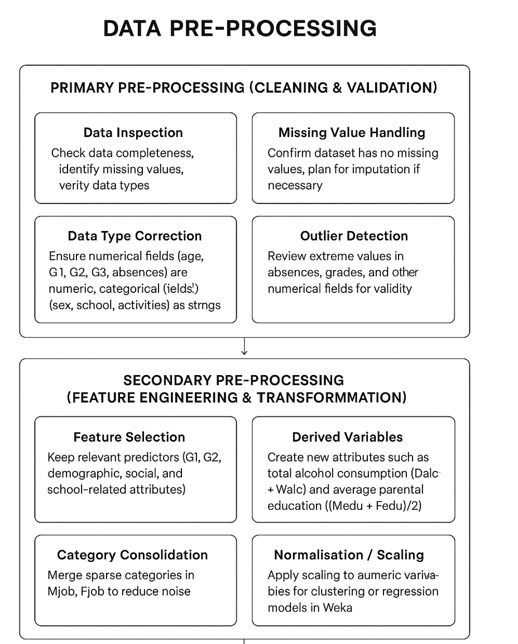
Figure 10: show the data preprocessing key points.

Post-processing in Tableau involved interactive dashboards such as Performance Distribution, Study Time Impact, Attendance and Success, and Parental Education dashboards [21–23]. These visualisations revealed key factors influencing achievement, providing clear, data-driven insights for educational improvement.
Overall, through systematic pre-processing, validation, and Tableau-based post-processing, the study produced reliable, interpretable insights that support data-driven educational improvement.

Analysis, Methods, and Results
This study applied two analytical methods prediction and clustering using Tableau to analyse student performance and identify behavioural patterns.
Prediction aimed to forecast students’ final grades (G3) based on factors such as study time, absences, and parental education [16]. Tableau’s linear regression model, implemented through trend lines on scatterplots, calculated slopes, intercepts, and R² values to evaluate accuracy. Results showed that longer study times and higher parental education positively correlated with performance, while absences had a negative impact [24].
Clustering, an unsupervised learning method, grouped students with similar academic and behavioural traits using Tableau’s k-Means algorithm [14]. Tableau automatically determined optimal clusters, revealing groups of high, moderate, and low achievers distinguished by study habits, attendance, and parental education [25].
Together, these Tableau-based analyses provided clear, interpretable insights, helping identify at-risk students and supporting targeted strategies for academic improvement and data-driven educational planning [5].

Key Insights from Maths Prediction Analysis

Studytime vs G3
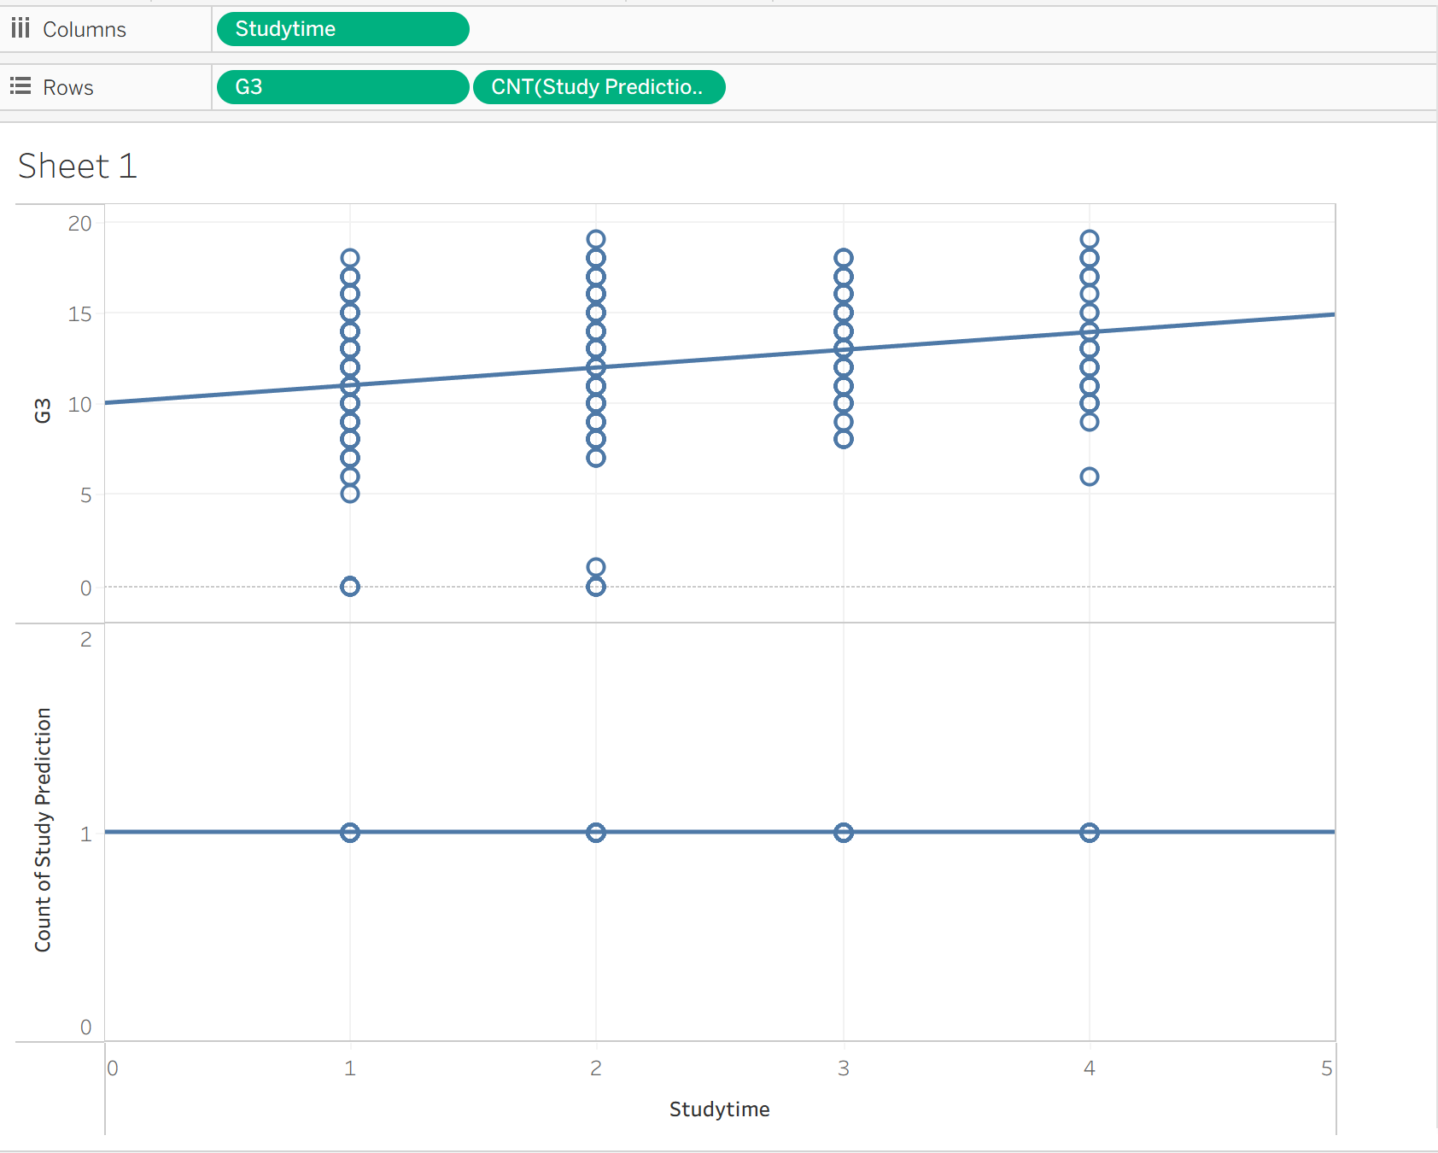
Figure 11: Maths prediction scatter plot one.

The scatter plot shows that students who study longer generally get better final grades (G3). Those who study 3–4 hours usually score higher, while students who study less have mixed results. Some students do well with little study, and others struggle even with more hours. Overall, it shows that study habits affect performance and that personalised support can help improve results. The following table summarizes study time levels and their corresponding G3 grade ranges: 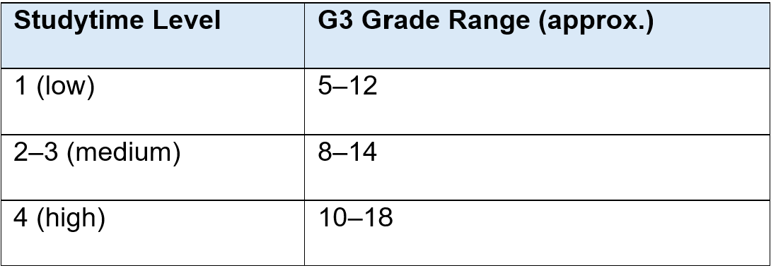
Figure 12: Maths prediction scatter plot table one.

Absence VS G3
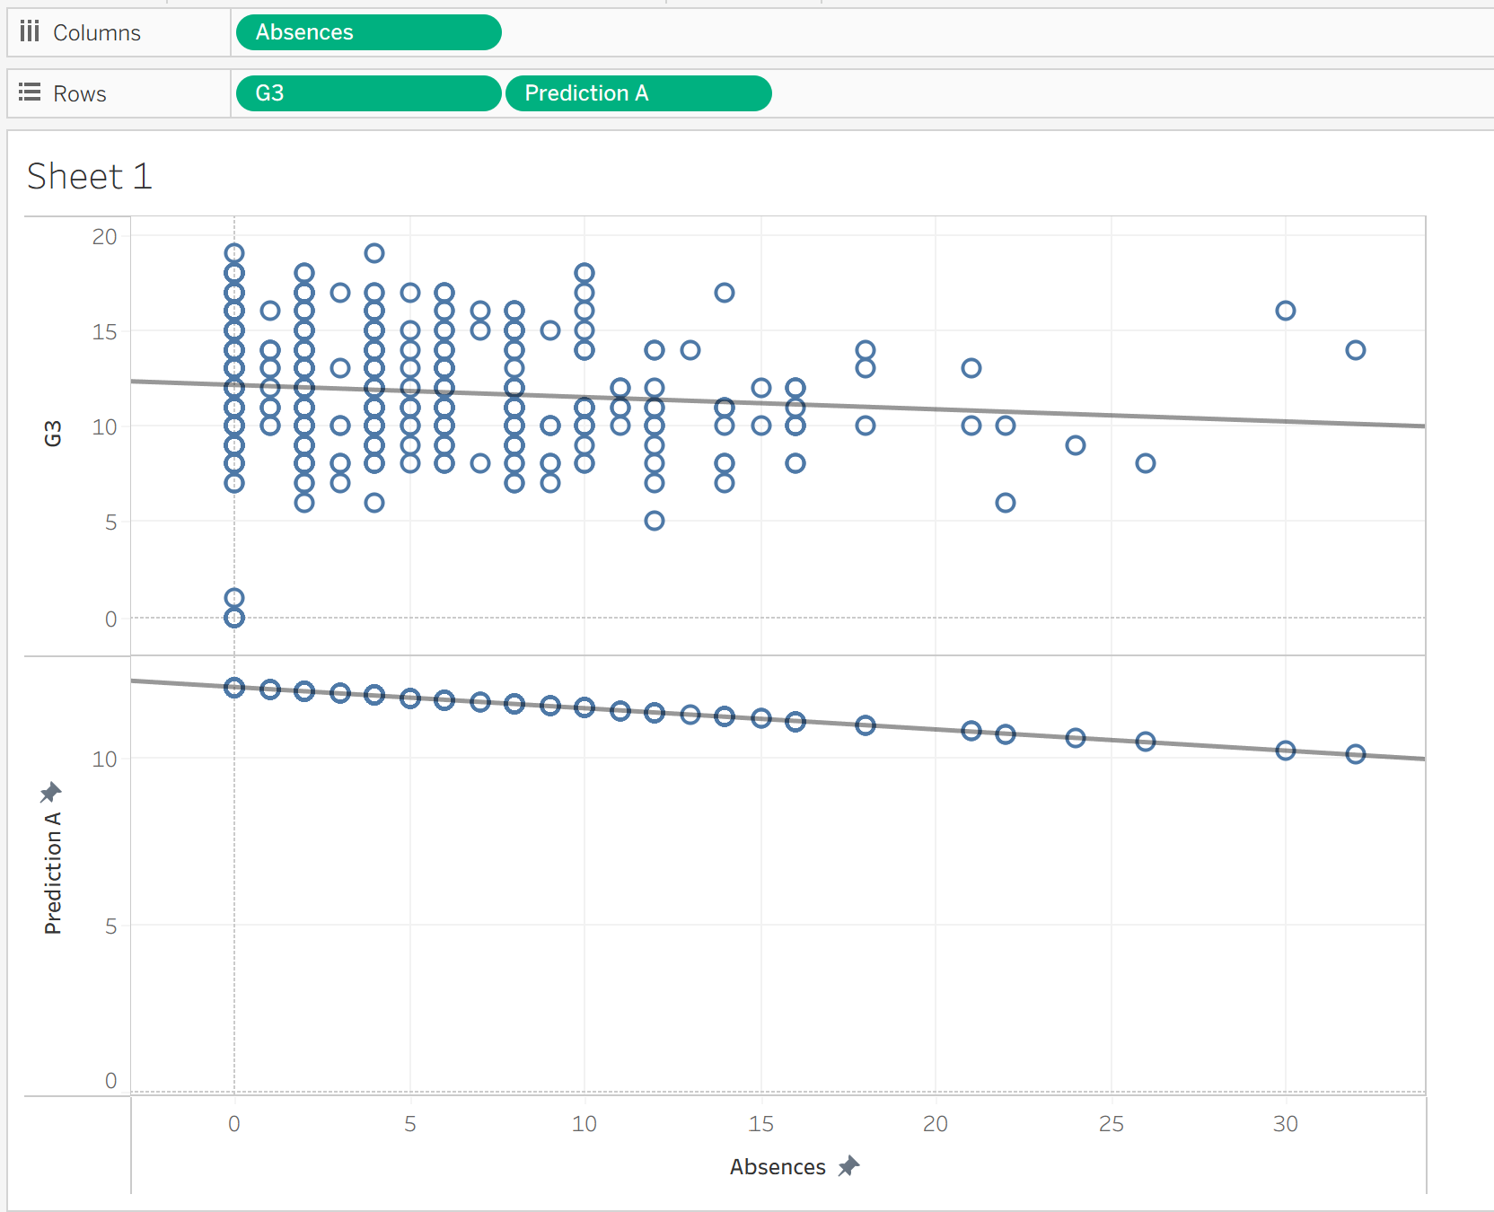
Figure 13:Maths prediction scatter plot two.

The scatter plot shows that more absences lead to lower grades. Students who attend classes regularly usually score higher, while those who miss more classes tend to perform worse. This clearly shows that good attendance is important for better academic results and overall student success. The table below summarizes the approximate grade ranges associated with different absence levels:

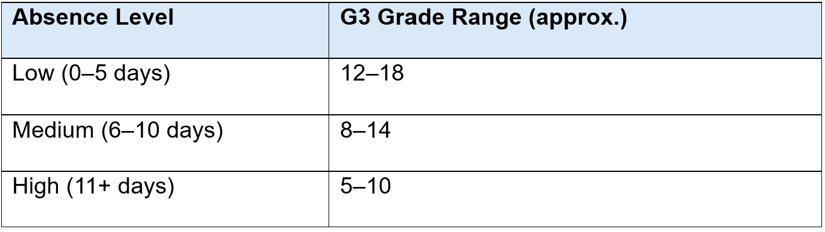
Figure 14: Maths prediction scatter plot table two.

Health VS G3
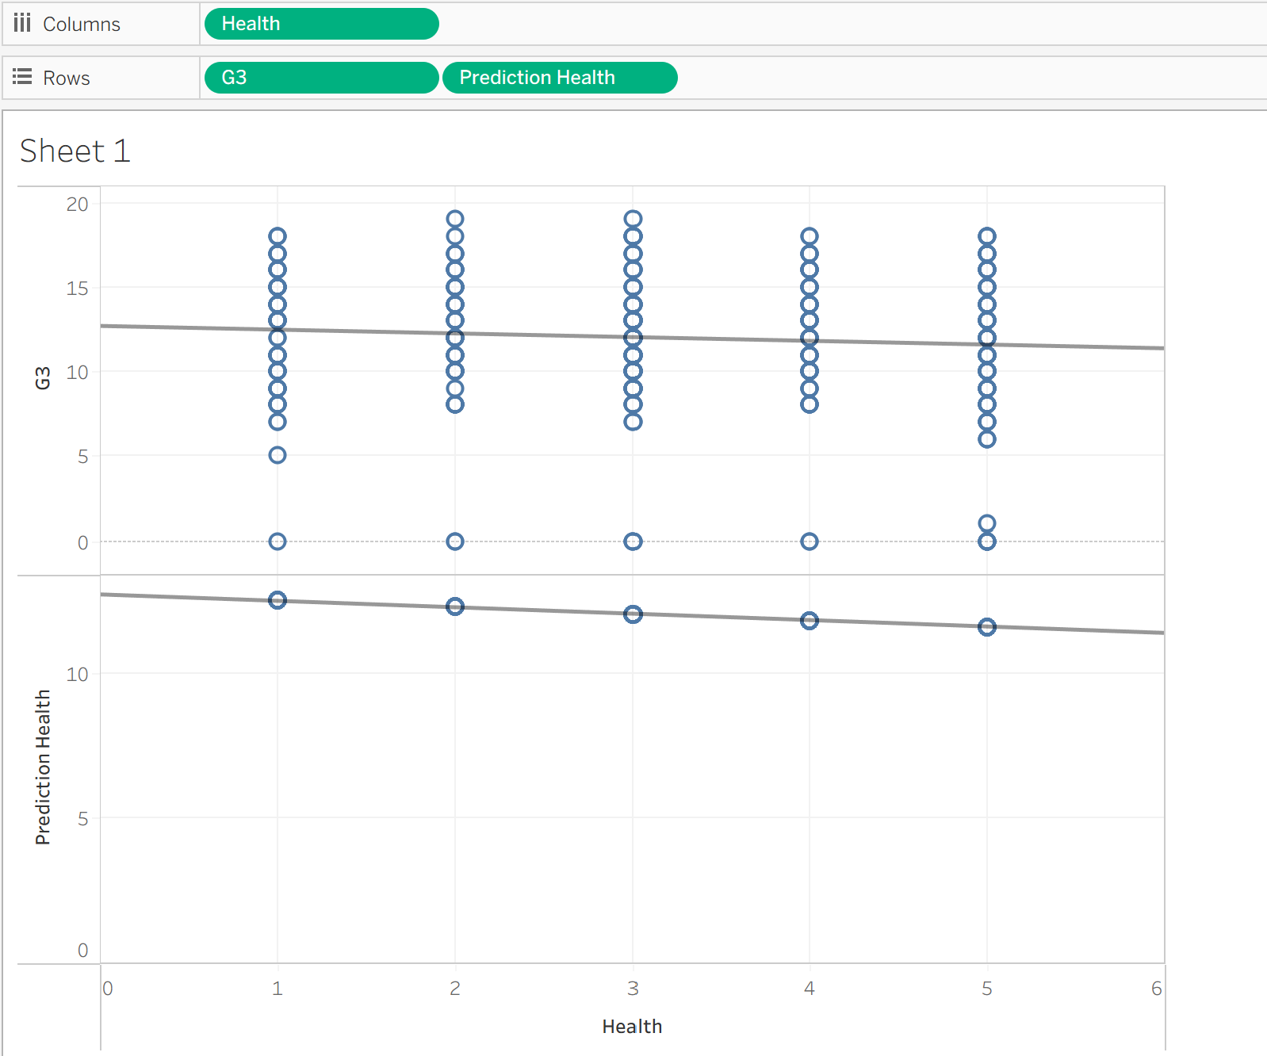
Figure 15: Maths prediction scatter plot three.

The scatter plot reveals a slight negative correlation between health and both actual and predicted grades (G3), suggesting that higher health ratings do not always align with better academic performance. Unlike the positive trend seen with study time, students reporting better health may still underperform, indicating that academic success depends more on consistent study habits than perceived well-being. Consistent monitoring of health and study balance is essential for academic success. The table below summarizes approximate grade ranges across different health levels.
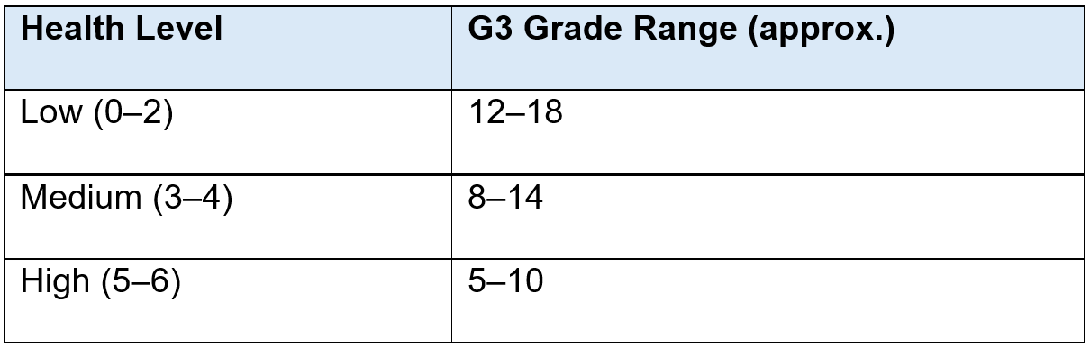
Figure 16: Maths prediction scatter plot table three.

Key Insights from Portuguese Prediction Analysis

Traveltime vs Studytime & Prediction Analysis
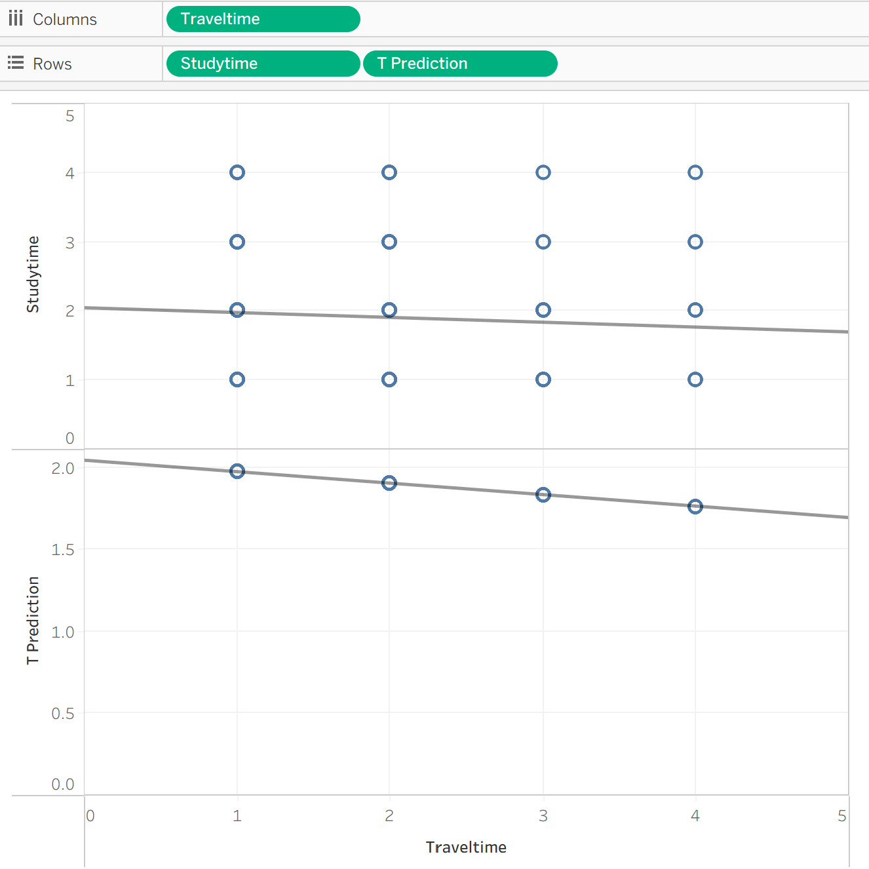
Figure 17: Portuguese prediction scatter plot one.

The scatter plot shows a negative correlation between travel time and both study time and predicted academic performance (T Prediction). As travel time increases from 1 to 4, students tend to study less, and their predicted performance also declines. This suggests that longer commutes may reduce available study hours and negatively affect academic outcomes.

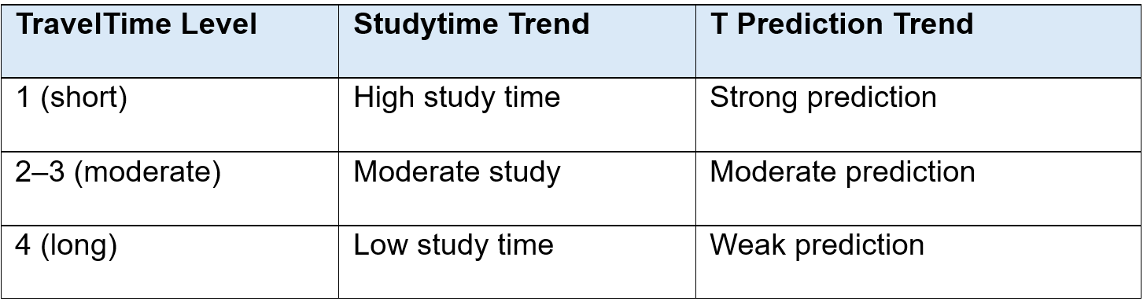
Figure 18: Portuguese prediction scatter plot table one.

Reducing travel time or offering remote study support may help students maintain better study habits and improve academic performance.

Femrel (Family Education) vs G3
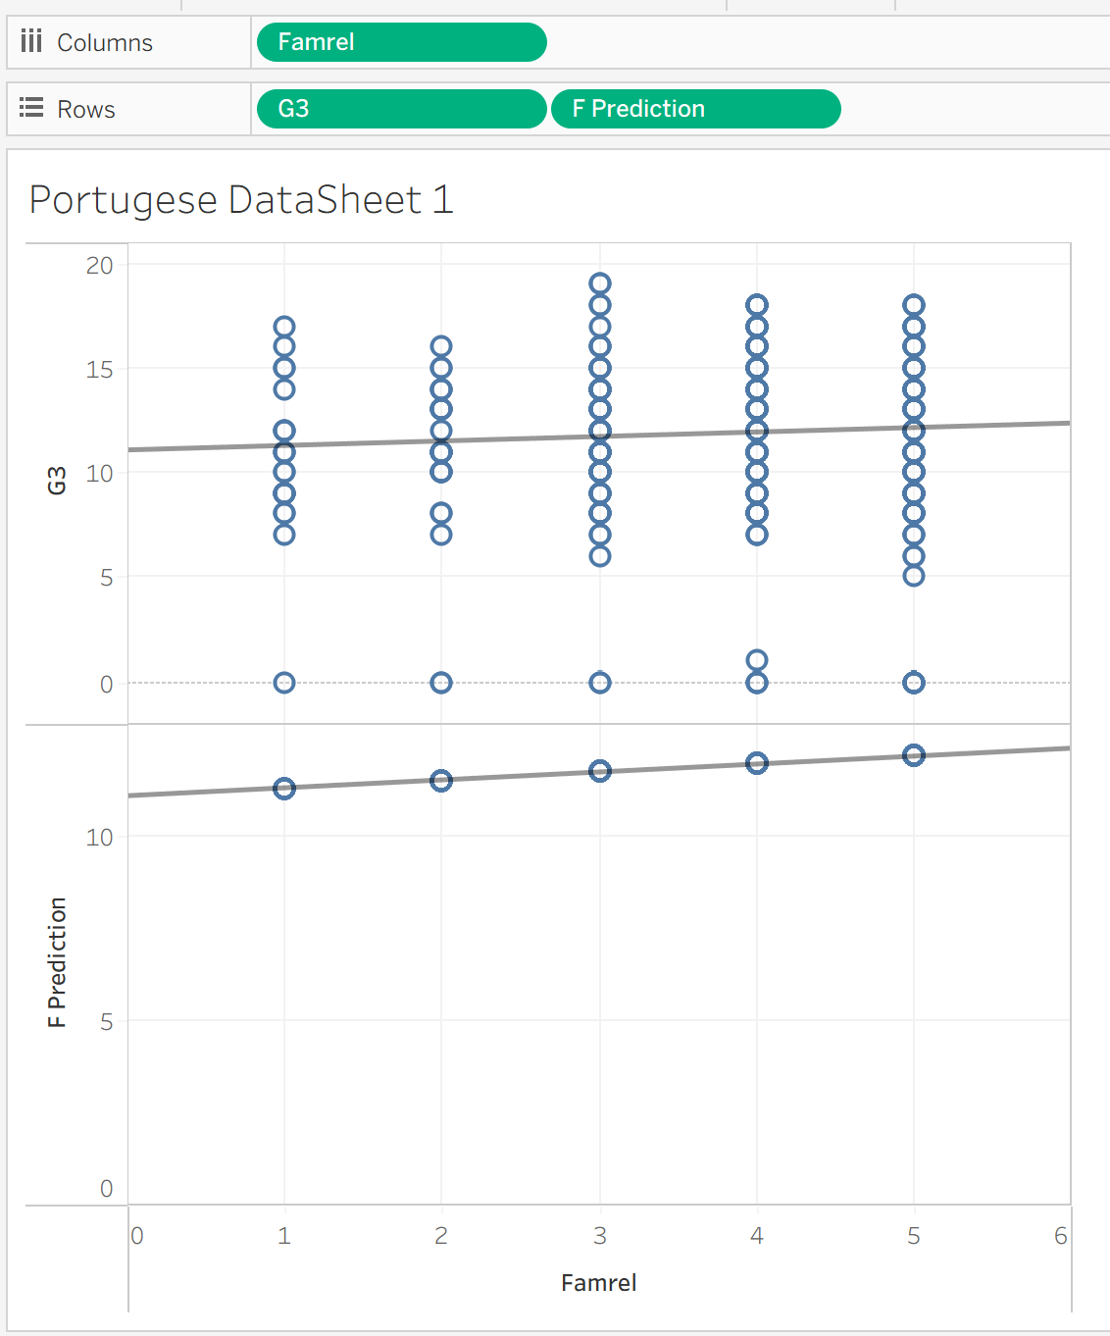
Figure 19: Portuguese prediction scatter plot two.

The scatter plot shows a slight positive correlation between family relationship quality (Famrel) and final grades (G3), as well as predicted performance (F Prediction). Students with stronger family support tend to perform better academically. The upward trend lines for both actual and predicted grades suggest that positive family dynamics may enhance learning outcomes. The table below summarizes grade trends by Famrel level:

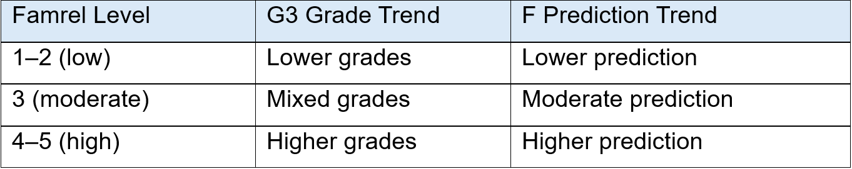
Figure 20: Portuguese prediction scatter plot table two.

Supportive family relationships contribute to academic success.

Goout vs G3
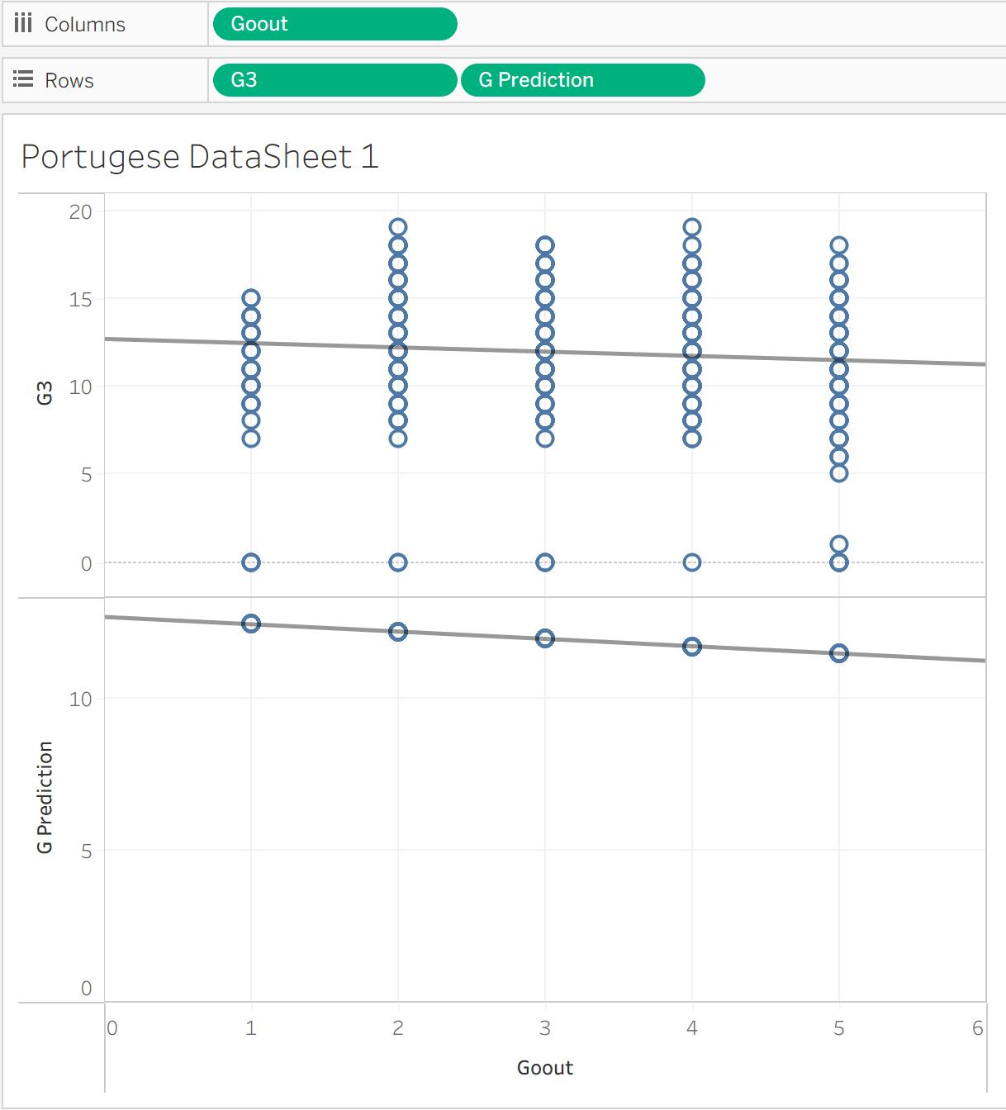
Figure 21: Portuguese prediction scatter plot three.

The scatter plot shows a slight negative correlation between frequency of going out (Goout) and both final grades (G3) and predicted performance (G Prediction). As Goout increases from 1 to 5, academic performance tends to decline. This suggests that excessive social activity may reduce study focus and impact grades. The downward trend lines confirm this pattern. Balanced social habits support better academic outcomes. The table below summarizes performance trends:
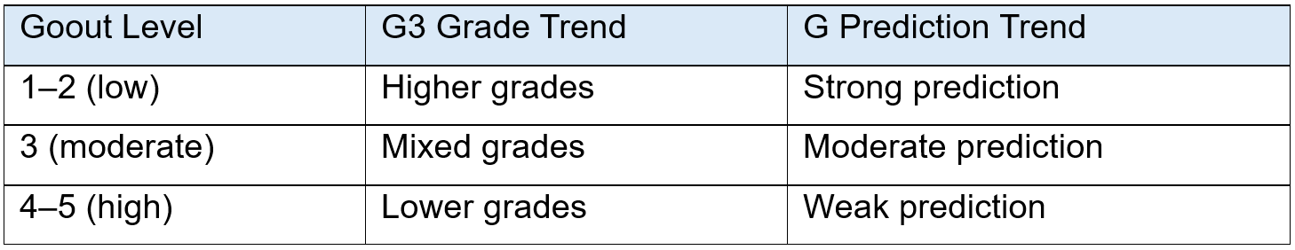
Figure 22: Portuguese prediction scatter plot table three.

Key Insights from Maths Clustering Analysis
Clustering is an unsupervised learning technique that groups data points based on similarity without predefined labels [17]. It used here to segment students into clusters sharing common attributes, such as study habits, absenteeism, or family support, which helps identify target groups for educational interventions.

Studytime VS G3
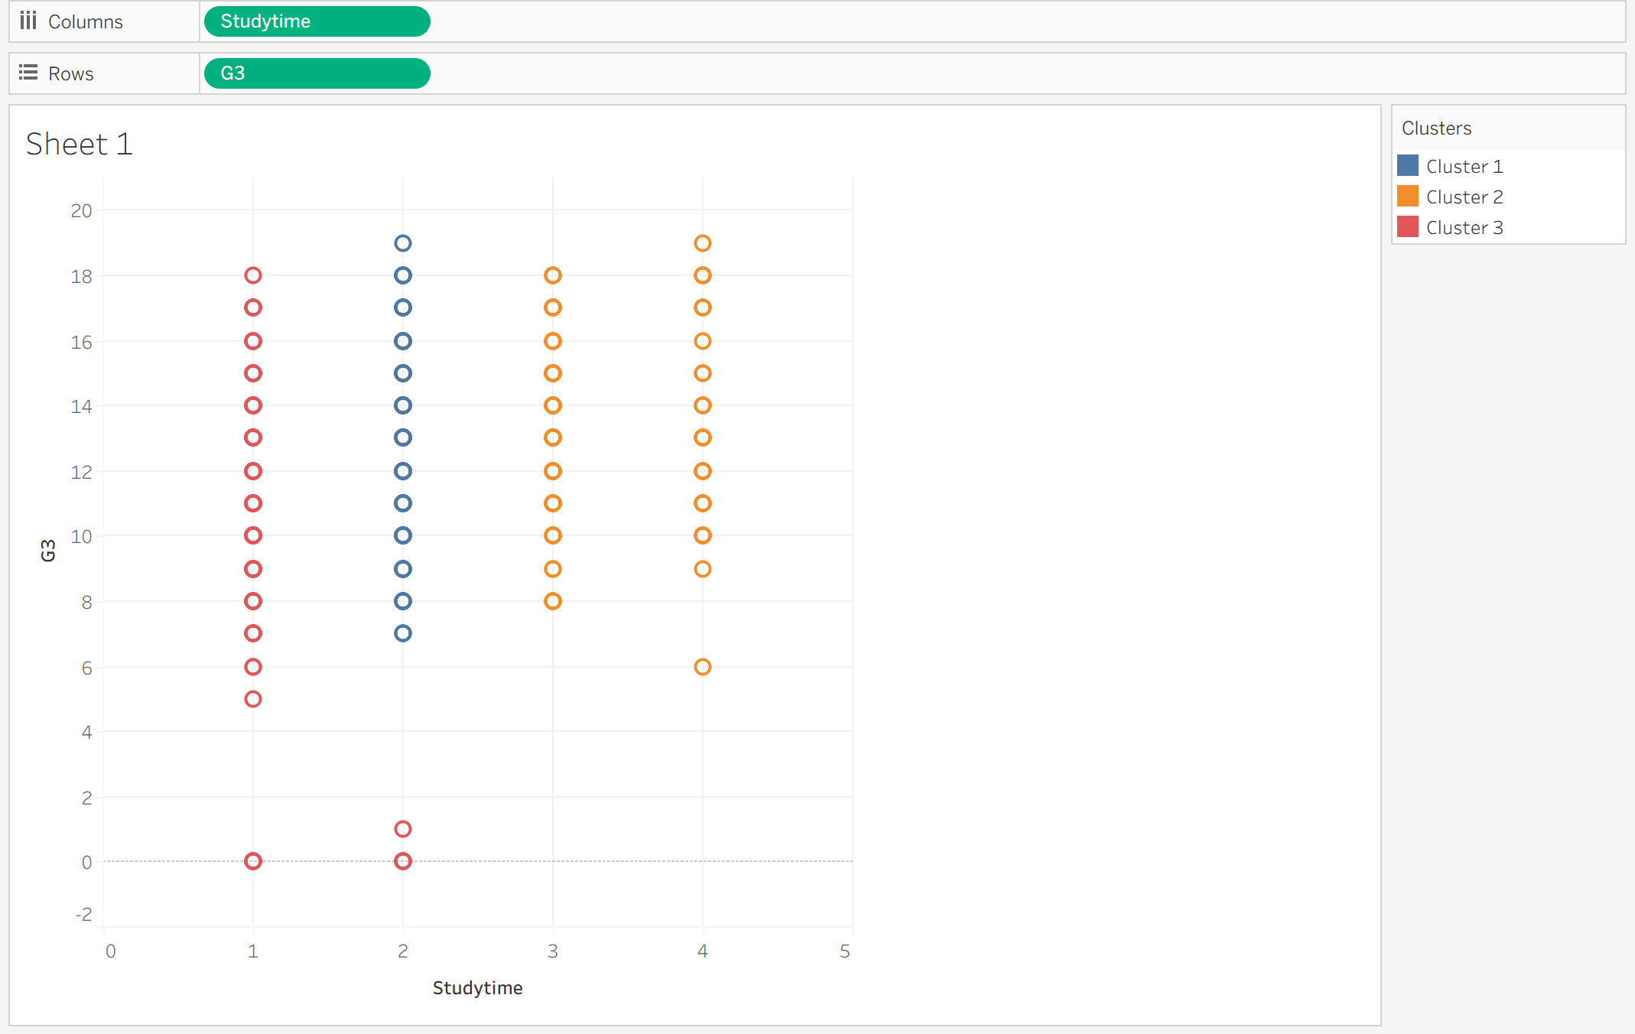
Figure 23: Maths Cluster scatter plot one.

The scatter plot displays the relationship between study time and final grades (G3), segmented into three clusters that highlight academic performance patterns. Cluster 1 (blue) includes students with low study time and mixed grades, reflecting inconsistent habits. Cluster 2 (orange) represents medium study time with moderate, steady performance. Cluster 3 (red) shows high study time and consistently strong grades, confirming the positive correlation between disciplined study and academic success. These clusters align with earlier insights, reinforcing the importance of tailored academic support. The table below summarizes studytime levels and their corresponding G3 grade ranges:

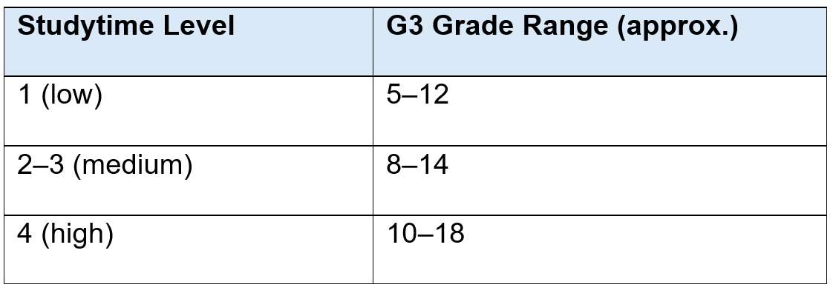
Figure 24: Maths Cluster scatter plot table one.

This clustering emphasizes that consistent, quality study habits are key to improving academic outcomes.

Health vs G3
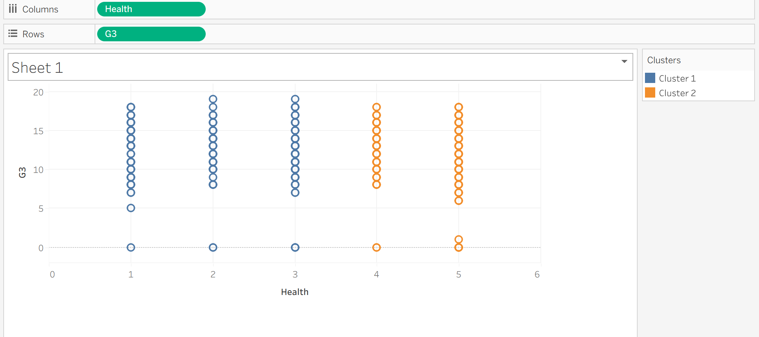
Figure 25: Maths Cluster scatter plot two.

The scatter plot shows a slight negative correlation between health and final grades (G3), divided into two clusters. Cluster 1 (blue) includes students with lower health ratings (1–3) and varied academic performance, while Cluster 2 (orange) represents higher health ratings (4–5) with lower grades. This suggests better health does not always align with stronger academic outcomes. The table below summarizes approximate grade ranges by health level:

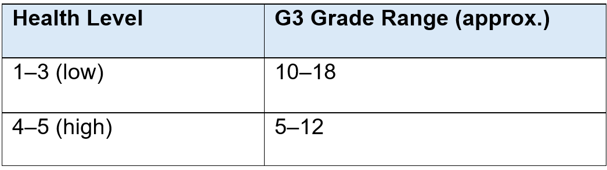
Figure 26: Maths Cluster scatter plot table two.

Maintaining good health supports focus, energy, and emotional stability, which are essential for learning. When combined with consistent study habits, students are more likely to achieve strong academic outcomes.
Absence VS G3
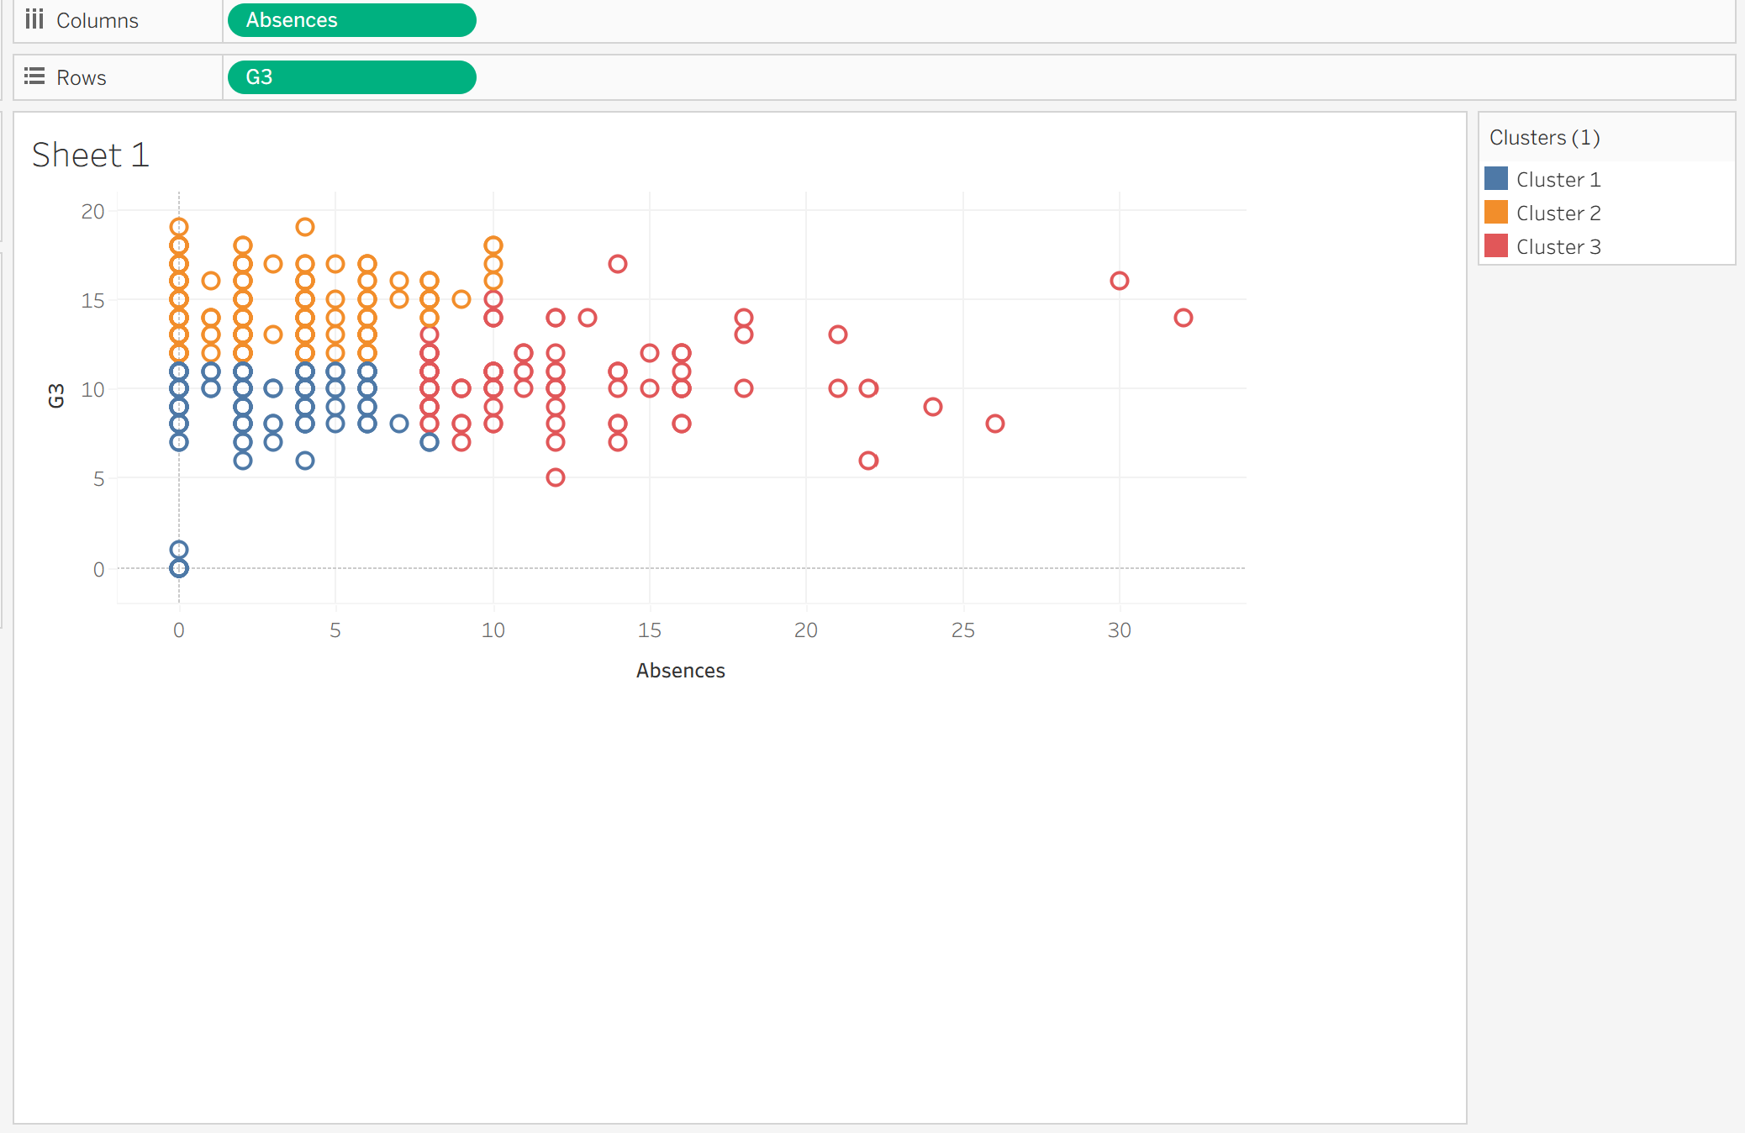
Figure 27: Maths Cluster scatter plot three.

The scatter plot shows a negative correlation between absences and final grades (G3), divided into three clusters. Cluster 1 (blue) includes students with low absences and high grades, Cluster 2 (orange) shows moderate absences with mixed performance, and Cluster 3 (red) reflects high absences and lower grades. This confirms that frequent absences reduce academic success. Performance is impacted by multiple factors while study time positively influences grades, frequent absences and even higher health ratings show slight negative effects, suggesting that consistent study habits and regular attendance are more critical to success than health alone. Regular attendance and disciplined study routines are key drivers of academic performance. The table below summarizes grade ranges by absence level:
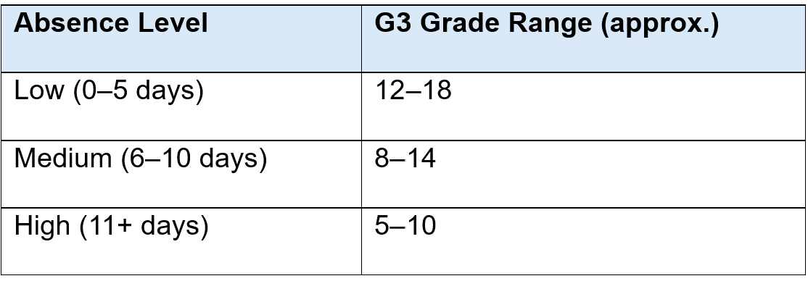
Figure 28:Maths Cluster scatter plot table three.

Key Insights from Portuguese Clustering Analysis
Fedu VS G3
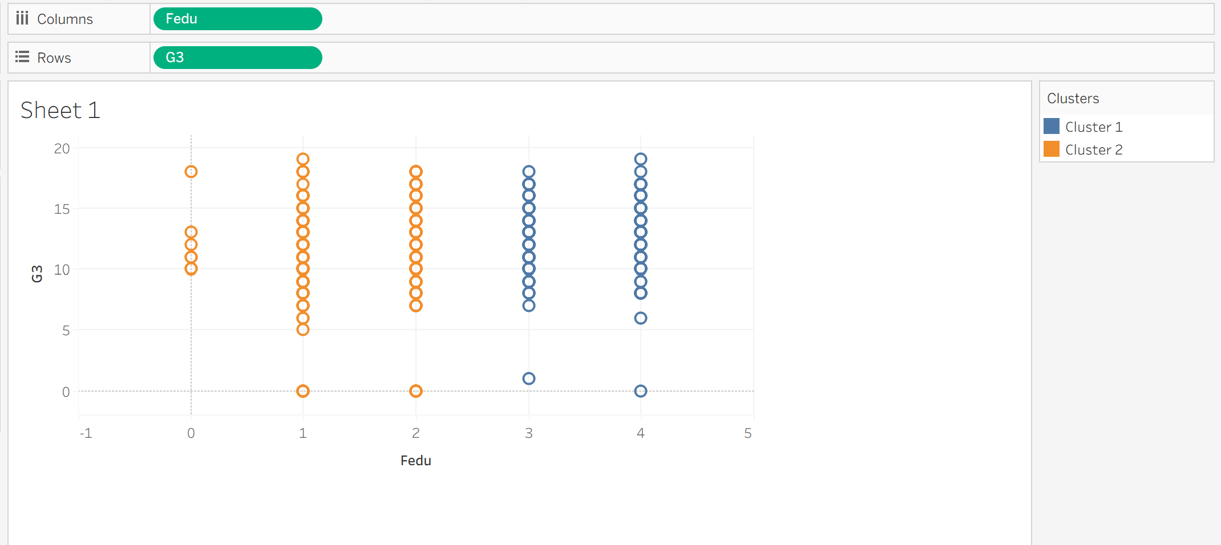
Figure 29: Portuguese Cluster scatter plot one.

The scatter plot shows how final grades (G3) vary with father’s education level (Fedu), divided into two clusters. Cluster 1 (blue) is more prominent at higher Fedu levels (3–4) and shows higher G3 scores, while Cluster 2 (orange) dominates lower Fedu levels (0–2) with lower grades. Clustering reveals educational impact patterns. This suggests that higher paternal education may positively influence academic performance. The table below summarizes grade ranges:

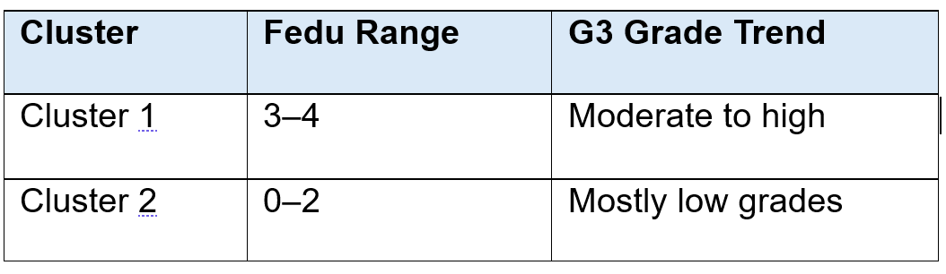
Figure 30: Portuguese Cluster scatter plot table one.
Study vs Medu.
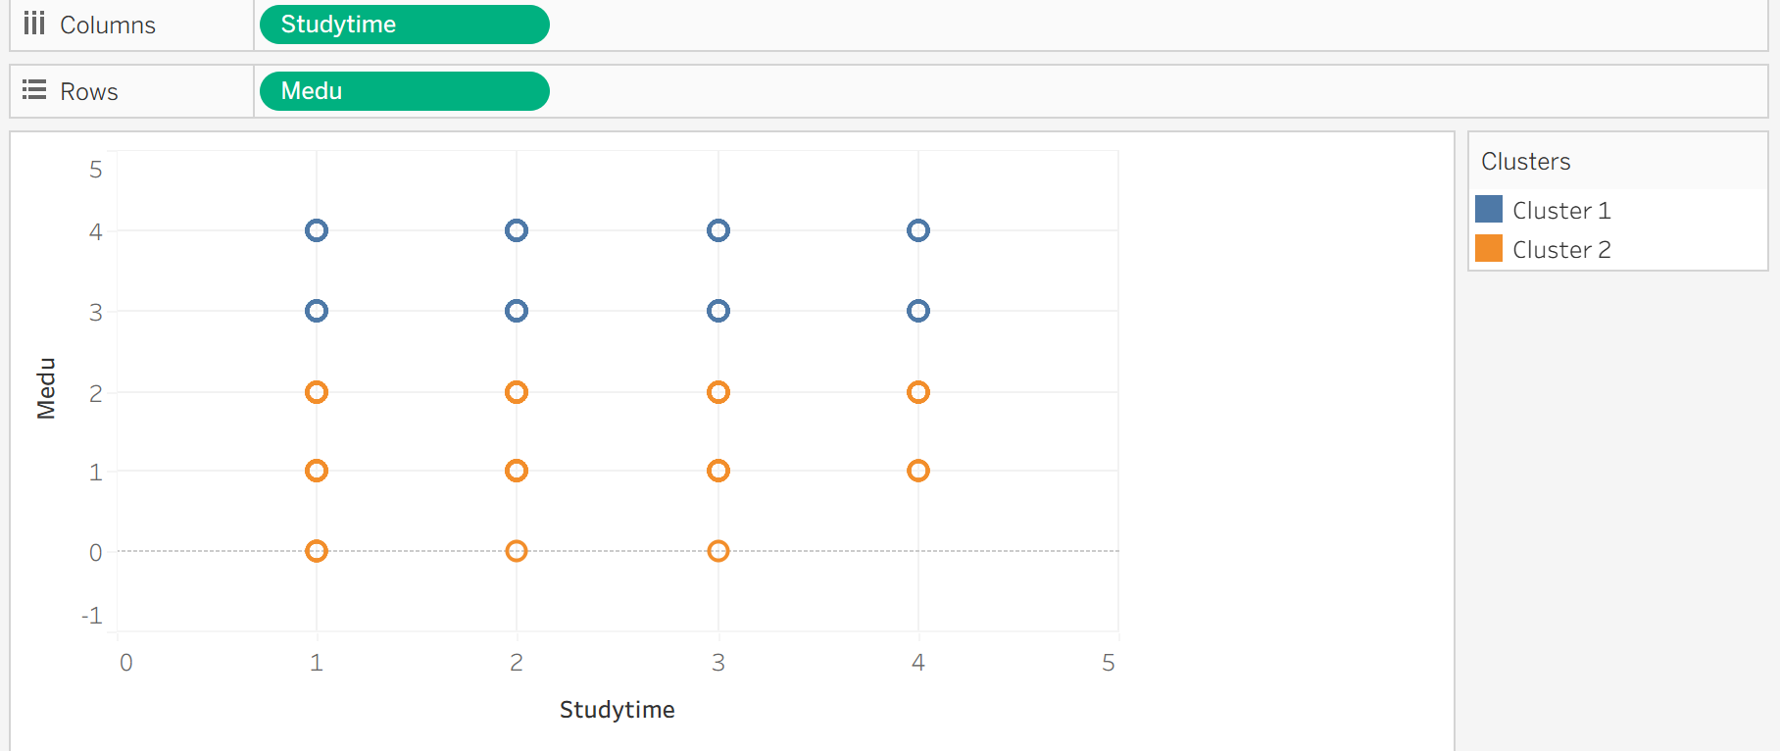
Figure 31: Portuguese Cluster scatter plot two.

The scatter plot shows how study time relates to mother’s education level (Medu), divided into two clusters. Cluster 1 (blue) is concentrated at higher Medu levels (3–4), indicating students with more educated mothers tend to study more. Cluster 2 (orange) dominates lower Medu levels (0–2), suggesting limited parental education may correlate with reduced study time. Parental education influences study habits. The table below summarizes study patterns:

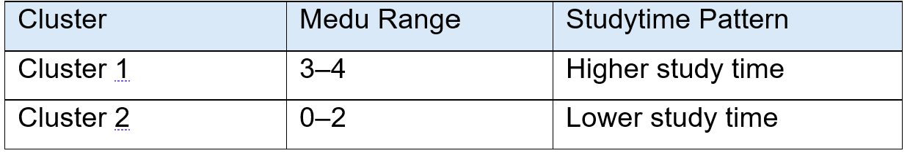
Figure 32: Portuguese Cluster scatter plot table two.

Studytime vs Health
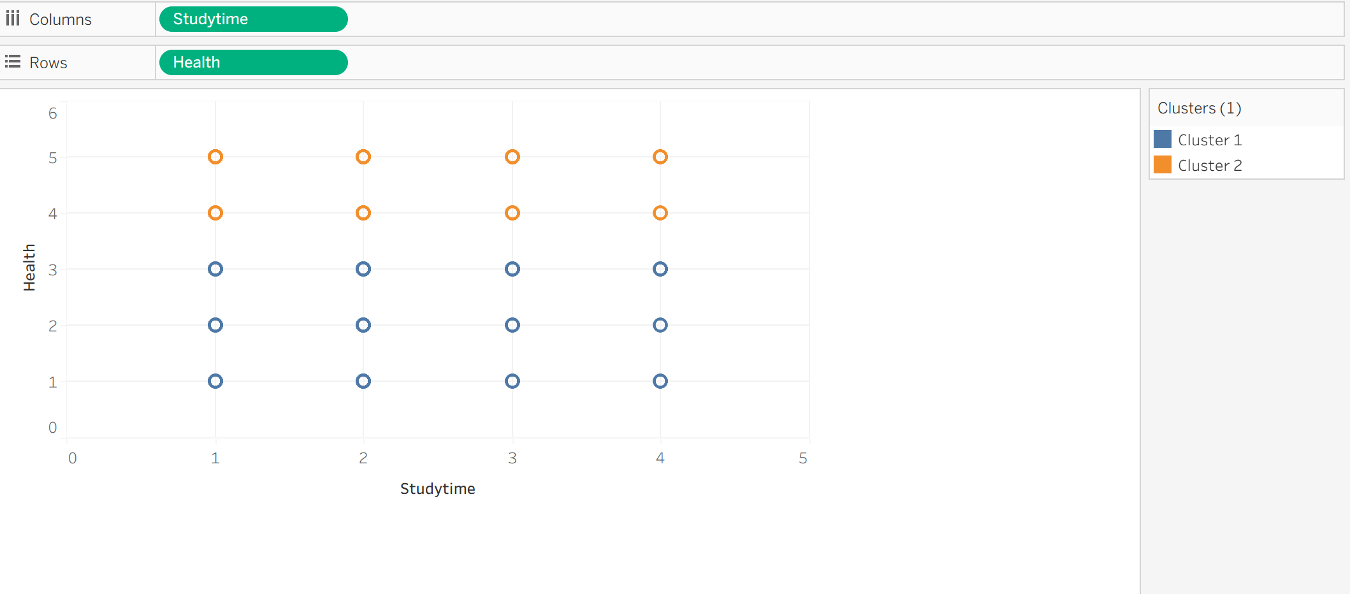
Figure 33: Portuguese Cluster scatter plot three.

The scatter plot shows how study time relates to health status, divided into two clusters. Cluster 1 (blue) is spread across all study time levels but leans toward better health ratings (4–5), while Cluster 2 (orange) is more concentrated at lower health levels (1–3), especially among students with less study time. This suggests that consistent study habits may correlate with better health. Study discipline may support well-being. The table below summarizes study patterns:

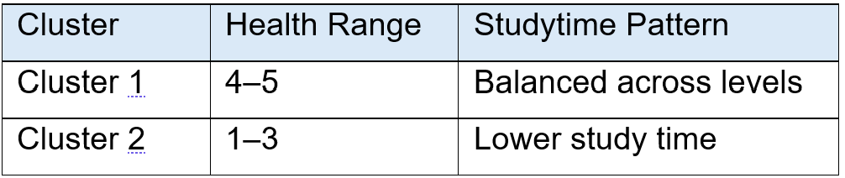
Figure 34: Portuguese Cluster scatter plot table three.

Business Recommendations
The analysis of the Student Performance dataset using Tableau employed both prediction and clustering to generate actionable insights for educators and school administrators. Prediction, through linear regression, identified study time, attendance, and prior academic performance (G3) as the most significant factors influencing final grades. This model quantified the impact of each variable, revealing that longer study times and consistent attendance positively affect performance, while higher absences negatively influence outcomes [24].
Clustering analysis further grouped students based on behavioural and academic characteristics, highlighting differences in engagement, study habits, and achievement patterns [25]. These insights support tailored interventions by identifying high-performing, moderate, and low-performing groups, each with distinct needs.
Based on the combined predictive and clustering results, several recommendations can be made. Schools should implement early intervention systems to monitor students with declining initial grades and provide targeted support, such as mentoring or remedial sessions, before final evaluations. Strengthening attendance and engagement policies is critical, while parental collaboration initiatives can promote supportive home learning environments. Personalised learning strategies should challenge high-performing students with enrichment activities and provide additional academic and motivational support for lower-performing groups.
Overall, Tableau based prediction and clustering analyses offer scalable, evidence-based approaches to support educational decision-making, curriculum planning, and resource allocation, enabling schools to enhance student outcomes effectively and equitably.

Reflection
The report provides a detailed analysis of the Student Performance dataset, illustrating how data mining techniques prediction and clustering can be applied to forecast academic outcomes and segment students by behavioural and demographic attributes. Predictive modelling indicated that early grades, study time, and attendance are strong predictors of final performance, while clustering revealed distinct student groups requiring targeted interventions. Tableau effectively used for data preparation, visualisation, and post-processing, enabling intuitive exploration and interpretation of patterns.
The study’s strengths include its systematic approach, adherence to the CRISP-DM framework, and clear visual communication of results. Combining the two datasets and ensuring data quality improved reliability, while normalisation and class balancing enhanced fairness. The integration of predictive and clustering analyses provided a more nuanced understanding of student behaviour beyond simple performance metrics.
However, limitations exist. Reliance on Tableau may restrict the use of advanced machine learning techniques and deeper statistical validation. Socio-emotional and qualitative factors were underexplored, and heavy dependence on early grades may overlook students’ potential for improvement.
Future enhancements could involve integrating diverse datasets, applying advanced algorithms such as random forests or neural networks, including longitudinal data, and incorporating qualitative factors like motivation and teacher effectiveness to improve predictive accuracy and support evidence-based educational strategies.

Conclusion
This study demonstrated the effective use of data mining on educational datasets to uncover patterns and support data-driven decision-making. Predictive modelling and clustering identified key factors affecting student achievement, including prior grades, study time, and attendance. Early performance strongly predicts final success, while absenteeism and low engagement correlate with poorer outcomes. These insights emphasise the need for early intervention, personalised learning, and initiative-taking monitoring. By applying predictive analytics, schools can identify at risk students, optimise resource allocation, and implement targeted programs, fostering more effective, equitable, and informed educational practices.

References
[1] Y. Zhang et al., “Educational Data Mining Techniques for Student Performance Prediction: Method Review and Comparison Analysis,” Front. Psychol., vol. 12, art. no. 698490, Dec. 2021.
[2] M. Yağcı, “Educational data mining: prediction of students’ academic performance using machine learning algorithms,” Smart Learn. Environ., vol. 9, art. no. 11, Mar. 2022.
[3] O. Azeroual, R. Nacheva, A. Nikiforova, and U. Störl, “A CRISP-DM and predictive analytics framework for enhanced decision-making in research information management systems,” Informatica, vol. 49, no. 18, 2025.
[4] W. M. Yafooz, Z. B. A. Bakar, S. A. Fahad, and A. M. Mithun, “Business intelligence through big data analytics, data mining and machine learning,” in Data Management, Analytics and Innovation: Proc. of ICDMAI 2019, vol. 2, Singapore: Springer Singapore, 2019, pp. 217–230.
[5] Milligan, J. N. Learning Tableau 2022, 5th ed., O’Reilly Media, 2022.
[6] S. Batool et al., “Educational data mining to predict students’ academic performance: A survey study,” Educ. Inf. Technol., vol. 28, no. 1, pp. 905–971, Jan. 2023.
[7] M. M. Hussain et al., “Prediction of Student’s Academic Performance through Data Mining Approach,” J. Informatics Web Eng., vol. 3, no. 1, pp. 241–251, Feb. 2024.
[8] Khairy, D., Alharbi, N., Amasha, M. A., Areed, M. F., Alkhalaf, S., & Abougalala, R. A.,“Prediction of Student Exam Performance Using Data Mining Classification Algorithms,” Educ. Inf. Technol., vol. 29, pp. 21621–21645, 2024, doi:10.1007/s10639-024-12619-w.
[9] D. Ying and J. Ma. “Student Performance Prediction with Regression Approach and Data Generation,” Appl. Sci., vol. 14, no. 3, art. no. 1148, Jan. 2024, doi:10.3390/app14031148.
[10] A. Sarasa Cabezuelo and R. González del Campo Rodríguez Barbero (eds.), Data Mining and Computational Intelligence for E-learning and Education, MDPI Books, 2025.
[11] E. Kalita, S. S. Oyelere, S. Gaftandzhieva et al., “Educational data mining: a 10-year review,” International Journal of Educational Technology in Higher Education, 2025.
[12] M. Fazil, “A novel deep learning model for student performance prediction,” J. Learn. Analytics, 2024.
[13] D. Ayu Nur Wulandari, R. Annisa, L. Yusuf & T. Prihatin, “Educational data mining for student academic prediction using K Means clustering and Naïve Bayes classifier,” J. Pilar Nusa Mandiri, vol. 16, no. 2, pp. 155–160, Sept. 2020.
[14] R. Liu, “Data analysis of educational evaluation using K-means clustering method,” Computational Intelligence and Neuroscience, vol. 2022, Art. no. 3762431, Jul. 2022.
[15] E. Dimara, H. Zhang, M. Tory and S. Franconeri, “The unmet data visualization needs of decision makers within organizations,” IEEE Trans. Vis. Comput. Graph., vol. 27, no. 2, pp. 786–796, 2021.
[16] C. Romero and S. Ventura, “Educational data mining and learning analytics: An updated survey,” Wiley Interdiscip. Rev. Data Min. Knowl. Discov., vol. 10, no. 3, 2020.
[17] S. Saqr, Learning Analytics Methods and Tutorials, 1st ed., OAPEN, 2024.
[18] M. A. Jassim and S. N. Abdulwahid, “Data mining preparation: process, techniques and major issues in data analysis,” in IOP Conf. Ser.: Mater. Sci. Eng., vol. 1090, no. 1, p. 012053, Mar. 2021.
[19] Y. S. Kim, “Investigating the impact of data normalization methods on predictive model performance,” Appl. Data Sci. J., vol. 8, pp. 121–130, 2025.
[20] A. Abukader, M. G. Alsharef, and S. A. Al-Obaidi, “Intelligent system for student performance prediction: An educational data mining approach using metaheuristic-optimized LightGBM with SHAP-based learning analytics,” Appl. Sci., vol. 15, no. 20, art. no. 10875, Oct. 2025.
[21] A. K. Hopkins, M. Correll, and A. Satyanarayan, “VisuaLint: Sketchy in situ annotations of chart construction errors,” Comput. Graph. Forum, vol. 39, no. 3, pp. 219–228, 2020.
[22] I. Masiello, A. Cole, and J. K. Reilly, “A current overview of the use of learning analytics dashboards,” Educ. Sci., vol. 14, no. 1, art. no. 82, Jan. 2024.
[23] T. Susnjak, P. Jovanovic, and L. H. Li, “Learning analytics dashboard: a tool for providing actionable insights to learners,” Int. J. Educ. Technol. High Educ., vol. 19, art. no. 12, Feb. 2022.
[24] L. Zhou, “Visual analytics for education data: A case study using Tableau,” International Journal of Emerging Technologies in Learning (iJET), vol. 18, no. 4, pp. 45–59, 2023.
[25] M. Correll, “Visualizing uncertainty in educational performance data,” IEEE Computer Graphics and Applications, vol. 42, no. 6, pp. 84–95, 2022.



