Project Planning

University of Wales Trinity Saint David
Engineering Academic Discipline
Jason Taberner
2404389
BEng, Motorsport Engineering
23/11/2025
Engineering Management, ACHA5012
Word Count: 2533 words

Introduction
This report will cover the roles and responsibilities of each member of the group, the tasks that will be carried out as a group as well as my individual tasks. The report will also cover the overall milestones of the whole project, a gateway within my own work, as well as the risks and timing of the project.
The project that our group is taking on is the remodelling of the MCR Sports 2000 car’s bodywork, making use of CFD simulation tools and 3D modelling tools to design the new bodywork. This area of the project will be taken on by 5 out of 8 members of the group. The project also includes creating a virtual model of the car in VI Grade to test the bodywork that is designed over the course of the project. This area will be carried out by a single member of the group. The final area of the project is a droop stop investigation; this includes digital and physical testing of droop stops with the aim to install them on the car. This area will be carried out by the last 2 members of the group.
The three areas of the project all work together as the droop stops impact the car’s position on track, this has a direct impact on the aerodynamics of the car. The VI Grade model ties into both the other elements as it is the only way to test both the drop stops and the aerodynamic models together using the real-world data for the droop stops and the CFD testing data.

Roles and Responsibilities

Will
Responsible for the investigation into front droop stops. Understanding how droop stops work and understanding how car characteristics change with and without droop stops during cornering. Investigating where they’ll be mounted and what type of design will be beneficial for performance and the critical link between suspension kinematics and aerodynamic stability.

Kiera
Responsible for all data and simulation analysis tasks within the project. Her role involves the use of VI-Grade to simulate droop stop modifications and CFD developments using a virtual model that will be created using MoTeC software to compare real-world data to a previous baseline model.

Evan
Responsible for the rear deck and engine cover aerodynamics, ensuring smooth airflow from the cockpit/sidepods to the rear wing region. The design will aim to reduce current drag, manage airflow over the engine cover while maintaining aerodynamic balance across the whole car.

Louis
Responsible for designing and analysing the effects of introducing a downforce generating device over the roll hoop and its effects on the aerodynamic efficiency of the rear wing in different locations and mounting styles. This will be proved with the use of a CAD file in CFD. Using CFD he will assess the different styles to find a model that works best with other members designs to keep the overall balance and COP within tolerance.

Cara
Her role focuses on the design and development of the midriff, sidepods, and cockpit regions of the car. These areas are key to managing airflow from the front to the rear, ensuring efficient aerodynamic performance across the vehicle. She will be responsible for refining these surfaces using CAD and CFD analyses. Her aim is to reduce drag and optimise airflow continuity, ensuring smooth integration with surrounding components while enhancing overall car efficiency and on-track performance.

Noah
Noah’s role focuses solely on the aerodynamic refinement on the front section of the car, which consists of, front pontoons, pushrod covers, and wishbone shrouds. The front components of the car are crucial to the aero-mechanical interaction, where suspension and aerodynamic efficiency are directly in contact.
His responsibility is to improve the airflow around the front of the car using CFD simulations. His aim is to reduce drag and turbulence through improving designs, ensuring that the sidepods and rear deck receive smoother airflow while enhancing front-end stability and aerodynamic efficiency.

Ethan
Project Manager:
Establishing objectives and setting performance targets for each area of the group. Coordinating CFD analysis and design development. Ensuring tasks are delegated evenly, and deadlines are met accordingly.
Aerodynamics:
In charge of the design and development of the splitter, floors & nosecone for the MCR. Using CAD & CFD analysis to optimize airflow to the rear of the car to activate the deck as well as reducing the overall pitch sensitivity. Collaborating closely with Noah & Cara to ensure integration and manufacturability.

Jason
Responsible for investigating droop stops and implementing them on the car. His role requires analysis of the car’s current performance and position on the track using MoTec Software. He will investigate how droop stops will affect the car and whether they are plausible with the current aero package through data analysis and testing. He is also responsible for the manufacture and installation of droop stops on the car.

Skills and Belbin’s Model
My area of the project includes practical work with modelling, digitally testing, and manufacturing the droop stops, research into how they work and what materials are suitable, as well as data acquisition and analysis. My area of the project is also linked to the areas of the other members of the group. Looking at these areas, the skills needed are:
- 3D modelling capabilities
- A good understanding and capabilities with milling and drilling machinery, as well as hand tools to manufacture the droop stops.
- Data analysis
- Good communication
- The ability to work in a team
- Effective planning
- Time management
- Confidence in voicing opinions and ideas
When looking at Belbin’s Model, the team roles that fit these skills best are implementer, teamworker, and complete finisher. The shaper and plant could also be useful roles for voicing opinions and solving problems. (Belbin, 2025)
- Implementer for the practical tasks, effective planning, and turning ideas into actions, helping turn 3D models and concepts into a physical product.(Belbin, 2025)
- Teamworker for good communication and working with others.(Belbin, 2025)
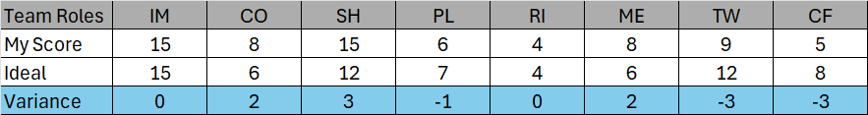
- Complete finisher for having an eye for detail in the data analysis (Belbin, 2025)
Table 1 Belbin's Model Scores

The variance row on the above table shows that the roles I am strong in align well with those that fit the required skills for my area in the project. There are some areas I will need to be aware of such as the shaper, as my score is higher than the ideal, I must be careful not to offend or become bad humoured (Belbin, 2025). I must also be aware that my complete finisher score is almost half of the ideal and so must be extra diligent during the data analysis element in order to minimise errors.

Group Tasks
It is important to identify the overall group tasks within the project to see which tasks require multiple team members to achieve them. The table below shows a list of the tasks where it is a necessity for multiple team members to work together, and their associated hours required and timings.
Table 2 Group Tasks
Tasks | Hours Required | Task Duration
Create aerodynamic maps using old bodywork runs | 28 hours | 2 weeks
Create aerodynamic maps using S2N bodywork runs | 28 hours | 2 weeks
S2-UW CFD bodywork runs where sections of the car overlap | 30 hours | 3 weeks
Initial droop stops investigations | 20 hours | 3 weeks
Measurements of forces on droop stops | 5 hours | 1 weeks
Simulate droop stops in VI-Grade | 8 hours | 2 weeks
Analyse actuations due to droop stops in VI-Grade | 8 hours | 2 weeks
Simulate CFD alterations in VI-Grade | 50 hours | 4 weeks
Analyse and evaluate final model simulation | 10 hours | 2 weeks

My tasks
Table 3 My Tasks
Tasks |  | Hours | Duration | Specialist Equipment
1 | Research Droop Stops | 20 | 3 Weeks | None
2 | Model Initial Designs | 10 | 1 Week | SolidWorks
3 | Digitally Test Initial Designs | 7 | 1 Week | SolidWorks
4 | Manufacture Prototype | 10 | 2 Weeks | Milling and Drilling Machines
5 | Test Prototype on the Car | 9 | 1 Week | None
6 | Create Load Transfer Spreadsheet | 6 | ½ a Week | MoTeC
7 | Analyse Test Data and Driver Feedback | 16 | 1 Week | MoTeC
8 | Use New Data for Further Research | 18 | 2 Weeks | MoTeC
9 | Learn and Validate Ansys Simulation Method | 8 | 1 Week | Ansys Software
10 | Implement Further Research into New Designs | 16 | 2 Weeks | SolidWorks
11 | Digitally Test New Designs | 16 | 1 ½ Weeks | SolidWorks and Ansys
12 | Create Design Specification Sheet | 2 | ½ a Week | SolidWorks
13 | Manufacture Validated Design | 18 | 2 Weeks | Milling and Drilling Machines
14 | Test Validated Design on the Car | 9 | 1 Week | None
15 | Analyse Results of Final Testing | 15 | 2 Weeks | MoTeC
16 | Report Findings | 15 | 1 Week | None
17 | Install Droop Stops on the Car for the 2026 Season | 5 | ½ a Week | None
 | Total | 200 | 23 Weeks

Task Descriptions
- I will research how droop stops work to effectively implement them on the MCR.
- Using SolidWorks I will model my designs before manufacturing them.
- In order to select a material and dimensions I will use the simulation capabilities in SolidWorks to stress test my designs.
- Using my model drawings, I will manufacture the droop stops using milling and drilling machines as well as hand tools.
- The tests on the car will be carried out at the November Pembrey test day.
- Using the data collected at Pembrey I will create a load transfer spreadsheet that will compare the load transfer of the car both with and without the droop stops.
- I will analyse the data and driver feedback using the load transfer spreadsheet to understand what the droop stops were doing to the car.
- I will be using the analysed data in further research and compare other’s experience with droop stops to the data of the MCR.
- Before creating new designs, I must learn how to use the more in-depth simulation software of Ansys which will be used to stress test the designs before manufacturing them.
- Using the further research, I will create new designs or modify the current one accordingly in SolidWorks to improve its performance and reliability.
- Once new designs have been created I will use the simulation capabilities of SolidWorks and Ansys to stress test them to validate my design choices and select the design I will be moving forward with.
- Once a design has been selected, I will create a full specification sheet, including technical drawings.
- Using the specification sheet I will manufacture the validated design, making use of milling and drilling machines as well as hand tools.
- The tests on the car for the validated design will be carried out at the February Pembrey test day.
- Using similar methods to the first Pembrey test I will analyse the results and determine if the droop stops are fit for track use.
- After the analysis I will write a report on my findings over the course of the project.
- Finally, I will install the validated design on the car if the analysis indicates that they are fit for use in the 2026 season.

Preliminary Bill of Materials
Table 4 Bill of Materials
Item | Cost | Purchase Lead Time | Type
30x30x3 90°Angle Iron | £9.43 p/m (metals4U, 2025) | >1 Working Week | Materials
M10 Nuts | £6.17 (Screwfix, 2025a) | Next Day Delivery | Fasteners
M10 Bolts | £13.89 (Screwfix, 2025b) | Next Day Delivery | Fasteners
SolidWorks2025 | £5775 without VAT  (SOLIDX Ltd, 2025) | No lead time | Software
MoTeC Software | £0 | No lead time | Software
Ansys Mechanical | No price without quote | No lead time | Software
Laptop | £294 (Currys, 2025a) | 3-5 Working days | Hardware
Desktop | £599 (Currys, 2025b) | 3-5 Working days | Hardware

Milestones
Throughout the project there are milestones that mark important points throughout the project. These milestones are objectives that are key to the project and act as targets during the different stages within the project (Miranda Eduardo, 2019).
Below is a combination of milestones for the overall project as well as milestones for my specific area which are highlighted in bold.
- Successful creation of baseline MCR VI-Grade mode
- Completion of CFD mesh method validation
- Prototype droop stop manufactured
- S2N CFD characterised
- November Pembrey droop stop prototype testing
- Load transfer spreadsheet created
- Simulated S2N adaptations in VI-Grade
- Mid December viva
- Validate Ansys stress testing method
- Prototype S2-UW created
- Simulated S2-UW in VI-Grade
- Validated droop stop design manufactured
- February Pembrey droop stop testing
- End of project viva

Gateway Objective

Purpose of Gateways
The purpose of having gateways withing a project plan is to have a measurable target that is clearly outlined and must be met for the project to continue. By having gateways, it allows those involved in the project to know if it is feasible for the project to continue or if there is sufficient planning and scope to move on to the next stage. The stage following any gateway relies of the deliverables of the gateway to have been met to an acceptable standard in order to progress.(Muiño Adrián and Akselrad Fabián, 2009)

Gateway
A gateway in my area of the project is testing the droop stops on the car at the Pembrey test in February 2026. During the test day I will be running the validated design of the droop stops in order to check their performance impact and reliability before they go on the car for the 2026 Sports 2000 season. If this test is not completed the project will not be able to progress and there would be means to install validated droop stops on the car.

Timing
The selected gateway will be reached in February 2026, and the criteria will take 9 hours to complete over a period of 1 week. This includes all the planning, setup, and execution of the test day. There will be a further 3 and ½ weeks of work following the test which are dependent on meeting the criteria of the gateway.

Entry Criteria
For this gateway to be reached there are certain criteria that must be achieved prior to the selected gateway.
- Preliminary tests on prototype droop stops.
- Extensive research on how droop stops work.
- Comparison of real-world data to preliminary research.
- Further research carried out and implemented into the manufacture of new designs.
- Manufacture of new designs to be tested at Pembrey in February 2026.

Gateway Criteria
The selected gateway has certain measurable criteria that must be met in order for the project to continue, if these criteria are not met the project will be significantly impacted and the project will not be able to be completed in the required time frame.
- After the test session there must be no deformation of the droop stops.
- There must be evidence of the droop stops limiting the wheel travel when the car is cornering. This limitation must be within ±0.2mm of the expected limitation, e.g. 2mm preload limiting the droop by 2mm ±0.2mm from static wheel position.
- The adjustment method must be proven quick and accurate over the duration of the test.
- The locking system for the setup must prove reliable and no change should be evident after a test session.

Following Work
After reaching the gateway, if all the criteria are met, the final stage of the project can go ahead. This final stage consists of evaluating and reporting the results of the test day, before installing the droop stops on the car. When the validated droop stop design is installed for the 2026 sports 2000 season the project will have been successfully completed. The report will include comparisons between running the car without droop stops, and the two Pembrey test sessions with the prototype and validated design.

Risks
A risk is something that could happen during the project that could have a negative impact on the progress of the project. Two of the potential risks are outlined below, as well as methods to mitigate the risks.(van der Heijden Lex, 2018)

Risk 1
A potential risk in my area of the project is damage to the suspension components when installing and removing the droop stops. Because the droop stops are mounted on the rocker, different suspension components must be removed when installing and removing them. During this process there is potential to damage the suspension which would delay my area of the project while I repaired or replaced the damaged or broken components. In order to mitigate this risk, I will be taking extra care when disassembling any suspension components and making use of other people in the workshop to help when necessary. Using this mitigation strategy will limit the likelihood of this risk since having others assist in any disassembly and reassembly will mean it can be done safely and effectively.

Risk 2
Another risk is delay due to injury. When making the droop stops, I will be using dangerous tools such a milling machines. I will also be using pillar drills and many hand tools which if used incorrectly could result in serious injury. In the event of injury, my area of the project would likely have to be either postponed or even concluded depending on the extent of the injury. To mitigate this risk, I will be wearing the correct PPE whenever I am operating any machinery or using hand tools, and I will ensure that I have the correct training on each piece of equipment I use. By using the correct PPE and ensuring correct training I will be taking as many precautions as possible whenever using dangerous equipment. This limits the risk of injury because in the event of flying swarf when milling and drilling I will be protected with safety glasses and the necessary screens. (Health and Safety Executive, 2024)

Timing

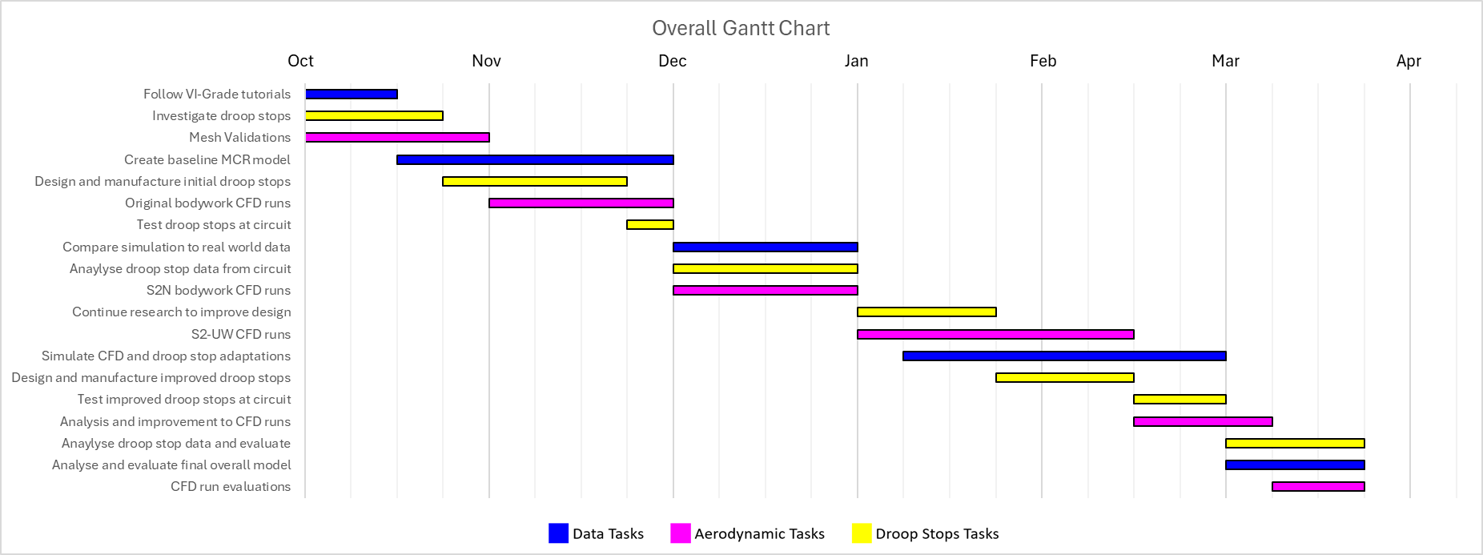
Project Gantt Chart
Figure 1 Overall Project Gantt Chart

Personal Gantt Chart
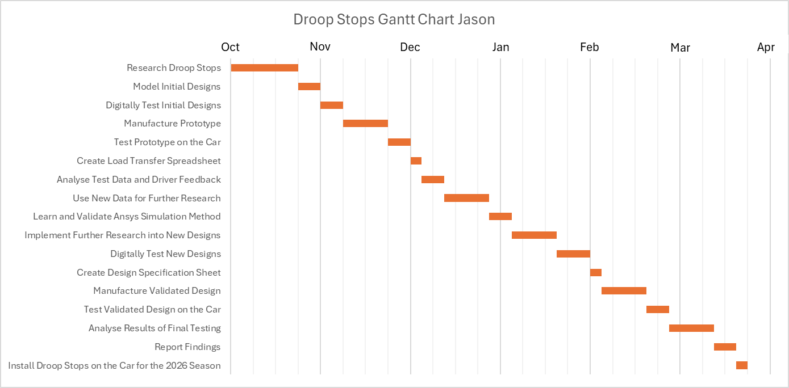
Figure 2 Personal Gantt Chart

Conclusion
In conclusion this report has shown the roles and responsibilities of all the team members and evaluated how well I fit into my area of the project using Belbin’s model. It has also outlined the personal and group tasks. This report has also identified overall project milestones, a gateway in my specific area and the risks involved. Finally, it shows the timing plans for both the overall project and my specific area.

References
Belbin (2025) Belbin Team Roles | Belbin. Available at: https://www.belbin.com/about/belbin-team-roles (Accessed: November 18, 2025).
Currys (2025a) Buy ACER Aspire Go 14" Laptop - AMD Ryzen 3, 128 GB SSD, Silver | Currys. Available at: https://www.currys.co.uk/products/acer-aspire-go-14-laptop-amd-ryzen-3-128-gb-ssd-silver-10284368.html (Accessed: November 21, 2025).
Currys (2025b) Buy HP OMEN 16L Gaming PC - AMD Ryzen 5, RTX 3050, 1 TB SSD | Currys. Available at: https://www.currys.co.uk/products/hp-omen-16l-gaming-pc-amd-ryzen-5-rtx-3050-1-tb-ssd-10286580.html (Accessed: November 21, 2025).
Health and Safety Executive (2024) Using personal protective equipment (PPE) to control risks at work: Using the right type of PPE - HSE. Available at: https://www.hse.gov.uk/ppe/using-the-right-type-of-ppe.htm (Accessed: November 19, 2025).
van der Heijden Lex (2018) A practical guide for holistic project management. 1st ed. Available at: https://ebookcentral.proquest.com/lib/trinity/reader.action?docID=5210515&c=UERG&ppg=59# (Accessed: November 19, 2025).
metals4U (2025) 30mm x 30mm x 3mm galvanised Steel Angle | metals4U. Available at: https://www.metals4u.co.uk/materials/mild-steel/mild-steel-angle-iron/8676-p (Accessed: November 21, 2025).
Miranda Eduardo (2019) A Participative Visual Approach to Milestone Planning. Available at: https://papers.ssrn.com/sol3/papers.cfm?abstract_id=3282382 (Accessed: November 22, 2025).
Muiño Adrián and Akselrad Fabián (2009) Gates to success - Tollgate Methodology | PMI. Available at: https://www.pmi.org/learning/library/2019/08/01/21/43/gates-success-tollgate-methodology-6842 (Accessed: November 18, 2025).
Screwfix (2025a) Easyfix BZP Steel Hex Nuts M10 100 Pack - Screwfix. Available at: https://www.screwfix.com/p/easyfix-bzp-steel-hex-nuts-m10-100-pack/19879 (Accessed: November 21, 2025).
Screwfix (2025b) Easyfix BZP Steel Set Screws M10 x 100mm 50 Pack - Screwfix. Available at: https://www.screwfix.com/p/easyfix-bzp-steel-set-screws-m10-x-100mm-50-pack/13414 (Accessed: November 21, 2025).
SOLIDX Ltd (2025) Instant SOLIDWORKS Price UK - SOLIDX - SOLIDWORKS Simplified. Available at: https://www.solidx.co.uk/pricing/solidworks-cad/#tab-rental (Accessed: November 21, 2025).

