Week 3 – Cash Flow Statement
  - Reference
Atrill, P., & McLaney, E. (2018). Chapter 5. Accounting and finance for non-specialists (10th ed., pp. 162–193). Pearson Education, Limited.
  - Exercise 1
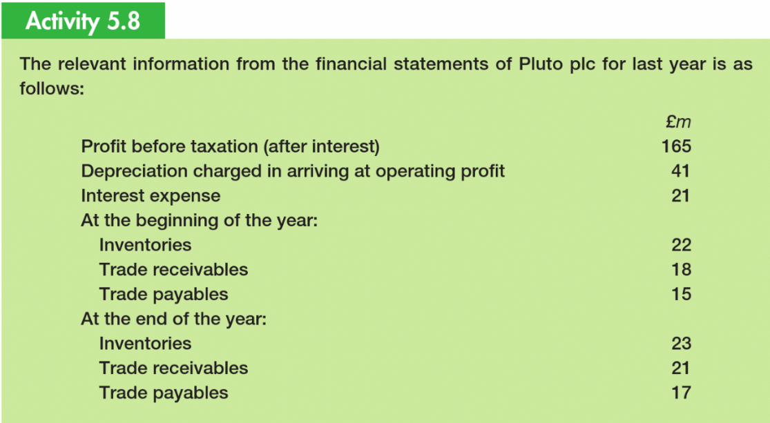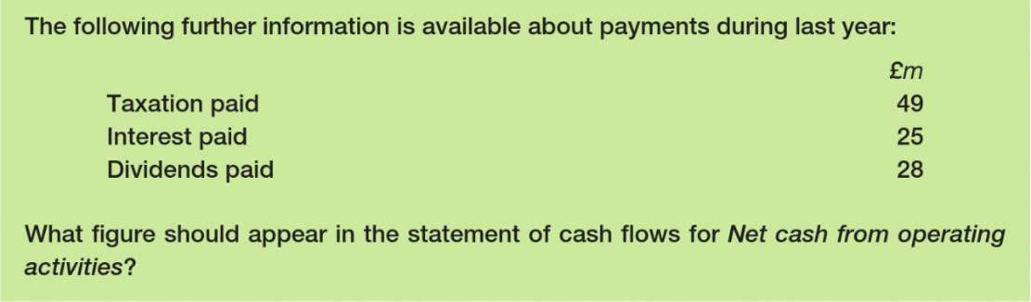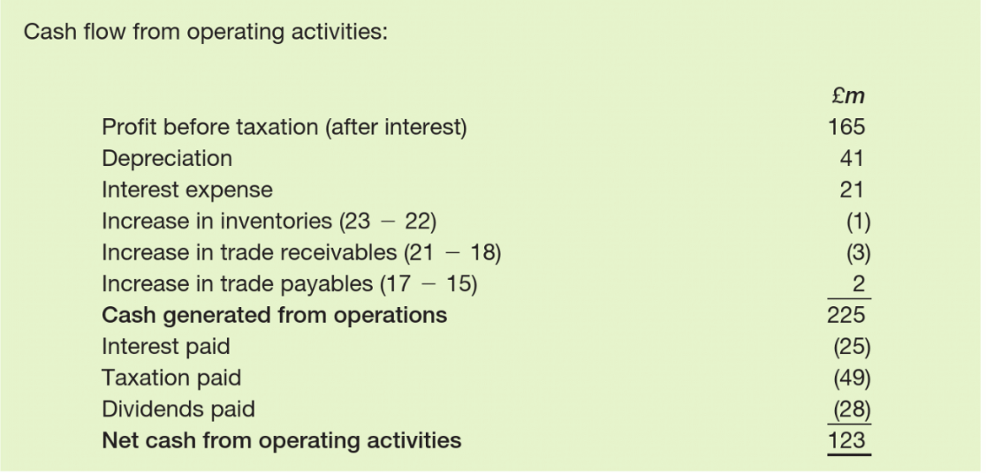

  - Exercise 2


