
University of Wales Trinity St David, Swansea

Positive Emotional Expression in Motion Graphics Design:
A Design Scheme of Life Happiness Based on
Dopamine Design Style

LIU Tianran
2214944@student.uwtsd.ac.uk, University of Wales Trinity St David, Swansea

Abstract
This article aims to explore dynamic visual design methods based on dopamine style design, aiming to stimulate positive emotions and happiness through visual communication(Coelho, Dias 2022). In the design process, I integrated the relevant theories of art, design, positive psychology, and color physiology, as well as the five dimensions and three levels of happiness, into various aspects of design. Selection theory, happiness level theory and positive Affect theory become the theoretical cornerstone supporting design ideas, providing profound guidance for creation. In addition, the article also explores the elements of dopamine style design, which aims to enhance happiness by triggering positive emotions and emotional experiences, as well as creating emotional connections with the audience. The proposed design methods and processes not only include visual effects, but also cover emerging technologies such as human-computer interaction, artificial intelligence, and augmented reality to enrich the audience's experience. Through the Focus group and data collection, I will continue to improve the design to ensure that the final design results can achieve the expected emotional communication and audience participation in design and research goals.

Table of Contents
Abstract 1
ⅠIntroduction 2
1.1 Background on the generation of design ideas 3
1.2 The significance of combining design projects with theory 3
Ⅱ Concept Reference 4
2.1 Background reference information 4
2.2 Theory and concepts related to design project 9
2.3 Theoretical framework of design project 11
Ⅲ Specific Content of Visual Design 13
3.1 Content and preliminary exploration of design project 13
3.2 Technologies that may be applied in the later stage of project implementation 15
3.3 Data collection and project improvement 16
Ⅳ Discussion 17
Ⅴ References 17

- Introduction
  - Background on the generation of design ideas
During my recent research on AI assisted design, I realized the lack of emotions in AI generated designs, despite the fact that artificial intelligence includes emotion analysis techniques. Artificial intelligence can affect people's emotional state(Chuah, Yu 2021). However, in my opinion, the existing AI related image generation and video generation works are still very rigid, which led me to shift from the focus of research technology to emotional theme design. And during the research period, there was news of my favorite musician committing suicide at home on July 2nd due to depression. These things have made me increasingly concerned about art and design that can generate positive emotions, and I hope to bring some positive social impact through my own practice.
In the world swept by the epidemic in previous years, as well as the increasingly turbulent global situation, people collectively fell into a state of "anxiety and panic", and their hearts were shrouded in gloom. In the current post Pandemic era, people are exploring various methods of "emotional therapy". In recent years, the art and design fields have increasingly accepted the combination of psychological principles to create visually engaging and emotionally uplifting experiences for audiences(Gomes, Preto 2018). This paper aims to explore a dynamic design form integrating positive psychology by combining Interaction design or artificial intelligence technology, and finally make a complete exhibition work.
I believe that design can bring positive emotions and happiness to people, which is also my positive feedback to society. I hope to become a mature multidisciplinary visual designer in the future. In the process of promoting this design project, demonstrate the growth process of a mature multidisciplinary visual designer. In this paper, I want to strive to explore my future design style, which I refer to as the "Dopamine Style", and use it as a direction to create some "Dopamine Style" designs and become a "Dopamine Designer". It mainly involves the creation of illustrations and motion images. In the process of writing the paper, the organic connection between practice and theory will be emphasized, and this paper provides a comprehensive basic exploration for the design of my exhibition.
  - The significance of combining design projects with theory
The combination of practice and theory is a key issue in many fields and disciplines. Of course, it is also particularly important for design creation. The process of linking practical projects with theoretical knowledge and concepts helps to enhance the understanding and application of knowledge, as well as theoretical creation, and improves the quality, effectiveness and rigorism of my practical projects(Piirainen, Briggs 2011). Combining practical projects with theory is an important step for me in advancing my research project. In the early research process, I mainly focused on how to carry out the technical field, ignoring the theoretical background of project implementation. I need to identify the background, problems, goals, and objectives of the actual project, and through the combination of theory, help me solve the problems in my creation and achieve the goals and objectives. I am able to have a clearer understanding of my ideas and actual presentation, as well as the various challenges that I will face in order to achieve the exhibition. I start from the fields of psychology and design to understand the correlation between these fields and my time, in order to explore the originality in my design and prove that my research has corresponding contributions.
Excellent design practice cannot do without the support of theory(Koskinen, Krogh 2015). When I noticed "Dopamine Dressing" a few months ago, I began to delve deeper into the theoretical support behind this globally popular media phenomenon. On the basis of my understanding of existing relevant theories, I began to summarize the rules and combine them with my own visual design. I hope to summarize the theoretical system of the entire new design style and use my practice as a case and research object to continuously improve the entire concept. At the beginning of design, I was thinking about whether visual design is not a physical product design, and whether it can truly bring joy and joy to the audience. I think literature reading plays a very important role here. The advantages I have seen in many excellent designs can be summarized from a theoretical perspective, which makes me believe that artistic practice can achieve the desired results.
- References to Concepts
  - Background references information
Affected by the COVID-19 in 2020, the global economy is at risk of a great recession. "Vintage" and "Remake" make it easier for young people to get in touch with past trends. In the past two years, the Internet media has spread a lot of information about art and design, which I think is a retro trend. A lot of information about American retro style, Retrofuturism, and Y2K style has begun to reappear.
American retro style refers to the cultural trends and styles that emerged in the United States from the 1940s to the 1970s, known as the "Golden Age" of American culture. Retro-futurism is a design style that imitates the early Futurism design style in contemporary art. This style appeared in the 1970s to 1980s, and the term was first proposed by Lloyd Dunn in 1983(Liu 2019). This style combines the retro style with the Futurism style with scientific and technological color. The design inspiration is usually from the design aesthetics influenced by Futurism and the space age, and uses a large number of popular neon colors, metal colors, curved geometric shapes and glass textures. The recurrence of Y2K style is like 20 years, expressing people's uncertainty, longing, and longing for the future. Its core ideas are mainly Optimism and scientific and technological utopia. These ideas are also commonly pursued by people today. These re popular styles, from a design perspective, share the common feature of using bright colors, black lines, black and white as auxiliary combinations, and embellishments with symbolic patterns.
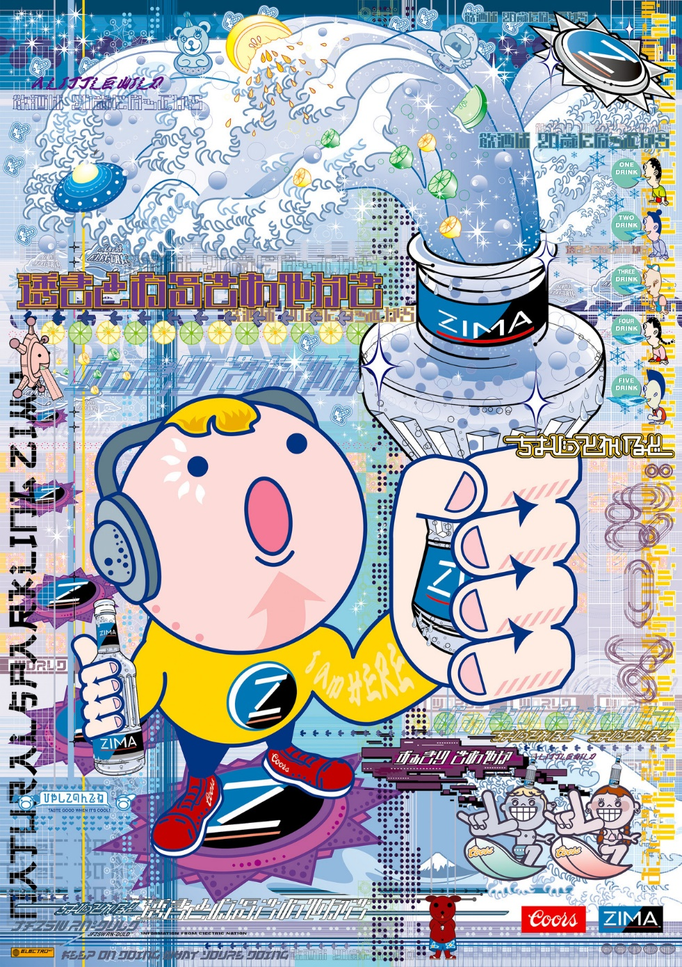
Figure 1. Electric (1999) Mitsuhiko Chigira and Takahiro Fujioka [Picture]. Available at:Https://Y2kaestheticinstitute.Tumblr.Com/Post/182288635704/Print-Ad-for-Zima-1999-Japan-Design (Accessed: 6 Agust 2023).
Since 2020, brightly colored designs have become widely popular on many fashion shows. The current popular "Dopamine Dressing" was created by fashion psychologist Dawnn Karen in 2020. During the COVID-19 epidemic, she began to explore ways to enhance dopamine. I think there are many similarities between the starting point for her proposal of this concept and the starting point for my practical creation(Shinkaruk 2019). She teaches Color psychology and general psychology at the Institute of Fashion Technology(Jain, Kim ). In her book, she wrote that wearing high saturation clothing can promote the brain to release the neurotransmitter dopamine that promotes emotion.
In 2000, Swedish scientist Arvid Carlsson won the Nobel Prize in Medicine for his discovery of dopamine as a brain transmitter. Dopamine is a key neurotransmitter in the hypothalamus and pituitary gland(Dolan, Brykman 2022), a chemical used to help cells transmit pulses, and a type of neurotransmitter. It can directly affect people's emotions. Research has shown that dopamine, known as the 'happiness hormone', can improve emotions and enhance happiness(Baghayeri, Nodehi et al. 2019). It is mainly responsible for the brain's desire, sensations, transmission of excitement and happiness information, and is also related to addiction. Research has shown that dopamine can also treat depression and improve memory. Dopamine (desire hormone) brings people a sense of anticipation before achieving happiness, which scientists refer to as the "expectation system" and "reward center" of the brain. When you have a particularly strong desire to complete something or engage in a certain behavior, your brain will secrete a large amount of dopamine, driving you to continue pursuing your desires and bringing happiness and satisfaction in the process(Pareek, Satapathy 2021).
People's dopamine can drive you to do meaningful things. Although there are significant individual differences in people's dopamine system, such as differences in sensitivity to external stimuli and differences in overall activity. That is to say, for some people, the secretion of dopamine is easier and more frequent, and vice versa. The study also pointed out that those with lower levels of dopamine system activity are less willing to make cognitive and behavioral efforts for possible rewards, especially when the likelihood of receiving rewards is relatively low(Treadway, Bossaller et al. 2012). Dopamine dressing largely utilizes color stimulation to shape the image. The essence of color association and its corresponding impact on our feelings, aesthetic judgments, etc(Elliot, Maier 2014).
So can my design visually activate people's desires, inspire them to do so many small things that make people feel happy and motivated, and promote a virtuous cycle of thought and action. I think the vibrant colors and retro style of 'Dopamine dressing' are similar to the Kidcore theme. Kidcore is an aesthetic style that reminisces about children's popular culture from the 1990s to the early 2000s. It is a concept centered around bright colors, retro, and children's themes, while also incorporating Y2K and retro styles, which make people secrete dopamine to feel happy upon seeing. Brazilian designer Marco Riberio also added many bold colors and childlike embellishments to his designs, combining fruit pattern elements with contrasting colors. Elements such as letters, fruits, vegetables, and animations can all be combined through rich colors.
In addition to the above theories, I have also focused on many videos related to color matching in media. These styles have been wildly spread through TikTok and Instagram. In addition to Dawnn Karen, there is a fashion blogger in China with a media account called 'Daytime Little Bear' who has become very famous recently. In her processing of videos and photos, she can find many designs that highlight visual effects, highlighting bright and bold colors that are refreshing. The color ratio is not fixed, but she will consider matching based on the maximum color, and also add a lot of Emoji. This is the representative of a media influencer who, in my eyes, combines various styles mentioned above. This aesthetic style is equivalent to a modern interpretation of childhood memories, with childlike charm being the most important feature. Therefore, most modeling colors are primary colors with high saturation such as red, yellow and blue, or pink, light blue, purple and Iridescence colors. From Hello Kitty, Sesame Street, Teletubbies and other images to Takashi Murakami's works, they can all be part of Kidcore's theme. However, these themes are often related to Fashion design. But looking back, I think these themes are also influenced by such artistic styles as ultra flat style, Pop art, new Pop art and Fauvism. At the same time, my visual elements are also generated from the development process of these artistic styles. Mainly based on the development of time, it can also be considered as a retrospective analysis of the current popular background.
At the same time, I will combine the characteristics of Fauvism. Fauvism emphasizes the expressiveness of form and color(Millard 1976), and pictures mainly express personal feelings and intuition, creating a new color language and composition. Its impact on visual design is manifested in:
Color application. Fauvism broke the fixed relationship between color and objects, and took color as an independent expression element to express atmosphere, emotion, rhythm, etc. The color application of Fauvism inspired visual designers to make more attempts and innovations in color matching, contrast, saturation and other aspects, making visual design more colorful.
Planarize the composition. Fauvism abandoned the traditional perspective and shading, and adopted a planar composition, emphasizing the balance and integrity of various elements on the screen. The graphic composition of the Fauvism School has important implications for visual design, which makes designers pay more attention to the relationship between form and space on the screen, as well as the layout and layout between graphics and characters.
Decorative style. Fauvism was influenced by oriental art and African art, drawing on their simple and decorative styles, such as geometric shapes, curves, patterns, etc. The color application of Fauvism inspires me to make more attempts and innovations in color matching, contrast, saturation, etc. Its decorative style provides a new aesthetic choice for design, allowing me to use different decorative elements based on different themes and occasions to enhance visual effects and aesthetics.
I will consider the elements of Pop art and new Pop art because Pop art attaches great importance to the visual effects of mass media. The difference between Pop art and new Pop art is an interesting topic. Pop art is a kind of Art movement popular in the middle of the 20th century. It uses popular culture, Consumerism, commercial advertising, etc. as creative materials, and uses bright colors, simple forms, repetitive images and other techniques to express observation and criticism of modern society. New Pop art is an art form developed in the early 21st century. It inherits the spirit and style of Pop art, but adds more innovative and diversified elements, such as animation, network, technology, globalization, etc., to reflect the changes and diversity of contemporary society.
The art source of new Pop art is more focused on globalization and diversified cultural phenomena. The art media makes more use of modern technology and digital media, which is more suitable for my creative environment. In terms of theme, Pop art mainly focuses on social reality and consumer culture, as well as personal feelings and values. New Pop art pays more attention to social problems and Cultural conflict, as well as personal identity and self-expression. Pop art mainly uses bright colors, simple lines, flat composition and other styles to highlight the visual impact and decoration of images. New Pop art uses more complex colors, detailed lines, three-dimensional composition and other styles to increase the visual level and depth of images.
My visual elements will also refer to the form of Keith Haring, an American pop artist, and mainly emphasize bright colors. A large number of colors with high saturation create visual impact and decoration. The concise black lines highlight the effects of planarization and cartoonization, while improving the speed and smoothness of creation. The repetition and variation of images create rhythm and dynamism. The combination of symbols and text in visual expression is more prominent, forming his own symbolic and universal visual language mode.
The ultra flat style born from Pop art and new Pop art is also inspired by Pop art and new Pop art. It is popular in Japan, and the representative figures are Takashi Murakami and Yoshitomo Nara. Their style will also be a source of inspiration for my creations. Ultra flat style is a term created by Japanese artist Takashi Murakami in 2001. It refers to various flat forms in art works, a non three-dimensional style, and a metaphor for the superficiality of consumer culture (meaning flat). This style has become one of the most active creative directions in post-modern times.
At the same time, I will display many photography, illustration, and dynamic graphic design works that I appreciate in my visual diary. I will also start with illustration and graphic design, and then make them dynamic. Dynamic graphic design is a subset of animation, which is the art of creating moving images. Dynamic graphic design focuses on giving motion to graphic design elements. Dynamic graphic design usually does not follow specific narratives or stories, but aims to convey information, emotions, and aesthetics through dynamic graphics. Among all my case studies, the most suitable example is the animated short film "Love & Balance" created by 13 graphic artists in collaboration with Silk Gallery and Le Cube. This work explores the changes in human communication after the pandemic, providing valuable information that love can be expressed more vividly in many different ways. Visualize their search for a unique interpretation of rhythm and symmetrical beauty in love.
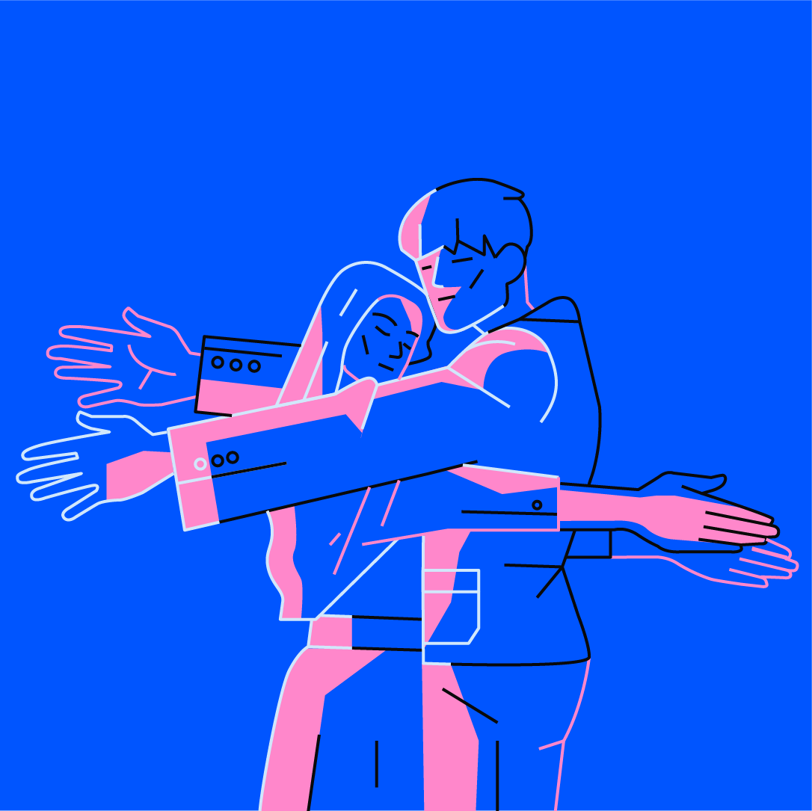
Figure 2. Love&Balance (2023) Santiago Oddis [Picture from Short Film]. Availableat:https://www.behance.net/gallery/175493827/Love-Balance?locale=en_US (Accessed: 7 Agust 2023).
  - Theory and concepts related to design project
The concept of Motion graphics design and its psychological effect on the audience. It is a method of utilizing elements such as animation, interaction, and sound to enhance the effectiveness and expression of visual design. Motion graphics design can be used in various media and fields, such as web pages, applications, games, advertisements, films, exhibitions, etc. The purpose of its design is to attract audiences' attention, convey some information effectively, evoke emotions, and enhance their experience and engagement.
The influence of Motion Graphics Design on emotions is multifaceted and can be observed through various dimensions:
Visual perception. Motion graphics design harnesses a range of visual elements, including color, shape, speed and so on, to craft distinctive visual atmospheres and effects. These elements play a pivotal role in influencing individuals' emotions. Further exploration will delve into the psychological implications of color, offering insights into its profound impact.
Emotional identification. Motion graphics design may efficiently transmit unique emotional information and meanings by using symbols, words, images, and other emotional factors. These aspects create emotional identities that viewers can identify with. A smiling face, for example, can create thoughts of happiness and friendliness, whilst a heart shape can evoke feelings of love and warmth.
Emotional transition. Motion graphics design uses dynamic elements such as change, transition, and contrast to create visually appealing and emotionally compelling sequences. These dynamic aspects are responsible for emotional shifts and stimulation. Gradients, for example, can elicit feelings of serenity and comfort, while jumps can instill a dynamic and interesting atmosphere, and opposites can elicit feelings of wonder and surprise.
In terms of color design, I first learnt about color therapy, color psychology, and color physiology as applied to "Dopamine Dressing". Color therapy is a method of using color and light to regulate a person's psychological and physiological state, thereby achieving the purpose of treatment and health care. Color therapy believes that colors of different wavelengths can affect people's emotions.
Color psychology is a subject that analyzes and displays the attributes of various colors and their physiological phenomena under effective mechanisms, and studies the influence and role of color on people's behavior and psychology. Color can affect people's perception, emotions, memory, attention, learning, creativity, preferences, and other aspects. It can also be used to convey information, express emotions, stimulate imagination, regulate atmosphere, and so on. Carl Jung, the representative of Color psychology research, participated in the pioneering stage of Color psychology in the 20th century. In his own Jungian therapy, we can find that he attaches great importance to the potential of art as a psychotherapy tool, which can help people build more meaningful and satisfying lives.
Color physiology is a discipline that studies the perception and processing of color by the human visual system. Color physiology indicates the way the eyes and brain process color stimuli. Johann Wolfgang von Goethe In his classic work "Theory of Colors", indicating the impact of color perception on emotional experience(Von Goethe, Eastlake 2019). But Goethe's theory is to divide colors into additive or subtractive "plus colors" or "minus colors". Dopamine design is often a series of designs formed by all color schemes, not just about distinguishing between two types of colors that cause emotions. I think it is the combination of high brightness and high purity colors that affects people's perception. In the last century, Kurt Goldstein further advanced Goethe's ideas and applied them to his clinical observations, which are of great reference value to me. He proposed that color perception has physiological effects in the human body, which are reflected in people's emotions and cognition. He believes that warm colors can be stored in people to generate strong actions, while cool colors can relax and produce calm and stable actions(Goldstein 1942). Later researchers experimented with these colors based on wavelength. The visual experience caused by the wavelength of colors can affect the performance of accomplished tasks. Long wavelength colors make people excited and can promote the performance of simple tasks, while short wavelength colors make people calm and can promote the performance of complex tasks(Stone, English 1998).
Starting from the color design of Dopamine Dressing, I went on to learn about positive design in positive psychology. As a comprehensive term for all forms of design, design research, and design intent, "positive design" clearly focuses on the impact of design on personal subjective well-being(Desmet, Pohlmeyer 2013). This is also my design intention for this design. In addition to the design of colors, I also aim to awaken people's positive emotions from the images that generate happiness activities. Positive and positive activities provide people with a lasting sense of happiness. Under the stimulation of desired goals, dopamine in the brain actively activates cells to drive people to engage in more activities. Various types of neurons and their released neurotransmitters in the brain interact with each other to maintain positive emotions.
In summary, I believe that by combining practice with theory, especially with theoretical support in terms of color and arousing positive emotional experiences, I can achieve my design goals and create a pleasant experience for the exhibition for the audience. Guided by in-depth theoretical research, I will continue to work hard to continuously improve my design concept.
  - Theoretical frameworks of design project
This section will draw on existing literature and previous research in the fields of art, design, positive psychology, and color physiology to delve into the relevant theories and concepts that support dynamic design methods. By identifying gaps in current knowledge or practice, this article will establish a theoretical framework that links actual design work with existing theories. We will explore the impact of concepts such as emotional design, user experience, and interactive devices on creating positive psychological effects through visual design. In this regard, good structure and coherence between practical works and reports are key to ensuring the successful achievement of project objectives.
Each individual visual display in my visual design is an independent thing, and the content creation will revolve around some theoretical structural foundations, including the five dimensions that affect happiness and the three levels that affect happiness.
Psychotherapist William Glasser proposed the Choice Theory in 1996, which is mainly used to explain human motivation and behavior(Glasser 1999). The theory of choice suggests that humans have five basic psychological needs that are not divided into different levels, and these five basic psychological needs are also the five dimensions that affect our sense of happiness: survival, love and belonging, power, freedom, and pleasure. These five choices are innate to humans and are also the source of human behavior. There will be some things that meet specific needs in the five dimensions. Survival dimension: money, safety, health... Love and belonging dimension: marriage, family, friends... Power dimension: achievement, ability, respect... Freedom dimension: freedom, autonomy, independence... Fun dimension: hobbies, leisure, play... These five dimensions, if there is any missing aspect, not all the things that can be done for the needs that have not been fully met, will become my creative material. If there is a lack of survival mode, the thing to do is to increase knowledge in financial management; If the dimensions of love and belonging are missing, you can choose to spend more time with people who are important to you; If the dimension of power is missing: doing tasks that are higher than one's current level to complete can promote the generation of heart flow(Debus, Sonnentag et al. 2014).
Psychologist Seligman believes that the concept of happiness has three gradually rising levels: a happy life, a satisfying life, and a meaningful life(Seligman, Csikszentmihalyi 2000). According to the three levels that affect happiness, I will use all the elements in the creation theme to conform to these three levels. Starting from three levels: being able to generate positive emotions in life, creating value, self-improvement, and forming emotional connections with others will all become the source of my creativity. So based on these theories, I have preliminarily listed the most basic categories of ideas about theme images:
Doing something with a sense of achievement: combining self-management with building long-term goals
Experience things full of freshness: exploring unknown fields, learning new skills, traveling, etc
Social interaction that enhances emotional experience: Establishing positive and meaningful social connections can stimulate dopamine production
Art and creative activities, such as painting, music, writing, etc., bring a sense of satisfaction and achievement
Doing activities with reward mechanisms: giving oneself small rewards can increase motivation and satisfaction
Keep a Positive mental attitude: positive and optimistic attitude and optimistic view of life can increase the sense of pleasure and satisfaction

- Specific Content of Visual Design
  - Content and Preliminary Exploration of Design Project
Throughout the creative process of the entire project, I will clarify the preliminary ideas of my design project, emphasizing the intention of arousing positive emotions and encouraging the audience to reflect and love themselves. The goals, methods, and expected results of the overall design will be thoroughly analyzed and linked to some academic concepts. Before this, I will analyze the styles of elements that I believe are similar to dopamine design in the work collection, and conduct work analysis to become my creative inspiration material.
I will closely integrate the relevant theories between happiness and visual elements, such as the influence of color physiology and visual elements triggered by emotions, into my design. The challenge in my design process is to create opportunities for people to bring positive emotions and meaningful experiences. In addition to the form of dynamic vision, the later stage may combine human-computer interaction and artificial intelligence technology.
Through my research and design, the expected outcome is a set of innovative and practical dynamic visual designs with the theme of enhancing dopamine in daily life. This design will combine theory with practice to present a visual effect that can touch the audience's emotions and convey a positive and upward sense of happiness. These design achievements will not only be applied to personal creative practices, but also provide useful references for similar theme designs, contributing to creating more visual experiences that generate happiness for people. In the following chapters, I will provide a detailed introduction to my research methods, design process, design framework, theories that can be used as conceptual references, and specific visual design works that can be referenced to achieve this important goal. By integrating theory and practice, I hope to bring a true, profound, and lasting sense of happiness to the audience.
My creative theme is about arousing positive emotions and bringing happiness to people. The pursuit of happiness can be said to be the core of personal life, but psychology only extensively studied it twenty years ago(Hassenzahl, Eckoldt et al. 2013). Positive emotions are the main indicator of health and happiness, and people can enhance their sense of happiness through learning and cultivating positive emotions. According to theory, the ability to experience positive emotions may be a fundamental core force in human prosperity research(Fredrickson 2001). Positive emotions are based on the theory of positive psychology, emphasizing the need to cherish the most valuable things in life and the factors that have the greatest impact on a better life. According to Lyubomirsky, happiness can be understood as the experience of producing happiness, satisfaction, or positive happiness in life, as well as the feeling of beauty, meaning, and value in life. A large part of the reason for happiness depends on activities, which indicates that happiness is actually variable(Howell, Kern et al. 2007). People can control their experiences and make themselves happier(Hassenzahl, Eckoldt et al. 2013).
This provides a challenging opportunity: Interaction design can "design for happiness", enrich people's daily life by promoting positive experience. This is my design philosophy centered around "happiness". I will analyze the design cases related to the project in the following text.
First of all, I refer to the case of dynamic icons for the 2020 Tokyo Olympic Games for the form of Motion graphics design. As a graphic language, graphic creativity can clearly express the meaning of design works. This set of works was designed by two Japanese designers Masaaki Hiroura and Yuta Iguchi in collaboration. The dynamic effect is generated and disappears in the form of fragments from a blank background, dynamically showcasing all sports events, bringing vitality and pleasure to the audience, effectively conveying visual information, and giving the audience stronger impact(Deng 2021).
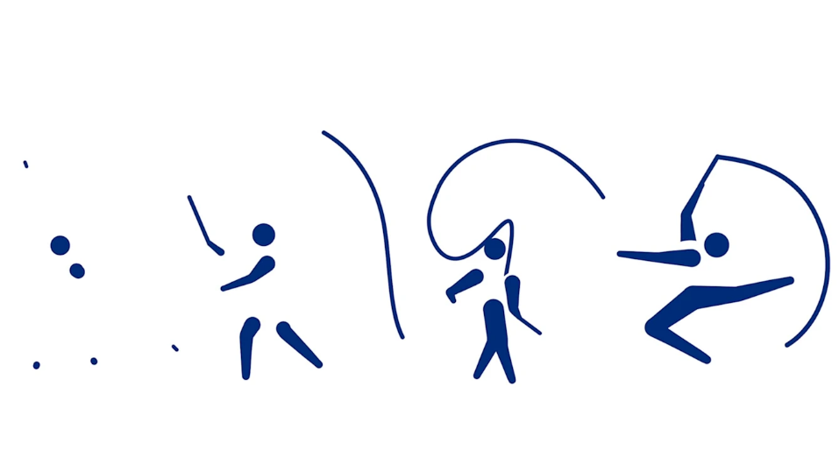
Figure 3. Tokyo 2020 unveils Games pictograms (2023) Masaaki Hiromura [Picture].Available at: https://olympics.com/en/news/tokyo-2020-unveils-games-pictograms (Accessed: 7 Agust 2023).
In addition to dynamic effects. Secondly, regarding the color design of the "dopamine style", it reminds me that it has many similarities with the color design of the above design styles. Many people may think that the cultural phenomenon brought about by dopamine dressing is nothing more than a product of popular culture. Even my classmates around me feel that such a popular culture is not suitable for further development or research. Just as in the 1960s, people criticized Pop art. Abraham Kaplan once discussed that Pop art is not a degradation of taste, but an immaturity, not a product of external social forces, but a dynamic product of aesthetic experience itself. It is not limited to the uniqueness of time and place, it has universality just like art itself. This, like 'dopamine dressing', has transcended the limitations of location and formed a global trend. I also hope that it can transcend the limitations of time and continue to develop. Since people can generate such consistency in their aesthetic preferences in the dynamic development of aesthetics. I think these elements make me firmly believe that they have an instinctive attraction to people, so it is even more necessary for me to summarize relevant laws and make such designs. The color and element design will refer to these art and design cases that share similarities with "dopamine dressing".
  - Theory and concepts related to design project
Regarding exhibitions, I may use AI or interactive technology. For the design of Interaction design, I referred to the Interaction design work presented in a graduation exhibition of the Central Academy of Fine Arts in 2023. The name of the work is "What's the Matter Between Demons?". Sitting, the Chinese Han Dynasty stone reliefs were Visualization redesigned, and images and videos were perfectly combined. Video interaction technology was used in the display process. Using an infrared camera to capture the screen area in real time, attach a QR code to the flashlight and use this auxiliary device to transmit signals. Then, the corresponding QR code of the flashlight illuminates the corresponding coordinate area of the playback screen, and the player receives the corresponding coordinate image and uses a mask to perform corresponding windowing processing. It can display static effects and then display dynamic effects after masking. This interactive technology can be used on other interactive devices, and signal sending devices are not limited to flashlights. I hope it can be a prop that represents my creative theme, making it enjoyable to use. My displayed images are first displayed in the form of static illustrations on the screen. After being masked, I can see the dynamic animated images, which not only have an interactive feeling but also fully leverage the advantages of graphic design, making the audience more flexible and interesting to experience.
By combining AI generated art, interactive installations, AR technology, and exhibitions, I will create an interactive display wall that combines gestures to allow the audience to control color changes and movements through gestures. This will allow the audience to more intuitively experience the emotional transmission of dopamine style design, creating a unique atmosphere and emotional experience. Regarding AI technology. First, collect enough raw data of the picture, which can be images, paintings, patterns, videos, etc. These data will serve as the foundation for AI generated art. For dynamic visual design, it may be prepared to collect data related to motion, shape changes, and other aspects. Secondly, select the appropriate AI model to generate artwork. Common models include Generative adversarial network (GANs), Variational autoencoder (VAEs), etc. When training the model, use the previously collected art data to enable the model to generate art images that are consistent with dopamine style design concepts. At the same time, AR technology can be used to see the dynamic effects of some images on electronic devices such as mobile phones. Rather than relying solely on electronic screens for interaction. At the same time, I may provide display devices for explanation and guidance at the exhibition site, presenting explanatory videos about AI and dopamine styles through information boards and guided videos, to help audiences better understand my design concepts, techniques, and creativity.
  - Theoretical frameworks of design project
During the design process, I will optimize and improve the design based on the collected data through a questionnaire survey. The organic connection between design, theory, and research serves as a means to verify whether my design tasks have met my requirements. This verification process not only enhances my design confidence, but also enhances the persuasiveness and credibility of the project results. When my previous theories were applied to actual design projects, any deviation between the initial theoretical framework and the actual design became apparent. Therefore, this provides me with the opportunity to reassess and optimize the design strategy, ensuring that the final presentation remains coherent and coordinated in emotional communication.
During the completion process of some visual works, I will promptly collect feedback from viewers. Understand their experiences and perspectives on the combination of AI generated art and dynamic visual design. Based on feedback, make improvements to the design to further enhance the quality and attractiveness of the exhibition's final effect. During the design process, I will establish a focus research group of ten people for my user data analysis. I will consider which groups of people are interested in my design and whether positive emotional experiences are needed to improve my life. I will recruit participants through social media and other channels, and ensure that their backgrounds and interests are relevant to my design theme. At the same time, develop a discussion guide with them on the design, including the problems I need to solve and the topics to be discussed, to ensure the openness of the issues, so that participants can freely express their opinions. I will also consider using online meetings to allow participants to share their opinions. I will conduct data analysis during these processes, identify commonalities, trends, and patterns, and address research and design issues. Improve your exhibition design according to the feedback and insight of the Focus group. This may involve adjusting visual elements, interactive design, presentation methods, and other aspects to better meet the expectations and interests of the audience. Participants of the Focus group can experience the final design of the exhibition online or offline, listen to their feedback, and incorporate the feedback into the summary of the exhibition design.
- Discussion
This article presents my preliminary results in multiple aspects regarding the elaboration of design concepts and practical methods. By integrating Applied arts, psychology and technology, a dynamic visual design framework based on dopamine design style was initially constructed. By providing a positive emotional experience and triggering emotional connection between the audience and the design, this design method provides a new way to create a positive sense of happiness experience. At the same time, combining Interaction design and emerging technologies, such as artificial intelligence and augmented reality, I hope to make my design scheme more creative and attractive in presentation.
However, the success of design not only depends on the combination of theory and technology, but also requires a deep understanding of the audience's needs and expectations. Through the Focus group and data collection, I will effectively obtain feedback from users, which is crucial to optimize the design and ensure that it achieves the expected goals. The user interaction in this process not only helps the design to be closer to the user experience, but also reflects the operability and attractiveness of the design.
- References
BAGHAYERI, M., NODEHI, M., VEISI, H., TEHRANI, M.B., MALEKI, B. and MEHMANDOST, M., 2019. The role of pramipexole functionalized MWCNTs to the fabrication of Pd nanoparticles modified GCE for electrochemical detection of dopamine. DARU Journal of Pharmaceutical Sciences, 27, pp. 593-603.
CHUAH, S.H. and YU, J., 2021. The future of service: The power of emotion in human-robot interaction. Journal of Retailing and Consumer Services, 61, pp. 102551.
COELHO, R. and DIAS, S., 2022. Dynamic Visual Identities: Reflection on Interaction and Playfulness in Visual Identity Design by Porto Design Studios. Perspectives on Design and Digital Communication III: Research, Innovations and Best Practices. Springer, pp. 297-311.
DEBUS, M.E., SONNENTAG, S., DEUTSCH, W. and NUSSBECK, F.W., 2014. Making flow happen: the effects of being recovered on work-related flow between and within days. Journal of applied psychology, 99(4), pp. 713.
DENG, W., 2021Research on the Performance of Creative Thinking Based on Graphic Creativity in Dynamic Graphic Design, 7th International Conference on Arts, Design and Contemporary Education (ICADCE 2021) 2021, Atlantis Press, pp. 462-466.
DESMET, P.M. and POHLMEYER, A.E., 2013. Positive design: An introduction to design for subjective well-being. International journal of design, 7(3),.
DOLAN, S.L. and BRYKMAN, K.M., 2022. THE USE OF DOPAMINE TO ENHANCE RESILIENCE IN A POST COVID-19 ERA. EUROPEAN BUSINESS REVIEW, .
ELLIOT, A.J. and MAIER, M.A., 2014. Color psychology: Effects of perceiving color on psychological functioning in humans. Annual Review of Psychology, 65, pp. 95-120.
FREDRICKSON, B.L., 2001. The role of positive emotions in positive psychology: The broaden-and-build theory of positive emotions. American psychologist, 56(3), pp. 218.
GLASSER, W., 1999. Choice theory: A new psychology of personal freedom. HarperPerennial.
GOLDSTEIN, K., 1942. Some experimental observations concerning the influence of colors on the function of the organism. American Journal of Physical Medicine & Rehabilitation, 21(3), pp. 147-151.
GOMES, C.C. and PRETO, S., 2018Artificial intelligence and interaction design for a positive emotional user experience, Intelligent Human Systems Integration: Proceedings of the 1st International Conference on Intelligent Human Systems Integration (IHSI 2018): Integrating People and Intelligent Systems, January 7-9, 2018, Dubai, United Arab Emirates 2018, Springer, pp. 62-68.
HASSENZAHL, M., ECKOLDT, K., DIEFENBACH, S., LASCHKE, M., LENZ, E. and KIM, J., 2013. Designing moments of meaning and pleasure. Experience design and happiness. International journal of design, 7(3), pp. 21-31.
HOWELL, R.T., KERN, M.L. and LYUBOMIRSKY, S., 2007. Health benefits: Meta-analytically determining the impact of well-being on objective health outcomes. Health psychology review, 1(1), pp. 83-136.
JAIN, S. and KIM, A., Fashion Industry Commission.
KOSKINEN, I. and KROGH, P.G., 2015. Design accountability: When design research entangles theory and practice. International Journal of Design, 9(1),.
LIU, J., 2019. The Origin and Application of Retro-futurism. Journal of Landscape Research, 11(5), pp. 104-108.
MILLARD, C.W., 1976. Fauvism. The Hudson Review, 29(4), pp. 576-580.
PAREEK, A. and SATAPATHY, S.K., 2021. Productivity Sustenance with Effectiveness of Work Circles: A Study on the “Happy Hormones”. Resource Efficiency, Sustainability, and Globalization: Exploring India-European Union Cooperation, , pp. 41.
PIIRAINEN, K.A. and BRIGGS, R.O., 2011Design theory in practice–making design science research more transparent, Service-Oriented Perspectives in Design Science Research: 6th International Conference, DESRIST 2011, Milwaukee, WI, USA, May 5-6, 2011. Proceedings 6 2011, Springer, pp. 47-61.
SELIGMAN, M.E. and CSIKSZENTMIHALYI, M., 2000. Positive psychology: An introduction. American Psychological Association.
SHINKARUK, S., 2019. AI Stylist: What Do I Wear? Mobile Application. AI Stylist: What Do I Wear? Mobile Application, .
STONE, N.J. and ENGLISH, A.J., 1998. Task type, posters, and workspace color on mood, satisfaction, and performance. Journal of Environmental Psychology, 18(2), pp. 175-185.
TREADWAY, M.T., BOSSALLER, N.A., SHELTON, R.C. and ZALD, D.H., 2012. Effort-based decision-making in major depressive disorder: a translational model of motivational anhedonia. Journal of abnormal psychology, 121(3), pp. 553.
VON GOETHE, J.W. and EASTLAKE, C.L., 2019. Goethe’s theory of colours. Routledge.

