
Project Title: MedAssist Clinic Management System
A Secure PHP and MySQL Web Application with SQL Injection Prevention
Part B – Website Development and Security Report
Module Name: Databases and Application Development
Module code: ACCA5026
Student Name: Cornelia Dobre
Student ID: 2333752

Table of Contents
1. Introduction 3
2. Overview of SQL Injection 3
2.1 What is SQL Injection 3
2.2 Why SQL Injection is Dangerous 3
2.3 Example of SQL Injection 3
3. SQL Injection in the Website 4
4. Anti-SQL Injection Implementation 4
5. SQL Injection Testing 5
6. Conclusion 6
References 7
Appendix 8
Application Screenshots 8

1. Introduction
MedAssist Clinic Management System is a PHP/MySQL-driven website. Secure user login, patient CRUD operations, doctor CRUD operations, appointment CRUD operations, database connectivity and searching. This report is focused on SQL Injection, an explanation of the risks associated with SQL Injection, and a discussion of the security measures taken to protect the website from SQL Injection attacks.

2. Overview of SQL Injection

2.1 What is SQL Injection
Web security attacks are not uncommon, and SQL Injection is one such attack that targets applications with databases. It occurs when an attacker submits bad SQL code in an input element, particularly when it's used to log in to or search a website [10]. The database could run the SQL statement if the application does not sanitize the user's input or employs prepared statements. This can enable unauthorized access to sensitive information or changes to the database. Websites are susceptible when SQL queries are built by directly using user input in SQL statements rather than following safe coding [1].

2.2 Why SQL Injection is Dangerous
Severe security issues can arise when using SQL Injection. An attacker might be able to log in without a username or password. It can even be used to display sensitive data, alter records, delete vital data, or even control the database. This attack can target the confidentiality, integrity and availability of the system [6].

2.3 Example of SQL Injection
A vulnerable SQL query is shown in Figure 1.

$sql = "SELECT * FROM Users WHERE username='$username' AND password='$password'";
An attacker can type in ' OR '1'='1 as the username, and the condition evaluates true, giving the attacker access without a valid username or password. The example demonstrates the importance of secure coding practices like prepared statements and input validation to prevent web application attacks [4].
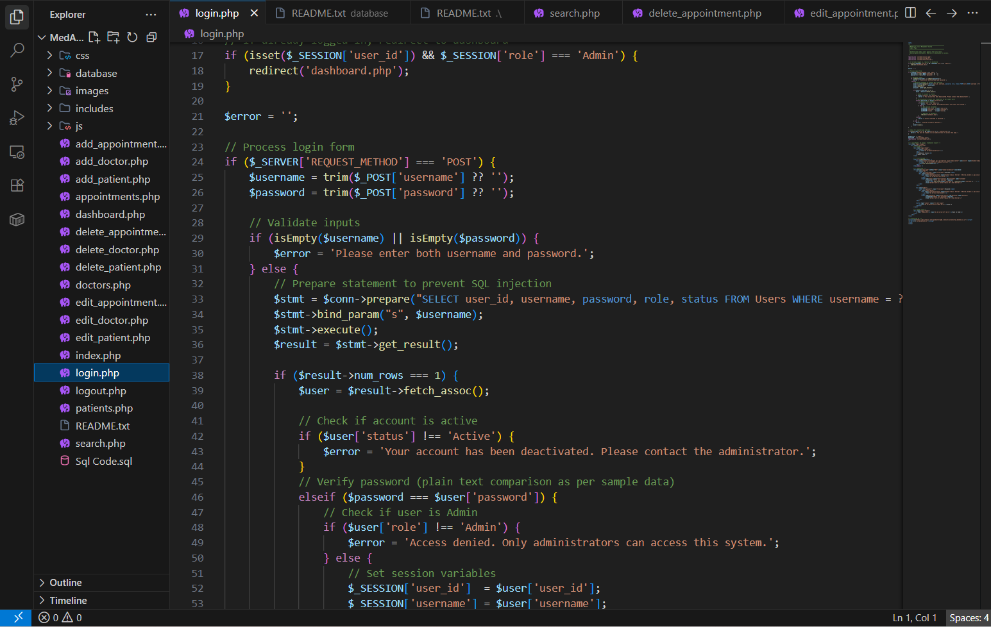
Figure 1 Vulnerable SQL Query

3. SQL Injection in the Website
The MedAssist Clinic Management System allows users to input data in multiple pages, such as Login, Search, Add Patient, Edit Patient, Add Doctor, and Appointment Booking. These inputs could be entered into SQL queries if they were not sanitized, allowing an attacker to run malicious SQL code and compromise the database [8]. The website employs prepared statements, parameter binding and input validation on all database operations to avoid this risk. These security features guarantee that the data entered by the user is only used as data, and not as SQL code to be executed. Figure 2 displays the Login page and the Search page, both of which have been secured to prevent SQL Injection attacks to the application [2].
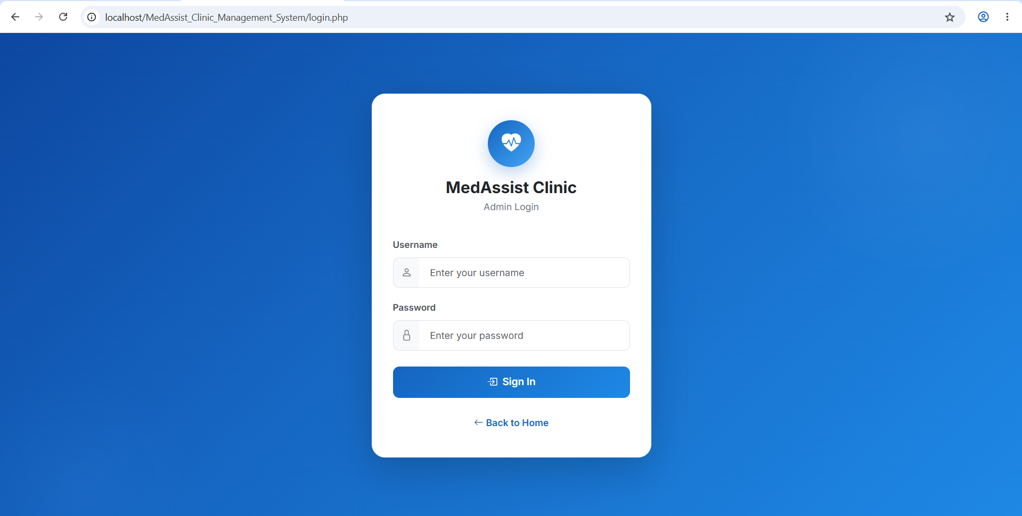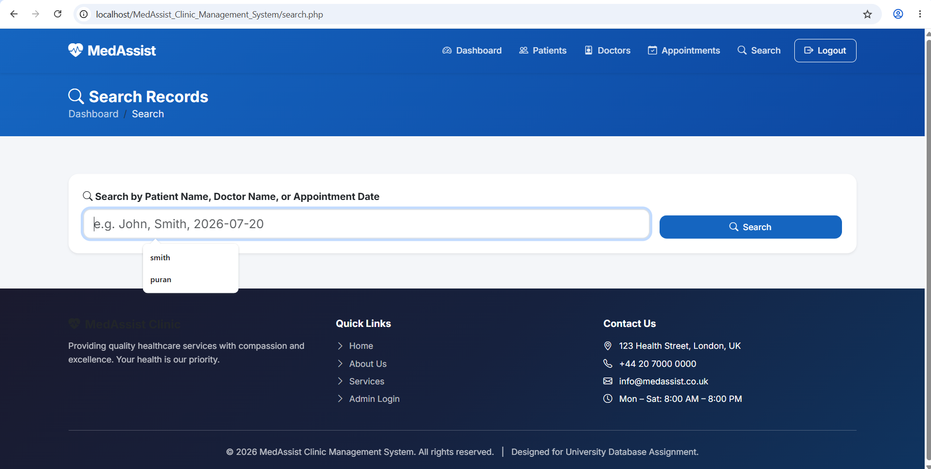
Figure 2 Login Form and Search Page

4. Anti-SQL Injection Implementation
The MedAssist Clinic Management System uses the following security techniques to prevent SQL Injection attacks. Firstly, all database queries are prepared statements and user input is treated as data not SQL. Parameter binding securely passes the user value(s) into the SQL statement, thereby avoiding the risk of SQL code being executed. Input validation is also made a part of the system, ensuring that the required fields are filled and that there are no unnecessary spaces in the input that are to be removed [7]. Session authentication guarantees that protected pages are only accessible to authenticated administrators, thus lowering the risk of unauthorized access. Furthermore, htmlspecialchars() is used to allow the application to prevent the rendering of malicious content in the browser when the output is displayed. This is the Prepared Statement in the login process, as shown in figure 3, and the input validation and execution of Prepared Statement to process the user credentials securely [3].
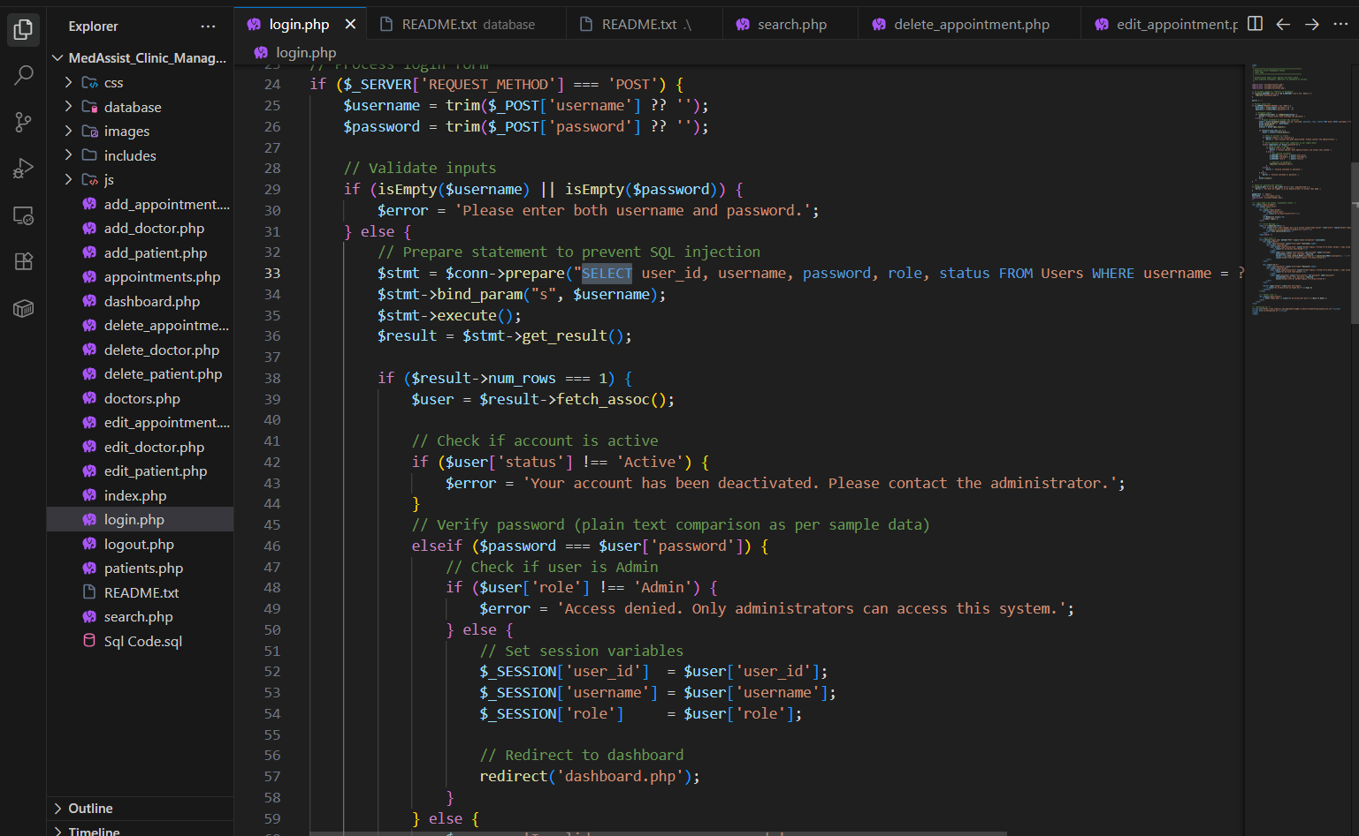
Figure 3 Login prepared statement

5. SQL Injection Testing
A SQL Injection test was performed on the login page of the MedAssist Clinic Management System with the input ' OR '1'='1' to verify the security of the system. The expected outcome was that the person would not be allowed to sign in to the system [9]. The application returned an "Invalid username or password" message as seen in Figure 5 and a successful unauthorized login did not take place. This verifies that the prepared statements and input validation methods were effective in thwarting SQL injection and preventing the database from being compromised by a malicious SQL query [5].
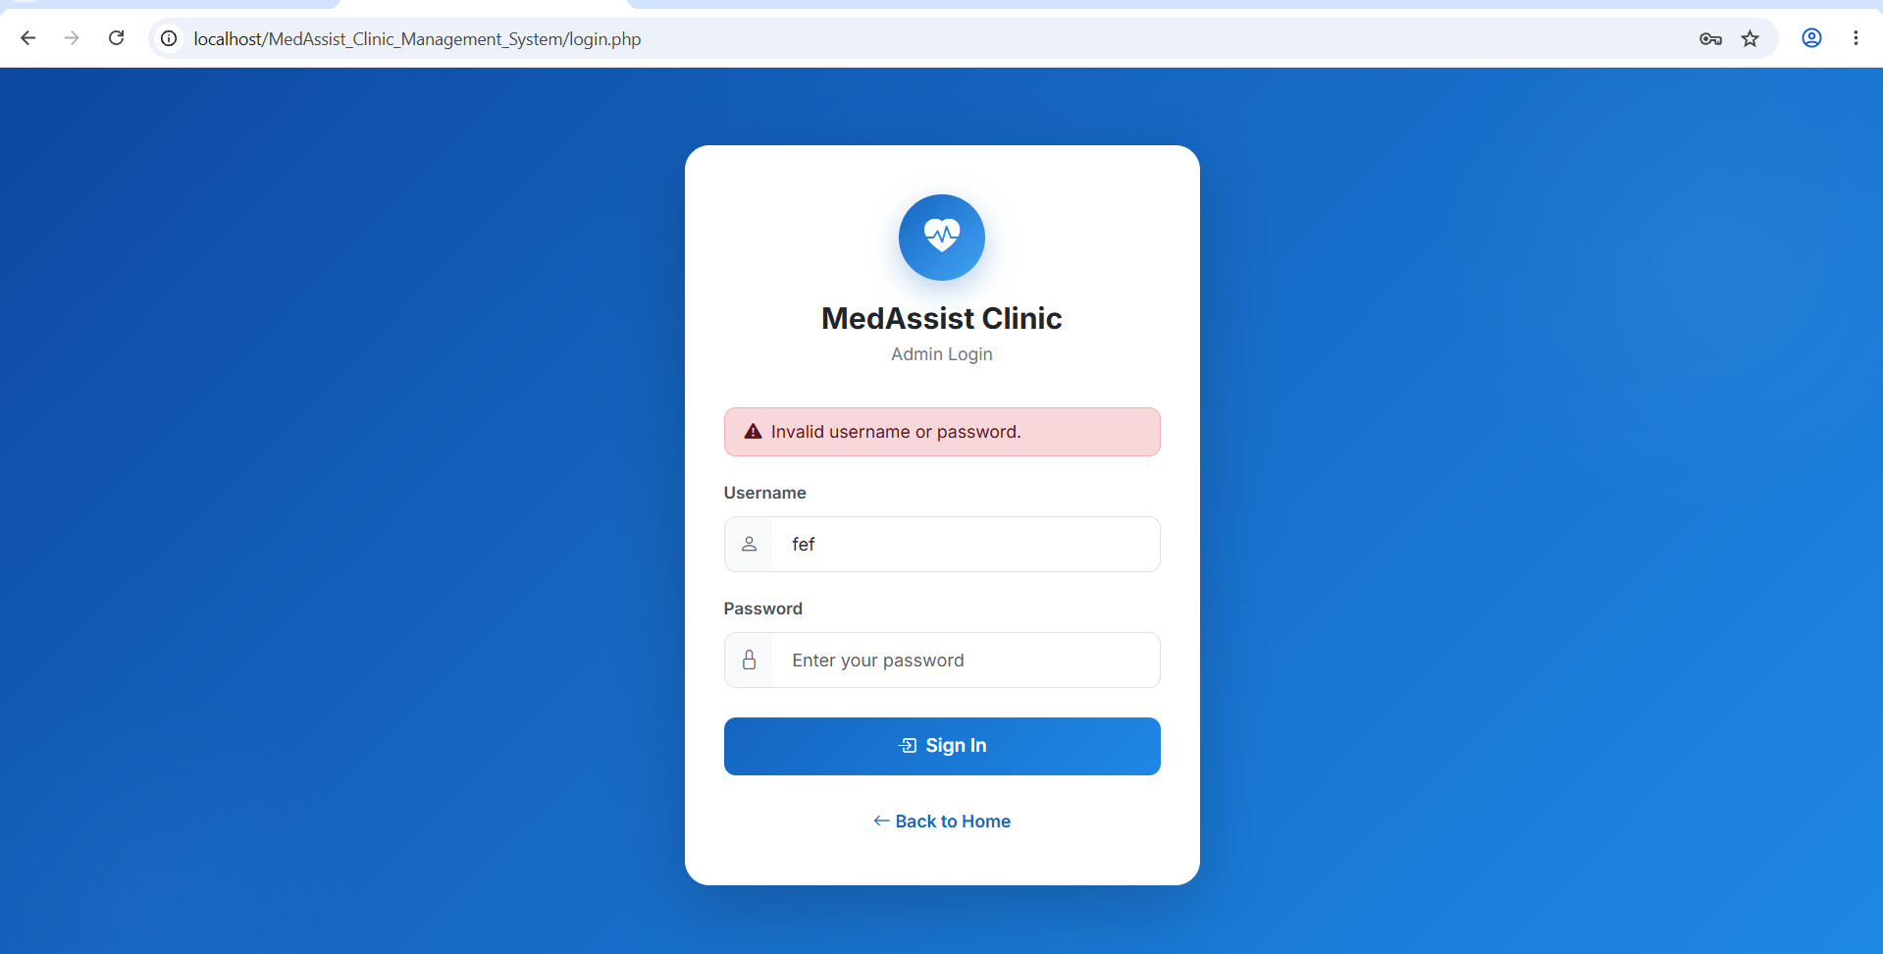
Figure 4 SQL Injection Attempt and Blocked Result

6. Conclusion
SQL Injection is a major security issue in web applications. The MedAssist Clinic Management System mitigates this risk by implementing prepared statements, input validation, and session authentication, all of which enhance the security of data access and safeguard user information.

References
- Abdullayev, V. and Chauhan, A.S., 2023. SQL injection attack: Quick view. Mesopotamian journal of Cybersecurity, 3(1), pp.30-34.
- ALAHMAD, M., ALKANDARI, A. and ALAWADHI, N., 2022. Survey of broken authentication and session management of web application vulnerability attack. Journal of Engineering Science and Technology, 17(2), pp.0874-0882.
- AVCI, İ. and DOĞAN, E., 2024. WEB APPLICATION SECURITY: DETECTION AND MITIGATION OF VULNERABILITIES. In 10th INTERNATIONAL NEW YORK CONFERENCE ON EVOLVING TRENDS IN INTERDISCIPLINARY RESEARCH & PRACTICES (pp. 491-508).
- Basil, N.N., Ambe, S., Ekhator, C., Fonkem, E. and Nduma, B.N., 2022. Health records database and inherent security concerns: A review of the literature. Cureus, 14(10).
- Boateng, F., 2025. SQL Injection Techniques and Mitigation Strategies: a study using OWASP Mutillidae II.
- Fadlalla, F.F. and Elshoush, H.T., 2023. Input validation vulnerabilities in web applications: Systematic review, classification, and analysis of the current state-of-the-art. IEEE Access, 11, pp.40128-40161.
- Hoffman, A., 2024. Web application security. " O'Reilly Media, Inc.".
- Ketema, A., 2022. Developing SQL injection prevention model using deep learning technique (Doctoral dissertation, St. Mary’s University).
- Rahayu, S.B., Ahmad, A. and Rashid, S.H.Z., 2022, November. Defensive programming: Developing a web application with a secure coding practices. In AIP Conference Proceedings (Vol. 2617, No. 1, p. 050006). AIP Publishing LLC.
- Sotnik, S., Manakov, V. and Lyashenko, V., 2023. Overview: PHP and MySQL features for creating modern web projects.

Appendix

Application Screenshots


