Critical Reflection

Introduction
The previous report identified Swansea University’s goals and targets concerning sustainability and questioned if they go far enough, whilst also identifying how the plan could go further in particular areas. The sustainability plan that followed concentrated on one aspect of the universities goals and proposed an event to support local businesses and people in the community post lockdown. It specifically looked at community engagement post pandemic, and the universities role in proactively working toward a positive relationship with local businesses and people. In this critical reflection, I will be examining if the plan goes far enough, how it has or could affect the organisational structure, staff buy-in, nature as a stakeholder and if Swansea University could become a sustainability leader within the HE industry.

Universities in general have an important responsibility in transforming societies, whilst in particular contributing to the development of a more sustainable future due to the fact they are an educational institution (Barth and Rieckmann 2012). Universities teach diverse subjects and educate future leaders in their respective fields, but it must go further than just the subject matter. Sustainability must be taught across the board, absorbed into every subject in some manner, to equip future decision makers with the knowledge to make sustainable decisions. Marullo and Edwards (2010) ask the question; should students be made aware or how their subject or service helps, or hinders, the issues surrounding sustainability and climate change? Armed with knowledge, students can help to shape the future.

One of Swansea University’s community schemes was ‘room to grow’ – a plan to transform the frontages of student HMO’s into urban allotment for growing in season fruit, vegetables and herbs. The idea was to be run in partnership with the local council and a local café - Hoogahs. The idea was pleasing to the university, as much of the complaints that are received through the community team are due to untidy frontages. This would solve that problem, allow green growth, whilst also selling back to the local café who would buy and sell the foods. The idea was circular – and very promising. The idea failed due to the unsteady relationship with the local community, which could be solved through the series of proposed events in the previous plan, contributing to a greener and more prosper future.

Sheffield University have pledged to introduce sustainability into every course, whether it be engineering, English or music. The change will begin in five years’ time (from 2020) and will introduce modules on global warming, poverty, gender discrimination and more, all within their respective fields. Subject departments will teach their curriculums through a sustainable lens, opposed to compulsory lectures solely focused on the climate crisis. Students are determining the way they want to be taught and are pressuring universities for a greener curriculum. This is encouraging for universities. However, universities must go beyond student desires and will need to measure how they affect business, environment and society on a local and regional level.

Wider impact on the business, environment and society
The previous sustainability plan recommended a twice-yearly event post-lockdown (and when safe) which is aimed initially to support local community and local businesses who have suffered during the pandemic. Nottingham University held a successful ‘boost your business’ event to promote the businesses in the local area. Supporting local people and businesses is important, not only to promote positive relationships, but it can also enhance the universities reputation.
Marullo and Edwards question if community work organised by universities and their students empowers the receivers. If Swansea University is to go further than just providing an event for the community, they will need to empower local people and businesses. This is justice work, rather than charity work. Justice work is, generally speaking, more sustainable, as it educates and encourages on a longer-term basis, so people will be able to ‘meet their own self determined needs’ (Marullo and Edwards, 2000). This is of utmost importance when you look at holding an event for the community that supports local people and businesses. Reflecting on this statement, the event(s) would need to go further than just providing a platform for businesses and enjoyment for people. Whilst the idea is promising to encourage an improved relationship with the local community, the initiative could have benefited from further inclusion of sustainable initiatives. In reality, the university holding events is not enough, further support to businesses and people would greatly benefit the local economy. Using the universities resources, there could be ongoing business support – perhaps from business and marketing students working on projects in conjunction with the local businesses. This would also improve the student community relationship which can often be challenging, due to the difference in lifestyles living in close proximity to one another. Collaborative effort across the board is required, from internal departments and external partners to local community and businesses.

Aside from supporting the community from now into the future, there are other issues surround the idea; it could be argued that the plan is one dimensional and does not incorporate the larger climate issues – such as energy usage and waste, as it solely focuses on events to support the local community and business. However, the plan could lead to sustainable communities in the future and therefore in the longer term would have an impact on the larger issues such as energy usage and waste. Sustainability is multi-level; and whilst this suggested event only concentrates on one part of the cause in the initial stages, as the event grows and evolves it would do so into the green . Incorporating sustainability on multiple levels will be important for the future of the event, but introducing green initiatives slowly, whilst also supporting the businesses growth is paramount for the community to trust the university and work in unison.

Nature as a stakeholder
When defining what a stakeholder is, there are many descriptions. For this critical reflection, we are following the definition that a stakeholder is a person or party with a particular interest in something, usually a business, whilst also taking into account who or what is affected by the business or interest. Generally, it is not widely recognised that nature is a stakeholder, so is it time we recognised it as one? And how do we convince leaders in the supply chain to acknowledge it is?

Stakeholder analysis tend to view organisations as operating within a social and economic network, but nothing beyond this (Laine, 2011). All human activities are ultimately dependent on the natural environment (Stead and Stead 1996) and “the natural environment should be taken into account by all human organisations” (Driscoll and Starik, 2004).
If we do not place nature as a stakeholder, nature’s demise will continue to threaten business. The World Economic Forum produces a global risk report annually, looking at the threats to our economy within the next 10 years. There are five categories to this report, one being environmental risk:
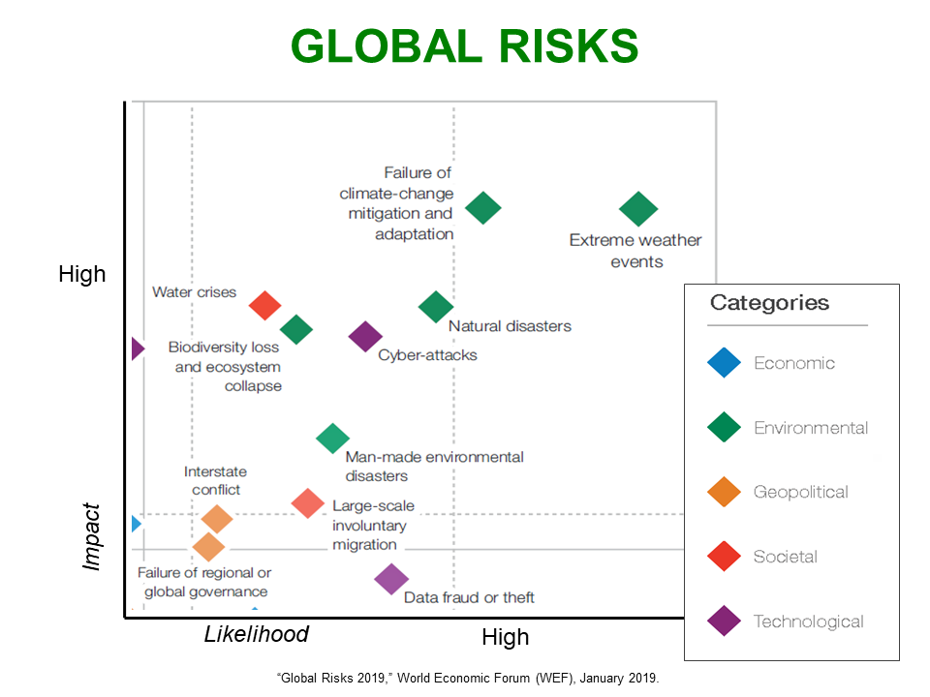
Image from the World Economic Forum showing the Global Risks – dated 2019

Recognising nature as a stakeholder is extremely important in the current, almost unpredictable, climate. In turn it can affect people all the way down the supply chain. If we do not contribute to a more sustainable future, we are instead contributing towards a more unreliable planet. Our actions ultimately effect nature – as seen by extreme weather we are having. Do we go further to include these people in the stakeholder analysis as a biproduct of the effect of climate change on nature? The impact of extreme weather events affects people all over the world, from forest fires in Australia, to dangerous flooding in China and India. Even locus swarms in Africa, ruining vegetation and crops estimated to be worth around 8 billion dollars, has been linked to climate change. Some financial losses are happening due to climate change and so the question is when, not if, Swansea University (and the HE sector in general) will be affected in some capacity. Another driver for sustainable change in the workplace and reason to recognised nature as a stakeholder.

Organisational structure
Often, organisational structure is seen as a barrier in regard to change within the system. This is no different when applied to sustainable change. In fact, there may be more resistance with internal sustainable change if communication with employees is not well executed. Successful interactions with staff is paramount to changing organisation structure (Soderstorm and Weber 2019). Their research proves the importance of sustainable advocates within the organisation. If these roles promote processes to the middle and lower levels, there is a much higher success rate for change in the business.

If we look further into the previous plan, we can estimate the impact this twice-yearly event could have on various departments in the university, most notably the internal community liaison team, as well as procurement. But we must ask the question, should this already be a part of the roles of these employees? If sustainability (inclusive of staff and community wellbeing) is the goal, shouldn’t roles slightly change within the structure to fulfil these initiatives? The finance department is in control of nearly all purchases, even other departments within the university need their purchases approved via the finance team. When purchasing goods or services, there are some guidelines to follow; if below £1,000 only one quote is needed, between £1,000 and £10,000 three quotes are needed and anything above £10,000 three quotes plus a business plan is required. There is no sustainable initiative within these guidelines, the price is the determining factor. Soderstorm and Weber’s research shows that bringing departments together to discuss greening the purchasing process encouraged both departments – employees left feeling positive. This research shows how communication is a significant part of changing organisation structure and keeping staff encouraged and positive about changes within their department.
The previous plan could have gone further than just community engagement, by also including staff engagement, or at least inviting staff to these events, the university would connect more so with its employees.

Swansea University have various good initiatives in place, with an internal sustainability team providing ongoing work towards the cause of a greener organisation. But the department (made up for 12 full-time staff) alone cannot do enough sustainable work without the assistance of the rest of the cohort - the university is made up of nearly 3,500 full-time staff in total. To reach all staff, especially on an individual basis, would take up time and resources. Staff may need to be communicated to as groups in the initial stages to reach all employees, and then looked at in smaller teams. To remind staff of Swansea Universities values and greener initiatives, there should be plenty of visual reminders around campus. For example, recycling bins around campus, rental bikes on show and promotional posters of awards won by the university.

Staff buy in
Initiatives of any kind can somewhat be received with some form of resistance from employees. Sustainability is a broad term, and it encompasses a great deal underneath its umbrella. Initially narrowing the focus to a few elements of sustainability can be a starting point to educate and encourage employees to a greener future. This gives a much clearer idea of Swansea Universities values which staff can revert back to when making decisions.
Sustainability is more than reducing our individual footprint, it is interlinked with some of the planet’s biggest issues, for example social justice. Communicating this message is important for employees to understand the gravity of sustainable actions. There is however a degree of responsibility from educators in this field not to overwhelm staff. Information overload could discourage employees; sustainability encompasses many different areas, as previously mentioned in this critical evaluation, and therefore is important to break these down into manageable chunks.

Swansea University has a sustainability network in place that can be utilised for further efforts in greening the organisation. This can be done by using the already appointed environmental leads from each department to communicate to their colleagues in their respective teams to help shape the conversation around the sustainability initiatives - empowering staff. The sustainability department could create a questionnaire, asking staff for suggestions on what they would like the university to do to make environmentally friendly changes. Therefor letting staff be a part of the process, shaping the conversation around a greener workplace.

It could be argued that sustainable courses should be in place for all staff as mandatory, it is important to educate employees with the knowledge and competence to make better decisions in the workplace. Helping employees to understand why sustainability is now critical in the workplace. Rather than creating new rules to follow, educating staff to make their own decisions shows the company trusts their employees. However, if courses are mandatory this will need to be monitored by some team or department – using extra resources. The courses could also face resistance if they are forced for staff. The question is, how to get staff to buy in to sustainable initiatives off their own accord?

Creating healthy competition within the workplace is a popular way to engage employees in Swansea University’s sustainability journey. Swansea University could create a webpage to gather information from staff about goals they have hit, from how they travelled to work, how many steps they have done, if they have brought their own food, do they turn they computer off at lunchtimes etc. – all of which carry points. The university can also monitor electricity usage for each room and calculate average usage per department. Once the information is collated and points counted, departments could win monthly prizes for most sustainable team.

Swansea University as a sustainability leader within the HE sector
Climate change is increasingly showing itself in the environment – from forest fires to melting ice caps to rising sea levels. The planet is struggling to flourish, and unless humans act now, there is growing evidence to show it will be difficult to fix the problems in which we ourselves have caused. In this light, it is irresponsible to ignore environmental and social justice and not think it wise to teach the future generations and decision makers about sustainability. Here lies the importance of sustainability within the HE sector. Not only through educating students, but also staff, community and beyond. However, we must look at how this is managed now, and how it can be appropriately managed and measured going forward.

With the growing research showing the impacts of universities on society and beyond, Marullo and Edwards (2010) believes ‘transforming higher education to transform society’. But the question begs, how do we monitor universities impact and manage the reporting structure?

There have been a number of declarations and charters taken to incorporate sustainability into higher education. See graph below for timeline of initiatives between 1972 and 2009:

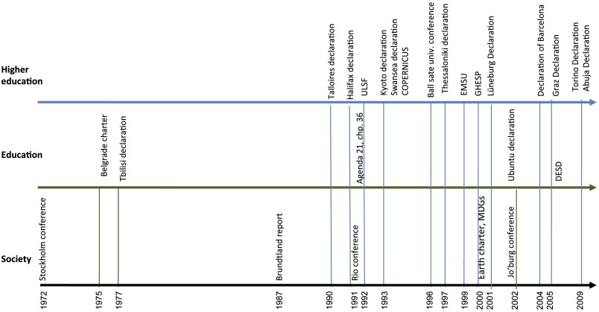 Image from Journal of Cleaner Production: The evolution of sustainable development milestones within education.

These initiatives were created to provide higher educational institutions with guidelines to implement and improve sustainability within their organisation.

Swansea University has made good progress according to their published reports over the past few years, furthering their goals once they have been reached, and adding new when appropriate. However, there is always room for improvement and further growth.

Filho (2010) listed four goals for universities to achieve to improve upon their sustainability initiatives:
- Holistic approach to sustainable initiatives, embedded in social, economic, biological and ecologic issues whilst in turn enhancing education to students and the quality of research from subject areas
- The importance of encouragement in particular with conservation among all those attached to the university (students, staff, community etc.)
- Education to staff in all departments so they are best equipped to make sustainable decisions and better use of the universities resources or purchases through supply chains etc.
- Lastly, Filho states the importance of sustainability courses for staff and students within the organisation. Raising awareness of Environmental Conservation policies and the regulations to further employee knowledge

It is important to note that even though there are government strategies for greening universities, there are no strict rules for universities to abide by - just targets to aim for. HE institutions create their own goals, and these can look different within each institution (with the same underlying theme of sustainability). Universities are however required to monitor and submit their carbon emissions on an annual basis to the Higher Education Statistics Agency which does contribute to some accountability. “National strategies need to be translated into institutional targets” – Open University.

A report published by People and Planet, a student led grass roots organisation who campaigning for social and environmental justice ranks the sustainability of universities in the UK annually. People and Planet published their last report in 2019 (no 2020 report took place due to the pandemic) ranking 154 universities is the UK; Swansea University placed 9th overall. Their report takes into consideration the following:
- Policy and strategy
- HR for sustainability
- Environmental auditing and management systems
- Ethical investments
- Carbon management
- Employees rights
- Sustainable food
- Staff and student engagement
- Education for sustainable development
- Energy resources
- Waste and recycling
- Reducing carbon emissions
- Water preservation

Whilst an extensive list, there can be debate in which sections should be worth more than others. It is also important to note that if they cannot find the information on the field, they will mark it a zero.

In reality, it is hard to truly judge how sustainable one university is in comparison to another due to the ever-changing landscape and complexity of the subject. That being said, People and Planet have shown to update their requirements as and when appropriate. For example, this year was the first time they assessed universities on whether the allowed migrants to access university, which is in line with Sustainable Development Goals four.
I think Swansea University could become a leader in the HE sector. Swansea Universities current climate status and their future goals in the sustainability sector, along with their awards of recognition of work in the area show promise. However, to become a leader in the industry, Swansea University need to reach further than their current goals and trajectories. To become the sustainable university that others aspire to be, they will need to demonstrate their hard work and commitment whilst also putting students and staff at the forefront of their plans.

References

Driscoll, C., & Starik, M. (2004). The primordial stakeholder: Advancing the conceptual consideration of stakeholder status for the natural environment

Filho, W. About the Role of Universities and Their Contribution to Sustainable Development. High Educ Policy 24, 427–438 (2011).

Laine, M. The Nature of Nature as a Stakeholder. J Bus Ethics 96, 73 (2010).

Leal Filho, W. (2010b) ‘Teaching sustainable development at university level: current trends and future needs’, Journal of Baltic Sea Education 9 (4): 273–284.

Marullo, S. and Edwards, B. (2000) ‘From Charity to Justice: The Potential of University-Community Collaboration for Social Change’, American Behavioral Scientist, 43(5), pp. 895–912.

McGrath, M. (2020). Climate change: Extreme weather causes huge losses in 2020. Available: https://www.bbc.co.uk/news/science-environment-55416013. Last accessed February 2021.

Niedlich, S, Kummer, B, Bauer, M, Rieckmann, M, Bormann, I. Cultures of sustainability governance in higher education institutions: A multi‐case study of dimensions and implications. Higher Educ Q. 2020; 74: 373– 390

People and Planet. (2019). University League. Available: Tatum, M. (2020). 'We deserve to be taught about it': why students want climate crisis classes. Available: https://www.theguardian.com/education/2020/sep/28/we-deserve-to-be-taught-about-it-why-studen. Last accessed February 2021.

Rodrigo Lozano, Rebeka Lukman, Francisco J. Lozano, Donald Huisingh, Wim Lambrechts,
Declarations for sustainability in higher education: becoming better leaders, through addressing the university system, Journal of Cleaner Production, Volume 48, 2013; Pages 10-19

Soderstrom SB, Weber K. Organizational Structure from Interaction: Evidence from Corporate Sustainability Efforts. Administrative Science Quarterly. 2020;65(1):226-271.

Stead, W. E., & Stead, J. G. (1996). Management for a small planet (2nd ed.). Thousand Oaks: Sage.

Tatum, M. (2020). 'We deserve to be taught about it': why students want climate crisis classes. Available: https://www.theguardian.com/education/2020/sep/28/we-deserve-to-be-taught-about-it-why-students-want-climate-crisis-classes. Last accessed February 2021.

https://www.theguardian.com/education/2020/sep/28
World Economic Forum
BBC News
United Nations
Lozano et all 2013
https://peopleandplanet.org/university-league

