

BA (Hons) Business Management
Student Name: Stefanita Cosmin Calarasu
Student Number: 2328896
Course Name: LCBB5015 Principles of Marketing

Assignment Title: Component 1: Individual Coursework Report on Marks & Spencer (M&S)
Session:
AI Acknowledgement
I confirm that I have not used any AI tools in the research and creation of this assignment. I confirm that I have not presented any AI-generated materials as my own work. I confirm I have copies of my drafts, notes, and other resources I used, which I may be asked to provide in evidence.

Table of Contents
1.0 Introduction 3
2.0 Situational Analysis 3
3.0 Critical Analysis and Evaluation 5
4.0 Conclusion 6
Reference List 7

1.0 Introduction
Marks & Spencer (M&S) is a very popular retail brand in the UK. The product portfolio usually includes home products, personal care products, clothing, and food items. M&S has approximately 380 stores and 46 websites all over the world (Marks and Spencer, n.d.a). It is considered one of the leading British retailers, which promises quality and value (Marks and Spencer, n.d.a). M&S is also known for its trusted customer service, which has offered a competitive advantage to the business against rivals such as Tesco, Sainsbury's, and more. Therefore, the main aim of this study is to understand how external factors and different situations impact M&S and their marketing decisions. Even though the business has a marketing team dedicated to excellence, this study focuses on a situational analysis to understand how the business is currently positioned. This helps identify areas requiring improvement. Also, the SWOT analysis provides a better understanding of the internal and external forces impacting M&S. Therefore, the main idea in this case is to understand how the brand can strengthen its position in the market and ensure future growth.

2.0 Situational Analysis
Strengths (S)  - Popular brand image.  - High-quality products (Marks and Spencer, n.d.a).  - Ensured the durability of the products.  - Loyal customer base. | Weaknesses (W)  - High prices of the products.  - Heavy dependence on the UK outlets.
Opportunities (O)  - Increasing demand for online shopping (Le et al., 2022).  - Opportunities to expand into emerging markets. | Threats (T)  - Intense competition in the retail market (John et al., 2023).  - Frequently changing behaviour of the customers (Chowdhury et al., 2024).  - Changes in market trends.
Table 1: SWOT Analysis
As mentioned in the SWOT analysis, the brand image of M&S is very strong in the UK retail market. The company has been consistently providing value and quality to customers, which has improved the brand image of M&S (Marks and Spencer, n.d.a). M&S has been in operation since 1884 and started from Penny Bazaar to establish the brand as a global retailer (Marks and Spencer, n.d.b). Therefore, it has been in the strategic core of the business to maintain quality and consistency to keep the customers loyal. A loyal customer base is also another legitimate strength of the brand to survive the changes in the retail market. Strong loyalty among brands supports repeat purchases and decreases customers’ behaviour of switching.
However, some weaknesses need attention in the strategic plan. The products of M&S are more expensive than those of the other rivals. For example, the standard loaf of oatmeal, which is 800 grams of sliced bread, is around 75p in M&S (Which, 2023). The same thing is priced, on average, around 45p across Aldi, Lidl, Sainsbury's, Tesco, and more (Which, 2023). Similarly, baked beans are priced at 50p at M&S, whereas they are priced, on average, between 27-28p in Tesco, Sainsbury's, Morrisons, Asda, and more (Which, 2023). Therefore, it is quite clear that in comparison to its rivals, M&S is quite expensive. The second most challenging factor for the business is that it is quite dependent on the UK market. As of now, there are more than 227 full-line stores all across the UK (Marks and Spencer, n.d.c). This indicates that the majority of the business is in the UK, which makes the operations quite dependent on the region.
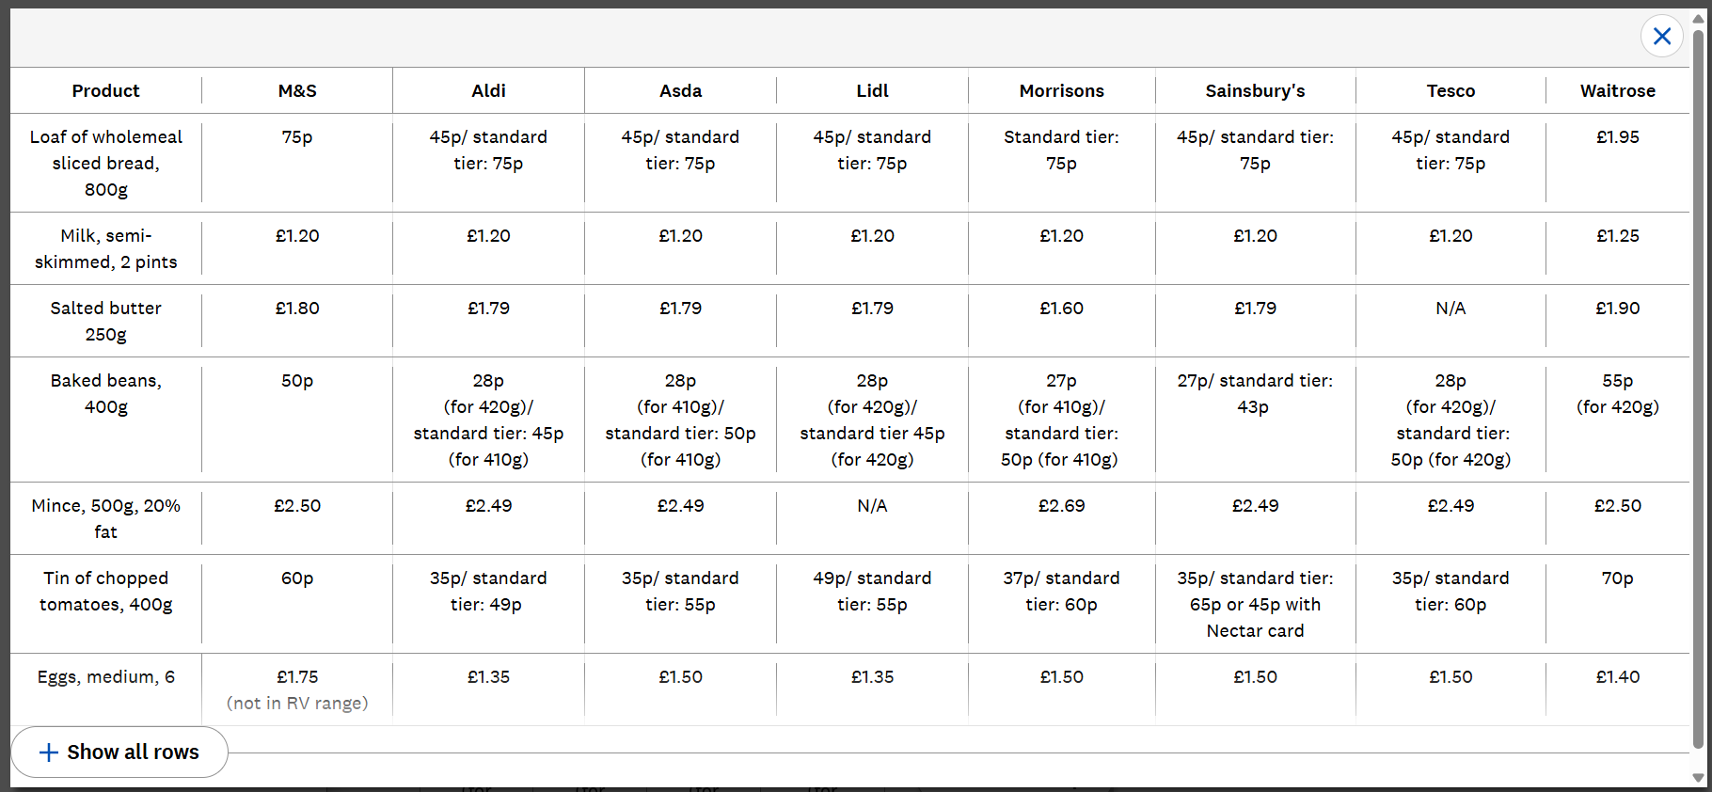
Figure 1: Price Comparison Between M&S and Its Rivals
(Source: Which, 2023)
However, there are also plenty of opportunities in the UK market that the business can take advantage of. Firstly, the rise of e-commerce and the online market has become very strong in the UK (Verbivska et al., 2023; Rose et al., 2024). The majority of people like online shopping privileges as they can compare the prices and the products to make an accurate purchase (Sin et al., 2025; Berends and Gerpott, 2025). Digital channels form opportunities for targeted promotions and personalised engagement among customers. Secondly, there is also scope for market expansion for M&S since it is mainly focused on the UK retail market, and the customer requirements are frequently changing. Internationalisation could increase sales and reduce dependence on the UK market, and support the growth of the market share. There are also potential threats from high competition. It is especially intense as the rivals maintain standard pricing and M&S fails to do so. Also, customer preferences in the retail sector are constantly changing as market trends change (Kalashnikova et al., 2023). This makes it difficult for companies to stick to strict strategic approaches. However, exploring different markets can be a good opportunity for the brand.

3.0 Critical Analysis and Evaluation
The situational analysis in this case identified that M&S is a globally recognised brand; therefore, it has a very strong impression on the UK market for continuously maintaining value and quality in its products. However, in contrast, the high prices of the products make its position less competitive in the market in comparison to rivals like Tesco, Sainsbury's, Aldi, Lidl, and more. Despite that, due to its product assurance, M&S has a very large and loyal customer base, which is important for long-term success. As per the Resource-Based View (RBV) theory, it is important for a business to have valuable competencies and resources that cannot be easily imitated by rivals (UYANIK, 2023; Komakecha et al., 2025). These resources present sustainable differentiation when competitors principally compete through the aspect of price. This essentially brings a competitive advantage to a business. It should also be the focus of M&S, where the company needs to improve its market position, besides maintaining customer trust. One of the most prominent industry examples would be Tesco, which consistently maintains affordability without compromising product quality or value (Tesco Plc, n.d.). Therefore, there should be continued focus on quality and brand reputation, but also strategic decisions at M&S should improve the pricing strategy to gain more market leverage.

4.0 Conclusion
It can be concluded through this report that despite having a very strong brand image and loyal customer base, M&S struggles to accurately plan its pricing strategies, which leaves it behind its rivals. Therefore, one of the suggestions to the company would be to improve its online presence and continuously optimise its pricing without compromising quality. SWOT analysis provides evidence-based decisions for marketing and long-term strategic planning. Situational analysis in this case has been quite important to understand how M&S is positioned in the retail sector against other companies and what would be done to improve its strategic approaches.

Reference List
Berends, J. and Gerpott, T.J. (2025) ‘Exploring price tolerance in online retail: A comparative analysis of price comparison website use and repeat purchases’, Electronic Commerce Research, 25(4), pp. 3165-3185.
Chowdhury, S.N., Faruque, M.O., Sharmin, S., Talukder, T., Al Mahmud, M.A., Dastagir, G. and Akter, S. (2024) ‘The impact of social media marketing on consumer behaviour: A study of the fashion retail industry’, Open Journal of Business and Management, 12(3), pp. 1666-1699.
John, J.M., Shobayo, O. and Ogunleye, B. (2023) ‘An exploration of clustering algorithms for customer segmentation in the UK retail market’, Analytics, 2(4), pp. 809-823.
Kalashnikova, T., Panchuk, A., Bezuhla, L., Vladyka, Y. and Kalaschnikov, A. (2023) March. ‘Global trends in the behaviour of consumers of retail enterprises in the digital economy’, In IOP conference series: Earth and environmental science (Vol. 1150, No. 1, p. 012023). IOP Publishing.
Komakecha, R.A., Ombatib, T.O., Kikwathab, R.W. and Wainainab, M.G. (2025) ‘Resource-based view theory and its applications in supply chain management: A systematic review’, Management Science Letters, 15, pp. 261-272.
Le, H.T., Carrel, A.L. and Shah, H. (2022) ‘Impacts of online shopping on travel demand: a systematic review’, Transport Reviews, 42(3), pp. 273-295.
Marks and Spencer (n.d.a) About Us - Marks & Spencer. Available at: https://corporate.marksandspencer.com/about-us (Accessed: 14 June 2026).
Marks and Spencer (n.d.b) Our History. Available at: https://corporate.marksandspencer.com/about-us/our-history (Accessed: 15 June 2026).
Marks and Spencer (n.d.c) Our Property Requirements - Marks & Spencer - M&S. Available at: https://corporate.marksandspencer.com/about-us/our-properties (Accessed: 13 June 2026).
Rose, D.E., Van Der Merwe, J. and Jones, J. (2024) ‘Digital marketing strategy in enhancing brand awareness and profitability of e-commerce companies’, APTISI Transactions on Management, 8(2), pp. 160-166.
Sin, R., Harris, T., Nilsson, S. and Beck, T. (2025) ‘Dark patterns in online shopping: do they work and can nudges help mitigate impulse buying?’, Behavioural Public Policy, 9(1), pp. 61-87.
Tesco Plc (n.d.) Core Purpose and Values. Available at: https://www.tescoplc.com/about/how-we-do-business/core-purpose-and-values/ (Accessed: 16 June 2026).
UYANIK, M. (2023) ‘Resource-based view in marketing literature’, Journal of Business and Management Studies, 5(4), pp. 29-39.
Verbivska, L., Zhuk, O., Ievsieieva, O., Kuchmiiova, T. and Saienko, V. (2023) ‘The role of e-commerce in stimulating innovative business development in the conditions of European integration’, Financial and credit activity-problems of theory and practice, 3(50), pp. 330-340.
Which (2023) M&S comeback: 5 M&S facts that may surprise you. Available at: https://www.which.co.uk/news/article/marks-and-spencer-facts-that-may-surprise-you-ac4Gi8A9VXFd (Accessed: 12 June 2026).

