Redevelopment of the Central Transport Hub
Student: Tiberiu Anghel
Student No. : 2422970
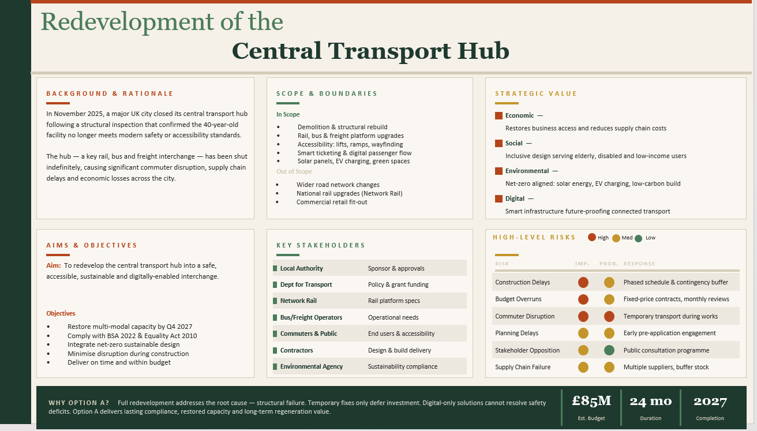
Part A: Poster

Part B: Reflective Commentary on Poster Feedback
TUTOR AND PEER FEEDBACK ON PART A
You have produced a well-structured and visually engaging poster that clearly justifies the redevelopment of the central transport hub. The proposal effectively addresses the project background, aims, scope, stakeholders, risks, and strategic value, while demonstrating a good understanding of sustainability, accessibility, digital transformation, and long-term urban regeneration. The inclusion of measurable objectives, a risk table, and a clear justification for selecting the redevelopment option strengthens the proposal.
To strengthen the work, the project objectives could be made more explicitly SMART by including additional measurable performance indicators beyond timescales. Greater application of project management tools, such as a stakeholder power-interest matrix, Work Breakdown Structure (WBS), or governance framework, would further demonstrate project management knowledge. Expanding the discussion of risks and trade-offs with more detailed mitigation strategies and supporting academic references would also improve the academic depth of the poster.
Overall, this is a strong poster that meets the assessment requirements effectively. The professional presentation, clear structure, and good application of project management concepts place the work within a strong merit to distinction standard.

The feedback above given to the Part A poster, is the reason for this reflection and the basis of the changes made to the Project Management Plan (in Part C).

Strengths Confirmed by Feedback
- Clear, well-justified case for full redevelopment (Option A) over interim alternatives
- Strong coverage of background, aims, scope, stakeholders, risk and strategic value
- Effective use of measurable objectives and a colour-coded risk table
- Overall placed at a strong merit-to-distinction standard
Areas Identified for Improvement
- Objectives only partially SMART — few measurable indicators beyond timescale
- Missing formal tools: stakeholder power-interest matrix, Work Breakdown Structure, governance framework
- Risk discussion lacks likelihood, ownership and supporting academic literature
How the Feedback Shaped the Final Plan
Each gap above is addressed directly in Part C, so the plan moves from a persuasive pitch toward an auditable delivery document that a real Programme Board could act on:
- SMART objectives — measurable KPIs added (interchange-time reduction, accessibility audit pass rate, carbon reduction), alongside the existing timescale, so every objective is quantifiable rather than only date-bound
- Power-interest matrix — Mendelow (1991) matrix added, replacing the flat stakeholder list with a defensible, tool-based engagement structure that ties reporting frequency to each stakeholder's actual influence
- Work Breakdown Structure — five-level WBS added, linking every work package to a named resource owner and, in turn, to the Gantt chart and budget
- Risk depth — full risk register added with probability, impact and ownership for each entry, grounded in Chapman and Ward (2003) and PMI (2019) rather than one-line responses
A governance strand is also introduced, clarifying decision rights between the Local Authority sponsor, the Department for Transport funder and the delivery contractor — an area implied as missing from the original stakeholder section. Together, these additions shift the plan's emphasis from justifying the choice of project, which the poster already does well, toward demonstrating how that choice is delivered and controlled.

Part C: Project Management Plan

- Introduction
The central transport hub stopped operating in November 2025 when a structural inspection revealed that the nearly forty-year-old combined rail, bus, and freight depot was not up to current safety and accessibility requirements. This plan outlines the implementation of full redevelopment (Option A) which is the option defended in Part A as it deals with the structural issue rather than the delaying of investment via temporary or even digital-only solutions.
- Project Description
The main transport hub stopped operation in Nov 2025 after a structural assessment showed that the forty-year-old railway, bus and freight terminal was not safe. The plan here is the full redevelopment of the hub (Option A). It is only one that the paper justified in Part A as a resolution to the structural issue whereas the others are simply pushing off investment via a temporary or digital-only solution. Traditional methods of project planning, including scope definition, work-breakdown structures (WBS), quad charts, a Gantt chart, stakeholder analysis, resource allocation and risk management, will change that strategic rationale into the schedule that is an auditable document, because a project management plan serves as the document controlling delivery against which it is later checked.
Local Authority provides funding to the programme, the co-funding being a grant from Department for Transport. A design-and-build contract involves a single contractor (the principal contractor) being responsible for the design, construction, systems integration and accessibility of the project. This minimizes the design-construction interfaces risks. The capital is estimated at £85 million. The project will last for 24 months, and the completion date is the second quarter of 2027.
Full development was selected for several reasons. It is the only option that tackles the structural problem. The temporary, digital-only or net-zero-only scenarios have none of the capability of the whole redevelopment to tackle the underlying structural problem on their own; each one is a partial solution or a repeat of the capital that is finally going to be spent. Now objectives are expressed as targets with measures rather than dates alone:
● Restore multimodal traffic volume by the end of December 2027
● Pass an independent disability audit with a score of 100%. (The Disability Equality Act and the New Safety Buildings Act)
● Passenger interchange time to be on average 20% less than before closure
● Embodied carbon in the whole life cycle of the building to be reduced by at least 30% compared to that of a building conventionally rebuilt (Transport Authority, 2021)
● Cost of construction not to exceed the estimated budget which is around £85 million and not to go under or over by more than 5%.

- Scope
Establishing a clear boundary can help prevent the uncontrolled expansion of scope within a public project of this magnitude (Larson and Gray, 2021).
The deliverables within the boundary are organized into five categories that align with the Work Breakdown Structure from Section 4 which allows the scope statement, schedule and budget to remain consistent and not become independent documents that might get out of sync during implementation.
Category | Detail
In scope | Demolition and structural rebuild; rail/bus/freight platform upgrades; accessibility infrastructure; smart ticketing and passenger-flow systems; solar, EV charging and green space.
Out of scope | Wider road network changes; national rail upgrades (Network Rail); commercial retail fit-out.
Table 1: Scope boundary.

- Work Breakdown Structure (WBS)
Package | Key activities | Owner
1. Design & Planning | Concept/detailed design; planning application; sign-off | Design lead
2. Enabling Works | Utilities diversion; site clearance; demolition | Site manager
3. Construction | Structural rebuild; platforms; accessibility fit-out | Construction lead
4. Systems & Digital | Smart ticketing; sensors; signalling interface | Digital subcontractor
5. Handover | Testing; regulatory sign-off; reopening | Local Authority lead
Table 2: Work Breakdown Structure, levels 1–3.
Each package connects to a schedule activity in Section 6 and a resource owner in Section 8. This way, the plan has one common foundation rather than separately maintained documents that might easily drift apart.
- Quad Chart
Quadrant | Content
Statement | Redevelop the hub into a safe, accessible, sustainable, digitally enabled interchange.
Milestones | Design freeze m4 · Enabling works m7 · Rebuild complete m16 · Systems complete m21 · Reopening m24
Budget | £85m; ~10% design/fees; contractor + specialist subcontractors; central contingency
Top risks | Delay · Overrun · Disruption · Supply chain (Section 9)
Table 3: Quad chart summary.
- Gantt Chart
Phase | Months | Notes
Design & Planning | 1–4 | Runs with early consultation
Enabling Works | 4–7 | Utilities, partial demolition
Construction | 6–16 | Overlaps platform works from m12
Systems & Digital | 16–21 | Ticketing, sensors
Handover | 21–24 | Testing, sign-off, reopening
Table 4: Gantt chart summary.
When phases are overlapping it is a signal about fast-tracking as in case dependencies would allow one can compress the schedule (Turner, 2014). The trade-of more intensive contractor coordination taking place on a restricted worksite enters the risk register.

- Stakeholders’ Involvement
Quadrant | Stakeholders | Engagement
Manage closely | Local Authority; DfT; principal contractor | Monthly steering board; variance sign-off
Keep satisfied | Network Rail; Environmental Agency | Compliance reviews at design gateways
Keep informed | Commuters; business; operators | Consultation programme; newsletter
Monitor | Wider public | Publicly available updates
Table 5: Stakeholder power-interest matrix.
A Programme Steering Group (Local Authority/DfT/contractor) situated above the matrix determines design and handles change requests. In the meantime, a Community Liaison Committee takes in local opinions through the public consultation process but is not entitled to any approval powers. Having the accountable and the consulted stakeholders like that can be quite helpful in major public development projects since mixing them together would lead to loss of the checking role of a non-affected decision maker (Association for Project Management; 2019; Freeman, 1984). It also shows to any stakeholder, whether they can approve a change to scope, cost or time because of their input or whether they are merely consulted before the decision is taken elsewhere.
- Allocation of Resources
Category | Share of £85m | Resource
Design & fees | 10% | Contractor design team, consultants
Enabling works | 12% | Site team, utility companies
Construction | 45% | Construction team, subcontractors
Systems & digital | 15% | Digital subcontractor
Contingency | 18% | Held centrally by Programme Board
Table 6: Resource and budget allocation.
HM Treasury's Green Book suggests an optimism-bias allowance to be part of a centrally held contingency rather than a split over different packages. Such approach makes most sense for public infrastructure projects at program level or above. This provision would give the Programme Board a single pool which could be released on risk triggers without going for separate buffers held by contractors each of whom had visibility at level lower than that of the program level.

- Risk Analysis
Risk | Prob. | Impact | Response / Owner
Construction delay | Medium | High | Phased float; delay-cost clause. Owner: contractor.
Budget overrun | Medium | High | Fixed price; monthly review; contingency. Owner: LA finance.
Commuter disruption | High | Medium | Temporary transport pre-agreed. Owner: LA transport lead.
Planning delay | Low | Medium | Early pre-application engagement. Owner: design lead.
Stakeholder opposition | Medium | Medium | Liaison panel; consultation. Owner: engagement team.
Supply chain failure | Medium | High | Multiple suppliers; buffer stock. Owner: procurement lead.
Table 7: Risk register.
Construction delay and budget overrun are both considered high-impact issues. Hence, contracts and financial arrangements are used to manage them rather than simply leaving a safety margin in the planning. Commuter disruption may seem only a medium-impact issue, its probability is, however, high because that hub is a major interchange point; hence, a temporary transport arrangement is agreed upon with the operators before the actual construction starts rather than dealing with the problem after the disruption has already started. Risks are reviewed on a monthly basis; whenever a risk moves to a high-probability, high-impact position, a mandatory response update is required no later than five calendar days after which it occurred, the purpose is mainly to maintain a dynamic document rather than having an initial one-off risk register at the beginning of the project (Project Management Institute, 2019).

- Risk Analysis
The Part A strategy gets turned into an audit-compliant model that includes:
- clear-cut scope;
- WBs packages assigned to owners;
- build schedule 24-month Gantt;
- stakeholder matrix showing who does what to whom;
- resource allocation with the central budget that is reserved as a contingency;
- risk register that is kept to date;
This solution targets two areas that the feedback highlighted were most in need of improvement: the lack of tools for project management and the provision of risk analysis only in words. Besides that, instead of focusing on setting time frames as objectives only partially, the technique leads to full SMART compliance of all objectives. In this way, the program aims to re-develop the central interchange within £85 million budget as a minimum and within a time frame of 24 months, and fulfil at the same time all required standards for safety, accessibility and transport net-zero that the Department for Transport has set (Department for Transport, 2021).

References (Harvard style)
Association for Project Management (2019) APM Body of Knowledge. 7th edn. Princes Risborough: Association for Project Management.
Bourne, L. (2016) Stakeholder Relationship Management: A Maturity Model for Organisational Implementation. 2nd edn. Abingdon: Routledge.
Chapman, C. and Ward, S. (2003) Project Risk Management: Processes, Techniques and Insights. 2nd edn. Chichester: John Wiley & Sons.
Department for Transport (2021) Decarbonising Transport: A Better, Greener Britain. London: HM Government.
Freeman, R.E. (1984) Strategic Management: A Stakeholder Approach. Boston: Pitman.
HM Government (2010) Equality Act 2010. London: The Stationery Office.
HM Government (2022) Building Safety Act 2022. London: The Stationery Office.
HM Treasury (2022) The Green Book: Central Government Guidance on Appraisal and Evaluation. London: HM Treasury.
Kerzner, H. (2017) Project Management: A Systems Approach to Planning, Scheduling, and Controlling. 12th edn. Hoboken, NJ: John Wiley & Sons.
Larson, E.W. and Gray, C.F. (2021) Project Management: The Managerial Process. 8th edn. New York: McGraw-Hill Education.
Mendelow, A.L. (1991) 'Stakeholder mapping', Proceedings of the 2nd International Conference on Information Systems, Cambridge, MA.
Meredith, J.R., Mantel, S.J. and Shafer, S.M. (2017) Project Management: A Managerial Approach. 10th edn. Hoboken, NJ: John Wiley & Sons.
Office of Rail and Road (2023) National Rail Infrastructure: Performance and Investment Report. London: Office of Rail and Road.
Project Management Institute (2019) The Standard for Risk Management in Portfolios, Programs, and Projects. Newtown Square, PA: Project Management Institute.
Project Management Institute (2021) A Guide to the Project Management Body of Knowledge (PMBOK® Guide). 7th edn. Newtown Square, PA: Project Management Institute.
Turner, J.R. (2014) The Handbook of Project-Based Management. 4th edn. New York: McGraw-Hill Education.
Winch, G.M. (2010) Managing Construction Projects. 2nd edn. Chichester: Wiley-Blackwell.

