Tamara Szantai
Module: Personal resourcing and development
Student number: 2026358
Lecturer: Kathryn Roberts
Title of the assignment: Research project proposal
Content page
Cover page ……………………………………………………………………...1
Content page ……………………………………………………………………2
Introduction…………………………………………………………………....…3
…………………………………………………………………………………….4
Employee engagement……………………………………………………...….5
…………………………………………………………………………………….6
…………………………………………………………………………………….7
Measuring employee engagement ………………………………………..….8
…………………………………………………………………………………….9
Conclusion…………………………………………………………………..….10
Reference list……………………………………………………………….….11
…………………………………………………………………………………..12
…………………………………………………………………………………..13

Introduction

Marriott County Hall Hotel is a part of the Marriot group. Situated in London, in prime location near to Waterloo station on the South bank. Only a couple of minutes’ walks from London eye (www.marriott.com,n.d.). This luxury hotel has 228 bedrooms, conference rooms and library. Also, there is a fitness center and indoor pool for the perfect relaxation of the guests. It is a fabulous hotel in the beautiful location, but something is missing because employees leaving instead to stay and build carriers and engage with the company. That is not only contribute to labour issue but, lack of service in the hotel. Sometimes people leaving without any hesitation. The reason can be long hours, late shifts, short staff, lack of transparent opportunities to progression (Hospitality and tourism workforce. Annex, 2019). One of the current challenges the report will focus is the staff shortage, and the employee turnover in the hotel. This problem has a considerable influence on the employee morale and engagement in the organisation. Something must be changed and improved. To find and retain new employees is a big challenge, especially after the UK left the European union. With the Brexit the free movement has changed, there are visa requirements in place which means new workforce from overseas are in not good situation to come (James, 2021). UK largest pub group Mitchells & Butlers confirmed that they lost over nine thousand employees because of the Brexit. It was a huge loss for the hospitality sector. 30 % of the hospitality industry in UK were from the European union. (Butler, 2021). To attract and retain the new workforce with the right skills is hardest than ever. Attracting and convincing new people to join the team is needed to recover for longer terms the hospitality section (Caterer.com, 2021). The Marriott County Hall Hotel must focus on new methods, to be more flexible and to recognise their staff. To show gratitude towards their work. To ask them what they would like to achieve, give them promotions, and pay them well. Every person is different, so everyone needs an individualistic type off support and approach (Terry, 20202). Managers need to put the employees on the first place which is not always happening in the hotel industry. If this would be accomplished they would pay it back with good work (Kurtzman, 2017). Communication strategy is an important aspect on what the managers need to pay attention. Using employee surveys, questionnaires doing meeting can help to keep up the team. Sometimes only enough to actively listen someone to thank them for their work.
Employee engagement
Employee engagement in hotel industry is specifically important topic, because if the personnel is engaged, they will be going to provide the best service they can. This will make the costumer happy and more likely them to recommend a hotel of their choice to the friends and family, therefore they will help the hotel to gain new guest and gather a world of mouth type recommendation (Tamigo, 2021). Most of the managers understand the importance of the employee engagement, but very few can pay direct attention on it. The employees need to understand the company core values and mission to build firmer connections. Understanding how they contributing to this will give them a feeling of importance and motivation. Deloitte Insights research shows that mission driven organisations have 40% higher retention in place, because they passionately focusing on the keen sense of purpose. Providing appropriate training is equally important as it helps the employees feel about work with confidence. Recognising and rewarding the staff also has a positive impact on the employee engagement. It can happen in diverse ways, extra day off or early leave on weekends or any type of team building, or staff party can be a particularly clever idea (Castrillon, n.d.). The little connections will add up, it is important to have friends at work Claudia Williams explains in her Ted talk ( www.youtube.com, n.d.). Teamwork will have a positive impact on the employee engagement and on the people creativity. People should be friends at work and honest with each other’s, discuss things and happenings. Say to each other what they need to hear not they want to hear. Presenting mission to the people and purpose more than materialistic return, will motivate the enthusiastic individuals and they will have a high level of engagement toward work. Another major element of the employee engagement practices is to create a flexible and supportive workplace. No one lives is easy so everyone will appreciate if they can be off on the days they need it or if they can use the pool in the hotel or the gym or have a free mail on their shift (Delloite Insights, n.d.). People with distinct characteristics have various levels of engagements. Adaptable individuals find it easier to engage. The most common drivers of the engagement are recognition and opportunities, receiving rewards, understandable meaning of purpose, possibilities to have open two-way communications, development opportunities and encouraging guidance. The given work from the engaged employee benefits the workplace (Robertson-Smith and Marwick, 2009).

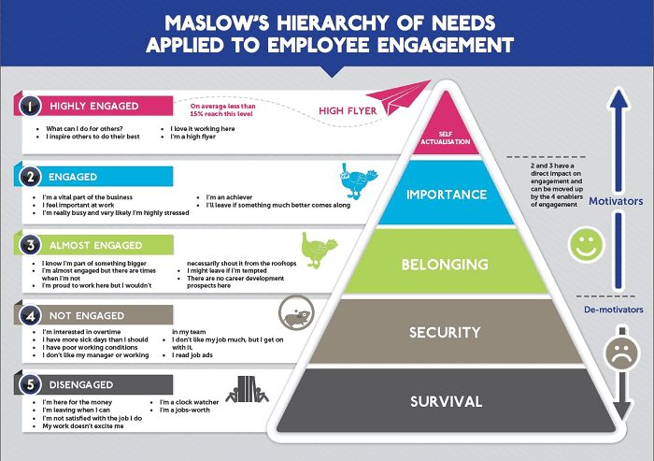

It is a five stage model reflecting the employee engagement levels and their needs, with a pyramidal structure.
(Amin, 2016)

Survival - Employees just working because of their basic needs to pay bills. This is a most basic need. These people are actively disengaged. They need attention and training to contribute for the higher goal of the organisation.
Security- Environment has impact on the employee how they feel, to perform they need to feel secured where they are. The people of this stage are not engaged. They needed to be looked after.
Belonging - This a is a third base which can not happen without the first two, the feeling of the trusting environment where people can progress and achieve results within the organisation. They know they belongs to something bigger, but they still not engaged.
Importance - Support and communication and direct relationship with managers are vital. The employees of this stage are engaged. They understand their role in the workplace, feeling important, but they would still leave if better job offer would come out

Self-actualisation – When this level is achieved the company can be assured that they achieved the most key point of their drive and that their employees highly engaged and contributing to the best possible work. Not only contributing, but inspiring others as well.

Maslow’s hierarchy of needs theory explains the five categories of the human needs determine of someone behaviour.

The needs are
- Psychological
- Safety
- Love and belonging
- Esteem
- Self-actualisation needs
(Cherry, 2022)

Measuring employee engagement
Measuring employee engagement with surveys deliver a way toward development and implementation of engagement strategies (Armstrong, M. 2014). Applying communication platforms in form of mobile apps showed improvement in the Watergate Hotel because it connected the different departments in the hotel. Real time communication was possible and smooth. Better communication between the day and night shift was built. Even introducing fresh staff members was easier (Beekeeper, n.d.). This is a tool which can benefit the Mariott county hall hotel going onward. Including staff surveys and questionnaires in widespread practice will most possibly help to boost the engagement. There is a different type of surveys, and they can give a management good knowledge about the engagement levels. They can be pulse surveys or annual engagement surveys. The annual engagement surveys are longer surveys and usually done once a year. These are limiting and way to slow according to Delloite. According to (Fuller, 2014) in this type of surveys the employees will not give honest answers, but something what is expected to be heard from them. This type of surveys would not be of too much help in this situation of the Mariott County Hall Hotel. Preferences and behaviours of the people are changing over the time. Pulse surveys are shorter. They are sent sometimes monthly, or in every couple of months questioning the employees to evaluate their wellbeing and their workplace (Boogard, n.d.). This type of survey is fast and people tend to be more happy to answer on the questions and being beneficial for boosting employee engagement and to gain information about the engagement levels (Mariya,2021). Although (Brown, 2020) explains that pulse surveys not the best way to measure the employee engagements, they are good to collect information and feedback in real time but shouldn’t be the only way used in the hotels. Having one on one type of meetings with the staff can be beneficial. Although not everyone is always ready to express their self in front of others. If they are the case, then both the employee and the employer or the manager need to be prepared with questions and arguments for this meeting. This type of meeting needs to be ideally a two wayed honest communication. Not only the employees progress can be discussed, but the performance and the personal development. Feedbacks work in both ways in this case, from the manager to the employee and opposite (Amin,2021). When someone gets feedback of their performance constantly, they are becoming attached to their work physically and emotionally. Employees will show positive attitude when they feel valued and heard. Activity in their contribution to work and develop innovative ideas will raise. Both the meetings and the monthly questionnaires can help to the company, and they need to be implemented. The benefit of them is the better knowledge of the employee engagement. Additionally focusing on the key subjects such as the motivation, communication, growth, and performance at work. Trying to motivate the employee and asking them what they would like to achieve in the organisation and try to accommodate their needs is especially important. Their answers will give understanding what can be accomplished for their happiness. Alternatively, the Marriott County Hall Hotel could use Gallup questionnaire to interview the hotel employees. The questionnaire covers twelve questions. These questions have proven to be efficient to measure employee engagement. According to Gallup group not only greater performance can be achieved when implementing these questions, but firmer connection between the employee and the manager can be achieved.
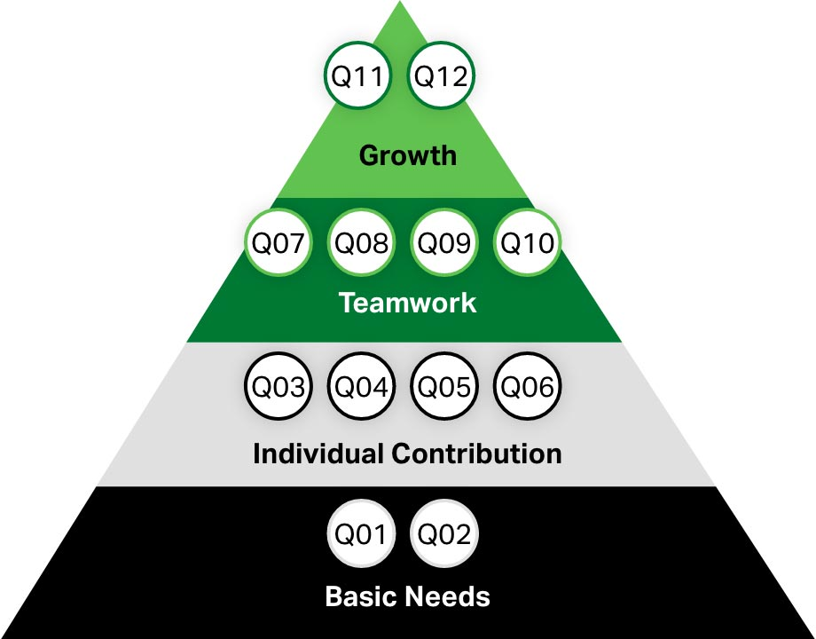

These levels are for the Mariott County Hall Hotel managers, to help to understand how they can develop and motivate their team. How can be the performance improved (Inc, 2021)
Conclusion
With the rising competitive levels in hotel industry, organisations must invest in their programs to boost employee engagement. Engaged employees are committing to the growth of the company, drives creativity and innovation, and reducing the employee turnover. Using correct approaches to train their staff and to equip the workplace with the suitable technology. Allows the employees to progress in their carriers and support them. Retain the workforce. Use appropriate software’s for optimal work and right communication. Embrace the technology and the tools available for them. Rethink about the way how they may measure the engagement. Measuring engagement on frequent basis is crucial for the organisation to gain knowledge about the engagement levels. For the Marriott County Hall Hotel recommended to use Gallup questionnaire because it has proven efficiency in many other organisations in the hotel industry. Using pulse surveys can be helpful, but the main focus should be on the Gallup questionnaire and on the relations between the managers and the staff. They are in same team and need to work together for the success of the company. As it explained in the Maslow’s hierarchy needs pyramid different people have unique needs. Therefore, to sustain lifelong employment the management really need to take care of the employees. Presenting them the Mariott County Hall Hotel core values, purpose, and mission. Showing gratitude for their work.

Reference list

Amin, H. (2021). 121 One-on-one Questions. [online] Hypercontext. Available at: https://hypercontext.com/blog/meetings/121-questions-for-one-on-one-meetings.
‌
Amin, H. (2016). The Employee Engagement Hierarchy: How It Works. [online] Hypercontext. Available at: https://hypercontext.com/blog/employee-motivation/employee-engagement-hierarchy.

Armstrong’s handbook of human management practice (11th edition) London
Michael Armstrong and Stephen Taylor
Accessed: file:///C:/Users/tamar/Downloads/Armstrongs%20Handbook%20of%20Human%20Resource%20Management%20Practice_1.pdf

Beekeeper. (n.d.). Beekeeper Tools Improve Guest Service Scores - Watergate Hotel. [online] Available at: https://www.beekeeper.io/blog/beekeeper-communication-tools-improve-guest-service-scores-at-the-watergate-hotel/ [Accessed 7 Jul. 2022].

Boogaard, K. (n.d.). How to Measure Employee Engagement. [online] employers.hosco.com. Available at: https://employers.hosco.com/blog/how-to-measure-employee-engagement [Accessed 7 Jul. 2022].
‌

Butler, S. (2021). ‘Quite a challenge’: UK restaurants and pubs face staffing crisis after Brexit. [online] the Guardian. Available at: https://www.theguardian.com/business/2021/may/01/uk-restaurants-pubs-brexit-staff-covid.
Brown, A. (2020). How to Measure Employee Engagement the Right Way. [online] www.quantumworkplace.com. Available at: https://www.quantumworkplace.com/future-of-work/the-right-way-to-measure-employee-engagement.

‌ Castrillon, C. (n.d.). 5 Ways To Develop And Sustain Employee Engagement. [online] Forbes. Available at: https://www.forbes.com/sites/carolinecastrillon/2022/02/27/5-ways-to-develop-and-sustain-employee-engagement/?sh=2b346d7d4a67 [Accessed 7 Jul. 2022].

Caterer.com. (2021). The impact of Brexit and Covid on the UK hospitality workforce | Caterer.com. [online] Available at: https://www.caterer.com/recruiter-advice/the-impact-of-brexit-and-covid-on-the-uk-hospitality-workforce#the-impact-of-brexit-on-hospitality-employment [Accessed 7 Jul. 2022].

Cherry, K. (2022). The Five Levels of Maslow’s Hierarchy of Needs. [online] Verywellmind. Available at: https://www.verywellmind.com/what-is-maslows-hierarchy-of-needs-4136760.
‌

‌ Deloitte Insights. (n.d.). Becoming irresistible: A new model for employee engagement. [online] Available at: https://www2.deloitte.com/us/en/insights/deloitte-review/issue-16/employee-engagement-strategies.html?fbclid=IwAR1-anBKg9oBvpfBOE-BRz8g8wOXiSaeuMAGdiCm0Krib2qp_UJ8R6k_nQI [Accessed 7 Jul. 2022].
‌

‌ Fuller, R. (2014). A Primer on Measuring Employee Engagement. [online] Harvard Business Review. Available at: https://hbr.org/2014/11/a-primer-on-measuring-employee-engagement?ab=at_art_art_1x4_s04.
‌
Hospitality and Tourism workforce landscape An annex to the research report mapping the sector workforce landscape for the Department for Digital, Culture, Media and Sport Hospitality and Tourism workforce landscape: Annex |. (2019). [online] Available at: https://www.economic-insight.com/wp-content/uploads/2019/10/DCMS-final-annex-13-06-19-STC.pdf.
‌
Inc, G. (2021). Gallup’s Q12 Employee Engagement Survey - Gallup. [online] Gallup.com. Available at: https://www.gallup.com/workplace/356063/gallup-q12-employee-engagement-survey.aspx.

James, W. (2021). The impact of Brexit on the hospitality sector; what’s the post-Brexit outlook? [online] Stint. Available at: https://stint.co/learning-hub/the-impact-of-brexit-on-the-hospitality-sector/.
‌
Kurtzman, J. (2017). Why is employee engagement in the hospitality industry important? [online] blog.rewardian.com. Available at: https://blog.rewardian.com/why-is-employee-engagement-in-the-hospitality-industry-important.
‌

Robertson-Smith, G. and Markwick, C. (2009). Employee Engagement A review of current thinking. [online] Available at: https://www.employment-studies.co.uk/system/files/resources/files/469.pdf.
‌
Terry, M. (2020). Employee Engagement and Retention – The Impact of Talent Management. [online] www.talkfreely.com. Available at: https://www.talkfreely.com/blog/employee-engagement-and-retention.
‌

www.marriott.com. (n.d.). Luxury Hotel London Westminster | London Marriott Hotel County Hall. [online] Available at: https://www.marriott.com/en-us/hotels/lonch-london-marriott-hotel-county-hall/overview/.

www.youtube.com. (n.d.). Frientorship: The Solution To The Employee Engagement Problem | Claudia Williams | TEDxPSU. [online] Available at: https://www.youtube.com/watch?v=IBHjUVFhFjA&list=PLUuBeOYGac-pkKmDwTc1S-MEytW-JnNj7&index=1&t=319s [Accessed 7 Jul. 2022].
‌

‌

