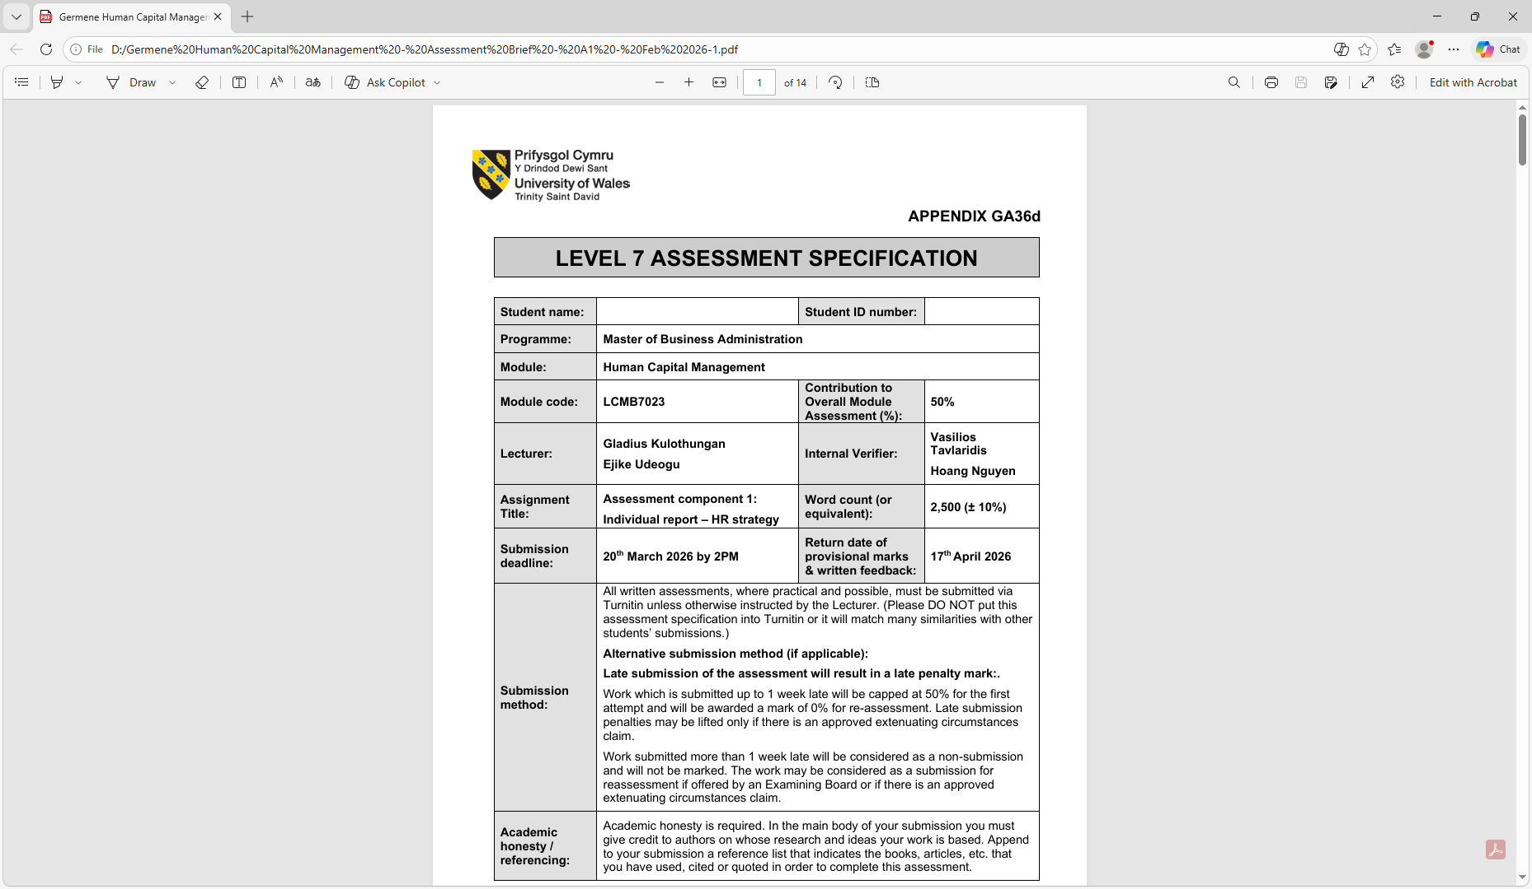

Master of Business Administration

Module: Marketing Management

Lecture Name : Mustakkima Afrim
Module code: LCMB7024
Student Number:2218041
Student: Germene Delfina

Assignment title: Assessment component 1: Marketing Environment Analysis

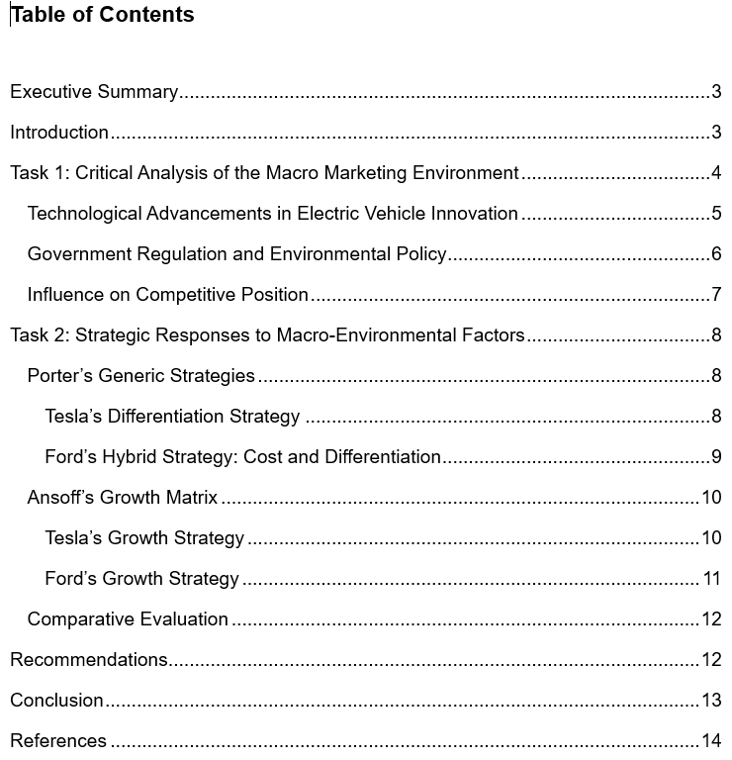

Executive Summary
This report critically investigates the macro marketing setting and its effect on strategic marketing management in the electric vehicle (EV) industry. Its efforts on two bodies functioning in the similar marketplace: the ground-breaking firm Tesla and the devotee firm Ford Motor Company. The aim of the report is to appraise how external macro-environmental factors generate opportunities and threats and how bodies retort tactically to keep competitive benefit.
The first part of the report explores two key macro-environmental players: technological improvement and government ecological law. Fast novelty in EV technology, battery change, and charging set-up has importantly changed the automotive industry. Tesla has profited from its early asset in electric vehicle technology and novelty, firming its competitive spot as a marketplace leader. In the other hand, Ford has confronted challenges familiarising from traditional internal burning engine cars but has gradually capitalised in electrification to keep on competitive. Ecological protocols intended at dropping carbon discharges have as well quicker worldwide EV implementation, making opportunities for both companies whereas augmenting pressure on traditional constructers.
The second part assesses the tactical retorts of both bodies utilising Porter’s Generic Approaches and Ansoff’s Growth Matrix. Tesla efforts on differentiation over technological novelty, whereas Ford implements a hybrid approach merging cost effectiveness and brand differentiation. These approaches determine how bodies familiarise to macro-environmental burdens to maintain long-term development.

Introduction
In current marketplaces, bodies function in multifaceted and quickly shifting settings that importantly affect tactical decision-making. The comprehension of the macro marketing setting is then a central element of efficient planned marketing management. External factors like change of technology, economic circumstances, political protocols, and socio-cultural trends outline the openings and threats confronted by bodies and eventually impact their aptitude to contest and maintain growing. As these factors lie beyond the direct control of companies, bodies need to continuously examine and retort tactically to keep on competitive in their industry.
This report critically investigates the macro marketing situation by exploring two companies working in similar industry: the ground-breaking company, Tesla, and the follower company, Ford Motor Company. Tesla is generally documented as a forerunner in the contemporary electric vehicle (EV) marketplace, driving novelty in battery technology, self-directed driving schemes, and direct-to-client sales models. Contrarily, Ford signifies a traditional automotive producer that has shadowed the marketplace change to electrification by presenting its particular choice of electric cars. Examining these two businesses offers understanding into how companies at different phases of marketplace leadership retort to external environmental burdens.
The report attentions on two main macro-environmental performers: technological development and government directive linked to sustainability and emissions. These factors have formed both openings and threats for automotive producers transitioning from inner burning engines to electric mobility. The examination explores how these external drivers impact the competitive aligning of Tesla and Ford inside the EV marketplace.
Building on this examination, the report assesses the strategic answers espoused by both companies utilising recognised strategic marketing structures, counting Porter’s Generic Strategies and Ansoff’s Growth Matrix, in line to measure how every business pursues to keep or reinforce its competitive benefit in a quickly developing industry.

Task 1: Critical Analysis of the Macro Marketing Environment
The macro marketing situation states to the comprehensive external factors that affect companies but keep on mostly outside their immediate control. These factors comprise political, economic, social, technological, environmental, and legal aspects that profile business dynamics and tactical decision-making. Examining the macro situation is then a vital constituent of planned marketing management since it allows companies to categorise developing opportunities and threats and familiarise their approaches consequently (Kotler and Keller, 2016).
In the worldwide automotive industry, the changeover from inner burning engine cars to electric vehicles (EVs) demonstrates how macro-environmental factors may redesign competitive dynamics. This part examines the above two companies operating inside the EV marketplace.

Technological Advancements in Electric Vehicle Innovation
Technological expansion is among the most important drivers renovating the automotive industry. Developments in battery technology, self-directed driving schemes, and charging infrastructure have quicker the implementation of electric cars universal. For Tesla, technological novelty has formed substantial chances that supported its competitive situation.
As a forerunner in the EV marketplace, Tesla capitalised seriously in battery technology, software addition, and charging set-up. The firm settled an exclusive charging connection and erected a wide Supercharger system to support EV implementation, making a solid ecosystem for its goods (Liu et al., 2025). This set-up benefit has reinforced Tesla’s distinction approach by improving client accessibility and firming brand devotion. Additionally, Tesla’s effort on self-directed driving technologies, for example its Autopilot scheme, establishes how technological modernisation may distinguish goods and position the company as a technological leader in the business (Vincent, 2018).
Though, technological growths as well generate threats for Tesla. As EV technology becomes more available, contestants are gradually capable to develop similar electric cars. This decreases Tesla’s first-mover benefit and strengthens rivalry in the EV marketplace. Traditional car manufacturer and developing EV producers are capitalising severely in research and growth, which has subsidised to falling marketplace share for Tesla in current years as contestants present new models and pricing approaches (Liu et al., 2025).
Concerning Ford, technological transformation originally characterised a danger since the firm historically concentrated on inner burning engine cars. The fast development of EV technology forced traditional producers to change their manufacture abilities and supply chains. Ford has had to capitalise seriously in electrification and battery technology to stay competitive in the developing marketplace. Though, technological developments as well-formed chances for Ford to enter the EV marketplace as a follower company. By leveraging present engineering know-how, supply systems, and brand status, Ford has been capable to present electric models and contest in the quickly escalating EV section.
Therefore, technological developments have redesigned competitive dynamics in the car industry. Tesla profits from its early technological leadership and modernisation abilities, whereas Ford pursues to close the technological gap over venture and strategic implemenbtation.

Government Regulation and Environmental Policy
Government strategies and ecological laws characterise additional main macro-environmental aspect affecting the EV industry. As governments pursue to lessen greenhouse gas discharges and fight climate change, severer emissions laws and motivations for electric cars have been presented crossways several worldwide marketplaces.
For Tesla, environmental law has mainly shaped important openings. The firm’s business model is erected on making completely electric cars that line up with government sustainability objectives. Policies for example emissions standards, EV supports, and zero-emission car orders have stimulated customers to approve electric cars and inspired request for Tesla’s products. Moreover, Tesla has created extra income by marketing controlling emission recognitions to other producers that struggle to encounter ecological standards (Autoweek, 2025).
Though, controlling environments may as well generate doubt and possible threats. Changes in government policy for example the elimination of EV supports or changes to emissions laws might decrease consumer motivations and negatively impact request for electric cars (Goover, 2025). Changes of regulatory might then affect Tesla’s long-standing productivity and market growth approaches.
Concerning Ford, ecological regulation firstly sits for a main threat. As a traditional car producer with a big portfolio of petrol and diesel cars, severer emissions standards needed important operational changes and asset in new technologies. Obedience with ecological laws frequently includes high growth costs and reorganisation of production schemes.
However, regulatory burden has as well-formed strategic chances for Ford. As governments enforce policies to quicken the changeover to low-emission transport, request for EVs is projected to rise importantly. By increasing its electric car portfolio, Ford may position its product offerings with governing needs whereas opposing in a quickly rising market section.
Therefore, government ecological law has played a vital part in determining rivalry in the EV industry. Tesla profits from regulatory position with its electric-only approach, while Ford need to familiarise its traditional business model to conform with developing ecological standards.

Influence on Competitive Position
The collaboration among technological novelty and government law has importantly affected the competitive situations of Tesla and Ford in the EV marketplace. Tesla’s early asset in EV technology and charging set-up has permitted it to create a robust brand uniqueness as an innovation leader. This first-mover benefit has assisted Tesla lead early EV implementation and keep a distinguished marketplace position.
Contrarily, Ford’s role as a follower firm needs it to retort tactically to technological and changes of regulations. Whereas the business profits from wide manufacturing abilities and worldwide brand recognition, it experiences the challenge of catching up with technologically cutting-edge EV players. Consequently, Ford’s competitive situation relies on its capability to successfully change from traditional cars to electric mobility.
In general, the macro marketing situation establishes how external factors may instantaneously generate opportunities and threats for companies. Technological modernisation and ecological laws have quicker the worldwide change to electric cars, strengthening Tesla’s ground-breaking position whereas obliging follower companies for example Ford to quickly familiarise their strategic strategies.

Task 2: Strategic Responses to Macro-Environmental Factors
Expanding upon the macro-environmental analysis from Task 1, both the leading organization Tesla and the subsequent organization Ford Motor Company have executed strategic solutions to maintain expansion in the swiftly transforming electric vehicle (EV) sector. Technological innovation and environmental regulation have transformed competition, necessitating those enterprises implement strategic marketing frameworks to sustain or enhance competitive advantage. This section assesses the strategies of both businesses with Porter’s Generic Strategies and Ansoff’s Growth Matrix.

Porter’s Generic Strategies
Porter’s Generic Strategies framework elucidates how businesses attain competitive advantage via cost leadership, differentiation, or focus strategies (Porter, 1985)

Tesla’s Differentiation Strategy
Tesla predominantly employs a broad differentiation strategy, emphasising innovation, cutting-edge technology, and cohesive ecosystems to set its products apart from rivals. The company highlights distinctive attributes including autonomous driving software, over-the-air updates, and a comprehensive worldwide charging infrastructure. These aspects generate considerable perceived value for customers and bolster Tesla's reputation as a technology leader (Panmore Institute, 2025).
Tesla benefits from vertical integration by overseeing a significant portion of its supply chain, encompassing battery development and software systems. This strategy improves efficiency, accelerates innovation, and elevates product quality, hence reinforcing its competitive edge in the EV industry (Teliance, 2025). Consequently, Tesla has successfully attracted technology-oriented consumers and sustained a robust market presence despite escalating competition.
Nonetheless, increasing competition from alternative EV manufacturers and diminishing market share in certain regions indicate that differentiation alone may not ensure sustained supremacy. Competitors are progressively embracing analogous technologies, diminishing Tesla's technological advantage.

Ford’s Hybrid Strategy: Cost and Differentiation
Conversely, Ford has implemented a hybrid strategy that integrates cost competitiveness with differentiation. As a follower organization, Ford utilises its extensive production skills and established brand reputation to produce electric vehicles at competitive pricing.
Ford's approach encompasses the introduction of electric variants of its renowned products, like the Mustang Mach-E and the F-150 Lightning. By electrifying established automotive brands, Ford mitigates consumer apprehension and expedites electric vehicle adoption among conventional car purchasers. This strategy enables the organization to distinguish itself through brand legacy while contending on pricing and availability.
Ford's strategy leverages economies of scale and a comprehensive dealership network, facilitating global car distribution and after-sales services that many emerging EV manufacturers find challenging to duplicate. Thus, Ford's strategy establishes the corporation as a formidable contender equipped to confront electric vehicle innovators.
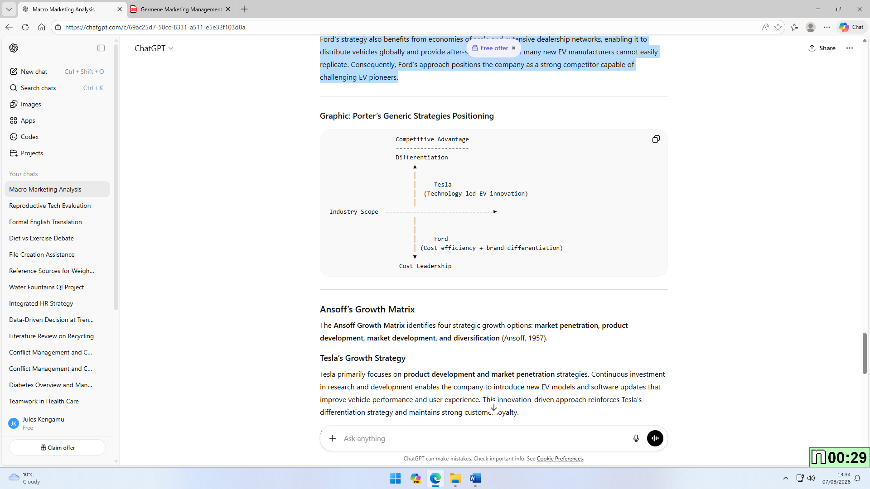
Source: AI (Chat GPT)

Ansoff's Growth Matrix
The Ansoff Growth Matrix delineates four strategic growth alternatives: market penetration, product creation, market development, and diversification (Ansoff, 1957).
Tesla’s Growth Strategy
Tesla primarily concentrates on product innovation and market expansion tactics. Ongoing investment in research and development allows the company to launch new electric car models and software enhancements that elevate vehicle performance and user experience. This innovation-centric methodology strengthens Tesla's differentiating strategy and sustains robust consumer loyalty.
Tesla engages in market development by entering new international markets and constructing giga-factories globally to enhance manufacturing capacity. This international expansion plan allows Tesla to access new client demographics while increasing production to save expenses.
Tesla has additionally pursued diversification, especially in energy storage and solar technology. This secondary strategy represents the company's overarching vision of sustainable energy ecosystems.
Ford’s Growth Strategy
Ford's growth strategy predominantly emphasises product development and market penetration. The corporation is significantly investing in electrification to enhance its electric vehicle portfolio and adhere to environmental requirements. The introduction of electric variants of established vehicle models enables Ford to engage current customers while penetrating the electric vehicle market.
Ford is actively pursuing market development by augmenting electric vehicle production in Europe and North America to satisfy escalating regulatory mandates and consumer demand for sustainable transportation.
In contrast to Tesla, Ford's strategy prioritises gradual transformation over radical innovation. As a follower organization, Ford adopts established EV technology while utilising its current competencies in large-scale car production.
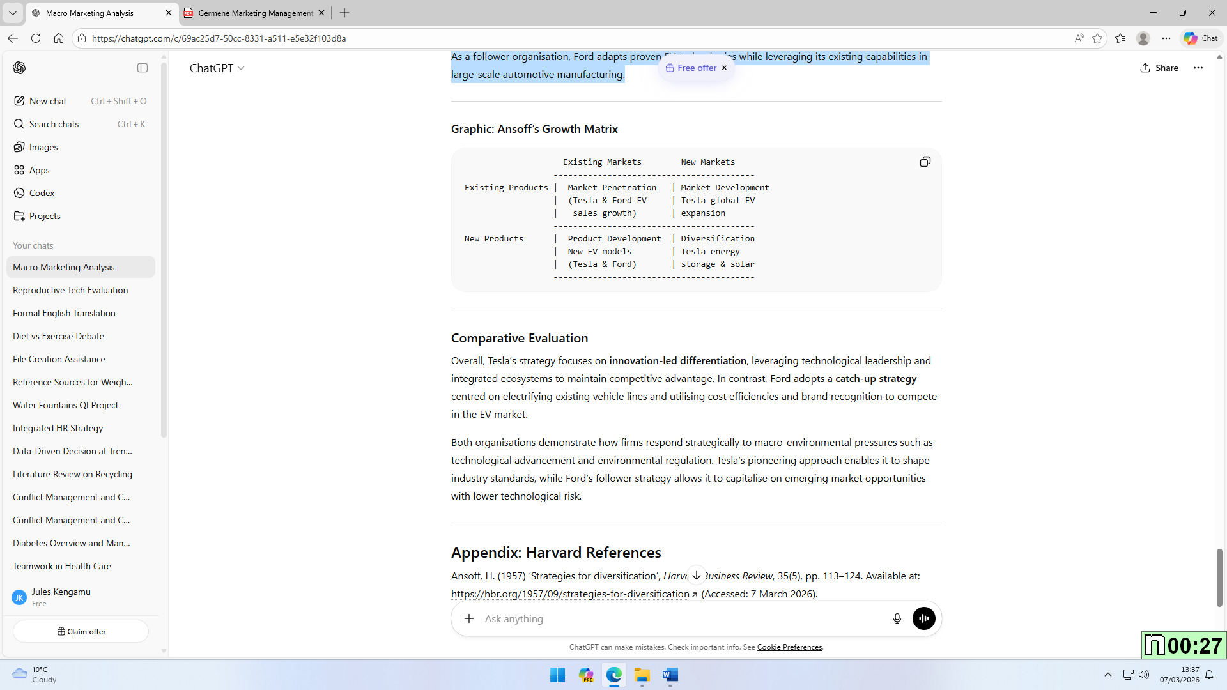
Source: AI (Chat GPT)

Comparative Evaluation
In general, Tesla’s approach efforts on novelty-led differentiation, leveraging technological leadership and combined ecosystems to keep competitive benefit. Contrarily, Ford implements a catch-up approach focussed on electrifying current car lines and using cost efficiencies and brand acknowledgement to contest in the EV marketplace.
Both firms determine how companies retort tactically to macro-environmental weights for example technological development and ecological law. Tesla’s ground-breaking strategy allows it to profile industry standards, whereas Ford’s follower approach enables it to capitalise on developing marketplace opportunities with lower technological threat.

Recommendations
Following a review of the macro marketing environment and strategic actions of Tesla and Ford Motor Company, numerous recommendations can be articulated to assist both organisations in maintaining a competitive advantage in the dynamic electric vehicle (EV) industry.
Tesla should persist in allocating resources to research and development to uphold its technological supremacy. As rivals swiftly embrace analogous EV technology, enhancing innovation in battery efficiency, autonomous driving features, and charging infrastructure will enable Tesla to bolster its differentiating approach. Moreover, augmenting collaborations with governmental entities and energy suppliers could enhance its international charging infrastructure.
Secondly, Ford ought to expedite its electrification approach while capitalising on its robust brand legacy and production capacity. Augmenting investment in battery technology and supply chain integration would diminish production costs and bolster competitiveness against electric vehicle pioneers. Moreover, Ford might augment its electric vehicle line in emerging areas where the need for sustainable mobility is increasing.
Both companies must remain adaptable to technology progress and environmental regulations to ensure sustained long-term prosperity.

Conclusion
In summary, evaluating the macro marketing environment is crucial for organisations aiming to formulate effective strategic marketing decisions in dynamically moving industries. This paper analysed the impact of two significant macro-environmental factors, technological innovation and environmental regulation, on the competitive standings of Tesla and Ford Motor Company in the electric vehicle (EV) sector. Tesla, as a trailblazing organization, has capitalised on early technology advancements, robust brand identity, and congruence with sustainability initiatives, facilitating its dominance in the electric vehicle market. Conversely, Ford exemplifies a follower organization that has strategically evolved by investing in electrification and utilising its established manufacturing skills and brand image.
The paper illustrated how both organisations employ distinct strategies for sustaining growth through the application of strategic frameworks like Porter’s Generic Strategies and Ansoff’s Growth Matrix. The capacity to successfully respond to external macro-environmental influences will be essential for sustaining competitive advantage and achieving long-term success in the global electric vehicle sector.

References
Ansoff, H. (1957) ‘Strategies for diversification’, Harvard Business Review, 35(5), pp. 113–124. Available at: https://hbr.org/1957/09/strategies-for-diversification (Accessed: 7 March 2026).
Autoweek (2025) Tesla urges EPA to keep climate rules intact. Available at: https://www.autoweek.com/news/a68077944/tesla-supports-epa-climate-rules/ (Accessed: 7 March 2026).
Goover (2025) Tesla: Pioneering the future of electric vehicles and clean energy. Available at: https://seo.goover.ai/report/202503/go-public-report-en-5f4d0b3c-1156-4ce8-83c6-e75e550ab8a1-0-0.html (Accessed: 7 March 2026).
Kotler, P. and Keller, K. (2016) Marketing Management. 15th edn. Harlow: Pearson.
Latterly (2025) Tesla global marketing strategy. Available at: https://www.latterly.org/tesla-global-marketing-strategy/ (Accessed: 7 March 2026).
Liu, C., Boothman, S. and Graham, J. (2025) ‘The rise and recent decline of Tesla’s share of the U.S. electric vehicle market’, World Electric Vehicle Journal. Available at: https://www.mdpi.com/2032-6653/16/2/90 (Accessed: 7 March 2026).
Panmore Institute (2025) Tesla’s generic competitive strategy and intensive growth strategies. Available at: https://greenbayhotelstoday.com/article/tesla-s-generic-competitive-strategy-growth-strategies-panmore-institute (Accessed: 7 March 2026).
Porter, M. (1985) Competitive Advantage: Creating and Sustaining Superior Performance. New York: Free Press.
Teliance (2025) Tesla investment analysis and competitive positioning. Available at: https://www.teliance.tech/tesla_investment_analysis.pdf (Accessed: 7 March 2026).
Vincent, K. (2018) ‘Ethical implications: The ACM/IEEE-CS software engineering code applied to Tesla’s Autopilot system’. Available at: https://arxiv.org/abs/1901.06244 (Accessed: 7 March 2026).

