Advanced character animation write up

Fear run

Day 1
For this animation clip I wanted to do a cartoony scared run that had the main character complete a jump to get away and then wipe his head in relief that he got away. This is something that is outside of my comfort zone as I have not done that much character animation in the past. I will try to be expanding on t knowledge that I already have and trying to learn new things about character animation that I can take forward into other areas of my work. This is where I did most of my research. I looked at different cartoons to see how the characters within them ran away when they are scared. One of the videos I looked at was scooby do. I looked at how shaggy runs during this clip
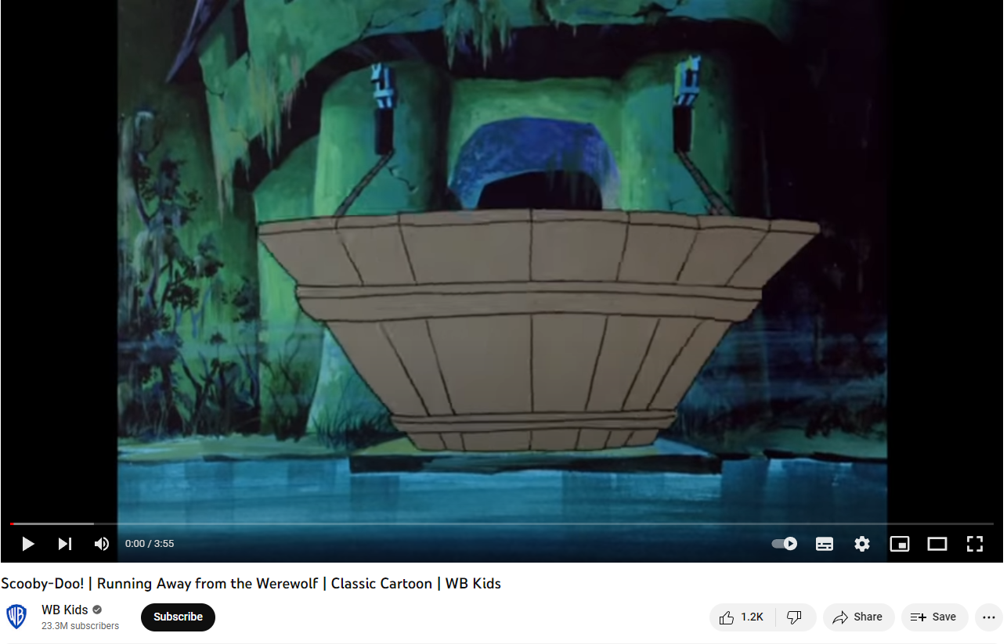
https://www.youtube.com/watch?v=e6fgKSpTmx4
I looked at a lot of different clips from scooby do of shaggy running away as this is what I wanted to convey in my animation. Here is another video I used for research and drew inspiration from.
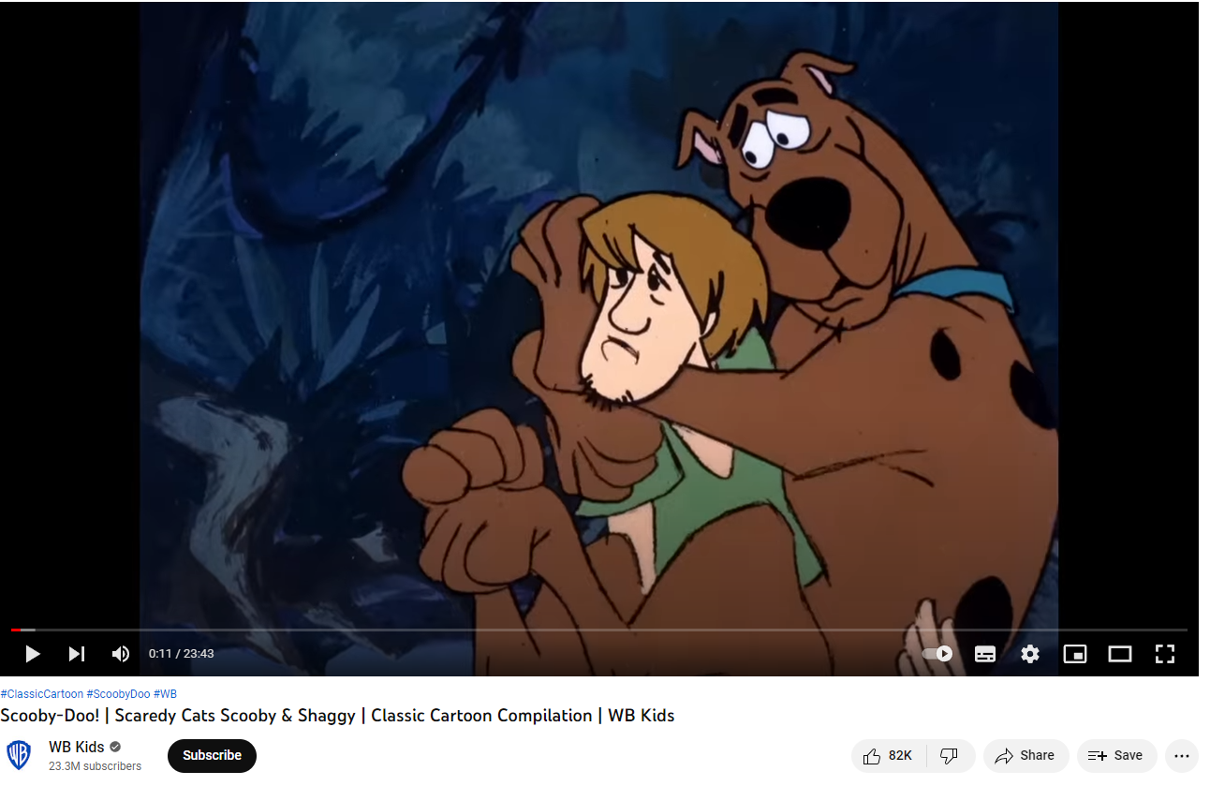
https://www.youtube.com/watch?v=Edr6_-L3bi4&t=814s

Day 2
I story boarded out what I wanted the animations to look like. During this process I was thinking about what I wanted the animation to look like. I found that just having the run on its own would not be enough to cover the whole 10 seconds of run time that I wanted the animation to be. To overcome this, I added a part at the start where the character would turn around and get scared. To show that the character was scared I wanted to him to jump in the air and wave his arms and legs about before landing and turning to start the scared run. I once again looked at different cartoons for inspiration for this I decided on this movement as my research showed that this is a common way for cartoons to show that a character had been scared by something. I also wanted my animation to show my character getting away from what he had been scared by and having a moment of relief at the end. I decided that the best way for me to show this was to have the character run towards a gap that they would have to jump over to get away. The character would then land from the jump and wipe the sweat from his forehead while placing his other arm on his side. I chose this movement as the jump would provide the animation with a bit of excitement and I chose to do a wipe of the forehead as this is a common thing that you see people do in real life and in cartoons when they are relieved about something. Which makes this motion heavily linked to the feeling of being relived which is what I want the character to feel.
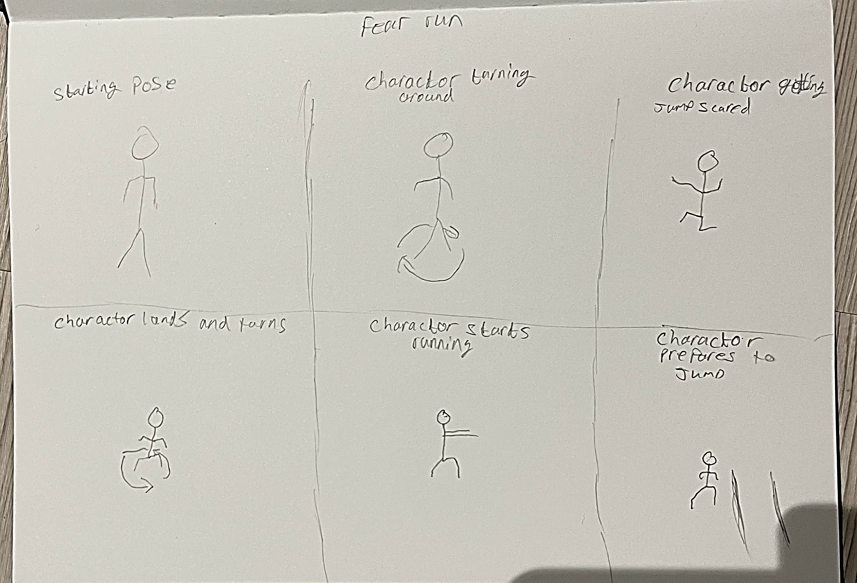
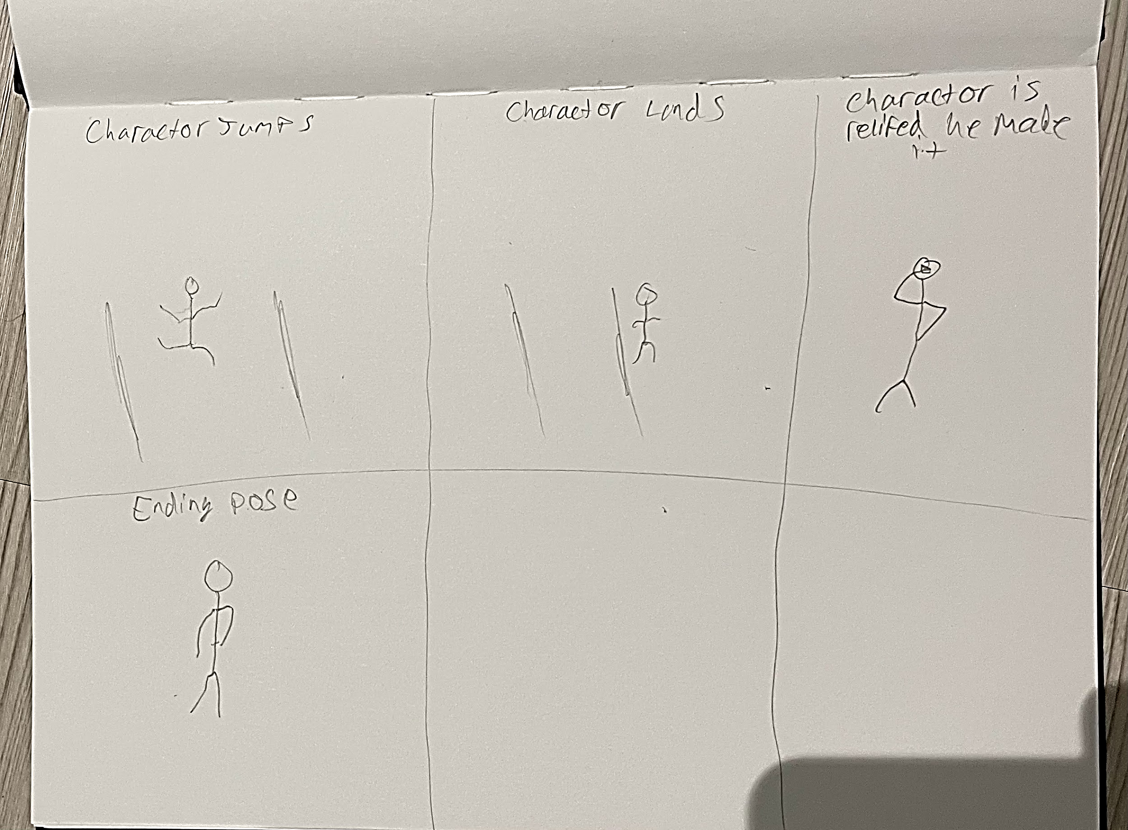
After I had finished planning out my story board, I then started to pose out the starting turn around and scared jump. To start I wanted the character to face away from what he was going to be scared by. For frame one I set the character to the starting pose of him being relaxed by having his arms by his side. The character will then slowly turn around to achieve this I initially set a new key frame every three frames. I then posed out the rest of the character turning around so that he is facing the opposite way to the initial pose. I then wanted the character to jump into the air and flail his arms and legs around. Sticking to the keyframes every three frames I first posed out the character bending his knees and getting lower to the ground. I then posed out the character when he initially goes into the air. I then posed out where the characters arms and legs would go while he is in the air. I then posed out the character lading from the jump scare to quickly turn around and start to run.

Day 3

The next part of the animation that I created was the run after the character lands from the jump. This is the part of the animation that I did the initial research for. I found this part of the animation the hardest to pose out and find the right timings for. For this I stuck to keyframing every three frames so that the animation would flow properly when I played it back. As per my research I found that a common way that cartoons show someone is scared when running away from something is to have their arms in front of them and flailing around which is what I wanted to achieve in my animation. Before I started to pose out my run, I wanted to plan out how far the character is going to have to travel before the jump part of the animation. To plan this out I created some plains inside of maya and rotated and scaled them to function as the floor the character would be running on, I then decided on where would be a good place to have the gap for the jump. After doing this I started to plan out the poses for the running part of the animation. When posing out the run I considered the fact that each step should be in the range of 14 to 16 frames to make the steps look good.

Day 4

The next and final part of the animation that I created was the jump over the gap and the whip of the forehead in relief that he made the jump. Sticking to keyframing every three frames I posed out what I wanted the character to do while he was in the air. Which was to act like he did not know what he was doing and did not have much control while he was in the air. After I had posed out the character landed, I then posed out the character wiping his forehead in relief of making the jump. This was the hardest part of the animation for me to create as I struggled to get the right poses for the jump. This is also the part of the animation that I struggled the most with timing as I found it difficult to find the correct amount of time that the character should stay in the air for without it looking out of place and ruining the flow of the animation as a whole.

Day 5

After I had finished posing out the animation, I played it through and noticed that the timing was off for the jump and the ending. The animation also did not hit the ten second run time for which I was aiming. This is what the animation looked like before I adjusted the timings

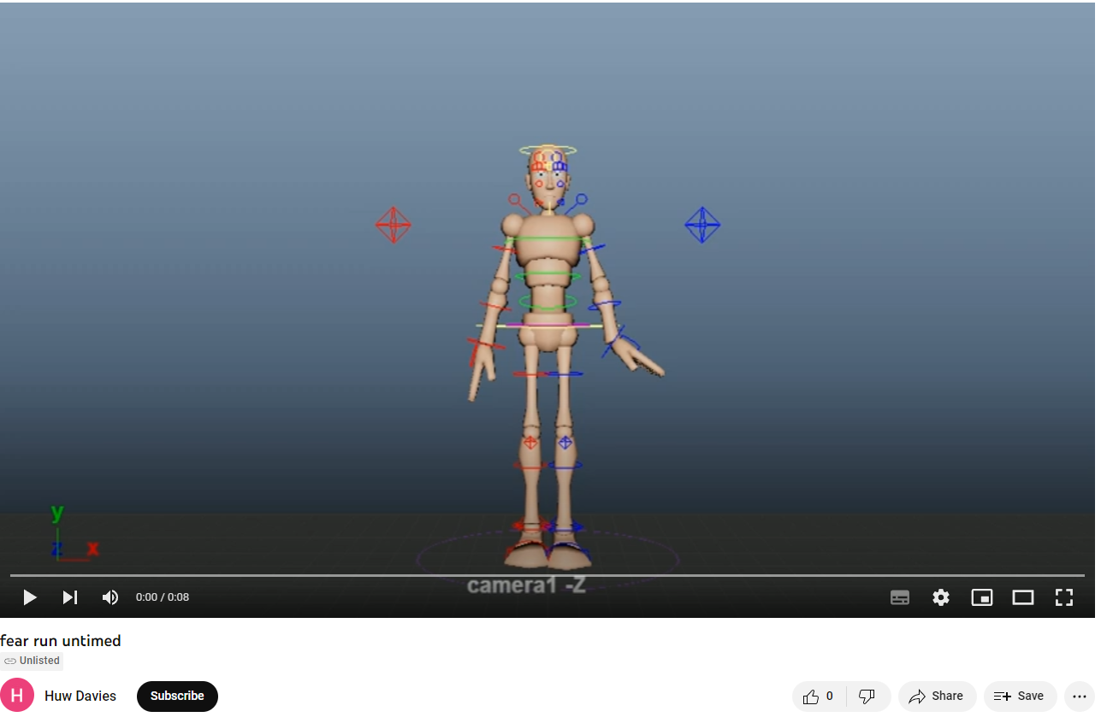
https://youtu.be/zk9X7Rq-XVI

To fix this issue instead of adding more to the end of the animation to meet the ten second run time I fixed the timing issue that I was having. To achieve this, I used the time editor in maya and uploaded the animation as one clip which I then split into three distinct parts to give me more control over the timing of each part of the animation. I then mainly adjusted the timings on the run, jump and the forehead wipe. To extend these clips and after doing this noticed that the animation as whole looked a lot smoother and flowed better. I then slightly adjusted the staying jump scare just to make sure that it flowed properly with the rest of the animation. This is what the animation looked like after I adjusted the timings
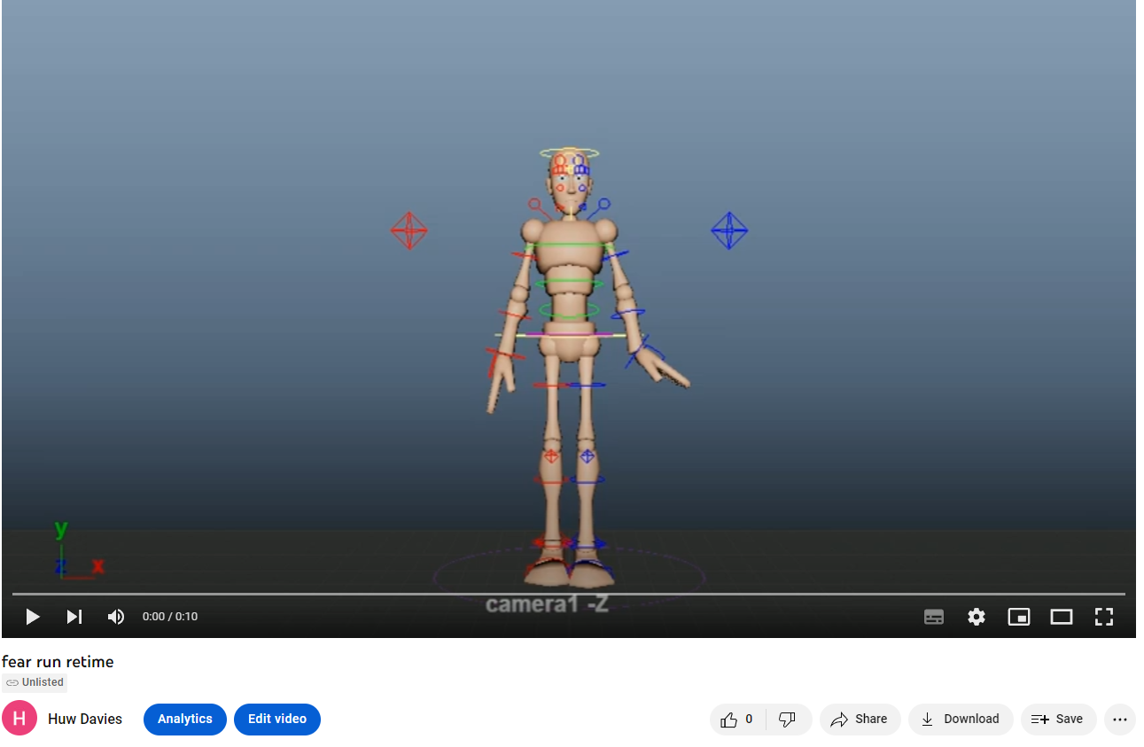
https://youtu.be/YgPDgAwjGow

This is what my final animation looked like
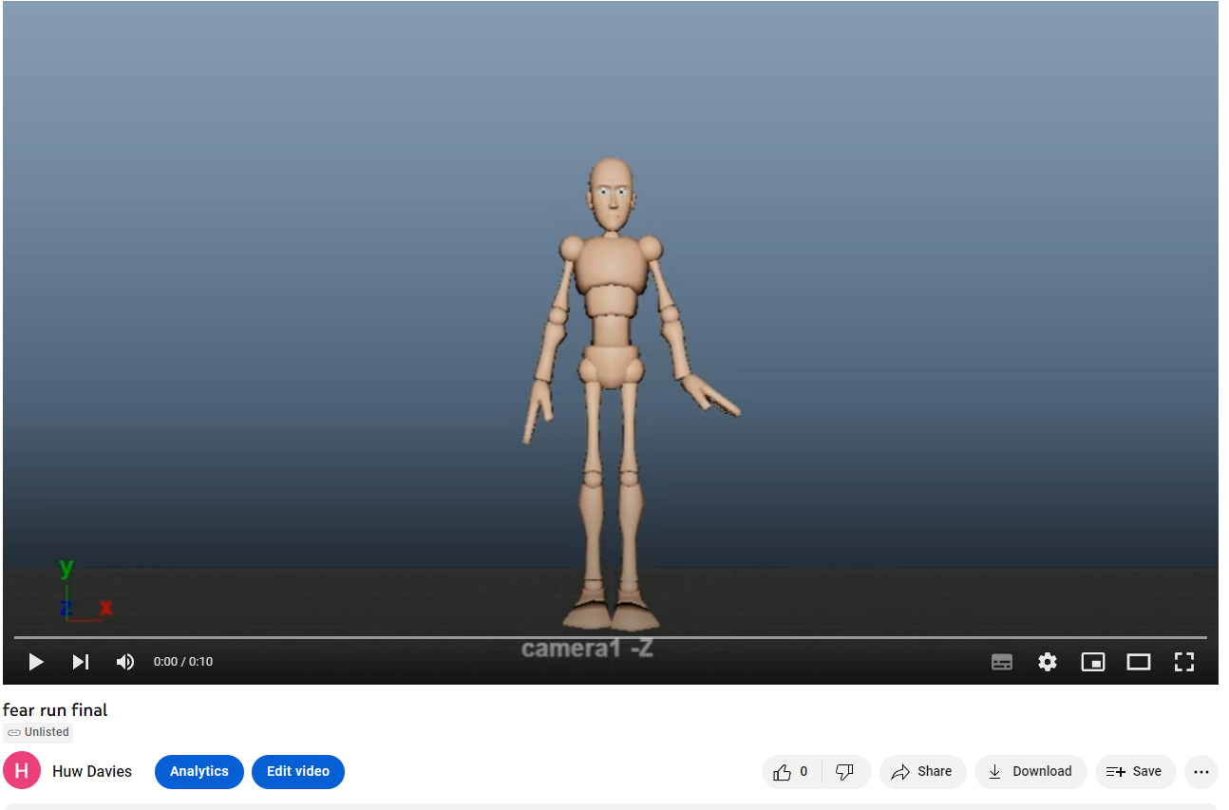
https://youtu.be/P-AH3Lm7ls

I encountered a few issues during the creation of this animation. The main issue that I encountered is after I had finished my keyframing, I splined the animation in the graph editor. After I did this, I noticed that a few of my poses moved a bit this occurred in the run portion of the animation with the legs being further apart than they were originally. To overcome this issue, I went back to my poses and realigned the legs to where they were meant to be.

I believe that I have achieved what I wanted to show with this animation. However, if I were to do this animation again, I would take more care with the timing of the animation and plan out the timings when creating the story board for the animation as this would help prevent some of the issues that I encountered during this project. If I were to do this animation again, I would look at adding some animation to the face of the character as this would bring a bit more life to the animation. Another thing that I would add to this animation next tine in order to make the animation look better is to have an object or another character in the scene and following him as I believe that this would give the animation more life and make it look better.

Ring walk

Day 1

For this animation I wanted to show a boxer getting pumped up in his ring walk before his fight.

For my research for this animation, I looked at different boxer’s ring walks from various levels of boxing and took some of the common tropes and put them into my animation. Some examples of the research that I looked at were Viddal Rileys most recent ring walk
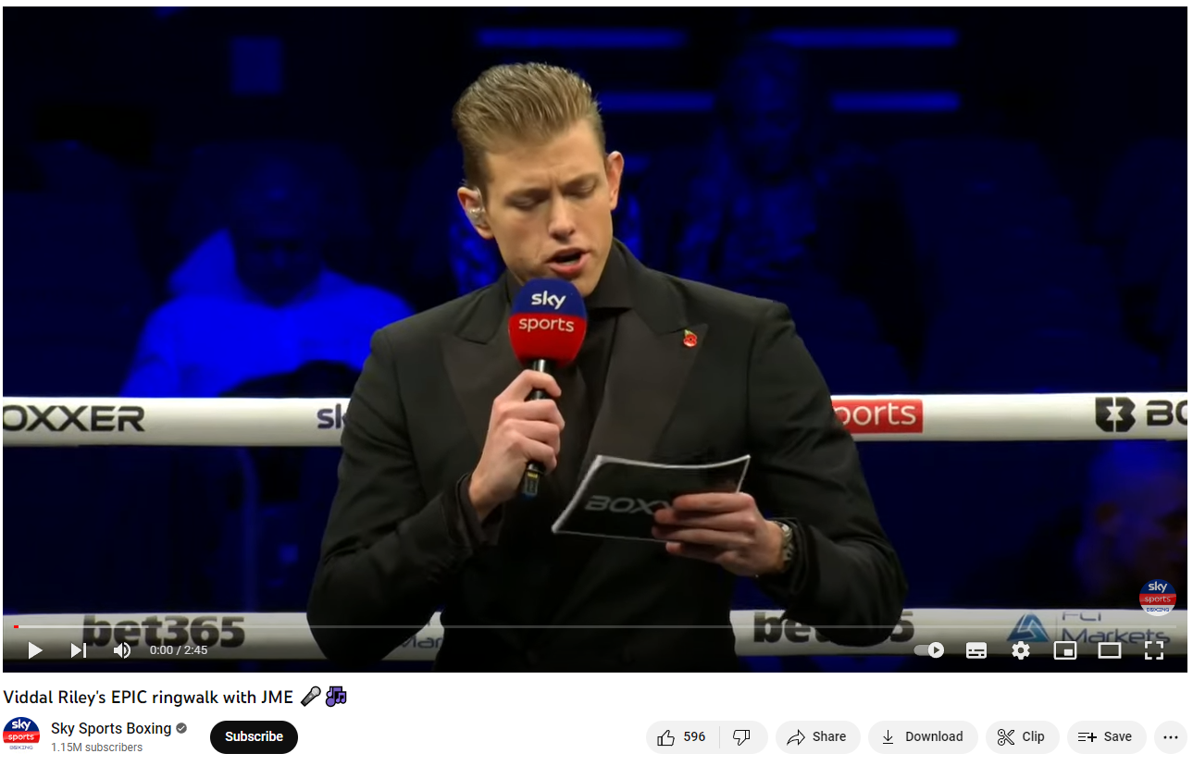
https://www.youtube.com/watch?v=wGL-Fz7hMmY
Another video I looked at for inspiration for this animation was Anthony Joshua’s ring walk
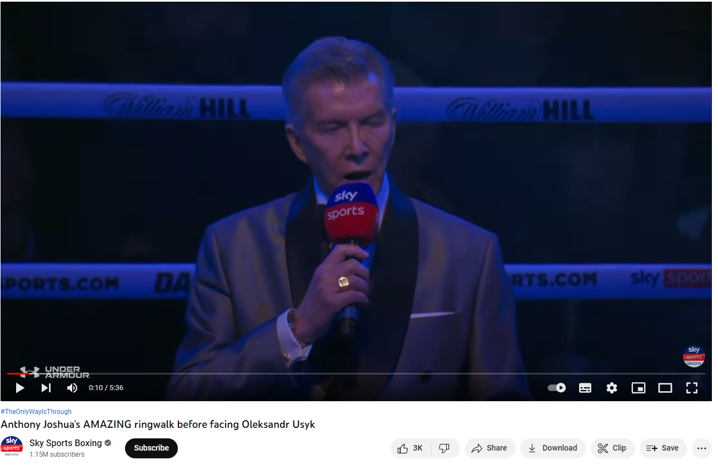
https://www.youtube.com/watch?v=E3X456B8F-4
Another ring walk that I looked at for research for this animation was Tyson fury’s ring walk
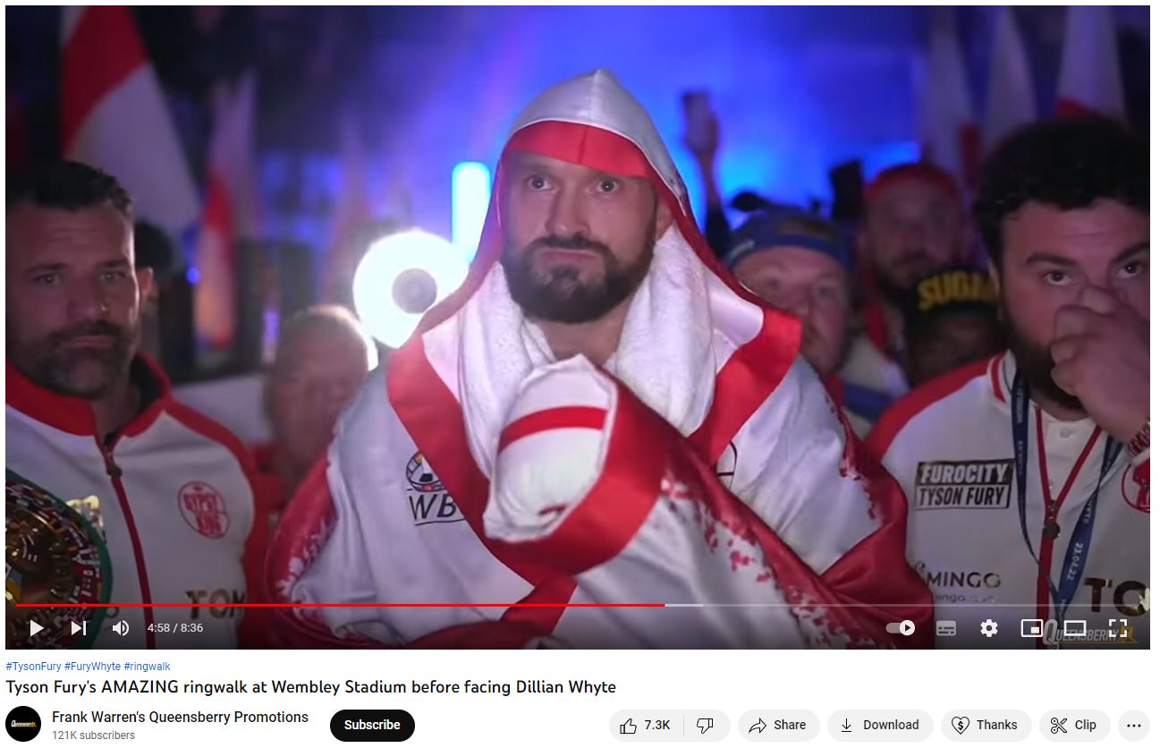
https://www.youtube.com/watch?v=0wBQt8Co2rI

After conducting this research, the common tropes of boxer’s ring walks are that they are getting pumped up before getting to the ring. This can consist of throwing a few punches towards the camera. Some boxers also like to jump and hit their fists together. Another thing that I found by doing this research is that boxers will often raise their hand to the crowd to wave towards them.

Day 2

After doing this research I started to plan out my animation by storyboarding out the poses that I wanted to create. After doing my research I decided that my character would throw a punch and then jump and hit his fists together then start to walk to the ring with one of his arms in the air before stopping and throwing two more punches before carrying on walking to the ring
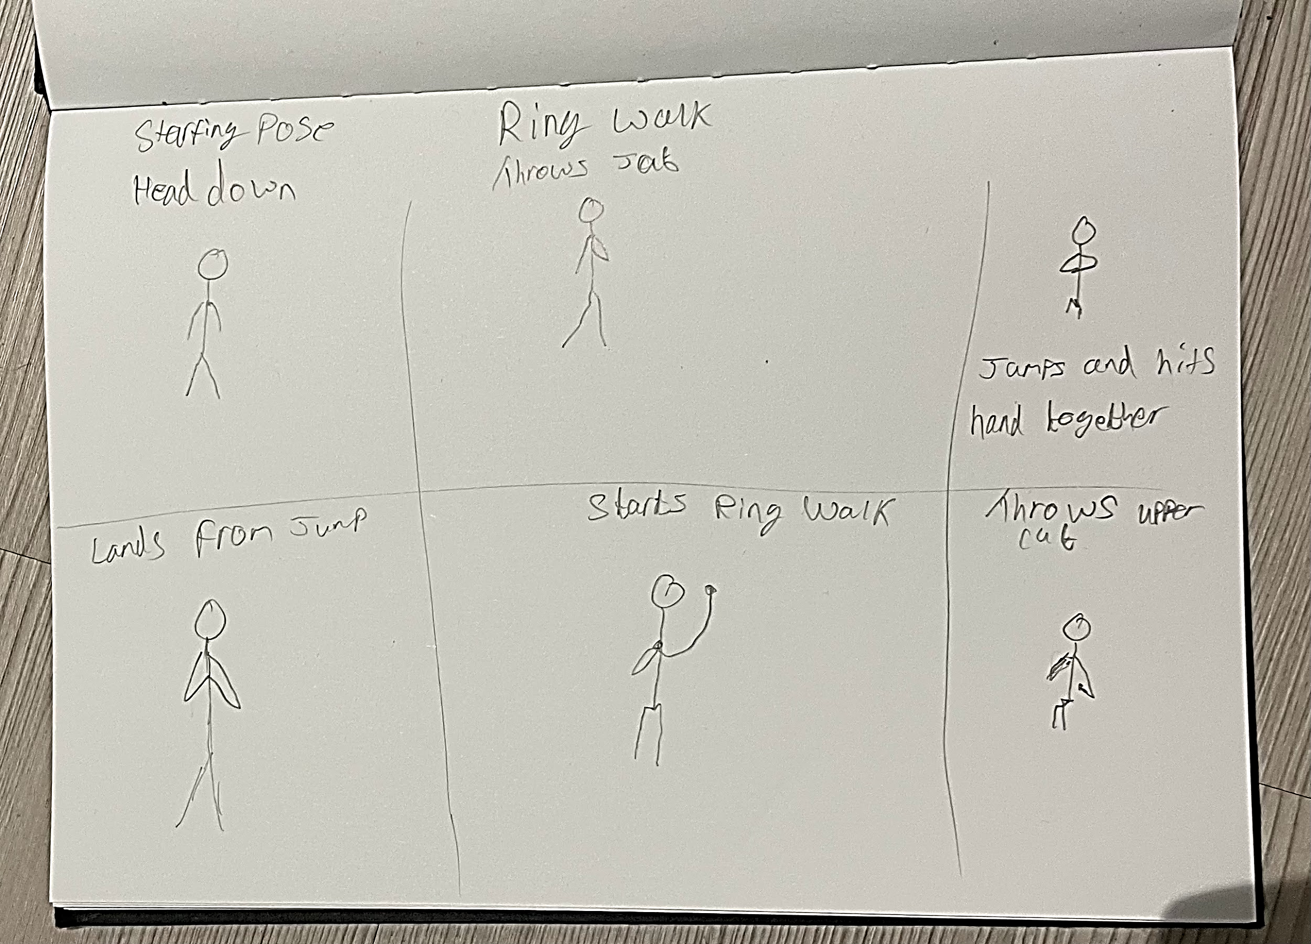

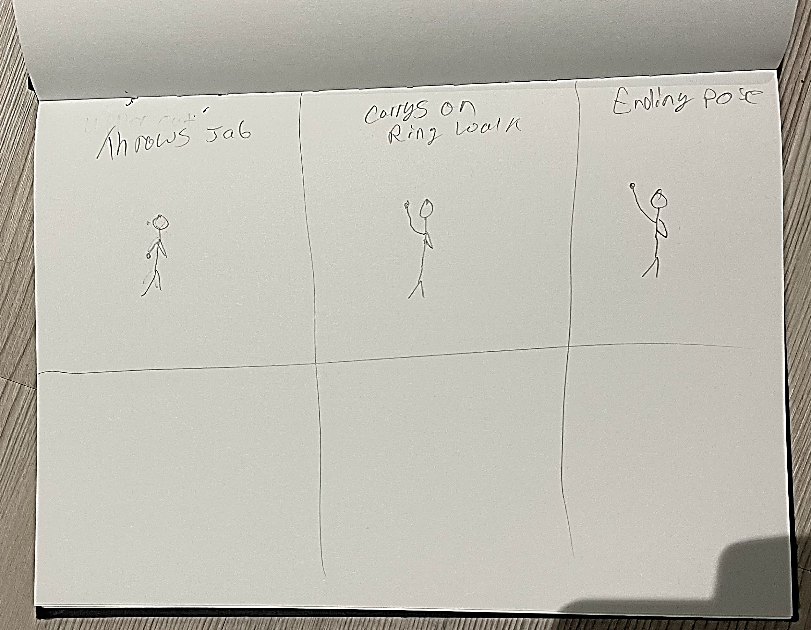

Day 3

The first part of the animation I created was the first jab that the character throws. This was an easy part of the animation to create. The only issue that I had with this part was trying to show how much power the punch had. To show this I made the characters shoulder go with the punch. After doing my last animation I decided that doing keyframes every five frames instead of three frames would be better for the timing and flow of the animation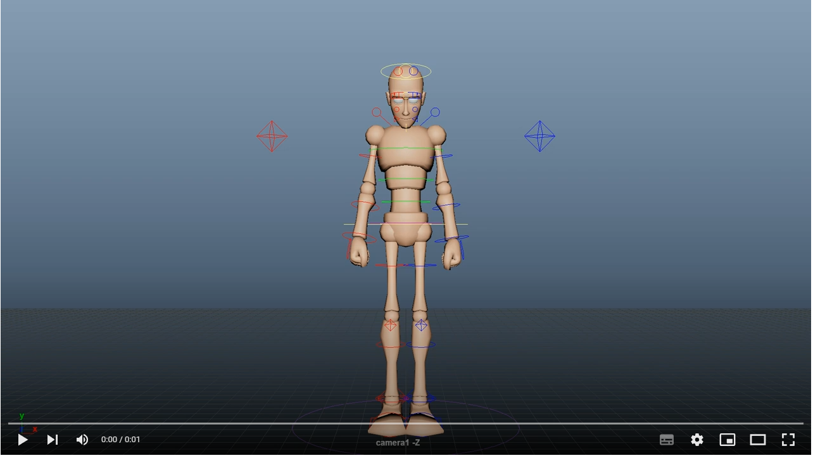

https://youtu.be/NiW-jZScXtE

Day 4

The next part of the animation that I created was the jump and the first walk. When creating this part of the animation I had to think about how long I wanted the character to be in the air for. I decided that the character should not be in the air for more than a second as he is only jumping to warm up. After deciding this I was able to carefully plan out my poses. For the walk part of the animation, I found that keyframing every five frames made it easier to create a walk cycle. I also used what I found in my research to have the character wave to the crowed as he walked.
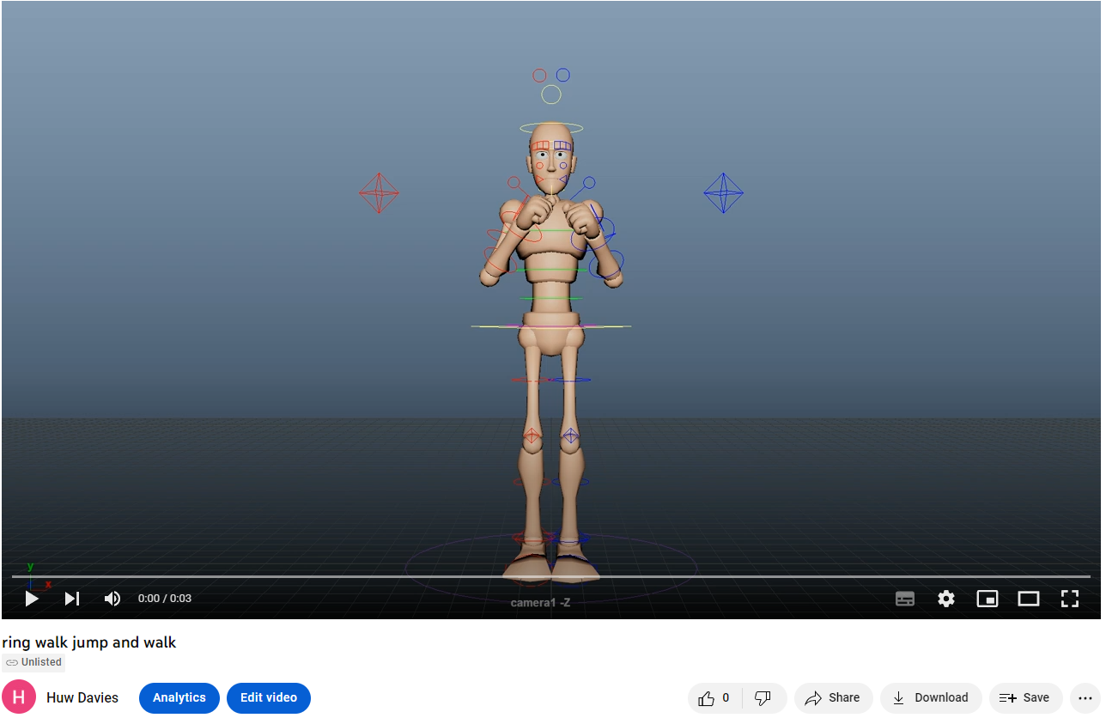
https://youtu.be/cffyRe_MRqo

Day 5

The final part of the animation that I created was the upper cut and jab that the character throws before he goes back to waving at the crowd and walking to the ring. I wanted to do another set of punches as it is a common thing for boxers to do in their ring walks to warm up before they get to the ring. I decided on an upper cut and a jab before the character hits his hands together which I mentioned before is a thing boxers do a few times before getting to the ring. The upper cut was the hardest part for me to animate. The reason for this is that I found the motion of crouching down before throwing a punch upwards hard to pose and keyframe. I also encountered the challenge of timing for this punch as it would take longer than other punches however, I wanted it to still flow well with the rest of the animation.
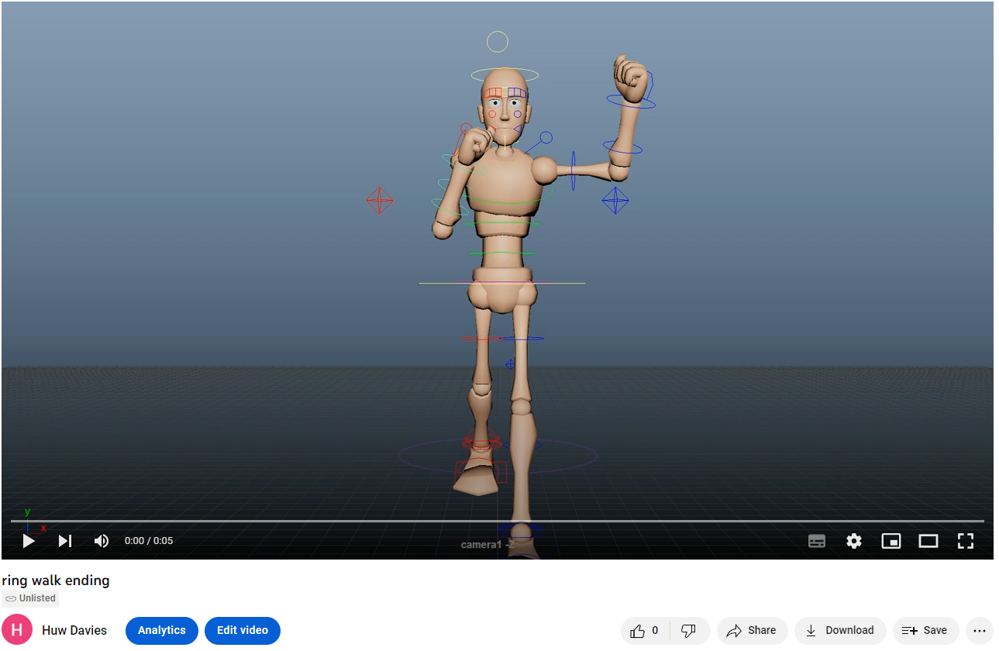
https://youtu.be/dXYMq_mrrkQ

This is what my animation looked like after I finished my keyframing
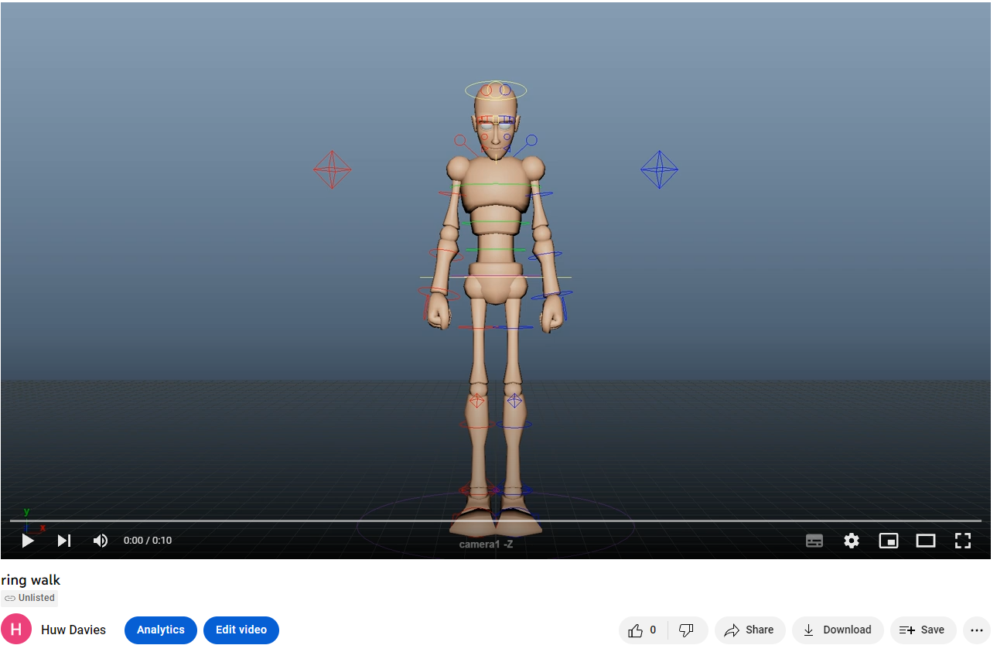
https://youtu.be/f6VLCiIqWvA

I encountered a few issuers during the choice of this animation. The main issue that I encountered was that after I splined the animation in the graph editor that the characters arms would spin all the way around to get to the next pose. The way that I fixed this issue was going back to my keyframes and reposing the controls that were having the issue to ensure that when I played the animation back that that the characters arms did not spin all the way around

After I had finished posing out the animation, I played it back and decided that I was happy with the timings for this animation, so I created a final play blast with the controls turned off
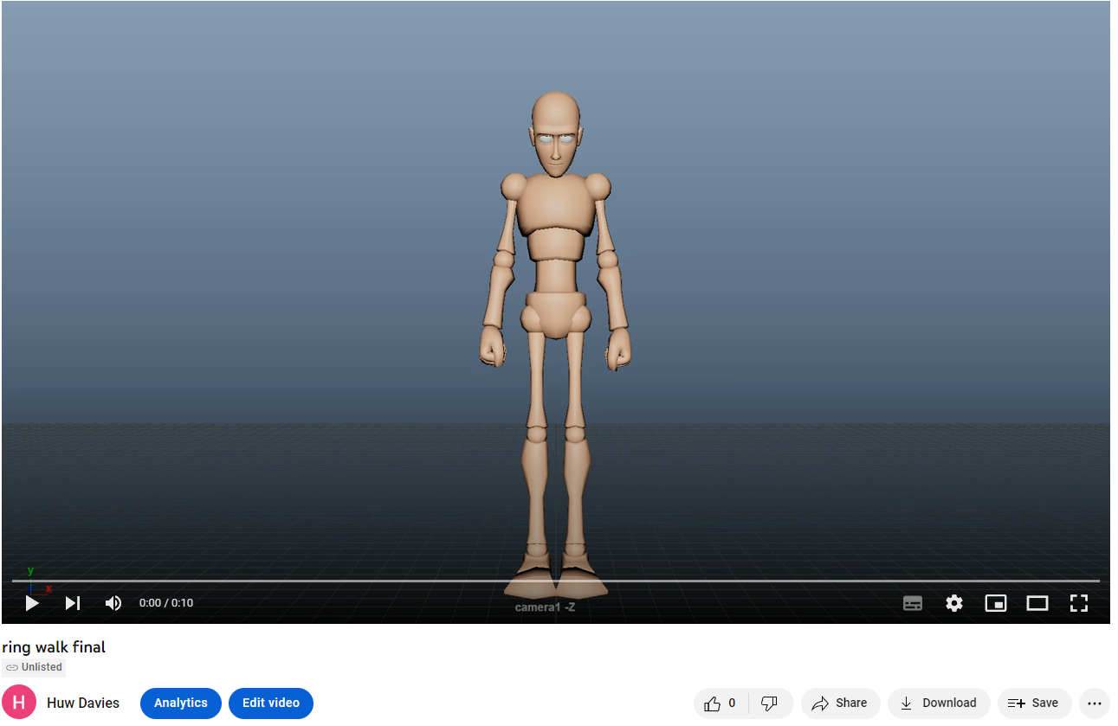
https://youtu.be/XNQdAHqZeYc

I believe that I have achieved what I wanted when starting this animation with a boxer getting pumped before a fight. However, if I were to do this animation again, I would put more keyframes on the characters head and face. While I believe that I achieved what I wanted to at the start these changes would bring a bit more life to the animation as whole and made it look better.

