

Programme: Master of Business Administration
Module: Marketing Management
Module code: LCMB7024

Marketing Environment Analysis and Strategic Growth: The Case of BHP's Transition to a Lower Carbon Business Model

Student name: Bhaveshkumar Arashibhai Odedara
Student id: 2536676
Lecturer name: Tushara Balendran
Word count: 2750
Submission date: 24th July 2026

Table of Contents
Introduction 3
Task 1: Marketing Environment Analysis 3
The Natural Environment 3
The Political and Legal Environment 4
Task 2: Strategic Growth and Competitive Positioning 6
Applying the Ansoff Matrix 6
Achieving Competitive Advantage 8
Task 3: Critical Reflection on AI Usage 9
Tool Disclosure 9
Critical Evaluation of AI Output 10
Contribution Analysis 10
Ethical and Professional Reflection 11
References 12

Introduction
This report critically examines the marketing environment that has an impact on BHP Group Limited's shift towards a lower carbon business model. It examines the natural and political–legal macro-environmental forces that impact the business, suggests a growth strategy from Ansoff's Matrix and Porter's Generic Strategies, and provides a reflective evaluation of the application of the artificial intelligence for the report.

Task 1: Marketing Environment Analysis
The BHP is a company that was incorporated in 1885 after the discovery of silver and lead ore at Broken Hill, Australia by Charles Rasp, and renamed Billiton in 2001 when BHP merged with it, and was renamed to its current name in 2018 (BHP, 2025). Based in Brisbane, Australia, BHP Group Limited is a dual-listed company listed on both the Australian Securities Exchange and the London Stock Exchange, and is the world's largest metals and mining firm by market capitalisation, with operations in Australia, Brazil, Canada, Chile, China, Colombia, Ghana, India, Mauritania, Peru, South Africa, Spain, Sweden, Turkey, and the United States. Its iron ore and metallurgical coal business is also integral to what Kotler et al. (2024) refer to as the 'metals and mining sector wide challenge', which is responsible for around 25% of the world's 12,000 largest companies' reported GHG emissions. This task focuses on the analysis of two external macro environment forces that are impacting BHP's shift towards lower carbon products, based on Kotler et al.'s (2024) classification of microenvironmental actors that are in close proximity to a firm and the macro environment forces that impact and enable a firm's marketing decisions.

The Natural Environment
According to Kotler et al. (2024) the natural environment refers to the availability of raw materials, energy costs and supply, pollution levels and the evolving role of governments and stakeholders in protecting the environment. BHP's force is in two different but related ways. First, physical climate risk directly impacts BHP's operational continuity, as water stress and extreme heat at its Pilbara iron ore operations, and at its Escondida copper mine in Chile, combined with cyclone exposure, place its ability to supply a reliable product at risk, at the heart of BHP's core business proposition to steelmaking and battery manufacturing customers. Second, transition risk is changing customer buying criteria. As upstream carbon reporting becomes more common, steel producers and buyers of battery metals, especially in Asia and the EU, are seeing a growing focus on carbon reporting downstream and are starting to separate out suppliers based on embedded carbon intensity instead of lumping iron ore and copper together as commodities. The International Energy Agency (2024) has forecast that demand for copper, nickel and other energy transition minerals will increase significantly faster than overall metals demand as clean energy technologies ramp up, and Attílio (2025) has illustrated how critical mineral prices are now more responsive to energy transition policy signals than to supply and demand fundamentals alone.
A theoretical framework that is useful for understanding BHP's response is the natural resource based view (NRBV) of Hart (1995). Pollution prevention, product stewardship and sustainable development are three strategies that can be used to build sustainable competitive advantage, which are all based on the firm's interaction with the biophysical environment, not only on the traditional resource based capabilities. Pollution prevention is reflected in BHP's Climate Transition Action Plan (BHP, 2024a) which aims to reduce BHP's Scope 1 and 2 emissions significantly by 2030 compared to a 2020 baseline, and product stewardship is reflected in BHP's investment in lower carbon pathways to iron making. Having reviewed the large body of literature on stakeholder pressure in the mining industry, Rodrigues et al. (2022) conclude that community and NGO pressure is a reinforcing mechanism in addition to microenvironment publics (physical and regulatory environmental pressure) and that in practice it is not always possible to separate the natural environment force from the stakeholder related force.
One of the key challenges for BHP is the damage to its reputation caused by the manner of communicating the transition. Neureiter, Stubenvoll and Matthes (2024) do find experimentally that abstract environmental claims create much higher perceived greenwashing than concrete, verifiable claims, and Keilmann and Koch (2023) show that a perceived discrepancy between a company's environmental claims and its environmental engagement is more damaging to corporate reputation and credibility than no claims whatsoever. The natural environment discipline is not just forcing BHP to change its way of doing business, it is also an independent discipline for marketing communication itself: any claims of sustainable mining or any progress towards achieving ‘Net Zero' will come at a cost if they are not backed up by independently verifiable and concrete metrics (Lock, 2017).

The Political and Legal Environment
The case of BHP closely interacts with the natural environment force in the political and legal environment because it is an environment that involves legislation, pressure groups, and government agencies that limit and influence marketing practices (Kotler et al., 2024). Domestically, the Safeguard Mechanism has introduced decarbonisation obligations for Australia's largest facilities, with emissions limits that decline over time, directly connecting legal obligations with operational decarbonisation as described above. BHP's environmental communications are indirectly subject to regulation of consumer facing businesses further downstream in the value chain, as the European Union'sDirective (EU) 2024/825 on empowering consumers for the green transition, along with the upcoming Green Claims Directive, restricts such claims in the supply chain from BHP's steelmaking customers. The extent and credibility of disclosure of environmental, social and governance (ESG) issues in resource extractive companies is found to be determined by both regulatory and stakeholder pressure, not just regulatory pressure alone, as demonstrated by the study by Alessa et al. (2024) of mining and manufacturing companies in Ghana. It illustrates a transferable principle: stakeholder pressure has an important influence on ESG disclosure, along with regulatory pressure. In the same vein, Aboagye Otchere, Simpson and Kusi (2020) directly tie the environmental performance to the quality of environmental disclosure, and Abeysekera (2022) offers a template for organizing sustainability reporting that is relevant to the way BHP organizes its non financial disclosures under these forces.
Together, the natural environment force and the political and legal environment force create the substantive imperative for BHP to decarbonise its operations and products, and the political and legal environment formalises, enforces and increasingly polices the way this imperative can be communicated to customers, investors and the public (Table 1).
In addition to these challenges, the same pressures offer a market opportunity – by investing early in verified lower carbon products, BHP will be able to charge a premium price before their competitors (International Energy Agency, 2024).
Table 1: Summary of external macro environment forces affecting BHP's transition to lower carbon products
Environmental Force | Nature of the Pressure on BHP | Marketing Implication
Natural environment | Physical climate risk (water stress, extreme heat, cyclone exposure) and transition risk from customers demanding lower carbon inputs to satisfy their own Scope 3 reporting obligations. | Requires product stewardship and pollution prevention capability (Gabler, Itani and Agnihotri, 2022); environmental marketing claims must be concrete and independently verifiable to avoid perceived greenwashing (Neureiter et al., 2024).
Political and legal environment | Australia's Safeguard Mechanism; the EU's Directive (EU) 2024/825 and forthcoming Green Claims Directive; mandatory ESG and sustainability disclosure regimes. | Disciplines how environmental claims may be marketed and increases the disclosure burden placed on BHP's communications (Abeysekera, 2022).

Task 2: Strategic Growth and Competitive Positioning
This task aims to apply Ansoff's (1957) product market growth matrix to recommend a strategic growth path for BHP and to assess how the company can gain competitive advantage by applying Porter's generic strategies framework, based on the natural resource based view of Hart (1995).

Applying the Ansoff Matrix
The lowest risk quadrant of the matrix is Market Penetration - BHP's existing bulk iron ore and metallurgical coal business in existing steelmaking markets that provide the cash flow to fund the transition in the near term. It cannot however, deal with the natural environment or political pressures outlined in Task 1 and does not constitute a strategy for growth, but rather represents a financial foundation.
Market development is a moderate risk opportunity, which involves selling BHP's current product line in a new geographic location. If BHP diversified into India's rapidly expanding electric vehicle and renewable grid infrastructure build-out, or potash sales into new agricultural markets throughout South Asia and Africa as global food security concerns grow, it would expand the company's customer base without the need for fundamentally new products, but with new regulatory, logistical and political risk in each new territory.
Product development is directly addressing this transition risk, which is outlined in Task 1, by addressing the creation of new lower carbon products for existing customer bases, particularly for BHP's direct reduced iron and hot briquetted iron products to be used in electric arc furnace steelmaking. Significant capital investment and metallurgical research and development are needed for this option and BHP must demonstrate product quality and consistency at scale before customers will consider reformulating existing blast furnace processes (Lock, 2017).
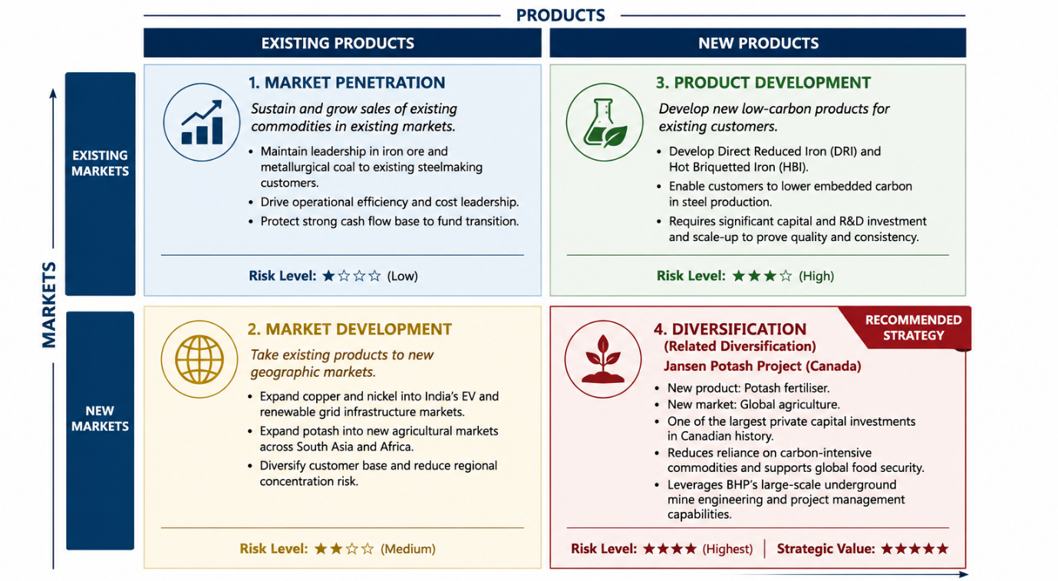
Figure 1: Ansoff Matrix applied to BHP's growth options
BHP's principle growth strategy should be diversification, creating new products for new markets, and this is in part being accomplished by the company's Jansen potash project in Saskatchewan, Canada. Jansen is a new product – a potash fertiliser – that is aimed at a new market – global agriculture – and is one of the largest private capital investments in Canadian history, with first production expected to be in late 2026, but that has been delayed to around mid 2027 due to reported cost increases (Lock, 2017; BHP, 2024b). If it is up and running, Jansen will be a significant contributor to global potash needs. Jansen is a related diversification as it is not a new industry for BHP, but rather one that they already have the capacity to work in, hence materially less execution risk than unrelated diversification into a completely different industry. Strategically, this lessens BHP's reliance on carbon intensive metallurgical coal and blast furnace grade iron ore, and exposes BHP to future facing commodities where demand is expected to grow disproportionately, as a result of the energy transition and, in the case of potash, global food security pressures, as identified by the International Energy Agency (2024).
This recommendation needs to be critically qualified. While diversification is the quadrant with the highest risk on the Ansoff matrix, Jansen's own experiences of cost overruns and schedule delays over the past year show that, in practice, execution risk is a significant consideration, and BHP's customer base for steelmaking and battery metals is different from its current agricultural distributors and fertilizer buyers. Diversifying into potash and maintaining the same more incremental approach to product development in lower carbon iron products spreads the risk of execution across two related but different efforts, instead of focusing on a new business offering (Puyt, Antoniou and Caputo, 2024).

Achieving Competitive Advantage
According to Porter's generic strategies framework there are three basic strategies to achieve competitive advantage which are cost leadership, differentiation and focus (Ali and Anwar, 2021). BHP has a good chance of being able to adopt a two-part generic strategy – rather than one single strategy – than to follow one of the other two. For its legacy bulk iron ore business, BHP's ability to be a lowest quartile cost producer is a sustainable competitive advantage that is largely independent of the sustainability transition and should be maintained. In the lower carbon and future facing commodities portfolio (including verified lower carbon iron products), copper and potash, a differentiation strategy makes more sense, as verified lower embedded carbon content and food security relevant framing enable BHP to command a premium from steel makers and purchasers, who have disclosure requirements and are subject to greenwashing scrutiny, directly. In this context, a differentiation claim will only secure a durable premium if it is concrete and independently verifiable, as the findings of Neureiter, Stubenvoll and Matthes (2024) and Keilmann and Koch (2023) discussed in Task 1, indicate. This combination of generic strategies is summarized in Figure 2.

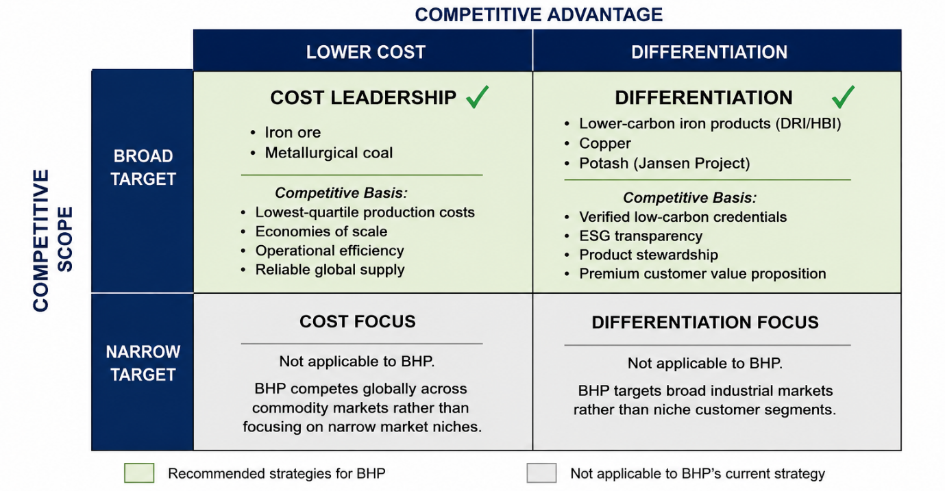
Figure 2: Porter's Generic Strategies applied to BHP's commodity portfolio
This dual strategy can create a sustainable advantage, not a temporary advantage, as per the natural resource based view (Gabler, Itani and Agnihotri, 2022). The pollution prevention and product stewardship and sustainable development elements developed as part of BHP's Climate Transition Action Plan alongside its diversification into potash are hard for competitors, like Rio Tinto or Vale, to quickly replicate, given the need to build up a body of tacit knowledge, the longer timelines for developing assets (measured in years not months) and the need for consistent disclosure over time that instills credibility. These attributes meet the criteria set by the resource based view, which states that resources must be valuable, rare, and difficult to imitate, thus moving from being an environmental and regulatory restriction to a real source of competitive advantage, not just a compliance expense.

Conclusion
Finally, the natural environment and political and legal pressures jointly influence BHP's journey towards a lower carbon business model, creating both a reputational risk and an actual market opportunity. Diversification into potash, combined with incremental product development in lower carbon iron products and a dual generic strategy, provides BHP with a viable path to a competitive advantage.

Task 3: Critical Reflection on AI Usage

Tool Disclosure
This assignment was prepared with the support of generative artificial intelligence (AI), specifically Anthropic's Claude. It was only used in two ways: it was used to help the initial search for relevant academic and industry sources, and it was used to proofread the finished written work to correct grammar, clarity and consistency of expression. The analysis, arguments, conclusions and recommendations in the submission were not prepared by the AI tool. Students completed the selection of the case organisation, the application of marketing frameworks, interpretation of evidence and the development of strategic recommendations independently of each other.
The first round of literature search was applied to determine the possible relevant sources for sustainable mining, environment marketing, low carbon products, strategic growth and competitive advantage. These suggestions were considered as a starting point for further investigation and not as automatically reliable information. Academic articles, industry reports and organisational sources were independently assessed for relevance and reliability.

Critical Evaluation of AI Output
While AI tools can enhance the research process, it is essential to verify the information generated, as it can sometimes contain inaccuracies, outdated data or references that are not supported. As a result, every source mentioned in the text has been cross-referenced in trustworthy academic databases, publisher websites and official organisational websites before being used in the final report. Sources that could not be found or not accepted as being academically credible were not included.
Likewise, the AI-generated proofreading suggestions were carefully analyzed and accepted. It was only used to identify potential language problems, to clarify sentences and to correct inconsistencies in grammar. The meaning, analytical direction or critical judgement of the assignment could not be changed. All key factual information was checked against authoritative sources such as BHP publications, government information and recognised organisations around the world.

Contribution Analysis
Students' ideas/explanations for this assignment are the key intellectual component. The factors in the key marketing environment for BHP, the evaluation of the natural and political/legal pressures, the application of the Ansoff Matrix and Porter's Generic Strategies and the recommendation of a lower carbon growth approach were developed independently and through academic research.
AI support was used to help find potential sources and to proofread the final document, improving the efficiency of the research process. Theories were interpreted and strategic alternatives judged and evaluated based on the student's understanding and critical assessment of the available evidence, with the student's own understanding and critical assessment of the evidence being the basis for the interpretation of theories, evaluation of strategic alternatives and judgement regarding BHP's competitive positioning.

Ethical and Professional Reflection
AI-powered marketing analysis offers opportunities and ethical considerations. AI can enhance productivity by assisting with information discovery and the quality of communication, but excessive reliance on AI-generated content can diminish critical thinking and introduce potential inaccuracies and fabrications of sources or shallow analysis. In the professional marketing landscape, the potential for misinformation is also high, as AI tools are increasingly being employed in decision-making processes and communication activities where precision and transparency are critical.
This assignment illustrates the need for human oversight, verification of information and accountability for final output in the responsible use of AI. Therefore, AI should be used as a complement to, not a substitute for, professional judgement, creativity and analytical ability for research and communication processes.

References
Abeysekera, I. (2022). A framework for sustainability reporting. Sustainability Accounting, Management and Policy Journal, 13(6), pp.1–22. doi:10.1108/SAMPJ-08-2021-0316
Aboagye-Otchere, F.K., Simpson, S.N.Y. and Kusi, J.A. (2020). The influence of environmental performance on environmental disclosures: An empirical study in Ghana. Business Strategy & Development, 3(1), pp.98–111. doi: https://doi.org/10.1002/BSD2.81
Alessa, N., Akparep, J.Y., Sulemana, I. and Agyemang, A.O. (2024). Does stakeholder pressure influence firms environmental, social and governance (ESG) disclosure? Evidence from Ghana. Cogent Business & Management, 11(1), 2303790. doi:10.1080/23311975.2024.2303790
Ali, B.J. and Anwar, G. (2021). Porter's Generic Competitive Strategies and its influence on the Competitive Advantage. International Journal of Advanced Engineering, Management and Science, 7(6), pp.42–51. doi:10.22161/ijaems.76.5
Attílio, L.A. (2025). Impact of critical mineral prices on energy transition. Applied Energy, 377, 124688. doi:10.1016/j.apenergy.2024.124688
BHP (2024a). Climate Transition Action Plan 2024. [online] Melbourne: BHP Group Limited. Available at: https://www.bhp.com/sustainability/climate-change/climate-transition-action-plan (Accessed: 12 July 2026).
BHP (2024b). Stage 1 of the Jansen potash project surpasses half way mark. [online] Available at: https://www.bhp.com/news/articles/2024/07/stage-1-of-the-jansen-potash-project-surpasses-half-way-mark (Accessed: 12 July 2026).
CMS (2024). Greenwashing directive: rules and practices for sustainable communication. [online] Available at: https://cms.law/en/int/publication/greenwashing-directive-rules-and-practices-for-sustainable-communication (Accessed: 12 July 2026).
Hagelüken, C. and Goldmann, D. (2022). Recycling and circular economy towards a closed loop for metals in emerging clean technologies. Mineral Economics, 35(3–4), pp.539–562. doi:10.1007/s13563-022-00319-1
Hermann, E. and Puntoni, S. (2025). Generative AI in Marketing and Principles for Ethical Design and Deployment. Journal of Public Policy & Marketing, 44(3), pp.332–349. doi:10.1177/07439156241309874
International Energy Agency (2024). Global Critical Minerals Outlook 2024. [online] Paris: IEA. Available at: https://www.iea.org/reports/global-critical-minerals-outlook-2024 (Accessed: 12 July 2026).
Keilmann, J. and Koch, T. (2023). When Environmental Claims are Empty Promises: How Greenwashing Affects Corporate Reputation and Credibility. Environmental Communication, 18(3), pp.266–284. doi:10.1080/17524032.2023.2267782
Kotler, P., Armstrong, G., Harris, L.C. and He, H. (2024). Principles of marketing. 19th edn. Harlow: Pearson.
Neureiter, A., Stubenvoll, M. and Matthes, J. (2024). Is It Greenwashing? Environmental Compensation Claims in Advertising, Perceived Greenwashing, Political Consumerism, and Brand Outcomes. Journal of Advertising, 53(4), pp.511–529. doi:10.1080/00913367.2023.2268718
Rodrigues, M., Alves, M.C., Silva, R. and Oliveira, C. (2022). Mapping the Literature on Social Responsibility and Stakeholders' Pressures in the Mining Industry. Journal of Risk and Financial Management, 15(10), 425. doi:10.3390/jrfm15100425
Yang, Z., Wu, J.G. and Xie, H. (2024). Taming Frankenstein's monster: Ethical considerations relating to generative artificial intelligence in education. Asia Pacific Journal of Education, pp.1–14. doi:10.1080/02188791.2023.2300137

