

Programme: BSc (Hons) Health and Social Care
Module Title: Digital Transformation in the Health and Care Professions
Module Code: BMHP6026
Assignment Title: Component 1: Written Report
Student Name: Mehwish Arshad
Student Number: 2312904
Lecturer’s Name: Joanne Davies

Table of Contents
Introduction 3
Workforce: Training, Role Adaptation, and Competency 3
Patient/Service User Perspective 5
Recommendation 9
Conclusion 9
Reference List 11

Digital Innovation: NHS App

Introduction
Digital innovation refers to the use of new technologies, platforms, and digital tools to improve services, processes, and experiences. In healthcare, it enhances efficiency, supports informed decision-making, and increases patient engagement, positioning it as a key driver of transformation in modern care (Costelloe, 2022).
The United Kingdom’s National Health Service (NHS) has increasingly adopted digital solutions to improve service delivery and patient experience, with the NHS App emerging as a central platform. Announced in July 2018 and rolled out nationwide in 2019, the app serves as the ‘digital front door’ to the NHS, offering core features such as booking General Practitioner (GP) appointments, ordering repeat prescriptions, and providing patients with access to their records. Designed to be free and user-friendly, it enables patients across England to access healthcare services quickly and securely (Department of Health and Social Care, 2022; NHS England, 2023).
Through the NHS App, patients can manage appointments, order prescriptions, view medical records, access NHS 111 online, and register as organ donors. Some practices also offer messaging services, digital forms, and care plan management. These features aim to empower patients, improve accessibility, and reduce administrative pressures, contributing to more efficient and patient-centred care (NHS England, 2023).However, despite its promise of convenience and efficiency, the app’s impact has been uneven across populations and workforce roles, raising questions about inclusivity and digital readiness. This report will critically evaluate the impact of the NHS App on patient care, workforce efficiency, and service delivery, highlighting both its benefits and challenges within the NHS.

Workforce: Training, Role Adaptation, and Competency
The implementation of the NHS App has significantly transformed job roles within the healthcare workforce, particularly in primary care and administrative services. Administrative staff, such as receptionists and practice managers, now spend less time on manual tasks, like appointment scheduling and prescription processing, and instead focus on managing digital workflows, handling online patient queries, and ensuring accurate data entry. Clinical staff, including GPs, nurses, and allied health professionals, now conduct digital consultations, remotely monitor patients, and respond to messages via secure platforms. This reflects a shift from traditional face-to-face care to a hybrid model of in-person and digital interactions (NHS Digital, 2021).
NHS England (2025) highlights the scale and complexity of the current health system, with over 1.5 million staff and approximately 1.7 million patient interactions occurring daily. Despite rising pressures, including inflation and industrial action, the service has delivered record levels of activity, including 369 million GP appointments in the 12 months to February 2025 and the establishment of 12,000 virtual ward beds, enabling hospital-level care at home. The NHS App now exceeds 34 million users, demonstrating the rapid expansion of digital health access and the growing need for a workforce skilled in digital systems. These achievements underline the importance of upskilling staff to manage technology-enabled care and data-driven healthcare delivery. While upskilling initiatives exist, evidence suggests they often rely on short-term training rather than embedding digital literacy within workforce planning (Health and Social Care Committee, 2023). This limits sustainable skill development and risks widening the digital capability gap over time. A more structured, long-term approach to digital education integrated into professional development frameworks would help ensure lasting competency and adaptability.
Digital transformation in the NHS aims not only to digitise processes, such as implementing electronic patient records and remote appointments, but also to embed innovative, technology-enabled approaches that personalise care and enhance efficiency. The Department of Health and Social Care (DHSC) emphasises that “strong digital foundations” and a national workforce strategy are essential to upskill current NHS staff and grow a specialist Digital, Data and Technology (DDaT) workforce capable of supporting safe and effective care (Health and Social Care Committee, 2023).
Brown and Bewick (2023) argue that digital health education develops an understanding of the pragmatic use of digital technologies, including health apps, artificial intelligence, and wearables, in the NHS. Staff should feel confident accessing up-to-date, quality-assured digital health solutions.
The NHS App has delivered several workforce benefits. Automating routine administrative tasks allows staff to focus more on direct patient care, improving efficiency and reducing operational bottlenecks. Digital records reduce the risk of errors in prescriptions and appointment management, enhancing accuracy and patient safety. Digital communication tools also enable staff to triage patient queries efficiently and distribute workloads effectively across teams (NHS England, 2023).

Despite these advantages, challenges remain. Resistance to change is common, particularly among staff who are less confident with technology. The learning curve associated with new systems, combined with time pressures, can increase workload and stress. Inconsistent integration of the NHS App across different practices may lead to inefficiencies, and staff must remain vigilant to maintain patient confidentiality and adhere to data protection standards. Supporting patients with low digital literacy or limited access to devices requires additional staff time, adding pressure to an already stretched workforce (NHS Digital, 2021). A 2023 NHS England evaluation found that GP practices using the app’s online triage system reduced telephone demand by 30%, but initial staff anxiety about workload redistribution delayed adoption (NHS England, 2023). Barriers to digital readiness, such as insufficient infrastructure, outdated systems, and limited time for staff training, continue to constrain digital transformation. Addressing these requires consistent investment in digital infrastructure, protected time for training, and stronger leadership commitment to change management. Without these, the NHS risks uneven digital capability and burnout among staff tasked with delivering innovation under pressure.
Overall, the NHS App has driven a clear shift in workforce roles, requiring enhanced digital competencies, continuous training, and adaptation to technology-enabled models of care. While it has improved efficiency, patient safety, and access to care, ongoing support, training, and infrastructure improvements are essential to address the challenges and ensure equitable, effective workforce integration of digital innovation.

Patient/Service User Perspective
Persistent long waiting times and limited access to care continue to pose significant challenges for patients within the NHS, with waiting lists reaching unprecedented levels (NHS, 2022). Amaré Health (2023) further identifies workforce shortages, health inequality, and the need for sustained digital transformation as key factors shaping patient access and overall care quality. In response to these ongoing pressures, digital solutions such as the NHS App have been developed to enhance accessibility, streamline service delivery, and empower patients to take a more active role in managing their health.
The NHS App has significantly influenced patient experience by improving access, convenience, and engagement with health services. It enables users to order repeat prescriptions, book GP and vaccination appointments, view health records, access NHS 111, and manage organ donation preferences (NHS England, 2023).

Positioned as a transformative digital tool, the NHS App supports integrated care, enhances patient independence, and enables more personalised healthcare. With over £1 billion annually devoted to digital transformation, real-time integrated data through electronic patient record systems (EPRs) facilitates risk assessment, clinical decision-making, and evaluation of digital innovations (Costelloe, 2022).

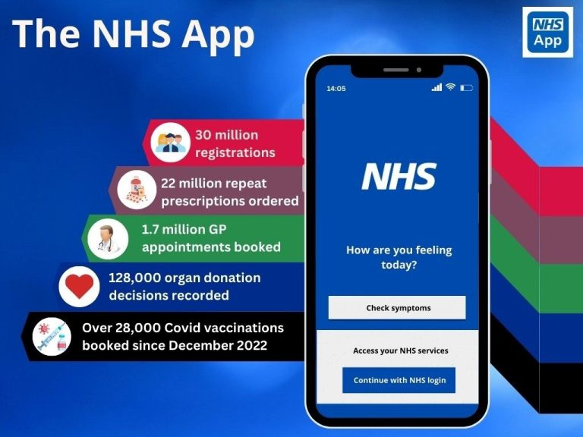
Figure 1:(Warwick House Medical Centre, no date).
During the COVID-19 pandemic, the NHS COVID Pass further increased the app’s relevance, supporting safer travel, social activity, and workplace participation. Evidence suggests high satisfaction among users, with 87% finding prescription ordering easy, 63% rating Health A-Z as useful, and 49-52% able to locate and understand information in their GP records (NHS Digital, 2021; KC et al., 2023).
However, the app also presents challenges. Less than half of users understood appointment names, and over two-thirds cited confusing jargon, highlighting issues of digital literacy and accessibility. Uptake varied across sociodemographic groups, with younger, more digitally literate patients more likely to engage, raising concerns about equitable access (Kc et al., 2023). Reidy et al. (2025) noted fragmented or system-facing information and inconsistent feature availability across practices, which sometimes limited patient self-care and caused frustration.
Despite the NHS App’s national rollout, the digital divide remains pronounced. Older adults and those in deprived communities are less likely to register or engage, suggesting that digital innovation may inadvertently widen health inequalities (Tapuria et al., 2021).
These barriers persist not only because of varying levels of digital literacy but also due to deeper systemic factors. Socioeconomic inequality affects patients' access to devices and reliable internet, while differences in GP practice policies, local IT infrastructure, and support services result in inconsistent app experiences. Without targeted investment and national standards, these factors continue to limit equitable access despite the widespread availability of the NHS App.
Launched in 2019, the NHS App received major enhancements in 2021 and further updates in 2025, improving usability, accessibility, and integration across healthcare providers (NHS Digital, 2021; NHS England Digital, 2025). These developments have been particularly beneficial for patients with mobility challenges, those living in remote areas, and individuals managing multiple long-term conditions, promoting engagement and empowering patients to take an active role in their care. However, the use of the NHS App also raises important ethical considerations. Protecting patient data, maintaining confidentiality, and ensuring informed consent are essential to sustaining trust in digital health services. Handling sensitive health information responsibly requires transparency and adherence to ethical standards. The National Data Guardian (2024) emphasises that health and care services must safeguard personal data, promoting accountability and reinforcing public confidence in digital healthcare systems.
These developments align closely with the national priorities outlined in the NHS Long Term Plan (2019) and the Digital Health and Care Plan (2022), both of which emphasise digital-first access, interoperability, and improved patient empowerment.
Patient access to the NHS App and linked electronic health records supports self-management, medication adherence, health literacy, and consultation preparation. Nevertheless, challenges remain, including privacy and security concerns, potential anxiety from sensitive information, and barriers related to digital literacy. Engagement also varies across patient groups, with lower usage among older adults, males, patients with long-term conditions, and those in more deprived areas, highlighting the need for targeted support to ensure equitable access and maximise the app’s potential (Tapuria et al., 2021).
From January 2019 to May 2021, descriptive statistics and time series analysis were used to examine monthly NHS App usage. During this period, the app was downloaded 8,524,882 times and had 4,449,869 registrations, with downloads rising fourfold following the introduction of the COVID Pass feature (KC et al., 2023).
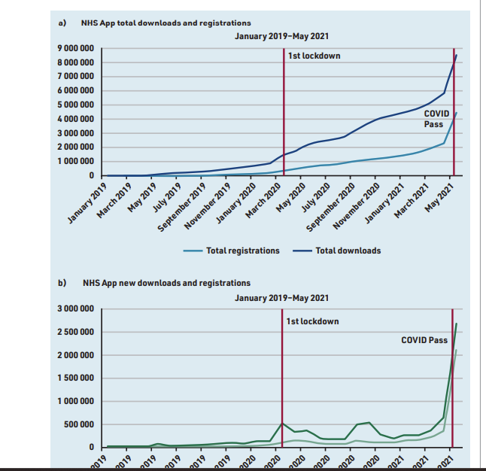
Figure 2: (KC et al., 2023)
The graphs show the number of people who downloaded and registered for the NHS App from January 2019 to May 2021. At first, only a few people used it, but downloads rose after the first UK lockdown in March 2020. There was another significant jump in May 2021, following the introduction of the COVID Pass. This indicates that major events, such as the pandemic and the COVID Pass, led to an increase in the number of people using the app (KC et al., 2023).

Recommendation
To maximise the benefits of the NHS App, both workforce and patient-focused strategies are essential. Continuous digital training and upskilling should be embedded across clinical and administrative teams, supported by protected learning time to prevent additional workload pressures (Health and Social Care Committee, 2023; Brown and Bewick, 2023). However, staff shortages and high workloads may limit participation; phased training schedules and the use of local digital champions could help embed skills sustainably. Leadership should promote a culture that views digital tools as enhancing rather than replacing patient care (Department of Health and Social Care, 2022). Though resistance to change may occur, clear communication of benefits and team-based mentoring can support adoption.
Staff must receive clear guidance on UK GDPR compliance to ensure that personal data is processed lawfully, fairly, and securely. Targeted support should be provided for older adults, deprived communities, and individuals with low digital literacy to reduce inequality (Tapuria et al., 2021). Maintaining multi-channel access through in-person, phone, and online services may strain resources, so prioritising priority populations and phased implementation could improve feasibility while maximising reach.
Ongoing feedback should be used to improve usability and ensure the app’s features meet the diverse needs of patients (KC et al., 2024). Embedding a system of regular review and adaptive updates ensures that feedback informs ongoing improvements while remaining practical within resource constraints.

Conclusion
The NHS App has fundamentally reshaped healthcare access and workforce practices in the UK, providing patients with convenient, secure, and personalised access to services while reducing administrative burdens on staff. Its integration with GP services, electronic patient records, and digital consultations has enhanced efficiency, improved patient safety, and empowered individuals to engage actively in their own care (NHS England, 2023; KC et al., 2023). However, challenges remain, including digital exclusion among older adults and deprived populations, uneven adoption across sociodemographic groups, and workforce pressures related to training and adaptation to digital workflows (Tapuria et al., 2021; Health and Social Care Committee, 2023).
Despite these challenges, the NHS App demonstrates significant potential as a transformative digital tool. Its ability to support self-management, preventative care, and integrated health records aligns with national digital strategies and priorities outlined in the NHS Long Term Plan and the Digital Health and Care Plan (Department of Health and Social Care, 2022; NHS England, 2025). Moving forward, addressing digital exclusion should be a critical priority, as equitable access underpins the success of all other digital innovations. By tackling this challenge, supporting the workforce, and continuously improving usability, the NHS App can deliver sustainable, patient-centred care while contributing to the broader goal of a digitally mature and connected health and social care system.

Reference List
Amaré Health (2023) Top 3 challenges for healthcare in 2023. Available at: https://amarehealth.co.uk/top-3-challenges-for-healthcare-in-2023/
Brown, T.M.H. and Bewick, M. (2023) ‘Digital health education: the need for a digitally ready workforce’ Archives of Disease in Childhood - Education and Practice Edition, 108(3), pp. 214-217. Available at: https://pmc.ncbi.nlm.nih.gov/articles/PMC10313993/ (Accessed: 4 October 2025).
Costelloe, C. (2022) Digital Innovation in Healthcare. Available at: https://www.openaccessgovernment.org/article/digital-innovation-in-healthcare/145149/?utm_source (Accessed: 4 October 2025).
Department of Health and Social Care (2022) A plan for digital health and social care. GOV.UK. Available at: https://www.gov.uk/government/publications/a-plan-for-digital-health-and-social-care/a-plan-for-digital-health-and-social-care#summary (Accessed: 4 October 2025).
Health and Social Care Committee (2023) Digital transformation in the NHS. House of Commons.Availableat:https://publications.parliament.uk/pa/cm5803/cmselect/cmhealth/223/report.html (Accessed: 4 October 2025).
KC, S., et al. (2023) ‘An observational study of uptake and adoption of the NHS App in England’ British Journal of General Practice. Available at: https://doi.org/10.3399/BJGP.2022.0150
National Data Guardian (2024) National Data Guardian 2023-2024 report. London: GOV.UK. Available at: National Data Guardian 2023-2024 report - GOV.UK (Accessed: 19 October 2025).
NHS Digital (2021) NHS App pilot research report: What we learned from users. Available at:https://digital.nhs.uk/services/nhs-app/nhs-app-pilot-research-report/what-we-learned-from-users?utm_source (Accessed: 30 September 2025).
NHS England (2021) NHS App strategy: developing the digital ecosystem. Available at: https://digital.nhs.uk/services/nhs-app/nhs-app-strategy (Accessed: 4 October 2025).
NHS (2022). Helping develop the NHS Long Term Plan. NHS Long Term Plan. Available at: https://www.longtermplan.nhs.uk/?utm_source (Accessed: 4 October 2025).
NHS England (2023) Delivery plan for recovering access to primary care. Available at: https://www.england.nhs.uk/long-read/delivery-plan-for-recovering-access-to-primary-care-2/?utm_source (Accessed: 4 October 2025).
NHS England (2025) Review of NHS performance and delivery. Available at: https://www.england.nhs.uk/long-read/review-of-nhs-performance-and-delivery/?utm_source (Accessed: 4 October 2025).
NHS England Digital (2025) NHS App features. Available at: https://digital.nhs.uk/services/nhs-app/nhs-app-features?utm_source (Accessed 4 October 2025).
Reidy, C. et al. (2025) ‘Qualitative evaluation of the implementation and national roll-out of the NHS App in England’, BMC Medicine, 23(20). Available at: https://link.springer.com/article/10.1186/s12916-024-03842-w
Tapuria, A., Porat, T., Kalra, D., Dsouza, G., Xiaohui, S. and Curcin, V. (2021) ‘Impact of patient access to their electronic health record: systematic review’ Health Informatics Journal, 27(2), pp. 194-206. Available at: https://doi.org/10.1080/17538157.2021.1879810
The King’s Fund (2020) The digital revolution: Eight technologies that will change health and care. Available at: https://www.kingsfund.org.uk/insight-and-analysis/long-reads/digital-revolution (Accessed: 30 September 2025).
Warwick House Medical Centre (no date) Patient Access. Available at: https://warwickhouse.org.uk/patient-access/

