Assessment 2
Programme: BA Business Management
Module: The Global Business Environment
Module code: LCC4005
Assignment title: Assessment 2
Environmental Analysis of an Industry
Student name: Anca Larisa Costache
Student number: 2021935

Contents
Introduction 3
Critical analysis of the changes 4
Competitive advantage position 8
Recommendation 8
Conclusion 10
References 11

Introduction
Given case study is concerned with the impact that clothing companies have on the environment. The clothing industry is considered the second most polluting industry. It is important for management and stakeholders to understand the impact that these business operations had on the environment. Protection of the environment should be considered an important regulated requirement for every company. These regulations should be made mandatory by the government and other regulatory authorities. Since these regulations are not compulsory in every country, businesses are taking advantage of the lack of regulation to save the cost of operation. The main focus of this report will be to identify the impact of business operations undertaken by Burberry on the environment. This report will also analyse the steps taken by Burberry in the past few years for regulating their business model. All of the concerns raised by stakeholders in the given case study will be analysed from the perspective of Burberry.


Critical analysis of the changes
The main focus of this report will be to analyse the changes made by Burberry to incorporate the suggestions made by shareholders in this study. After reading the case study it can be said that there are two major concerns associated with the operations of businesses in the clothing industry. The first concern is related to the impact of the production process undertaken by clothing companies on the environment. To reduce the cost of operation, the fast-fashion technique is being used by the majority of companies. In this technique, the primary focus of these companies is to increase the speed of production processes to provide products and services at a lower cost. companies are not concerned with the environmental impact of the speedy production process in this technique of production and marketing (Joy and Peña, 2017).
Another concern raised by the shareholders is related to the violation of labour laws in developing countries. The primary focus of every organization operating in this industry is to save water corporations. Laws are very strict in developed countries whereas these regulations are not followed properly in developing countries. it is one of the primary reasons that these clothing companies are establishing their manufacturing units in developing countries such as Pakistan, China, Turkey, Rwanda, etc. SWOT analysis is required to be undertaken to identify the strength and weaknesses of the company before analysing the steps taken by Burberry for dealing with the concerns raised in this case study.

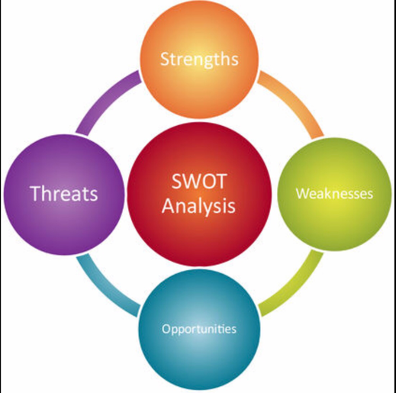

Strength
Brand value is one of the primary strengths of the organization as it has experience of more than 150 years of operating in the United Kingdom. It is an associated name of clothing business in the United Kingdom. In addition to that, it has been able to increase the variety of products and services over the period.
Quality of products and services in other strength of the organization due to which popularity of the company has been increasing over the period. Customers are satisfied with the product and services offered by the company.
Marketing resources available with the organization have resulted in a constantly growing demand for the product in the market. TV Advertisements, signage, and other modern methods of marketing are being used to promote their products (Khandual and Pradhan, 2019).
The international presence of this brand has also helped in domestic as well as international sales of the company. Burberry has a presence in around 50 countries with more than 500 stores all across the globe.
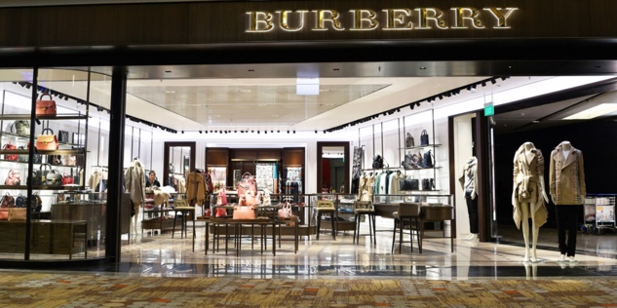
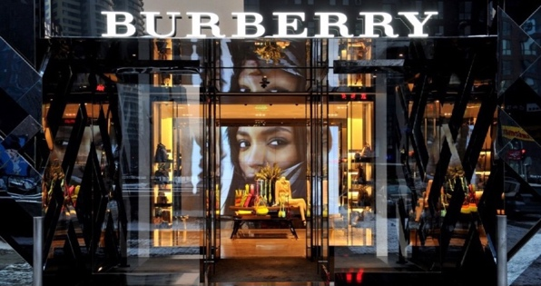

Weaknesses
One of the primary weaknesses of this brand is its premium range. The price of products and services offered in the premium range is significantly higher as compared to other competitors in the market. The company is also not providing a better quality of products in this premium range as compared to competitors.
The majority of clothing companies have established their market in Asian countries as the potential of the Asian market has not been achieved to its full potential. Burberry has not been able to establish its operations in the Asian market that is affecting its revenue.
Opportunities
There is a scope of growth in the Asian market with effective advertisement and marketing strategies. The company has to alter its product and services under the demand of consumers in the Asian market. This will have a very positive impact on its ability to generate more revenue (Millington and Darnell, 2019).
Expanding the product lines will also create a lot of opportunities for the company to target different consumer markets. the production level of the company should be reduced in the premium range and excess capacity should be used to extend the product range.
Threat
One of the major threats in the current business scenario is created due to the covid-19 pandemic. Overall revenue of the organization has reduced significantly as products and services offered by Burberry are not considered as essential services or products.
Extensive competition is another major threat to operating the clothing business. There are other organizations such as Versace, Gucci, Prada, etc. that have established their operations all across the globe.
Steps were taken by Burberry to cope up with the concerns raised by different stakeholders in the last few years-
Purchasing policies
Purchasing policies of the organization have been altered in the last few years. One of the primary reasons for wastage and pollution in the clothing industry is excessive buying. Overbuying results in the disposal of clothes in such a manner that it creates a footprint on the environment. The demand and supply analysis technique are being used by the organization to ensure that the production level is in line with the demand for the product. It also has a very positive impact on the ability of the organization to maintain the cost of operation. Limited purchase of raw material will result in a limited amount of direct expenses (Shafie and Kamis, 2019). It will also provide a competitive advantage over other competitors as the product will be cheaper as compared to other competitors.
Governance over manufacturing units
One of the major problems identified by stakeholders in the given scenario was labour Law not being followed in developing countries. Over the period, it has become very common for businesses in the clothing industry to tablets their operations in developing countries like India, Pakistan, Turkey, Rwanda, etc. labour laws are not followed very strictly in these countries as overpopulation of these countries is significantly higher as compared to developed countries. The overall supply of labour is significantly higher as compared to demand which forces them to work at very cheap prices. The sustainable practice of constant governance is being followed by Burberry overall manufacturers in developing countries. Every manufacturer in developing countries needs to follow labour regulations applicable in their countries. Any non-compliance can result in the shutdown of such manufacturing units.
Recycling
The recycling department has been established by Burberry to ensure that unused raw material is not wasted. One of the primary contributors to pollution in the clothing industry is the wastage of raw materials and clothes. Disposal of clothes is also a contributed towards the soil pollution and water pollution (Sandin et.al, 2019). The main focus of this department is to use new technology for recycling raw material and clothes returned by customers. This recycling process has created a brand image of a Sustainable organization for the company in the United Kingdom.
Internal standards
Internal standards of operations have been created by an organization that is required to be followed by the production department. This internal standard also includes the marketing techniques for the marketing and advertising department. The main focus of the marketing efforts is to prevent the wastage of clothes and property cycling in the hands of the consumer (Niinimäki et.al,2020). These internal standards are revised constantly so that changes can be made following the changes in the business environment. The internal standard committee keeps an eye on new technology being introduced in the clothing industry so that the recycling process can be improved. It is also the responsibility of this community to ensure that all the standards are being followed by All the departments properly. The internal review is undertaken by this committee on a regular interval time.
Front end approach
This alludes to the joining of feasible activities toward the early phases (front-finish) of the material item life cycle, for example, in the crude material sourcing and plan and advancement measures. In this way, for instance, a front-end reasonable activity could be the choice to utilize "low natural impact*" material strands as the crude materials for the material products being delivered. A front-end reasonable activity could likewise be shown in the plan and improvement measure, for instance, by using computerized instruments to limit the requirement for actual model examples or via preparing planners to embrace an eco-cognizant outlook into their manifestations (Harris, Roby and Dibb, 2016). (*Note that we are utilizing the expression "low ecological effect" material filaments instead of "manageable" or "eco-accommodating" or "green" material strands because the last terms can be deceiving as there are no totally "economical/eco-accommodating/green" strands; all materials represent some effect. Moreover, as talked about in the past area, it is hard to fearlessly affirm the effect of a specific material, as there are numerous features of ecological effect. Along these lines "low climate sway" is a more precise portrayal of what is feasible to take a stab at in reasonable materials).

Competitive advantage position
It can be said that the management of Burberry is making efforts for sustainable management of the company. One of the primaries focuses of this organization has been to ensure sustainable development and create an environmentally friendly image among the consumer. In today's business environment, consumer awareness about the negative impact that a business organization has on the environment (Guimarães, Severo and Vasconcelos, 2017). They prefer to purchase products and services of businesses that are involved in the sustainable management of business operations. It is one of the primary reasons that forget social responsibility activities are undertaken by these business organizations. These activities are undertaken as a method of marketing and advertisement for creating a positive image among the consumer.
On an overall analysis of the efforts made by Burberry in past few years, it can be said that it will provide a competitive advantage (Almada and Borges, 2018). One of the steps taken by Burberry to sustainable development will create a brand image among the consumer. Consumers will prefer to purchase products and services of Burberry to open other computers. Consumers are becoming aware of the advantages of environmentally friendly operations by business organizations. Consumers are even willing to pay the additional amount for similar quality products if they are aware that a particular organization practices sustainable development. Burberry will be required to ensure that all the steps taken by them are properly communicated to the consumers. Marketing strategies adopted by Burberry should promote sustainable and environmentally friendly practices of the company. These activities should be published on the official website as well as every material issued by the company in their AGM.

Recommendation
Marketing
Marketing of these activities is an essential step that is required to be taken by Burberry. The overall cost of production is expected to increase after environmentally friendly steps are taken by the company (Geissdoerfer, Vladimirova and Evans, 2018). Consumers will be willing to pay an additional amount only if they are aware that sustainable practices are being used in the production process. If these practices are not communicated properly through marketing then consumers will move towards alternative products.
Constant review
Establishing internal procedures is not sufficient to form an organization to practice sustainable management. Management must be reviewing these activities to identify their efficiency. The main focus of this review process will be to identify whether there has been any positive impact on the operations of the company after undertaking the sustainable development (Hakkak and Ghodsi, 2015). Key performance indicators should be established by the company and these are required to be reviewed every quarter.

Conclusion
On an overall analysis of this report, it can be concluded that sustainable and environmentally friendly practices are becoming very essential for businesses and the clothing industry. The clothing industry is contributing significantly towards pollution of soil, water, and air. It has affected the brand image of many companies in past. This report has been focused on sustainable practices initiated by Burberry in the past few financial years. It can be said that these sustainable practices will have a positive impact on the revenue generation capabilities of the company. Consumers are becoming aware of the impact that these practices have on the environment. Consumers will be willing to pay the additional amount of selling prices for consumer search products and services. This report has also provided some recommendations that will improve the sustainable practice management of Burberry.

References
Almada, L. and Borges, R., 2018. Sustainable competitive advantage needs green human resource practices: A framework for environmental management. Revista de Administração Contemporânea, 22(3), pp.424-442.
Geissdoerfer, M., Vladimirova, D. and Evans, S., 2018. Sustainable business model innovation: A review. Journal of cleaner production, 198, pp.401-416.
Guimarães, J.C.F.D., Severo, E.A. and Vasconcelos, C.R.M.D., 2017. Sustainable competitive advantage: a survey of companies in Southern Brazil. BBR. Brazilian Business Review, 14(3), pp.352-367.
Hakkak, M. and Ghodsi, M., 2015. Development of a sustainable competitive advantage model based on balanced scorecard. International Journal of Asian Social Science, 5(5), pp.298-308.
Harris, F., Roby, H. and Dibb, S., 2016. Sustainable clothing: challenges, barriers and interventions for encouraging more sustainable consumer behaviour. International Journal of Consumer Studies, 40(3), pp.309-318.
Joy, A. and Peña, C., 2017. Sustainability and the fashion industry: conceptualizing nature and traceability. In Sustainability in fashion (pp. 31-54). Palgrave Macmillan, Cham.
Khandual, A. and Pradhan, S., 2019. Fashion brands and consumers approach towards sustainable fashion. In Fast fashion, fashion brands and sustainable consumption (pp. 37-54). Springer, Singapore.
Millington, R. and Darnell, S.C. eds., 2019. Sport, Development and Environmental Sustainability. Routledge.
Niinimäki, K., Peters, G., Dahlbo, H., Perry, P., Rissanen, T. and Gwilt, A., 2020. The environmental price of fast fashion. Nature Reviews Earth & Environment, 1(4), pp.189-200.
Sandin, G., Roos, S., Spak, B., Zamani, B. and Peters, G., 2019. Environmental assessment of Swedish clothing consumption—six garments, Sustainable Futures. Mistra Future Fashion
Shafie, S. and Kamis, A., 2019. The Sustainability in the Industry of Green Apparel: Are We Ready?. International Journal of Psychosocial Rehabilitation, 23(4).

