

Cloud Engineering Principles and Practice

Programme Name: MSc Cybersecurity & Digital Forensics
Module Name: Cloud Engineering Principles and Practice
Module code: ACCA7027
Lecturer: Renuga Jayakumar
Student Name: Babariya Ashthaben Girishbhai
Student ID: 2507706

Table of Contents
1. Introduction 4
2. Principles of Virtualisation 5
2.1 Definition of Virtualisation 5
2.2 Benefits of Virtualisation 6
2.3 Limitations of Virtualisation 6
3. Containerisation and Docker 7
3.1 Principles of Containerisation. 7
3.2 Advantages of Containerisation. 8
3.3 Docker Architecture 8
3.4 Dockerfile Construction 9
4 Images and Publishing 10
4.1 Docker Images 11
4.2 Publishing to Docker Hub 11
5. Container Volumes and Networking 12
5.1 Container Volumes 13
5.2 Container Networking 14
6. End-to-End Docker Application 14
7. Cloud Computing Concepts 16
7.1 Load Balancing 16
7.2 Scalability 17
7.3 Application Gateways 17
7.4 Cloud Concepts Complementarity. 18
8. Driving Forces of Cloud Computing 18
8.1 Cost Efficiency 18
8.2 Flexibility and Agility 19
8.3 Serverless Computing 19
8.4 Container-Based vs. Serverless Approaches. 19
9. Conclusion 20
9.1 Docker Web Server Setup: Images, Containers and Dockerhub Video……………….21
10. References 21

List of Figures
Figure 1 : Dockerfile FROM instruction defining nginx:latest as the base image 9
Figure 2: Dockerfile instruction copying the application HTML file into the Nginx container directory 10
Figure 3: Dockerfile showing the configuration steps used to build a custom Nginx web server container 10
Figure 4: Terminal output confirming successful push of the Docker image to Docker Hub 12
Figure 5: Docker Hub repository showing the published image aastha0512/docker-web-demo 12
Figure 6: Creation of a Docker volume to enable persistent storage for the containerised application 13
Figure 7: Browser output confirming successful delivery of web content from the Docker container 13
Figure 8 : Output of docker network ls showing Docker bridge networks used for container communication 14
Figure 9 : Web application accessed through a load-balanced Docker setup on port 8081 15
Figure 10 : Successful deployment of multiple containers and reverse proxy using Docker Compose 16
Figure 11 : Docker Compose command demonstrating horizontal scaling by running three instances of the web service 17

1. Introduction
Cloud computing is a new paradigm which has been a core pillar of the contemporary information technology where an organisation is able to access computing resources like server, storage, networking and applications on the internet on an on-demand flexible basis (Ümit Demirbaga et al., 2024). Cloud computing also enables resources to be brought dynamically, scaled as needed and paid on a consumption basis compared to utilizing the locally hosted infrastructure. The approach has changed greatly the design, deployment and management of applications, and has provided better efficiency, agility, and cost-effectiveness in the process.
Virtualisation is a fundamental block of cloud computing, enabling several computing environments to be independent of each other, on common physical equipment (Sudheer Mangalampalli et al., 2023). Virtualisation also allows more efficient use of hardware resources, fault isolation and fast provisioning of systems. Continuing on this, the idea of containerisation has been developed as a lighter and more efficient method compared to the traditional virtual machine. Applications are bundled along with their dependencies in containers that share the host operating system and have shorter start-up and lower overhead times as well as being more portable across environments.
Docker is now the standardized platform of containerisation offering a fully integrated environment of building, running and maintenance of containers. Docker can make the task of deploying applications straightforward because it enables the developers to describe application environments in Dockerfiles and release them in the form of portable images (Ilg, 2024). The usage of these images can be used reliably in development environments, testing environments, and production environments, which is more than consistent with DevOps and continuous integration/continuous deployment (CI/CD) concepts. Consequently, Docker is an important part of cloud-native application development.
The report gathers the concepts of cloud engineering both theoretically and practically. It studies the basics of virtualisation and containerisation, and then provides a practical example on Docker. The practical part comprises the creation and publication of Docker images, setting up of container volumes and networking, as well as the deployment of an end-to-end containerised web application. Moreover, the report also examines some of the key concepts in cloud computing including load balancing, scalability and application gateways and how they are applied in managed cloud computing such as Microsoft azure. Lastly, the report assesses the forces that have managed to drive cloud adoption such as cost efficiency, flexibility and the rise of serverless computing and presents a critical analysis of the container-based architecture versus the serverless architecture.

2. Principles of Virtualisation
Virtualisation is a supporting technology that is the basis of current cloud computing and was used to efficiently utilise physical computing resources over the last several decades. Virtualisation enables the sharing of physical resources by means of an abstraction of the underlying physical infrastructure into multiple autonomous computing environments, which can run simultaneously on the same physical system.

2.1 Definition of Virtualisation
Virtualisation is a process that involves the deployment of computers on a network without the need of being physically on the same geographical location.Virtualisation is the design of virtual copies of real computing resources, such as servers, storage devices, and networks as well as operating systems. Fundamentally, virtualisation allows the one physical machine to run several independent virtual machines (VMs), each with its operating system and applications that it would be presented as its own system. A software layer called a hypervisor is used to perform this abstraction.
Hypervisors have the duty of controlling and distributing physical resources like CPU, memory and storage to virtual machines. Hypervisors are of two main types. A bare-metal hypervisor, also called type 1 hypervisor, is a hypervisor that operates directly on the hardware of the host, that is, it does not need a host operating system. They include VMware ESXi, Microsoft Hyper-V and Xen. These hypervisors find application in enterprise data centres and cloud platform as they have high majority of performance, scalability and minimal overheads (Stoyanov, 2024).
Type 2 hypervisor, on the other hand, consists of a regular operating system of a host. They may be VirtualBox and VMware Workstation. Unlike Type 1 hypervisors which can be installed with far fewer overheads, Type 2 hypervisors come with more overheads and are often not as efficient as Type 1 hypervisors. Type 1 hypervisors are more suitable in cloud environments since they offer better isolation and enhance performance as well as control of hardware resources.

2.2 Benefits of Virtualisation
Enhanced use of resources can be seen as one of the greatest advantages of virtualisation. Physical servers are also normally used with low utilisation which wastages of the computational capacity. Virtualisation gives the possibility to share a physical hardware with various virtual machines to enhance the overall usage and avoid the necessity of purchasing extra physical servers. The outcome of this consolidation is the more efficient utilization of data centre space, power and cooling resources.
Another important benefit is isolation. The virtual machines are not interdependent, i.e. the failure, crashing down, or a security breach in one virtual machine does not directly impact the other virtual machines that are in the same physical host (Rakesh Reddy Gurrala, Kumar and K. Anuradha, 2024). This isolation increases the reliability and security of the system, thus virtualisation is especially appropriate in the context of multi-tenant cloud computing where users of the infrastructure share the system.
Cost efficiency is also a factor brought about by virtualisation. It enables organisations to reduce capital expenditure on hardware and operational costs that are incurred in servicing, energy usage and maintenance of their infrastructure. Also, virtual machines may be quickly deployed, copied, or moved across hosts and enhance operational responsiveness and allow dynamic scaling of workloads in response to demand fluctuations. These attributes cause virtualisation to be one of the enablers of Infrastructure as a Service (IaaS) models provided by cloud providers.

2.3 Limitations of Virtualisation
There are a number of limitations that are generated by this, and it is important to weigh all these limitations in the light of virtualisation. Performance overhead is one of the weaknesses. Since the virtual machines use a layer of hypervisor to access hardware resources, there must be some performance loss, as compared to the performance when running the applications on physical hardware. This overhead can still be a problem to latency-sensitive or high-performance workloads even though modern hypervisor versions have mitigated much of the overhead.
The other weakness is associated with boot times and overhead. Virtual machines take much longer to boot than lightweight technologies like containers because they have to be loaded with an entire operating system (Alndawi, 2021). This may make it less responsive in a situation where quick scaling or high instance count must be done.
Lastly, virtualisation usually results in duplication of resources especially at operating system levels. Every virtual machine also includes an instance of any OS, libraries, and background services which can take up a lot of memory and storage resources. This redundancy is opposite to the containerisation strategies where containers use the same host operating system kernel thus using fewer resources and more efficient.

3. Containerisation and Docker
Containerisation has become a central technology in cloud engineering today, as it provides a more lightweight and efficient substitute to the conventional virtualisation. Though virtual machines are still popular, containerisation can accommodate most of the limitations of the virtualization because it allows the applications to run on a controlled environment that shares a host operating system (Queiroz et al., 2023).

3.1 Principles of Containerisation.
Containerisation Containerisation is a type of operating system-level virtualisation that enables applications to be bundled along with dependent libraries and executed in separate user spaces called containers. Containers do not need a complete instance-guest operating system, as is the case with virtual machines. Rather, they share the kernel of the host system yet they are isolated using namespaces and control groups (cgroups).
The major difference between containers and virtual machines is the abstracted resource. Virtual machines are replications of hardware that execute entire operating systems, which lead to an increased overhead and slow start-up. In comparison, containers isolate the operating system layer enabling multiple applications to execute on the same host with much less resource usage. The architectural difference helps containers to boot up quickly almost instantly and scale within a short time in direct proportion to the work load.
Containers are also less heavyweight compared to virtual machines since they depend on the kernel of the host operating system. Nevertheless, isolation is maintained and the processes in one container will not be affected by another. The combination of efficiency and isolation of containerisation renders it especially suitable to the microservices architecture and the design of cloud-based applications.

3.2 Advantages of Containerisation.
The first advantage of containerisation is the lightweight nature. Containers also consume less system resources as compared to virtual machines since they do not replicate operating systems. This enables more applications to be operated on the same physical or virtual infrastructure and enhances the overall utilisation of resources as well as minimising operation costs.
Another important benefit is the portability. Containerised applications may be put into practice uniformly amongst various environments and these may encompass local development machines, in-premises servers and public cloud infrastructures (Bentaleb et al., 2021). Since all dependencies of the application are encapsulated into a container, the compatibility problems commonly linked to the deployment of the software are removed. This portability was evidenced in the practical part of this coursework where a Docker image was developed locally and then it was pushed to Docker Hub in order to be reused again.
Containerisation also facilitates the rapid deployment and scaling. Containers can be easily started, stopped, and replicated, and therefore, it can scale applications very fast with the changing demand. This feature is very similar to other attributes of cloud computing like elasticity and high-availability. As part of the practical implementation, the horizontal scalability was put into practice with Docker Compose being used to scale out several instances of a web service behind a reverse proxy.
Lastly, containerisation has a high score in DevOps practices. Containers can be easily incorporated with CI/CD pipelines, whereby applications can be constructed, tested and deployed automatically. Containers enhance configuration drift prevention and development and operations co-operation due to standardisation of application environments. Due to this, containerisation has been integrated into the modern DevOps processes.

3.3 Docker Architecture
Docker is the most used containerisation system and offers a rich ecosystem of developing, distributing and operating containers. The most important element in the architecture of Docker is the Docker Engine that creates and manages containers. Docker Engine contains a daemon that facilitates operations related to container lifecycle, an API that enables working with Docker using a programmable interface, and a command-line interface that works with developers and administrators.
Docker images are templates that are impossible to edit and specify what a container should contain (Chen et al., 2021). Images are constructed in layers and each layer is a certain command in a Dockerfile. Such a layered architecture is more efficient because the layers can be reused by being stored and used across an array of images. In the actual application, a personalized image was created upon the official image of Nginx, which illustrates the ability of base images to be extended to form application-centric environments.
Docker images can be implemented as containers. An image can be executed, and in doing so, Docker will form a container which will contain a writable layer over the image read-only layers. Containers are separated both with each other and with the host system, but they have the same operating system kernel as that of the host. This model allows to carry out the work effectively and at the same time, it is safe and reliable.
Docker Hub is a free and open-source image repository and distributor of images. Posting pictures to Docker Hub helps in collaboration as well as allowing the deployment of system consistency among environments. The custom Docker image was successfully uploaded to Docker Hub in this coursework, which proves the ability to version an image and reuse it in a cloud-based workflow.

3.4 Dockerfile Construction
A Dockerfile is a configuration file (text based) that details the way a Docker image is constructed. It includes a list of commands specifying the underlying base image, application files and configuration to runnable container. Dockerfiles facilitate infrastructure as code because they allow the definition of application environments in a declarative manner and allow their reproducibility (Moreau, Wiebels and Boettiger, 2023).
In the real-life application, the Dockerfile started with the following command:

Figure 1 : Dockerfile FROM instruction defining nginx:latest as the base image
This direction defines the official image of Nginx as a basimage which offers a ready web server environment. Reliability is ensured by using trusted base image because the underlying software is maintained and updated by the image provider, making the image solution less complex.
The application content deployment was done as the following instruction:
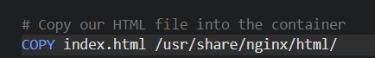
Figure 2: Dockerfile instruction copying the application HTML file into the Nginx container directory
This is the command that will be used to copy an HTML custom file to the default Nginx web directory of the container. Consequently, in case the container is started, the Nginx server will automatically serve the custom web page. Here the content of the application may be directly embedded into a container image.
Through the process of image building, Docker runs every command in the Dockerfile one by one, and a new image layer is built during each step. Such layers are stored in the cache to enhance efficiency in the speed of building, such that layers that are not changed do not necessarily have to be re-built. After the building process has been run, the generated image may be performed as a container or may be released into a registry to be distributed.
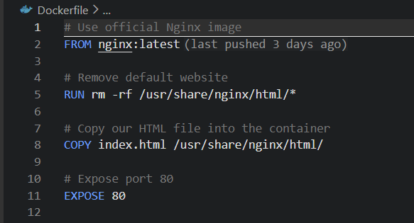
Figure 3: Dockerfile showing the configuration steps used to build a custom Nginx web server container

4 Images and Publishing
Docker images can be described as a key component to container based applications deployment, offering a portable, reusable, and consistent representation of an application and a runtime environment. Images help to develop applications only once and deploy it consistently across various systems, which are very much aligned with the purposes of cloud computing and DevOps practices.

4.1 Docker Images
A container is created using an image that is defined by container icons and built as an immutable read-only template known as a Docker image. Images are built with a layered architecture with each layer being associated with a command in a Dockerfile. It is a basic design element of the efficiency of Docker because this design enables each layer to be made and reused by other images. E.g. in the case where an image is stacked atop an existing base image like nginx:latest, Docker does not recreate the base image layers, but it uses them, which saves time and space during building and storage.
The consistency of deployments is guaranteed by the immutability of Docker images. Having created an image, its contents cannot be modified: to make any changes, one has to create a new version of a picture. This property minimizes the configuration drift and makes applications act in a similar way in the development, testing and production environments. The concept of immutability in the cloud engineering setting is especially useful since it enhances reliability, eases the process of debugging, and provides a way to version control the application environment.
In the practical part of this coursework, it was necessary to build a custom Docker image with the help of a Dockerfile, which extended the official Nginx image (Malhotra, Bansal and Marouane Kessentini, 2023). The resulting image had the web server and application contents in one, portable box, in which Docker images encapsulate an application logic and configuration.

4.2 Publishing to Docker Hub
One of the most important processes in order to make collaboration and scalable deployment possible is to publish Docker images into a container registry. Docker Hub is a popular open registry, where developers can store, share as well as distribute container images. Images should be tagged in order to be published, which will most often be of the form <username>/<repository):<tag> The image was labeled and hosted in the repository aastha0512/docker-web-demo in this coursework.
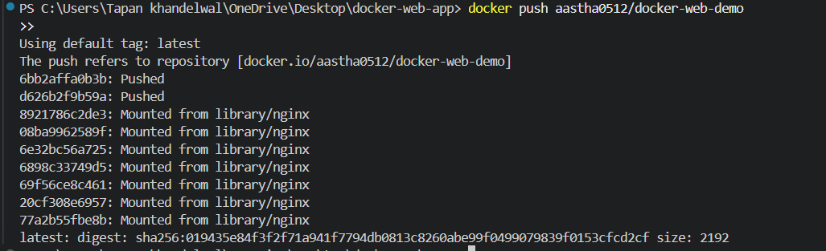
Figure 4: Terminal output confirming successful push of the Docker image to Docker Hub
Images can be accessed in any environment with Docker installed and this enables images to be portable and reusable with public repositories in Docker Hub. This facility is especially significant in cloud-based workflows, where pictures can be automatedly drawn through orchestration tools or deployment pipelines.
Publication of images is also important in CI/CD pipelines, in which automated tasks are used to develop, test and deploy applications. The ability to incorporate image publishing into CI/CD processes can provide organisations with the ability to make deployments repeatable, consistent, and traceable. Publishing of a Docker image to Docker Hub, as shown in this coursework, is a major move to leave the local development environment and move to scalable and cloud-ready deployment (Wist, Malene Helsem and Gligoroski, 2021).
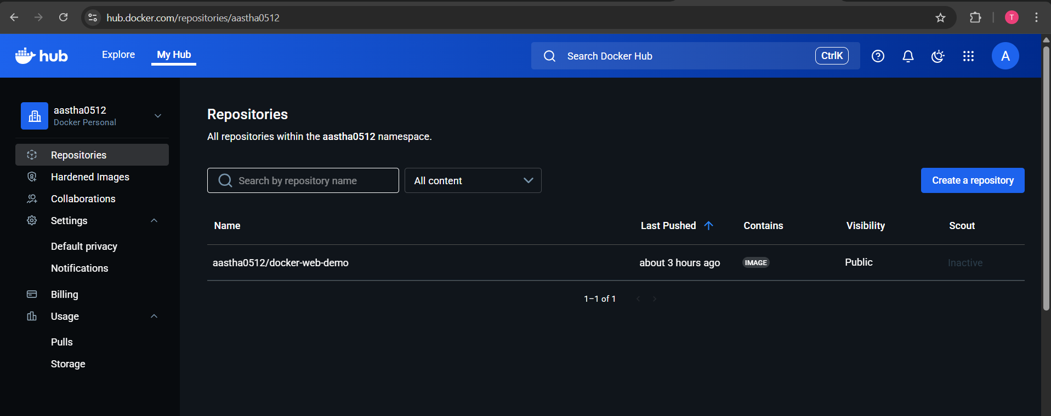
Figure 5: Docker Hub repository showing the published image aastha0512/docker-web-demo

5. Container Volumes and Networking
Container volumes and networking are vital elements of container-based application deployment because they solve two essential issues of cloud-native systems, namely data persistence and inter-container communication. The containers are meant to be lightweight and ephemeral but in practice persistent storage and secure networking is needed in real life applications..

5.1 Container Volumes
Containers are default ephemeral, i.e. any data to the container is destroyed when the container is removed or stopped. This behaviour is appropriate to stateless applications but is problematic with applications where persistent data is needed. Docker volumes mitigate this shortcoming by offering a storage data mechanism that is unrelated to the lifetime of a container.
A Docker volume is an object of management and storage that is developed and managed by the Docker engine (Acharya and Suthar, 2022). Volumes enable the data to persist even when the containers are deleted or recreated to enable the separation of concerns between application logic and data storage. This is one of the main principles of cloud-native design because it allows scaling, updating, and redeployment of applications without any risk, not even the loss of data.
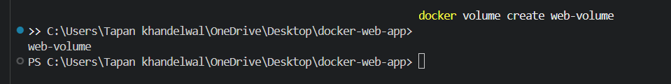
Figure 6: Creation of a Docker volume to enable persistent storage for the containerised application
In the real implementation, a Docker volume was made and its mount to the web directory of the Nginx container was done. This made sure that the web content was not lost during restarting of containers. Volumes show that stateful data can be easily managed in containerised environments and maintain the flexibility and portability of containers.
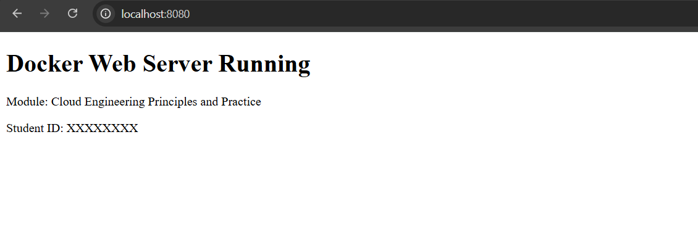
Figure 7: Browser output confirming successful delivery of web content from the Docker container
Lifestyle wise, Docker volumes are autonomous of containers and have to be removed explicitly when not in use. This behaviour offers more control of data management and well behaves by best practices of persistent storage of cloud systems.

5.2 Container Networking
Container networking is a process that allows communication between containers and outside clients without isolation and security (Jarkas et al., 2025). Docker has a number of drivers available in networking, the most popular of which is bridge networks in single-host settings. Bridge networks enable containers to exchange messages between them using internal IP addresses but isolate them to other irrelevant containers.
To support a restricted communication between various containers, such as a reverse proxy and scaled instances of a web service, a tailor-made Docker network was developed in the context of this coursework. This arrangement is typical of patterns of cloud deployment, with services communicating on private networks, as opposed to being publicly exposed to the internet.
Docker networking facilitates isolation as well since, between containers, connected to different networks, communication is not possible unless configured to do so. This seclusion enhances security and minimises the attack area of containerised applications. Besides, the DNS resolution provided by Docker enables the containers to learn about the other containers and talk to each other by name instead of using hard-coded IP addresses.
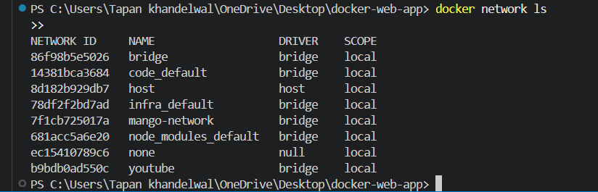
Figure 8 : Output of docker network ls showing Docker bridge networks used for container communication

6. End-to-End Docker Application
End-to-end Docker application is an application that illustrates the full cycle of a containerised system, including creating an image and letting users access it via the web browser (Kane and Matthias, 2023). This part is in compliance with a coursework requirement of a general process demonstration by providing a working web application that is deployed through Docker.
The app created as part of this coursework is a basic web server which is built on Nginx because it is lightweight, stable and has been used extensively in both containerised and cloud deployment. An application-specific HTML page was developed to contain application-related information, such as module and identification information. A Dockerimage containing this web content was created with the help of a Dockerfile and this meant that the environment in which the application was to be used could be replicated across different systems.
The Docker image has been created locally by using the docker engine and run as a container. In the execution of containers, port mapping was done to expose the internal Nginx service to the host machine. In particular, port 80 within the container was associated with port 8080 within the host system. This mapping allowed an external user to use the application using a standard web browser by going to the URL: http://localhost:8080. The fact that the custom HTML page was shown successfully proves that the containerised application was functioning well and network communication between the container and the host was configured correctly.
Further scaling and cloud-relevant behaviour configuration In order to show more scalability and cloud-relevant behaviour, a reverse proxy and more configuration were added, using Docker Compose. Several copies of the web service were implemented in the background of an Nginx based load balancer, whereby the requests are distributed among containers. It was pointed out that the access to the load-balanced application was made available using a different port, 8081, and this depicts how containerised services can be scaled horizontally to enhance availability and performance. This strategy reflects typical cloud implementation patterns, in which load balancers redirect the traffic among a number of service instances.
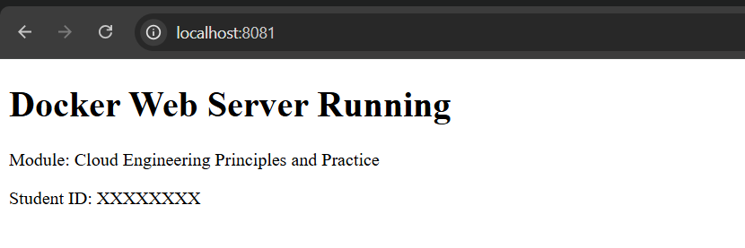
Figure 9 : Web application accessed through a load-balanced Docker setup on port 8081
The full process of creating the Docker image, containerisation, exposing services by using a port mapping and accessing the application through the use of browser illustrates the practical value of containerisation. It points out the capability of Docker to ease the effort of deploying applications, lessen complexity in configuration, and offer consistent environment of running applications. The fact that the implementation of the end-to-end was validated, that is, containerised applications are capable of being deployed in an efficient way and accessed reliably, demonstrates that Docker is an appropriate platform when developing cloud-native applications today.
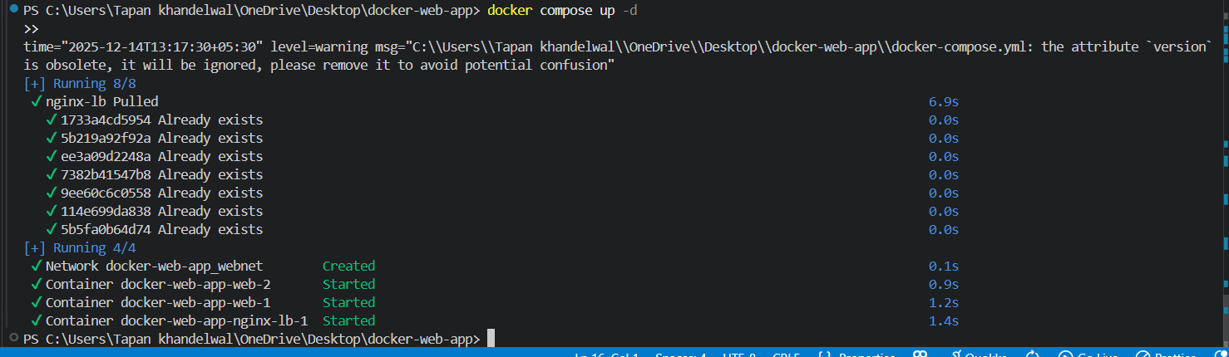
Figure 10 : Successful deployment of multiple containers and reverse proxy using Docker Compose

7. Cloud Computing Concepts
The implementation of the cloud computing environments is based on a number of fundamental architectural principles that guarantee the performance, availability, and resiliency of the applications. Some of its most critical ones are load balancing, scalability, and application gateways..

7.1 Load Balancing
Load balancing defines it as the act of spreading network traffic entering into a network to various computing devices in order to ensure that the network does not have a single component as a bottleneck (Farahi, 2025). To enhance the performance of the applications, to enhance the availability and to be fault tolerant is the main aim of load balancing. Load balancers evenly distribute traffic to ensure that the response times remain constant even with a high load.
A load balancing process with the help of an Nginx reverse proxy was evidenced in the real world within a Docker. Several web service instances were implemented, and requests were sent on these containers. By accessing the end point at port 8081, it was established that the reverse proxy was working and this offered viable evidence of the behaviour of load balancing.
Load balancing is also offered as a managed service in Microsoft Azure in Azure Load balancer and Azure Application Gateway (Kasture, 2023). These services will automatically allocate traffic between the virtual machines or containers automatically without requiring one to configure it manually. Although the Docker-based approach needs explicit configuration, it is similar to the general principles that are used by cloud providers.

7.2 Scalability
Scalability refers to the capacity of a system to withstand a higher workload through the capacity to increase the resources. There are two main scaling strategies: vertical scaling and horizontal scaling. In the former strategy, the scaling is accomplished by adding resources to one instance, whereas in the latter strategy, the scaling is achieved by adding more instances.
This coursework illustrates the horizontal scalability with the help of Docker Compose, in which a number of replicas of the same service were run at the same time. This strategy allows applications to work with more traffic because it can allocate the requests among multiple containers. In cloud environments, horizontal scaling is the solution of choice as it enhances resiliency and minimizes the number of points of failure.
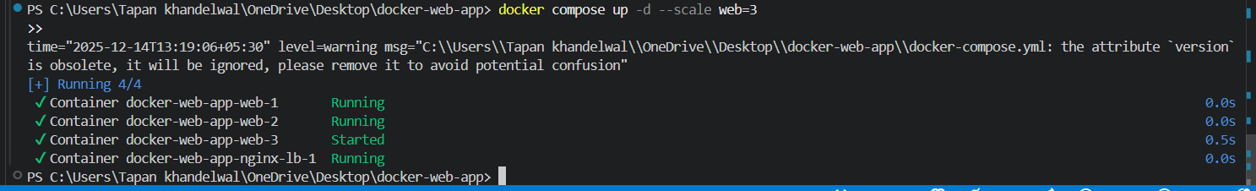
Figure 11 : Docker Compose command demonstrating horizontal scaling by running three instances of the web service
In Azure, it is implemented using Virtual Machine Scale Set or using container orchestration, like Kubernetes. The services are automatically configured to scale the number of running instances in accordance with demand. Even though the implementation is different, the Docker-based demonstration can be effectively used to demonstrate the same scaling principles under a controlled environment.

7.3 Application Gateways
Application gateways act at the application layer and offer sophisticated traffic control features including request routing, terminating of the use of the SSL and security filtering. The Nginx reverse proxy, in this coursework, serves as an application gateway, whereby the request directed to it is sent to respective backend containers (Huotari, 2025).
Azure offers this feature by use of Azure Application Gateway which is a managed service that combines load balancing, security as well as routing features. The theoretical resemblance between the Docker reverse proxy and Azure Application Gateway underscores that the local implementations with containers can depict the actual real-world cloud configurations.

7.4 Cloud Concepts Complementarity.
Scalability, load balancing, and application gateways are used in combination with each other to facilitate high-performance, highly available, and resilient cloud system. The distribution of traffic occurs by load balancing, demand by scalability, and intelligent routing by application gateway. Collectively, these ideas are the pillars of contemporary cloud computing designs.

8. Driving Forces of Cloud Computing
The adoption of cloud computing has been very fast due to the combination of technological, economic, and operational forces. Cloud platforms are increasingly being used in organisations in any industry to facilitate the development of modern applications, enhance efficiency, and the need to respond promptly to the fluctuating needs of the business (George, George and Baskar, 2023). In this section, the authors analyze the major drivers of the cloud computing adoption, paying special attention to the cost efficiency, flexibility, and agility, the advent of the serverless computing, and comparing it to the container based methods.

8.1 Cost Efficiency
Cost efficiency is one of the biggest sources of cloud computing. Conventional on-premises infrastructure is costly in terms of capital investment in hardware acquisition, data centres and maintenance. Contrastingly, cloud computing is based on pay-as-you-go business model enabling organisations to pay per use of the resources. This model minimizes capital investments and it transfers the cost to the operational costs.
Economies of scale also favour cloud providers who are able to provide computing resources at a lower cost than many organisations are able to do on their own. Some of its other features, like automatic scaling and resource optimisation, also minimise wastages by releasing unutilised resources back into circulation when the demand is low. Due to this, cloud computing offers a cost effective solution to the small organisations and the large enterprises alike.

8.2 Flexibility and Agility
Cloud computing has a major operational advantage in flexibility and agility. It has been found that cloud platforms enable infrastructure and service to be deployed in minutes as compared to weeks, thereby greatly accelerating the application development and deployment cycles. This accelerated provisioning helps in experimentation as well as innovation and quicker time-to-market of new applications.
Cloud environments also permit organisations to dynamically scale resources based on the changes in the workloads. This elasticity makes sure that there is performance of applications when there is peak demand without incurring unnecessary expenses during low usage. The practical implementation shown in this coursework with Docker proves the similar principles, with the container instances easily starting or stopping, according to the demand. This alignment shows that containerisation is an extension of the cloud flexibility (Muzumdar et al., 2024).

8.3 Serverless Computing
Another significant force that drives the adoption of clouds is the advent of serverless computing. Serverless computing models, which include Azure Functions or AWS Lambda, do not require developers to engage at all with infrastructure management, but instead provide a way to encapsulate a piece of logic to an application (Risco Gallardo, 2024). In serverless models, the applications are deployed as reactive to events and the cloud provider allocates and deallocates resources.
Some features of serverless computing include simplicity in terms of operations, automatic scalability, and intelligent billing of execution time. But it also brings down some constraints such as less control over the runtime environment, possible vendor lock in and limitations to long running processes. Such trade-offs imply that serverless computing cannot be used in all applications.

8.4 Container-Based vs. Serverless Approaches.
Whereas serverless computing cuts down on the deployment process, containerisation provides better control, interoperability and environment consistency. Applications are packaged together with certain dependencies and configuration, suitable to complex long-running service and microservices architectures, in containers (Hamzaoui et al., 2024). Serverless solutions, on the other hand, are most appropriate in event-based and stateless workloads.
Practically, a hybrid model is embraced by most organisations, which enable the integration of serverless functions and containerised services to use the advantages of both models. This trend is indicative of the overall development of cloud computing to a more flexible, modular architecture that is capable of adapting to various needs of the applications.

9. Conclusion
This report has discussed the concepts and implementation of cloud engineering using both theoretical and practical coverage. It explored the underlying principles of virtualisation in cloud computing and the role of containerisation in expanding upon such principles to provide more efficient, portable and scalable application environments. To illustrate these points in practice, Docker served as the main platform in the containerisation to ensure that the theory and the actual practice of the application are clearly interconnected.
The practical part has managed to illustrate the entire lifecycle of a containerised application, such as image creation, publication to Docker Hub, volume management, networking, and end-to-end deployment. Docker Compose and a reverse proxy also demonstrated important concepts of clouds like load balancing and horizontal scaling that are typical of deployment patterns in a modern cloud. The implementations validated the appropriateness of Docker in the development of cloud-native applications and agreement with DevOps.
Moreover, the report examined the basic concepts of cloud computing like scaling, application gateways and serverless computing and compared container-based and provided cloud services through platforms like Microsoft Azure. This analogy indicated the complementary aspect of local containerisation and cloud-managed infrastructure. Altogether, this report shows that the effective design of the resilient, efficient, and scalable systems in the modern context of cloud engineering requires a solid knowledge of not only the container technologies but also the cloud concepts.

9.1 Docker Web Server Setup: Images, Containers and Dockerhub Video
https://youtu.be/NHsDR8wudsc?si=CHRsqiawiqp8jnps

10. References
[1] J. N. Acharya and A. C. Suthar, “Docker Container Orchestration Management: A Review,” in Proceedings in Adaptation, Learning and Optimization, pp. 140–153, 2022, doi: 10.1007/978-3-030-97196-0_12.
[2] T. Alndawi, Replacing Virtual Machines and Hypervisors with Container Solutions, 2021. [Online]. Available: https://www.diva-portal.org/smash/record.jsf?pid=diva2:1562828. [Accessed: 14-Dec-2025].
[3] O. Bentaleb et al., “Containerization technologies: taxonomies, applications and challenges,” The Journal of Supercomputing, 2021, doi: 10.1007/s11227-021-03914-1.
[4] C. Chen et al., “Docker and Kubernetes,” pp. 169–213, 2021, doi: 10.1002/9781119739920.ch5.
[5] R. Farahi, “A comprehensive overview of load balancing methods in software-defined networks,” Discover Internet of Things, vol. 5, no. 1, 2025, doi: 10.1007/s43926-025-00098-5.
[6] A. S. George et al., “Edge Computing and the Future of Cloud Computing,” Zenodo, 2023, doi: 10.5281/zenodo.8020101.
[7] I. Hamzaoui et al., “Container-Based Cloud Revolution,” SN Computer Science, vol. 5, no. 4, 2024.
[8] H. Huotari, NGINX as an API Gateway, 2025. [Online]. Available: http://www.theseus.fi/handle/10024/881098.
[9] M. Ilg, From Infrastructure to Code, 2024, doi: 10.34726/hss.2024.100463.
[10] O. Jarkas et al., “A Container Security Survey,” ACM Computing Surveys, 2025.
[11] S. P. Kane and K. Matthias, Docker: Up & Running, O’Reilly Media, 2023.
[12] A. B. Kasture, “Load Balancing Services in Azure,” SSRN, 2023.
[13] R. Malhotra et al., “Vulnerability Analysis of Docker Hub Images,” 2023.
[14] D. Moreau et al., “Containers for computational reproducibility,” Nature Reviews Methods Primers, 2023.
[15] P. Muzumdar et al., “Navigating the Docker Ecosystem,” 2024.
[16] R. Queiroz et al., “Container-based Virtualization for Real-Time Systems,” ACM Computing Surveys, 2023.
[17] R. R. Gurrala et al., “Virtual Machine Security Issues,” 2024.
[18] S. Risco Gallardo, Serverless Strategies, 2024.
[19] B. Stoyanov, “Virtualization – Concept and Development,” 2024.
[20] S. Mangalampalli et al., “Cloud Computing and Virtualization,” 2023.
[21] Ü. Demirbaga et al., “Cloud Computing for Big Data Analytics,” 2024.
[22] K. Wist et al., “Vulnerability Analysis of 2500 Docker Hub Images,” 2021.

