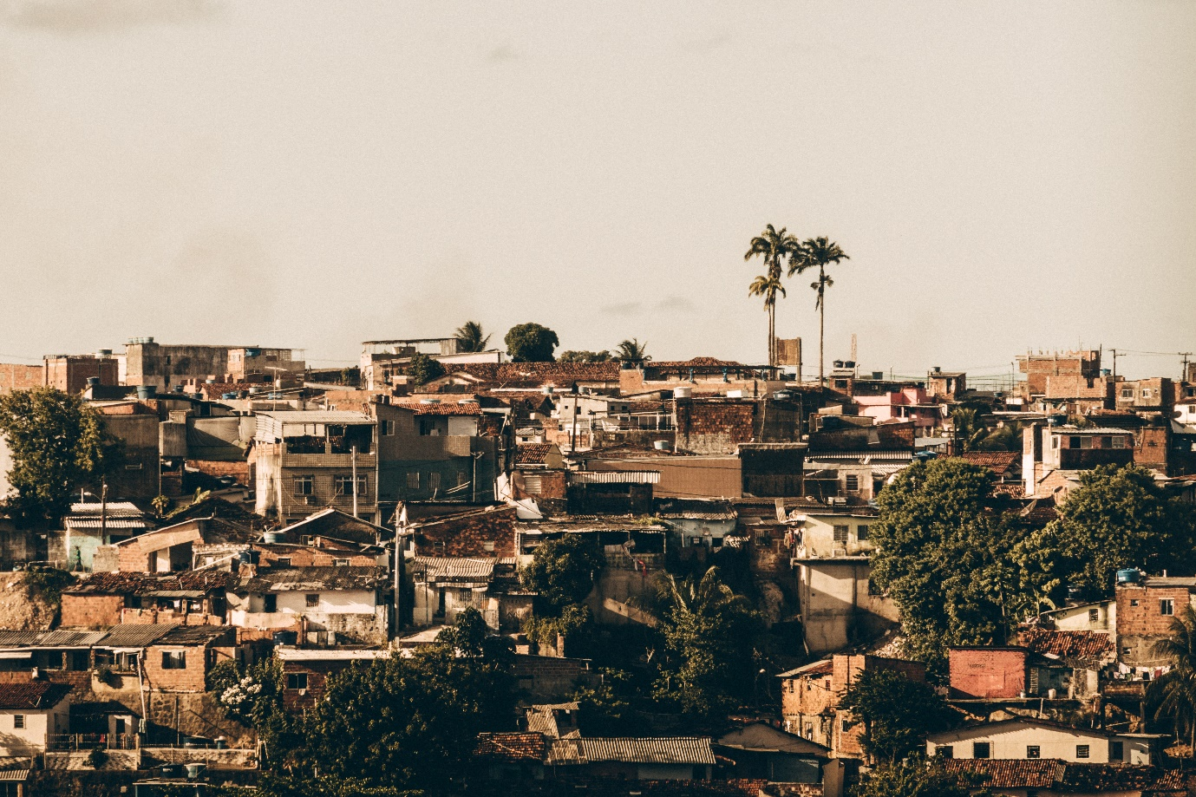
Thiago, J. March 15, 2020 Recife - PE, Brasil, Unsplash
This picture shows the reality of millions of Brazilian families, in the mist of poverty, lack of a proper education, health and diet. The struggle to survive just buried another dream somewhere in the picture you neither need to have a murder scene noir a corpse, just look at the conditions we live in.

Jones, H. (2016) More Education, Better Jobs? A Critical Review of CCTs and Brazil’s Bolsa Família Programme for Long-Term Poverty Reduction. Social policy and society : a journal of the Social Policy Association. [Online] 15 (3), 465–478.
A great article talking about the need for generational wealth, giving a good starting point on how to star thinking about generational wealth , investing and understanding capital, definitely very relevant due to the situation in brazil and millions feel stuck and don’t know how to get out of the situation they are in.

The Truman Show (1998) directed by Peter Weir, produced by Scott Rudin, Andrew Niccol, Edward S. Feldman, and Adam Schroeder, and written by Niccol , Scott Rudin productions , paramount pictures

The Truman Show ET. AL (1998) Scott Rudin productions, paramount
(added two because I wasn’t sure for a movie if I added everything or ET AL)**I think ET AL**
One of my favourite movies, brings a great perspective of how we perceive ourselves and how other perceive us, on how we live our life’s, assumption of being watched, the affected of that though in our actions and reality.

Brazil a biography (2019) Ilia, S. and Heloisa M , penguin random house UK, first edition published in 2015 in Portuguese by companhia das letras.
This book is an interesting piece very insightful bringing a beautiful biography of the country in a time line, touching subjects such as race, politics, culture and culture development.

Katia, M. Brazil: decades behind other countries in fighting inequality
24th September 2017, Oxfam international
Blog gives a clear understanding of how bad the situation is in brazil compared to some of the neighbours and how long it will take for brazil to reach a level where the situation starts to look better or shall we say it will take about another 85 years for things to be on a European standards.

