

An analysis and critical evaluation of a major change previously implemented within an organisation.
Leading and Implementing Workplace Change
Student: Zilvinas Miksys
Student nr.:1815997
Module Code: BMSW6103
Tutor: Lect. Brynach Heffernan
Date of report publication: 18/03/2022
Word count: 3815

Executive summary

This report investigates how Reed Hastings' leadership has changed Netflix's organizational structure and culture. Subscription service provider Netflix offers online and mail-order DVDs for television shows and movies. In 2006, Hastings made the changes in response to Amazon's streaming offerings. At one point, Netflix was clinging to the end of its rope and falling apart. Netflix CEO Reed Hastings believed it was past time for the company to turn into a money-making streaming service to ensure that Netflix was on the right track.
Hastings recognized the company's long-term health was dependent on how it managed its transition to a digital future, even though the move originally faced a crossroads. The company helped the company achieve its new aim by facilitating the move using technology. The financial results, employee viewpoints, and customer feedback all reflect the success of the approved improvements. The effectiveness of the alterations was tested using a public relations campaign and Kotter's methodology (Kotter, 2014). Transformational leadership, as exemplified by Hastings, was crucial in helping him articulate his vision and guide his team through change. Considering the findings, the recommendations for firms undergoing transition would be to learn from their competitors and to always seek to improve, even after a successful change, and to strengthen the company's vision.

Table of Contents

Introduction 4
1.0 Procedure 5
1.1 Background of NETFLIX organization 5
1.2 Reason of Change 6
1.3 Leadership 10
1.4 Changing agents 11
1.5 Culture of Netflix organization 12
2.0 Conclusions 13
3.0 Recommendations 13
4.0 References 15

Introduction

We live in an ever-changing world, and the pace of change is unstoppable. Even while the economics of globalization seem to be dominating much of our political and business discourse, global issues like migrants, exploitation, and terrorism continue to escalate at an alarming rate.
Humans can't keep up with the rapid pace of change and discovery that is taking place. Organizations in which we work or rely on to meet our wants and desires are also undergoing huge changes in their strategies, structures, systems, and boundaries, as well as their expectations of their employees and management.
It is our sincere hope that Making Sense of Change Management would help reduce some of the pressures and priorities that face managers in the private and public sectors. In addition, we hope to persuade them that eliminating the reasons that contribute to poor change management in companies would lead to better experiences for them as well as more meaningful lives for their employees.
Research on Netflix's organizational change is summarized below, using a few methods to analyze this topic. As a guide for managers and others implementing or undergoing change, this study provides an understanding of how individuals are affected by the process, as well as ideas for aiding people through change to achieve desired goals.

1.0 Procedure

1.1 Background of NETFLIX organization

Netflix was created in 1997 by Reed Hastings and Marc Randolph in California. The idea for a mail-order DVD rental service was hatched by Hastings and Randolph. When Netflix.com went live in 1998, it was the world's first online DVD rental store. After a year, Netflix began offering a membership option that included unlimited DVD rentals for a flat monthly fee. In 2002, Netflix went public on the NASDAQ under the ticker symbol NFLX for an IPO price of one dollar per share. After doubling its membership base in the previous two years, it reached a million users in 2003. Netflix's streaming service was debuted in 2007. Netflix's streaming service launch was a turning point in the company's history. They immediately became well-known in the media and entertainment worlds. In the beginning, Netflix was a mail-order company, and then it transitioned to streaming. Netflix pioneered a new way to watch movies and television shows; they were forward-thinking. Their popularity quickly spread to the point where established DVD rental firms, like Blockbuster, couldn't keep up and went bankrupt as a result. A few years later, Netflix began offering its service in Canada, allowing them to enter the worldwide market. With the expansion of Netflix's operations in 2013, it began to produce its own original programs, such as "House of Cards," and "Orange Is the New Black." In the same year, Netflix was nominated for 31 Primetime Emmy Awards. For the first time, a prime-time online television network was recognized with an Emmy nomination (McFadden, 2020). Netflix's international expansion continued throughout the next few years, with a total of 62 different languages available on the service. Currently, Netflix is available in 190 different countries. It also has 193 million customers as of July 2020. This fast-changing business has made Netflix a multibillion-dollar company, but can it stay relevant?

1.2 Reason of Change

An excellent example of how an organization can undergo growth is Netflix. It can adapt to changing conditions since it is able to tolerate changes. As an example of how Lewin's change management paradigm is being put into practice, consider Netflix's recent organizational restructuring. It takes a lot of time and effort to implement an organizational change. Technology, culture, and the external environment all have a role in encouraging an organization to embrace change. New techniques have been implemented by Netflix's Organizational Change to keep pace with shifting conditions. As a result, Netflix serves as the most public example of organizational reform. With the help of transformation, Indian software companies Wipro and Infotech are gaining a competitive advantage, as well as Samsung and Amazon.
Real-world implementations of many processes detailed in the models of change are impossible (Bernoff and Schadler, 2010; Blood, 2013). Therefore, the bulk of change models displayed on Netflix are not necessarily full in terms of theoretical criteria (Berry and Fazzio, 2010). In some cases, change agents miss steps or complete many stages simultaneously, making it impossible to discern separate levels (Cooper, 2012; Deshmukh and Naik, 2010).
Change is introduced in three stages: unfreezing, moving, and freezing, according to Lewin Lewin's Three-Step Model. Netflix turned to Lewin's Three Step Model after running into difficulties implementing pricing strategies that accounted for Internet access costs and license fees.
To begin with, the CEO expressed displeasure with the single pricing system. A single pricing system does not satisfy all customers, he said, because each one's wants, and needs differ greatly (Barr, 2011; Bell, Koren and Volinsky, 2010)). Essentially, this was a policy of unfreezing the existing price structure to prepare customers for change. Second, the corporation has made it obvious that they want to implement the proposed strategy. There is an openness to change here (Bransley, 2010; Bell and Koren, 2007; Delimitrou and Kozyrakis, 2013). However, they have not yet reached the final stage of returning to normalcy.
Transitions to a three-tiered pricing structure by Netflix have shown many aspects of the process. Anxiety, fear, and threat are all depicted as three stages of transition. Here, it is crucial to recognize that the company is currently working on integrating the new pricing structure but has not yet completed the process. That's why customers were so fearful of a repetition of what happened in 2011 when the CEO announced that they were raising rates in January. Additionally, investors appear to have doubts about Reed Hastings' ability to successfully make the transformation.
The first of Kotter's eight phases has already been carried out by the organization. CEO convinced customers to change the price plan in this scenario. A single pricing model would not be ideal for all clients, Hastings acknowledged while announcing the company's plan to implement the notion. Focusing on the company's concern for its customers' well-being is the purpose of this argument.
He has also shown a dedication to forming a strong group of supporters for the company. For the first time since 2011, when one of the executives openly criticized the option, he sought input from his co-founders before making a judgement in this case as well. His coalition members have also helped him to establish an appealing vision for the future Kotter's three-stage approach shows that this is what they did. The CEO and his co-founders completed the model's fourth phase by presenting their idea to customers and investors.
For the sake of their study, they want to develop a price structure that accommodates all customers based on their preferences and financial resources. Kotter's eight-step strategy has thus far been implemented in its first four stages.
In next part the researcher will present a SWOT analysis and PESTEL analysis base on the change’s management at NETFLIX:
STRENGTHS- Internal factors:
- Netflix has become a household name and has surpassed some of the most popular television shows. As a result, the organization has seen a dramatic increase in size during the past few years.
- Several Southeast Asian countries provide Netflix for a reasonable price, and the service is available in more than 100 countries. It has given them a leg up in an ever-changing market.
- There are numerous opportunities for budding filmmakers to showcase their work on Netflix's original films and television shows. The platform's presentation of content is appreciated by the audience as if it were their own.
- Adaptability is a strong suit of the organization. Netflix is always making changes to its service based on feedback from customers and the market. Netflix is in high demand because of this.
WEAKNESSES- Internal factors:
- Netflix is one of the world's most successful organizations, but there is one problem that is limiting its growth: a lack of advertising revenue.
- To make money, Netflix's copyright is restricted. Also, the company's debt continues to rise in size.
- Authentic material is scarce in many nations. As a result, they have less competition for expensive subscriptions in certain countries.
- This company's revenue primarily originates from customers in North America.

OPPORTUNITIES – External factors:
- Due to the current market's significant demand for OTT platforms, Netflix's reputation as a brand may help it to grow further.
- They can expand their line of products by signing up for exclusive Netflix-exclusive stuff, such as video games and comic books.
- In terms of geography, Netflix has already made a name for itself around the world. As part of a strategic partnership with local marketplaces, they will be able to expand their subscriber base.
- An alternative is for the company to put all its efforts into creating fresh concepts that outperform those of the competition's OTT services. With their objection to the traditional advertising-based business model, Netflix has an opportunity to show their devotion towards outstanding customer service.
THREATS – External factors:

- In the television and film industry, COVID-19 has had a significant impact. The epidemic has a direct impact on the entertainment industry, including Netflix. It will become better over time as the condition normalizes.
- Government regulations in some nations may limit their ability to expand.
- Piracy of Netflix material is a specific concern. Many people choose to watch the free, pirated version of the original series, putting the company at risk.
- In addition to the drop in Netflix's member base, several people are simultaneously using the same account.

PESTEL Analysis:

Political Factors:
Every country has its own political opinion on Netflix. Netflix must follow local legislation and norms in each location. Laws and rules are always changing. Netflix's tax cost in Europe may grow dramatically as the European Union studies new tax regulations for global technology companies (Amaro, 2020). Unchecked tax increases may be detrimental. In some cases, it may be better for Netflix to avoid selling its services in some countries due to distinct laws and regulations. Another political consideration is that certain content is restricted in certain countries. As a result, Netflix must be aware of content that is restricted in some areas and prevent access to it.

Economic Factors:
Based on the local economy and what Netflix considers culturally appropriate for the area, this cost is set by Netflix. The pandemic and COVID-19 may have caused the second and third quarters of 2020 in the United States to be in the recession phase of the economic cycle. The fourth and first quarters of 2021 will be recovering quarters. It is unsurprising that Netflix achieved good ratings in 2020 because everyone stayed at home and there were few options for entertainment.

Social Factors:
Religion and culture can both impart values. Netflix is now more socially tolerant than ever. Netflix is now in 190 countries. Netflix must consider aspects like culture, religion, and language while developing content. Clients and areas have varying tastes in film and television. A religious and cultural sensitivity is required if Netflix wishes to maintain its existing social standing. Language shapes social interaction. Consumers like content written in their native language . However, customers prefer to watch shows in their own language. Netflix distributes material in 62 languages to reach as many people as possible (Moore, 2020). A linguistic barrier will cost Netflix subscribers. To maximise its value, Netflix must continue to generate content in other languages.

Technological Factors:
Technology and internet capabilities of Netflix are at the cutting edge of the industry. Software like Netflix's can reduce the amount of bandwidth necessary to stream movies and television episodes without sacrificing quality. Netflix members can use this software to reduce the amount of data they use on their personal devices. In addition, this data compression reduces the amount of energy used by the system. Netflix has added a feature that allows users to save videos for later viewing ,"Downloads Make Netflix on the Go Even Easier"(Netflix, 2019). Customers can access Netflix content even if the service is down or they are not connected to the internet. The Netflix website and apps also incorporate software that allows customers to rate the films and television episodes they've seen previously.

Environmental Factors:
Netflix is eco-friendly (Tapalaga, 2019). Despite this, Netflix's carbon dioxide pollution continues to hurt the environment. Netflix must do more to reduce its carbon footprint. They sought to "use as little electricity as possible and encourage the use of renewables or counterbalance non-renewable energy in facilities we do not control"(Netflix, 2020). Because Netflix's last environmental report was three years ago, it's hard to tell if their sustainability goals have been met. Netflix plans to use almost exclusively renewable energy by 2020 (Bylund, 2020). When a direct source of green energy is not accessible, the company acquires renewable energy credits.
Legal Factors:
One of Netflix's most serious legal challenges is a violation of copyright laws (Moore, 2020). In the past, Netflix has had challenges with foreign consumers wanting to access content that is only available places. When hackers violate copyright agreements, content owners may bring infringement actions against Netflix. Since Netflix was forced to install new equipment to ensure that copyright laws were not broken. Another legal concern is the protection of clients' personal information and the preservation of their privacy.

1.3 Leadership

In a business setting, effective management and leadership are essential. A company's ability to achieve its goals is directly correlated to the quality of its leadership. All organizations, according to (Nohria and Khurana,2010), have a distinctive composition of management based on their affiliations and actions within the diverse members of the institution.
The focus of the leadership strategy is on the experience and talents of the leader, as well as how certain abilities can position the leader as a significant and outstanding leader in the development of the organization. It is implied by the leadership method that a leader or individual can learn specific attributes. Leaders can be attracted by their capabilities, but leadership attributes are innate. (Northouse, 2015)
Streaming subscription service Netflix has achieved and maintained its great success by constantly reinventing itself in response to technological, regulatory and customer preference changes – all while simultaneously pioneering changes within the industry to satisfy and anticipate stakeholder needs. To do this, each business function was given its own strategy and a set of flexible and separate business models. Internal implementation and change management were critical to the success of these organizational improvements. A good understanding of the human component of change management is essential to achieving success in strategic and tactical strategy development. When an organization's culture, beliefs and behaviors are aligned with its stated goals, it is referred to as "alignment". Managing change is a challenging and time-consuming process that involves many moving parts (Mabey, 1993). A combination of both technical and human-centered solutions is always the best option.
Re-freezing new behaviors after they have been unfrozen is an important part of effective transformation, according to some experts (Mosca, 2011). At the top of an organization, change is most likely to succeed. Senior management of a company must have a firm handle on and be able to articulate the current state of change. All eyes are on the organization's leaders during times of uncertainty and change. It is imperative that leaders work together toward a same goal. After that, a strong case for the change must be made. All levels of the organization must receive a clear explanation of the upcoming changes and why they are so critical. Everyone in the organization must be aware of their responsibilities during times of transition to avoid feelings of uncertainty and confusion, which can lead to a lack of support for and rejection of the new direction. The failure rates of change management are caused by a variety of variables. A poor implementation strategy, leaders who are not committed, and a failure to fully utilize or integrate the organization's existing systems and procedures can all contribute to the organization's incapacity to adapt to organizational changes, even when management has endorsed them (Mariotti, 1998).

1.4 Changing agents

Change agents oversee the strategy and execution of the transformation. At the very least, the success of this execution is a factor in their judgement of the results. An agent's performance is judged by the results of their work, and they should understand this. The Change Agent's function is important to the success of any initiative, whether it is a simple procedure or a major transformation. Assemble the necessary number of Change Agents in the proper positions, all of whom possess the necessary competence. To be successful, your project will need to address this issue in its management of internal change.
Change agents within an organization, such as managers or other employees designated to watch over the implementation of the changes, may be present. Managers and staff are qualified to build the necessary capacities for monitoring performance in a variety of creative organizations (Tschirky, 2011).
It was 12 years ago when Patty McCord and Allison Hopkins of Netflix's human resources department presented Reed Hastings with a deck of slides (figure 1).

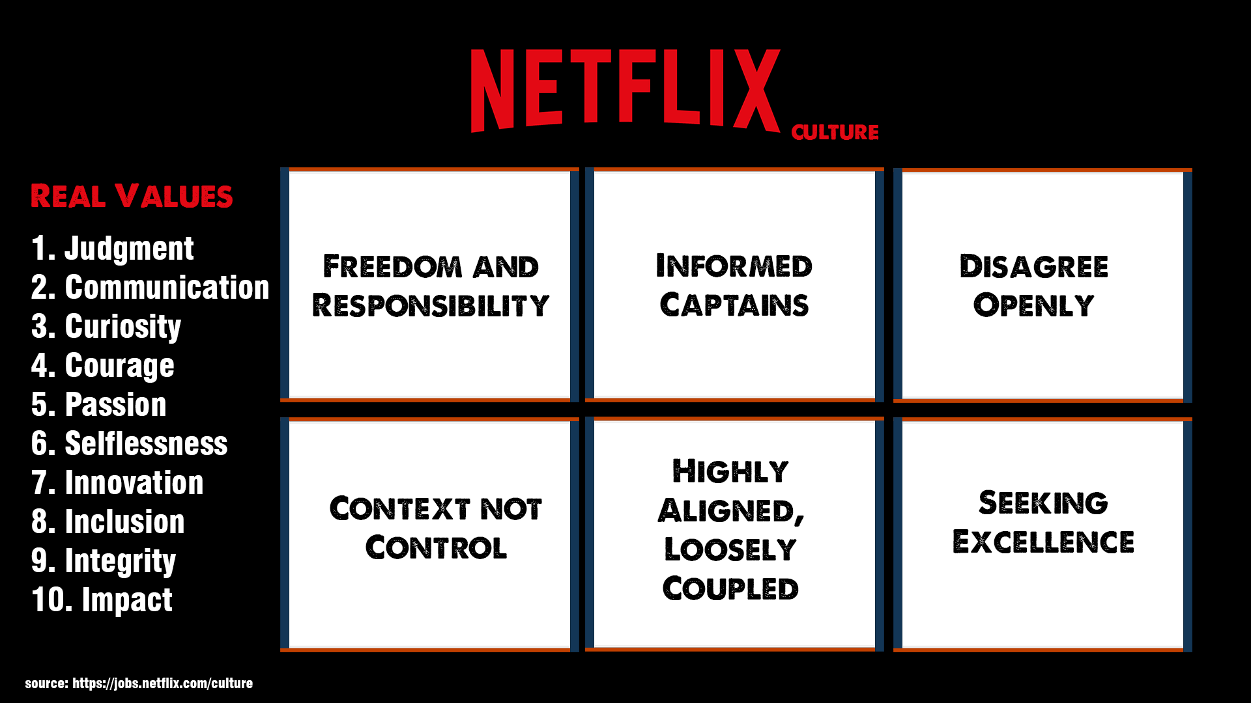

Figure 1- Key parts of Netflix OC deck (Netflix, 2019)

The "Netflix culture deck" redefined human resources, formed the distinct Netflix culture that exists today, and was, in the words of Sheryl Sandberg (CEO of Facebook), "one of the most significant documents to come out of Silicon Valley" Netflix (and now many other companies) have established how they attract, retain, and manage people in large part because of the content of these memorable presentations.
Additionally, successful change management requires an understanding of the organization's values and general objectives. Instead of reacting to every opportunity for change, firms benefit from reacting only to those that are relevant to their overall goals to make wise and practical decisions. (Mosca, 2011). There are more factors at play than ever before, and it is necessary to respond and take action that aligns with an organization's or their stakeholder's demands in reaction to these changes. An organization's performance is negatively impacted by constant change with no rationale, as unneeded change drains business resources, including both financial and human. Large organizations that employ many people are doomed to failure because of the excessive bureaucracy they develop. According to Steiner, bureaucratic and hierarchical firms are less adaptable, less open to change, and less likely to empower their employees (Steiner, 2001). If organizations expect their staff to do nothing but what they are instructed, they will be wasting their resources. As a result, leaders must learn how to deal with change to succeed in their roles. Change management is not a one-size-fits-all process. Organizations must implement organizational change initiatives that are tailored to their unique objectives and demands (Mosca, 2011)

1.5 Culture of Netflix organization

There have been numerous big changes at Netflix over the course of its existence, and the company has demonstrated great change management. Netflix has been able to do this because of their unique company culture, which is both inventive and distinctive. As a result, Netflix isn't a classic industrial corporation, as most current organizational theories and practices assume, but rather a creative one. Contrary to what Reed Hastings, the company's founder, and current CEO, has said, "industrial organizations live on minimizing variance or errors" (McCord, 2014). Considering Netflix's shift to a more creative line of business, the corporation is forced to adopt new organizational procedures that better reflect its changing business model. As a company, Netflix values open and honest communication at all levels and across all departments. Instead, then having explicit vacation standards, Netflix encourages employees to choose their own appropriate vacation time and dates and communicate this to their supervisors. Higher management could set an example by taking vacation time and communicating it to employees to encourage them to take advantage of this policy. The CEO reportedly took four separate vacations of a week or more each in 2015. Netflix, on the other hand, will preserve this idea from being used in its next cultural feature. Their compensation plan is based on this. Effort that brings no results is not rewarded. An honest explanation and generous severance compensation will be provided if a highly valued employee is no longer able to fulfil Netflix's developing needs. With the help of an excellent team and the best employees, Netflix has learned how to adapt and flourish as a company. There are many ways to keep the firm functioning if an employee is no longer able to contribute. Netflix hires people who are aware of this, which explains why nearly all dismissed employees can accept and understand their dismissal from the service. It's Netflix's philosophy to rely on its employees to do their jobs in the most effective manner possible. Giving its employees freedom and flexibility allows Netflix to avoid the bureaucratic and hierarchical problems that might arise when a corporation of Netflix's size gets involved (Mosca, 2011). Netflix found that removing restrictions and replacing them with principles of openness, responsibility, and trust increased productivity and performance while lowering expenses. As a company, Netflix is committed to hiring and guiding employees based on common sense and the firm's best interests (McCord, 2015).

2.0 Conclusions

This research shows how the change management concept, which is widely utilized in the business world, is put into practice. The ability of an organization to progress and remain effective in the long run depends on its ability to effectively manage change. To successfully implement change, organizations must first establish and adapt their internal business processes. A process-oriented approach is emphasized, together with a rethinking of activities and the upgrading of organizational structures. As a result, managers are always looking for ways to push their teams further than they are right now. Organizational culture, like Netflix, has the potential to be both a help and a barrier. An important part of managing an organization's behavior is understanding and respecting its unique culture, which the author has described in prior chapters. Internal and external elements are typically involved in the process of change management. Any time a company starts to fall behind its competitors, it is time for a change. There is no single source of external or internal impact on the change management process.

3.0 Recommendations

Author compiled a set of recommendations to aid the Netflix organization in future planning and implementation of a change process. These recommendations were presented in the form of an improvement plan (figure 2)

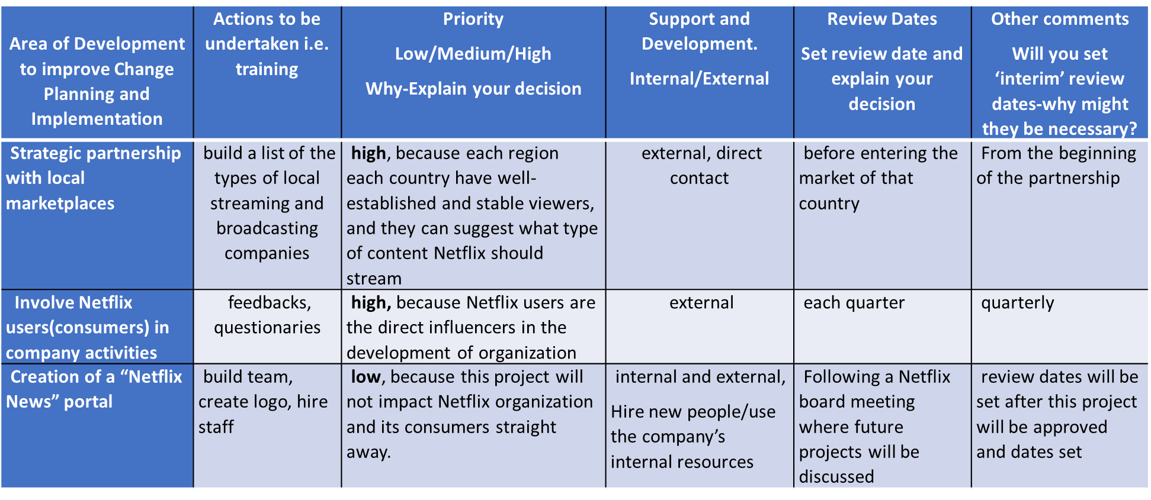
Figure 2, improvement plan

4.0 References

- About Netflix. 2017. About Netflix - Renewable Energy at Netflix: An Update. [online] Available at: <https://about.netflix.com/en/news/renewable-energy-at-netflix-an-update> [Accessed 13 February 2022].
- Amaro, S., 2020. Tech giants are the ‘winners’ of the coronavirus crisis and should pay more tax, Europe official says. [online] Available at: <https://www.cnbc.com/2020/09/05/big-tech-needs-to-pay-more-tax-eus-gentiloni-says.html> [Accessed 5 March 2022].
- Barr, T., 2011. Television’s newcomers: Netflix, Apple, Google and Facebook. Telecommunications Journal of Australia, 61(4).
- Bell, R. and Koren, Y., (2007). Lessons from the Netflix prize challenge. ACM SIGKDD Explorations Newsletter, 9(2), pp.75-79.
- Bell, R., Koren, Y. and Volinsky, C., 2010. All Together Now: A Perspective on the Netflix Prize. CHANCE, 23(1), pp.24-29.
- Bernoff, J., & Schadler, T. (2010). Empowered: unleash your employees, energize your customers, transform your business. Boston, Mass.: Harvard Business Press.
- Berry, S., Fazzio, S., Zhou, Y., Scott, B. and Francisco-Revilla, L., 2010. Netflix recommendations for groups. Proceedings of the American Society for Information Science and Technology, 47(1), pp.1-3.
- Blood, P 2013, Implementing Restorative Practice in Schools a Practical Guide to Transforming School Communities, Jessica Kingsley Publishers, Philadelphia.
- Bransley, T., (2010). Netflix cancels contest sequel. Computer Fraud & Security, 2010(3), pp.2-3.
- Bylund, A., 2020. Netflix Just Started Reporting Renewable Energy Use and Content Removal | The Motley Fool. [online] The Motley Fool. Available at: <https://www.fool.com/investing/2020/02/08/netflix-just-started-reporting-renewable-energy-us.aspx> [Accessed 5 March 2022].
- Cameron, E. and Green, M., 2015. Making sense of change management. 4th ed. London: Kogan Page, pp.1-2, 106-108, 176-204, 296-304.
- Cooper, S 2012, Change: models and processes, Thomas Publisher Limited, Springfield.
- Delimitrou, C & Kozyrakis, C 2013, ‘The Netflix Challenge: Datacenter Edition’, IEEE Computer Architecture Letters, vol. 12, no. 1, pp. 29-32.
- Deshmukh, A & Naik, A 2010, Educational management, Himalaya Pub. House, Mumbai.
- Frue, K., 2018. PEST Analysis of Netflix: How Politics and the Economy impact the Media Provider. [online] PESTLE Analysis. Available at: <https://pestleanalysis.com/pest-analysis-of-netflix/> [Accessed 20 February 2022].
- Ganz, M., Nohria, N. and Khurana, R., 2010. Leading change. In Handbook of Leadership Theory and Practice: A Harvard Business School Centennial Colloquium.
- Kähkönen, T. (2020). Employee trust repair after organizational change. Journal of Organizational Change Management, 33(6), pp.1143-1161.
- Kobiruzzaman, M.M., 2022. Netflix Organizational Change & Structure Case Study 2022. [online] Newsmoor.com. Available at: <https://newsmoor.com/netflix-organizational-change-organizational-management-change-examples/> [Accessed 18 February 2022].
- Kotter, J. (2012). Leading change. Boston, Mass.: Harvard Business Review Press.
- Llopis, G., 2014. Every Leader Must Be A Change Agent Or Face Extinction. [online] Forbes. Available at: <https://www.forbes.com/sites/glennllopis/2014/03/24/every-leader-must-be-a-change-agent-or-face-extinction/ > [Accessed 13 February 2022].
- Mabey, C. and Mayon-White, B., 1993. Managing change. 2nd rev ed. London: Paul Chapman.
- Mariotti J. (1998). 10 steps to positive change. Ind Week.
- McCord, P., 2014. How Netflix Reinvented HR. [online] Harvard Business Review. Available at: <https://hbr.org/2014/01/how-netflix-reinvented-hr> [Accessed 5 March 2022].
- McFadden, C., Ozdemir, D., Emir, C., Papadopoulos, L. and Loeffler, J., 2020. The Fascinating History of Netflix. [online] Interestingengineering.com. Available at: <https://interestingengineering.com/the-fascinating-history-of-netflix> [Accessed 18 February 2022].
- Moore, K. and Moore, K., 2020. Does Netflix Have Too Much Foreign Content? [online] What's on Netflix. Available at: <https://www.whats-on-netflix.com/news/does-netflix-have-too-much-foreign-content/> [Accessed 6 March 2022].
- Mulllins, L. (2016). Management and Organizational behavior. 11th Ed. Harlow: Pearson.
- Murphy Jr., B., 2021. Netflix Made 9 Big Changes, and Most Subscribers Now Have No Idea. [online] Inc.com. Available at: <https://www.inc.com/bill-murphy-jr/netflix-made-9-big-changes-most-subscribers-have-no-idea-about-them.html> [Accessed 15 February 2022].
- Northouse, P. G. (2015). Leadership: Theory and practice (7th ed.). Thousand Oaks, CA: Sage.
- Rosenberg, S., & Mosca, J. (2011). Breaking Down The Barriers To Organizational Change. International Journal of Management & Information Systems (IJMIS), 15(3), 139–146.
- Sherman, N., 2020. Five ways the virus has changed Netflix. [online] BBC News. Available at: <https://www.bbc.co.uk/news/business-54623959> [Accessed 14 February 2022].
- Steiner, C. (2001), 2A role for individuality and mystery in “managing” change", Journal of Organizational Change Management, Vol. 14 No. 2, pp. 150-167.
- Stenovec, T., 2017. One Huge Reason For Netflix's Success. [online] HuffPost UK. Available at: <https://www.huffingtonpost.co.uk/entry/netflix-culture-deck-success_n_6763716> [Accessed 2 March 2022].
- Tapalaga, A., 2019. A PESTEL Analysis of Netflix to Show You Its Value in Marketing Research. [online] Medium. Available at: <https://bettermarketing.pub/a-pestel-analysis-of-netflix-to-show-you-its-value-in-marketing-research-554f9ca12af6> [Accessed 4 March 2022].
- Tschirky, H. (2011). Managing innovation-driven companies: Approaches in practice. New York, NY: Palgrave Macmillan.
- Wang, U., 2014. How the Netflix model impacts the environment, economy, and society. [online] the Guardian. Available at: <https://www.theguardian.com/sustainable-business/2014/feb/06/how-the-netflix-model-impacts-the-environment-economy-and-society> [Accessed 18 February 2022].

