

Assessment 1 – Reading Task Template
PART 1: Upload your photo of your A3 in-class notes here:
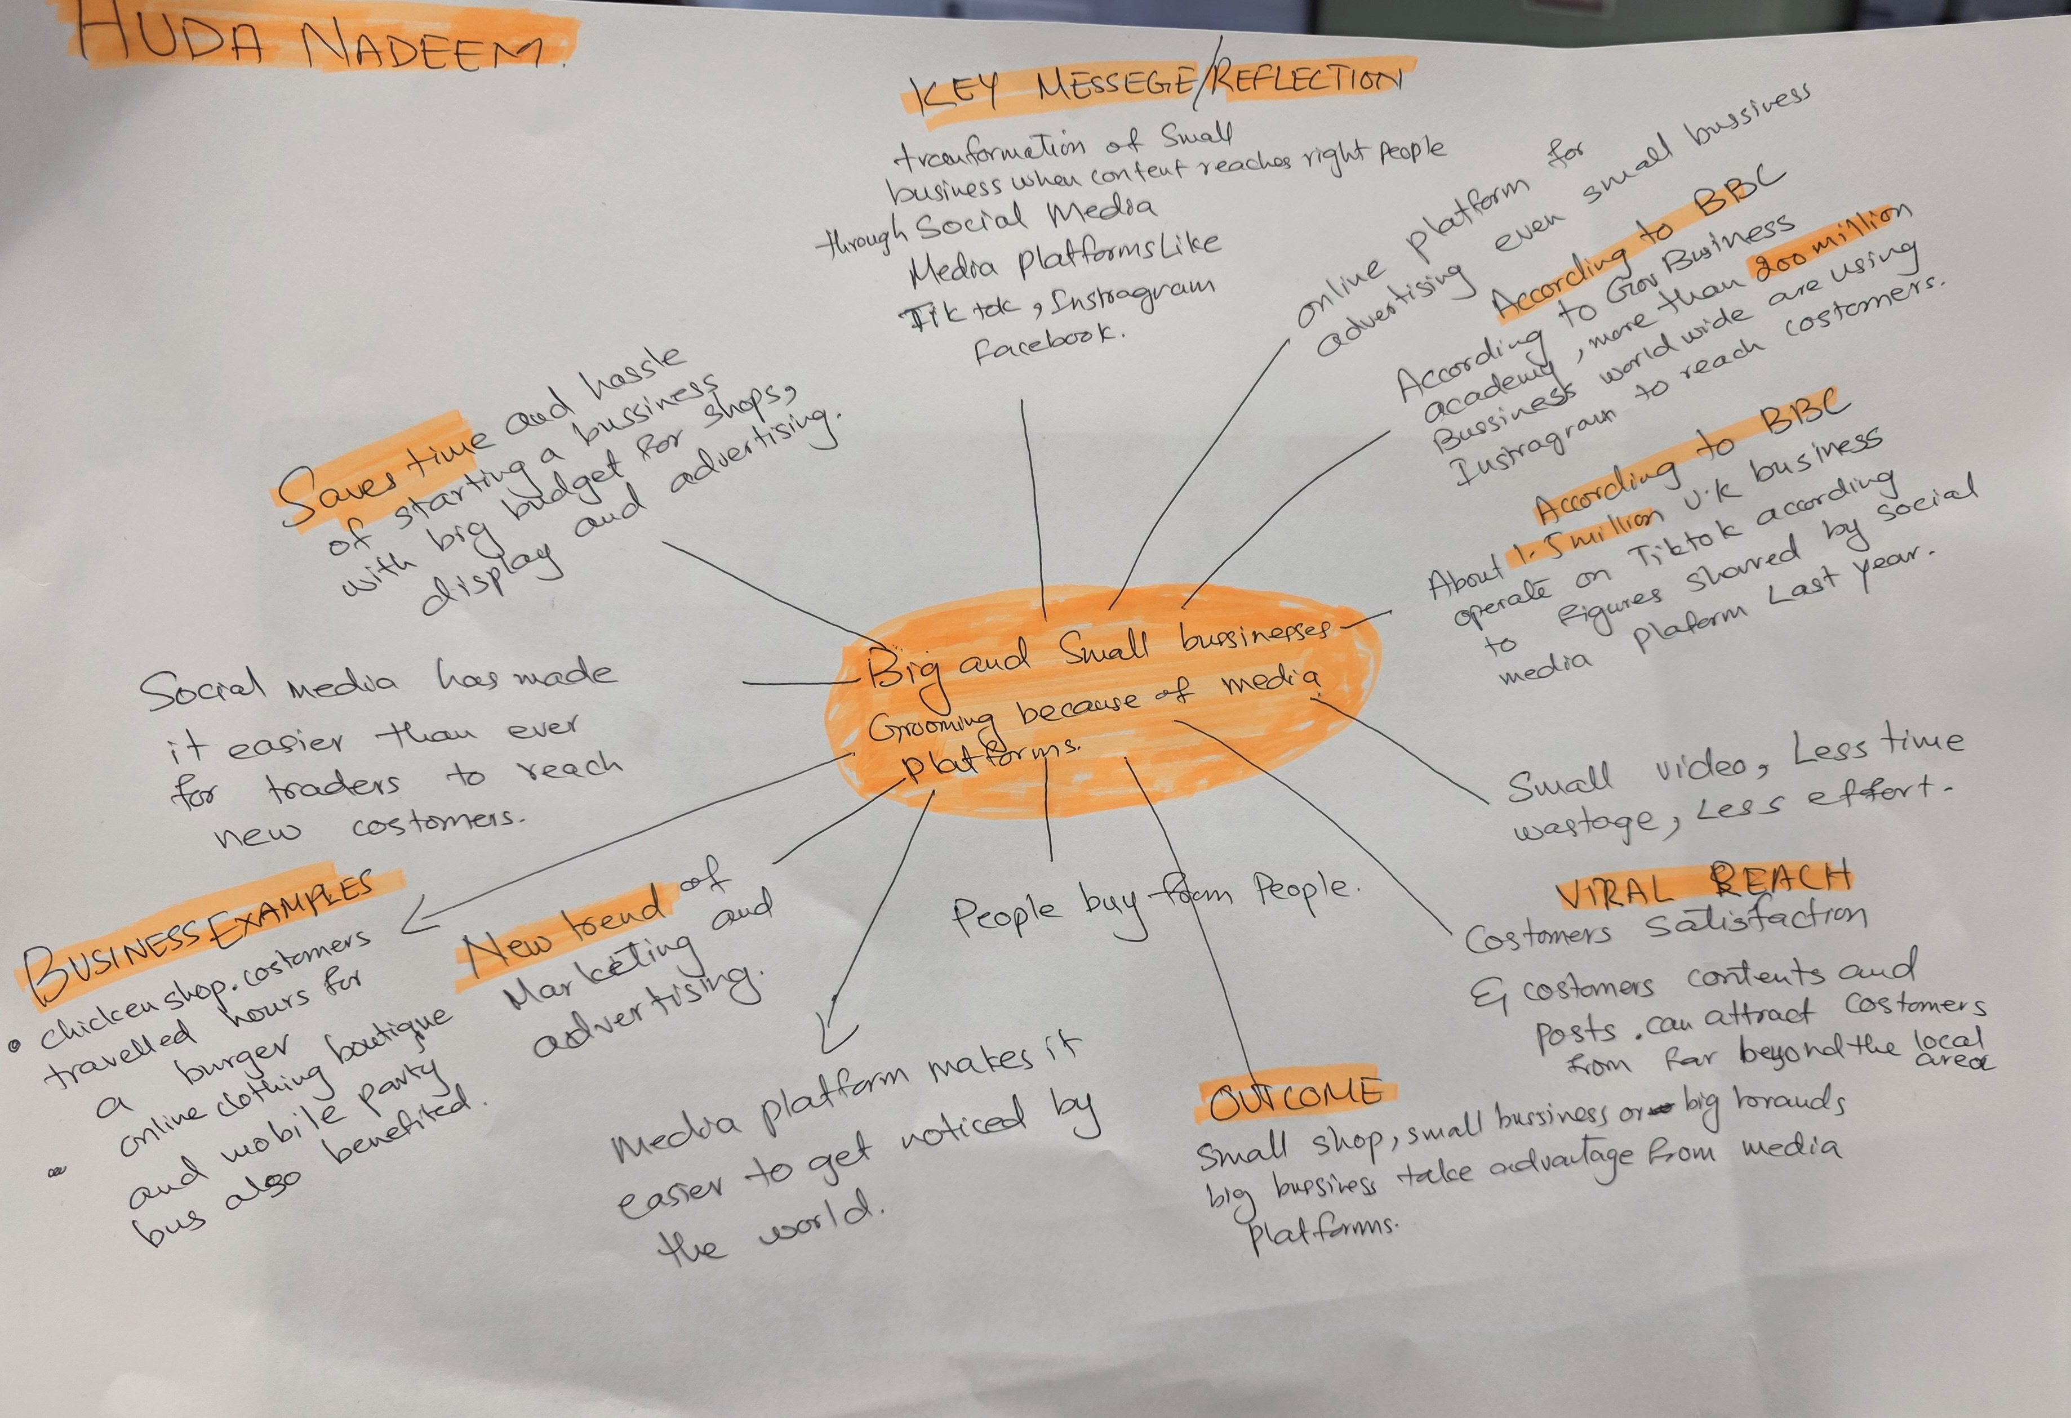

PART 2:
- Answer every question below in 1-3 full sentences.
- Use your own words. Do not use generative AI to answer these questions.
- Include a specific detail from the text when asked.
REMINDER
- The main idea is the overall message of the whole text.
- A key point helps to explain the main idea.
- A specific detail or example from the text shows that the key point is true.

- What is the main idea of the whole text?
The main idea of this text is that the social media like tiktok , Instagram and facebook helps in advertising the business and attract customers and boost the business. Social media promotes online marketing .

- What is one key point that supports the main idea, and which specific example from the text shows this?
One key point is that social media helps businesses increase their sales. For example, Binley Mega Chippy increased its trade tenfold after videos of the shop went viral on social media.

- What is a different key point that supports the main idea, and which specific example from the text shows this?
Another key point is that social media helps businesses reach customers from far away. For example, Krystalls boutique attracts teenagers from the Channel Islands and Cyprus after its funny videos became popular online. The most important point is that the social media helps small businesses become popular and increase their sales. For example, Honywood Sandwich Shop attracted customers from far away after its video became popular and viral online.

- Which part of the text do you think is most important, and why?
The most important part of the text is how social media helps businesses attract new customers and increase sales. For example, Honywood Sandwich Shop became popular after customers posted videos of its food on TikTok. Some people travelled for three hours just to try its chicken burger.

This is important because it shows that businesses can use social media as a free or low-cost way to advertise their products, reach a wider audience and increase their profits.

Reflection:
After reading this article, I have learned how powerful social media can be for businesses. I used to think social media was mainly for entertainment, but now I understand that it can also help businesses grow and become successful. I was surprised that people were willing to travel long distances because of videos they saw online. In the future, I would consider using platforms such as TikTok and Instagram to promote a business because they can help reach more customers and increase sales. However, businesses also need to post good-quality content and maintain their reputation to keep customers interested.
- What did you find difficult in this task (including in-class components), and why was it difficult?
I had no difficulty doing this task (including in class components ) because the teacher illustration over this assignment was very clear.

- What helped you with this difficulty, and how did it help you?
In class lecture by the teacher and discussion over the topic and in class work helped a lot in understanding this topic

