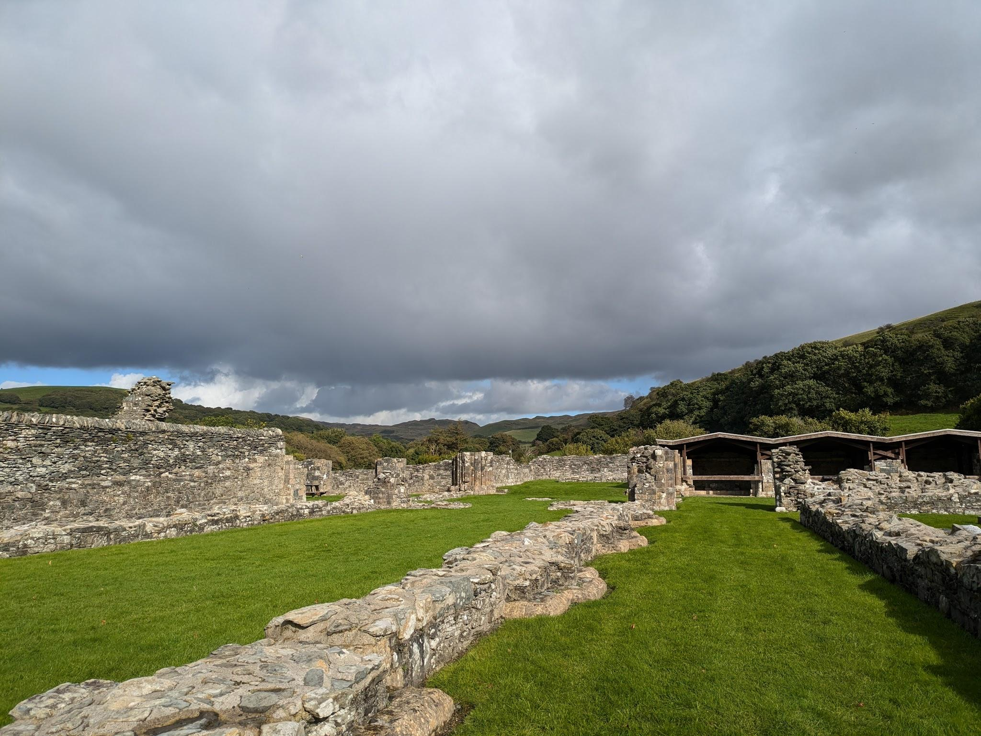
Ruins unsettle me, it seems odd, and I’d never actually voiced it aloud before we went to Strata Florida, I say aloud, I called my mum and told her about it because she loves ruins also, but they do. I’d never really thought about why they made me uncomfortable until we were wandering about the Abbey and actually discussed the building itself and who lived there but when I was there I felt like I was interrupting, interrupting what I couldn’t tell you but I felt it also when I go castle, then I felt as though I’m intruding in someone’s home but they haven’t been a home for centuries.
Strata Florida

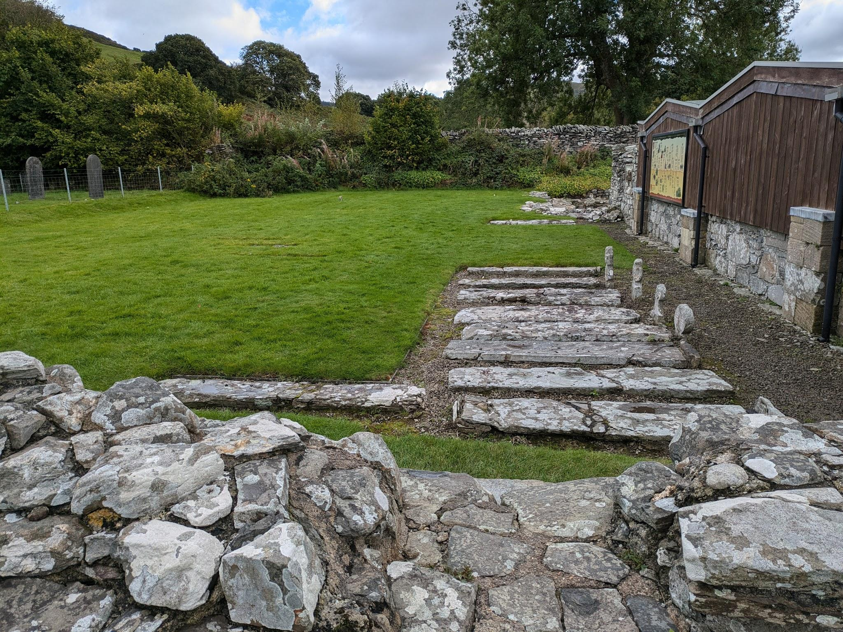
I have always found ruins impressive and beautiful, remnants in modern times when they were once awe-inspiring structures, especially considering the times they were built in and the effort, time, skill and dedication it would require. Then you think about what’s left and either it is all the more impressive for all that’s still left of it or it's sad or lacklustre that something so incredible could be brought down so completely. I say completely, its carcass is still there, that’s what we visit. Maybe that’s why it unsettles me so, the death of a creation, the people, the impermanence of existence but if that’s what it is then really, I ought to be feeling unsettled all the time.
Graves
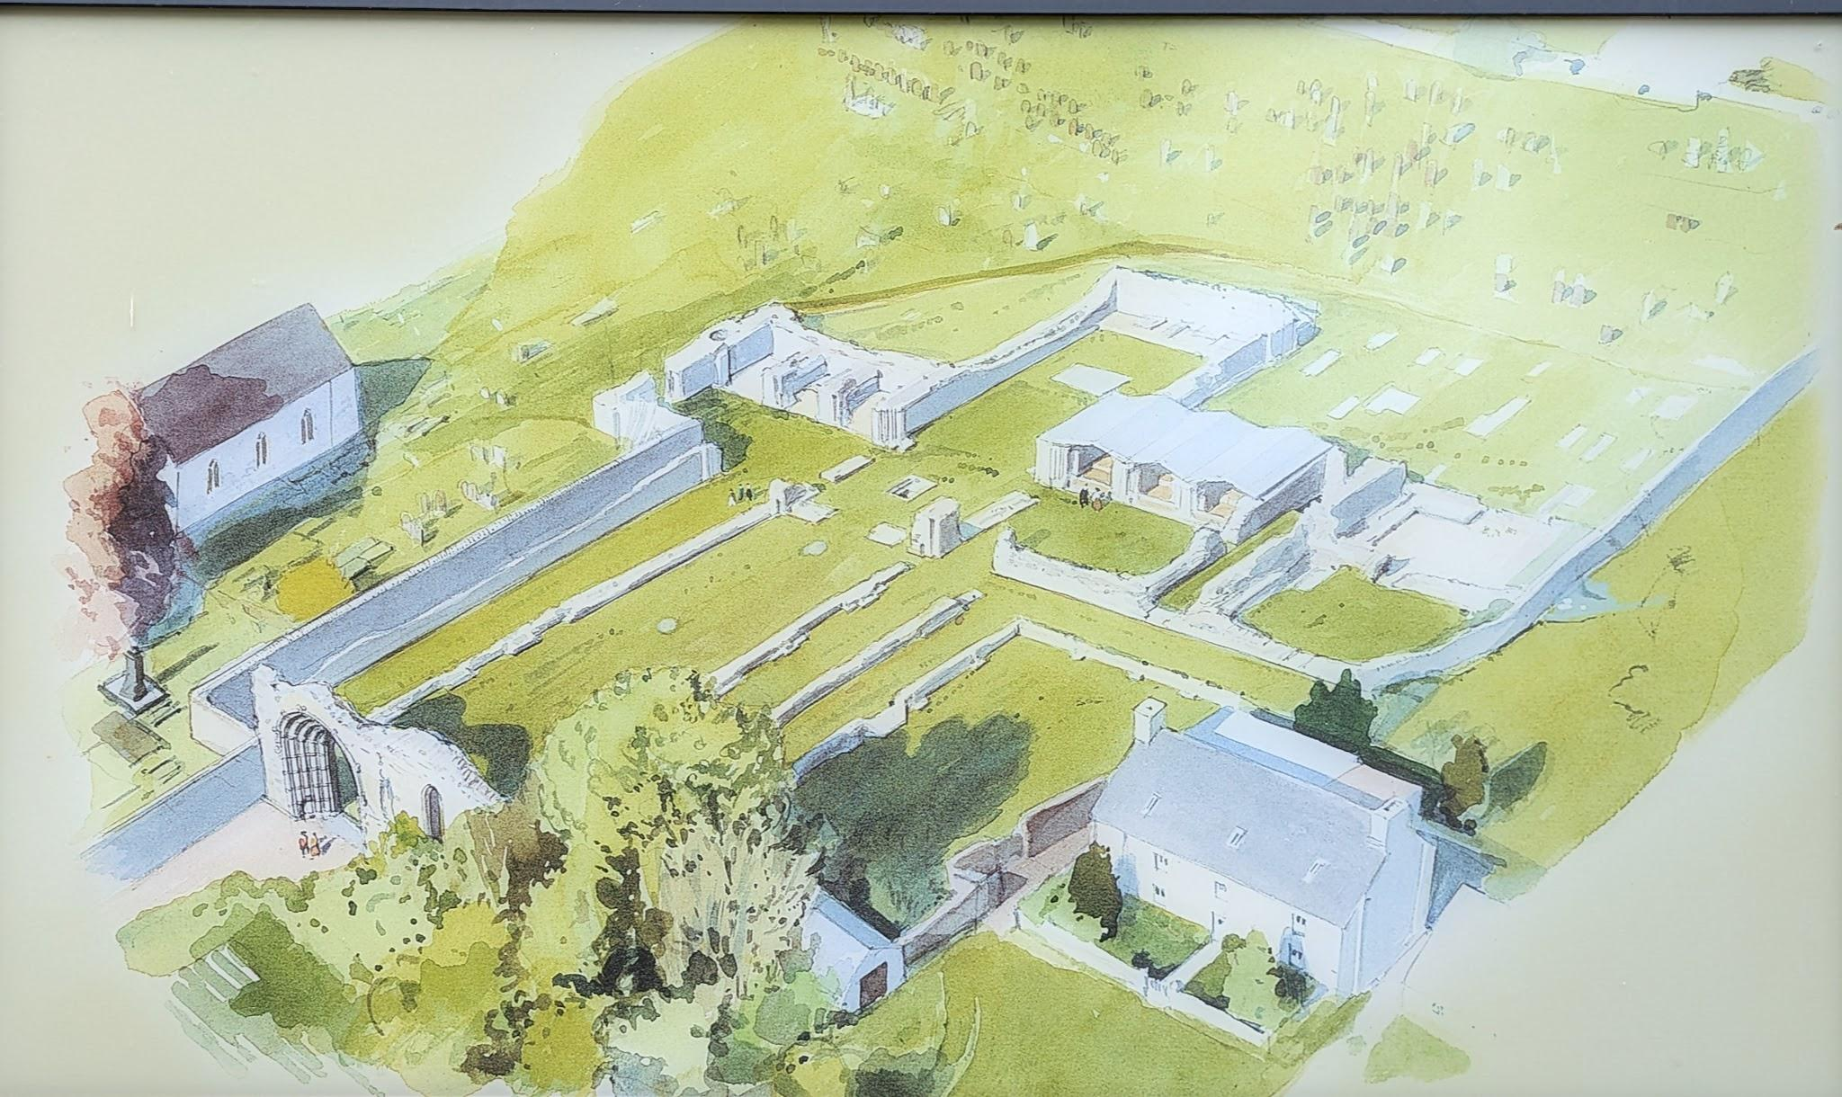
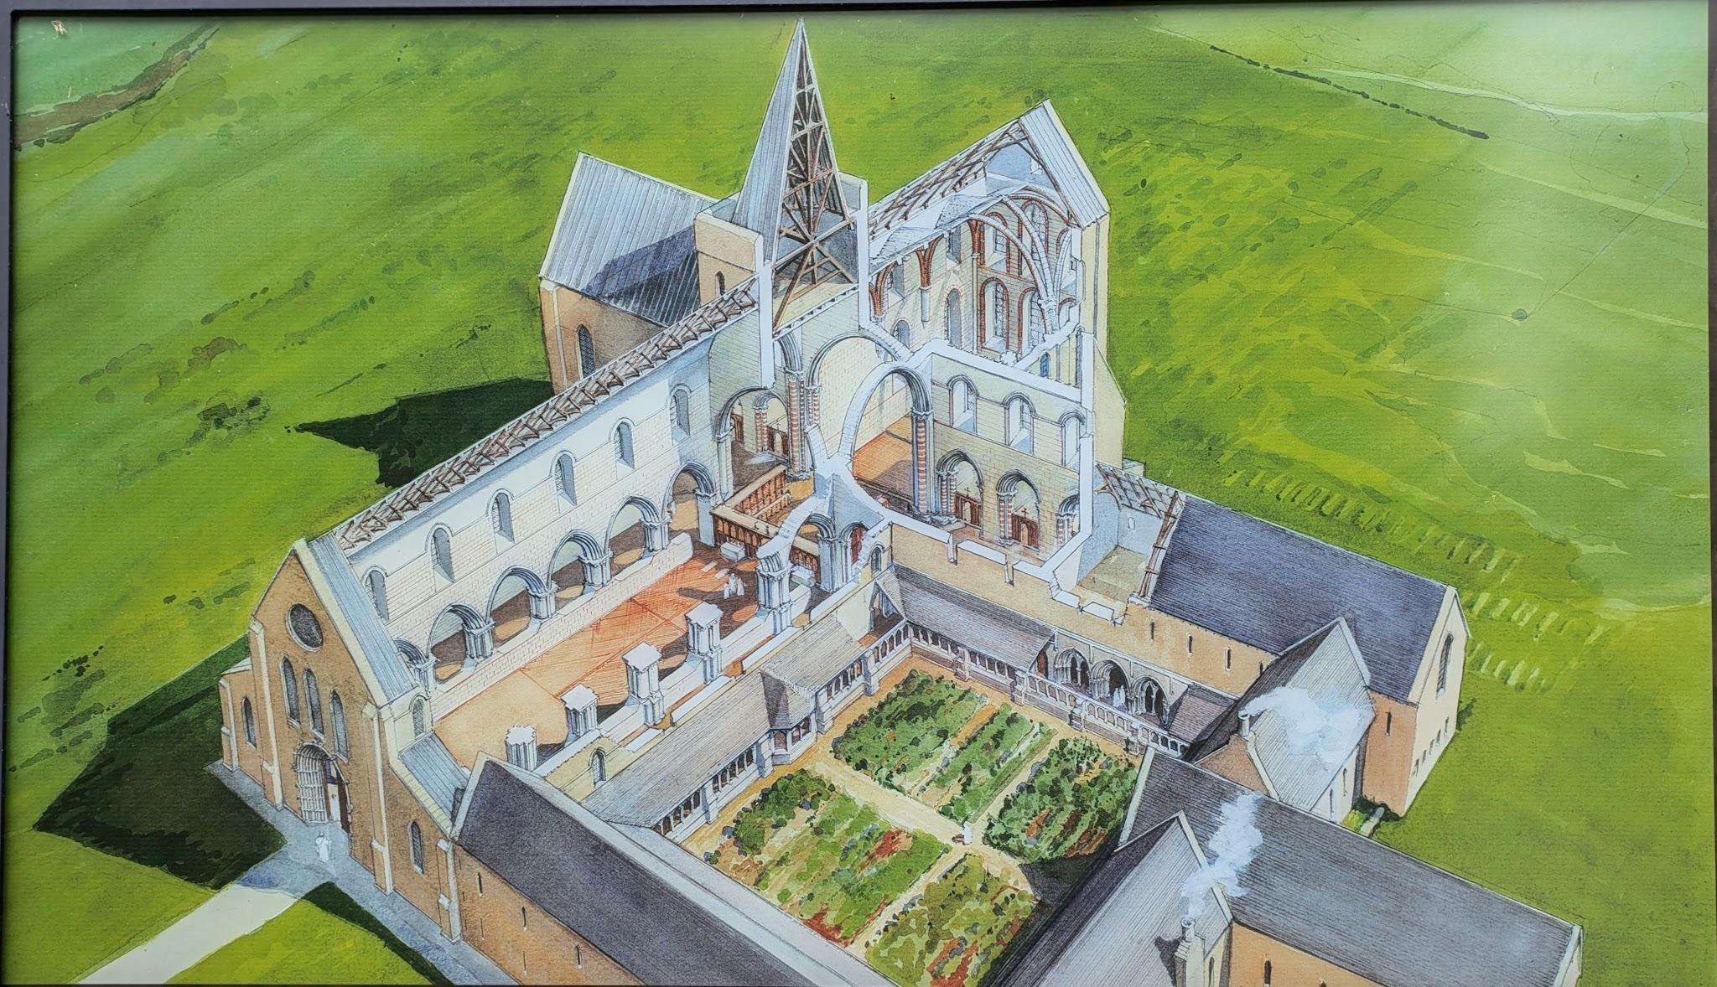
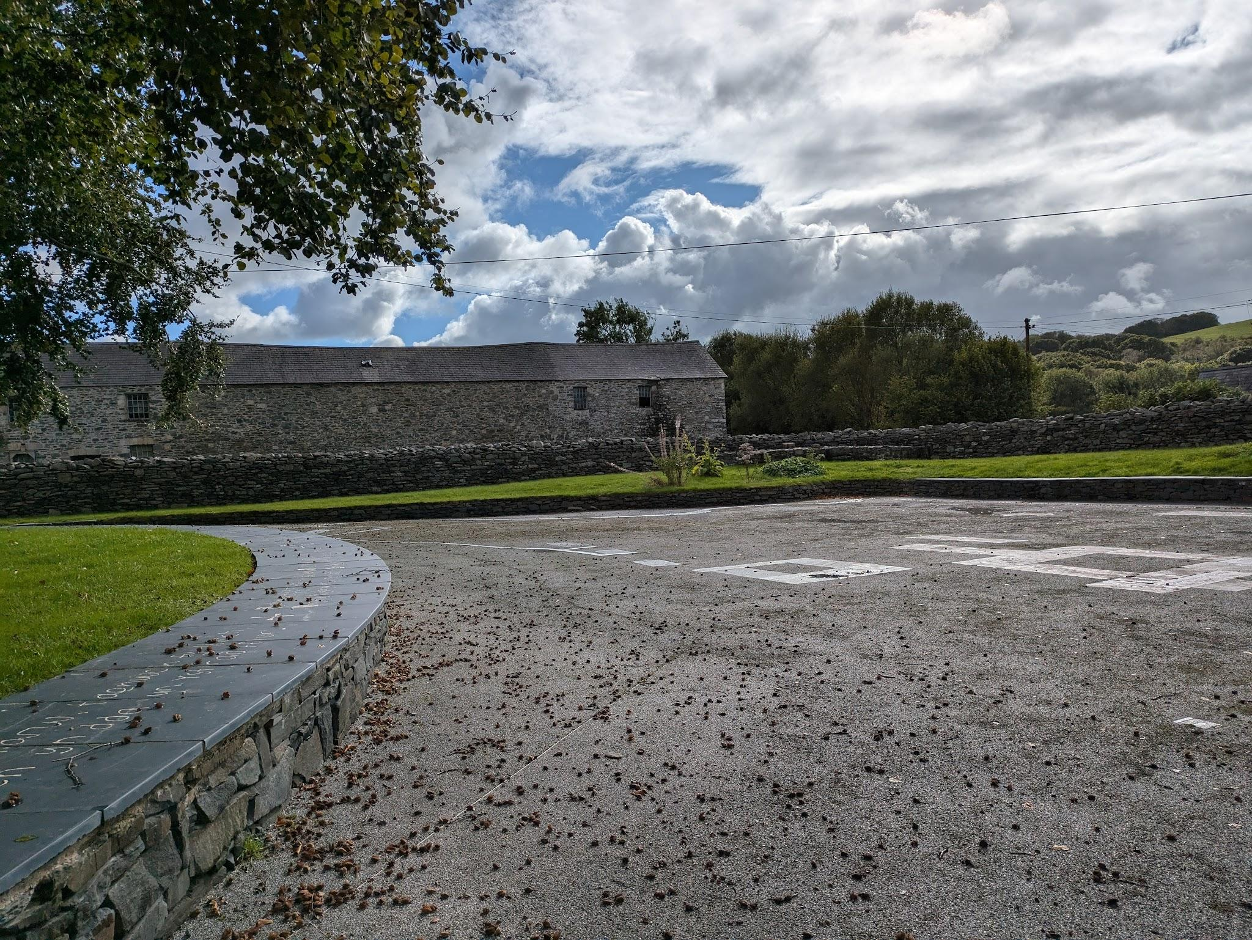
The architectural interpretations of what they once looked like or may have looked like always catches my eye when they are displayed on information boards - mind you I don’t remember seeing the recreations until I visited Talley Abbey and some Castles earlier in the year and again at Strata Florida - the contrast of what was created, regardless of how accurate the drawings are, compared to what stands now is incredible.

While it isn’t a spectacularly clear picture this, to the right, is actually a depiction of where other buildings are thought to have been. Some of the buildings are known to have existed while others are inferred. Estimation is, now, the only way we would have an idea on the layout of the monastery grounds.
Strata Florida Abbey, West Gate - Lexin Jessopp
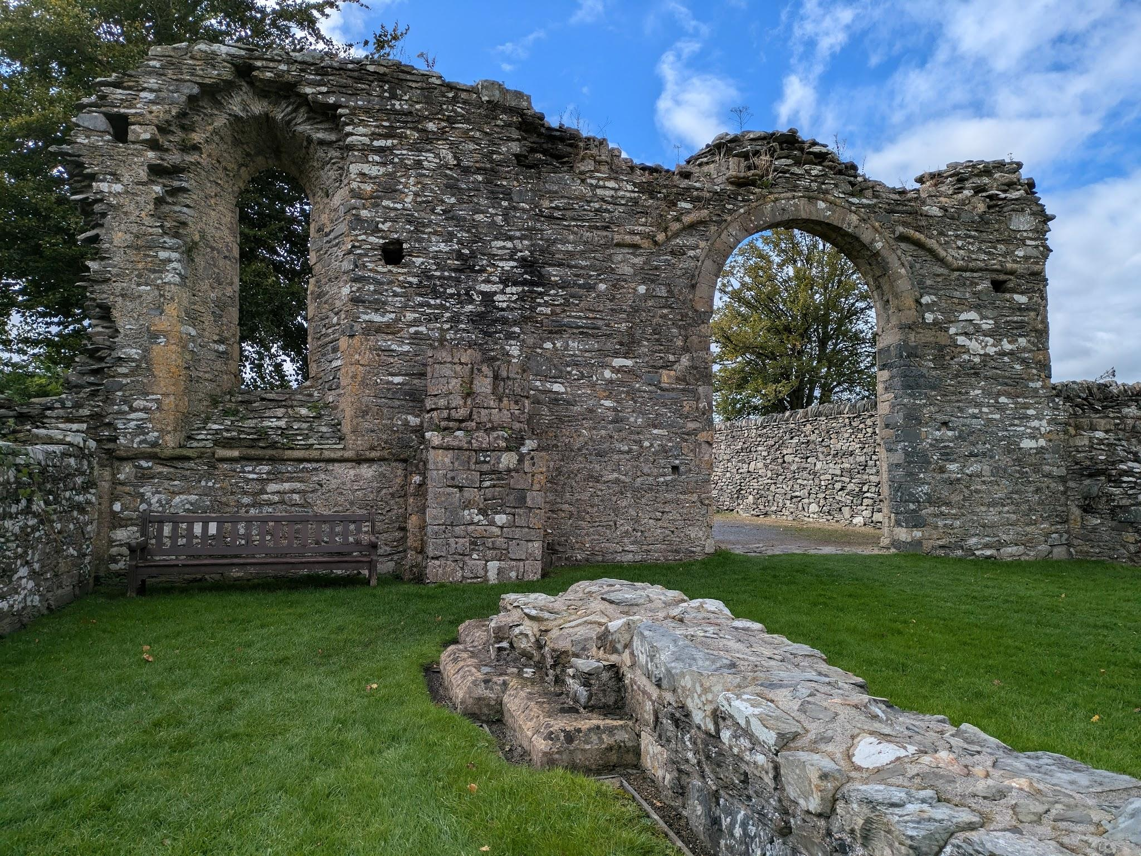
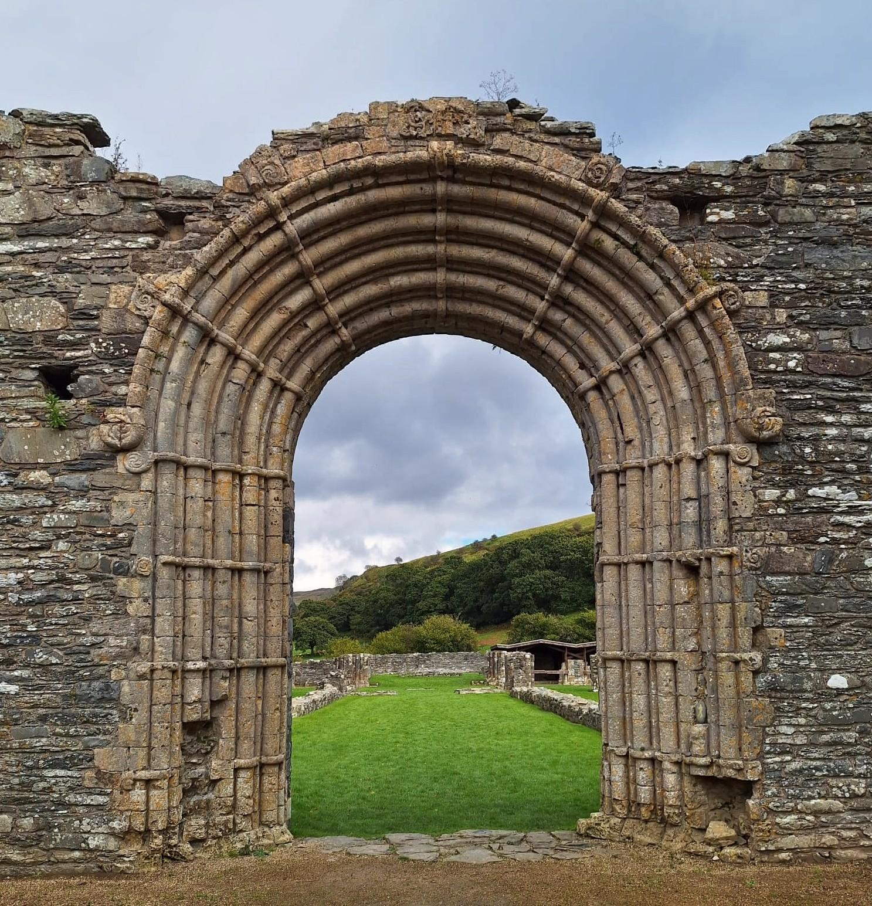
Nevertheless, when we visited Strata Florida and were left to look around I wanted to see the ruins of the Abbey but the only entrance I could see was the gate at the side of the ruins and I wasn’t even sure that was the way we were ‘supposed’ to enter, there wasn’t a path just a trail in the grass where others had walked before and I believe the gate wasn’t even in the Abbey itself but rather the wall around it and that section of the Abbey had gone completely. There was a gate, right the way round, sitting at the front of the West Gate leading in but ultimately not the only way in anymore. The West Gate would once have been the entrance where everybody entered the Abbey, likely the main entrance to at least the public even if the monks had other doors. At the end of the day, I used it to exit the ruins and the gate at the end to leave and I think there is some sort of irony or something to be mourned in that. At one point you would first see the exterior of the gate, the columned archway with the shell-like designs at the end of the ridges in the columns, the, for the time, opulence yet the first thing I saw was the interior, no less impressive in my opinion but certainly plainer.
Strata Florida, Exterior of West Gate - Lexin Jessopp
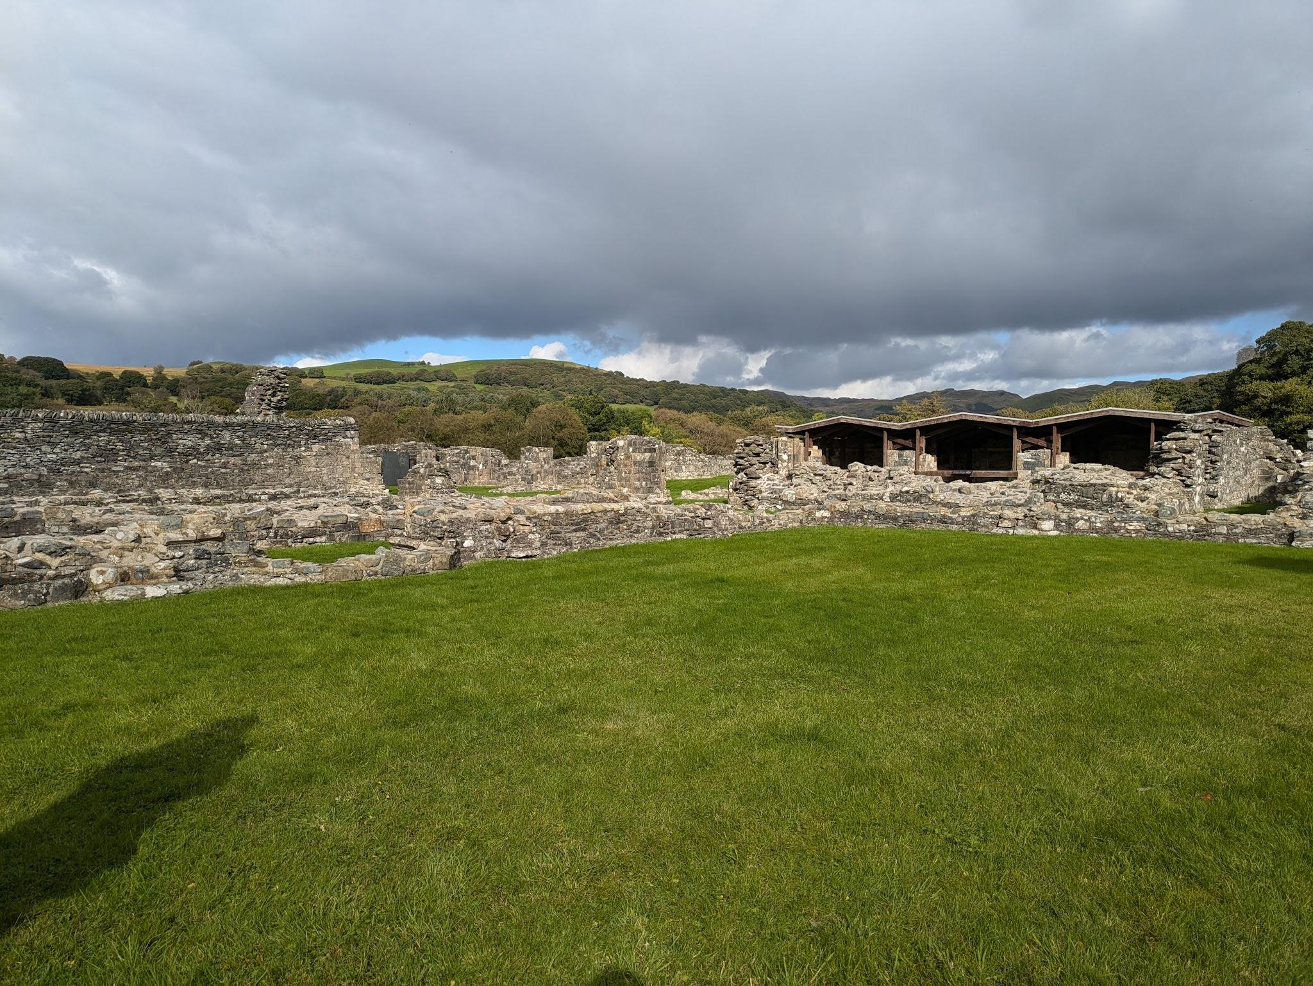
Ruins are ultimately a significant part of the ancient times both as an era and a subject of study, as most everything is ruins, fragments and pieces of previous civilisations that have long collapsed and though Strata Florida Abbey is roughly 500 years short of ancient being built around the 12th Century AD it still has a rich history of religion, royalty and conflict. Having been built by Cistercians, a branch from the benedictine church from France, they followed the Normans over and were later supported by the Welsh Princes of Deheubarth and was eventually taken by English kings, used a base of battle before being returned and dissolved come the reign of Henry VIII.
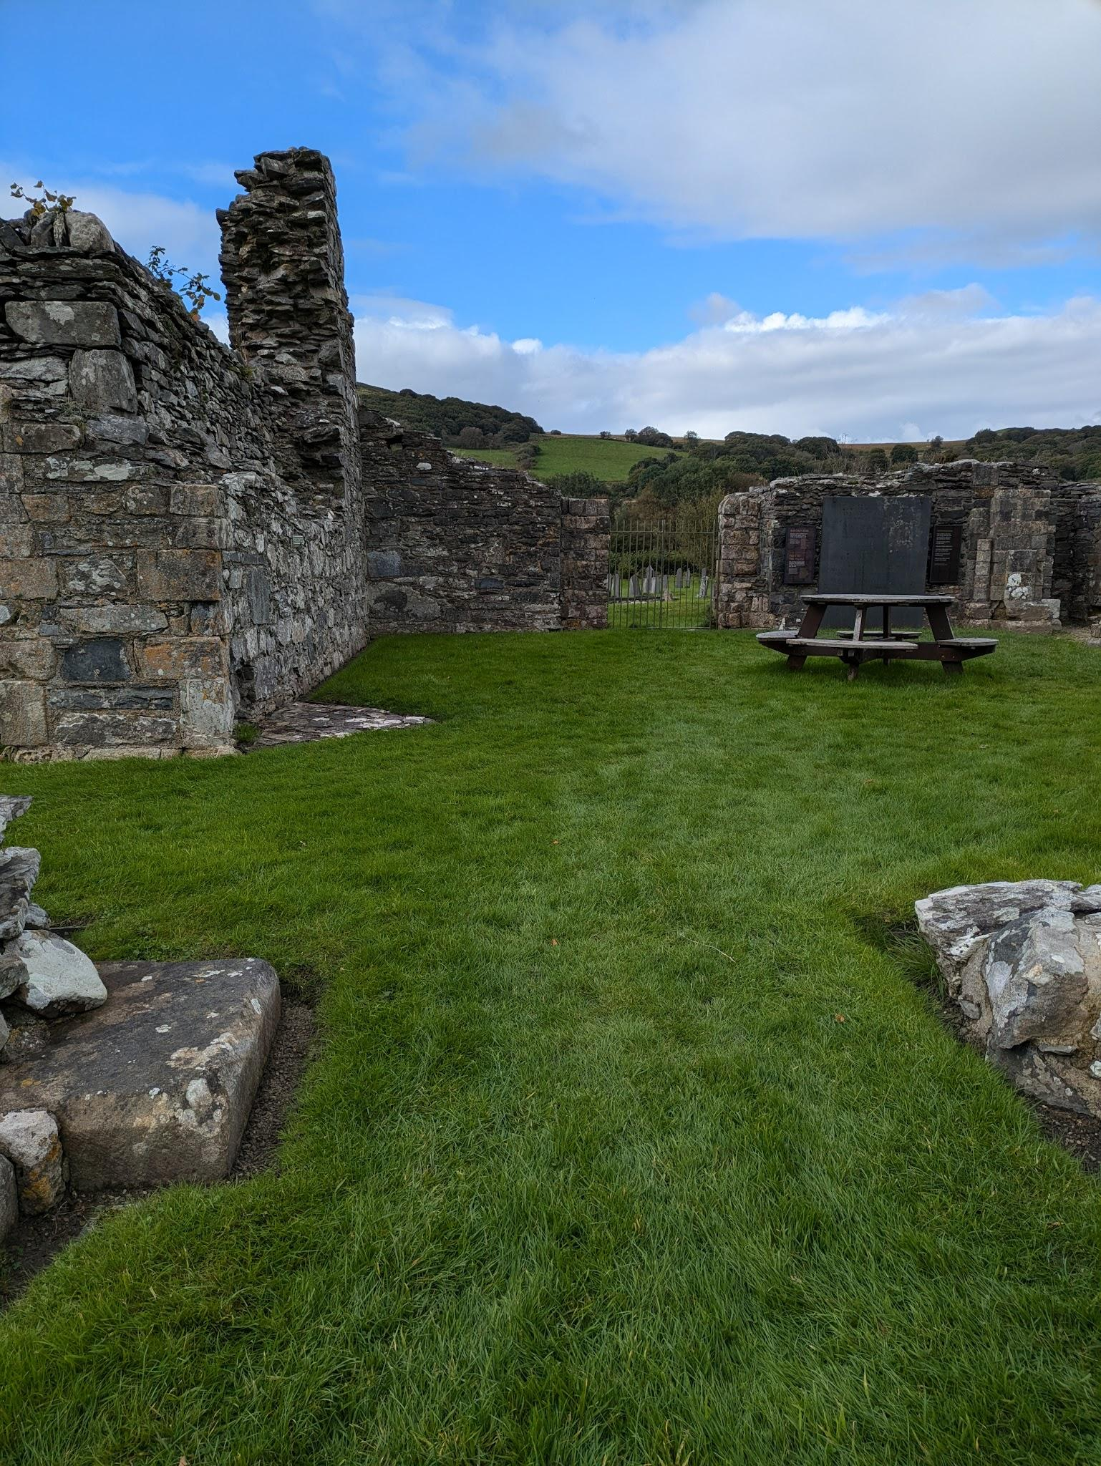
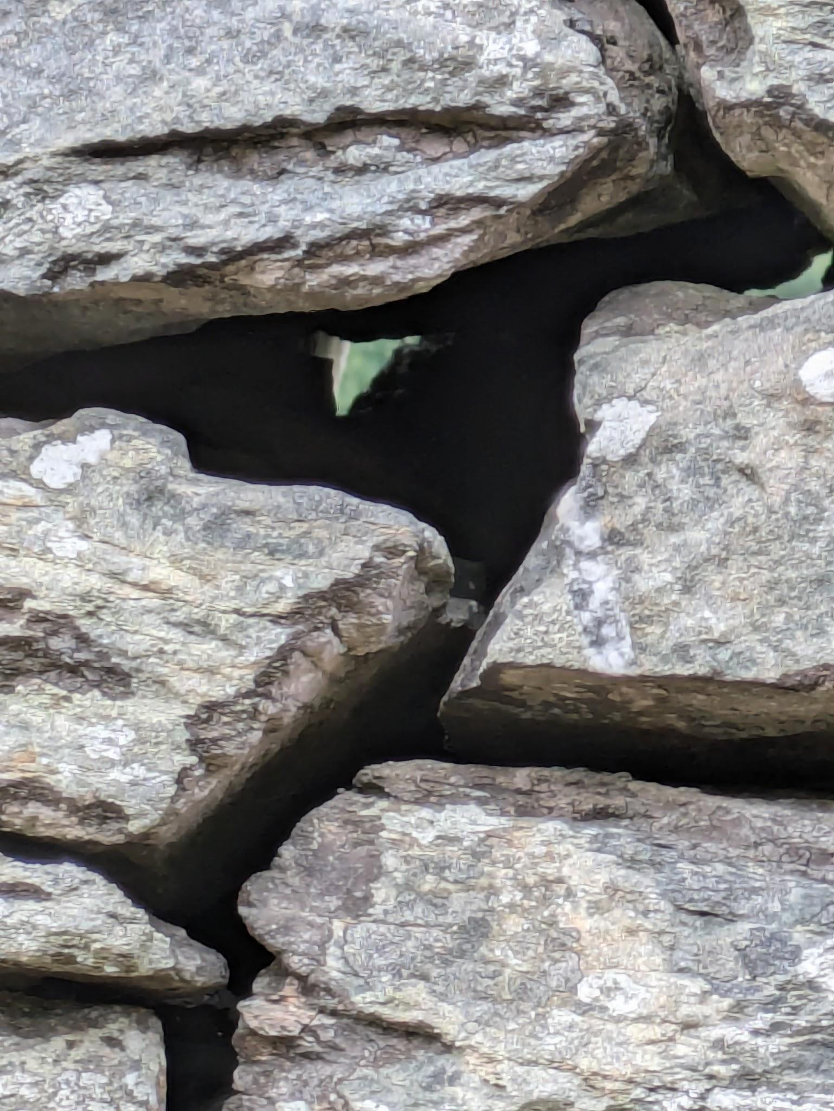
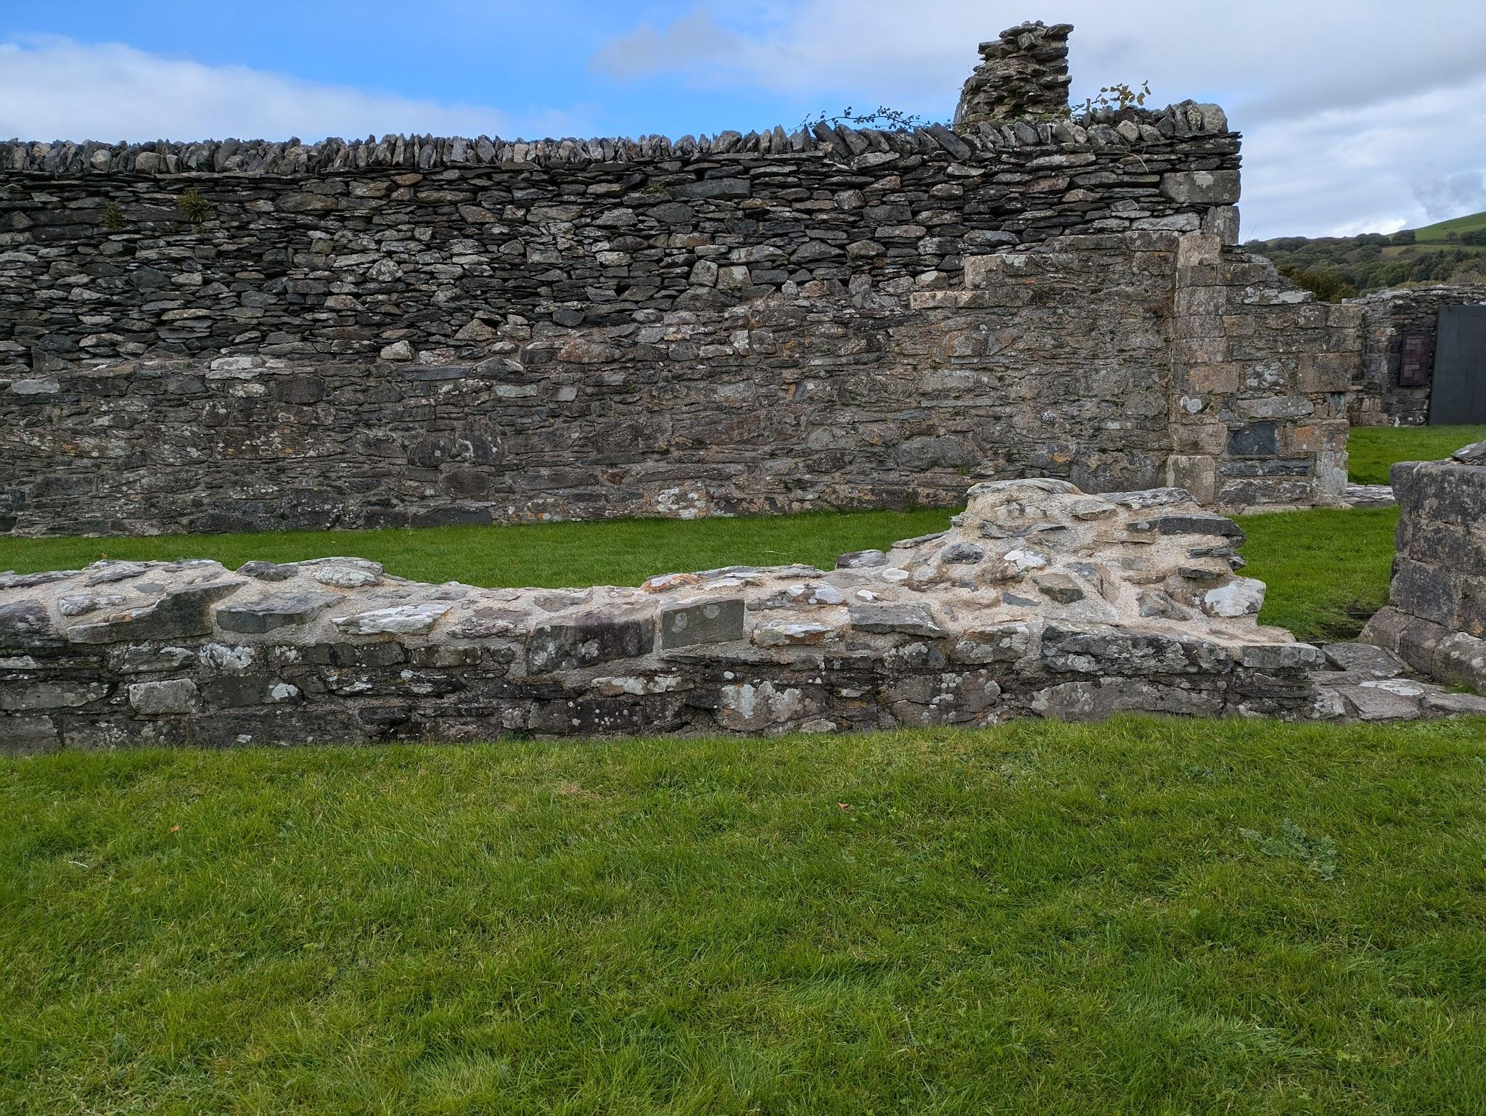
As a result of the dissolvement the abbey was taken apart, the stone and materials taken to be reused about the village and the Abbey left to fall to ruin. Consequently, you can see both interior and exterior walls and the difference in the build, unless it’s just preservation efforts either way it is fascinating to see the difference where the exterior walls are stacked with some precision but retain holes whereas the interior walls are filled. It isn’t so difficult to understand that the inside walls are more precise as there wasn’t any central heating at the time, unless of course they utilised Roman or Korean underfloor heating, but I doubt it, so they had to, so they didn’t freeze but it is interesting in that the interior and exterior walls act as insulation themselves.

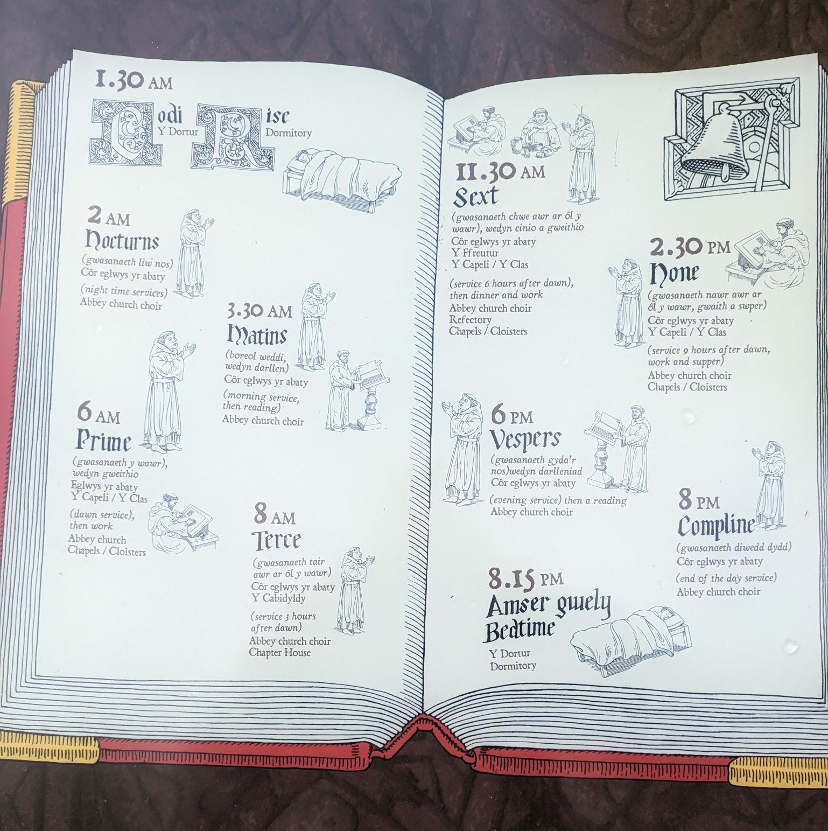
Either way I thought both the grounds and ruins were beautiful, even though they unsettle me, they make me think back and wonder about everyday life. It doesn’t sound particularly interesting, but it does impress me that they were so committed. It also makes me wonder about the advantages of where it was built, in that it was built as the bottom of the valley, though admittedly my first thought on it had been advantages in battle, as enemies would either be visible or come stumbling down the hillsides rather than irrigation and then my concern was whether they got a lot of floods due to the weather and being in a basin.

I didn’t see the entire site, like inside the sheds which I believe protect tiles, or behind and the graveyard but I enjoyed what I did see, and I can always go back.

cadw.gov.wales. (n.d.). Strata Florida Abbey | Cadw. [online] Available at: https://cadw.gov.wales/visit/places-to-visit/strata-florida-abbey#overview [Accessed 12 Oct. 2024].

