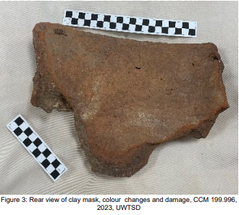
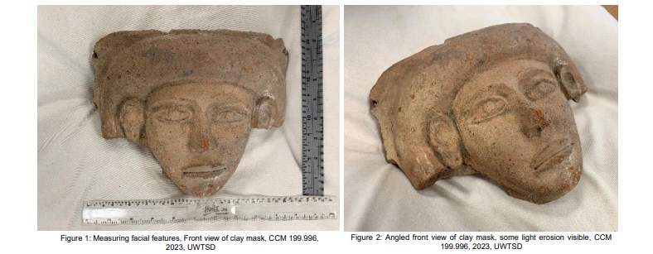

Cyfarthfa Castle, Merthyr Tydfil CCM 199.996
Object type: Mask cut from clay coffin.
Material: Nile Silt / Clay
Period: Estimated 3rd Intermediate Period 1070-664 BC
Provenance: Northern Egypt or (Sinai / Israel)
Dimensions: Height 20.5cm Width 26.0cm Depth 4.5cm
Object analysis by: Kurtis Lloyd Williams 1801031

The mask removed from an ancient Egyptian funerary pot shaped coffin is approximately 20.5 cm high, 26 cm wide and has a depth of 4.5 cm. Overall the mask presents rather feminine features with larger lips and a larger hair piece area, along with pronounced eyes that appear to be defined around where the eyelashes would be. Its simplistic ears are exposed by depicting the hair folding behind them. All these individual aspects, along with generalised features lend itself to the idea that this wasn’t a commissioned piece but a generalised addition to a funerary pot.
There are areas of minor damage and some significant damage all over this artifact. The back and edges exhibit the most extensive damage and is potentially the result of its’ initial removal from the coffin. There are several steep slopes on the back edges, one of which encompasses and bisects the left ear of the face. The sections presenting minor wear are featured across the face in areas such as the chin, lips, left eyebrow and nose. This erosion reveals burnt orange colours compared with the beige featured across the rest of the face. This artifact is potentially made utilising the Nile silt or clay prominent within pottery and burial pots throughout Egypt. This potential manufacturing process possibly explains the varying colour differences along the damaged slopes, resulting from inconsistent curing temperatures.
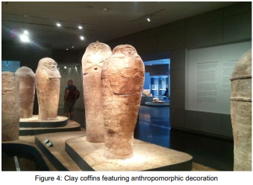
When most people think of the burial practices of the ancient Egyptians, they most frequently envisage the tombs of the Pharaohs. Beautiful, highly decorated and wealth laden in preparation for the Royals journey to the afterlife. However, for many Egyptians this opulence was unavailable and simpler means of burial were utilised. One such method that was regularly employed were ceramic pots. These coffins worked as a means of protecting the dead across a myriad of countries in the ancient world, including those within sub-Saharan Africa. For some historians this practice in ancient Egypt is confined to “the Predynastic to Old Kingdom periods whereas others identify its persistence throughout the entire Pharaonic period”, highlighting the divide within the archaeological community. There are several instances of anthropomorphic burial vases and pots, along with coffins carved from wood and stone bearing facial decorations found throughout Egyptian burial sites.
The reasoning behind the desire to preserve the body for the ancient Egyptians was not just as a means of practicality in corpse disposal, but had a key place in their beliefs surrounding death and the transition to the afterlife. Their stance was “that the mummified body was the home for this soul or spirit. If the body was destroyed, the spirit might be lost”. Having a idealised depiction of ones face might have been included as a means of embodying this depiction in the afterlife. It was believed that everything in the afterlife, should you be deemed worthy, would be the idealised version of your life. The deceased would then be able to enter the afterlife as a younger “more fertile” version of themselves.
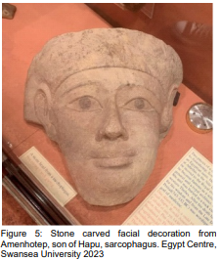
Burial artifacts discovered from the time period of Amenhotep III often illustrate examples of this belief system. Part of the sarcophagus of an Egyptian saint, also named Amenhotep, is on display in the Egypt centre at Swansea University. This fragment (Figure 5) has very similar design features to the Cyfarthfa artifact. The pronounced hair piece, nose, larger lips and eyes and the simplified ears all suggest that these two artifacts are connected. There are subtle variations although there is an overall similar design aspect when it comes to forming these masks. This depiction might be a more precise representation of Amenhotep due to his standing and closeness with the Pharaoh. As “Amenhotep III even ordered the building of a small funerary temple for him next to his own temple, a unique honour for a nonroyal person in Egypt”. The very materials utilised in this mask highlights the importance of the individual, as the carving of stone leaves very little room for error and was likely a commissioned piece specifically for the sarcophagus.
When comparing both of these artifacts (Cyfarthfa and Swansea), it is clear that all levels of ancient Egyptian society utilised similar methods of burial. Individuals’’ status and wealth had a fundamental impact on the quality of the depiction, the level of detail and the materials used.
The use of Nile silt/clay for this artifacts construction indicates that it was potentially intended for the burial of someone of lower standing within the Egyptian hierarchy. Alternatively, this could also be an example of the coffins utilised in the 3rd intermediate period. During this time there were ”a succession of changes in response to an era of economic distress”. This resulted in “the decoration became more simplified” and “over-large smiling face, was the style of choice”. Given that there is no set date attributed to this artifact, by utilising these parameters an educated assumption can be made regarding the period from when this artifact originated.
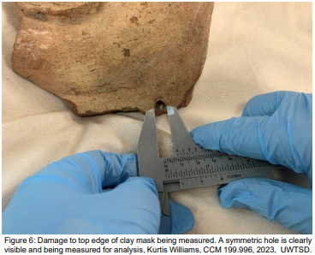
This clay artifact has obviously been manufactured by a skilled craftsman. The sculptor has clearly been able to adhere to the concepts established by the ancient Egyptians’ desire to manifest themselves in a much better position when arriving in the afterlife. This artifact may have been part of an elongated ovoid clay coffin, positioned where the face of the deceased would have been. Clay coffins, given their size and shape had the potential to be recycled pots cut and added to in order to achieve the correct form. It was common practice as “recycling was an essential component of ancient economic and technological sustainability, and does not necessarily represent a diminishment of ‘value’”.
One interesting feature of this artifact is a 9-millimetre hole along the left rim. The actual cause of this rather precise hole is unclear, however it could be the result of someone trying to display/mount this object. At the beginning of the 20th century the British upper classes organised expeditions and archaeological digs throughout Egypt. These “collectors” secured scores of artifacts, both real and forgeries, for their collections. This hole therefore has the potential to be, damage caused by a proud Victorian displaying an artifact they had collected on their travels.
From the overall design and structure of this clay mask, there is a possibility that it was constructed as several pieces. These were then combined shortly before being added to the coffin. When examined closely the fixing points of the features to the backing are evident. The hair, ears, lips and eyes are the more obviously attached elements. Whatever the techniques used to create this artifact, it has resulted in a very aesthetically pleasing object, something appropriately suited for transportation of the deceased to the next world.

References
Caroline Arbuckle MacLeod, “The Development of the Egyptian Coffin”, American Research Centre in Egypt, (Accessed February 1st 2023), Available from: https://www.arce.org/resource/development-egyptian-coffin
Ronika K Power, Yann Tristant, “From refuse to rebirth: repositioning the pot burial in the Egyptian archaeological record”, Journal of Antiquity, Volume 90, Issue 354, pages 1474 – 1488, December 2016, (Accessed January 25th 2023), Available from: https://www.cambridge.org/core/journals/antiquity/article/from-refuse-to-rebirth-repositioning-the-pot-burial-in-the-egyptian-archaeological-record/7E77AE24D521DF29778CB577D8B0C034
Smithsonian, “Egyptian Mummies”, www.si.edu, (Accessed January 31st 2023), Available from: https://www.si.edu/spotlight/ancient-egypt/mummies#:~:text=But%20why%20preserve%20the%20body,ka%2C%20ba%2C%20and%20akh.
The editors of the encyclopaedia Britannica, “Amenhotep, son of Hapu”, Encyclopaedia Britannica, May 28th 2013, (Accessed January 30th 2023), Available from: https://www.britannica.com/biography/Amenhotep-son-of-Hapu
Bibliography
Anna Stevens, “Ancient Egyptian Coffins Craft traditions and functionality”, Peeters publishing, 2018, (Accessed January 25th 2023), Available from: https://researchmgt.monash.edu/ws/portalfiles/portal/262006682/Beyond_iconography_The_Amarna_coffins_in.pdf
Caroline Arbuckle MacLeod, “The Development of the Egyptian Coffin”, American Research Centre in Egypt, (Accessed February 1st 2023), Available from: https://www.arce.org/resource/development-egyptian-coffin
Cale Staley, “Anthropoid Clay Coffin1.jpg”, Wikipedia, August 16th 2012, (Accessed January 20th 2023), Available from: https://commons.wikimedia.org/wiki/File:Anthropoid_Clay_Coffin1.jpg
Elaine A. Evans, “Ancient Egyptian Ba-Bird”, The University of Tennessee, (Accessed January 31st 2023), Available from: https://mcclungmuseum.utk.edu/1993/11/01/ba-bird/
Emily DeMarco, “Ancient Egyptian pot burials were not just for the poor”, Science News, January 3rd 2017, (Accessed February 1st 2023), Available from: https://www.sciencenews.org/article/ancient-egyptian-pot-burials-were-not-just-poor
James Allen, Marsha Hill, “Egypt in the Third Intermediate Period (ca. 1070–664 B.C.)”, The Metropolitan Museum of Art, March 2018, (Accessed February 2nd 2023), Available from: https://www.metmuseum.org/toah/hd/tipd/hd_tipd.htm
Nicola Harrington, “Living with the Dead: Ancestor Worship and Mortuary Ritual in Ancient Egypt”, Oxbow Books, 2013, (Accessed January 25th 2023), Available from: https://www-jstor-org.ezproxy.uwtsd.ac.uk/stable/j.ctvh1ds21.8?seq=19#metadata_info_tab_contents
Museum of Fine Arts Budapest, “Lid of a Coffin of a Child”, www.mfab.hu, 2019, (Accessed February 4th 2023), Available from: https://www.mfab.hu/artworks/lid-of-a-coffin-of-a-child/
Ronika K Power, Yann Tristant, “From refuse to rebirth: repositioning the pot burial in the Egyptian archaeological record”, Journal of Antiquity, Volume 90, Issue 354, pages 1474 – 1488, December 2016, (Accessed January 25th 2023), Available from: https://www.cambridge.org/core/journals/antiquity/article/from-refuse-to-rebirth-repositioning-the-pot-burial-in-the-egyptian-archaeological-record/7E77AE24D521DF29778CB577D8B0C034
Smithsonian, “Egyptian Mummies”, www.si.edu, (Accessed January 31st 2023), Available from: https://www.si.edu/spotlight/ancient-egypt/mummies#:~:text=But%20why%20preserve%20the%20body,ka%2C%20ba%2C%20and%20akh.
The editors of the encyclopaedia Britannica, “Amenhotep, son of Hapu”, Encyclopaedia Britannica, May 28th 2013, (Accessed January 30th 2023), Available from: https://www.britannica.com/biography/Amenhotep-son-of-Hapu
Images
Figure 1,2,3,6: Kurtis L. Williams 1801031, “Mask Cut From Clay Coffin”, Front, Angled, Rear view, Taken January 24th 2023, UWTSD Lampeter
Figure 4: Cale Staley, “Anthropoid Clay Coffin1.jpg”, Wikipedia, August 16th 2012, (Accessed January 20th 2023), Available from: https://commons.wikimedia.org/wiki/File:Anthropoid_Clay_Coffin1.jpg
Figure 5: Kurtis L. Williams 1801031, “Piece of Sarcophagus Amenhotep, Son of Hapu”, Front view, Taken January 25th 2023, Swansea University Egypt Centre

Ronika K Power, Yann Tristant, “From refuse to rebirth: repositioning the pot burial in the Egyptian archaeological record”, Journal of Antiquity, Volume 90, Issue 354, pages 1474 – 1488, December 2016, (Accessed January 25th 2023), Available from: https://www.cambridge.org/core/journals/antiquity/article/from-refuse-to-rebirth-repositioning-the-pot-burial-in-the-egyptian-archaeological-record/7E77AE24D521DF29778CB577D8B0C034
Smithsonian, “Egyptian Mummies”, www.si.edu, (Accessed January 31st 2023), Available from: https://www.si.edu/spotlight/ancient-egypt/mummies#:~:text=But%20why%20preserve%20the%20body,ka%2C%20ba%2C%20and%20akh.
The editors of the encyclopaedia Britannica, “Amenhotep, son of Hapu”, Encyclopaedia Britannica, May 28th 2013, (Accessed January 30th 2023), Available from: https://www.britannica.com/biography/Amenhotep-son-of-Hapu
Caroline Arbuckle MacLeod, “The Development of the Egyptian Coffin”, American Research Centre in Egypt, (Accessed February 1st 2023), Available from: https://www.arce.org/resource/development-egyptian-coffin
Ronika K Power, Yann Tristant, “From refuse to rebirth: repositioning the pot burial in the Egyptian archaeological record”, Journal of Antiquity, Volume 90, Issue 354, pages 1474 – 1488, December 2016, (Accessed January 25th 2023), Available from: https://www.cambridge.org/core/journals/antiquity/article/from-refuse-to-rebirth-repositioning-the-pot-burial-in-the-egyptian-archaeological-record/7E77AE24D521DF29778CB577D8B0C034

