
Noise Susceptibility of FM transmissions

Tuning in to the World of FM Communication and Anti-Interference Strategies

Embedded Electronic Systems, Year 3
Jack Lonsdale
Student No: 2114210
Word Count: 2,311
Similarity: 8%

Contents
Introduction 2
Background research 2
FM modulation 2
FM demodulation 2
Jamming Techniques 2
Anti-Jamming techniques (HFSS) 2
Ethical and Legal Implications 2
Task 1: Jamming Techniques 2
Narrow Band FM Modulation and Demodulation 2
Narrow Band FM jamming 2
Implementation of Frequency Hopping Spread Spectrum techniques 3
Analysis and Comparison 4
Ethics and Impact 5
Task 2: Design and Analysis of an RTL-SDR Receiver 5
References 5

Introduction
This report investigates the FM modulation, its susceptibility to jamming, and how it can be mitigated with FHSS (frequency hopping spread spectrum).
This is practically tested with software models in GNU radio. By first implementing an FM modulator and demodulator, then modifying it to work with FHSS. Both of these are evaluated when exposed to a Gaussian-noise jammer of varying strength.
GNU radio was selected because it’s an industry-level software that is also open source. It provides many ways to analyse the integrity of a signal such as in the frequency domain, and time domain, and with waterfall and constellation diagrams. It also provides the capability to use sound recordings as sources and play them as audio to test clarity.
Unfortunately, the FHSS model is non-functional so the noise-resistance capability that FHSS provides was unable to be practically verified.

Background research
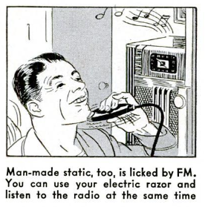
Figure 1. A cartoon demonstrating the noise resistance of FM. [1]
FM (Frequency Modulation) is a way of altering the frequency of a sinusoidal carrier wave to encode information onto it, as shown below in figure 2:
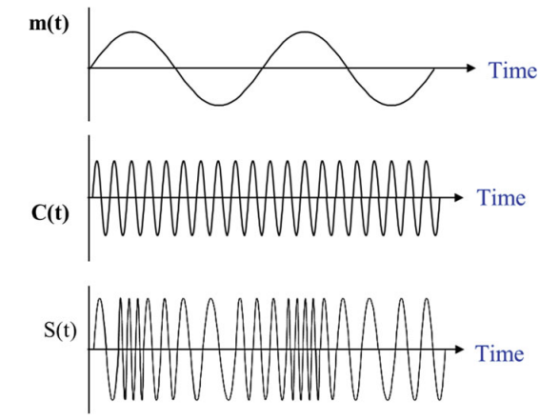
Figure 2. FM modulation, where: m(t) is the message signal, C(t) is the carrier wave, and S(t) is the modulated FM wave. [2]
$s(t)$=$A_{C}Cos [2πf_{c}t+β\sin{2πf_{m}}t]$
Equation 1. FM modulated wave equation [3]. Where $β is the modulation index, β =\frac{A_{m}k_{f}}{f_{m}}$
Given in Equation 1, the frequency of the modulated wave is the sum of:
- Product of modulation index and message frequency
- The frequency of the carrier wave
FM modulation made headlines on its discovery for significantly better noise resistance than AM (Amplitude Modulation). [1]
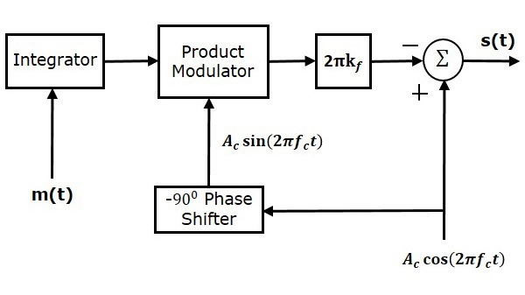
Figure 3. Block diagram of an FM modulator. [4]
The FM modulator works as follows:
- The message signal is integrated
- This is multiplied by a -90⁰ shift of the Carrier wave
- Then scaled by a factor of ${2πk}_{f}$ (where $k_{f}$ is the modulation constant, controlling the sensitivity of the modulated wave to the message signal) [5]
- This is then subtracted from the carrier wave and transmitted.
FM Demodulation
FM demodulation is naturally the reverse process of FM modulation, the modulated wave must be extracted from the carrier and modified to recreate the original message signal.
There are multiple ways to demodulate FM waves, the two most common are:
- High pass filter: selected to be highly sensitive to frequency changes within the frequencies of the incoming wave, this attenuates a higher frequency more so than a lower frequency, altering the amplitude.
- Phase locked loop: A more precise method for demodulation, consisting of a phase detector, loop filter, and voltage controlled oscillator [6]
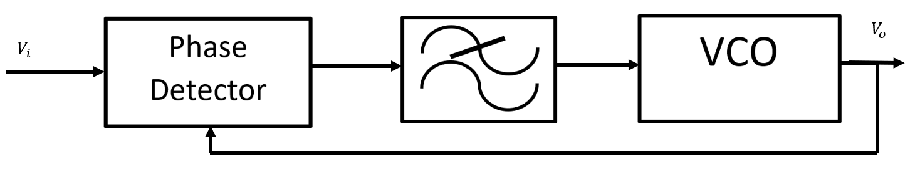
Figure 4. Phase locked loop. [7]
The Voltage Controlled Oscillator generates a sinusoidal wave with frequency proportional to the incident analogue voltage. This is inputted to the phase detector, which outputs corrective feedback through the low pass filter (smoothing feedback, allowing the “locking” onto the phase).
Jamming techniques
Jamming is the deliberate disruption of electromagnetic signal to degrade, disrupt, or destroy a wireless device. Jamming can be considered a “brute force” attack, simply trying to drown out the original signal with larger power. This is different to spoofing, where usual communication is intelligently mimicked to provide disruption.
Jamming takes many different forms, but some of the common categories include [8]:
- Narrow band jamming: When the communication to disrupt is only a few frequencies, and these frequencies are known, then all of the power can be focused into a small part of the spectrum, producing an effective jammer with low power requirements.
- Wideband jamming: When the system to disrupt operates on frequencies across a band, or the frequency of a system is unknown, jamming signals can be transmitted across a band. This uses a lot of power and is not as effective as narrowband jamming.
- Sweep Jamming: Shares attributes of both narrow and wideband jamming. The frequency being jammed is constantly changing (sweeping), providing wide spectral coverage, but also high power. This comes at the disadvantage of only jamming a given frequency for a certain length of time, and transmissions may get through in null periods.
Anti-jamming techniques [9]
There are many techniques for safeguarding against jamming, these include:
- Changing Frequency: In the case of Narrowband jamming, it’s possible to avoid the jamming altogether by moving to another frequency, where the disruptive signals can be easily filtered out. Some systems communicate on multiple frequencies and jump between them (Frequency Hopping Spread Spectrum, HFSS)
- Improving link budget: Increasing the gain of the transmitting or receiving antenna, or increasing transmission power may means that the jammer no longer has power high enough to override the signal, and becomes background noise.
- Data redundancy: Transmissions can be sent multiple time, providing error detection. This is particularly effective against sweep jamming, but does reduce data throughput.
- Excision: If the jamming signal is of a known or recognizable pattern, it may be possible to remove it mathematically simply by subtracting it, revealing the original signal.
Ethical and legal implications
The unauthorized jamming of communications is illegal in most countries of the world. In the UK, it is legislated by the Wireless Telegraphy Act 2006 [10], and is enforced by OFCOM (office of communications). Offenders can be fined, thrown in prison, or have equipment confiscated.
Jamming can cause significant disruption to essential infrastructure such as the emergency services, Air Traffic control, Automatic Identification System and many more. The results of disruption to these services could lead to significant damage and/or loss of life.
Special exceptions are granted by the government to agencies that may need to interfere with signals for the greater good. For example, military units may need to disrupt enemy communications, or law enforcement may need to jam drone near sensitive areas such as nuclear power stations or airports.

Task 1: Jamming Techniques

Narrow Band FM Modulation and Demodulation
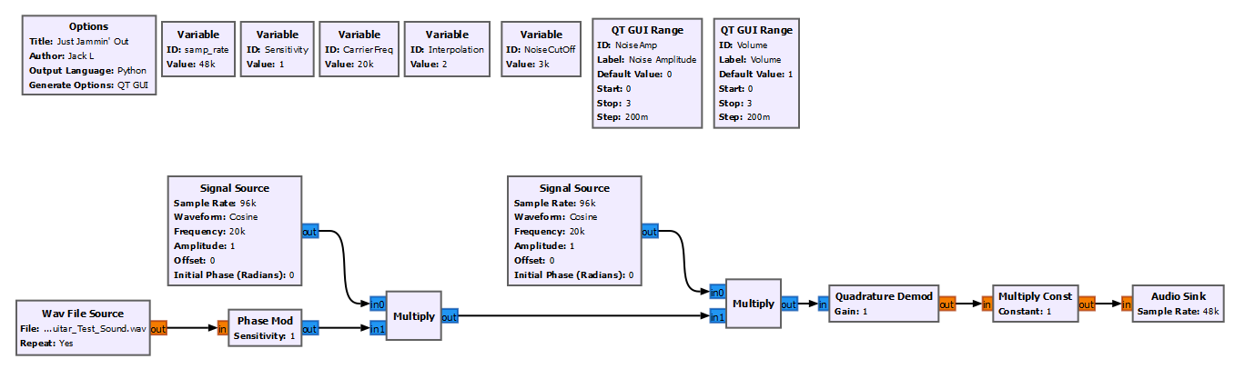
2
1
Figure 1. Narrow Band FM Modulator (1) and Demodulator (2).
Explanation
The FM modulator is comprised of two main stages:
- Phase modulating the message signal, converting changes in amplitude to changes in phase (and therefore changes in frequency). These frequency deviations represent the information contained in the message signal.
- Multiplying by the carrier wave for transmission
The demodulator then has the task of reversing the process, by:
- Multiplying by the carrier wave, essentially removing it from the message signal.
- Converting the changes in phase back into amplitude changes (done by the quadrature demod block).
The output of the demodulator is then amplified as required to boost the signal strength.
The sensitivity of the phase modulator block controls the change in phase for a given changes in amplitude, such that:
$$Δθ α K∙ΔA_{m}$$
Equation 1. Change is phase is proportional to the "Sensitivity" constant, and change in amplitude.
In order to reproduce the message signal accurately, the gain of the quadrature demod block must be the reciprocal of the sensitivity of the phase mod block.
Sound recordings
Analysing the audio signal as it travels through the network can be difficult with screenshots given that the signal is constantly changing, and the output corresponds to a previous input, slightly delayed from the current input being shown. This can make it hard to determine anything more than basic properties of the signal. However, we can verify that the demodulation sequence matches the modulation sequence properly with audio recordings:
Sound 1. The message signal.
The message signal (Sound 1), is the test audio selected to analyse the network. It has a range of frequencies, and is royalty free.
Sound 2. The message signal frequency modulated and applied to a carrier wave.
Sound 2 is the modulated waveform, the message signal is encoded onto the carrier wave.
Sound 3. The demodulated signal, revealing the message from the received signal.
Sound 3 is the demodulated message signal, a replication of the original message signal.

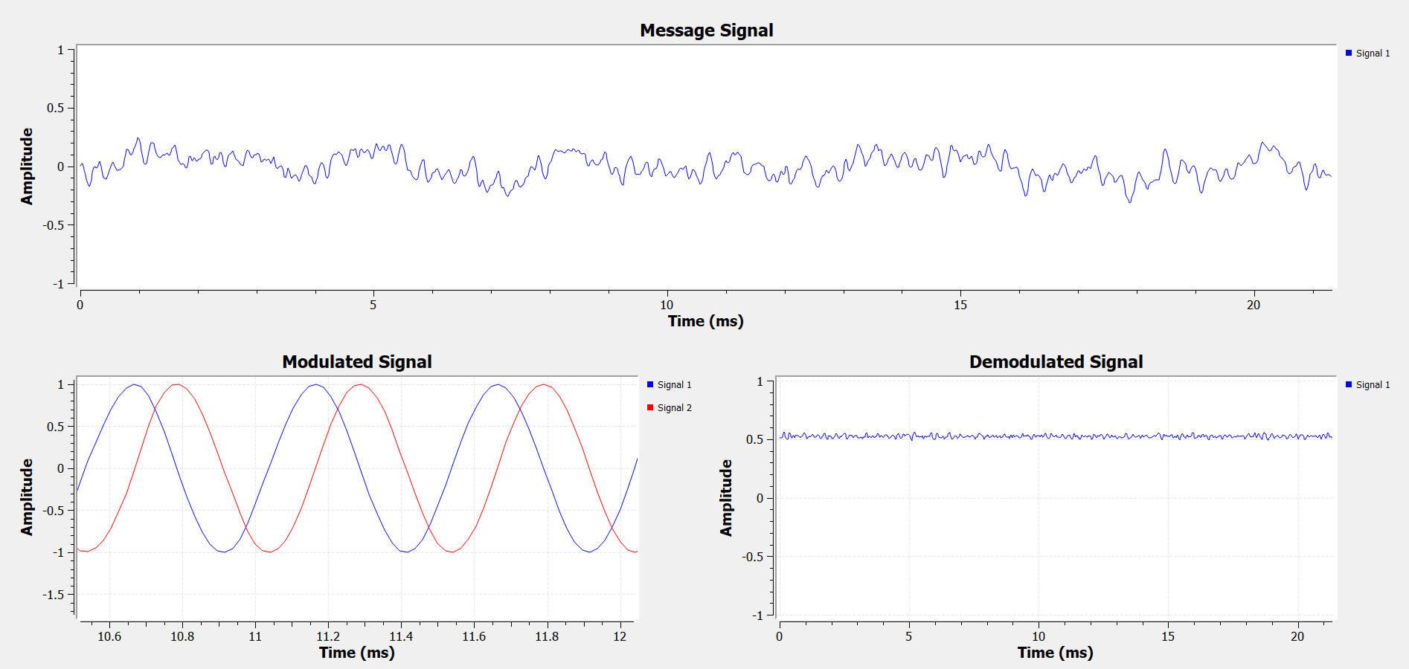
Figure 6. A comparison of the message signal with modulated signal and demodulated signal in the time domain.
Looking at the modulator and demodulator in the time domain (figure 6), the message signal contains small variations in amplitude. These are modulated onto the carrier wave. It’s worth noting that since this snapshot is a small instance of time (~2ms), these variations are very small, not noticeable.
The message signal is extracted from the carrier wave, reproducing the small amplitude changes. The demodulated signal has a 0.5V offset voltage which is a by-product of the quadrature demod block. This could easily be filtered out by the DC-blocker block, but ultimately isn’t necessary since the audio sink blocks DC anyway.
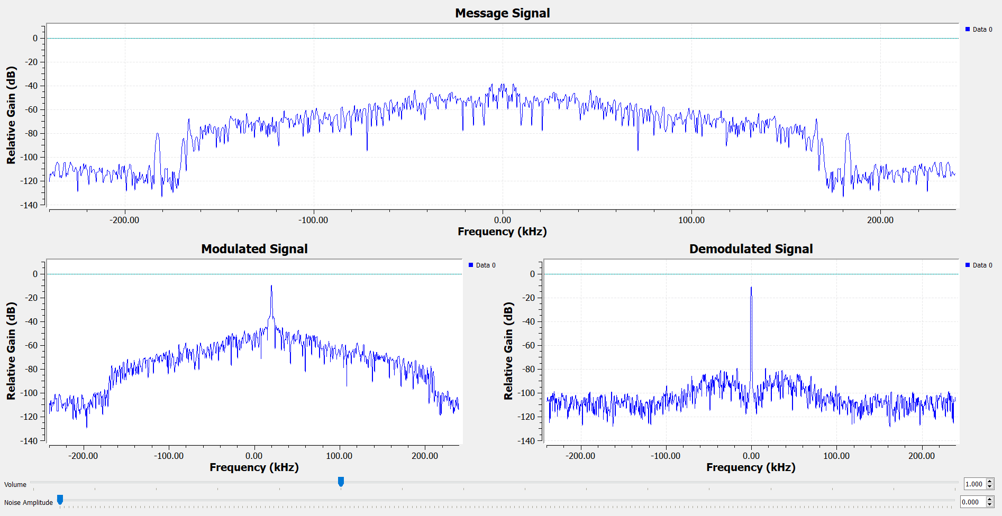
Figure 7. A comparison of the message signal with modulated and demodulated signals in the frequency domain.
Looking at the frequency domain (figure 7), it can be seen that the audio-based message signal contains a large number of different frequency components.
The modulated signal has a spike at 20kHz, the carrier wave. When the carrier wave is removed, this spike becomes a DC voltage, ignored by the audio sink at the end.
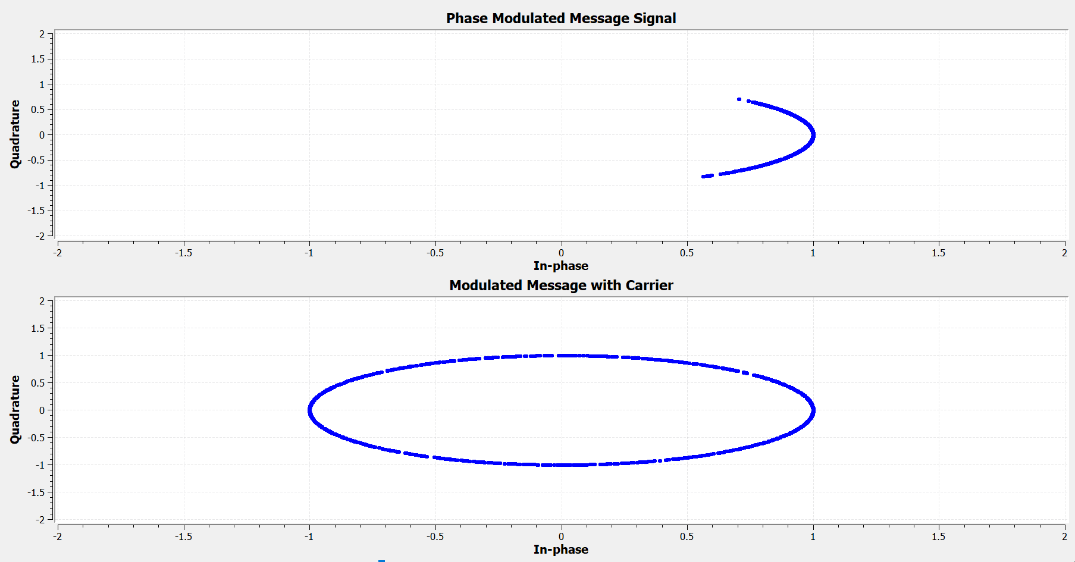
Figure 4. Phase Modulated Message Signal and Modulated Message Signal with Carrier Wave shown in the Complex Domain.
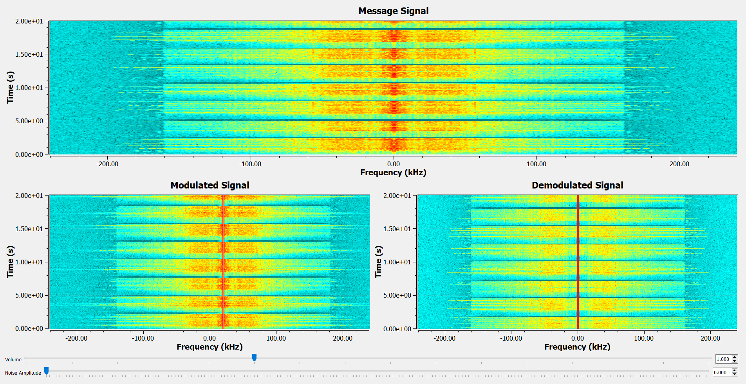
Figure 9. Message Signal compared to the modulated and demodulated signals, shown as a waterfall graph.
Looking at the waterfall graph (figure 9), we see a confirmation of modulation onto a 20kHz carrier, as demonstrated by the high-strength (red line) shifts right by 20kHz, then shifted back when the carrier is removed.
This graph shows that the signal has lots of components across the spectrum.

Narrow Band FM jamming
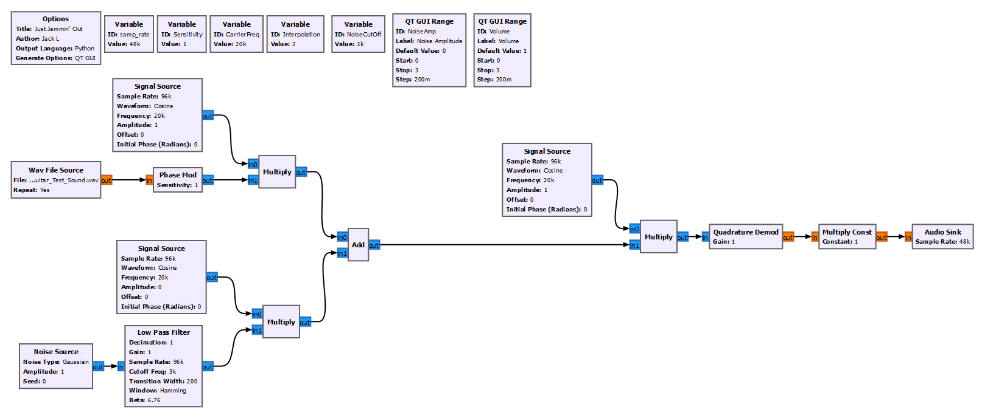
2
3
1
Figure 10. FM Transmitter and Receiver with added Gaussian Jammer.
The flowgraph shown in figure 10 has three main components:
- FM modulator (see previous section)
- FM Demodulator (see previous section)
- Gaussian jammer
Jammer
The Jammer comprises of Gaussian noise modulated onto an identical carrier wave to the FM modulator. This is added to the modulated signal, simulating a real-world combination of the two signals.
Gaussian noise was selected because its non-causal characterisation means it is immune to excision anti-jamming techniques. The amplitude of the noise can be controlled by altering the amplitude of the wave it is modulated onto.

Sound
To observe the effects of noise on the reconstructed message signal, open each sound recording below:
No Noise | 20% Noise | 40% Noise | 100% Noise | 200% Noise | 400% Noise | 600% Noise

Note, each sounds file is labelled with an approximate SNR (signal to noise ratio), given as a percent:
$$SNR (\%)= \frac{A_{m}}{A_{N}} ×100$$
With no noise, the signal is received with clarity, but at SNR of 600%, the signal is not distinguishable.

Frequency
Figure 11. Frequency Domain of the unjammed signal
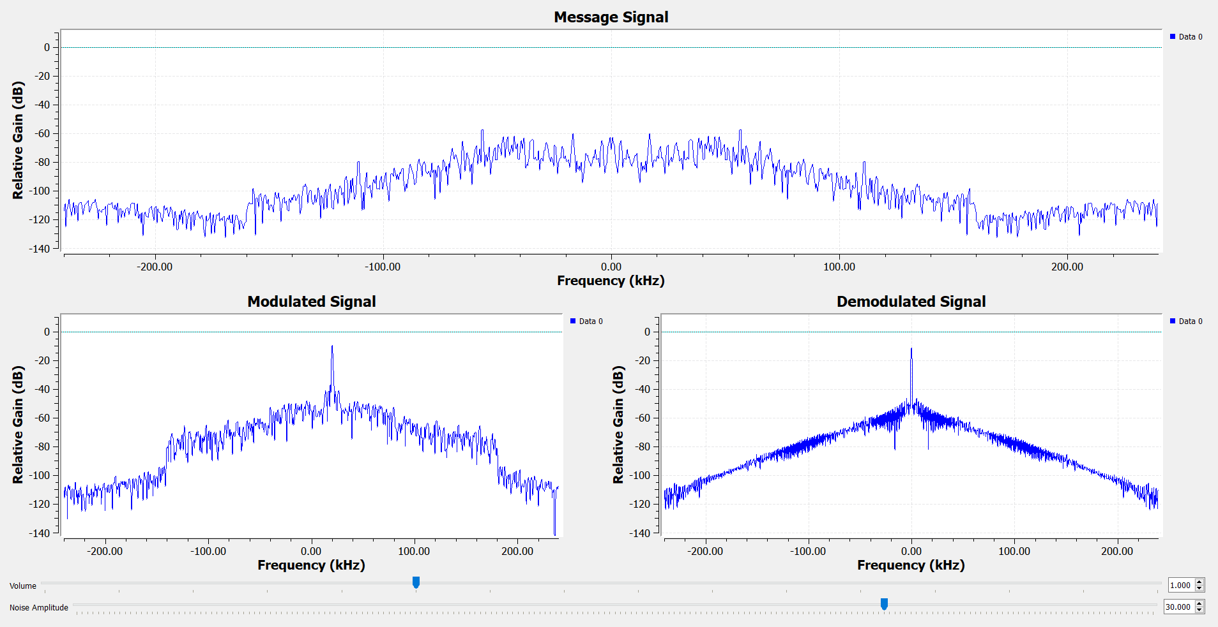
Figure 12. Frequency domain of the signal with a 600% SNR Gaussian jammer.
Although difficult to compare frequency sinks due to the inconsistent input signal, it can be seen when comparing figures 11 and 12 that the demodulated signal has the profile of the Gaussian jammer.

Time
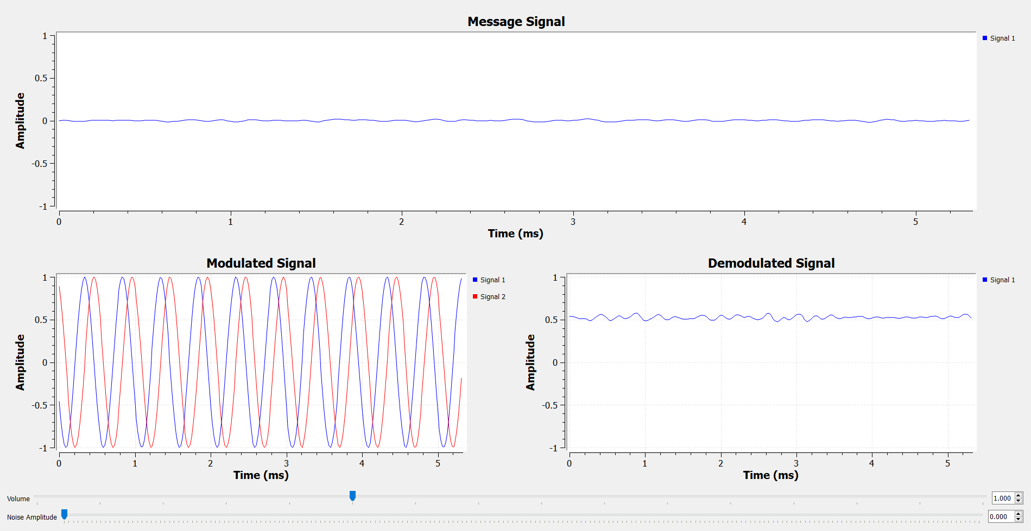
Figure 13. Time domain of the network without noise.
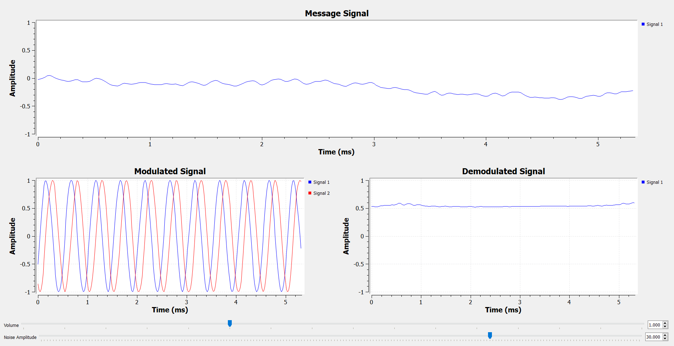
Figure 14. Time domain of the signal with 600% SNR.
As figure 13 and 14 demonstrate, the noise is difficult to notice in a single screenshot of time, and much better represented in the sound recordings above.

Waterfall
Figure 15. Network without noise shown in a waterfall graph.
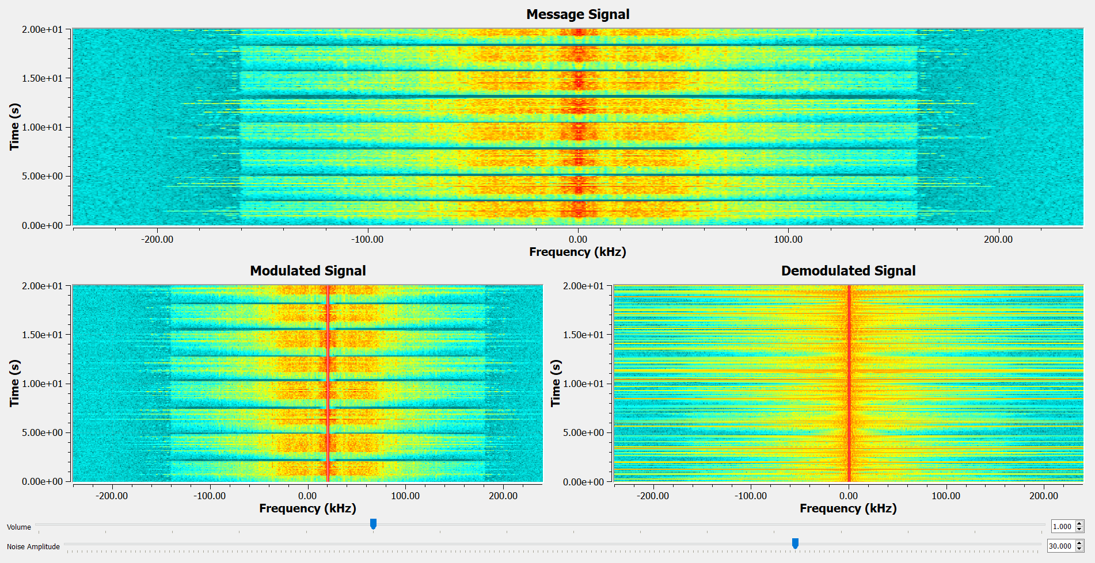
Figure 16. Network with added noise in waterfall graph.
As figure 15 and 16 show, the waterfall graph illustrates the noise well, showing that it has components across a multitude of frequencies.

Constellation
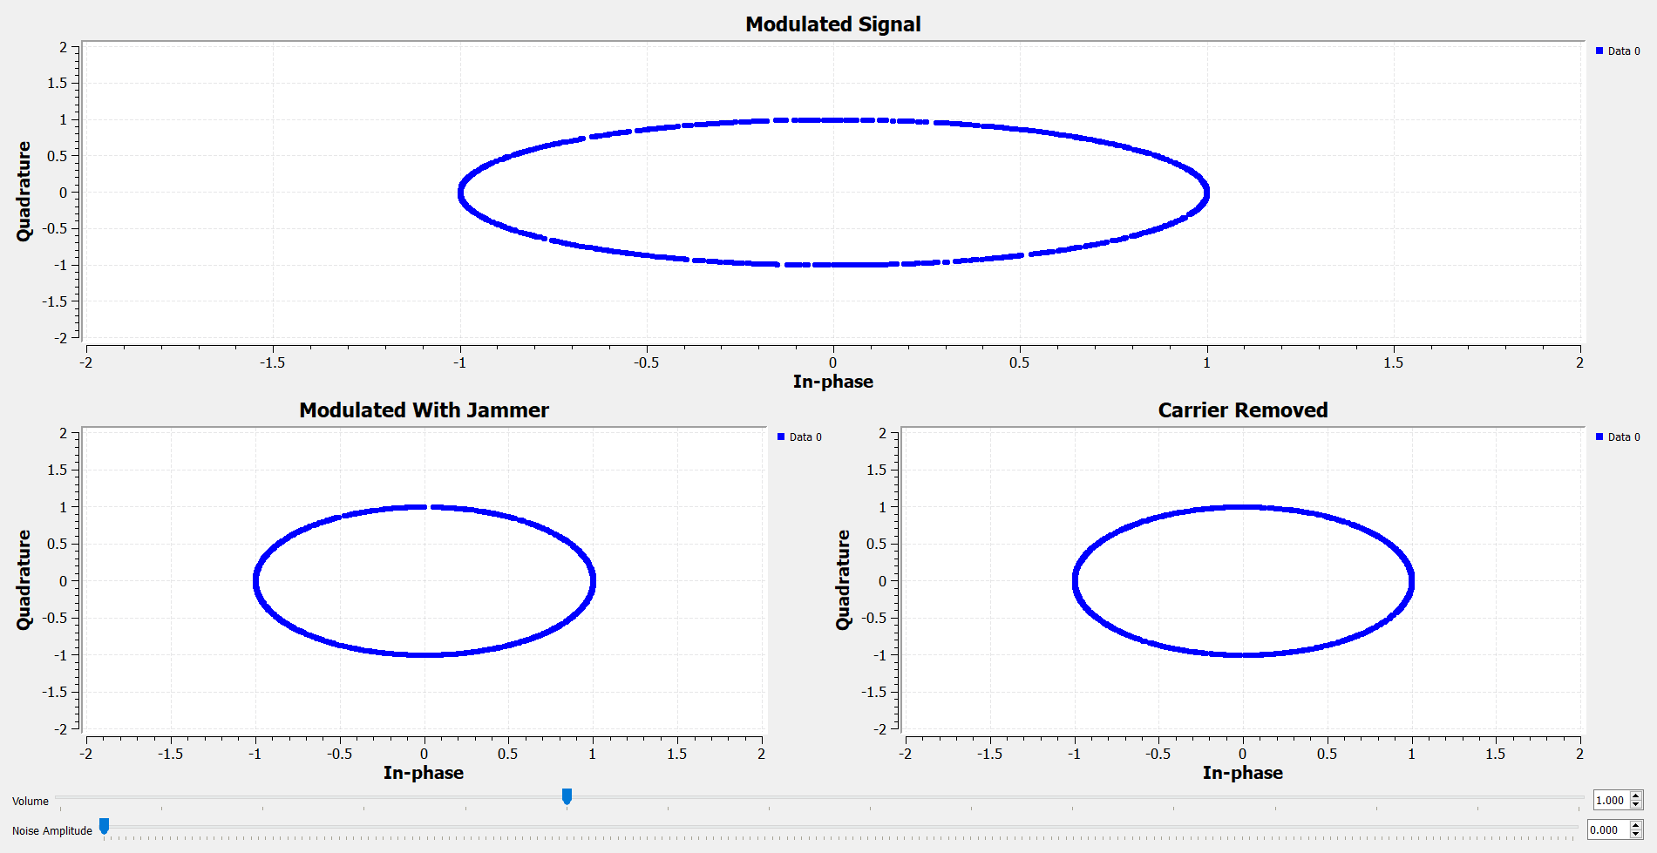
Figure 13. Constellation sink showing the network with no noise.

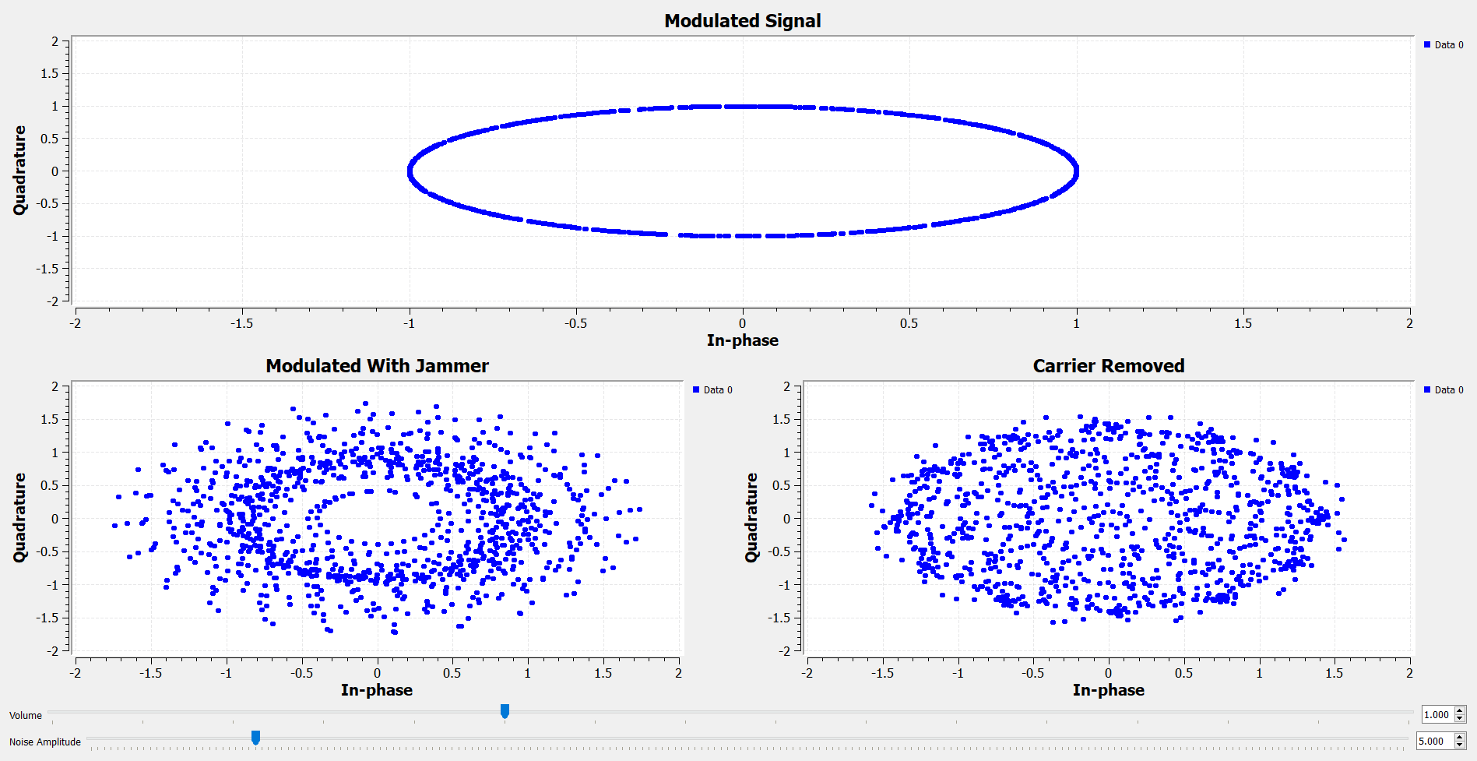
Figure 14. Constellation sink showing the effect of 100% SNR on the message signal.

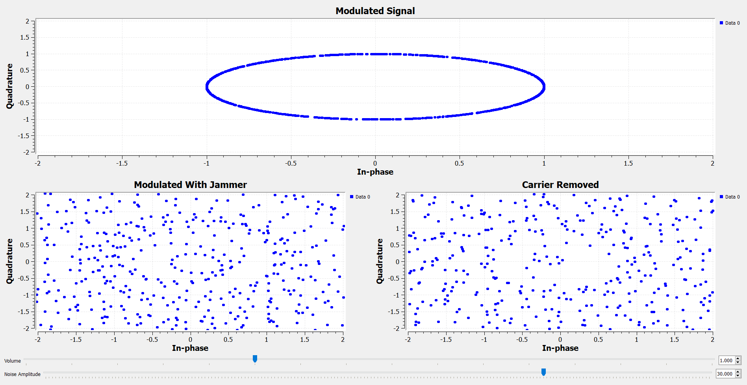
Figure 15. Constellation diagram showing the effects of 600% SNR on the message signal.

Implementation of Frequency Hopping Spread Spectrum techniques
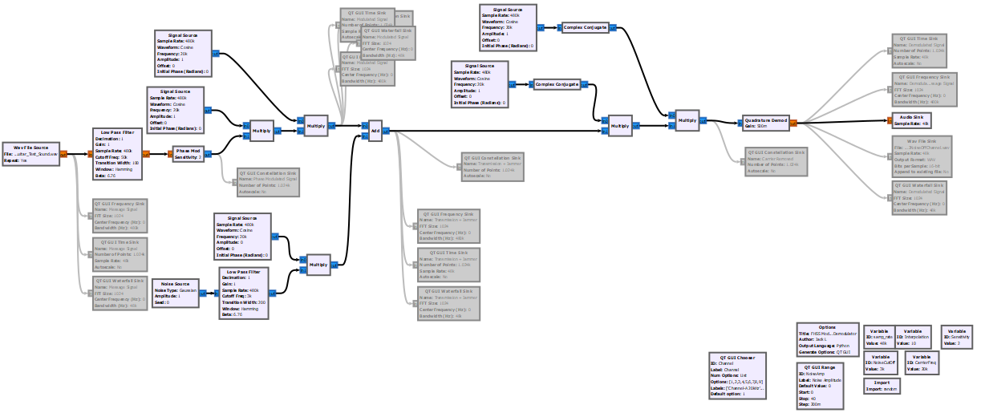
3
2
1
Figure 20. FHSS Modulator and Demodulator in GNU radio.
The FHSS modulator and demodulator does not function as intended. Through observation, the Gaussian jammer interferes with the signal significantly on all frequencies when this should not be the case. Numerous attempts have been made to understand and rectify this issue, with no success.
The main problem encountered is the wide spectral width of the signal when passed through the phase modulator block. There doesn’t seem to be any way to limit this width without degrading the signal, leaving it open to interference on all frequencies.
Issues aside, the FHSS modulator and demodulator (shown in figure 20) comprises of three main sections:
- Modulator
- Demodulator
- Gaussian jammer
Modulator
The message signal is passed through a low pass filter in an attempt to reduce spectral width. It is then phase modulated and multiplied onto its usual carrier wave. It is then multiplied by a different carrier wave to change the channel. The frequency of the second carrier wave changes randomly when the program runs, and as the user changes the “chooser” widget.
Demodulator
The demodulator first removes the channel by multiplying a complex conjugate of the second carrier. The complex conjugate must be taken as GNU radio removes the lower band of a product calculation (unlike reality). This is repeated for the carrier wave, and the signal is demodulated with the Quadrature Demod block.
Gaussian Jammer
As per the previous section of the report, a Gaussian jammer is modulated on the carrier wave and added to the transmission.

Sound
No Noise | 40% Noise On the same channel | 40% Noise on a different channel

It can easily be heard that the interference from the noise on the same channel and on a different channel is the same. If working correctly, you should see a noticeable drop in the amount of noise.
All of the following sections have screenshots showing three situations in the frequency, time, waterfall, and constellation graphs:
- The function of the FHSS modulator and demodulator with no noise
- The function of the FHSS modulator and demodulator with 40% noise on the same frequency as the transmission
- The function of the FHSS modulator and demodulator with 40% noise on a different frequency as the transmission (transmission on channel I, 180kHz and Noise on channel A 20kHz)

Frequency
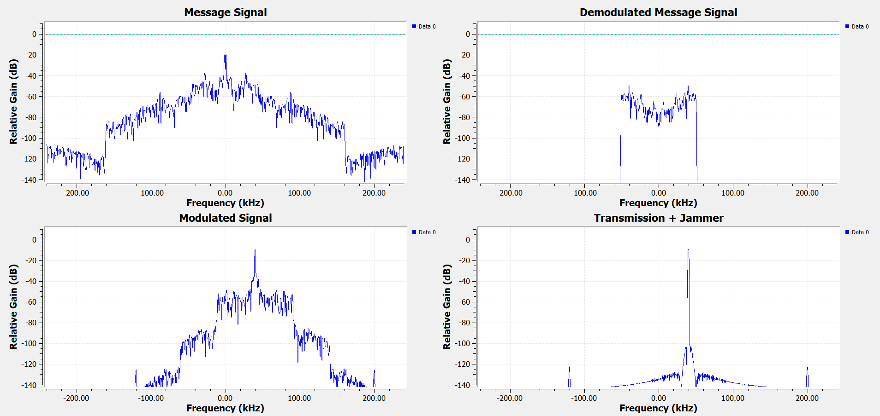
Figure 17. FHSS Modulator and Demodulator with no noise.

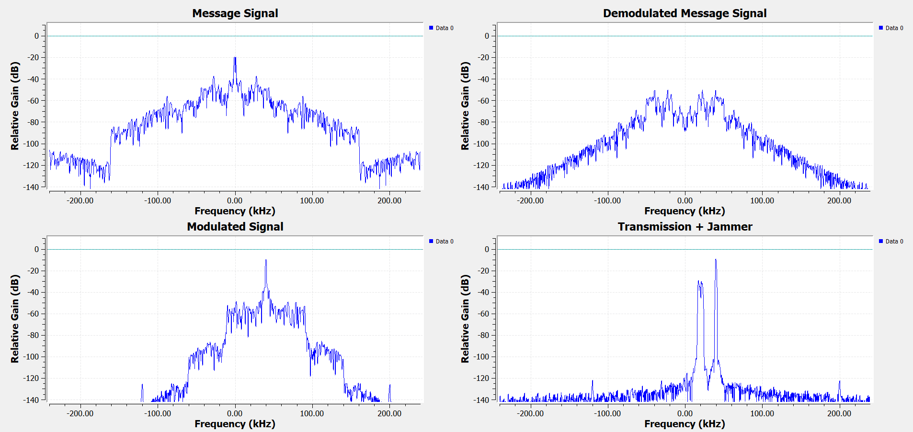
Figure 18. HFSS Modulator and Demodulator with 40% noise on the same frequency as the transmission.
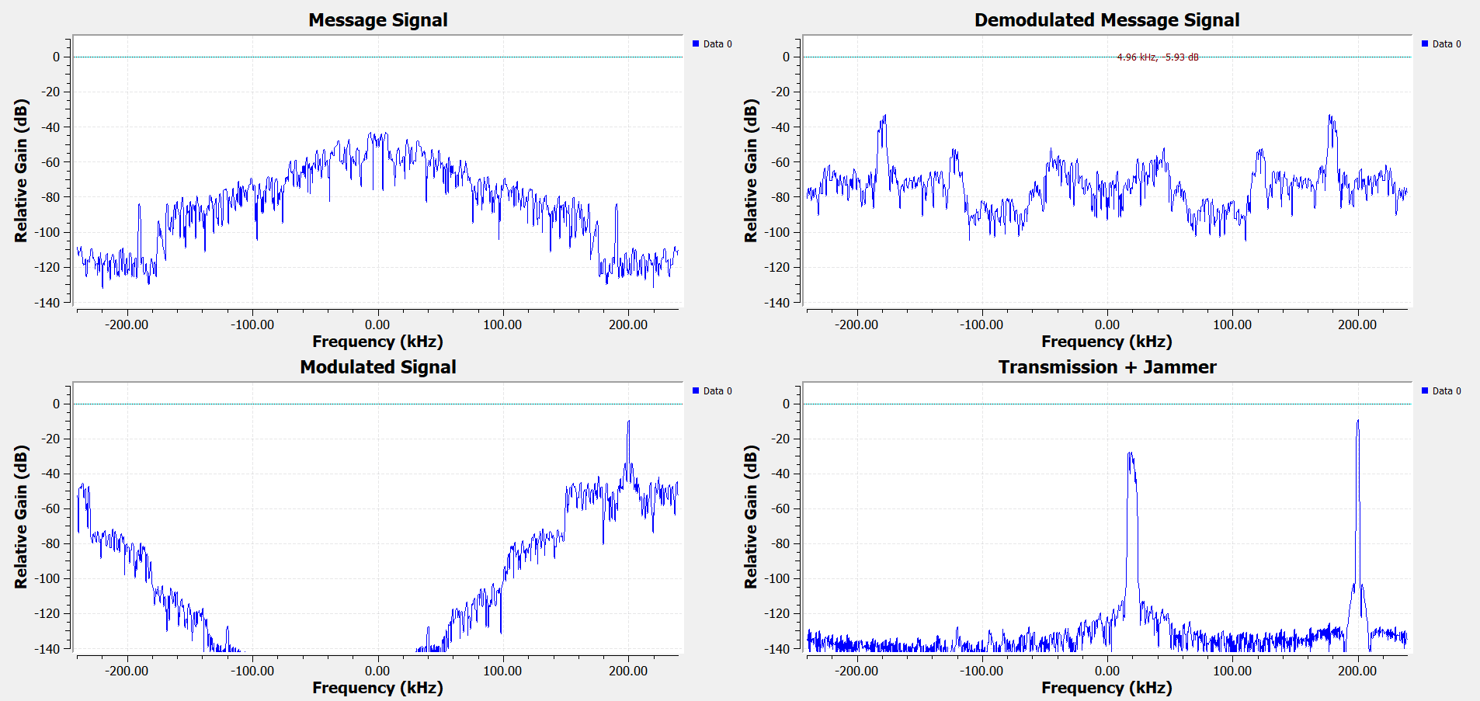
Figure 19. FHSS Modulator and Demodulator with 40% noise on a different frequency.

Time
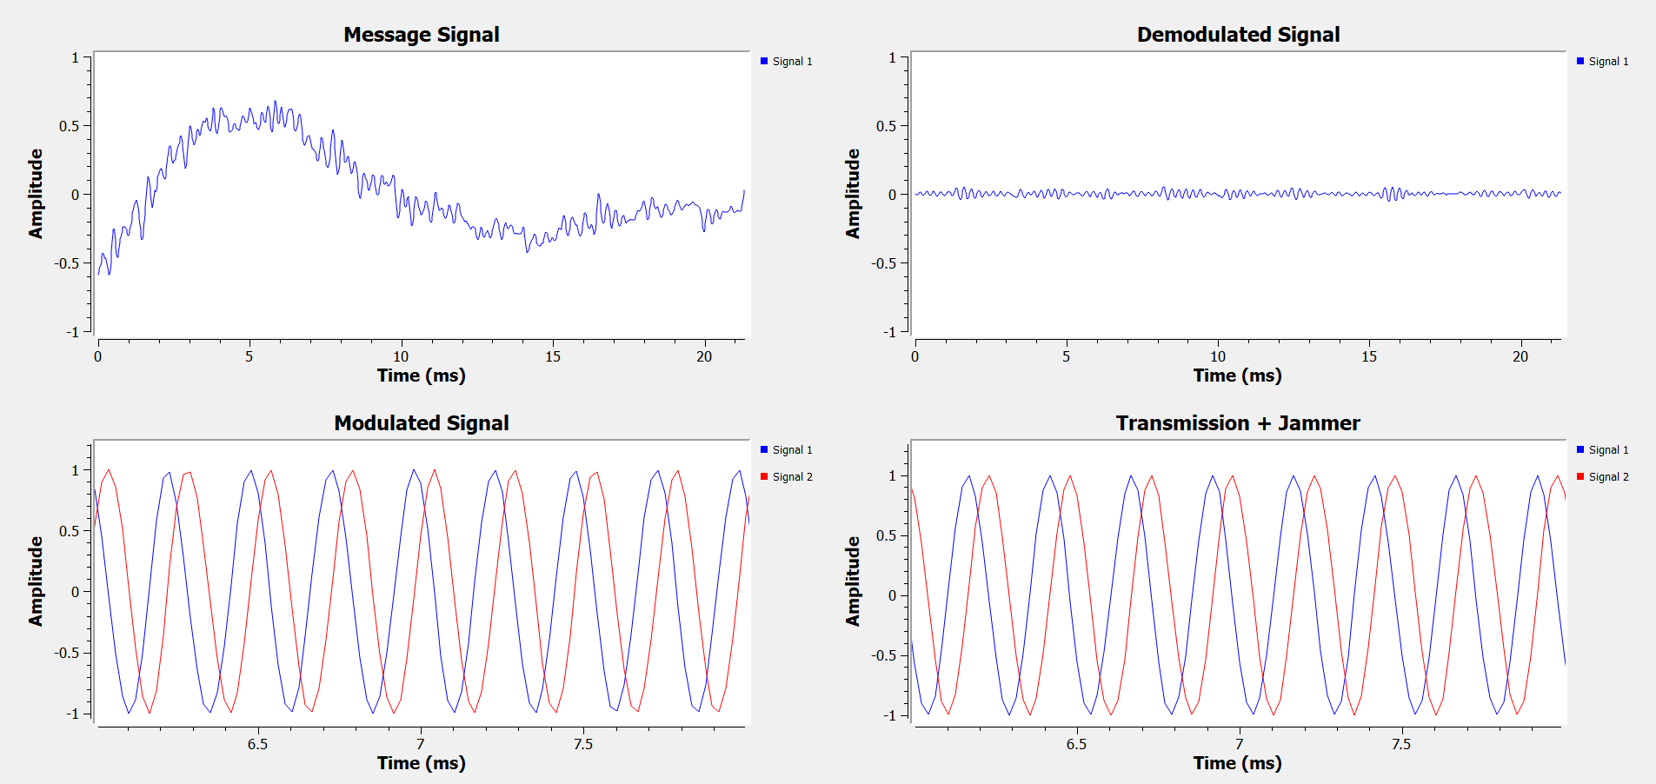
Figure 20. FHSS Modulator and Demodulator with no noise in the time domain.
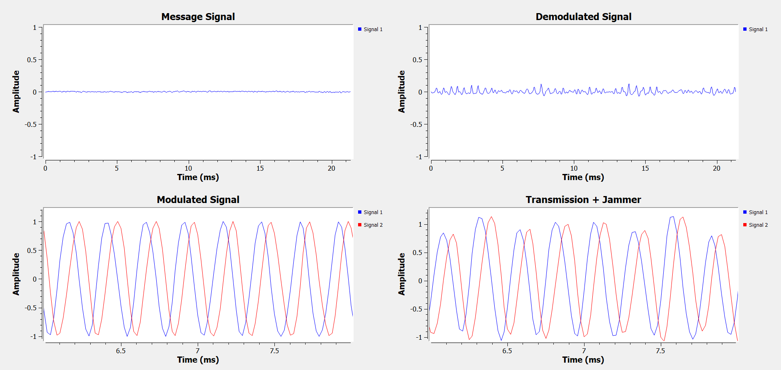
Figure 21. FHSS Modulator and demodulator with 40% noise on the same carrier frequency.
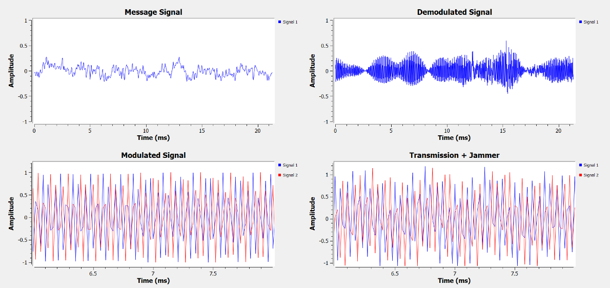
Figure 22. FHSS modulator and demodulator with 40% noise on a different frequency.

Waterfall
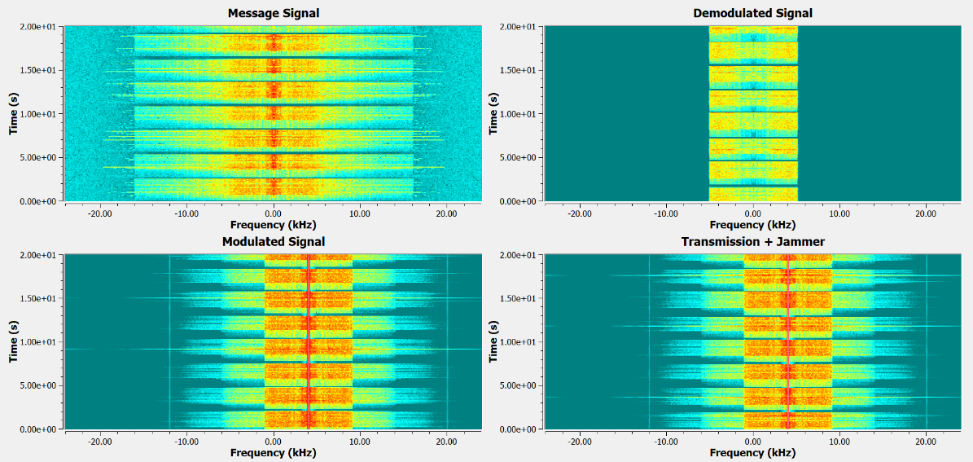
Figure 23. FHSS Modulator and demodulator with no noise shown on the waterfall graph.
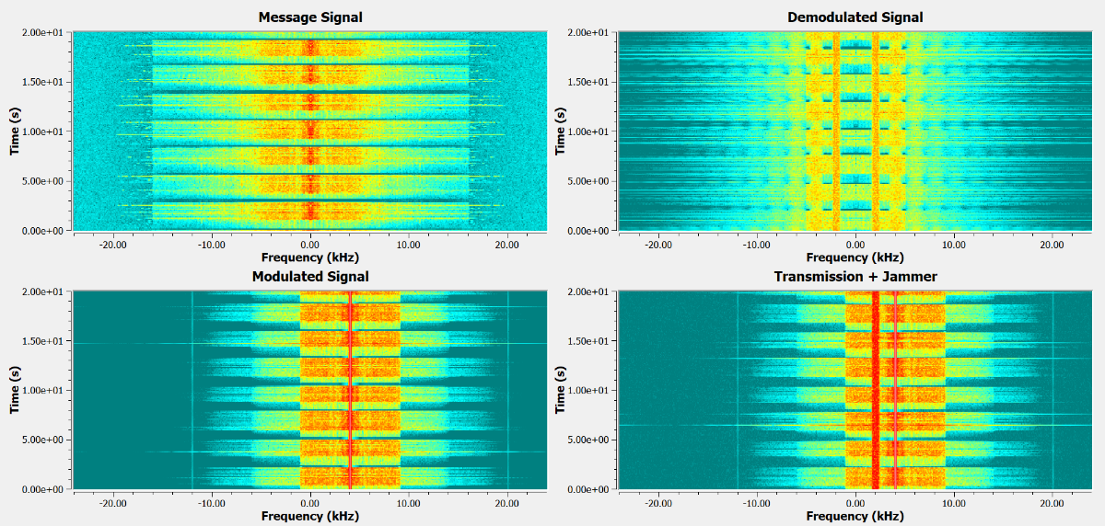
Figure 24. FHSS Modulator and Demodulator with 40% noise on the same frequency as the message signal.
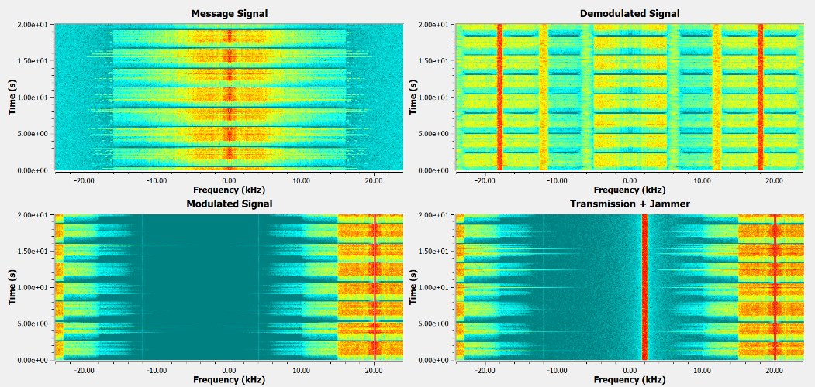
Figure 25. FHSS modulator and demodulator with 40% noise on a different frequency.

Constellation
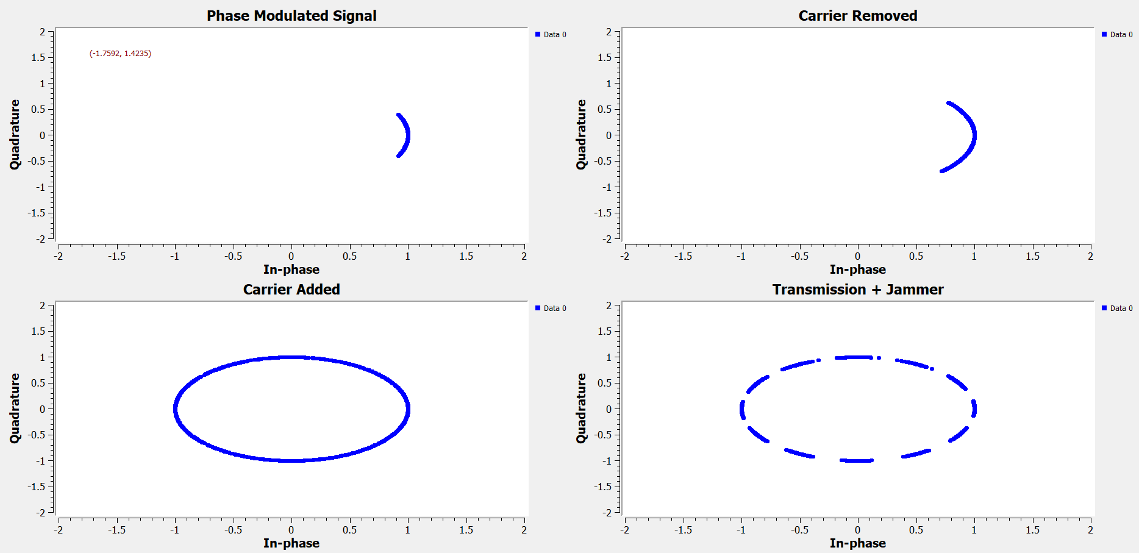
Figure 26. FHSS modulator and demodulator with no noise.
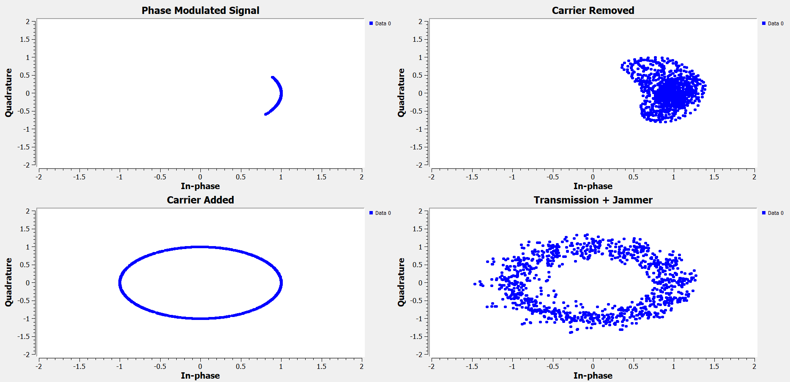
Figure 27. FHSS modulator and demodulator with 40% noise on the transmission frequency.
Figure 28. FHSS Modulator and demodulator with 40% noise on a different frequency to transmission.

Analysis and Comparison
What was observed:
Gaussian noise can degrade the quality of the signal, making audio difficult or impossible to hear as it is drowned out by static. This was observed by both the regular FM modulator/demodulator and the FHSS modulator/demodulator.
What should have happened:
As the FHSS modulator/demodulator changed frequencies away from the noise, the interference should have reduced significantly. If the FHSS was working correctly then this should have happened.

Ethics and Impact
FHSS provides an effective means by which to avoid signal disruption caused by jamming. When implemented it can help safeguard important infrastructure that society depends on (phone network to call emergency service, GNSS navigation, Air traffic control, etc…). By protecting these communications links, engineers can help reduce the risk of damage or loss of life through insecure and vulnerable networks.

References
[1] Popular Science. “What are the Facts about FM?”, Nov. 1940 [Online] Available: https://books.google.co.uk/books?id=gycDAAAAMBAJ&pg=PA70&redir_esc=y#v=onepage&q&f=false Accessed 14/01/2025
[2] Element14, “Adalm Pluto SDR roadtest”. [Online] Available: https://community.element14.com/products/roadtest/rv/roadtest_reviews/1710/adalm_pluto_sdr_roadtest, Accessed 14/01/2025
[3] J.prince-devaraj. “GNU Radio Lecture 10”, slide 29. Faculty of Applied Computing, University of Wales Trinity St. David
[4] TutorialsPoint.com. “Analog Communication - FM Modulators” [Online] Available: https://www.tutorialspoint.com/analog_communication/analog_communication_fm_modulators.htm, Accessed 14/01/2025
[5] Saleh Faruque, “Radio Frequency Modulation Made Easy”. [Online] Available: https://nvhrbiblio.nl/biblio/boek/Faruque%20-%20Radio%20Frequency%20Modulation%20made%20easy.pdf Accessed 14/01/2025
[6] Allaboutcircuits, “How to Demodulate an FM Waveform”. [Online] Available: https://www.allaboutcircuits.com/textbook/radio-frequency-analysis-design/radio-frequency-demodulation/how-to-demodulate-an-fm-waveform/ Accessed 14/01/2025
[7] Analog Devices, “Phase-Locked Loop (PLL) Fundamentals” [Online] Available: https://www.analog.com/en/resources/analog-dialogue/articles/phase-locked-loop-pll-fundamentals.html Accessed 14/01/2025
[8] JEM Engineering, “An introduction to jammers”. [Online] Available: https://jemengineering.com/blog-an-introduction-to-jammers/ Accessed 14/01/2025
[9] Chelton, “The Evolution of Anti-Jamming”. [Online] Available: https://chelton.com/about-us/latest-thinking/the-evolution-of-anti-jamming/ Accessed 14/01/2025
[10] Wireless Telephony Act, 2006, UK

