3/24/2025
University of Wales Trinity Saint David
London campus
E-Portfolio Link: https://produoneshot0.wixsite.com/my-site-1
Module Name: Learning In the Digital Era
Module Code: ACCA 4025

Student Name: Eulalio Alesino Fernandes
Student ID: 2441942
Group: 1

Lecturer’s Name: Koushik Modak

LDE Assignment 1
E-Portfolio
Table of Contents
Introduction 2
Main Body 2
Task 1: Essential Academic and Employment Skills for the future career Path 2
Task 1 (a): Report on Essential Academic and Employment Skills 2
Task 1 (b): Evaluation of Task 1 (a) based on Similarity report 2
Task 2: Collaborative Mind Map and Individual Poster 2
Mind Map (Collaborative) 2
Poster (Individual) 2
Task 3: Virtual Collaboration and RefWorks 2
Report on Virtual Collaboration 2
Step-by-step process of using RefWorks with visuals 2
Task 4: E-Portfolio Creation and Evaluation 2
Task 4 (a): E-Portfolio Creation 2
Task 4 (b): Illustrative Review of E-Portfolio tool Selection 2
Conclusion 2
References 2
Task 1 References: 2
Task 3 References: 2

TASK 1 (a)
Essential skills for study and employment are the underpinning skills necessary for learners to function academically and professionally. These include communication, critical thinking, time management, teamwork, and adaptability; these skills will enhance learning, improve performance, and better prepare individuals for the demands of today's workplace.
Study skills are a fundamental part of students' academic competency and achievement in all subjects and for different types of learners. This article presents an information-processing explanation of study skills, demonstrating their role in promoting learning through enhanced information encoding, storage, and retrieval. Four major categories of study skills are identified: repetition-based skills that reinforce memory by practice; procedural skills which plan and structure learning tasks; cognitive-based skills that allow deeper understandings; and metacognitive skills that enhance the student's processes by planning, monitoring, and evaluating learning. Evidence-based strategies that enhance these skills are also discussed, indicating that effective instruction in study strategies should be explicit, structured, and integrated within regular academic activities. Teaching students to identify proper strategies and apply them appropriately enhances their independence and general academic performance [1].
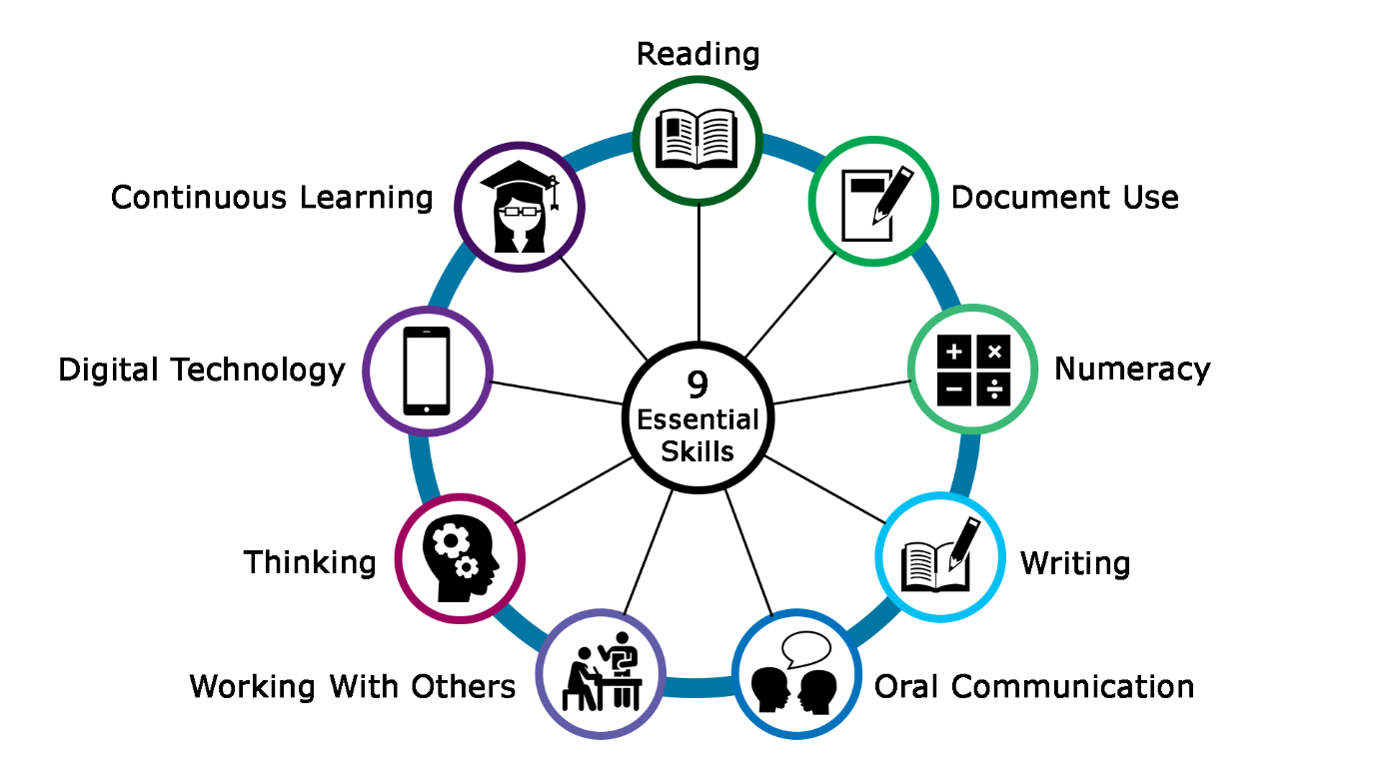
[2].

This article explores the importance of work-related social skills for promoting long-term employability, while noting that very little research in this area has been conducted in recent decades. In a replication of earlier work by Salzberg, Agran, and Lignugaris/Kraft, secondary teachers nationwide rated the importance of a number of social skills for on-the-job success and indicated how frequently they taught each of the skills. Teachers identified a number of critical skills, including seeking clarification when instructions were unclear, arriving on time, avoiding inappropriate physical contact, completing urgent tasks promptly, informing supervisors when help was needed, responding appropriately to feedback, and interacting appropriately with customers or clients. However, many of the most highly valued skills were not those most frequently taught in schools. Implications for better aligning instruction with workplace demands are discussed [3].
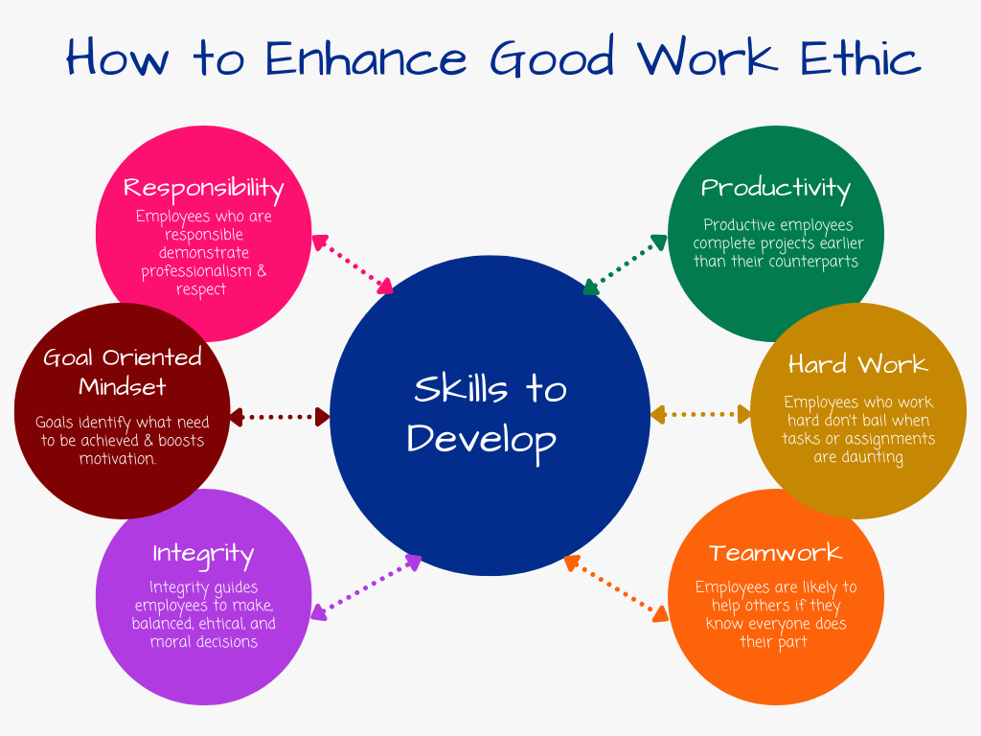

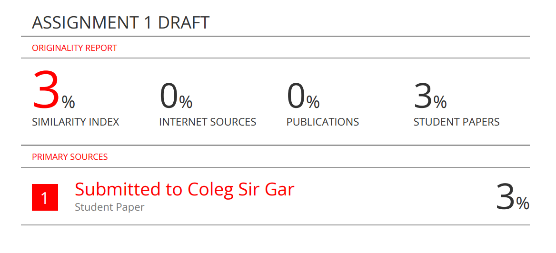
TASK A(b)

I scored my work 55 out of 100 because I know a few sections were not to standard. Some were incomplete, and my explanations in these parts were neither clear nor well-structured. Though I tried to touch on all the main points, the overall quality did not fully align with the effort required.
This score helps me to understand how well I performed and where I have failed.I will work harder next time to improve my performance through better planning, clear structuring of ideas, and careful review before submitting. I will also seek feedback, practice more consistently, and check for the completion of requirements in assignments.

TASK 2 (a)
POSTER LINK
https://www.canva.com/design/DAG4_VVmm6I/IGe7BYm4wy_BoubAfBT7Tw/edit?utm_content=DAG4_VVmm6I&utm_campaign=designshare&utm_medium=link2&utm_source=sharebutton
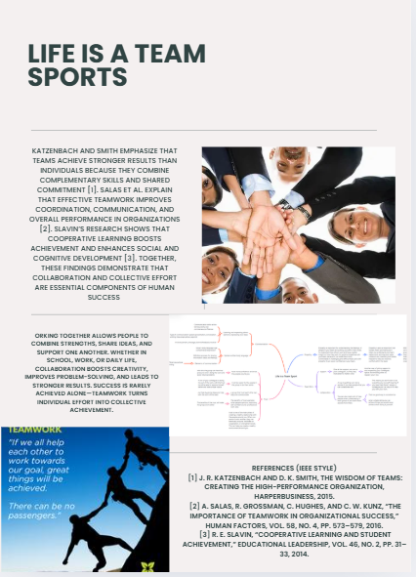

TASK 2 (b)
MINDMAP
https://www.mindmeister.com/app/map/3844890329?t=Xlz4Gnyl6M
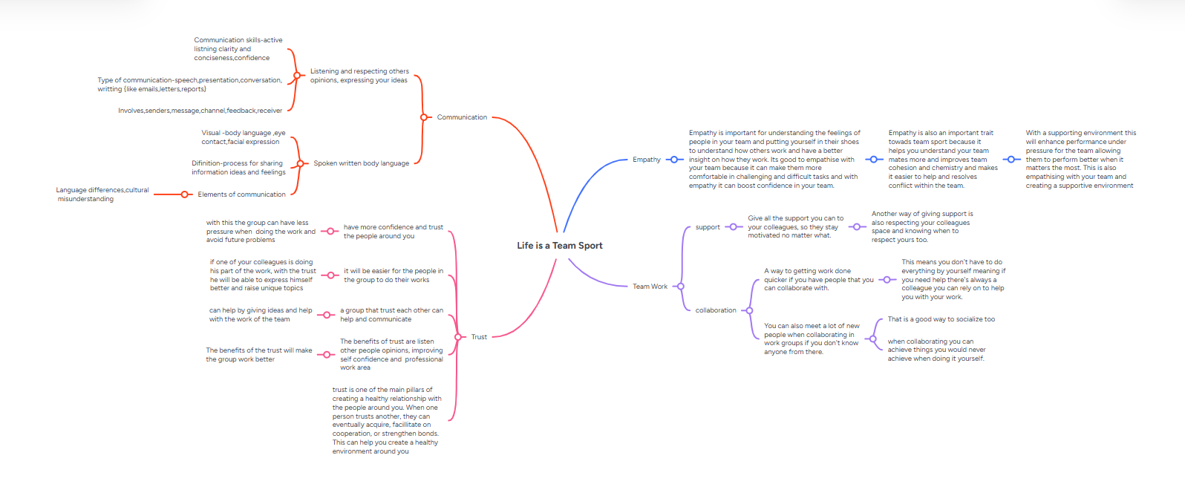

TASK 3 (a)
Forming a Team
Effective virtual team formation is core to successful online collaboration. Since members work remotely, team formation entails effective communication, building trust, and some forethought in member selection. Understanding these processes helps create strong, productive teams that can work efficiently despite physical distance.

The study analyzes the impact of different levels of computer-mediated communication, namely face-to-face, online learning systems, and online systems integrated with social networking, on team formation in virtual settings. Using a sample of 140 university students, this research measured such factors as task performance, team cohesiveness, computer skills, and social bonding. Significant differences related to the level of CMC were identified in terms of perception of computer skills and task performance when gender was taken into consideration. Further significant effects that depended on education, academic major, and academic year were identified. In general, this study shows how different CMC environments affect the outcome of forming successful virtual teams. [1]

This article addresses how trust is developed and impacts communication and cohesiveness in temporary, work-focused virtual teams. Results indicate that team members rapidly generate calculus-based trust by analyzing the costs and benefits associated with cooperation with others, as well as knowledge-based trust using prior experiences to assess the competence of teammates and estimate their behavior. Identification-based trust develops early but plays a less important role than either of the other two. Generally speaking, initial trust has a strong impact on later quality of communication and team cohesiveness, emphasizing the importance of early trust development for short-term virtual teams [5].

This case study examines the reasons for the strong success of virtual marketing teams at T Company, a branch of China Telecom. It identifies four key factors that exert an influence on high performance: effective virtual communication, careful personnel selection, high levels of trust, and sustained motivation. It highlights some very important managerial insights and gives implications for organizational change as well as for future research [6].
This study investigates how Mozilla Hubs can be used to facilitate student interaction and teambuilding during a virtual reality course. Researchers developed three bespoke 3D rooms and trained the students on how to use and design an avatar. Their observations and survey revealed that more detailed, confined, small-scale virtual environments had more occurrences of communication and collaboration than larger, open ones. The study provides some guidelines on designing virtual environments for supporting teamwork and interaction in online learning environments [7]

References
[1] A. Gomes de Siqueira, et al., "Toward facilitating team formation and communication through avatar based interaction in desktop-based immersive virtual environments," Frontiers in Virtual Reality, vol. 2, pp.647801, 2021.
[2] Z. Kai and W. Jin’ai, "The formation and management of virtual teams in T Telecom Company," Frontiers of Business Research in China, vol. 2, no. 4, pp.591–620, 2008.
[3] E. Melon-Melon, "No title," A study of the success of group formation in virtual teams using computer-mediated communications, 2016.
[4] F. Kuo and C. Yu, "An exploratory study of trust dynamics in work-oriented virtual teams," Journal of Computer-Mediated Communication, vol. 14, no. 4, pp.823–854, 2009.

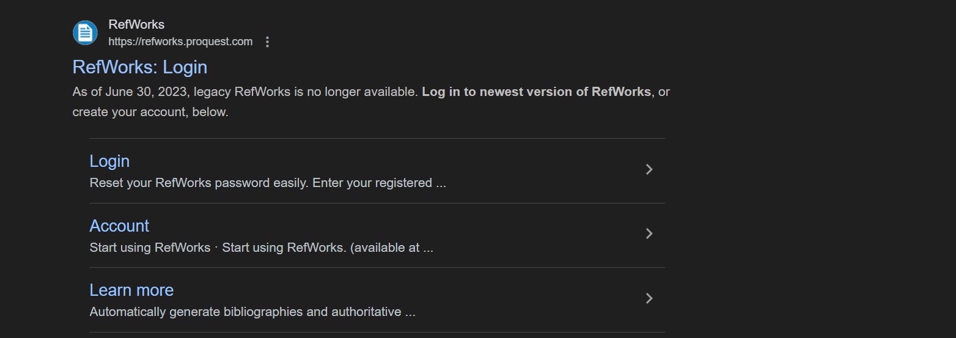
TASK 2 (b)

FIRST OF ALL SEARCH FOR REFWORKS ON GOOGLE

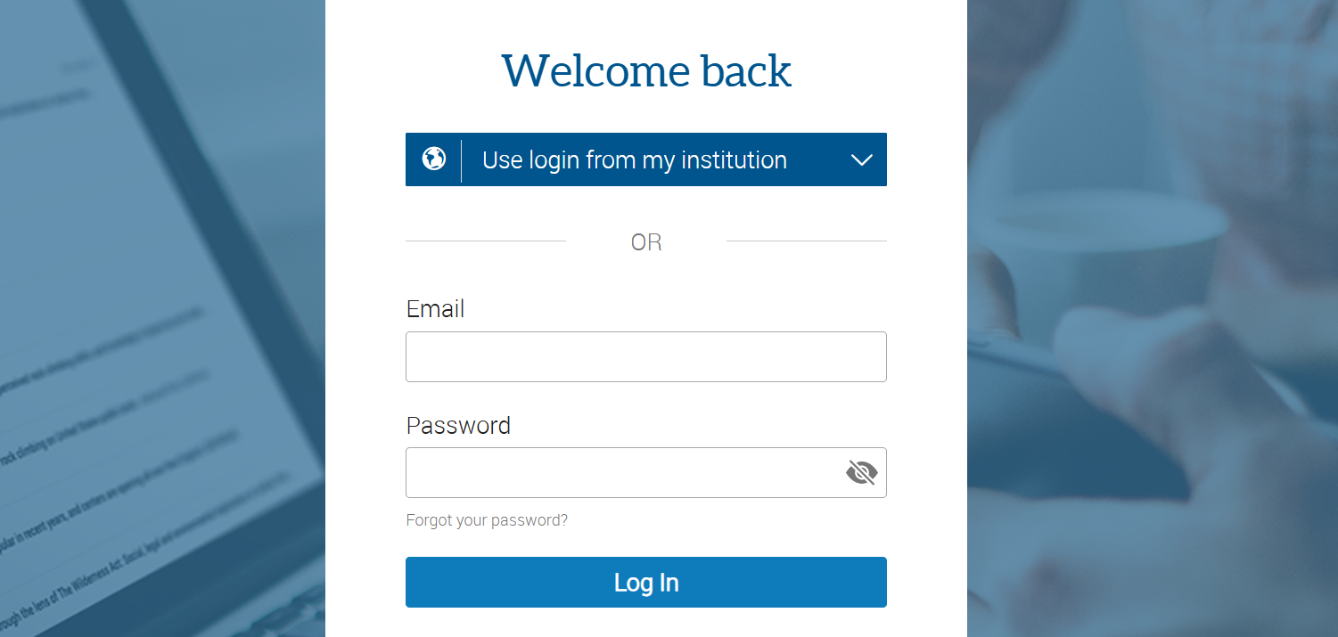

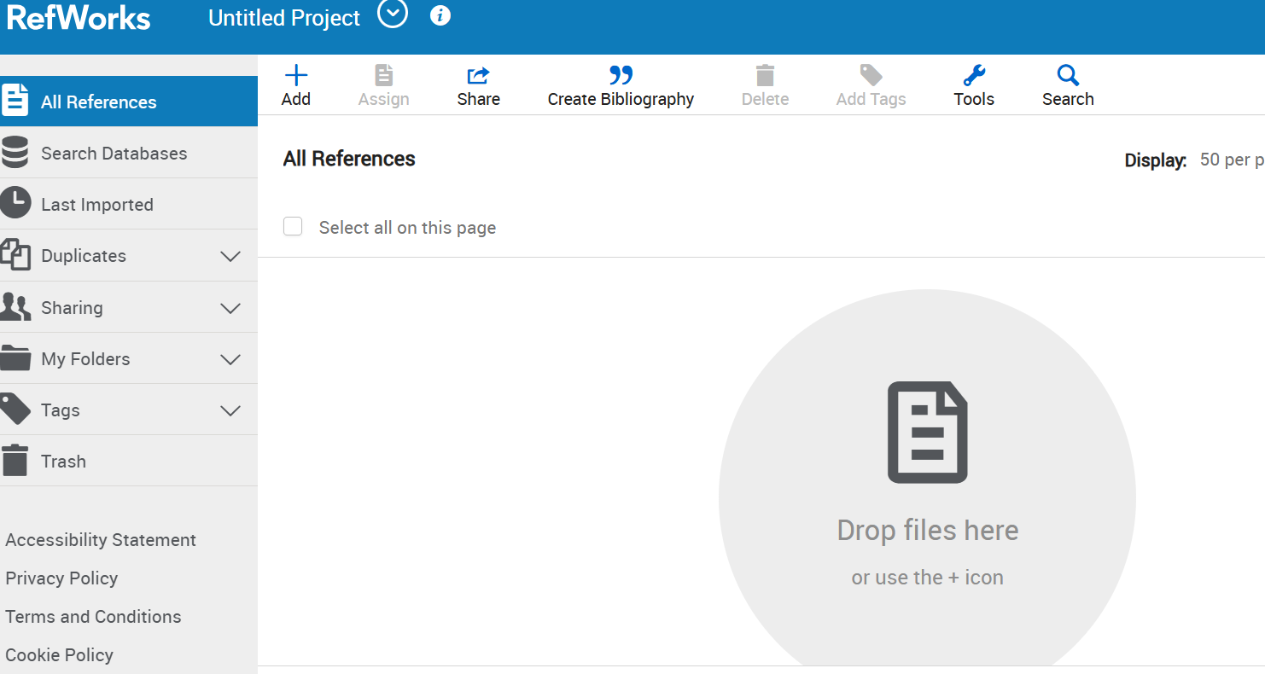
LOGIN WITH YOUR STUDENT EMAIL AND PASSWORD

THIS IS HOW THE INTERFACE LOOKS WHEN YOU ARE LOGGED IN
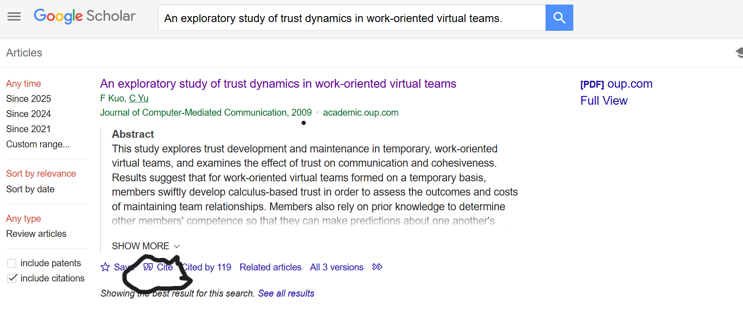
GO BACK TO GOOGLE SCHOLAR AND SEARCH FOR YOUR TOPIC
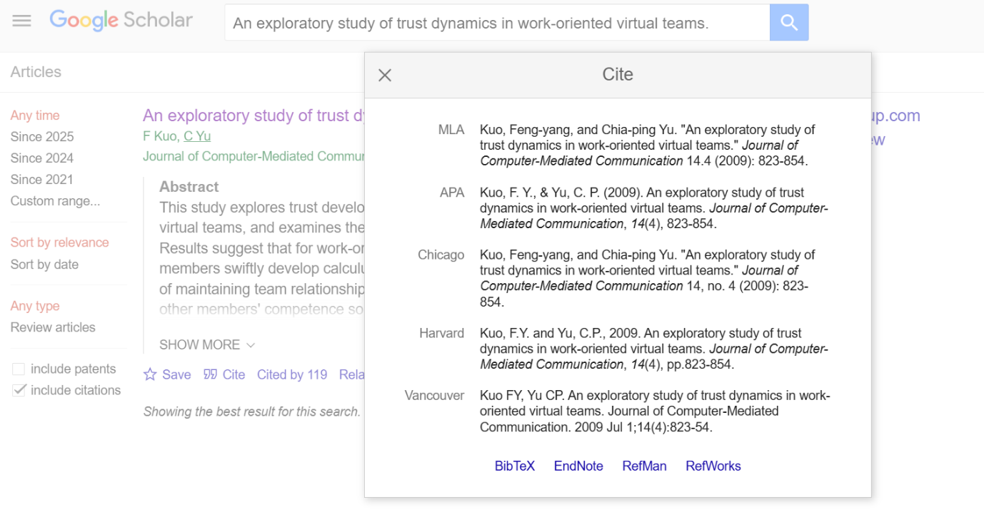
THEN CHOOSE REFWORKS FROM THE ABOVE OPTION

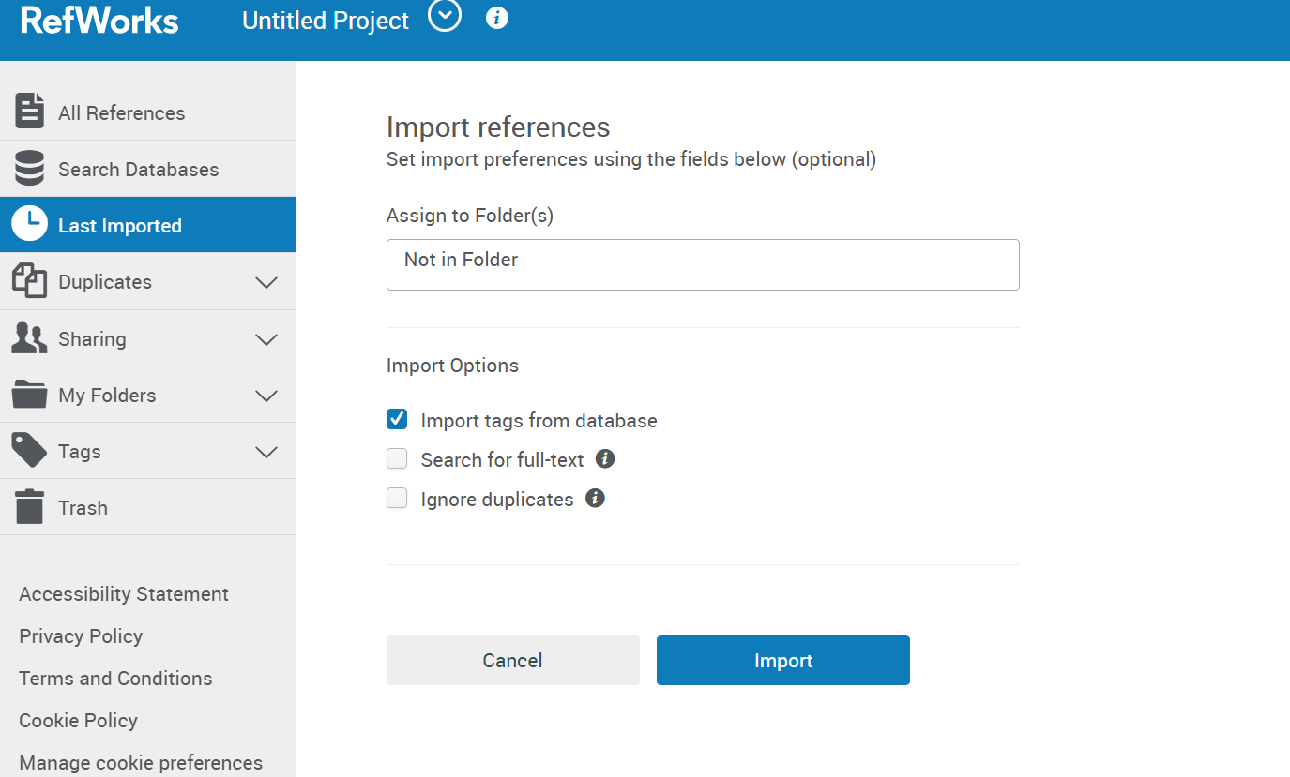
CHOOSE THE LDE TASK OPTION WHEREEVER YOU WANT TO PUT THE REFERENCES
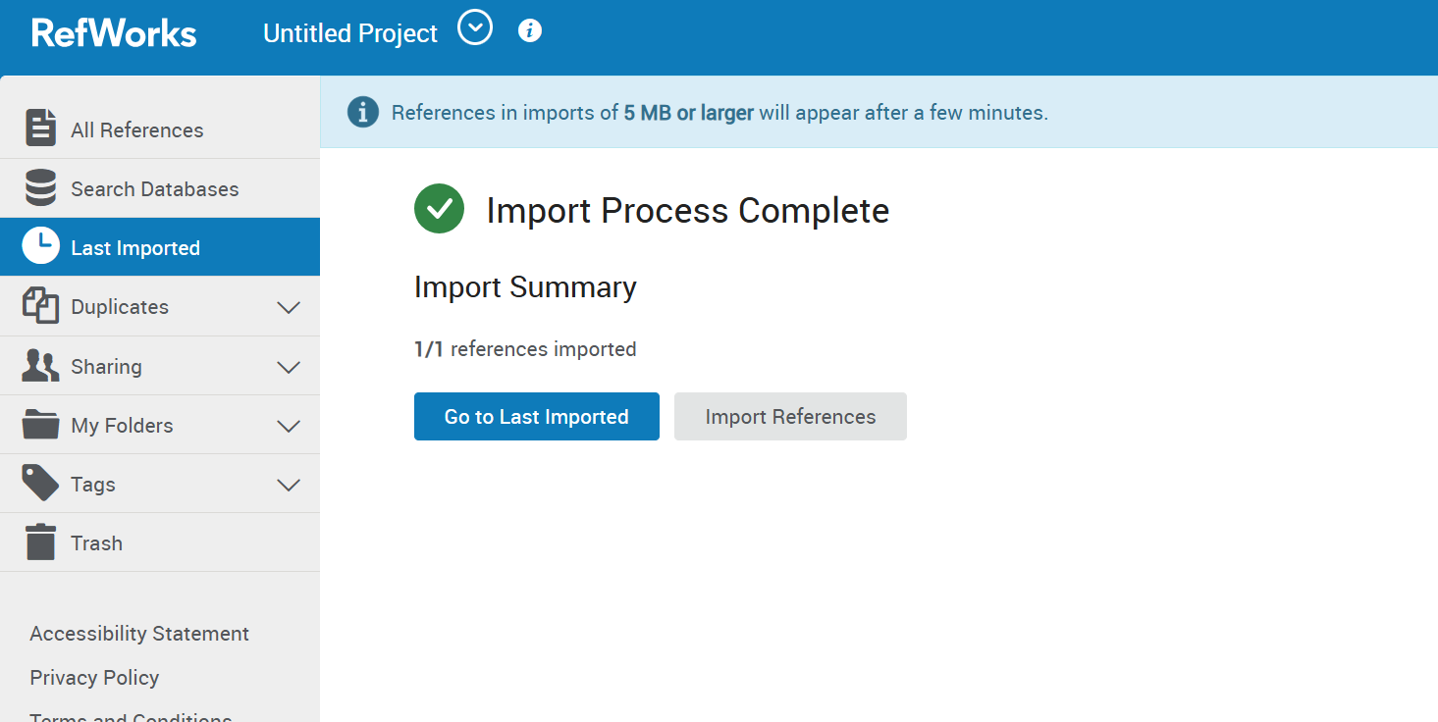

ONCE YOUR REFERENCES ARE IMPOTED
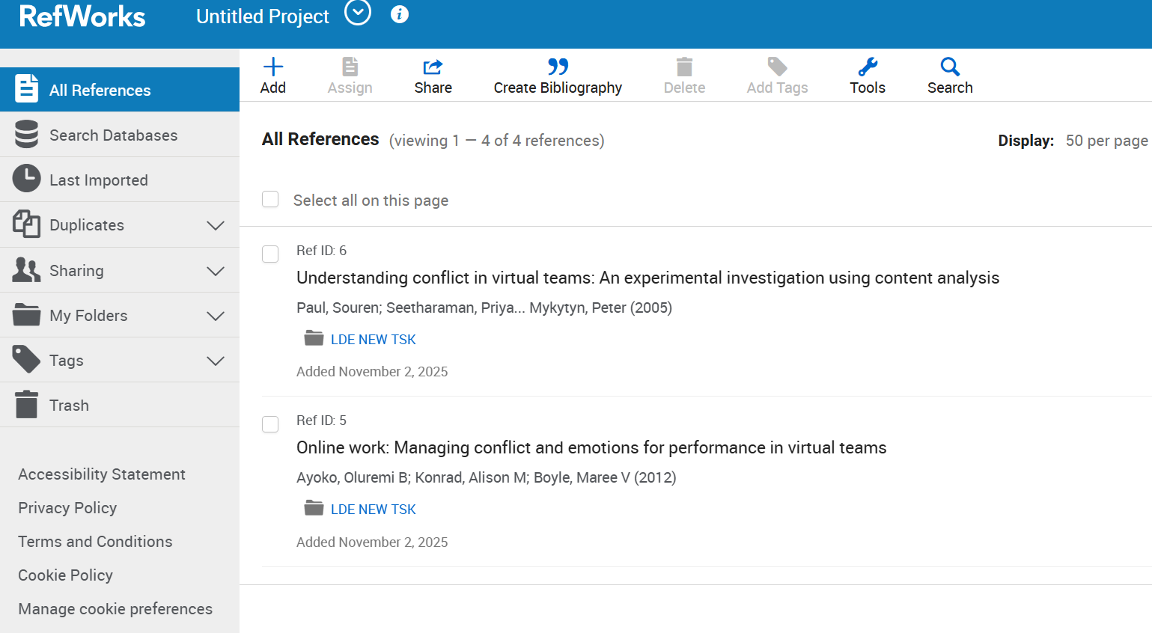
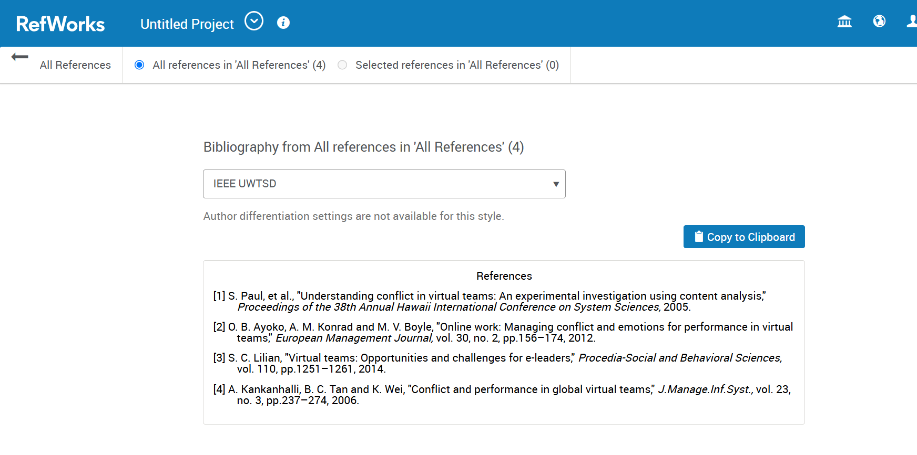
CREATE A BIBILIOGRAPHY FOR YOUR REFERNCES.

SEE YOUR REFERENECES HERE AND THEN

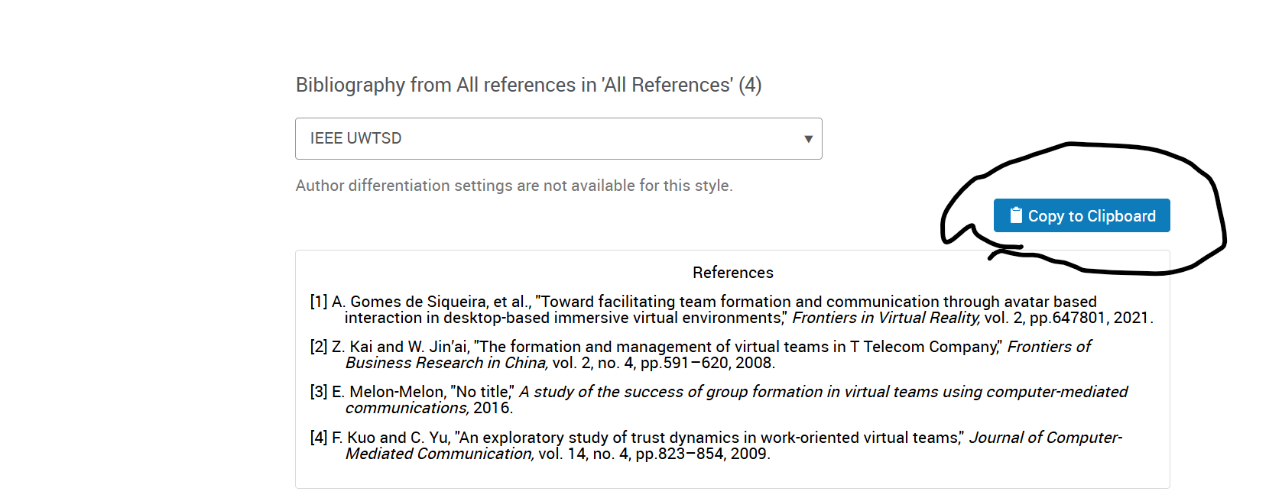
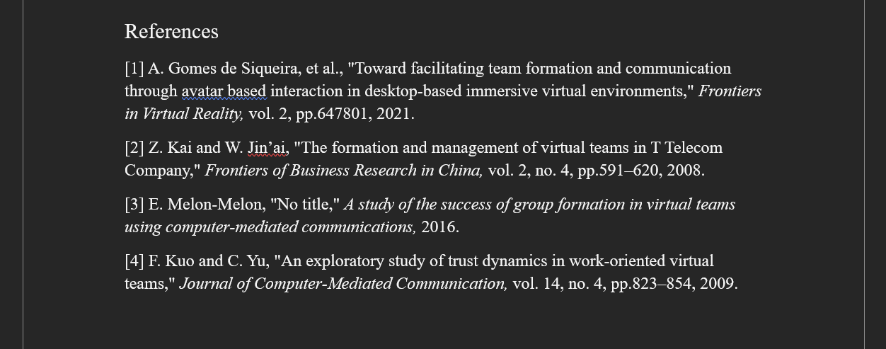
COPY YOUR REFERENECES AND PASTE THEM TO YOUR WORD DOCUMENT

PASTE YOUR REFERNCES

