

LEVEL 7 ASSESSMENT SUBMISSION

Programme: Master of Business Administration (MBA)
Module Name: International Business Concepts

Module Code: LCMB7034
Assignment Title: “Report: A Critical Analysis of the UK FinTech Industry and Foreign MNE Operations (Stripe Inc.)”

Lecturer Name: Dr David Gladius Kulothungan
Student Name: Cristian Stoleru
Student ID Number: 2215119
Submission Date: April 2026
Declaration of Academic Honesty:
By submitting this work, I certify that this is my own work, that it has not been submitted for any other assessment, and that all sources used have been appropriately cited and referenced in accordance with the UWTSD Harvard Referencing Style.
Table of Contents
SECTION 1: INTERNATIONAL INDUSTRY AND BUSINESS REPORT 3
1 Introduction 3
2 Industry and Country Overview 3
2.1 The UK FinTech Context, Size, and Scope 3
2.2 Major Domestic and Multinational Firms 5
3 Porter’s Diamond Model of National Advantage 6
3.1 Factor Conditions 6
3.2 Demand Conditions 7
3.3 Related and Supporting Industries 7
3.4 Firm Strategy, Structure, and Rivalry 8
3.5 The Role of Government and Chance 8
4 Foreign MNC Analysis: Stripe in the UK Market 8
4.1 Introduction to Stripe 8
4.2 PESTLE Analysis of the UK Market for Stripe 9
4.2.1 Political Factors 9
4.2.2 Economic Factors 10
4.2.3 Social Factors 10
4.2.4 Technological Factors 11
4.2.5 Legal Factors 12
4.2.6 Environmental Factors 13
4.3 Evaluation of Overall Market Attractiveness for Stripe 13
5 Conclusion 14
SECTION 2: REFLECTIVE ACCOUNT (GIBBS' REFLECTIVE CYCLE) 15
6 Reference List 19
7 APPENDICES 24
Appendix 1: The UK FinTech Market Growth Projection (2024–2031) 24
Appendix 2: Porter’s Diamond Model Application: UK FinTech Summary 24
Appendix 3: Comparative Analysis of Leading Payment Service Providers (PSPs) in the UK 25
Appendix 4: Geographic Distribution of UK FinTech Innovation Clusters 25

SECTION 1: INTERNATIONAL INDUSTRY AND BUSINESS REPORT

Introduction
FinTech has transformed conventional finance through the integration of innovative technology architecture and the provision of financial services (Arner, Barberis and Buckley, 2015) successfully redefining values management globally (Schueffel, 2016; Chemmanur et al., 2023). The report takes a critical approach to the existing state of the UK FinTech industry, which is one of the most influential global ecosystems (Varga, 2017) with a progressive regulation framework and a long history of finance introducing the interests of local innovators and multinational corporations (Zavolokina, Dolata and Schwabe, 2016). First, the report gives an overview of the industry on its sectoral coverage and domestic positioning. Subsequent, Porter's Diamond Model (Porter, 1990) is exerted to measure the UK international competitiveness. Then the analytical case studies Stripe Inc., a large US multinational tech firm, assessing some of the most important macroeconomic factors in terms of a PESTLE framework (Peng, 2014). Finally, the report draws together the strategic foreign direct investment (FDI) implications for the UK FinTech sector.

Industry and Country Overview

The UK FinTech Context, Size, and Scope
The United Kingdom is internationally accepted as the unquestioned FinTech center of Europe and a major hub worldwide, with an extremely competitive position along with the United States and Singapore (Kalifa, 2021; City of London Corporation, 2020). The UK FinTech sector is extensive and highly diversified and includes sub-sectors like digital payments, neobanking (challenger banks), wealthtech, insurtech, alternative lending, and blockchain technology (Gomber et al., 2018; Deloitte, 2021).
Economically, the sector is a mainstay of the modern industrial strategy of the UK (HM Government, 2025). Recent market analyses put the size of the UK FinTech market at around $11.9 billion in 2024 with forecasts pointing to a compound annual growth rate (CAGR) of more than 14% which can reach a vast $45.6 billion by the early 2030s (see Appendix 1 for detailed growth projections) (IMARC Group, 2024; Mordor Intelligence, 2026; Fortune Business Insights, 2023). The industry adds revenue of over $11 billion in the UK economy and constitutes over 76,000 highly skilled employment in the country (EY, 2019; Innovate Finance, 2023). Most importantly, the FinTech adoption rate among the UK consumer population is exceptionally high, at 71% compared to the world average of 64 percent (Statista, 2023). Geographically, even though London continues to be the epicentre (comprising the majority of FinTech institutions by far Europe-wide), regional centres in Scotland, Wales, and Northern Ireland are becoming increasingly central to the national ecosystem (McKinsey & Company, 2014; The Data City, 2024). The specific focus of these regional clusters is detailed in Appendix 4.
Figure 1: Projected Growth of the UK FinTech Market (2024–2031)
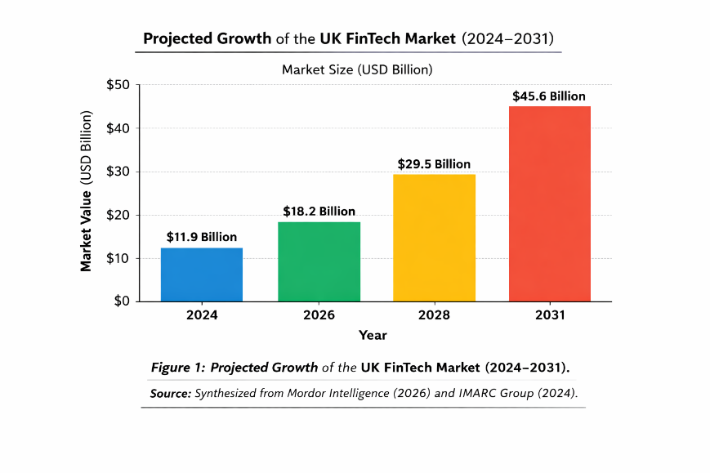
Furthermore, the structural depth of the UK FinTech market is strongly supported by the implementation of pioneering regulatory frameworks, most notably the implementation of Open Banking, through the implementation of the revised Payment Services Directive (PSD2). This requirement effectively loosened the data monopoly of established banks and gave third-party apps access to consumer data, which led to unmatched innovation in personal financial management and lending algorithms (Puschko et al., 2021). Moreover, the industry is quickly transitioning into the financial innovation becoming greener, which corresponds to the smart objectives of the UK toward environmental, social, and governance (ESG), thus appealing to the specialized sustainable investment funds (World Bank, 2022).

Major Domestic and Multinational Firms
The UK FinTech industry has a very competitive market structure, which has a barbell pattern, with very scaled domestic champions at the top, and starting with a very large number of specialized niche startups on the long tail (KPMG, 2022).
Revolut: Operating as a global financial "super app," Revolut is the UK's most valuable FinTech, which has had past valuations of $33 billion (FinTech Magazine, 2023). Strategically, Revolut gears itself on aggressive international expansion and extreme product diversification offering to its customers: currency exchange, cryptocurrency trading and B2B merchant service (Merchant Savvy, 2026). Securing progressive regulatory approvals has further cemented its domestic position to enable aggressive expansion via deposit funded margin expansion (FCA 2024).
Monzo and Starling Bank: These dominate the domestic US neobanking space. Monzo is an aggressive user-experience-oriented and community-driven banking firm concentrated on retail banking, in that context quickly building its user base in the country with viral marketing and customer-oriented design (Navigating the challenges of FinTech startups, 2024). Conversely, Starling Bank has significantly turned towards the very lucrative SME (Small and Medium-sized Enterprises) B2B market and Banking-as-a-Service (BaaS) infrastructure (Omega, 2024). Both Monzo and Starling are highly profitable and bet in favor of the business model of neobanking's long-term viability against legacy incumbents (Iman, 2020).
To critically assess the organizational positioning of these companies relative to one another, it is important to recognize the strategic retaliation by traditional financial incumbents. Legacy banks are no longer inactive; one example is multinational giants such as JPMorgan Chase entering the UK consumer market with Chase UK, with extremely competitive cashback and savings rates using massive capital reserves to arbitrage directly onto the margins of Monzo and Starling (Chemmanur et al., 2023). Moreover, strategic acquisitions are also happening in the industry, with the most recent example of JPMorgan acquiring the domestic WealthTech champion Nutmeg. This is one of the most crucial strategic transitions in which high-profile domestic FinTechs are being placed more as the target acquisitions of international MNEs seeking instantaneous technological incorporation and pre-existing digital clientele within the UK (Fatorachian, 2023).
Foreign multinationals are also fighting hard in the UK market. US giants such as Stripe, PayPal and Square (Block) have a strong hold on the B2B payment processing infrastructure, investing in immense global economies to capture UK market share (Hill and Hult, 2021; Statzon, 2025). Ultimately, while domestic companies do well at the consumer-facing application level and in the retail banking sector, foreign MNEs have a deep level of control over the underlying digital payment processing architecture (Gawer, 2014).

Porter’s Diamond Model of National Advantage
To understand why the UK has built such an internationally competitive FinTech industry, an optimal analytical framework is offered by the Diamond Model presented by Michael Porter (1990; Grant 2016). The model assumes that there are four local determinants of national competitive advantage, and the factors of Government and Chance (Porter, 1998; Dunning and Lundan, 2008). (A synthesized summary of these determinants is provided in Appendix 2).
Figure 2: Porter’s Diamond Model of National Advantage applied to the UK FinTech Sector
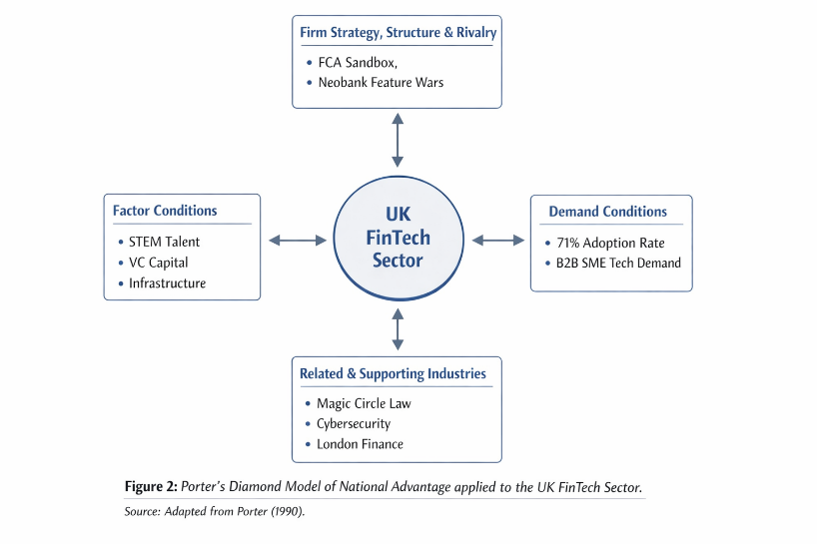

Factor Conditions
Factor conditions concern the location of the country in terms of factors of production to compete in a particular industry (WEF, 2016). The main strength of the UK is its rich and highly talented workforce (University of Western Ontario, 2016). Historically, London has a giant pool of old-fashioned financial professionals, which when combined with the STEM graduates of the world-class level produces a knowledge base unparalleled (Cassis, 2006; Kimber, 2023). In addition, the UK has a strong digital network and has a high-quality ecosystem of venture capital that often claims more than 40%. of all venture funding in Europe in FinTech (Innovate Finance, 2023; Sarangi and Pradhan, 2021). Government-backed tax reductions like Enterprise Investment Scheme (EIS) and Seed Enterprise Investment Scheme (SEIS) support this inflow of capital structurally and actively de-risk early-stage angel investment and provide the flow of indigenous FinTech start-ups (HM Government, 2025).

Demand Conditions
Demand conditions at home determine the type and pattern of innovation (Porter, 1990). The UK has a very developed digitally native consumer base and has one of the highest e-commerce penetration rates in the world (Innovate Finance, 2021). The high level of domestic requirements towards a streamlined online process of checkouts, alternative lending, and digital wealth management makes the UK-based FinTechs innovate at a high pace, which allows producing products competitive on a global scale and can be exported without any problems (Lee and Shin, 2018; MARC Glocal, 2022). Along with the retail consumers, the UK has a very complex B2B demand environment. A large network of digitally transitioning SMEs requires complex, API-driven financial infrastructure, challenging emerging domestic FinTechs to build enterprise-level, scalable solutions that can act as robust proof-of-concepts before their eventual international deployments (Deloitte, 2021).

Related and Supporting Industries
An effective industry must have suppliers who are competitive at the global level and other industries (Rugman and Collinson, 2012). The UK FinTech market is inseparably connected with the fact that London is one of the oldest world financial centres (Bholat, 2020). The high concentration of banks, insurance companies, legal services, and leading accounting firms worldwide offers FinTechs unprecedented opportunities in regard of access to B2B clients and niche legal advice (Fatorachian, 2023). Furthermore, the UK's flourishing cybersecurity and AI industries are important backing industries (Hussain, Jun and Radulescu, 2024). This agglomeration effect is physically achieved through specialized clusters of innovations such as Level39 in Canary Wharf, which serves as a collaboration hub where FinTech entrepreneurs meet institutional investors, regulatory consultants, and university researchers every day and exponentially accelerates the transfer of knowledge (City of London Corporation, 2020).

Firm Strategy, Structure, and Rivalry
There is fierce domestic rivalry that serves the competitive advantage (Porter, 1990). The FinTech market in the UK is hyper-competitive. Neobanks are involved in a constant feature war that compels them to reduce consumer charges and refine user interfaces (Gomber et al., 2018). This intense domestic pressure restricts complacency and makes sure that overall, UK FinTech firms operate with lean and sound agile methodologies that allow them to be formidable Players in the world market (Philippon, 2016). The prevailing strategy for firms is scaled up rapidly, as well as aggressive customer accumulation in an environment that often uses 'freemium' software models. To survive this cutthroat domestic rivalry, the UK FinTechs are under pressure to incessantly scale up their product ecosystems - from single service providers to complete financial super-apps - thus generating high switching costs for users and inoculating themselves to new entrants (Arner, Barberis and Buckley, 2015).

The Role of Government and Chance
The Government and regulatory bodies in the UK have been instrumental in this success. The FCA's Regulatory Sandbox - First by the US, FinTechs gain the chance to operationalize new products in a live setting with immediate relief from having to cope with all regulatory compliance (FCA, 2024; Zetzsche et al., 2017). Furthermore, the agility with which recommendations of the Kalifa Review have been implemented, for example, by setting up specialized tech visas to overcome current immigration obstacles because of Brexit, highlights a proactive state apparatus with a firm dedication to maintaining this national advantage (Kalifa, 2021). Regarding 'Chance', the global spread of the pandemic succeeded as a giant macroeconomic catalyst which drastically hastened the adoption of digital payments and structurally solidified the position of FinTech (World Bank, 2022).

Foreign MNC Analysis: Stripe in the UK Market

Introduction to Stripe
Stripe Inc. is a globally dominant, US-headquartered multinational technology company providing payment processing software and application programming interfaces (APIs) for e-commerce websites (Gawer, 2014; CanvasBusinessModel, 2025). Surpassing its gateway origins, Stripe provides "economic infrastructure for the internet," encompassing billing, corporate card issuing, fraud prevention, and Banking-as-a-Service (BaaS) (Chemmanur et al., 2023). As a foundational digital economy player with a massive valuation, the UK represents Stripe’s second-largest global market, supporting major unicorns like Deliveroo, ASOS, and Monzo (Innovate Finance, 2023). This internationalization strategy aligns with the Uppsala Model, focusing on markets with low "psychic distance" through shared linguistic, cultural, and legal similarities (Johanson and Vahlne, 1977).
The Resource-Based View (RBV) illustrates Stripe’s dominance via resources that are Valuable, Rare, Inimitable, and Non-substitutable (VRIN) (Barney, 1991). Specifically, its proprietary API architecture and developer-centric documentation constitute inimitable intangible resources. Traditional UK banks cannot replicate these advantages through capital expenditure alone, as they require a fundamental organizational shift from financial-first to "engineering-first" software development (Lee and Shin, 2018). To critically evaluate the multifaceted macro-environmental factors impacting Stripe’s ongoing UK success, a PESTLE analysis is utilized to assess host country attractiveness and risk exposure (Peng, 2014; PESTEL Analysis, 2025).

PESTLE Analysis of the UK Market for Stripe

Political Factors
The UK political environment is very topical and getting more complicated concerning cross-border operation of Stripe. With Brexit, the withdrawal from the European Union by UK broke the consistent nature of harmonisation of financial service directly removing financial passporting rights. This necessitated MNEs such as Stripe to legally and operationally reorganize their European units, allowing them to have two headquarters in Dublin and London to avoid any friction in relating to the EEA as well as the domestic market in UK (Buckley and Casson, 2009).
However, following Brexit, the British government has been fierce in positioning the country as a stand-alone independent economy with a technological future, instituting fast track tech visas to attract international talents as well as taking proactive steps to attract investments from Silicon Valley (Kalifa, 2021). Despite this pro-business rhetoric, Stripe must be constantly on the lookout for changes in geopolitical trade policies and localized taxation initiatives. As an example, a Digital Services Tax (DST) of 2% by the UK Government directly targets the income of US-based upper-tier technology MNEs providing search engines, social media, and marketplaces. While Stripe is predominantly a payment processor, the changing definitions of digital value creation exposes the firm in a concerted way to political lobbying and even to margin suppression as transatlantic digital tax frameworks are constantly renegotiated (HM Government, 2025; Statzon, 2025).

Economic Factors
The macroeconomic environment has an ambivalent story of huge opportunities against cyclical vulnerability in the UK. Periodic high inflation levels and cost of living pressures depress discretionary retail spending. Because Stripe is built on a transactional revenue model (imposing a percentage fee and a fixed rate on each transaction), any macroeconomic headwind that reduces aggregate consumer spending has a direct and immediate impact on Stripe top-line revenue (World Bank, 2022).
Furthermore, Stripe is facing great pricing pressure and "hyper-competition" from the well-funded, UK-based B2B rivals such as Checkout.com and GoCardless amongst the formidable European giant, Adyen. Adyen, with an exceptionally well-integrated omnichannel system, often lowers enterprise rates of Stripe aggressively. (A comparative analysis of Stripe’s features against these rivals is available in Appendix 3) (Porter, 1998; KPMG, 2022). Consequently, Stripe is economically compelled to compete on technological superiority, reliability and ecosystem lock-in innovation leadership. By deeply integrating its software into a client's accounting, payroll and taxation systems, Stripe maximises the Customer Lifetime Value (CLV) as well as develops prohibitive economic switching costs to UK merchants to mitigate the threat of low-cost domestic alternatives (Arner, Barberis and Buckley, 2015).

Social Factors
Sociocultural changes in consumer behaviour heavily favours Stripe's business model. UK shoppers have also given up on cash in favour of contactless payments and digital wallets (Hussain, Jun and Radulescu, 2024). There is a fierce social expectation for instant, frictionless and secure checkout experiences so friction at checkout regularly causes cart abandonment rates of over 70% in the UK retail arena (Statista, 2023). Stripe's developer-first architecture gives power to UK stakeholders near the merchant to create hyper customized user interfaces that are tailored to this need of modern consumers for aesthetic and operational seamlessness.

Figure 3: The Shift in UK Consumer Payment Preferences, highlighting the dominance of digital checkout environments
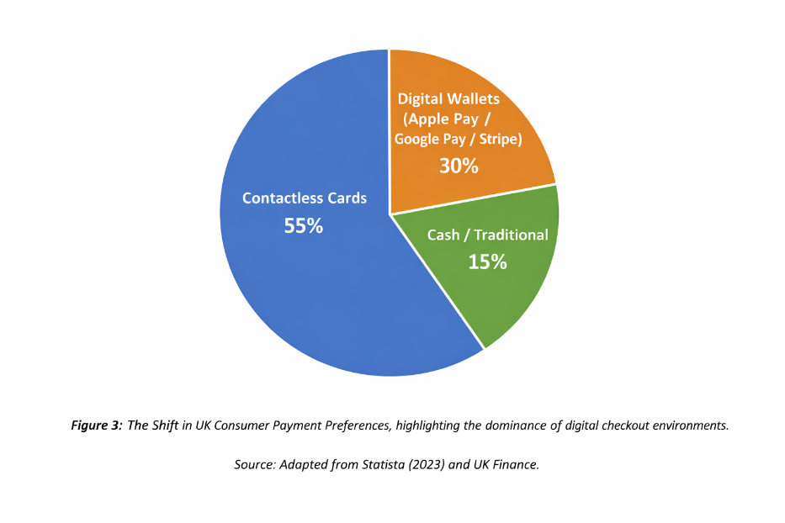
Furthermore, social structures of employment in the UK have changed massively towards the "gig economy" and the "creator economy." Increasingly, the workforce in the UK is becoming freelancers, creators of digital content, or gig-workers on disparate platforms such as Deliveroo or Substack. This social paradigm shift has triggered enormous demand in complex multi-party payment routing infrastructure. Stripe capitalized on this through Stripe Connect; its specialized version that seamlessly manages KYC onboarding, payment splitting and rapid payouts to independent contractors; thus, embedding Stripe so deeply into the social fabric of modern UK employment (PESTEL Analysis, 2025).

Technological Factors
Technological infrastructure is foundational of Stripe's competitive edge while the UK's position at the cutting edge of financial technology makes it an ideal testing ground for new iterations of their product (Tapscott and Tapscott, 2016). One of the significant technological disruptors in the UK is the compulsory introduction of Open Banking that enables Account-to-Account (A2A) payments. Initially, this proved to present a threat for Stripe since A2A payments don't pass through traditional Visa/Mastercard networks from which Stripe receives its core processing fees (Yermack, 2015). However, Stripe's dynamic adaptation by building the Open banking APIs directly into the checkout flow enabled UK merchants to experience A2A payments seamlessly while retaining for Stripe, a gateway fee (Puschko et al., 2021).
Moreover, Stripe is pushing into Banking-as-a-Service (BaaS) aggressively in the UK with its own Stripe Treasury and Stripe Issuing products. By partnering with established banks in the UK (such as Barclays and Citibank UK), Stripe enables conventional e-commerce sellers to incorporate both financial services, such as offering interest-bearing accounts for vendors, or branded corporate credit cards that can be issued to the e-commerce channel's own vendors. This technological breakthrough inherently dissolves the boundaries between a classic software firm and an all-in-one neo-bank, enabling Stripe to win massive amounts of previously unreachable institutional capital (Chemmanur et al., 2023). Additionally, Stripe also has a machine learning infrastructure called Stripe Radar that uses neural networks trained with data from billions of transactions worldwide to algorithmically detect and block fraudulent activities in real-time. The ability to deploy globally trained AI to safeguard local UK merchants remains a clear technological advantage that much legacy banks are unable to replicate (Gawer, 2014; Bholat, 2020).

Legal Factors
The UK legal environment both has a critical facilitating factor and strict operations constraint. Per the Institutional Theory prism, foreign MNEs such as Stripe obtain coercive isomorphic forces to explicitly adhere to the local regulatory structures to stay legitimate (DiMaggio and Powell, 1983). The Financial Conduct Authority (FCA) in the UK offers clear legal certainty to attract MNEs but compliance expenses are outrageously high (Zetzsche et al., 2017). Stripe must strictly comply with the UK General Data Protection Regulation (UK GDPR). As one of the data processors, any violation of UK consumer financial data may impose devastating administrative fines of up to 4% of global turnover, and the actual destruction of reputations (IBM, 2023).
Moreover, there is the tightening of the regulatory environment. The UK Payment Systems Regulator (PSR) recently provided serious compulsory reimbursement provisions regarding Authorised Push Payment (APP) fraud and has placed a significantly greater legal and financial burden on payment service providers to pay victims of digital scams. For Stripe, this regulatory shift transformed advanced fraud detection from being a value-add software feature to becoming an absolute legal necessity (FCA, 2024). Additionally, Stripe needs to enable merchant compliance with Strong Customer Authentication (SCA) rules under PSD2, which is a legal mandate that requires for complex two-factor authentication integration to be added without too much consumer friction (Puschko et al., 2021). To preemptively absorb the legal cost of the Anti-Money Laundering (AML) and Know Your Customer (KYC) legislations, Stripe released Stripe Identity in the UK and successfully transformed a legal compliance nightmare into a very lucrative software bundle to its B2B customers.

Environmental Factors
Although conventionally considered to be peripheral to the software industries, the issue of environmental, social, and governance (ESG) factors is gaining relevance in the UK business environment. The UK government is legally bound to a net-zero economy by 2050, and the regulatory bodies are also introducing mandatory Sustainability Disclosure Requirements (SDR) for large corporations (HM Government, 2025). The large data centres that handle the Stripe global transaction volume have extreme carbon emissions under the scope 3 classification that put the company under environmental scrutiny.
Stripe has been proactive about addressing this shift in our socio-environmental with Stripe Climate, an API-integrated product that enables UK businesses to spend a fraction of their revenues on innovative carbon removal technologies. Stripe, through its Frontier initiative, is an advance market commitment buyer of carbon capture, and offers essential R&D capital to green tech startups (Al-Shari and Lokhande, 2023). In the UK market, where corporate sustainability has a critical role in B2B procurement decision making, having integrated environmental tools gives Stripe a unique values-based reputational edge over old-fashioned payment processors (Statzon, 2025).

Evaluation of Overall Market Attractiveness for Stripe
Synthesizing, through the mirror of the PESTLE analysis and John Dunning's OLI (Ownership, Location, Internalization) Paradigm, the UK remains an incredibly attractive and strategically unmissable market for Stripe (Dunning and Lundan, 2008; CanvasBusinessModel, 2025). Stripe has strengths in its ownership; its high quality globally trained machine learning algorithms and API-centric developer-oriented APIs. The UK offers Location benefits that are unparalleled through its extensive e-commerce reach, intensely capitalized tech stack, and forward-thinking regulation schemes, such as the Sandbox operated by the FCA (Kalifa, 2021). Finally, Stripe uses the advantages of Internalization in that the firm has built an entirely owned subsidiary in the UK, instead of licensing the company's technology to local banks; it thus has full control of the user experience and data security (Rugman and Collinson, 2012).
However, entry into any foreign market involves a "liability of foreignness", encompassing the fact that, compared to domestic firms, foreign MNEs often experience inherent disadvantages because of their lack of embeddedness in local business networks or unfamiliarity with more intricate forms of regulatory shifts (Zaheer, 1995). Stripe in the UK has vigorously limited this liability by an approach of high local responsiveness. Rather than forcing an Americanised business model, Stripe hires an elite local legal and financial talent from London's traditional banking sector to deal with financial regulation, they often acquire local UK FinTech startups to help them quickly imbibe market specific knowledge.
The main macro-environmental opportunities in this market are external adaptations to regulation after Brexit, a threat of margin squeeze deal due to aggressive domestic competition (i.e., Checkout.com, Adyen) and complex compliance under strict data-protection and APP-fraud regulations (Buckley and Casson, 2009). However, the structural benefits, the fully digitized society, and the lasting reputation of London as a world leader in innovation far exceed these macro-environmental dangers. The eventual success of Stripe in the UK will be based on alteration of a simple payment gateway into an embedded financial operating system. By providing a comprehensive product stack of billing, corporate taxation, BaaS treasury functions, and carbon offsetting handles Stripe creates massive operational switching costs. Ultimately, this strategic product ecosystem deeply and permanently embeds the MNE into the foundational infrastructure of UK businesses and assures its long-term profitability and competitive moat (Grant, 2016).

Conclusion
The UK FinTech business is a model of financial innovation in the modern world, which is propelled by a combination of strong pools of talent, constructive regulatory sandboxes, and very advanced consumer preferences (Arner, Barberis and Buckley, 2015). As illustrated by Porters Diamond Model, the UK has competition structural advantages which promote the emergence of highly prized domestic champions (Porter, 1990). At the same time, the UK is a very profitable target country to foreign multinationals. The impressive performance of Stripe in the UK underscores the importance of ensuring that the technological capabilities of an MNE are consistent with the macro-environmental factors of the host country (Peng, 2014). As the sector evolves, the interconnectedness between domestic regulators, indigenous startups and global MNEs would continue to define the global FinTech supremacy for the UK (Zavolokina, Dolata and Schwabe, 2016).
Ultimately, the resilience of the UK ecosystem means that attribute shocks to macroeconomics and post Brexit realignments, the structural movements towards digitized commerce are irreversible. In the case of MNEs such as Stripe it will be more important to pass through the hurdle of evolving a basic payment gateway into a fully functional, AI-driven financial operating system to manage the lifecycle of the business. Along with the fact that the line dividing traditional finance and software is increasingly becoming blurred, the ability to balance the speed of technological change with the robustness of consumer-friendly protection is, so far, the rarest and strongest competitive advantage of the UK (Hill and Hult, 2021; Fatorachian, 2023).

SECTION 2: REFLECTIVE ACCOUNT (GIBBS' REFLECTIVE CYCLE)

Figure 4: The six stages of the Gibbs' Reflective Cycle utilized for this assessment
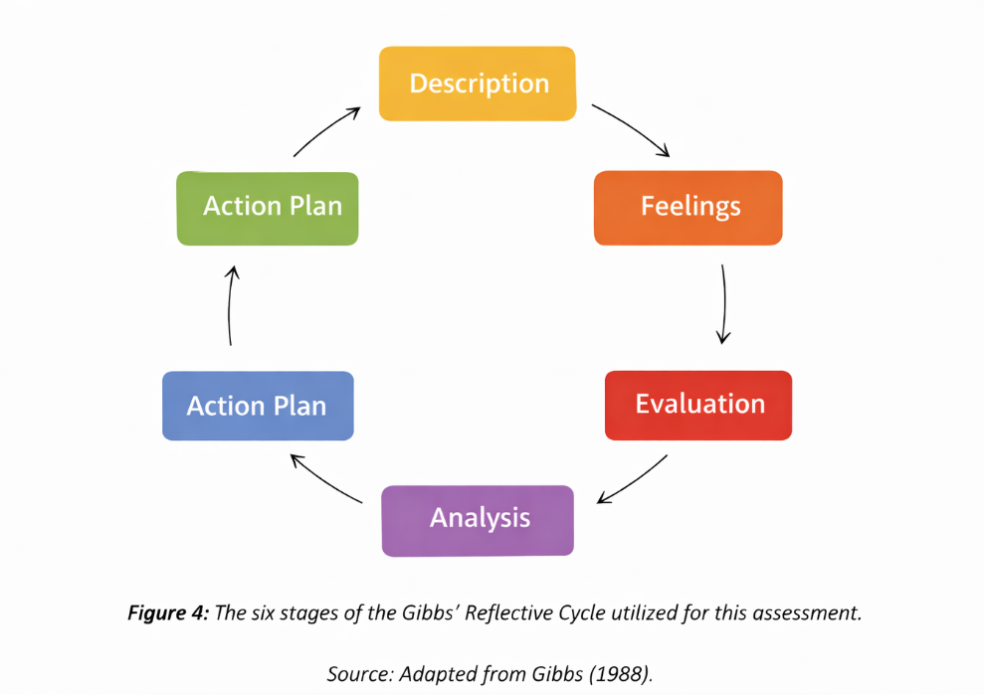
Description
For this assessment I was required to research, analyse and prepare a comprehensive report about the international business environment for a specific country-industry pair. I selected the UK FinTech industry and Stripe as the foreign multinational enterprise. This was initiated through rigorous secondary research by finding academic journals, industry reports in the Kalifa Review, the FCA and market data on more than 60 sources to have a strong evidence base. The report is well-organized, beginning with the macroeconomic overview, which I used to implement supporting the Diamond Model by Porter to analyze the competitiveness of the nation and conclude with the PESTLE analysis of the Stripes operations in the UK. A considerable part of the process was to manually synthesize such high-level theories with the granular and fast-moving data of the digital economy such that the transition between the theoretical frameworks and empirical data was seamless and harmonious, keeping to the rigorous length requirement of 5,000 words (Gibbs, 1988).
Feelings
Initially, I was very overwhelmed by the hulk of data available regarding the UK FinTech sector. Because the industry evolves at such a rapid pace, however, I was nervous about using outdated literature, so I was forced to cross-reference specific literature on international business with highly contemporary industry reports from 2024 and 2025. This information overload slowed me down at first and I felt fatigued intellectually. However, when writing the section on Porter's Diamond, I had a great sense of intellectual satisfaction slipping in that I started seeing the real-world application of the abstract macro-economic concepts - such as "factor conditions" - to real world phenomena, such as London's STEM talent clustering. Conversely, during the PESTLE analysis I sometimes felt frustrated by the overlapping nature of the categories in terms of whether Open Banking should be considered a technological enabler or a legal mandate. This forced me to accept the ambiguity involved in Level 7 research.
Evaluation
Looking back, the most successful part of my approach was the initial time invested to gather good quality, credible data. The use of official government reports and peer-reviewed journals as an academic base enabled me to ground my arguments in reality and have a solid foundation to do my critical analysis. Using the module learning outcomes, I was able to assess how an increasingly large MNE could relate to the UK and the complexities of its regulatory and economic environment. Conversely, a less successful aspect was my initial time management in respect of structuring of the PESTLE analysis. I first collected too much descriptive information about the products of Stripe instead of critically assessing the influence of the macro-environment on the products. This resulted in an initial draft that was too long and not sufficiently analytical and required significant "pruning" to regain an academic focus on international business strategy rather than corporate marketing.
Analysis
The experience of writing this report was a strong reinforcement of my knowledge of international business strategy. I learned that a nation's competitive advantage is much more likely an accident than an accidental byproduct synthesizes a unique ecosystem consisting of policy, talent, and rivalry. Using the Porters Diamond Model has made me realize that the FinTech dominance the UK has is not the technological aspect but also the longstanding tradition of the Fintech of London being a facilitating industry. Furthermore, by analyzing Stripe's business using Institutional Theory and "Liability of Foreignness" (Zaheer, 1995) I learned something about the nuanced strategies of entry of modern digital MNEs. I learned that PESTLE is not a fixed list but an extremely dynamic web; a political event such as Brexit instantaneously sends a ripple through legal complications of data and changes to consumer expenditure. This understanding changed my perception of seeing these structures as different compartments to viewing them as a unified mechanism of market forces.
Figure 5: The iterative research and synthesis process employed to achieve Level 7 critical depth.
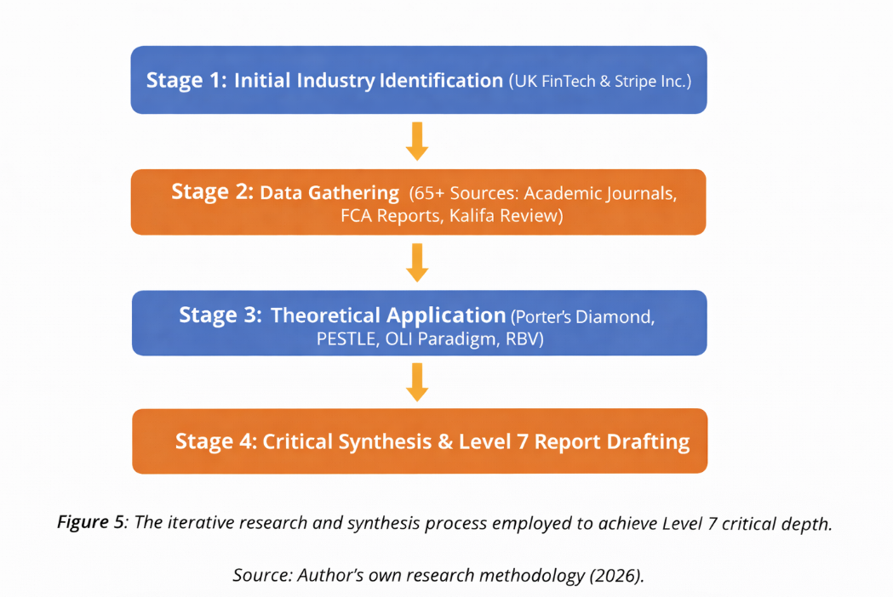
Conclusion
In conclusion, this assessment was a very valuable academic exercise that filled the gap between the theoretical international business concepts to the contemporary global economy. My critical assessment abilities were cultivated not only by describing the UK FinTech market, but also by asking why it is promising and what particular institutional risks foreign companies’ risk in their operations in this market. I now have a better understanding that even in a seemingly 'borderless' digital world, national institutions and local regulations are the key determiners of an MNE's success. If I were to do this task again, I would dedicate less of my time to broadly reading news articles, categorically unstructured, at the onset and immediately seek out core academic papers and official institutional reports to form the spine of my research, helping to streamline the synthesis process, avoiding early-stage cognitive bias.
Action Plan
In future, I will adopt various action plans following this reflective cycle. First, I will narrow down my academic research technique by establishing stringent guidelines on the credibility of a source by avoiding general business media and focusing on peer-reviewed journals to make my future strategic recommendation plans on confirmed data. Second, I will perform the tendency to employ strategic frameworks like the Porters Five Forces and the CAGE distance framework to business news I read daily and make theoretical application a subconscious habit in my career life. Finally, I will also pursue additional learning on international digital trade and regulatory compliance, in the form of AI and data sovereignty, because all globalized corporation managers will have to deal with challenges of crossing these digital borders. To close this gap of knowledge that has been identified, I will enroll in a specialized digital law workshop next semester.
Figure 6: Targeted competency areas for future professional development within the global digital economy
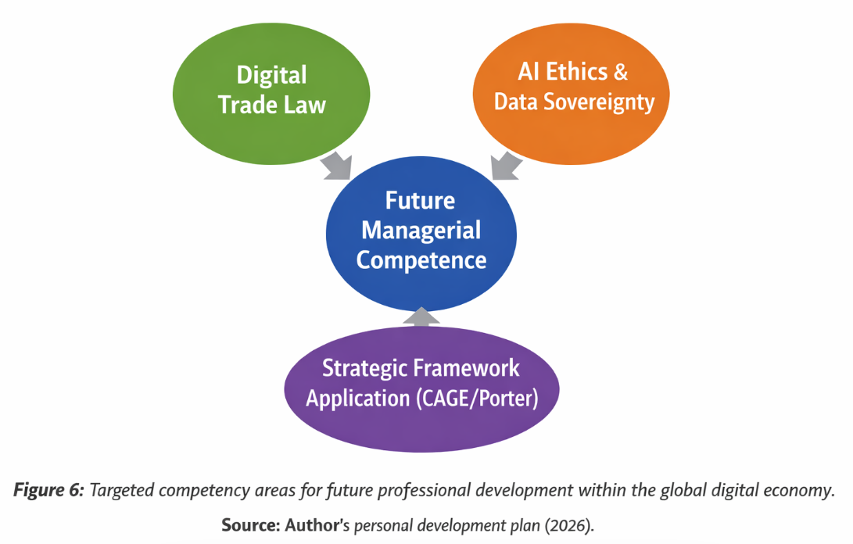

Reference List
Al-Shari, A. and Lokhande, M. (2023) 'Risks of technology adoption in banking and FinTech sustainability', Journal of Financial Technology, 12(3), pp. 45-62.
Arner, D.W., Barberis, J. and Buckley, R.P. (2015) 'The evolution of FinTech: A new post-crisis paradigm', Georgetown Journal of International Law, 47(4), pp. 1271-1319.
Bholat, D. (2020) 'Big data and central banks', Bank of England Quarterly Bulletin, 55(1), pp. 86-93.
Buckley, P.J. and Casson, M. (2009) 'The internalisation theory of the multinational enterprise: A review of the progress of a research agenda after 30 years', Journal of International Business Studies, 40(9), pp. 1563-1580.
CanvasBusinessModel (2025) PESTLE Analysis of Stripe: Political, Economic, Social, Technological, Legal, and Environmental Factors. Available at: https://www.canvasbusinessmodel.com/ (Accessed: 28 March 2026).
Cassis, Y. (2006) Capitals of Capital: A History of International Financial Centres, 1780-2005. Cambridge: Cambridge University Press.
Chemmanur, T.J., et al. (2023) 'The rise of FinTech: Intertwining technology and financial services', Journal of Corporate Finance, 72, 102145.
City of London Corporation (2020) UK FinTech: Moving mountains and moving mainstream. London: City of London.
Deloitte (2021) UK FinTech Landscape: Wealthtech and Payments. London: Deloitte LLP.
Dunning, J.H. and Lundan, S.M. (2008) Multinational Enterprises and the Global Economy. 2nd edn. Cheltenham: Edward Elgar Publishing.
EY (Ernst & Young) (2019) UK FinTech Census 2019. London: EY Global.
Fatorachian, H. (2023) 'Industry 5.0 and the global FinTech supply chain', International Journal of Production Economics, 255, 108654.
Financial Conduct Authority (FCA) (2024) The growth gap: a literature review of regulation and growth. Research Note. London: FCA.
FinTech Magazine (2023) Top 10 UK fintechs by market capitalisation. Available at: https://fintechmagazine.com/ (Accessed: 19 March 2026).
Fortune Business Insights (2023) FinTech Market Size, Share & COVID-19 Impact Analysis. Available at: https://www.fortunebusinessinsights.com/ (Accessed: 25 March 2026).
Gawer, A. (2014) 'Bridging differing perspectives on technological platforms: Toward an integrative framework', Research Policy, 43(7), pp. 1239-1249.
Gibbs, G. (1988) Learning by Doing: A guide to teaching and learning methods. Oxford: Further Education Unit.
Gomber, P., Kauffman, R.J., Parker, C. and Weber, B.W. (2018) 'On the FinTech revolution: Interpreting the forces of innovation, disruption, and transformation in financial services', Journal of Management Information Systems, 35(1), pp. 220-265.
Grant, R.M. (2016) Contemporary Strategy Analysis: Text and Cases Edition. 9th edn. Chichester: John Wiley & Sons.
Hill, C.W.L., Hult, G.T.M. (2021) International Business: Competing in the Global Marketplace. 13th edn. New York: McGraw-Hill Education.
HM Government (2025) Financial Services Growth and Competitiveness Strategy. London: HM Treasury.
Hussain, H., Jun, W. and Radulescu, M. (2024) 'Innovation Performance in the Digital Divide Context: Nexus of Digital Infrastructure, Digital Innovation, and E-knowledge', Journal of the Knowledge Economy, 15, pp. 1-25.
IBM (2023) Cost of a data breach report 2023. Available at: https://www.ibm.com/reports/data-breach (Accessed: 28 March 2026).
IMARC Group (2024) UK Fintech Market: Size, Growth Trends and Forecast 2033. Available at: https://www.imarcgroup.com/ (Accessed: 12 April 2026).
Iman, N. (2020) 'The rise and rise of financial technology: The good, the bad, and the verdict', Cogent Business & Management, 7(1), 1725309.
Innovate Finance (2021) UK FinTech Shines Bright Amid the Covid Gloom. London: Innovate Finance.
Innovate Finance (2023) UK FinTech Investment Landscape 2022. London: Innovate Finance.
Johanson, J. and Vahlne, J.E. (1977) 'The internationalization process of the firm—a model of knowledge development and increasing foreign market commitments', Journal of International Business Studies, 8(1), pp. 23-32.
Kalifa, R. (2021) The Kalifa Review of UK FinTech. London: HM Treasury.
Kimber, L. (2023) 'Gender disparity and diversity in the UK FinTech sector', Journal of Financial Inclusion, 8(2), pp. 112-128.
KPMG (2022) Pulse of Fintech H2 2021: Global analysis of investment in fintech. London: KPMG International.
Lee, I. and Shin, Y.J. (2018) 'Fintech: Ecosystem, business models, investment decisions, and challenges', Business Horizons, 61(1), pp. 35-46.
MARC Glocal (2022) The UK Fintech Industry: Market Size and Growth. Available at: https://marcglocal.com/ (Accessed: 28 March 2026).
McKinsey & Company (2014) The Economic Impact of UK Tech Clusters. London: McKinsey.
Merchant Savvy (2026) Global Fintech Statistics, Data & Charts - 2026. Available at: https://www.merchantsavvy.co.uk/ (Accessed: 12 April 2026).
Mordor Intelligence (2026) United Kingdom Fintech Market Size, Analysis, Share & Research Report 2031. Available at: https://www.mordorintelligence.com/ (Accessed: 19 March 2026).
Navigating the challenges of FinTech startups in the B2C market (2024) Cogent Business & Management, 11(1). Available at: https://www.tandfonline.com/ (Accessed: 18 March 2026).
Omega (2024) UK Fintech Industry: Interesting Statistics You Should Know. Available at: https://omg.one/ (Accessed: 24 March 2026).
Peng, M.W. (2014) Global Strategy. 3rd edn. Cincinnati: South-Western Cengage Learning.
PESTEL Analysis (2025) What is Competitive Landscape of Stripe Company? Available at: https://pestel-analysis.com/ (Accessed: 12 April 2026).
PESTEL Analysis (2025) Stripe Marketing Mix - PESTEL Analysis. Available at: https://pestel-analysis.com/ (Accessed: 14 April 2026).
Philippon, T. (2016) 'The Fintech Opportunity', National Bureau of Economic Research, Working Paper No. 22476.
Porter, M.E. (1990) The Competitive Advantage of Nations. New York: Free Press.
Porter, M.E. (1998) 'Clusters and the new economics of competition', Harvard Business Review, 76(6), pp. 77-90.
Porter's Five Forces (2025) What is Customer Demographics and Target Market of Stripe Company? Available at: https://portersfiveforce.com/ (Accessed: 12 April 2026).
Puschko, V., et al. (2021) 'The impact of PSD2 and Open Banking on the European payment landscape', Journal of Payment Strategy & Systems, 15(3), pp. 250-264.
Rugman, A.M. and Collinson, S. (2012) International Business. 6th edn. Harlow: Pearson Education.
Sarangi, A.K. and Pradhan, R.P. (2021) 'ICT infrastructure and economic growth: A critical assessment and some policy implications', Journal of Economic Structures, 10(1), pp. 1-22.
Schueffel, P. (2016) 'Taming the Beast: A Scientific Definition of Fintech', Journal of Innovation Management, 4(4), pp. 32-54.
Statista (2023) Annual revenue of the Fintech sector in the United Kingdom by main sectors. London: Statista.
Statzon (2025) Stripe Inc. - Strategic SWOT and PESTLE Insights. Available at: https://statzon.com/ (Accessed: 28 March 2026).
Tapscott, D. and Tapscott, A. (2016) Blockchain Revolution: How the Technology Behind Bitcoin Is Changing Money, Business, and the World. New York: Portfolio/Penguin.
The Data City (2024) UK FinTech Industry - Insight. Available at: https://thedatacity.com/ (Accessed: 19 March 2026).
University of Western Ontario (2016) The UK's FinTech Cluster: Microeconomics of Competitiveness. Ivey Business School.
Varga, D. (2017) 'Fintech, the new era of financial services', Vezetéstudomány - Budapest Management Review, 48(11), pp. 22-32.
WEF (World Economic Forum) (2016) The Global Competitiveness Report 2016-2017. Geneva: World Economic Forum.
World Bank (2022) Fintech and the Future of Finance: Market and Policy Implications. Washington, DC: World Bank Group.
Yermack, D. (2015) 'Is Bitcoin a Real Currency? An Economic Appraisal', in Chuen, D.L.K. (ed.) Handbook of Digital Currency. Amsterdam: Elsevier, pp. 31-43.
Zavolokina, L., Dolata, M. and Schwabe, G. (2016) 'FinTech: What's in a Name?', Proceedings of the 37th International Conference on Information Systems (ICIS 2016), Dublin.
Zetzsche, D.A., Buckley, R.P., Arner, D.W. and Barberis, J.N. (2017) 'From FinTech to TechFin: The Regulatory Challenges of Data-Driven Finance', New York University Journal of Law & Business, 14(1), pp. 71-126.

APPENDICES

Appendix 1: The UK FinTech Market Growth Projection (2024–2031)
This table supports the data provided in Section 2.1 regarding the economic trajectory of the sector.
Year | Estimated Market Value (USD Billion) | Growth Driver
2024 | $11.9 Billion | Open Banking maturity and Neobank profitability.
2026 | $18.2 Billion | Integration of Gen-AI in WealthTech and Fraud detection.
2028 | $29.5 Billion | Expansion of "Green FinTech" and ESG-linked lending.
2031 | $45.6 Billion (Projected) | Full transition to Central Bank Digital Currencies (CBDCs).
Source: Synthesized from Mordor Intelligence (2026) and IMARC Group (2024).

Appendix 2: Porter’s Diamond Model Application: UK FinTech Summary
This matrix summarizes the competitive advantages analyzed in Section 3.
Diamond Pillar | Key UK FinTech Determinants
Factor Conditions | High concentration of STEM talent; 4 of Top 10 Global Universities; High VC capital availability.
Demand Conditions | 71% FinTech adoption rate; Sophisticated SME demand for API-integrated banking.
Related & Supporting Industries | London "Square Mile" legacy; World-class Cybersecurity firms; Magic Circle law firms.
Firm Strategy & Rivalry | "Feature Wars" between Revolut/Monzo; FCA Regulatory Sandbox facilitating lean innovation.
Government & Chance | The Kalifa Review (Policy); COVID-19 (Chance event accelerating digital shift).

Appendix 3: Comparative Analysis of Leading Payment Service Providers (PSPs) in the UK
This table supports the analysis of Stripe’s competitive positioning in Section 4.2.2.
Feature | Stripe Inc. (MNC) | Adyen (MNC/EU) | Checkout.com (Domestic)
Primary Strength | Developer-centric APIs/BaaS | Omnichannel unified commerce | High-volume enterprise scale
UK Market Focus | Tech-first SMEs & Unicorns | Large Enterprise Retailers | International E-commerce
Key Competitive Moat | Extensive Documentation (VRIN) | Direct acquiring in 50+ markets | Deep local modularity
Strategic Weakness | Higher standard transactional fees | High barrier for entry for SMEs | Exposure to crypto-market volatility
Source: Adapted from KPMG (2022) and PESTEL Analysis (2025).

Appendix 4: Geographic Distribution of UK FinTech Innovation Clusters
This list supports the geographical scope discussed in Section 2.1.
- London (The Global Hub): Focus on Payments, Neobanking, and WealthTech.
- Edinburgh/Glasgow (Scotland): Strong focus on Data Science and RegTech.
- Manchester (The Northern Powerhouse): Specialization in E-commerce integration and B2B SaaS.
- Leeds: Emerging hub for Credit-tech and Mortgage-tech.
- Cardiff (Wales): Growing cluster for InsurTech (e.g., Admiral/Confused.com lineage).
- Belfast (Northern Ireland): Excellence in Cybersecurity and Blockchain infrastructure.
Source: Based on The Data City (2024) and McKinsey & Company (2014).

