

LOCATION: Swansea | LLEOLIAD: abertawe
LEVEL 4 | LEFEL 4
EXAMINATION PERIOD | CYFNOD ARHOLIADAU
May 2023 | MAI 2023

MODULE CODE: ACDA4004
Micros Peripherals and Interfaces
TIME: 2 HOURS
answer all questions

This Paper is marked out of 50. Allocate your time accordingly.
Marking Scheme

ANSWER ALL QUESTIONS
(This Paper is marked out of 50. Allocate your time accordingly)

- The following comprise a number of mnemonics from the PIC16F887 microprocessor instruction set. Give the meaning of what each mnemonic stands for and explain what the instruction actually does:
  - BSF
[2 Marks]
Bit Set File – Sets a specific bit in a given file register

  - BTFSC
[2 Marks]
Bit Test File Skip if Clear – Tests the specified bit of the specified file and skips the next instruction if the bit is false (0), or executes the next instruction if it is true (1)

  - ANDLW
[2 Marks]
AND Literal with Working – Performs a bitwise AND operation on the literal value supplied and the value in the working register. The result is placed in the working register.

  - MOVWF
[2 Marks]
Move Working to File – moves the value in the working register to the given file register.

  - INCF
[2 Marks]
Increment File – increment the value stored in the given file. The result can be placed in either the working register or back in the original file register.

- What is the resolution of a 10 bit ADC with a maximum input voltage of 2.5V? Give your answer in mV.
[4 Marks]
$$resolution=\frac{Vin Max}{2^{n}-1}=\frac{2.5}{2^{10}-1}=2.44379 mV$$

- For the Ramp Compare ADC shown in Fig Q3, explain the general principle of operation of the circuit.

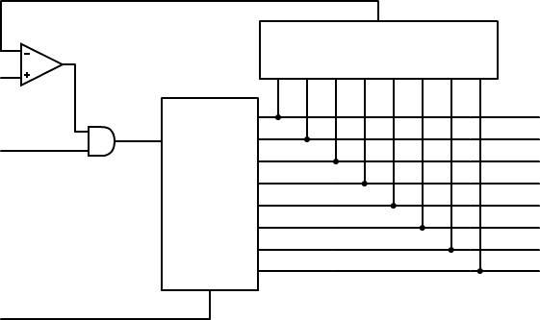
Analogue
input
Clock
Input
Reset
Digital
Output
Comparator
DAC
D7
D6
D5
D4
D3
D2
D1
D0
Q7
Q6
Q5
Q4
Q3
Q2
Q1
Q0
Binary
Counter

Fig Q3
[6 Marks]
The analogue voltage is applied to the + input of the comparator, with the – input being fed by the DAC. Initially the counter is reset to zero (00000000) and the DAC output is 0 volts. With these input conditions, the comparator output is set to logic level 1, which enables the AND gate, allowing the counter to be clocked. On each clock pulse the counter counts up in binary sequence and the quantized DAC output voltage increases in step with the counter. When the DAC output exceeds the value of the analogue input voltage, the comparator output will change to logic level 0. This disables the AND gate and stops the counter, whose output is held at the digital equivalent of the analogue input voltage.

- Draw the logic symbol for a NAND gate and provide the truth table for it.
[4 marks]
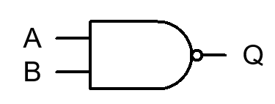

A | B | Q
0 | 0 | 1
0 | 1 | 1
1 | 0 | 1
1 | 1 | 0

2 marks for correct symbol, 2 marks for correct truth table.

- The following circuit comprises two inputs, A and B. Construct a truth table, showing the output states of all the intermediate logic gates as well as the final, overall output. Provide a circuit diagram of a simplified circuit.

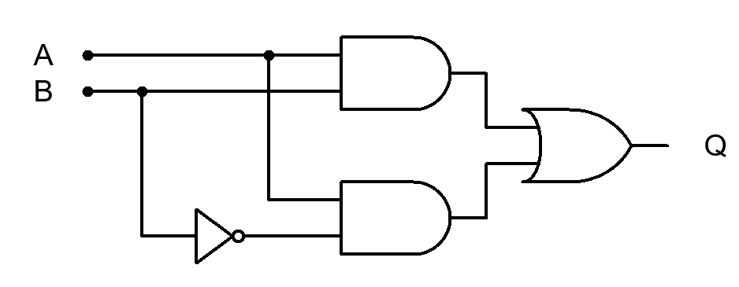

Fig Q5
[8 Marks]
A | B | $$\overline{B}$$ | $$A∙B$$ | $$A∙\overline{B}$$ | Q
0 | 0 | 1 | 0 | 0 | 0
0 | 1 | 0 | 0 | 0 | 0
1 | 0 | 1 | 0 | 1 | 1
1 | 1 | 0 | 1 | 0 | 1

As the output Q follows only input A and input B has no effect, input B can be disregarded, and the new circuit could be either:
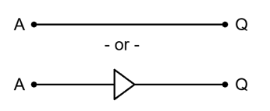

- You are required to drive a traditional mechanical relay from a PIC output port. The PIC is powered from 5V, but the relay will require 48V DC and 120mA to operate it. Sketch a typical circuit configuration that you could use, explaining your reasoning for your choice of all components you use.
[8 Marks]
Correct Diagram = 4 marks (MUST include back EMF protection diode)
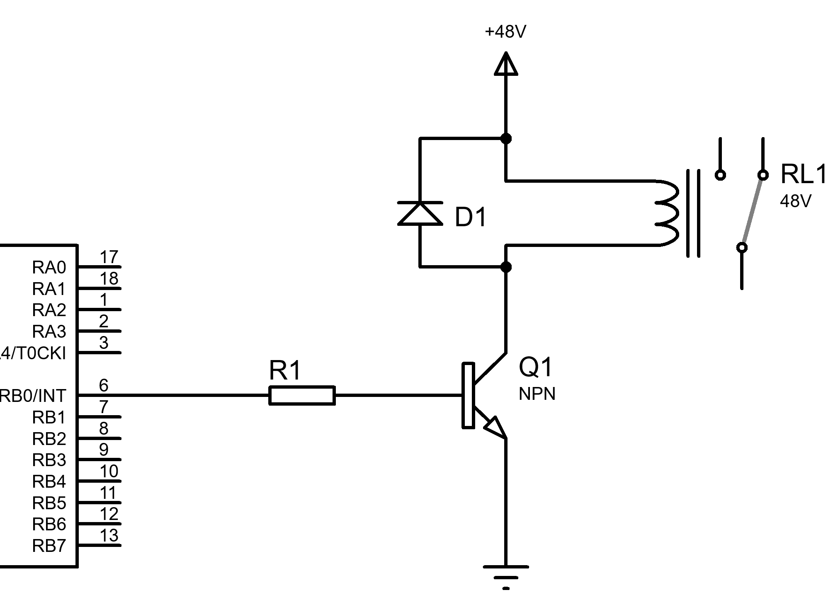
Description of needing to use a FET or Bipolar transistor to allow the additional current demands that a PIC pin cannot supply, series resistor to limit current from PIC pin, pull down resistor on PIC output (if using FET) to keep FET off during startup i.e. while pin is tri-stated, description of purpose of back EMF diode = 4 marks

- In a typical Von Neumann architecture, the busses are labelled as ‘data’ ‘address’ and ‘control’ Describe what each bus is used for, and what the effect is of having different widths for the Data and address busses.
[10 Marks]
Description of the 3 busses – 2 marks each – 6 marks total
Wider Data bus width enabling more data transfer per memory fetch/write cycle e.g a 32 bit bus allowing 4 bytes per transfer as opposed to 1 byte for an 8 bit bus – 2 marks
Wider address buss allowing a greater range of memory and/or I/O to be accessed – e.g. a 16 bit address buss allowing 2^16=64K locations vs say a 20 bit system giving 2^20=1Mb – 2 Marks

Diwedd/End

