

Student: Mariana Monalisa Paun
Student ID Number: 2126836
Module: Effective Team Working and Communication
Module code: BMSW4002
Module lead: Dami Pakubo

Table of Contents
Introduction 2
Model of teamwork 2
Tuckman’s model 3
Forming stage 3
Storming stage 4
Norming stage 4
Performing stage 4
Adjourning stage 4
Wheelan’s model 5
Roles for creating effective teams 5
Impact of effective teamwork or team success 5
Conclusion 6
References 7

Introduction
Teamwork is “the collaborative effort of a group to achieve a common goal or to complete a task in the most effective and efficient way” (Montebello & Buzzotta, 1993, p.59). This report analyses the teamwork concept in relation to the case study given and outlines the issues found in the proposed scenario. Firstly, an in-depth analysis will be introduced to explore the meanings of a team and then research on the “teamwork” term will be conducted. In this way not only that the reader will have a better understanding of the proposed theme, but the report will provide a wide range of academic references to demonstrate the uniqueness spectre and work that has been put through to solve and find a recommendation to the case scenario. The paper is segmented in multiple sub-sections explaining the theory frameworks of Tuckman’s (1965) model, Wheelan’s model (2020) and give a brief descriptive information of the Gersick’s model. Furthermore, the team roles within any team would be analysed to demonstrate how these could have an impressive impact on team’s performance.

Model of teamwork
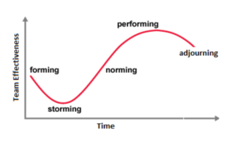
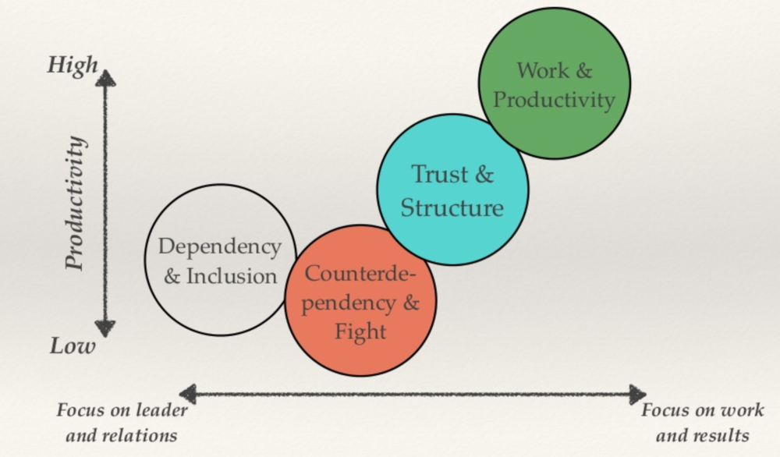
The term “team” is a sub-group of the term “group”. Teams tend to have a smaller circle of members with all of them working towards a common goal. Thus, a team is defined as a “small group of people with complementary skills committed to a common purpose and set of specific performance goals” (Katzenback and Smith, 1993). There are numerous frameworks and models but sometimes the team might now follow them, or it might get stuck in the early ages due to poor management. Some of the models are Tuckman’s, Wheelan’s, Lencioni, T7, LaFasto and Larson etc. The most used of this one and the most popular amongst all of the academic research is Tuckman’s. Harris & Harris (1996) suggest that a team has a common goal or purpose where these team members can develop relationships to achieve the proposed goals and objectives. These teams are part of any business society, and they form the segment of delivering a specific project. It is imperative that the manager delegates the team members based on their strengths and weaknesses, qualities and flaws. In this way, all team members would be balanced and a better synergy, which is the core of any team would be in place. Successful teamwork relies on the environment and how the team leader nurtures it. The team members should be flexible enough to adapt to different tasks and to cooperate, having a social interdependence rather than an individualistic approach (Luca & Tarricone, 2001). Having explained the terms “team” and “teamwork", the Tuckman’s model of team development would be explained (Figure 1). While Tuckman suggests that the team would reach maturity at the end of the project, Wheelan’s model, even though it is based on Tuckman’s, suggests that team mature through the stages they are going through (Figure 2).
Figure 1: Tuckman's model of team development
Figure 2: Wheelan's model

Tuckman’s model

Forming stage
The forming stage implies team members to get to know each other and “test the waters”. Uncertainty is high and people are usually looking for authority and leadership in this stage. Most of the interactions are social as mentioned before, team members get to know each other. Some of the relevant questions they might be asking would be “What is expected from me?”, “Will I fit in?” or “What are the benefits of taking part of this team?”. For instance, in any new job position that we get, we tend to analyse the team and ask ourselves if this is the right place for us. Getting acquainted with other people and getting to know each other is important as this will shape the future stages of this model.

Storming stage
The storming stage is found to be at the lowest point of the effectiveness of any team. This period is marked by conflicts and chaos as personalities start to emerge and break through. As these conflicts start to arise, the energy is put onto the unproductive activities rather than on the goal. Members tend to disagree between their ideas and to try and take leadership by forming cliques or subgroups. This is the most critical stage of any team. Thus, a good leader would address these issues and would sort them out to avoid the long-term problems.
In the case scenario, Tom failed to provide an effective communication channel and, thus, issues started to arise especially between Mihaela and Spencer. Both of them are unmotivated and their commitment is low due to the poor leadership approach.

Norming stage
If teams get through the storming phase, then conflict would be resolved, and consensus would develop among team members. The differences between team members are better understood and, nonetheless, team members start to appreciate the differences between them. Furthermore, the team performance starts to increase as in this stage members got over the issues and started to communicate effectively which, of course, leads to an efficient teamwork. As the norming stage sits between storming and performing, the team can anytime slide back into the storming phase if any issue arise or if any of the disagreements re-emerge. This is why the leader has to keep the harmony and make sure that the environment is a prolific one.

Performing stage
In the performing stage, the synergy of the team starts to appear as consensus and cooperation have already established well. The team is considered to be mature at this stage and all of the energy would be put through meeting the goal. Members are committed and there is a clear and stable structure and hierarchy among them. Plus, if any disagreement arise, it would be dealt constructively and maturely.

Adjourning stage
This is the stage when the team disbands, and the final work is delivered. While some of the members would be working together on different projects, some of them would not. There might be regrets and sadness as the team has to split up, but acknowledgements and the success of the team would be celebrated.

Wheelan’s model
According to Wheelan, the development of the team could be compared to a child growing up. Thus, infancy and adolescenting are the two early stages. In order to grow and work independently, one must go through these stages. Thus, even teams go through the same process. Wheelan’s model is based on psychological and behavioural factors of any group development. The psychological component determines how the team is perceived by the outsiders, while the behavioural one would explicitly describe the behavioural style to the people who are not taking part of the team (Grangberg, 2020).

Roles for creating effective teams
There are several role theories, but the most popular and most used one is Belbin’s theory. He found out that there are several roles in a team, specifically 9. Furthermore, there is research that agrees to the fact that any team is more effective if the team roles are mixed and there is no dominance from one to another. The 9 roles are shaper, implementer, complete-finisher, coordinator, team worker, resource investigator, plant, monitor-evaluator, specialist. There are action-oriented roles, people-oriented roles or thought-oriented roles. There is not needed to find people to cover every of the 9 roles as some people can assume 2 or even 3 roles as secondary and tertiary roles. By filling in the Belbin questionnaire at the beginning of any team formation, team leaders and managers can see the strengths and weaknesses, qualities and flaws. Thus, leaders can work on improving the drawbacks and start bringing more value and assets to the team composition. There are no specific roles needed to create an effective team, but leaders should try to cover all of the areas. In this way, the team would have a mixed composition of talents. For instance, if the majority of the members would be thought-oriented, then it would be too many ideas without actually putting them into practice.

Impact of effective teamwork or team success
There are numerous benefits of having an effective teamwork, but the most important ones are these: better problem solving, increased potential for innovation and personal growth, happier team members thanks to the nurturing environment, less burnout. The team members reach the maximum potential of output they have as a team and the effectiveness is found to be at the maximum level. An effective teamwork would not only lead to team success and achieving the goals proposed, but it will also go beyond the bottom line of the company. Each individual has unique gifts, talent and skills. However, if various talents are brought to the table, it could create an immense competitive advantage to the other companies.
Nonetheless, when forming the team, it is important to make sure that the leader knows and is aware of each team member’s traits and personality. To do this, the Belbin questionnaire and other psychometric tests could be given to identify the talents of the team. Working together facilitates the idea of teamwork and could generate more unique ideas, it brings better business results and boosts up the employee morale and motivation.
Unfortunately, there are some barriers when it comes to an effective teamwork. Some of these might be ineffective leadership, goal confusion, lack of trust, communication gaps, poor conflict and resolution skills etc. The barriers that Tom has encountered are mainly about communication errors as he failed to provide an effective communication channel. Plus, the team formation constituted by Tom was poorly made. Not following the team members tests to check for the talents and having them in his inventory, Tom would be needed to solve the issue with Mihaela and Spencer. The most common approach would be to have a one-to-one conversation and try to motivate them and remind them about the ultimate goal. As a prestigious e-commerce company, Amazon prides by being the leader in such an immense market. If Tom succeeds to establish a proper communication channel either by implementing an app to work on, or by holding video-conferences, having phone calls and text messages, Tom would be able to keep the information flowing.

Conclusion
To sum up, this report analysed different models of team formation and tried to outline the importance of creating an effective team even from the early stages. Even though Tuckman’s and Wheelan’s model were presented, there are limitations to the timeframe of each stage. Thus, each team is responsible to adhere to the next stage in their phase. As explained and showcased, Tom needed to conduct tests at the beginning of his team formation in order to make sure he knows what kind of team members he has in his team. The fact that conflicts appeared in the early stages with the team members questioning already what they are going to be earning from this project means the lack of motivation and lack of trust Tom had inspired.

References
Belbin, R. (1981). Management teams. London: Heinemann
Granberg, A. (2022). When should Susan Wheelan’s Integrated Model of Group Development be applied? - BALEVO. BALEVO. Retrieved 7 October 2022, from https://balevo.se/when-should-susan-wheelans-integrated-model-of-group-development-be-applied/.
Harris, P. R., & Harris, K. G. (1996). Managing effectively through teams. Team Performance Management: An International Journal, 2(3), 23-36.
Katzenbach, J. R. & Smith, D. K. (1993). The discipline of teams. Harvard Business Review, 71 (March-April), 111-146.
Luca, J., & Tarricone, P. (2001). Does emotional intelligence affect successful teamwork?. Proceedings of the 18th Annual Conference of the Australasian Society for Computers in Learning in Tertiary Education at the ASCILITE, p. 367 – 376, Melbourne: University of Melbourne.
Montebello, A. R., & Buzzotta, V. R. (1993). Work teams that work. Training & Development, 47(3), 59-65.
Tuckman, B. (1965). "Developmental sequence in small groups". Psychological Bulletin. 63 (6), pp.384–399
Wheelan, S. A., Åkerlund, M., & Jacobsson, C. (2020). Creating effective teams: A guide for members and leaders. Sage Publications.

